Statistical analysis
Diagnostic parameters were evaluated: sensitivity, specificity, positive and negative predictive value (PPV and NPV), positive and negative likelihood ratio (LR+ and LR-). Based on the literature data, priors of sensitivity and specificity of the Wells score (67% and 90%, respectively) were used through the beta distribution (alpha1 = 12, beta1 = 6; alpha2 = 47, beta2 = 5) [doi: 10.1186/s13017-016-0078-1], then a posterior distribution was obtained based on our own data. After 10,000 iterations through LR+ and LR- post-test probability values (PPV and NPV) were obtained for each prevalence (pre-test probability from 1% to 99%), later we calculated estimate and 89% credible interval. For statistical processing, we used the open-source software R version 4.2.2 (The R Foundation, http://www.R-project.org) with packages «tidyverse», «epiR», «gt», «ggplot2», «tidybayes», «ggdist».

Results

Table 1. The two-by-two contingency table.
 | Outcome
Test | + | - | Total
+ | 429 | 38 | 467
- | 33 | 367 | 400
Total | 462 | 405 | 867

Our research data on test results and outcomes.

Table 2. Diagnostic characteristics.
Parameters | Estimate | 95% CI
Prevalence, % | 53.29 | 49.90 – 56.65
Sensitivity, % | 92.86 | 90.11 – 95.03
Specificity, % | 90.62 | 87.35 – 93.27
PPV, % | 91.86 | 89.00 – 94.18
NPV, % | 91.75 | 88.61 – 94.25
LR+ | 9.897 | 7.304 – 13.41
LR- | 0.079 | 0.057 – 0.11
PPV - positive predictive value, NPV - negative predictive value, LR+ - likelihood ratio positive, LR- - likelihood ratio negative, CI - confidence interval.

Figure 1. Priors and posteriors for sensitivity and specificity.
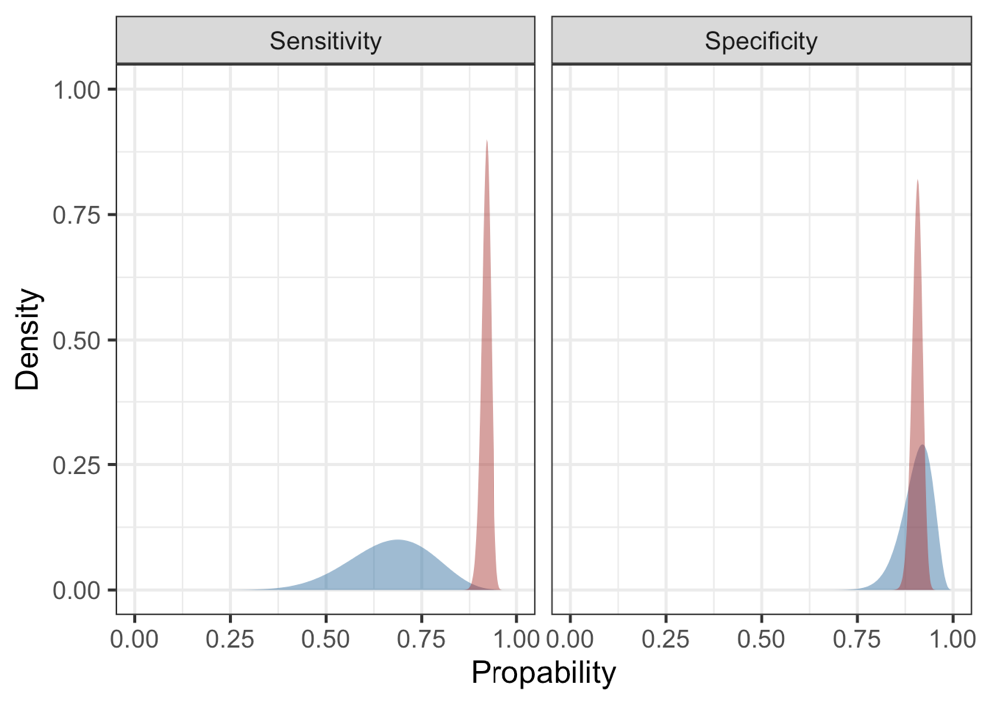
Blue density plot - prior beta distribution, red density plot - posterior beta distribution.

We used literature data on the sensitivity and specificity of the Wells test (67% and 90%, respectively). [doi: 10.1186/s13017-016-0078-1]

Figure 2. Dependence of post-test probability on prevalence.
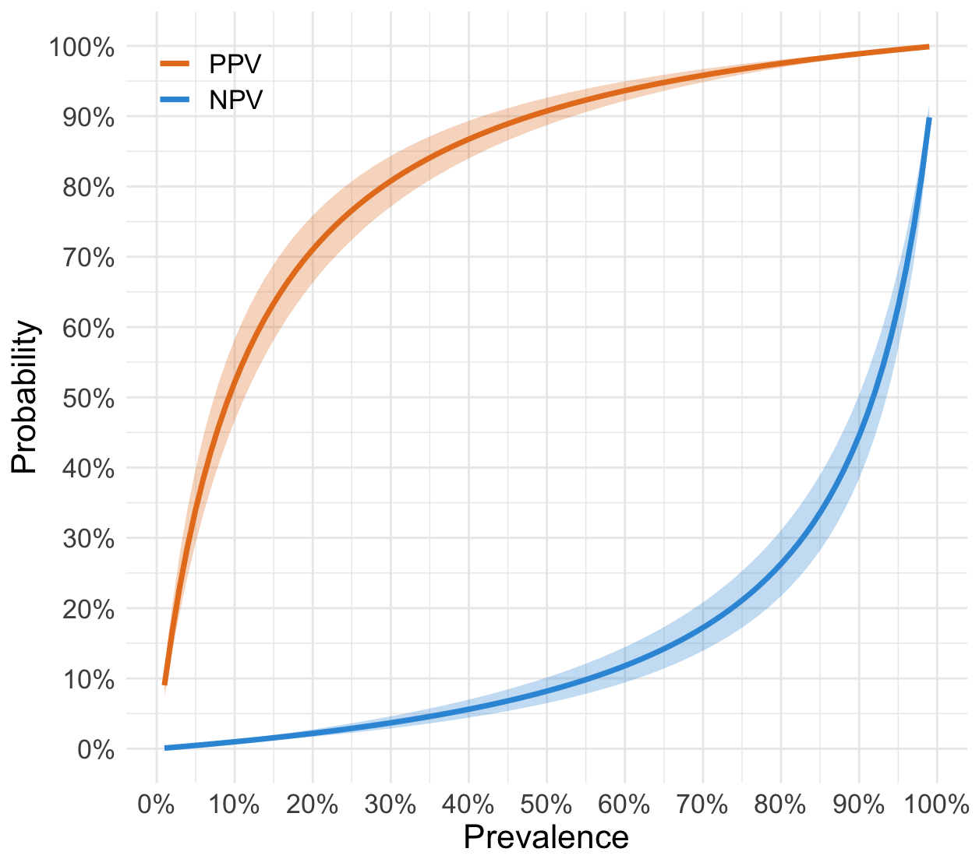
PPV - positive post-test probability. NPV - negative post-test probability. Saturated lines are a point estimate of probability, semitransparent areas are 89% credible interval.
The graph also shows that starting from about 30% of the prevalence, you can be fairly sure of a positive (gradually coming to a plateau) or negative (still on a plateau) result of the Wells test.

Table 3. Post-test probability depending on prevalence.
Pre-test  probability, % | PPV  (89% CI),% | NPV  (89% CI),%
1 | 9.05 (7.37 – 11.24) | 0.09 (0.07 – 0.11)
5 | 33.94 (29.14 – 39.55) | 0.46 (0.36 – 0.58)
10 | 52.00 (46.43 – 57.97) | 0.97 (0.75 – 1.22)
15 | 63.22 (57.9 – 68.64) | 1.53 (1.19 – 1.92)
20 | 70.87 (66.06 – 75.59) | 2.15 (1.67 – 2.7)
25 | 76.42 (72.17 – 80.49) | 2.84 (2.21 – 3.56)
30 | 80.63 (76.91 – 84.13) | 3.62 (2.82 – 4.53)
35 | 83.93 (80.69 – 86.93) | 4.51 (3.52 – 5.62)
40 | 86.59 (83.79 – 89.16) | 5.51 (4.31 – 6.85)
45 | 88.78 (86.36 – 90.97) | 6.67 (5.23 – 8.27)
50 | 90.78 (88.7 – 92.62) | 8.17 (6.42 – 10.1)
55 | 92.46 (90.75 – 93.98) | 9.97 (7.88 – 12.25)
60 | 93.76 (92.32 – 95.03) | 11.95 (9.48 – 14.61)
65 | 94.89 (93.69 – 95.94) | 14.36 (11.47 – 17.46)
70 | 95.88 (94.91 – 96.74) | 17.39 (13.99 – 20.97)
75 | 96.77 (95.99 – 97.44) | 21.28 (17.28 – 25.42)
80 | 97.55 (96.96 – 98.07) | 26.48 (21.77 – 31.23)
85 | 98.26 (97.83 – 98.63) | 33.76 (28.25 – 39.13)
90 | 98.90 (98.62 – 99.13) | 44.72 (38.45 – 50.49)
95 | 99.47 (99.34 – 99.59) | 63.03 (56.84 – 68.25)
PPV - positive post-test probability. NPV - negative post-test probability. CI - Credible interval. The pre-test probability corresponds to the prevalence of DVT in the population. A positive result was considered to be a value on the Wells scale of 2 points or higher.

According to the data obtained, we can say that with a prevalence of DVT in the population above 30%, one can be fairly confident in the test result, since a positive post-test probability will be about 80% (with a probability of 89%, the true result lies in the range of 77-85%), and a negative one is about 4% (true in the range of 3-5%).

