Course Project: Shiny Application and Reproducible Pitch

User Guide for the FHFA HPI app

# Summary

This document to be used as a user guide for navigating and operating the “FHFA HPI” app (Federal Housing Finance Agency, House Price Index). The application has three functioning tabs.

# Tab 1: Historic HPI

The first tab presents historic values for the House Price Indexes recorded/calculated by the FHFA for selected metro areas. The left side of the screen is a control box that allows the user to select which metro areas to view.

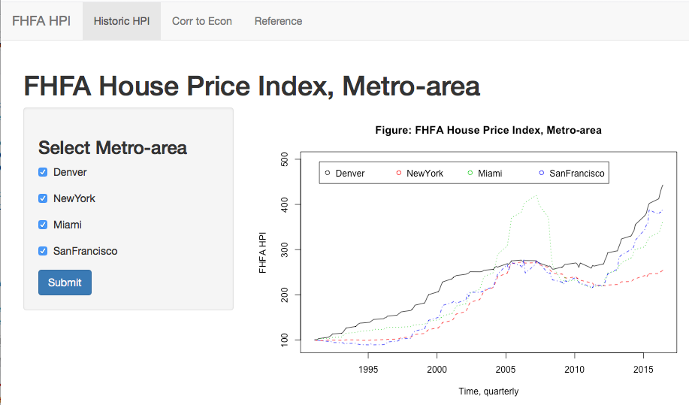

The user can select from one up to four metro-areas by selecting the checkbox next to each metro area. Once a selection is made, the user has to “submit” the choice. The plot on the right side of the screen then allows the user to compare the trends in the FHFA HPI across the selected metro-areas.

# Tab 2: Corr to Econ

The second tab presents correlations between a selected metro-area HPI and a selected Macro-economic indicator (with a specific lag). The left side of the screen presents the user with the functionality to select a metro-area, an economic indicator (RealGDP, CaseShiller_HPI, Unemployment Rate) and a lag for the macro-economic indicator (between 0,2,3,4,6 quarters lag). The drop-down menus allow the user to select only one metro-area, one economic indicator and one lag combination.

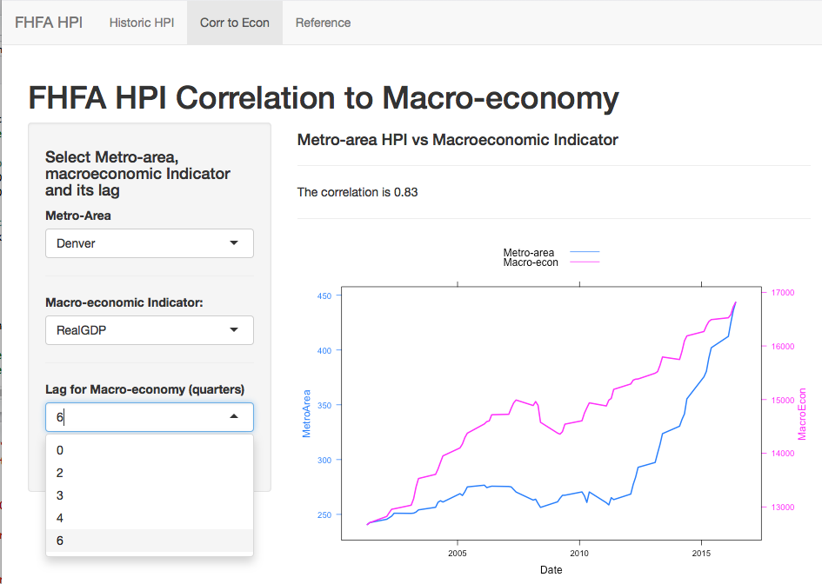

Once the selection is made the user has to “submit” their choice, and the right-hand side of the screen presents the correlation coefficient between the two curves, plus it presents the two time-series on the same plot for trend comparison.

# Tab 3: Reference

Tab3 contains any referenced white papers and documentation.

