

Insertion

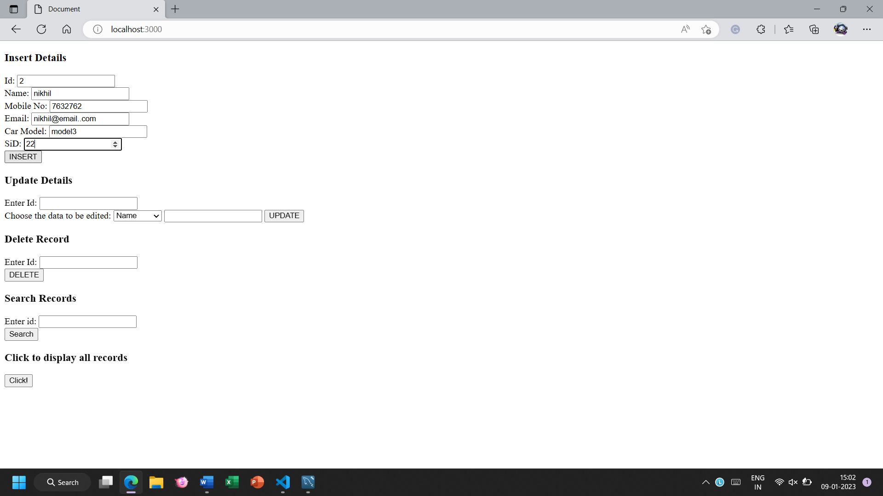

search

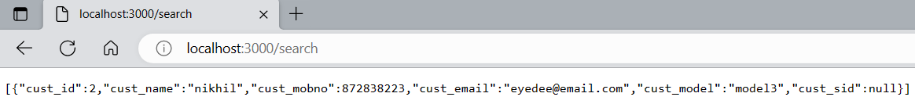



Update

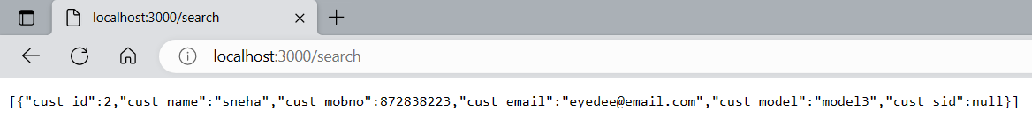

Before delete:

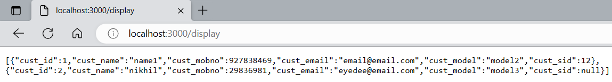

After delete:

