Network Failure Recovery

Nikhil John (100915166), Arif Awasaf Aquib (100910387), Uthman Falola (100929801)

ONTARIO TECH UNIVERSITY

FACULTY OF BUSINESS, AND IT

Advanced Communication Network- MITS 5200G

Project Objective
The development of computer networks transformed communication technology and made data sharing easier and more effective. Although the design and implementation of traditional network devices were impressive, they are insufficient in the modern day. People have been waiting for software defined networking, an emerging technology that appears to be the most suitable and is currently undergoing further development to meet the needs of more networking devices, including high availability, programmability, and cost-effectiveness. With its availability and flexibility, SDN is being implemented in a carrier-grade network. Faster recovery of failing links is necessary for high availability. As a result, numerous approaches were put out and carried out by academic researchers. Offering a backup route for a source to travel in order to reach its destination is one of the fundamental link failure recoveries. This work implements rerouting, or giving a dynamic, alternate path to minimise link failure, on a Mininet. SDN typically consists of devices with distinct data and control planes, with a controller a unique device serving as the system's brain. The Pox controller is utilised in this experiment, and Mini edit, a Python programme that serves as a GUI for constructing topologies and displays the interrupt-less ping flow, is used to observe the experimental topology. This implementation forms the basis for the enhanced failure recovery techniques.

- Introduction
Computer networks make it possible for users to share data among themselves when they are linked. For instance, if a printer is installed on one computer, other users who are connected to the same network can utilise it. This lowers the expense of installing printers on every computer and eliminates the requirement to install printers on individual systems. Additionally, computer networks offer scalability and stability. The two planes that the data in the network passes through are the control plane and the data plane. The logic controlling the forwarding behaviour is found in the control plane, while the data plane is responsible for forwarding the packets. In software-defined networks, the control plane is software-based and accessible through a connected device, as opposed to traditional networks where the control plane is housed within a switch or router and makes it difficult for administrators to control traffic flow. This led to a revolution in which the entire network was virtualized and an administrator could manage traffic from a single interface.

- Experimental setup
2.1 Access the Virtual Mininet.
Your computer should be running the Mininet virtual machine (VM), and it should be reachable at the IP address that the VirtualBox host-only interface assigned. In this case, the IP address of the VirtualBox host-only adapter is 192.168.56.101. Examine the Mininet VM's interface to determine the IP address that is assigned to you. Login to Mininet via putty using the ip address found earlier
Enter Mininet as the password in the putty terminal. You are currently logged into the Mininet VM, according to the prompt:
mininet:~$mininet@mininet-vm
In order to have three terminal windows open and logged in duplicated the putty session, repeat this at least three times.

2.2 Establish the network
Mini Edit will be used to build our network scenario. You can find the Mini Edit script in the examples folder of Mininet. Run Mini Edit by typing the following command:
Make a network with hosts, switches, and a controller using the Mini Edit GUI. Introduce redundant connections among switches, resulting in network loops. We establish a network topology in our case as indicated below:
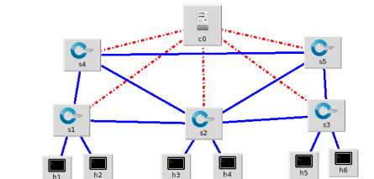
Figure 1. Network in Mini Edit
2.3 Get the simulation started
Click the Mini Edit GUI's Run button to launch the simulation scenario. You should now see the Mininet prompt in the terminal window that you used to launch Mini Edit, assuming you configured Mini Edit according to the instructions in my post about using Mini Edit.

2.4 Start POX
Developers write and execute Python programmes that use the POX API to change the state of network switches and react to data those switches communicate to the POX controller in order to create network applications utilising the POX software defined network controller. Programmers have two options: they may create stand-alone apps that leverage the POX API or they can create apps that directly enhance POX with new features. A POX component is a programme of the latter kind.
Launch a fresh terminal window. We will launch the POX SDN controller in the newly opened terminal window.
We used the following command to launch POX:
In order to construct a network application that switches based on Ethernet MAC addresses, provides redundant links in the network, and prevents packet storms caused by loops, this initiates POX and calls upon POX components. Additionally, it adds features to the POX console that will show more network events and enable debug mode so that we may view those events.
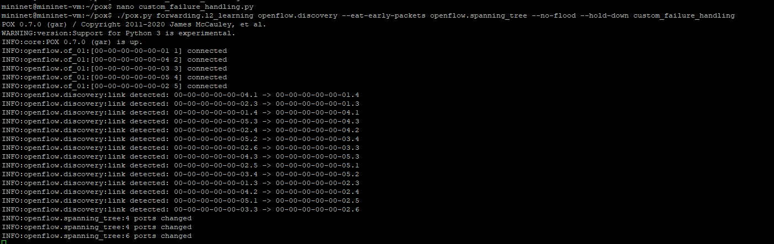
Figure 2 Log records of pox starting and setting up the network
2.5 Identify the network's topology and details
We have constructed a simulated SDN network that can forward traffic between hosts and control redundant network links to enable traffic rerouting in the event of an active link failure.
Prior to exploring the network's capabilities, we must first acquire some network data and take some notes that will be useful in creating a more thorough network diagram. The names of the ports and their current states must be noted.
To see which ports are connect to which switches, use the Mininet link command: 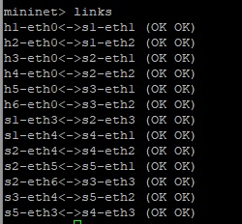
Figure 3 Port details of the topology

From this, we will mark up a screen capture of the network diagram. Our examples results in the following annotated diagram:
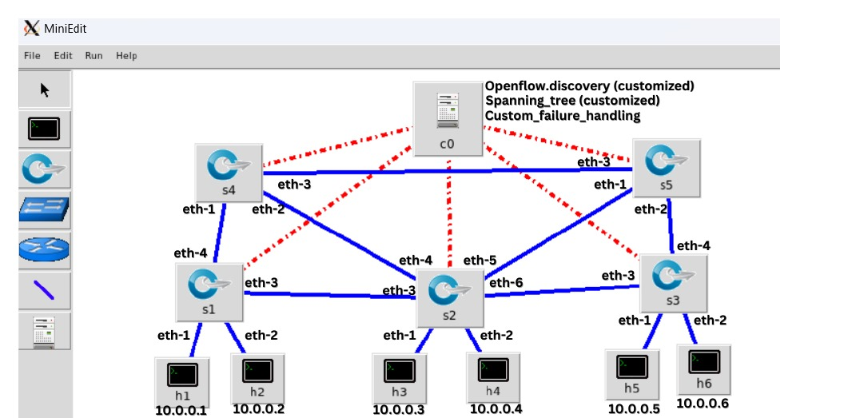
Figure 4 Network diagram with port details

2.6 Launch Wireshark
Wireshark is then launched, and packets are captured on the loopback interface of the Mininet virtual machine. In order to determine which switch uses which port address, we must first start Wireshark and then the POX controller. This is necessary in order to capture the switch setup messages sent by the POX controller.

Use the following command to launch Wireshark in one of the terminal windows:
And we will be able to see all details of all switches and ports
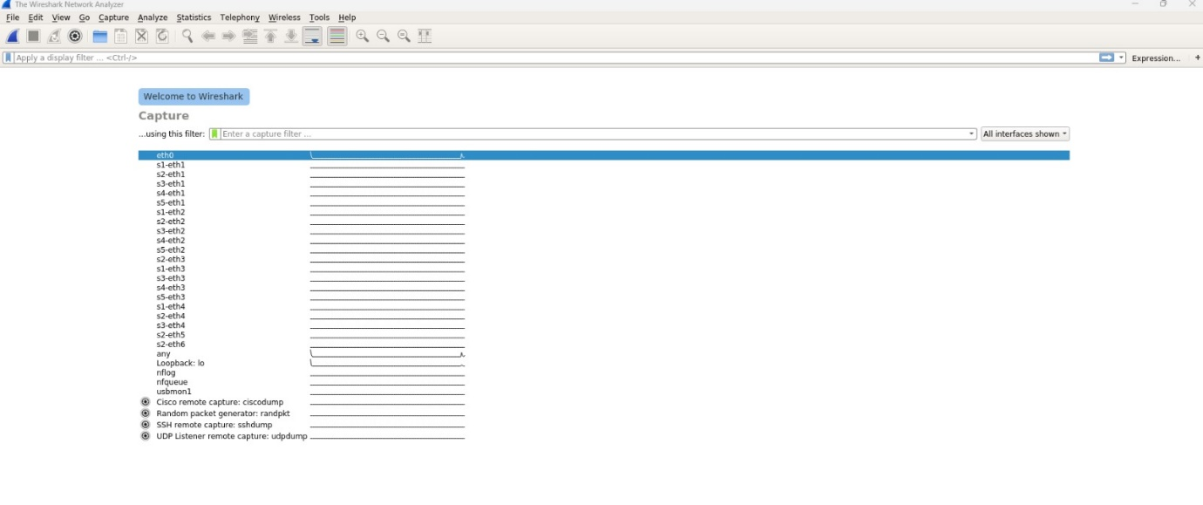
Figure 5 Wireshark captures of the network

- Result
An x-term terminal appears when you enter the command Xterm h1. Ping host 6 in the terminal by entering ping 10.0.0.6, the equivalent IP address of host h6, as indicated in in the below figure. The figure displays the outcome of the ping command. The linkages between the switches may now be configured to go down by right-clicking on the link and selecting the link down option (the topology, where the solid line represents link up and the dotted line represents link down) or using the link down command. The ping command on the host terminal is still active, despite the openflow_discovery packets being shown in the Pox console window.
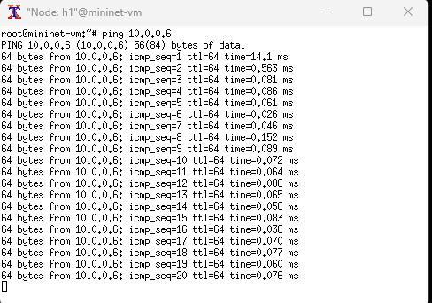
Figure 6 Ping command
And the following the Wireshark packet readings after link down
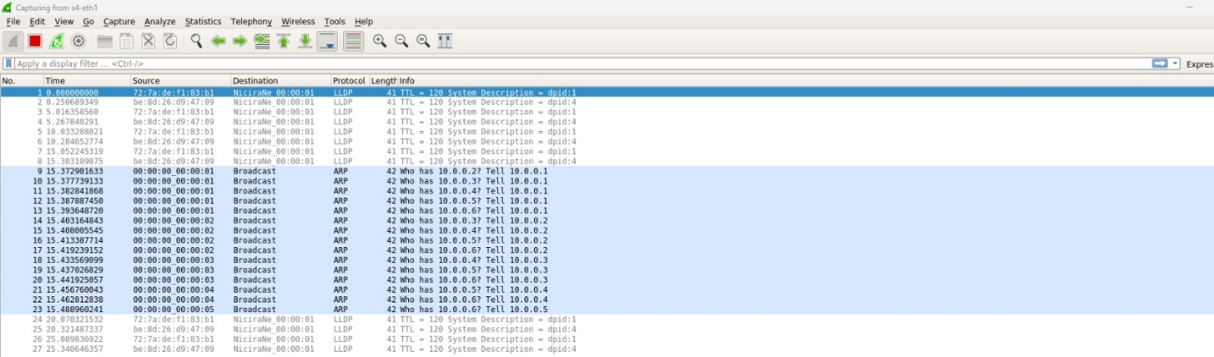
Figure 7 Wireshark captures and displays OpenFlow messages

- Conclusion
Even after the link is made down, the host is still reachable. This is because the spanning tree component has the redundant path to reach the destination. Hence the host is finding another way to reach the destination through openflow.discovery component and forwarding.l2_learning component whose logs were shown in the terminal as shown below. For every 5 seconds the flows in switches are getting updated. Since the path is kept as a backup that act as an alternate path to reach the destination. SDN plays an important role with its flexibility, availability and fast recovery from link failure.
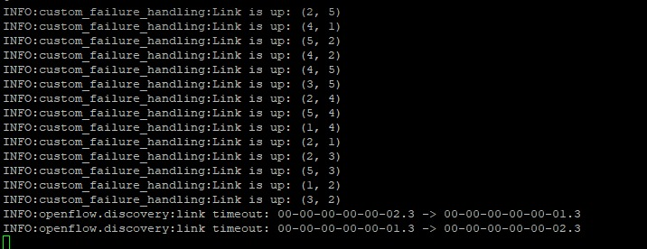
Figure 8 Logs showing the Link Failure

- My Role
Firstly, in the initial stages of the project I played an important role in understanding Mininet and how to use it. This understanding helped me explain to my teammates on how Mininet work, for example how to use external display through ssh, using putty application to open multiple terminals and how to create topologies using Mini edit and different command (like Sodo mn, net, links, dpctl dump etc) in Mininet that could help us in the project and I also created the initial topology consisting of 6 host, 5 switches and 1 controller and configured them accordingly. Secondly, I had researched and implemented different POX controller modules mentioned below.
The forwarding.l2_learning component makes OpenFlow switches act like ethernet learning switches that creates flows with idle timeout values. The openflow.discovery component uses link layer discovery protocol messages sent to and received from open flow switches to discover the network topology. The component OpenFlow spanning_tree --no-flood --hold-down prevents the loops and to ensure no packets are flooded in the network before the component creates the spanning tree. The log.level --DEBUG component is used to specify the amount of detail they will see in the log information produced by the pox. The pretty_log provide attractive and readable log output on the pox console. The host_tracker component keeps track of hosts in the network.
Finally, I contributed in the introduction of the presentation where I explain the project objective, how Mininet and pox controller work in brief.

- What could we have done better
In the current configuration configures a POX controller with support for Spanning Tree Protocol, learning switch functionality, debug level logging, network discovery, host tracking, and packet dumping for in-depth study but all these are modules that already available in the pox controller. Nevertheless, a network failure detection or recovery mechanism is not specifically mentioned.
SDN often uses a variety of approaches for network failure detection and recovery, including link utilisation, switch status monitoring, and redundant path implementation of failover mechanisms. Although these techniques may not be specifically mentioned, they may be incorporated into more comprehensive network management plans or extra modules that enhance the capabilities of the SDN controller.
We also faced multiple challenges like flooding the network that effected the performance of the recovery which we overcame by implementing spanning tree protocol. We also faced any issues with Mininet and pox controller itself like the python version difference in Mininet and pox controller. But in the end of the day this was a wonderful and interesting opportunity to learn about routing and failure in networks.
- Future Improvements
Some improvements that could be added are firstly, adding an alternate network path on layer 3 instead of the controller automatically choosing a path using layer 2 to the destination when a link failure occurs. Secondly, to add rerouting algorithms like Dijkstra’s to improve efficiency of rerouting by enabling shortest path. Finally, to add performance monitoring to help analyse the traffic in the switches.

- Reference

[1] https://www.comparitech.com/net-admin/software-defined-networking/
[2] https://www.rfwireless-world.com/Terminology/traditional-networking-vs-software-defined-networking.html
[3] mininet.org/walkthrough

