

MODULE: B9DA111 DATA STORAGE SOLUTIONS FOR DATA ANALYTICS (B9DA111_2425_TMD3)
ASSESSMENT: CA_1
GROUP MEMBER:
Harsh Vardhan (20066051)
Harsanbruno Maria Joseph Esuraj (20065575)
Gunasekhar Vasireddy (20061005)

Proof of Concept: Data Warehouse for Railway Ticketing and Journey Analytics

1. Introduction
Railway companies handle huge amounts of data every day—everything from ticket sales and passenger movements to payment details, train schedules, and interactions with customers. But even though this data is incredibly valuable, much of it does not get used to its full potential. This happens because the information often exists in different formats, is not well connected, or companies simply do not have the right tools to make sense of it all.
This Proof of Concept (PoC) tackles that problem by introducing a dedicated Data Warehouse, built around a dimensional modelling approach. The goal is to take all those scattered bits of raw information and bring them together in one organised, structured place that is designed for efficient analysis. By using a star schema with fact and dimension tables, the warehouse lets teams quickly answer questions, spot trends, and make decisions backed by data.
For this project, we are working with a wide variety of details: transaction IDs, travel dates, departure and arrival stations, ticket types, class of travel, how people paid, whether a railcard was used, prices, refunds, and journey status. All this data is cleaned up, linked together, and arranged in a flexible schema that supports rich reporting and analytics from multiple perspectives.
With this new data warehouse in place, different teams—such as operations, finance, and customer service—can easily dive into historical trends, monitor important performance metrics, track patterns in refunds, and understand how passengers are travelling throughout the network. This platform also lays the groundwork for creating interactive dashboards in tools like SSRS or Tableau, helping railway organisations improve planning, boost revenue, and make smarter strategic choices.

2. Subject Area and Justification
Selected Subject Area: Railway Ticketing and Journey Analytics
Justification:
We chose this area because it delivers significant value to the business and involves a wealth of detailed information. Ticket sales are a primary source of income for railways, while journey records shed light on how reliable and efficient the services are. Analysing refund requests can uncover areas where customers are unhappy or where processes are breaking down. By looking at all these data points together, the organization can fine-tune services, predict revenue more accurately, and create a better experience for travellers.
This focus area also lends itself well to in-depth, multi-angle analysis and supports a robust, scalable data warehouse structure. Plus, it closely supports the objectives of various teams across the company, including operations, finance, marketing, and customer support.

3. Key Stakeholders and Their Objectives
The implementation of a data warehouse directly supports a range of stakeholders across the railway organization, each with unique goals and responsibilities. By centralizing critical operational data, the warehouse ensures that every team has access to consistent, accurate, and timely information to drive smarter decision-making.
- Operations Management relies on the warehouse to track train performance, identify routes with frequent delays, and adjust scheduling to improve service reliability and efficiency.
- Finance Teams use the data to evaluate revenue trends, measure the financial effects of ticket refunds, and assess how discounts and promotions are impacting profitability.
- Sales and Marketing Departments gain insights into customer purchasing patterns, helping them understand which products or ticket types are most popular—and where opportunities exist to promote higher-margin offerings.
- Customer Support Teams benefit from access to journey and refund data, allowing them to respond more effectively to complaints, monitor service issues, and take proactive steps to enhance the customer experience.
- IT and Data Teams are responsible for maintaining the backend infrastructure, ensuring that ETL processes are running smoothly, data quality is upheld, and access to analytics tools is secure and reliable.
Across all departments, the data warehouse acts as a single source of truth—eliminating data silos, improving reporting accuracy, and enabling cross-functional collaboration.

4. Business Vision
Building a data warehouse is a strategic step toward helping the organization make decisions based on solid evidence. By converting raw transactional data into a format that’s ready for analysis, this warehouse empowers different departments to review past results, spot inefficiencies, and plan smarter improvements for the future.
The main goals include:
- Creating a centralized system that brings together data from various sources.
- Enabling trend tracking, historical reporting, and gaining operational insights.
- Ensuring smooth integration with business intelligence tools for easy dashboard creation and reporting.
- Offering business users, the ability to perform their own analyses without heavy IT support.
- Setting the stage for advanced capabilities like forecasting and machine learning applications.
Ultimately, this data warehouse acts as the organization’s key repository for monitoring essential performance metrics, evaluating business outcomes, and pinpointing opportunities for operational or financial enhancements.

5. Dimensional Model Design
To enable fast, user-friendly analytics, the data warehouse is structured using a star schema. This architecture places a central fact table at its core, surrounded by several connected dimension tables that provide the descriptive details needed for meaningful analysis. The simplicity and performance of this model make it ideal for slicing, dicing, and aggregating data across multiple perspectives.

5.1 Fact Table: Journey Transactions
At the centre of the schema lies the Journey Transactions Fact Table, which houses the measurable events linked to each customer interaction with the railway system. This includes data related to ticket purchases, journey timings, and service outcomes.
Key Metrics Captured:
- Ticket Price: The revenue earned from each ticket transaction.
- Departure & Arrival Times: Scheduled travel times for the journey.
- Actual Arrival Time: Recorded arrival time, used to measure delays.
- Journey Status: Indicates whether the train was on time or delayed.
- Refund Request: Flags whether a customer requested a refund for the journey.
Foreign Keys and Relationships:
- Purchase Date & Journey Date: Connected to the Date Dimension for time-based insights.
- Departure & Arrival Stations: Linked to the Station Dimension to allow for geographic and route-specific analysis.
- Ticket Type: Related to the Ticket Dimension to evaluate pricing strategies and customer preferences.
- Payment Method & Purchase Channel: Mapped to the Payment Dimension to analyse buying behaviour and payment trends.
The fact table forms the foundation for key reporting functions—such as tracking punctuality, calculating revenue, analysing refund patterns, and evaluating how different ticket types and discounts influence performance.
5.2 Dimension Tables: Descriptive Context
Dimension tables support the fact table by offering the descriptive attributes necessary for breaking down and interpreting raw metrics. Each dimension contains a surrogate key and fields that describe one of the main entities involved in a transaction.
Date Dimension
Stores key temporal data, enabling powerful time-based filtering and trend discovery.
- Attributes:
  - Full Date
  - Day, Month, Year
  - Day of the Week
- Business Purpose:
Enables analysis of sales and traffic patterns across time. For example, stakeholders can compare weekday vs. weekend travel, identify seasonal demand peaks, and track revenue growth over different periods.
Station Dimension
Captures details about departure and arrival stations along with their geographical metadata.
- Attributes:
  - Station Code
  - Station Name
  - Region
  - Zone
- Business Purpose:
Helps analyse performance at a regional level—such as identifying the busiest stations, monitoring high-revenue routes, and highlighting zones prone to delays or disruptions.
Ticket Dimension
Describes the characteristics of tickets sold, helping assess customer choices and product strategies.
- Attributes:
  - Ticket Class (e.g., Standard, First Class)
  - Ticket Type (e.g., Advance, Anytime)
  - Railcard Type (e.g., Student, Senior)
  - Discount Percentage
- Business Purpose:
Enables financial analysis of fare structures, tracks usage of railcards and discounts, and helps optimize ticketing offerings based on customer behaviour and revenue impact.
Payment Dimension
Provides information about how transactions were completed, combining purchase methods and sales channels.
- Attributes:
  - Purchase Type (e.g., Online, At Station)
  - Payment Method (e.g., Credit Card, Contactless)
Business Purpose:
Supports marketing and IT teams in assessing consumer preferences and monitoring the adoption of digital channels. It is particularly useful for evaluating the success of contactless payments and online ticketing campaigns.
Strategic Benefits
By organizing railway transaction data into this star schema, the warehouse empowers teams to perform advanced analytics efficiently. It transforms raw data into a reliable foundation for tracking operational KPIs, understanding customer behaviour, and driving strategic improvements across departments.
6. Business Insights Enabled by the Data Warehouse
The implementation of a structured data warehouse allows the railway organization to transform raw, disconnected data into meaningful insights. These insights provide the foundation for strategic decisions that drive operational efficiency, customer satisfaction, and revenue growth. By aligning the data warehouse with key performance indicators across departments, the organization can unlock a variety of analytical capabilities.
Operational Performance Monitoring
With integrated data on journey timings, delays, and routes, operations teams can closely monitor service delivery and identify performance gaps.
- Track on-time arrival rates by individual stations and entire routes.
- Detect recurring delays on specific lines and correlate them with customer refund requests.
- Identify time windows—such as peak hours or specific days—when delays are more frequent than average.
Revenue and Sales Analysis
By consolidating ticket sales, pricing models, and discount programs, the finance team can perform detailed financial analysis at multiple levels.
- Break down total revenue by station, ticket type, or date to identify high-earning segments.
- Measure how different railcards and promotional discounts affect overall revenue.
- Compare sales trends over time to assess growth or decline in demand by season or year.
Customer Behaviour Insights
The warehouse captures data on purchasing methods and ticket preferences, enabling marketing and planning teams to understand customer habits.
- Analyse whether passengers prefer buying tickets online, at stations, or through other channels.
- Identify the most popular ticket types (e.g., Advance, Anytime) and classes (e.g., First Class, Standard).
- Evaluate the usage of various payment methods to guide future upgrades and initiatives.
Refund Trend Analysis
Refund data, when examined alongside journey performance, reveals valuable insights into service quality and customer pain points.
- Monitor patterns in refund requests based on route, station, or ticket category.
- Quantify the financial implications of frequent delays that lead to refunds.
- Use refund frequency to highlight service reliability concerns or customer dissatisfaction trends.
Strategic Value
These insights empower various departments to move from reactive to proactive planning. Whether it is adjusting train schedules, redesigning ticket offers, or investing in infrastructure, the data warehouse provides the factual grounding needed to make smarter, evidence-based decisions across the organization.
7. Strategic Benefits and Future Scope
Strategic Benefits
- Establishes a centralized, consistent source of truth for all key performance metrics.
- Reduces reliance on manual data extraction and fragmented reports.
- Promotes a culture of data-driven decision-making across departments.
- Supports automation of regular reporting and KPI dashboards.
2. Schema Design and Justification
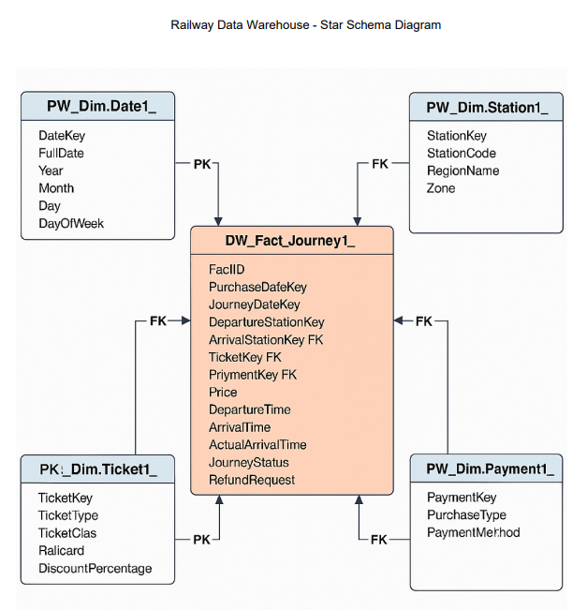
The schema used in the railway data warehouse operates under star schema architecture that makes it perfect in analytical processing since it is simple, scalable, and efficient. At the core of the model is the fact table DW_Fact_Journey1_, which comprises of all the measurable data that is journey specific such as journey and purchase dates, price, and travel times, journey status and refund details. This table is related to the following four-dimension tables: DW_Date1_, DW_Station1_, DW_Ticket1_, and DW_Payment1_. The dimension tables can hold descriptive attributes of dates, stations, ticket details, and payment methods respectively, so that the users can slice the journey data in various perspectives and analyse the data. The reason as to why this design was adopted is to enable quick and easy reporting on the performance indicators like top stations, journey delay, ticket class preference and payment trends. It enables effective querying of the business intelligence and data integrity and modularity and as such is the best option in creating an insightful and maintainable data warehouse.
3. ETL
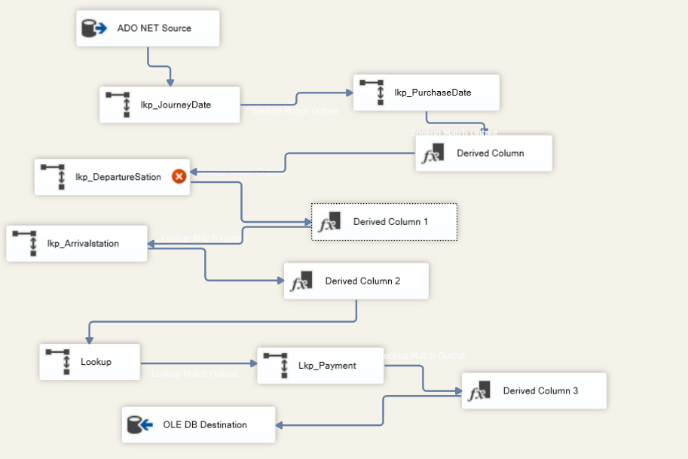
ETL Process for Populating the Railway Data Warehouse Using SSIS
To efficiently transfer railway transaction data from external sources into the data warehouse, a structured ETL (Extract, Transform, Load) process was designed and implemented using SQL Server Integration Services (SSIS). The pipeline follows a modular and performance-optimized approach, incorporating multiple stages of validation and transformation to ensure data quality and integrity.
Overview of the SSIS Workflow
The ETL workflow comprises several components organized within an SSIS Data Flow Task. This pipeline facilitates the seamless flow of data—from raw input to final warehouse storage—while applying key transformation and lookup logic along the way.
ETL Stages
1. Data Extraction (Source)
- The process initiates with an ADO.NET Source component, which connects to an external data source—typically an Excel file or a staging database containing raw railway transactions.
- Fields extracted include:
  - Purchase Date and Journey Date
  - Departure and Arrival Station Names
  - Ticket Type and Payment Method
  - Ticket Price, Journey Status, and Refund Status
This step ensures that all necessary attributes required for analysis and warehouse loading are captured upfront.
2. Lookup Transformations (Dimension Mapping)
To link incoming data with the appropriate dimension records in the warehouse, several Lookup components are employed:
- lkp_JourneyDate and lkp_PurchaseDate
Match date fields from the source with entries in the dw_date1_ dimension, retrieving surrogate keys for both journey and purchase dates.
- lkp_DepartureStation and lkp_ArrivalStation
Identify and map station names to the dw_station1_ dimension, returning keys for both the departure and destination points.
- lkp_Payment
Connects payment methods and purchase channels from the source with entries in the dw_payment1_ dimension table.
Each lookup operation enforces referential integrity by replacing business (natural) keys with surrogate keys used by the fact table.
3. Derived Column Transformations
To standardize and clean the extracted data, a Derived Column transformation is introduced:
- It modifies or reformats key fields such as station names, ticket types, and payment methods into a consistent format.
- This ensures that all incoming data adheres to naming conventions and quality standards before loading into the data warehouse.
4. Data Loading (Destination)
- Once transformed, the data flows into an OLE DB Destination, which writes the finalized records into the fact table within the data warehouse schema.
- The destination table maintains proper foreign key relationships by referencing surrogate keys from the associated dimension tables.
This step completes the ETL cycle, ensuring clean, consistent, and relationally accurate data is stored in the warehouse.

Key Features of the ETL Pipeline
Feature | Description
Parallel Lookup Execution | Lookup components are configured to run in parallel, improving overall speed.
Data Standardization | Derived columns ensure that key text fields follow consistent formatting rules.
Referential Integrity | Surrogate keys are retrieved via lookup to maintain accurate table relationships.

Data Validation and Verification
After executing the SSIS ETL package, data integrity was verified using SQL queries within SQL Server Management Studio (SSMS). Each table was checked for completeness and correctness:
- The dw_date1_ table contains properly formatted calendar dates, with details such as year, month, day, and weekday.
- The dw_station1_ table holds unique station codes and names.
- The dw_ticket1_ table includes various ticket types, travel classes, and applicable railcard categories.
- The dw_payment1_ table reflects different combinations of purchase methods and transaction types.
- The dw_fact_journey1_ fact table successfully references all relevant dimension tables using surrogate keys and captures key transactional details including price, timing, journey status, and refund requests.
This thorough validation confirms that the ETL process accurately extracted, transformed, and loaded data into the warehouse according to the dimensional model, supporting high-quality analytics downstream.

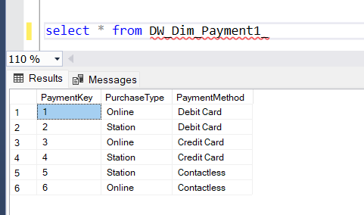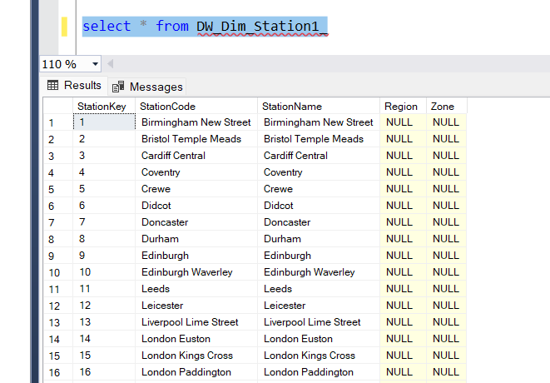
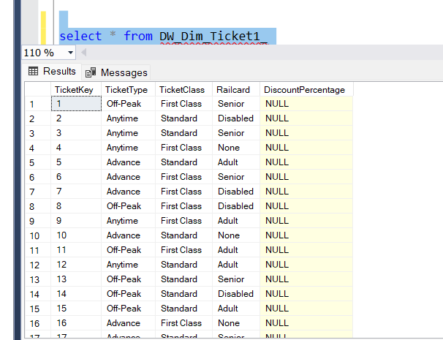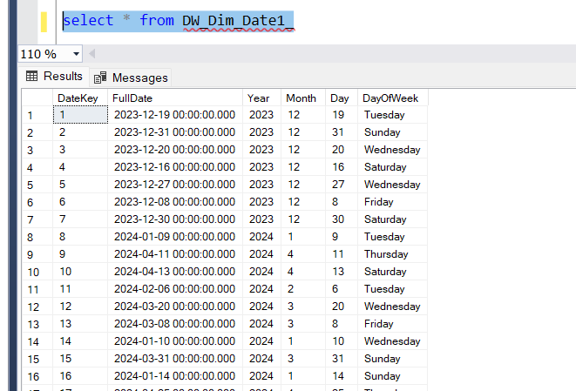
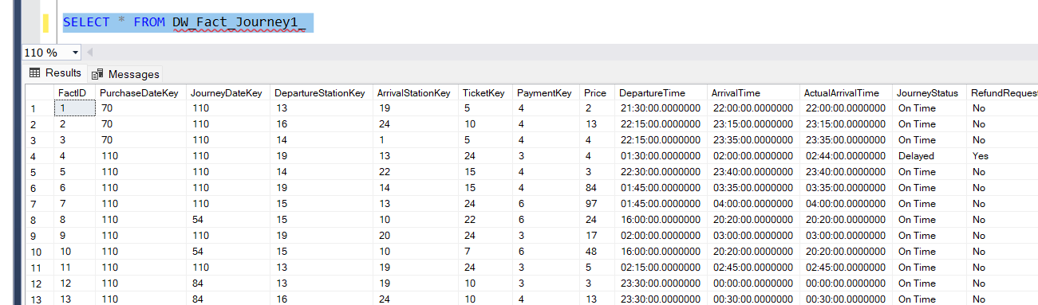

4. SSRS Reports Overview
To transform raw data into actionable insights, a suite of interactive and visually structured reports was developed using SQL Server Reporting Services (SSRS). Each report caters to different stakeholder needs, enabling dynamic data exploration, performance tracking, and decision-making.
1. Tabular Report
Title: Top 50 Train Ticket Prices – Detailed Journey Information
Report Type: Tabular Report
This report presents detailed, transaction-level records, focusing on the top 50 tickets by price. It provides a comprehensive view of each journey, including:
- Unique transaction identifiers and key travel dates
- Departure and arrival station names
- Ticket type, travel class, payment method, journey status, and ticket price
Use Case:
Designed to support pricing analysis and route performance, this report helps stakeholders evaluate which routes generate the highest revenue and understand ticket pricing trends.
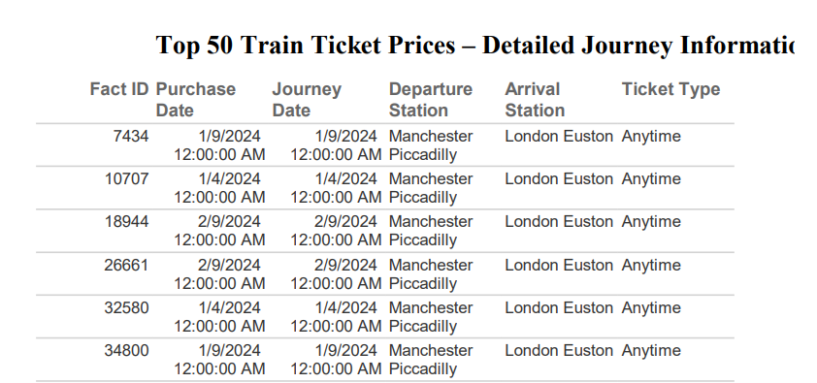
2. Matrix Report
Title: Revenue by Ticket Class and Payment Method
Report Type: Matrix Report
This report summarizes revenue performance by ticket class (e.g., Standard, First Class) and payment method (e.g., Credit Card, Contactless), using a matrix layout for cross-tabulated analysis.
Use Case:
Ideal for sales and marketing teams, it helps uncover customer preferences, informs pricing strategies, and evaluates the impact of specific payment methods on total revenue.
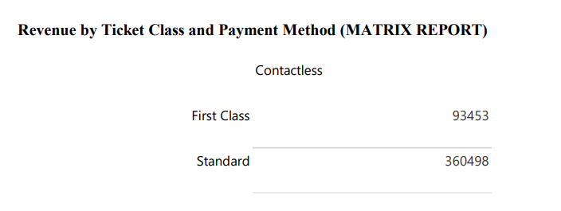
3. Parameterised Report
Title: Ticket Sales Summary by Departure Station and Journey Date
Report Type: Parameterised Report
This dynamic report allows users to input specific journey dates and filter results accordingly. The report then displays ticket sales metrics segmented by departure station.
Use Case:
Enables operational managers to track travel demand across stations on a day-by-day basis. This supports short-term planning, resource allocation, and response to changing passenger flow patterns.
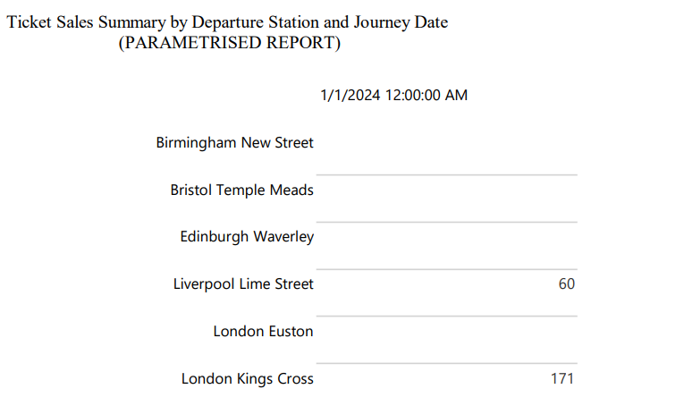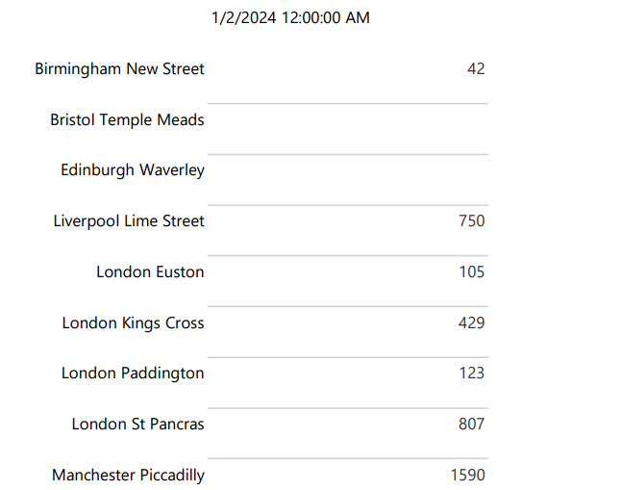
4. Drill-up/Drill-down Report
Title: Zone-wise Station Revenue Report
Report Type: Drill-up/Drill-down Report
Designed for executive-level insights, this report offers the ability to drill from high-level (zone-wide) revenue summaries down into specific stations within each zone.
Use Case:
Ideal for strategic planning, this report helps regional managers and executives identify top-performing locations, evaluate zone-level profitability, and inform investment or staffing decisions.

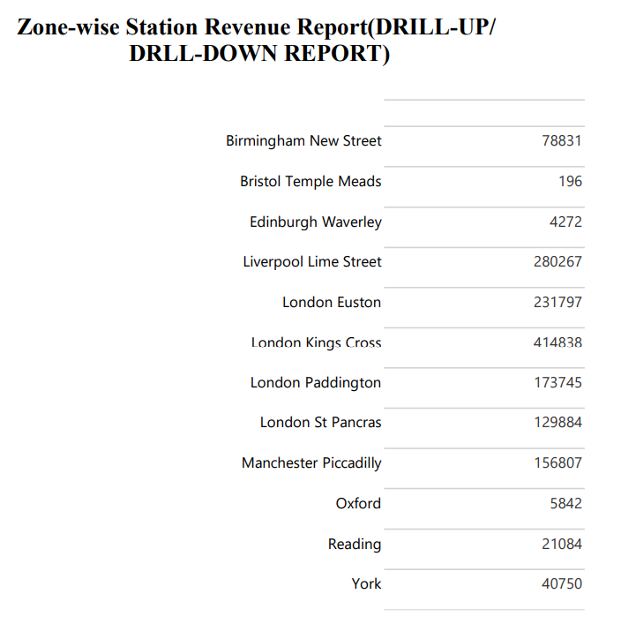

4. Tableau Visualisations and Dashboard
Further to help sustain business intelligence considering the developed data warehouse, four insightful visualisations that incorporated the developed Tableau Dashboard were generated. The visuals have a direct connection to the subject area chosen (data about railway journeys) and help the key stakeholders to achieve their goals to obtain operational and strategic data.
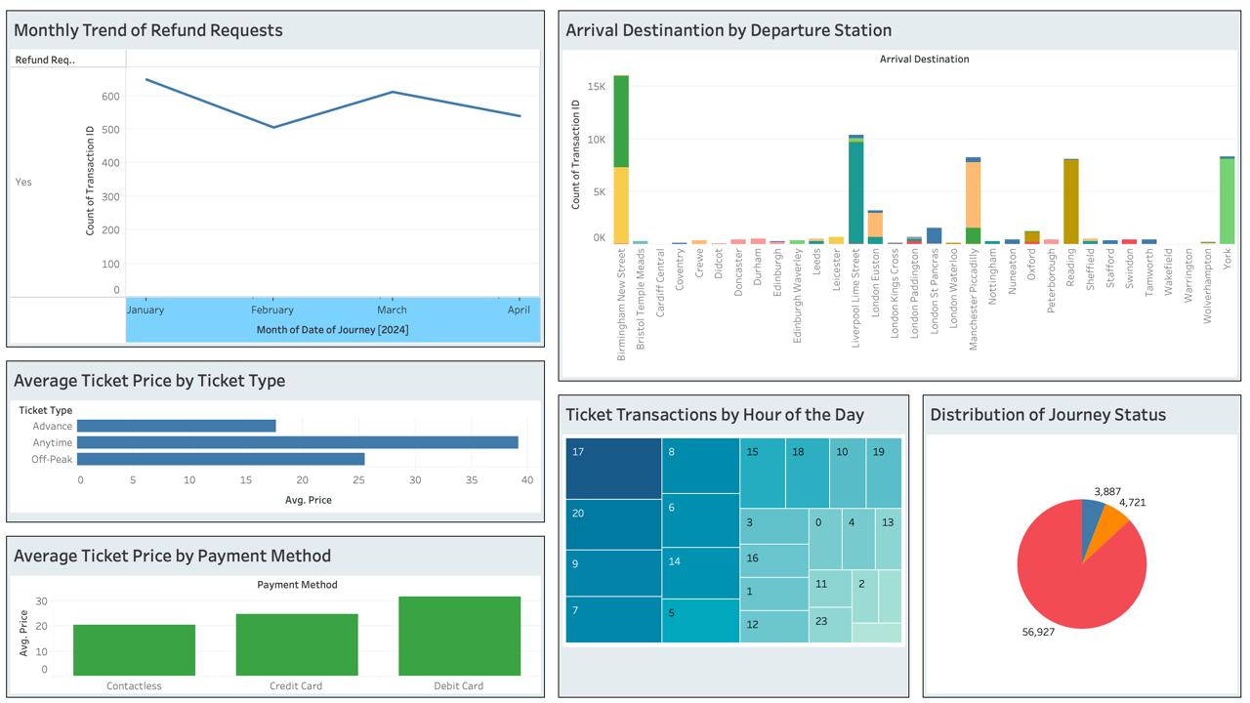
1. Monthly Refund Request Trend
Insight: A line chart visualizes the monthly count of refund requests marked as "Yes" from January to April 2024.
Business Value:
- Enables customer service and operations teams to detect periods of increased dissatisfaction.
- Helps management correlate spikes in refunds with delays, cancellations, or seasonal variations.
- Encourages proactive policy changes during months with a higher volume of refund requests.
2. Popular Routes: Arrival by Departure
Insight: A bar chart shows the volume of journeys (based on Transaction ID) from each departure station to various arrival destinations.
Business Value:
- Identifies high-traffic routes, helping with schedule optimization and resource allocation.
- Assists station managers in planning for capacity needs.
- Useful for forecasting demand and making data-backed decisions about train frequency.
3. Average Ticket Price Breakdown
Two bar charts analyse average ticket prices from different angles:
a) By Ticket Type
- Compares prices across Advance, Anytime, and Off-Peak tickets.
- Insight: Anytime tickets are the most expensive, aligning with their premium flexibility.
b) By Payment Method
- Displays average spend by Contactless, Credit Card, and Debit Card users.
- Insight: Debit Card users tend to spend more, possibly suggesting a preference for flexible ticket options.
Business Value:
- Helps pricing teams adjust or promote ticket types for better revenue optimization.
- Supports marketing teams in crafting targeted promotions based on payment behaviour.
4. Journey Status Distribution
Insight: A pie chart shows the proportion of journeys categorized as On Time, Delayed, or Cancelled.
Business Value:
- Provides a snapshot of operational efficiency.
- Helps quality assurance teams evaluate service reliability.
- Informs transport authorities about areas needing improvement or investment.
5. Ticket Sales by Hour
Insight: A heatmap displays ticket transaction volumes across each hour of the day.
Business Value:
- Reveals peak purchase periods, guiding staff scheduling and system performance planning.
- Assists with workforce management and helps ensure customer support readiness.
- Enables off-peak promotional strategies to increase sales during low-traffic hours.
Dashboard Relevance for Stakeholders
This dashboard delivers critical metrics and trends valuable for:
- Operations Managers – to optimize train routes and resource distribution
- Revenue and Ticketing Teams – to improve pricing models and payment analysis
- Marketing Analysts – for data-driven customer engagement strategies
- Customer Service and Quality Assurance Teams – to monitor service performance and enhance the passenger experience
5. Relational vs Graph Database Query Comparison
Dataset: Railway Journey Transactions
Relational DB: SQL Server
Graph DB: Neo4j (Cypher Query Language - CQL) 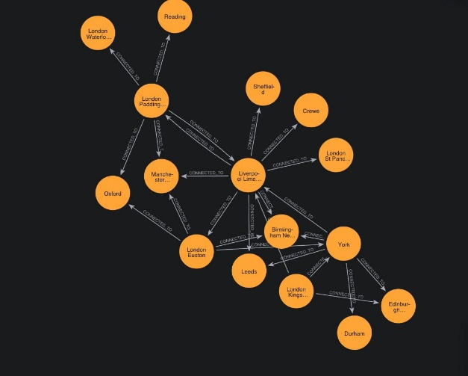
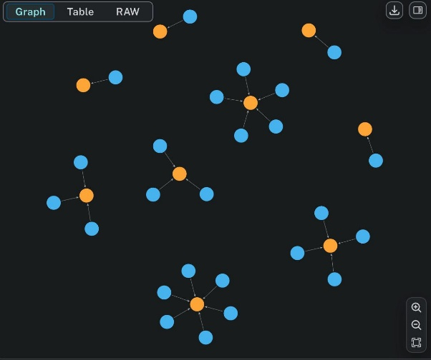
1. Journey Count per Departure Station
SQL Query:
SELECT [Departure Station], COUNT(*) AS JourneyCount
FROM Sheet1$
GROUP BY [Departure Station]
ORDER BY JourneyCount DESC;
This query calculates how many journeys start from each departure station. It groups the records by [Departure Station], counts the number of entries in each group, and sorts them from highest to lowest.
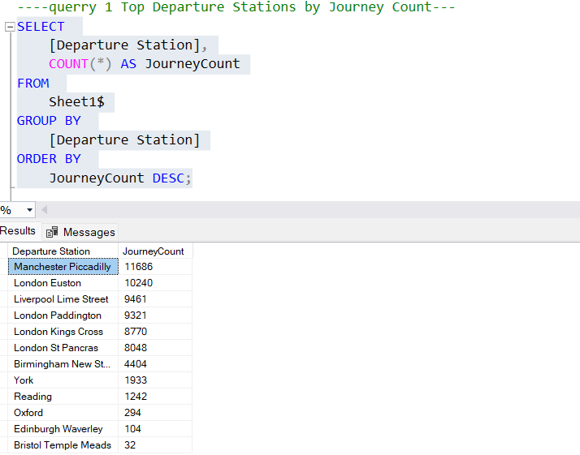
Cypher Query:
MATCH (s:Station)<-[:STARTS_AT]-(j:Journey)
RETURN s.name AS DepartureStation, COUNT(j) AS JourneyCount
ORDER BY JourneyCount DESC;
In Neo4j, this query finds all Journey nodes that have a STARTS_AT relationship with a Station node. It counts how many journeys begin at each station and orders the result by the journey count in descending order.
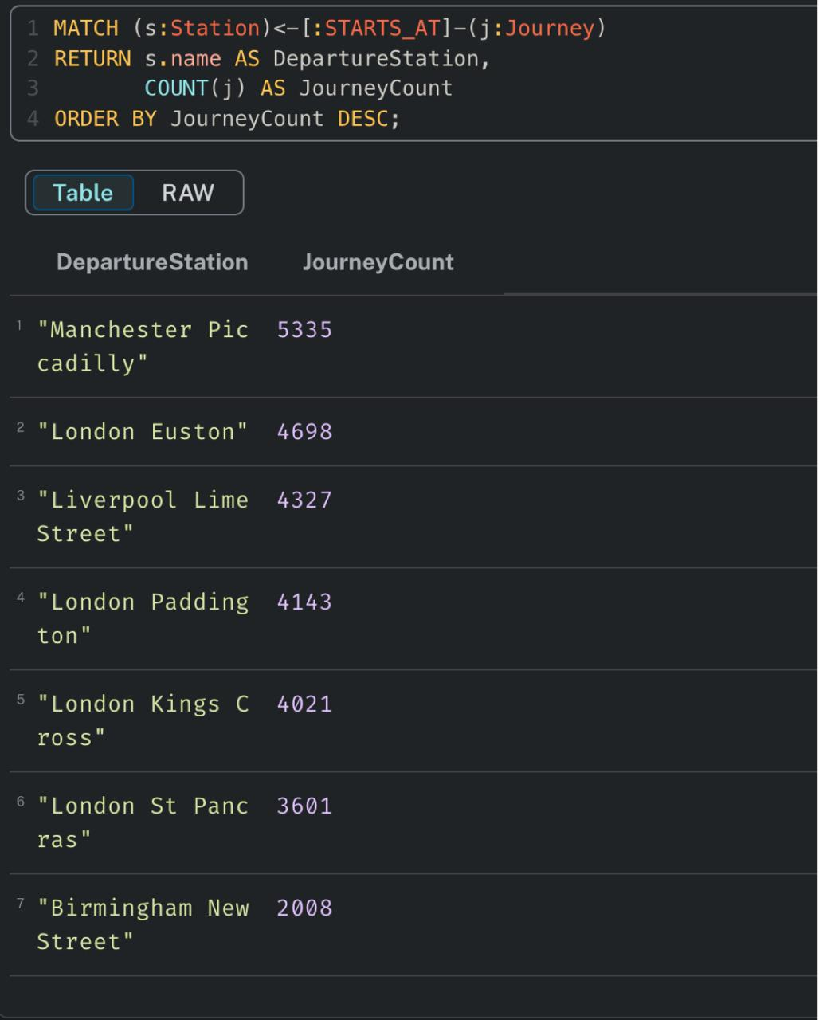
2. Journeys with Price Greater than 50
SQL Query:
SELECT [Transaction ID], [Departure Station], [Arrival Destination], [Price]
FROM Sheet1$
WHERE [Price] > 50
ORDER BY [Price] DESC;
This retrieves all journeys where the ticket price exceeds 50. It displays details like transaction ID, departure and arrival stations, and the price, ordered by the highest fare.
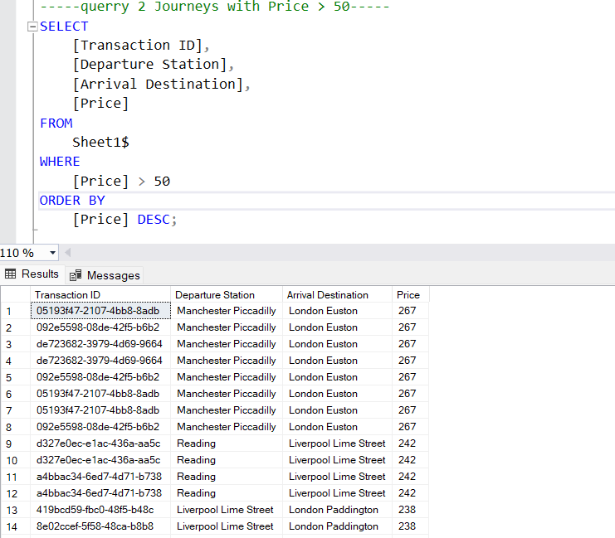
Cypher Query:
MATCH (j:Journey)-[:STARTS_AT]->(src:Station)-[:CONNECTED_TO]->(dest:Station)
WHERE j.price > 50
RETURN j.id AS TransactionID, src.name AS DepartureStation, dest.name AS ArrivalStation, j.price
ORDER BY j.price DESC;
In the graph database, it matches Journey nodes that are connected from a src (departure station) to a dest (arrival station). It filters those journeys with a price above 50 and lists them by highest price.
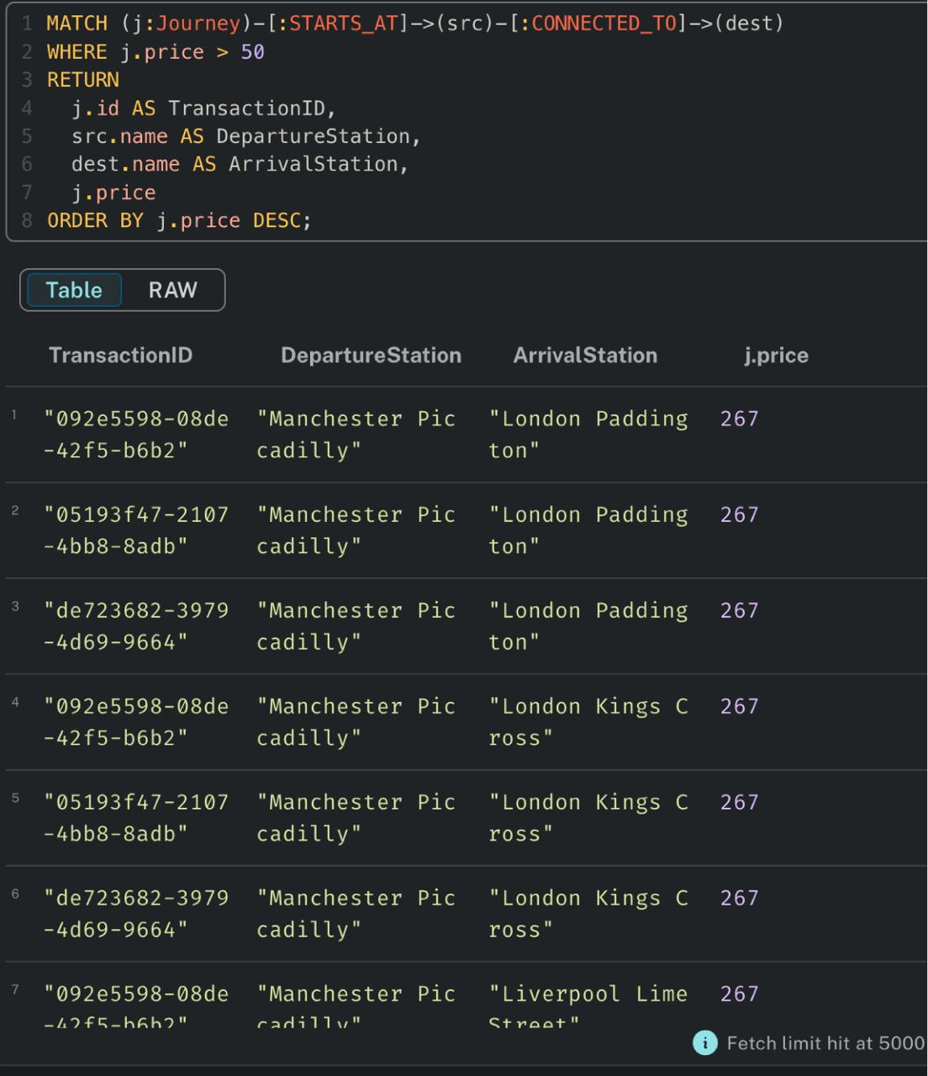
3. First Class Tickets
SQL Query:
SELECT [Transaction ID], [Departure Station], [Arrival Destination], [Ticket Class]
FROM Sheet1$
WHERE [Ticket Class] = 'First Class';
This selects journeys where the ticket class is 'First Class'. It shows relevant details like transaction ID, departure, and arrival locations.
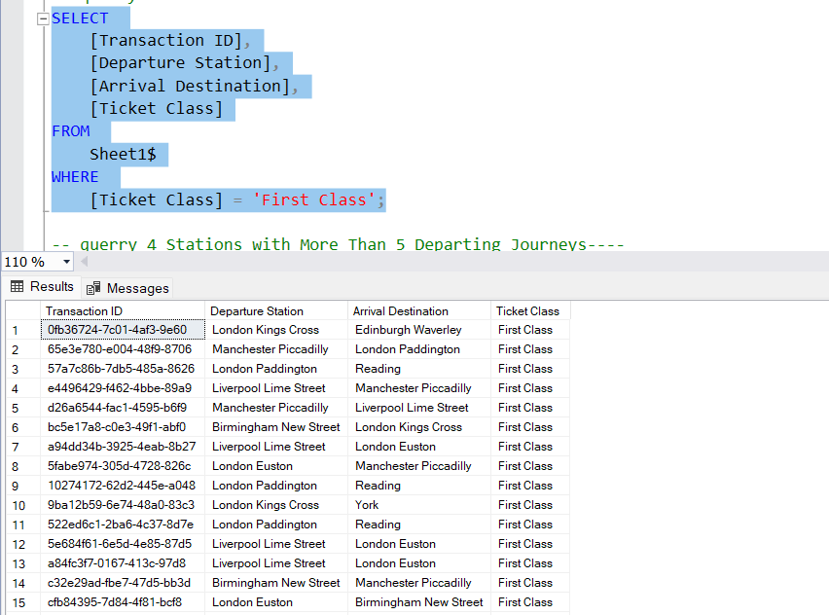
Cypher Query:
MATCH (j:Journey)-[:STARTS_AT]->(src:Station)-[:CONNECTED_TO]->(dest:Station)
WHERE j.ticket_class = 'First Class'
RETURN j.id AS TransactionID, src.name AS DepartureStation, dest.name AS ArrivalStation, j.ticket_class;
This graph query locates journeys labelled with 'First Class' tickets and retrieves associated station information, similar to the SQL output.
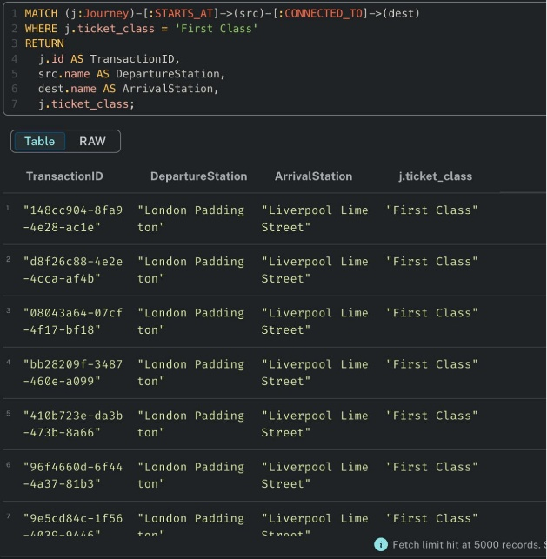
4. Stations with More Than 5 Departing Journeys
SQL Query:
SELECT [Departure Station], COUNT(*) AS JourneysDeparted
FROM Sheet1$
GROUP BY [Departure Station]
HAVING COUNT(*) > 5
ORDER BY JourneysDeparted DESC;
The query counts how many journeys start at each station and filters for stations that have more than 5 departures. It then displays those stations along with the count of departing journeys.
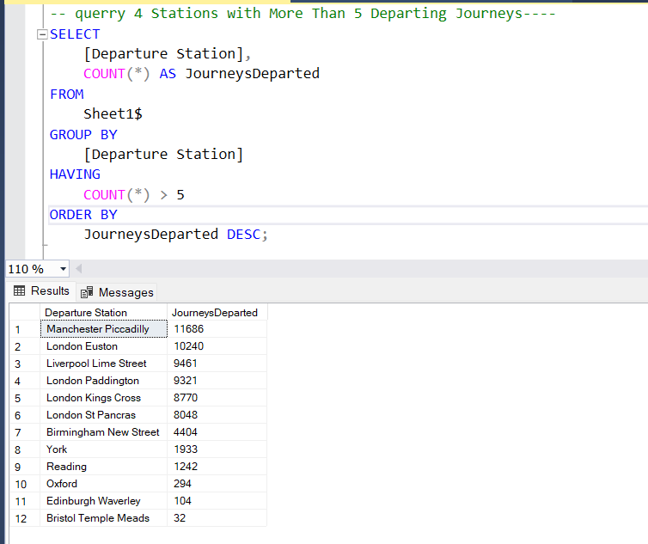
Cypher Query:
MATCH (s:Station)<-[:STARTS_AT]-(j:Journey)
WITH s, COUNT(j) AS JourneysDeparted
WHERE JourneysDeparted > 5
RETURN s.name AS DepartureStation, JourneysDeparted
ORDER BY JourneysDeparted DESC;
This matches stations linked with journeys through STARTS_AT, counts how many journeys are linked per station, and filters those with more than five. The result is sorted by the number of departures.
5. Journeys Ordered by Date
SQL Query:
SELECT [Transaction ID], [Departure Station], [Arrival Destination], [Date of Journey], [Price]
FROM Sheet1$
ORDER BY [Date of Journey];
This simply displays journey records ordered by their journey date, allowing for chronological tracking of trips.
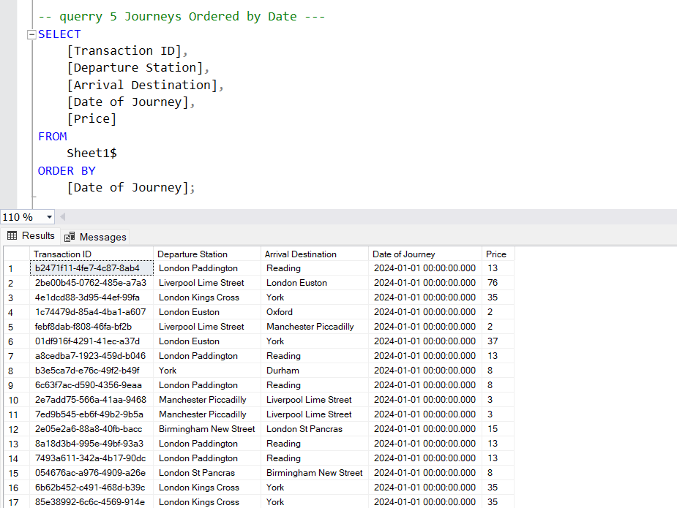
Cypher Query:
MATCH (j:Journey)-[:STARTS_AT]->(src:Station), (j)-[:ENDS_AT]->(dest:Station)
RETURN j.id AS TransactionID, src.name AS DepartureStation, dest.name AS ArrivalStation, j.date AS DateOfJourney, j.price AS Price
ORDER BY j.date;
This retrieves journeys from departure to arrival stations, along with their travel dates and price, and lists them in ascending order of journey date.

6. Late Arrivals (Actual Arrival > Scheduled Arrival)
SQL Query:
SELECT [Transaction ID], [Departure Station], [Arrival Destination], [Arrival Time], [Actual Arrival Time]
FROM Sheet1$
WHERE TRY_CAST([Actual Arrival Time] AS TIME) > TRY_CAST([Arrival Time] AS TIME);
This query identifies journeys where the actual arrival time is later than the scheduled arrival. It compares time values using TRY_CAST for safe type conversion.
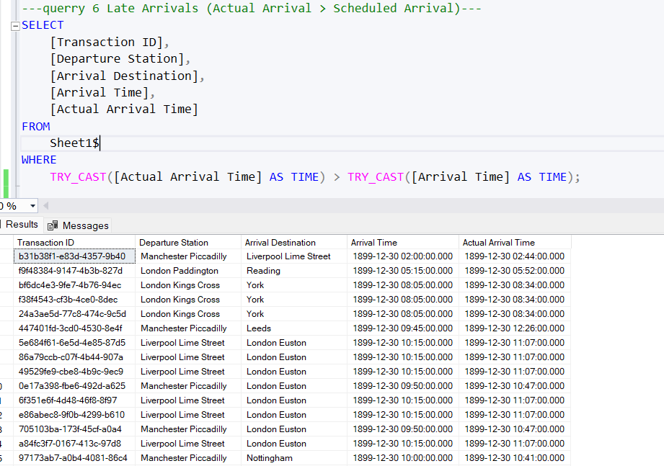
Cypher Query:
MATCH (j:Journey)-[:STARTS_AT]->(src), (j)-[:ENDS_AT]->(dest)
WHERE j.actual_arrival_time > j.arrival_time
RETURN j.id AS TransactionID, src.name AS DepartureStation, dest.name AS ArrivalStation, j.arrival_time, j.actual_arrival_time;
In Neo4j, it checks if the actual_arrival_time on a journey node is greater than its arrival_time and returns such records with station details and timing.
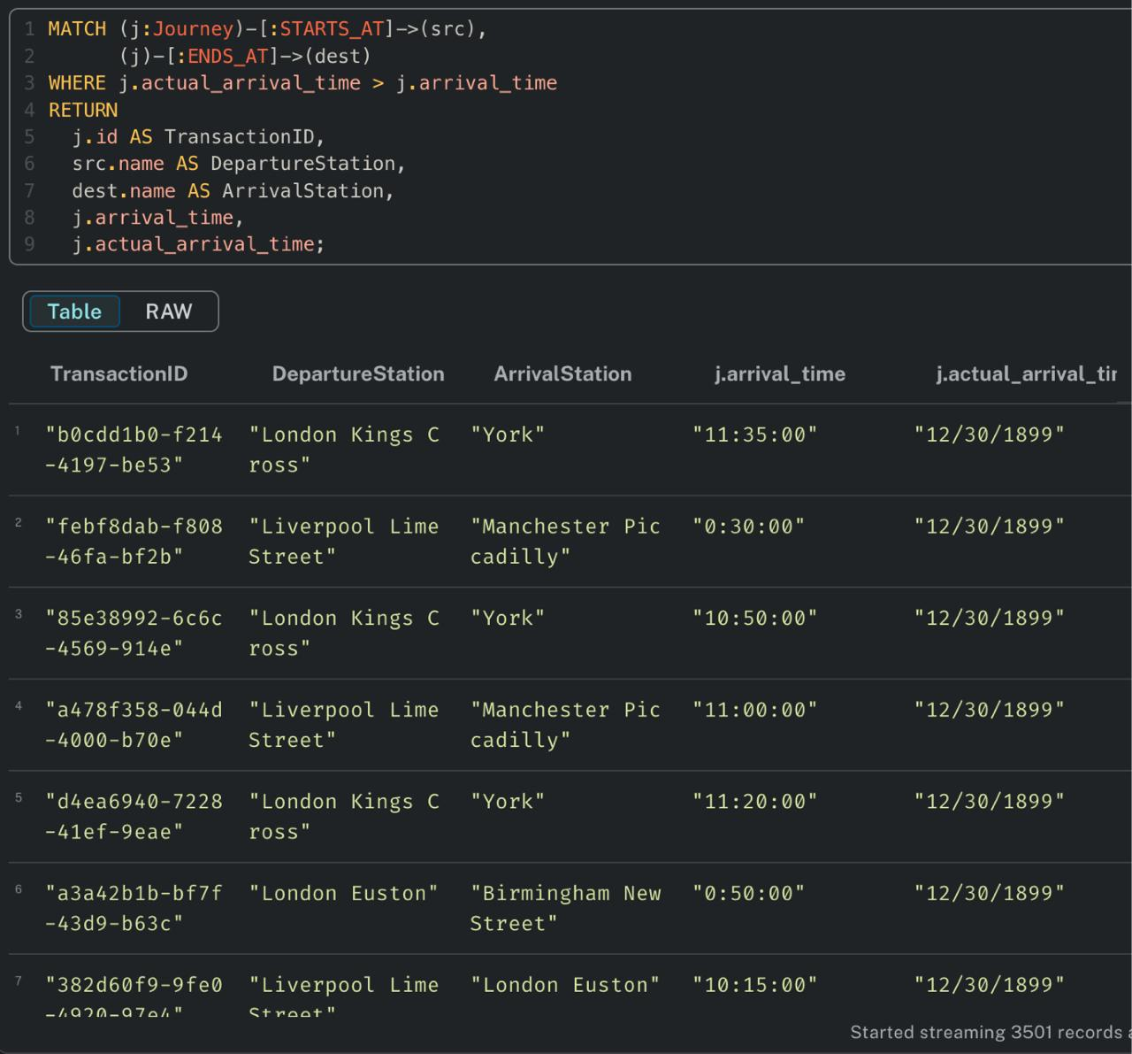
7. GetJourneyDetails_SQL
SQL Query:
SELECT [Transaction ID], [Departure Station], [Arrival Destination], [Date Of Journey], [Journey Status] FROM Sheet1$ ORDER BY [Date Of Journey];
Retrieves journey data from an Excel sheet where all journey details are stored in a flat table format
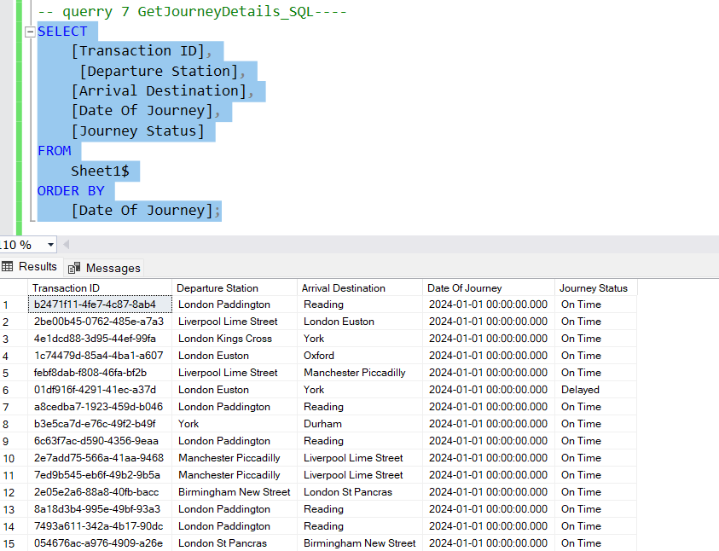
Cypher Query:
MATCH (j:Journey)-[:STARTS_AT]->(src:Station), (j)-[:ENDS_AT]->(dest:Station) RETURN j.id AS TransactionID, src.name AS DepartureStation, dest.name AS ArrivalStation, j.date AS DateOfJourney, j.status AS JourneyStatus ORDER BY j.date;
Retrieves journey data by traversing relationships between Journey and Station nodes in a graph database.
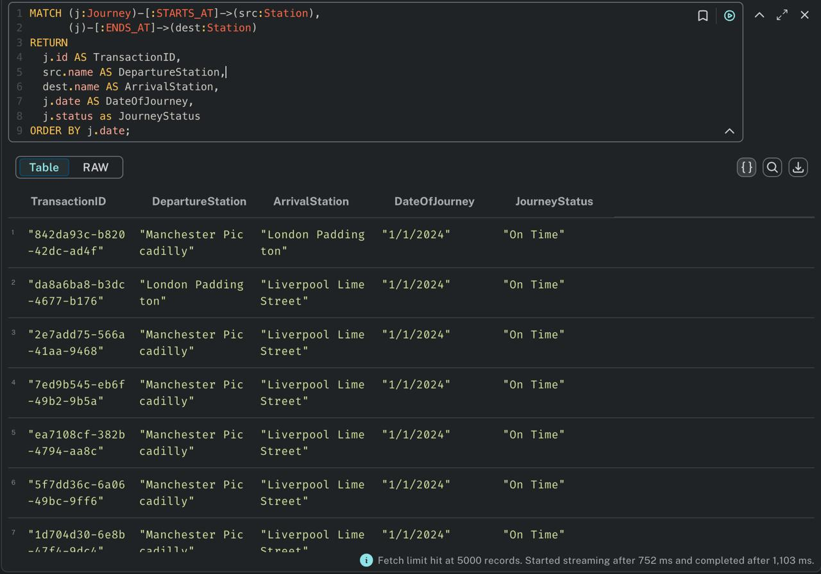
Summary of Observations
Criteria | SQL (Relational DB) | CQL (Graph DB - Neo4j)
Schema Design | Tabular, fixed schema | Node-relationship model, flexible
Query Complexity | Increases with more joins | Simplified with pattern matching
Relationship Handling | Indirect (via foreign keys) | Direct and intuitive
Performance | Slower with complex joins | Faster for deeply connected data
Use Case Fit | Ideal for tabular data and reporting | Best for relationships and graph analytics

Comparison
1. Journey Count per Departure Station
- SQL: Performed better due to efficient grouping and indexing.
- Neo4j: Worked correctly but was slightly slower due to traversal and pattern matching.
2. Journeys with Price Greater than 50
- SQL: Performed well; simple numeric filtering was quick.
- Neo4j: Performed similarly; property filtering was straightforward and fast.
- Performance: Comparable in both.
3. First Class Tickets
- SQL: Efficient with basic filtering.
- Neo4j: Also, efficient and more intuitive to read.
- Performance: Comparable in both.
4. Stations with More Than 5 Departing Journeys
- SQL: Performed better; aggregation with GROUP BY and HAVING was optimized.
- Neo4j: Slightly slower due to additional pattern matching and the use of WITH.
5. Journeys Ordered by Date
- SQL: Performed better; indexing made sorting by date fast.
- Neo4j: Functional but less efficient due to traversal involved.
6. Late Arrivals (Actual Arrival > Scheduled Arrival)
- SQL: Worked well but needed data type conversion, adding some complexity.
- Neo4j: Performed better as date/time comparisons were more direct and readable.
7. Get Journey Details (Basic Info with Status and Date)
- SQL: Performed better with flat, direct column retrieval.
- Neo4j: Required extra relationship traversal, making it slightly slower.
Overall Observation:
- SQL performed better in: Journey Count, Stations with >5 Departures, Journeys Ordered by Date, and Get Journey Details.
- Neo4j performed better in: Late Arrivals.
- Both performed equally well in: Price > 50- and First-Class Tickets.

6. Conclusion
This project has been able to present an all-inclusive Proof of Concept (PoC) on the construction of data warehouse solution that would integrate into Railway Ticketing and Journey Analytics. Through conversion of raw transactional data to stored star schema and an end-to-end ETL process through SSIS, historical and in-time business intelligence across the departments is now aided efficiently through the data warehouse. The design supports multidimensional analysis with the help of properly designed fact and dimension tables to allow stakeholders, such as operations managers, finance departments, customer support and marketing analysts, to base their decisions on evidence. The major insights on the business that the railway organization can get thanks to the warehouse, including journey punctuality, pattern of ticket sales, patterns of refund, and payment behaviours allow enhancing the services offered, enhancing customer experience, and increasing revenue. The solution is further enhanced by:
- SSRS Reports (tabular, matrix, parameterized, drill-down) enabling diverse report delivery.
- Tableau Dashboards offering visual, interactive insights to key stakeholders.
- ETL Pipelines that ensure data integrity, quality, and performance.
- SQL vs Graph DB (Neo4j) comparison, revealing context-specific advantages of each database type.
Its scalable architecture provides a good basis to future-proof the data warehouse by extending it with more advanced features, like machine learning driven forecasting, anomaly detection and operational dashboards in real-time. It can be considered a strategic transition to the culture of data and the digital turning of the railway industry.
7. References / Bibliography
- Microsoft. (n.d.). SQL Server Integration Services (SSIS) Documentation. Retrieved from: https://learn.microsoft.com/en-us/sql/integration-services/
- Tableau. (n.d.). Data Visualization Best Practices. Retrieved from: https://www.tableau.com/
- Microsoft. (n.d.). SQL Server Reporting Services (SSRS). Retrieved from: https://learn.microsoft.com/en-us/sql/reporting-services/
- Neo4j. (n.d.). Cypher Query Language Manual. Retrieved from: https://neo4j.com/docs/cypher-manual/

8. Individual Contribution Report
Working on this data warehousing project provided a highly valuable and insightful learning experience. It allowed me to deepen my understanding of real-world data processing, integration, and analytics. My key contribution to this project was in developing and executing the ETL process using SSIS, designing the data warehouse schema in SSMS, and creating reports using SSRS.
To begin, I worked extensively on SQL Server Management Studio (SSMS) to create the dimensional model based on the star schema. This involved designing the fact and dimension tables, ensuring referential integrity through surrogate keys, and loading cleaned and validated data. I also defined appropriate data types and handled indexing to support optimized queries.
In SQL Server Integration Services (SSIS), I developed the complete ETL workflow. I handled the data extraction from the Excel source, applied necessary transformations such as data standardization, and used multiple lookup transformations to map natural keys to surrogate keys in dimension tables. Ensuring referential integrity and data consistency throughout the pipeline was a major focus. I also verified the load success using SQL queries on the populated warehouse tables.
For reporting, I created multiple SSRS reports, including a tabular report to show detailed transaction data, a matrix report for revenue comparison by ticket class and payment method, and a parameterized report allowing users to dynamically explore ticket sales. These reports offer useful insights for various stakeholders and demonstrate how well-structured data supports strategic decision-making.
In addition to my contributions, I would like to acknowledge the efforts of my teammates:
- Harsh (myself) – Led the work on SSMS, SSIS, and SSRS.
- Gunasekhar Vasireddy played a crucial role in implementing the graph database component using Neo4j. He helped write Cypher queries and supported the comparison with relational SQL queries, which enriched our understanding of graph-based analytics.
- Harsanbruno Maria Joseph Esuraj was instrumental in creating visual dashboards using Tableau. He also contributed to SSRS by supporting the design of the drill-down report and helped validate the accuracy of visuals generated from our data warehouse.
This project helped me improve my technical skills, enhance team collaboration, and gain confidence in working with BI tools and analytical thinking. It reinforced the importance of data quality, clean architecture, and collaboration in building meaningful data-driven solutions.

Appendix A: SQL Code – Data Warehouse Schema Creation
DROP DATABASE IF EXISTS Railway_DW_;
CREATE DATABASE Railway_DW_;
GO
-- Use the newly created database
USE Railway_DW_;
GO
-- Create Date Dimension Table
CREATE TABLE DW_Dim_Date1_ (
DateKey INT IDENTITY(1,1) PRIMARY KEY,
FullDate DATE NOT NULL,
Year INT NOT NULL,
Month INT NOT NULL,
Day INT NOT NULL,
DayOfWeek VARCHAR(10) NOT NULL
);
-- Create Station Dimension Table
CREATE TABLE DW_Dim_Station1_ (
StationKey INT IDENTITY(1,1) PRIMARY KEY,
StationCode VARCHAR(10) NOT NULL,
StationName NVARCHAR(255) NOT NULL,
Region VARCHAR(50),
Zone VARCHAR(20)
);
-- Create Ticket Dimension Table
CREATE TABLE DW_Dim_Ticket1_ (
TicketKey INT IDENTITY(1,1) PRIMARY KEY,
TicketType VARCHAR(50) NOT NULL,
TicketClass VARCHAR(50) NOT NULL,
Railcard VARCHAR(100) NOT NULL,
DiscountPercentage FLOAT
);
-- Modify columns in Ticket Dimension Table
ALTER TABLE DW_Dim_Ticket1_
ALTER COLUMN Railcard VARCHAR(100) NULL;
ALTER TABLE DW_Dim_Ticket1_
ALTER COLUMN TicketType VARCHAR(100);
-- Create Payment Dimension Table
CREATE TABLE DW_Dim_Payment1_ (
PaymentKey INT IDENTITY(1,1) PRIMARY KEY,
PurchaseType NVARCHAR(50) NOT NULL,
PaymentMethod NVARCHAR(50) NOT NULL
);
-- Create Fact Table for Journey Data
CREATE TABLE DW_Fact_Journey1_ (
FactID INT IDENTITY(1,1) PRIMARY KEY,
PurchaseDateKey INT NOT NULL,
JourneyDateKey INT NOT NULL,
DepartureStationKey INT NOT NULL,
ArrivalStationKey INT NOT NULL,
TicketKey INT NOT NULL,
PaymentKey INT NOT NULL,
Price FLOAT NOT NULL,
DepartureTime TIME NOT NULL,
ArrivalTime TIME NOT NULL,
ActualArrivalTime TIME,
JourneyStatus VARCHAR(50) NOT NULL,
RefundRequest VARCHAR(10) NOT NULL,
FOREIGN KEY (PurchaseDateKey) REFERENCES DW_Dim_Date1_(DateKey),
FOREIGN KEY (JourneyDateKey) REFERENCES DW_Dim_Date1_(DateKey),
FOREIGN KEY (DepartureStationKey) REFERENCES DW_Dim_Station1_(StationKey),
FOREIGN KEY (ArrivalStationKey) REFERENCES DW_Dim_Station1_(StationKey),
FOREIGN KEY (TicketKey) REFERENCES DW_Dim_Ticket1_(TicketKey),
FOREIGN KEY (PaymentKey) REFERENCES DW_Dim_Payment1_(PaymentKey)
);

-- Sample Queries to View Populated Tables
SELECT * FROM DW_Dim_Payment1_;
SELECT * FROM DW_Dim_Station1_;
SELECT * FROM DW_Dim_Ticket1_;
SELECT * FROM DW_Dim_Date1_;

-- Modify FullDate to store full datetime if required
ALTER TABLE DW_Dim_Date1_
ALTER COLUMN FullDate DATETIME;

