IFSC 3360: System Analysis and Design

Final Project Report

Student registration System

(Hajar Tavasoly)

Introduction

This system is called “Student Registration System” and is designed to facilitate student registration process in an organized and efficient way. This online system offers a user-friendly platform for students to communicate with different departments to obtain necessary information about courses schedule, tuition, fees and available funding/scholarships, and enrollment requirements. Moreover, it allows student to register and track their registration status. Once registration is complete, it sends the student information to the taken courses professors and tracks the registration statistics. This system also helps the school to manage the admission process easily and effectively.
Although the system is not all new, but it is improved in several aspects. It is designed in an organized and well-defined architecture that acts as a central hub. It collects all the necessary registration information from different departments and acts as a database that has proper answers to any possible question that students may have. It is very important to make the process straight forward for student and prevent any source of confusion and this central system offers this by minimizing individual places that a student needs to contact. It also collects all the enrollment information from students and make an organized list of enrolled students for the corresponding professor. Finally, it keeps track of number of students, their requested and submitted documents and their performance in each course.
To justify the system, we should recognize the advantages that the new system offers as compared with conventional registration process.

- Process automation: the new system helps schools to automate the registration process. It saves schools time and effort for collecting forms, documents, and transcripts. Also, saving documents in digital format reduces paperwork and the physical space needed for bookkeeping. It also reduces the time and effort to keep, sort or search documents. The system can even automatically send digital acknowledgements, payment receipts and reminders to students. Reduction in paperwork also helps student since they no longer need to print documents and keep receipts.

- No waiting in line: Students no longer need to wait in long queues to submit a document or payment receipt.

- Less staff involvement: admission season is often a busy time for schools and all manpower gets involved in the registration process. By using the new system, most of the tasks can be completed online in a more efficient way.

- Less errors: the online registration system can design to provide immediate alerts if students miss out on filling information or fill out incorrect information. As a conclusion, the new online student registration system offers a user friendly and efficient admission method that saves time and reduces errors, manpower and effort for school and students. Moreover, it requires less paperwork that makes it an environment friendly approach.

System Requirements Model

The Context Diagram demonstrates a student registration system. It provides all necessary information for a student, so he/she can see and choose available courses to enroll. Once the student enrolled the course, he/she can pay, and the system confirms the payment. At the end, a list with names of all students is generated for the class professor that shows the enrolled students.

In the next step, the DFD 0 Diagram explains the process with more details for better understanding. It shows the student can only enroll available classes. Once enrolled, classes go to student schedule and the student’s name is sent to the professor’s list. Meanwhile student can move forward and make a payment.

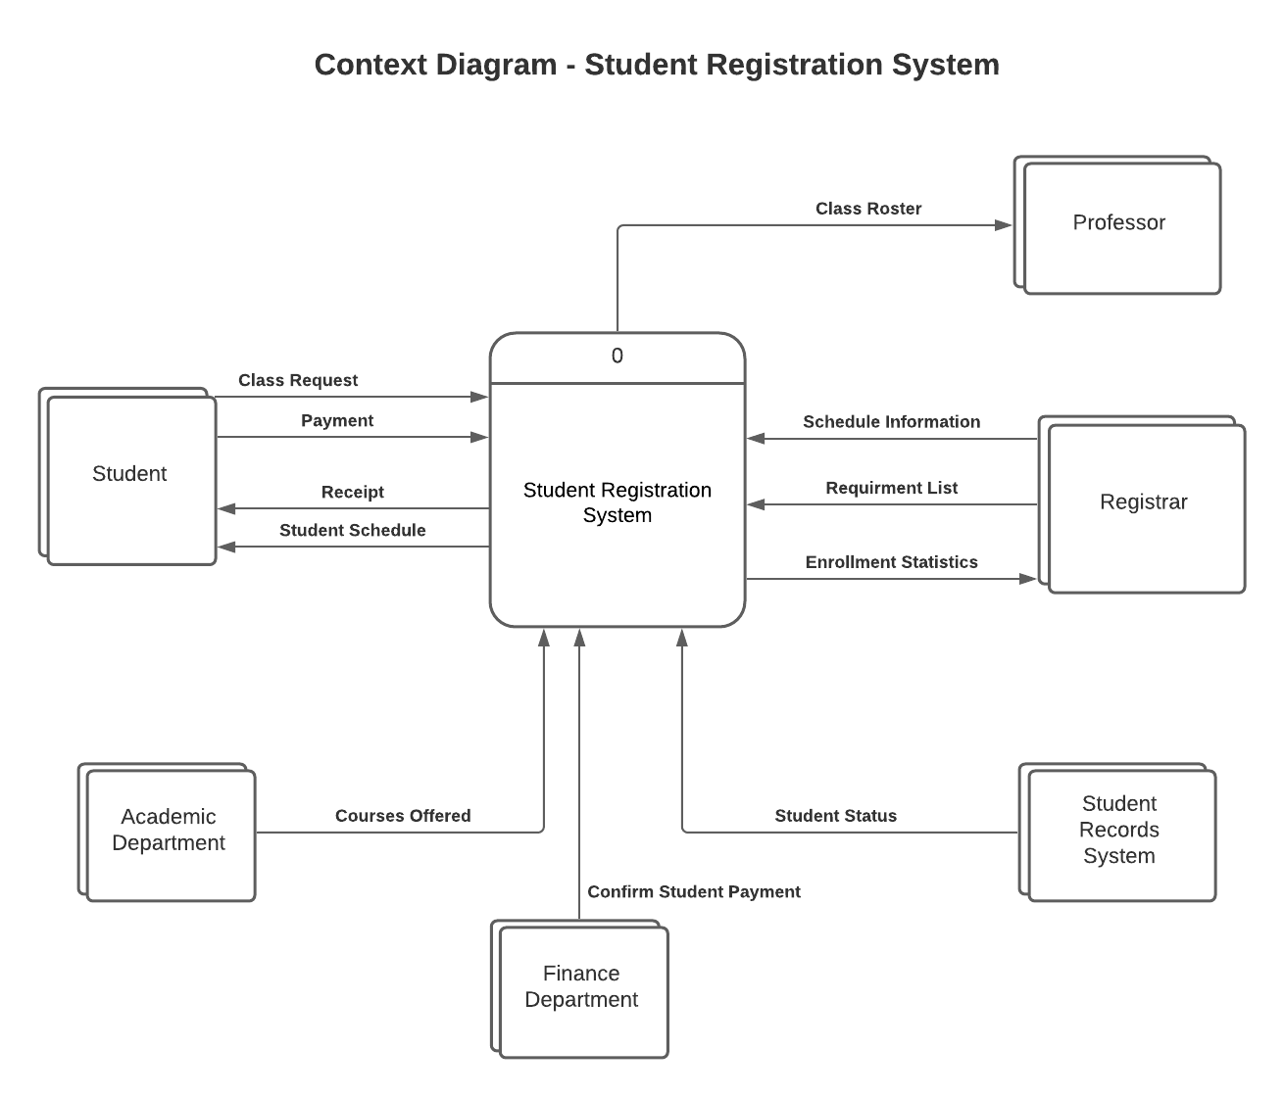

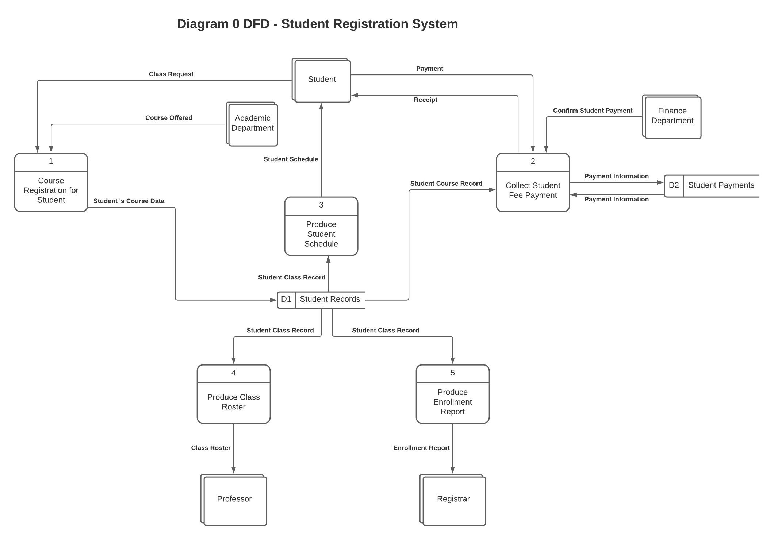

The following Use Case Diagram represent all interactions with the student registration system. Student registers for semester and gets consult to better plan towards successful graduation by choosing proper courses to take. Then he/she adds available courses which is approved by enrollment service and pays for them.
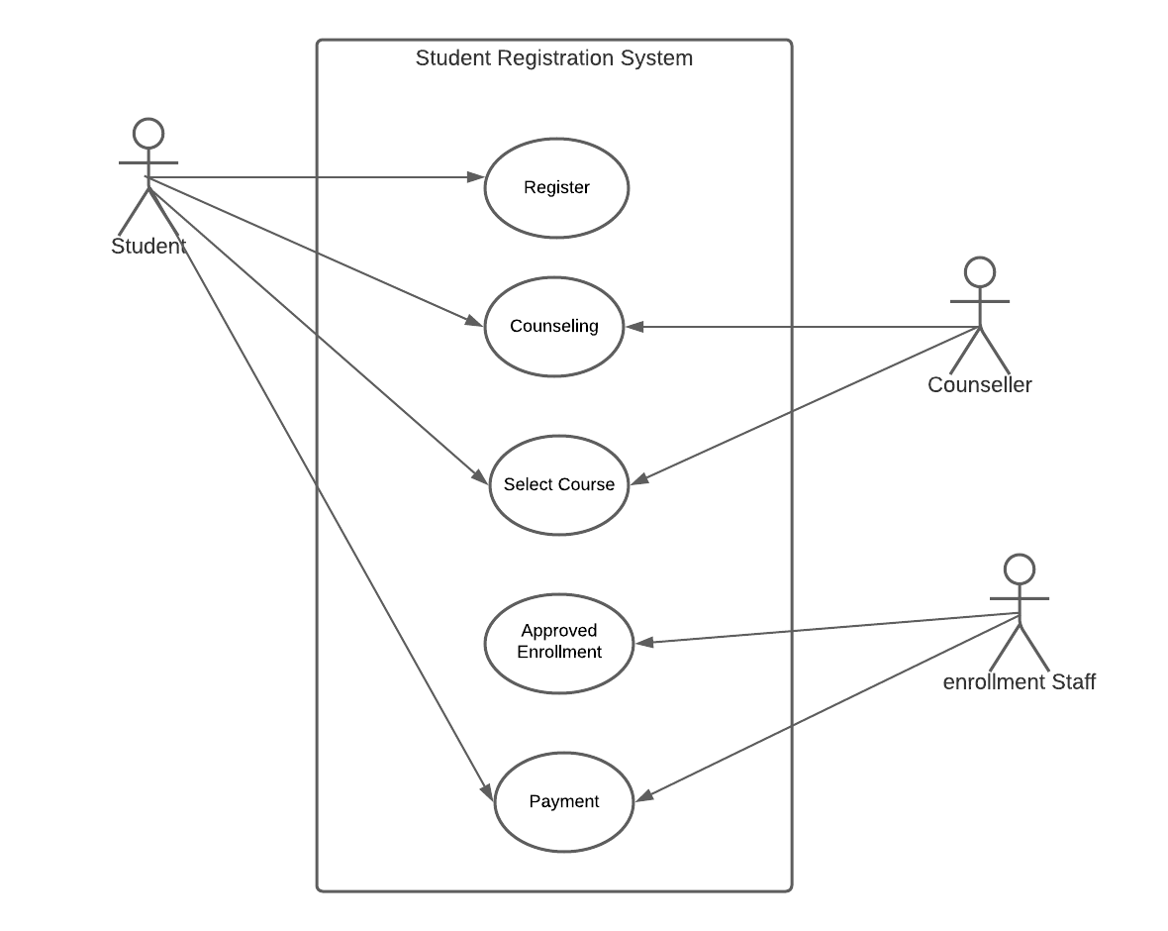

For each of the use cases, main/success scenarios, alternate scenarios, pre-conditions, and post-conditions are explain bellow.

UC1: Register
Scope: Student Registration System

Main success scenario
- Student accesses the system.
- Student expresses an intent to register.
- Student provides account information.
- Student’s information is captured by the system.
- Student proceeds to account verification.

Alternate scenarios
*a. At any time, Student can request help.
1a. System is unavailable.
- Student can receive a message with contact information.
2a. Student provided information that already exists in the system.
- Student is requested to check the information provided.
3b. Student provides an invalid email address.
- Student is requested to provide valid email address.

Preconditions
- The classes should exist.

Postconditions
- Student is allowed register.

UC2: Counseling
Scope: Student Registration System

Main success scenario
- Student checks the available appointment.
- Student schedule an appointment.
- System verifies the appointment.
- Student meet, call or chat the counsellor.
- Student receives advice from the experts.
- Student selects and enroll relevant courses and classes.

Alternate scenarios
*a. At any time, Student can request help.
1a. Appointment scheduling page is unavailable
- Student receives technical issues contact info to call or email.
2a. Students select a taken time slot
- System grays out the taken spots or show a proper message
3a. Counsellor cannot meet the student because of emergency reasons.
- Text and email are sent, and call is made to make sure student is aware of cancellation
- New time slots are emailed to student and system allows the student to reschedule

Precondition:
- Student must schedule an appointment.
Postcondition
- Student receives advice by counsellor.

UC3. Select course
Scope: Student Registration System

Main success scenario
- Student checks his/her schedule.
- Student checks the available courses and classes.
- Some courses need perquisites to be taken and without perquisites are not available for enrollment.
- Student decides how many courses to take based on his/her graduation timeline plan.
- Student sees the number of students in available classes.
- Student adds the classes/courses to a shopping cart and see the fees immediately.

Alternate scenarios
1a. The enrollment page does not exist or has problems
- Student receives technical issues contact info to call or email.
2a. Students select an irrelevant course:
- System should only show the courses depending on student’s field of study
3a. Student select a course that has already taken
- System shows an alert
4a. Student takes more units than allowed
- System should gray out remaining classes after cap reached.

Precondition:
- Student knows what courses to take and has all the perquisites.
Postcondition
- Student enrolls the classes.

UC4. Approved enrollment
Scope: Student Registration System

Main success scenario
- Student receives a message and email for enrollment approval.
- Student receives a message for payment with payment link and deadline.
- Student can review, change, add or remove courses before a deadline and confirmation email for any change is sent to student for every change.
- System adds the student to the class list if student is enrolled in a class and keeps the spot.
- After enrollment deadline, student can only remove the course and no other change is allowed.
- System automatically remove the course if payment is not submitted before deadline.
- Student decides how many courses to take based on his/her graduation timeline plan.

Alternate scenarios
1a. The enrollment cannot be completed, or confirmation is not sent.
- Student receives technical issues contact info to call or email.
2a. Student request a change after the deadline
- System is locked in any change, but system shows the contact info of registration office and student can request a change, if possible.

Precondition:
- Student finalizes the class enrollment before the deadline.
Postcondition
1. Student enrollment is confirmed, and confirmation is sent.
- If payment is made before the deadline, enrollment is completed.

UC5. Payment

Scope: Student Registration System

Main success scenario
- A payment link and the amount are provided on student page and email is sent to the student.
- Student can pay using bank account information or credit/debit card.
- System only allows the payment of exact amount of due to avoid errors and extra payments.
- Once payment is received, a confirmation message and email is sent to student and enrollment is considered completed.
- System makes a list of enrolled students and sends to the class instructor after the payment deadline.

Alternate scenarios
1a. The payment link is not working, or enrollment confirmation is not received.
- Student receives technical issues contact info to call or email.

Precondition:
- Student makes a payment for enrolled classes before the deadline.
Postcondition
1. Enrollment is completed, and student will be in the class list.

The System Sequence Diagram for student registration system is shown below. Student logs into the system and requests for consulting. The consulting service provides advise and suggestions based on student schedule and required courses for graduation. For every course, student choose a class based on its availability and enroll. If student can enroll and has all the prerequisites, the enrollment section accepts student enrollment. Finally, student receives the bill to make a payment and pays for his/her courses.

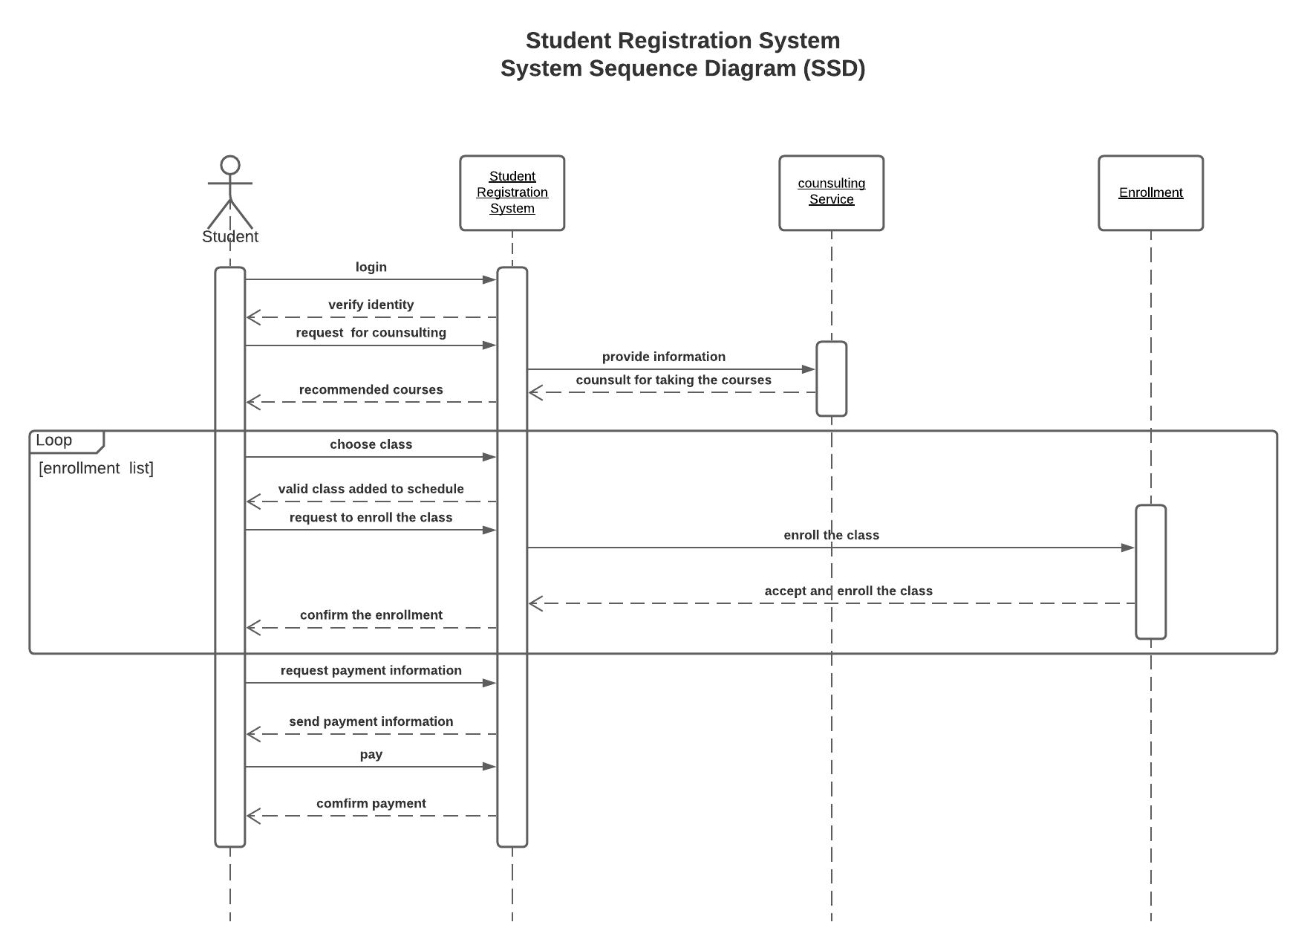

The interactions between student and the website in SD-Register Use Case is shown below in which student logs in to the system and after getting permission to register, he/she can register.

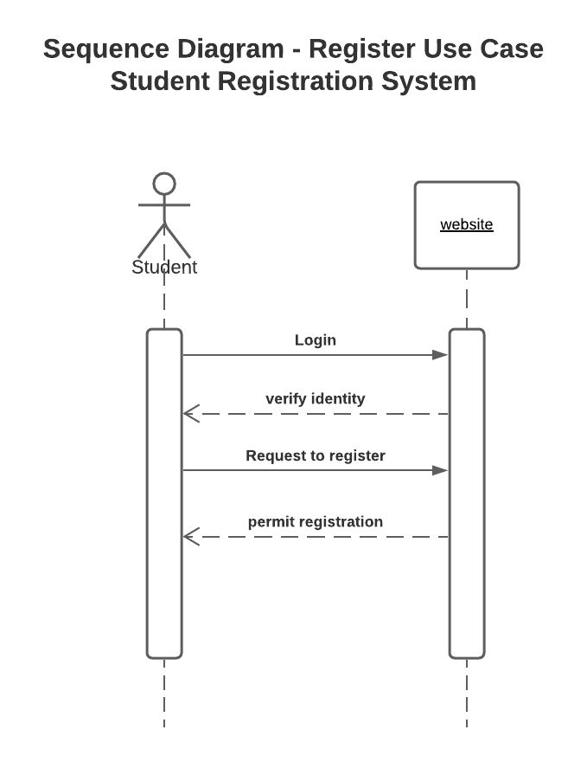

In this SD- Counselling Use Case, student first request for counseling and provides his/her academic information to the academic department. Academic department, counselling section checks for available courses that student requires to graduate. A full list of available remaining courses will be sent to the academic department. Academic department make recommendations based on student needs and schedule.
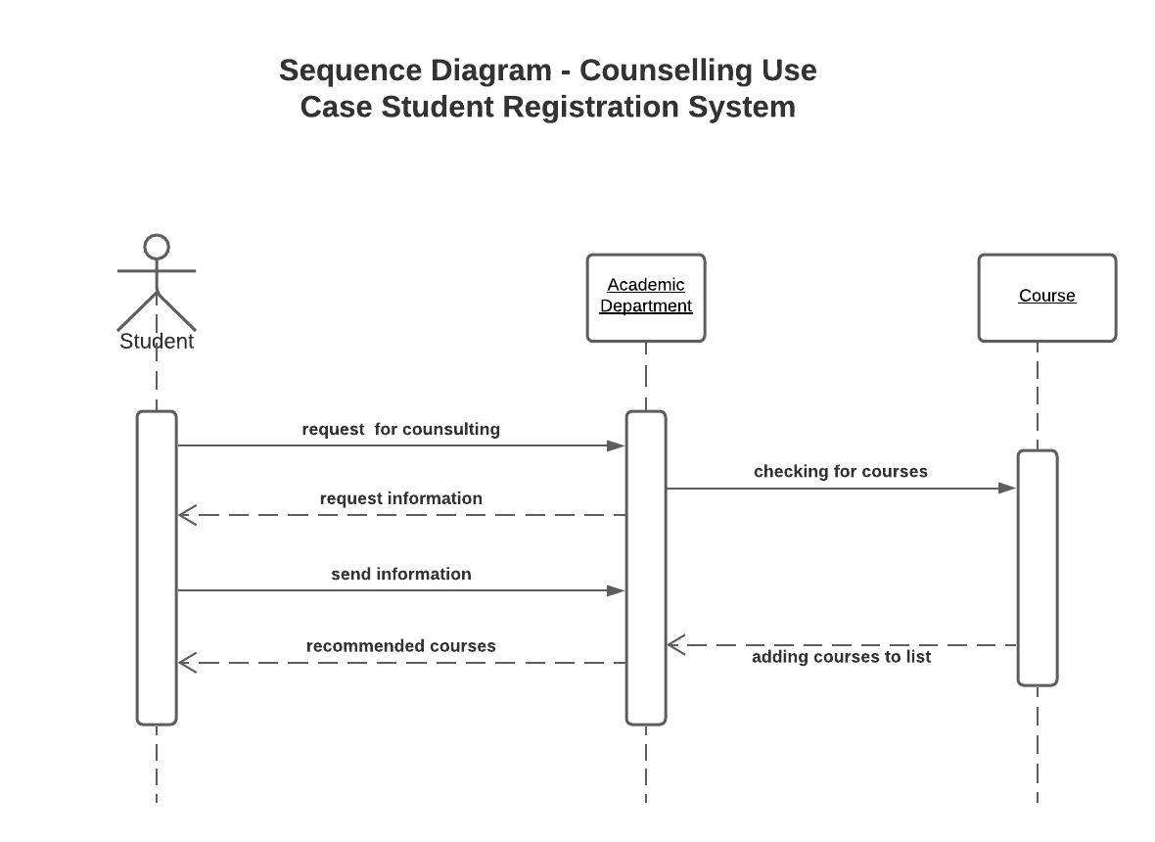

In SD-Select Course Use Case, student searches for courses and gets a list of available courses. Then, for every course student checks the availability of a class and academic department provides a list of all available classes with different instructors and schedules for that specific course. Student selects the course base on his/her schedule and sends a request to register for that class and if the registration is successful, he/she gets a confirmation.

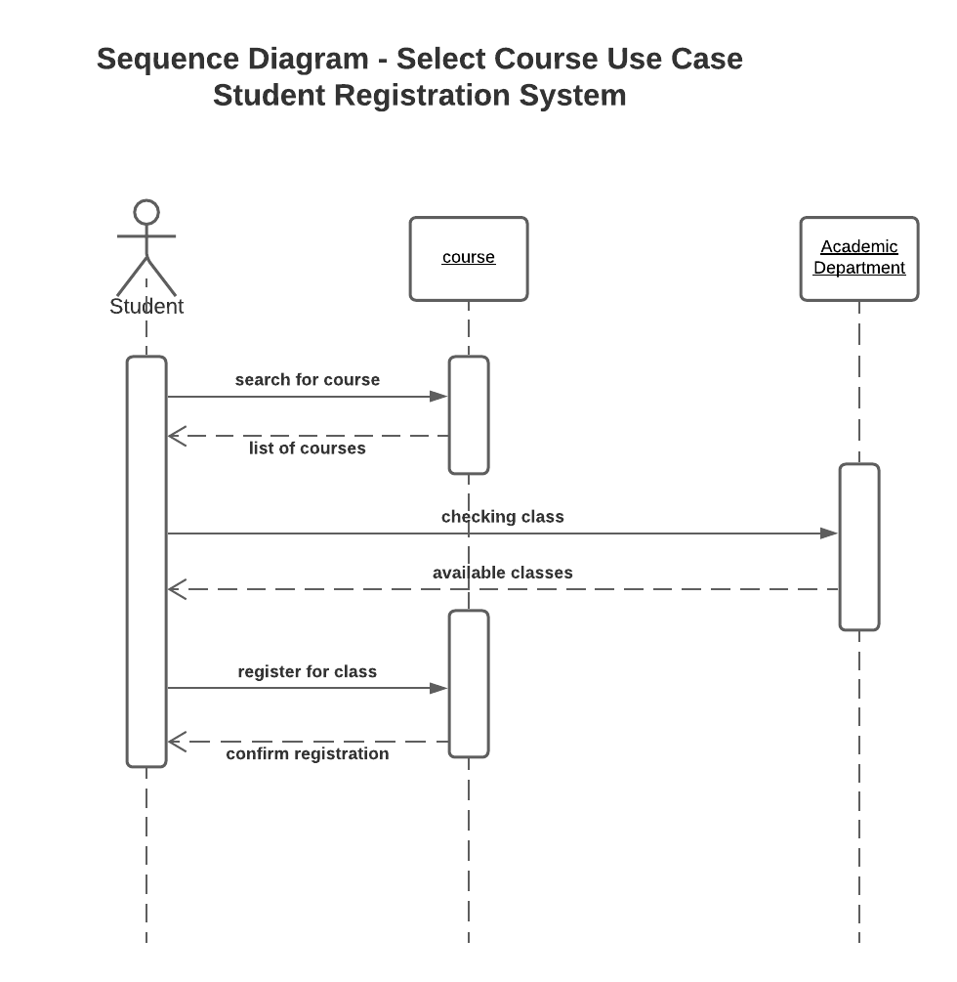

In SD-Approved Enrollment Use Case, student sends a request to academic department to enroll the course that he/she has registered for. Based on student eligibility, and if the class meets the minimum registrants, academic department authorizes the enrollment. Then, student will enroll the class and if he/she successfully completes the enrollment process, receives a confirmation.

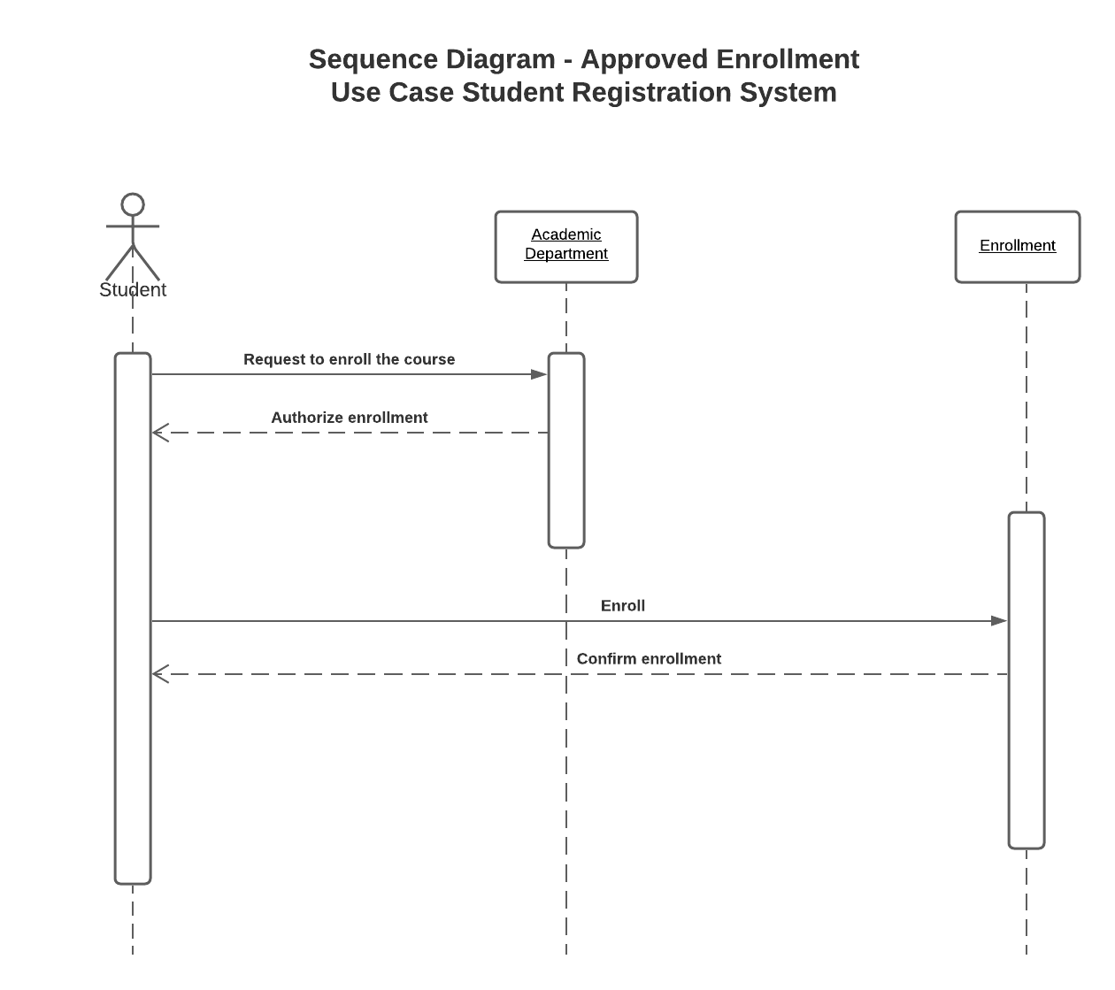

In SD- Payment Use Case, after student completed the enrollment process, he/she sends a request to finance department to get his/her payment amount dues. Finance department will provide a detailed bill including the total payment and a payment portal along with other acceptable methods of payment.

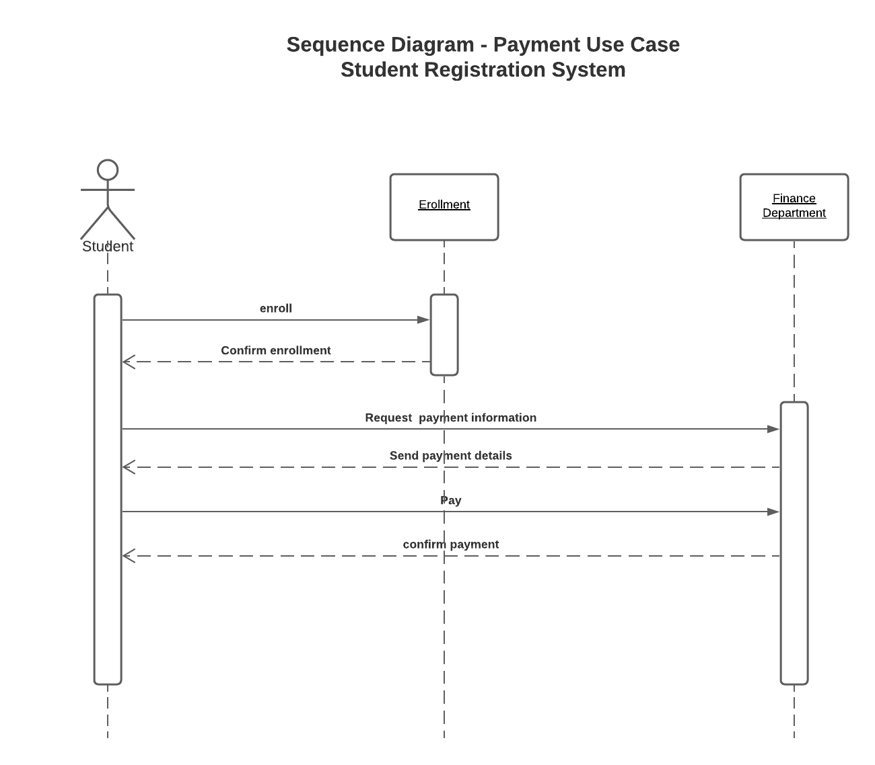

The following class diagram demonstrates the process. A student is a subcategory of possible users, however not all the users are necessarily students. A student registers for the courses in the system, enroll the selected courses and instructors and finally makes a payment.

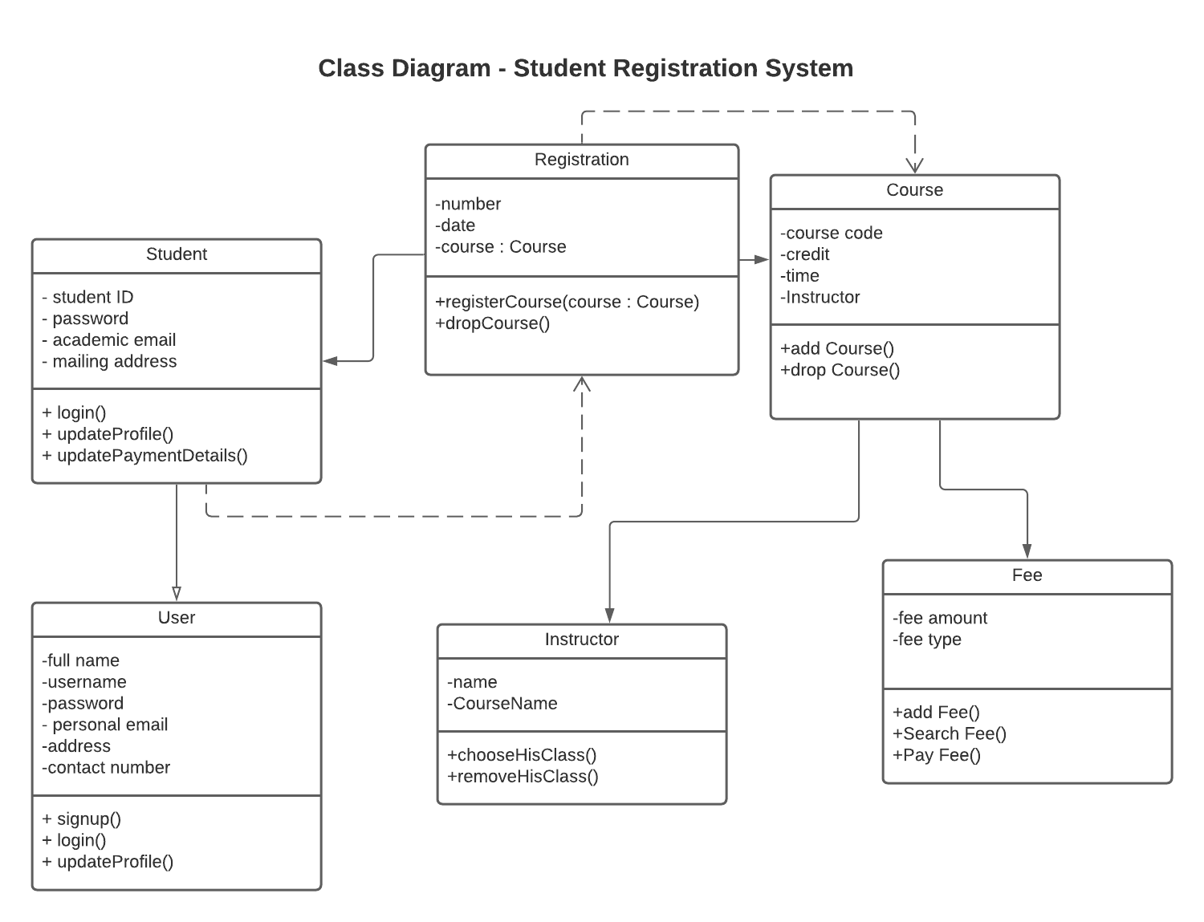

Lessons Learned

If I were given another shot to analyze the system differently, I would probably analyze the system with more details to make sure every possible scenario is included with proper responses and alternatives.

