Daytale — Complete Implementation PRD
Product • UX/UI • mascot • animation • system controls • assets • technical architecture • implementation references

0. Document Purpose
This is the build-reference PRD for Daytale. It consolidates the product scope, screen flow, visual language, mascot system, animation behavior, emoji/icon policy, system-level controls, third-party dependencies and technical architecture required to create the MVP. It should be used alongside the separate Product PRD, Technical Architecture and UI/UX documents, but this document is the most complete implementation reference.

1. Product Definition
Daytale is a privacy-first, multilingual mobile journal that turns a user's day into a first-person journal with minimal manual input.
Core loop: Schedule → one-tap Start → live normally → background capture → optional clarification → journal generation → delete temporary source data → keep the journal.

2. Product Personality
- Fun, warm and friendly — never clinical or surveillance-like.
- Simple enough to feel like setting an alarm.
- Character-led, but not childish.
- Calm when privacy or recording status is involved.
- Journal-reading mode becomes quieter and more editorial.

3. Visual Design References
The following concept boards are the current visual references for implementation. They are directional rather than pixel-perfect production specifications.
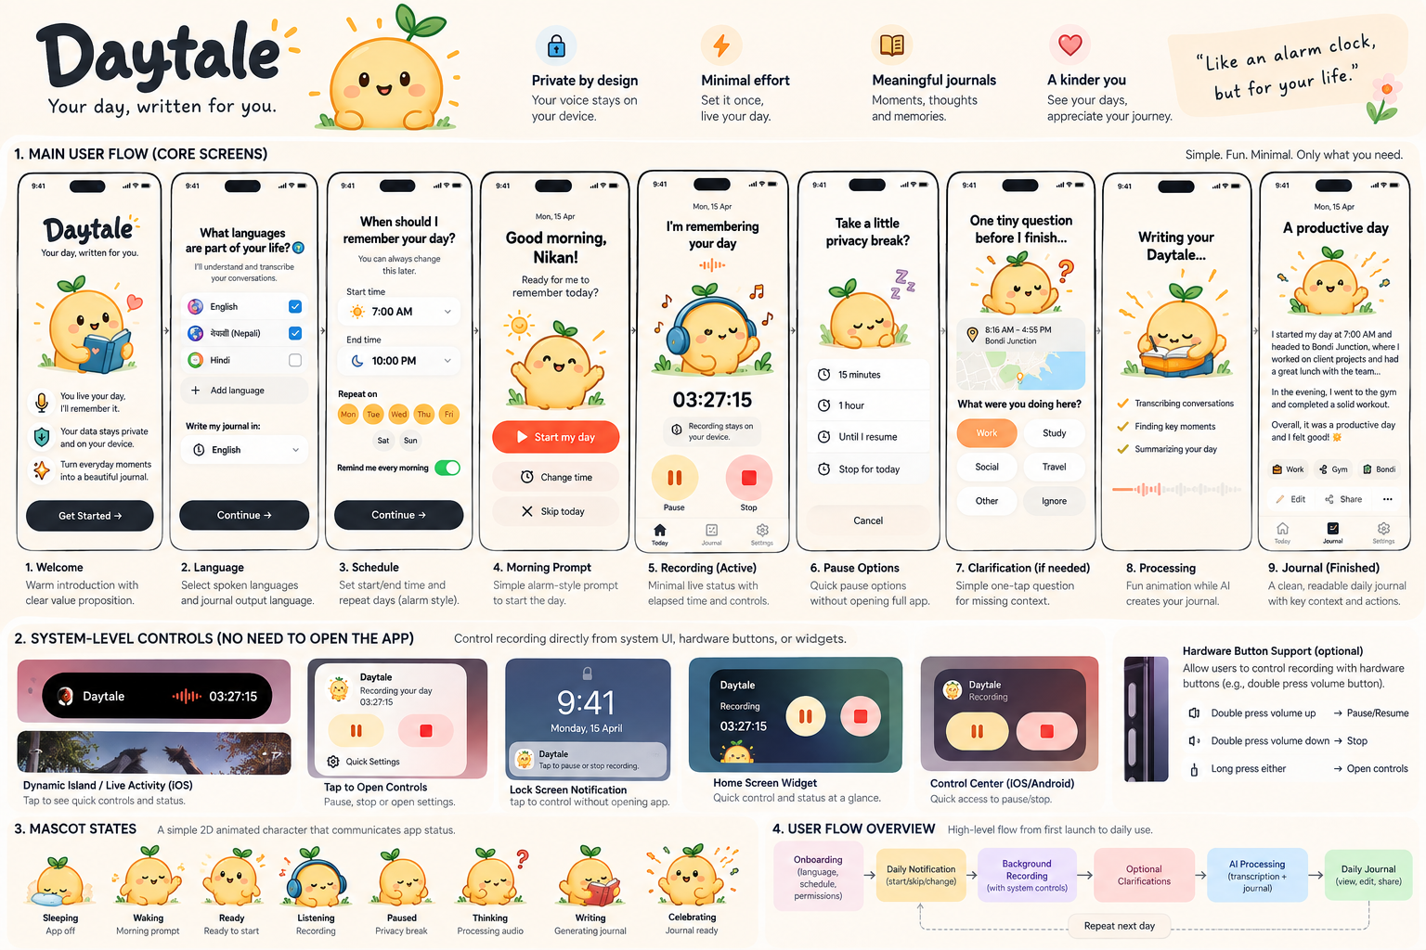
Figure 1 — Daytale complete concept board: screens, system controls, mascot states and user flow.
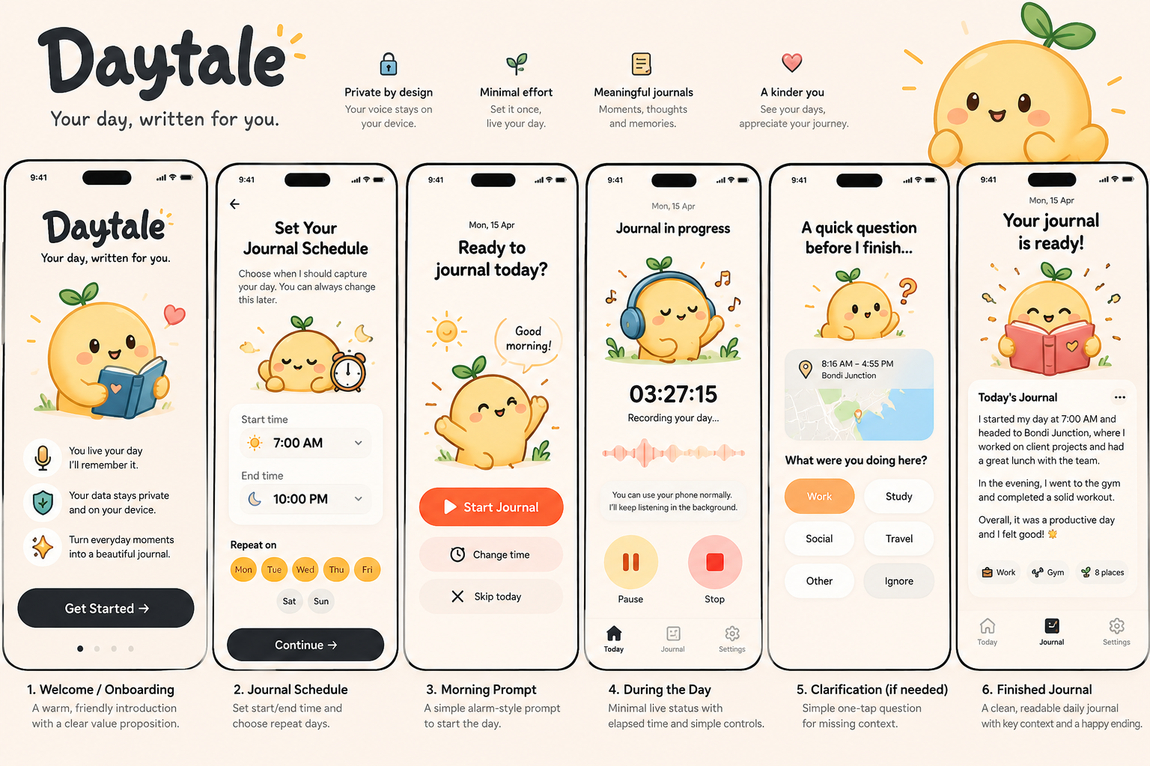
Figure 2 — Earlier six-screen exploration: onboarding, schedule, morning prompt, active state, clarification and finished journal.

4. Information Architecture
The MVP has only three primary tabs: Today • Journal • Settings.
Today: Current state, Start/Skip, active recording state, Pause/Stop and clarification entry points.
Journal: Daily entries, reading, editing, sharing/export and deletion.
Settings: Schedule, spoken languages, journal language, privacy, data retention and permissions.

5. Full User Flow
First run: Welcome → spoken languages → journal language → schedule → privacy explanation → permissions → Ready.
Daily: scheduled notification → Start / Change Time / Skip → active background session → system quick controls → optional privacy break → optional clarification → processing → journal ready.
Return: Journal → date → read/edit/share/delete.

6. Screen Specification
Welcome: Mascot holding diary. Headline: “Your day, written for you.” Supporting line: “You live your day. I’ll remember it.” One primary Get Started action.
Languages: Select 1–3 commonly spoken languages. Journal output language is a separate selector. Do not expose transcription-model terminology.
Schedule: Alarm-clock visual model. Start/end time, repeat days, reminder toggle.
Morning Prompt: Signature screen. Mascot awake. Primary: Start my day. Secondary: Change time / Skip today.
Active Day: Mascot with headphones, clear active state, elapsed time, privacy statement, Pause and Stop. Avoid complex waveform-recorder UI.
Privacy Break: 15 min / 1 hour / Until I resume / Stop for today.
Clarification: One question at a time. Prefer one-tap chips: Work, Study, Social, Travel, Gym, Shopping, Other, Ignore.
Processing: Mascot writing. Show only a few understandable stages, e.g. Organizing moments → Finding key moments → Writing your journal.
Journal: Calm typography, generous whitespace, subtle context chips, Edit / Share / Delete.
Settings: Functional, restrained, minimal mascot use. Recording schedule, languages, retention, privacy and permissions.

7. Mascot System
Use one original Daytale mascot: a simple sun/day character with a tiny sprout. The mascot is part of the product state machine, not merely decoration.
State | Visual | Meaning
Sleeping | Eyes closed, small cloud/pillow | App/session off
Waking | Stretch/yawn | Morning reminder
Ready | Smile/wave | Ready to start
Listening | Headphones + tiny pulse | Recording active
Paused | Headphones off / resting | Privacy break
Thinking | Question mark | Needs clarification
Writing | Notebook + pencil | Generating journal
Celebrating | Confetti / happy bounce | Journal ready
Error | Concerned but calm | Recoverable problem

8. Animation System & Tuning
Recommended split: React Native Reanimated for interface motion; Rive for the mascot if interactive state-machine animation is desired. Lottie is a simpler alternative for pre-rendered mascot loops.
Interaction | Target | Tuning
Button press | 90–140 ms | Scale to ~0.97 then return; subtle haptic where appropriate.
Card/sheet enter | 180–260 ms | Ease-out; 8–16 px translate + fade. Avoid dramatic slides.
Tab/state transition | 160–220 ms | Crossfade or short translate.
Mascot idle | 3–6 s loop | Very subtle breathing/blink; no constant distracting bounce.
Mascot wake | 600–1000 ms | Stretch/blink/wave; play once.
Listening | 1.5–2.5 s loop | Tiny headphone/pulse movement. Keep calm because it may run for hours.
Paused | 400–700 ms | Headphones lower; settle into resting pose.
Thinking | 1.2–2 s loop | Question mark/eye movement; low amplitude.
Writing | 1–2 s loop | Small pencil/notebook movement.
Success | 700–1200 ms | One short bounce/confetti burst; no endless confetti.
Reduced Motion | Immediate/short fade | Respect OS Reduce Motion; replace large movement with opacity/state changes.
Performance rule: avoid continuously animating large full-screen layers while recording. Long-running active-state animation should be tiny, low-frequency and stoppable when the app is backgrounded.

9. Emoji, Icon & Illustration Policy
Daytale should not depend on platform emoji as its primary brand artwork because Apple/Google/Samsung emoji artwork differs visually. Use Unicode emoji only as lightweight copy accents; use custom Daytale assets for persistent product visuals.
- Use system Unicode emoji in microcopy/chips: ☀️ morning, 🌙 evening, 🎧 listening, ✍️ writing, ✨ ready, 📍 place, 💼 work, 📚 study, 🏋️ gym, 🚆 travel, 👥 social.
- Do not use emoji as the main mascot, app logo or critical status indicator.
- Create an original Daytale mascot and custom status pictograms as SVG/vector assets so they are visually identical across platforms.
- For general UI icons, use a consistent icon set rather than mixing emoji and icons. Lucide is a suitable third-party option; confirm package/license version at implementation time.
- If custom emoji-like stickers are desired later, create them as Daytale-owned SVG/PNG/WebP assets rather than copying Apple emoji artwork.
- Maintain light/dark variants where necessary and export raster fallbacks at appropriate device scales.

10. Asset Creation Workflow
Recommended production workflow:
1. Define mascot geometry and brand tokens in Figma.
2. Create master mascot poses as vectors.
3. Export static SVG/PNG/WebP assets for screens that do not require animation.
4. For interactive mascot states, import vector layers into Rive and create a state machine: OFF / READY / RECORDING / PAUSED / THINKING / WRITING / COMPLETE.
5. If Rive is not used, animate exported assets with Lottie or Reanimated.
6. Keep source design files under version control or a clearly versioned design folder; keep app-ready assets in the repository.
7. Document asset name, state, size, dark-mode behavior and animation trigger.

11. Third-Party Design/Animation Dependencies
Dependency | Purpose | Decision
React Native Reanimated | UI transitions, press states and microinteractions | Recommended. Expo documents it as the advanced animation option.
Rive | Interactive mascot/state-machine animation | Recommended if mascot animation becomes central. Third-party runtime/editor dependency.
Lottie | Alternative for simple prebuilt animation loops | Optional. Easier for one-shot/loop animations; less stateful than Rive.
Figma | Design system, vectors, component specs | Recommended design tool; not a runtime dependency.
Lucide | Consistent functional UI icons | Optional third-party icon set. Use one icon family consistently.
System Unicode emoji | Small copy accents | No bundled artwork; rendering varies by OS, so not for core branding.

12. System-Level Compact Controls
A key Daytale requirement is controlling an active session without opening the full app.
- iOS: implement a Live Activity using ActivityKit/WidgetKit for glanceable active-session state on the Lock Screen and Dynamic Island on supported devices. Design minimal, compact and expanded presentations.
- iOS quick actions should prioritize Pause/Resume and Stop; tapping the activity may deep-link to the Today screen or compact control surface.
- Android: use the required foreground-service notification to make microphone activity visible and provide Pause/Resume and Stop actions.
- Home-screen widget/control surfaces are secondary enhancements after the recording pipeline is reliable.
- Hardware-button control is optional. Do not depend on intercepting normal volume buttons for MVP; prefer official OS action/shortcut mechanisms when available.

13. Visual Tokens
Token | Direction | Use
Background | Warm off-white / cream | Primary canvas
Text | Near-black charcoal | High contrast; avoid pure decorative gray for body copy
Accent | Sunny yellow / warm orange | Primary Daytale brand and success warmth
Recording | Warm orange/red accent | Use with explicit text/icon; never color alone
Paused | Soft amber | Calm temporary state
Success | Warm yellow + subtle green accents | Journal completion
Corners | ~18–24 px cards | Friendly, soft geometry
Touch targets | At least platform-recommended comfortable sizes | Buttons should feel alarm-clock simple

14. Accessibility & Motion
- Respect Reduce Motion / Remove Animations preferences.
- All mascot/status meaning must also be communicated with text or accessible labels.
- Do not rely on color alone for recording/paused/stopped.
- Use Dynamic Type / scalable text where practical.
- Provide sufficient contrast in both light and dark modes.
- System-level controls need concise accessible labels such as “Pause Daytale recording” and “Stop Daytale recording.”

15. Technical Stack
- Expo + React Native + TypeScript.
- Expo Development Builds + Prebuild; Expo Go is not the target runtime.
- Expo Router + Zustand.
- Swift + AVFoundation native module on iOS.
- Kotlin + microphone foreground service on Android.
- Encrypted local structured storage; platform secure key storage.
- whisper.cpp/local multilingual transcription after recording reliability is proven.
- Minimal transient journal-generation API; raw audio should not be uploaded in the intended MVP architecture.
- Reanimated for UI motion; Rive or Lottie only where justified.

16. Build Order
1. Static Expo shell + design tokens + navigation.
2. Implement Today, Journal and Settings screens from this PRD.
3. Physical-device background recording spike on iOS and Android.
4. Add Android notification controls and iOS Live Activity prototype.
5. Measure battery/storage and interruption recovery.
6. Add encrypted chunking and local transcription.
7. Add multilingual settings and journal generation.
8. Add clarification system.
9. Integrate mascot static states.
10. Add Reanimated microinteractions.
11. Add Rive/Lottie mascot animation only after core state machine is stable.
12. Accessibility, reduced motion, dark mode, QA and beta instrumentation.

17. External Documentation References
- Expo Animation / Reanimated: https://docs.expo.dev/develop/user-interface/animation/
- Apple Live Activities: https://developer.apple.com/documentation/WidgetKit/LiveActivities-Collection
- Apple Dynamic Island: https://developer.apple.com/documentation/WidgetKit/DynamicIsland
- Apple WidgetKit controls/interactivity: https://developer.apple.com/documentation/widgetkit
- Android Foreground Services: https://developer.android.com/develop/background-work/services/fgs
- Rive React Native documentation: https://rive.app/docs/runtimes/react-native/react-native
- Lottie React Native repository/documentation: https://github.com/lottie-react-native/lottie-react-native
- Lucide icons: https://lucide.dev/

18. Related Daytale Documents
- Daytale_Product_PRD.docx — product scope and success criteria.
- Daytale_MVP_Technical_Architecture.docx — technical implementation and validation order.
- Daytale_UI_UX_User_Flow.docx — screen/user-flow design specification.
- This document — consolidated implementation PRD and design/asset reference.

19. MVP Guardrail
Do not let animation, mascot polish, widgets or hardware shortcuts delay the fundamental proof: the user intentionally starts Daytale, it reliably captures a long session with understandable battery/storage impact, produces a useful multilingual journal, and safely deletes temporary source data.

