Daytale - UI/UX & User Flow Specification
Minimal, fun, character-oriented alarm-clock interaction model

1. Design Direction
Daytale should feel like a cute alarm clock plus a tiny diary companion. The interface is intentionally small: Today, Journal and Settings. The mascot communicates state rather than acting as decoration.

2. Visual Concept Board
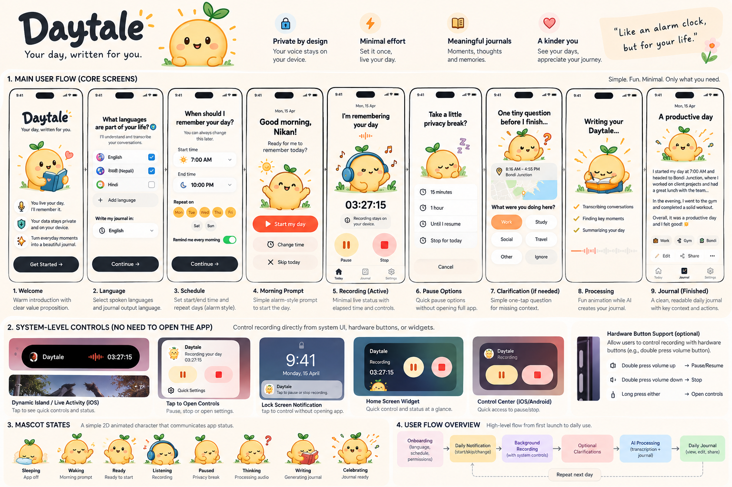
Concept board: core screens, system-level controls, mascot states and high-level flow.

3. Core Screen Flow
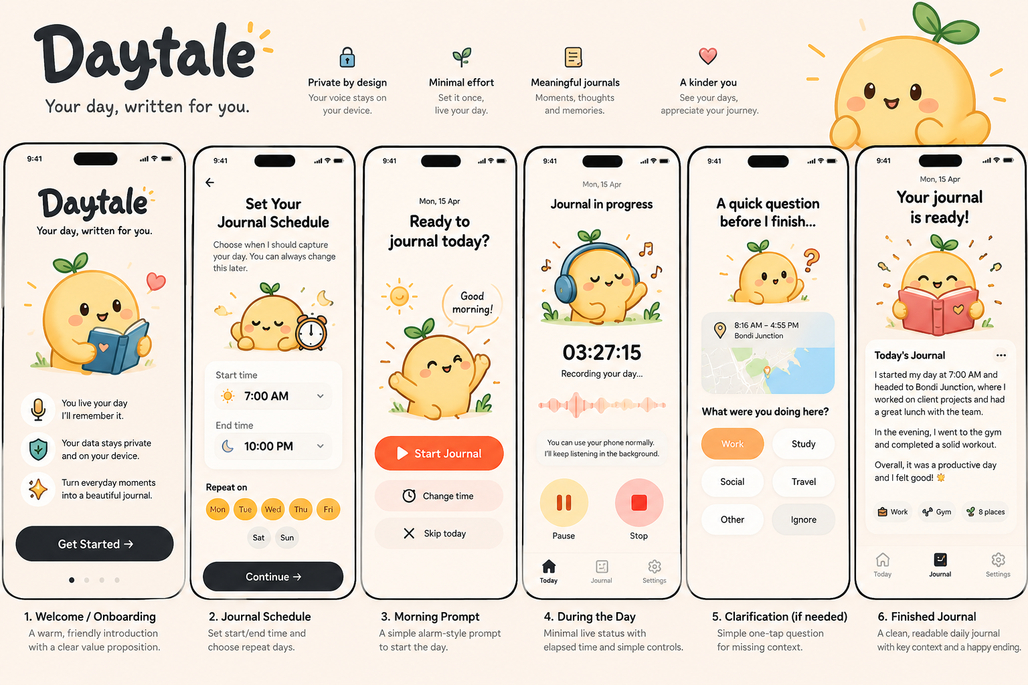
Early core-flow exploration: onboarding -> schedule -> morning prompt -> active day -> clarification -> finished journal.

4. Information Architecture
Three tabs only: Today | Journal | Settings.

5. First-Run Flow
Welcome -> Spoken Languages -> Journal Language -> Schedule -> Privacy/Permissions -> Ready.

6. Daily Flow
Scheduled notification -> Start / Change Time / Skip -> background recording -> system-level quick controls -> optional clarification -> processing -> journal ready.

7. Core Screens
Welcome: Mascot with diary; 'Your day, written for you.' One primary Get Started button.
Languages: Select spoken languages such as English and Nepali. Separately select final journal language.
Schedule: Alarm-clock style start/end times and repeat days.
Morning Prompt: Large Start My Day action, with Change Time and Skip Today secondary actions.
Active Day: Mascot wearing headphones, elapsed time, recording state, Pause and Stop.
Privacy Break: 15 min, 1 hour, until resumed, or stop for today.
Clarification: One small question at a time with one-tap activity choices.
Processing: Mascot writing; lightweight progress states.
Journal: Mostly typography and whitespace; edit/share/delete and subtle context chips.

8. System-Level Compact Control
A major product requirement is controlling Daytale without reopening the app. The active state should surface as a compact system-level indicator where the platform permits it.
- iOS concept: Live Activity / Dynamic Island-style status showing Daytale mascot/icon, elapsed session state and a tap-through to controls.
- Android concept: persistent foreground-service notification with Pause/Resume and Stop actions.
- Lock-screen controls should expose the smallest safe action set.
- A compact home-screen widget can show state and provide quick access.
- The mascot/icon changes state: sleeping=off, awake=ready, headphones=recording, resting=paused, thinking=needs clarification, writing=generating, celebrating=ready.

9. Hardware Interaction Principle
Hardware shortcuts can be explored after the core system controls work. Do not depend on repurposing normal volume-button behavior for v1. Any hardware shortcut must be deliberate, configurable and compatible with platform rules.

10. Visual System
- Warm off-white background, charcoal text, sunny yellow/orange accent.
- Rounded cards and large touch targets.
- Original 2D sun/day mascot with simple vector geometry.
- Approximately 70% clean interface, 20% character and 10% delightful motion.
- Use animation only when it communicates state or rewards completion.
- Journal reading mode should be calmer and less playful than the Today screen.

