Temperature anomalies are preferred over absolute temperatures for several reasons:

1. **Relative Comparison**: Anomalies provide a more meaningful measure for comparison because they represent deviations from a baseline or average temperature rather than absolute temperature values. This allows for a clearer understanding of whether a given temperature is above or below what is typical or expected for a particular place and time.
2. **Consistency in Comparison**: Anomalies allow for consistent comparisons over time and across different locations. By using a fixed baseline period (such as the 30-year period 1951-1980 in the case of GISS analysis), anomalies provide a standardized reference point for comparison. This consistency enables researchers to identify long-term trends in temperature variations without being influenced by changes in absolute temperature scales or local factors.

PART 1.1 (2)

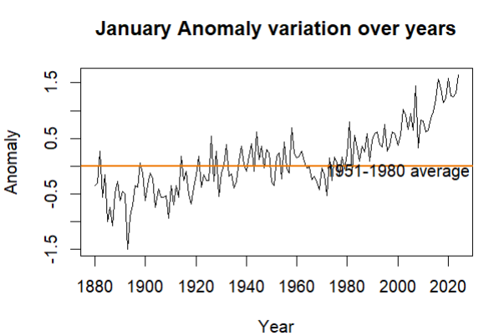

PART 1.1 (3)

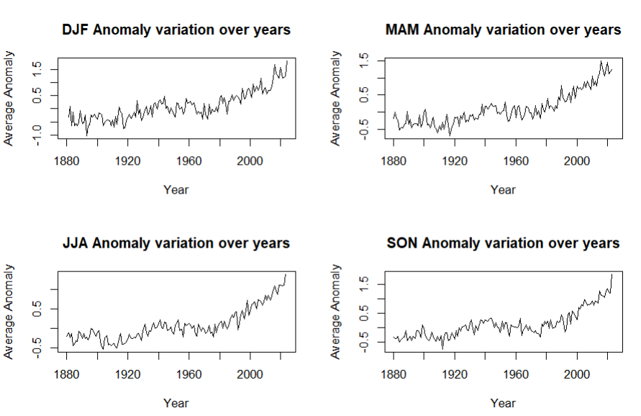

PART 1.1 (4)

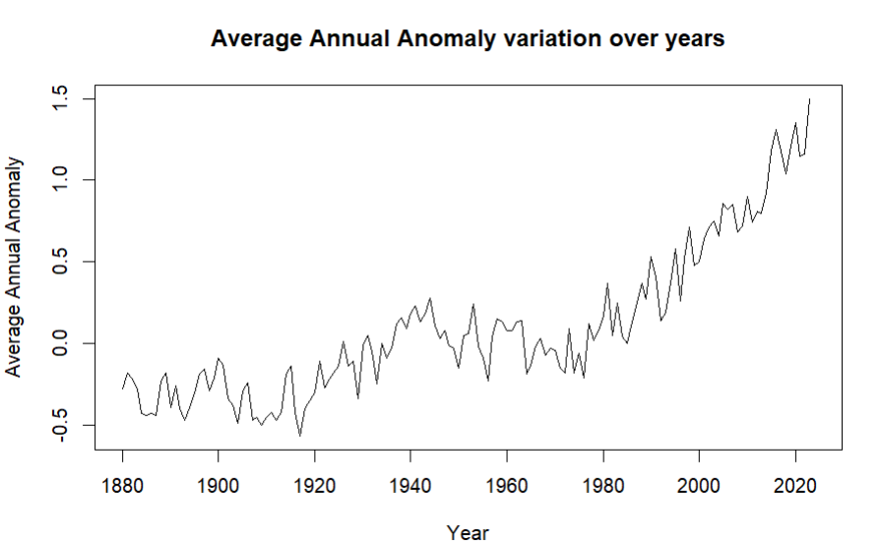

4(b).

The graphs suggest, that as time is progressing, the temperature anomaly is increasing on a positive side of the base line. This is the case for almost all months, hence the average anomalies of three months, or even the annual average temperature anomalies are increasing as the time is progressing.

5.

If we study, only month wise graphs/data we are missing out the factor of changing seasons on earth. If we study only seasons, then we are missing out the factor, the different part of the world has different seasons at different times. Also, the analysis of overall year gives a better view at the temperature anomalies. Along with that, monthly/season anomalies can help us analyze which seasons/months are contributing most to the global temperature rise, and thus can help us in identify the factors related to that.

6.

Doubt - How is the mean base line period decided on the basis of the graph?

**PART 1.2**

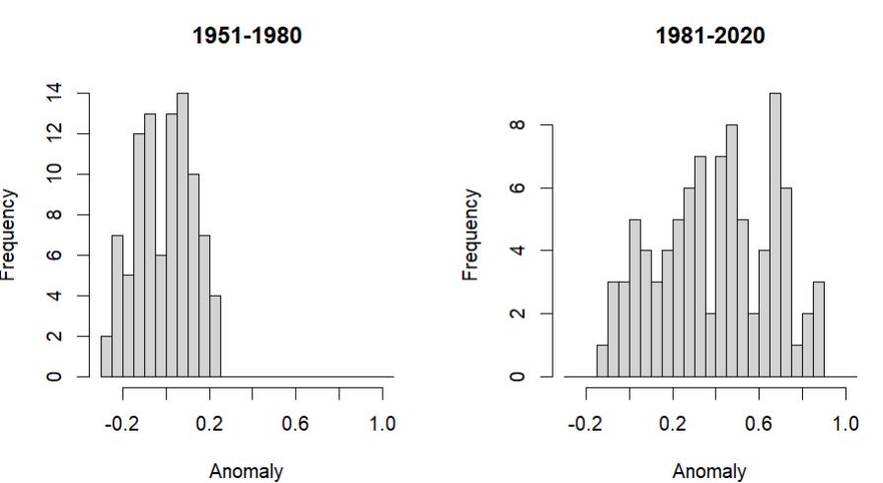

Plots generated from my graphs.

2 (b) Earlier, the temperature anomalies lied more in the ranges below 0.3, and after 1981 they distributed and shifted towards the right, showcasing the increase in the global temperatures

3.

In descriptive statistics, the term “decile” refers to the nine values that split the population data into ten equal fragments such that each fragment is representative of 1/10th of the population. In other words, each successive decile corresponds to an increase of 10% points that the 1st decile or D1 has 10% of the observations below it. Then, the 2nd decile, or D2, has 20% of the observations below it, and so on.

**Di = [i * (n + 1) / 10] th data**

Temperature anomalies below dec3(−0.1) are therefore considered ‘cold’, and temperature anomalies above dec7(0.1) are considered ‘hot’.

4.

In 1951-1980, the hot temperatures are 30% of the overall anomalies, but in 1981-2010 the hot temperatures are 88% of the overall anomalies, hence the temperature is increasing more than before.

5 (B)

* Yes, on comparing the variance of different seasons, for all seasons the variability of anomaly temperature has increased in the later period of time. Temperature in most seasons appears to be more variable in 1981–2010 compared to 1951–1980 or 1921–1950 (and the mean anomaly in each season has increased in each period for most seasons).

The temperature anomalies in DJF have a larger variance than those in JJA. The variance in DJF is about three times larger than that in JJA, particularly until 1980. For the period 1981–2010, the JJA temperature anomalies start becoming more variable.

6. After reading New York Times article

**PART 1.3**

1. Measurements made at the Mauna Loa Observatory reflect truth about our global atmosphere. The main reasons for that confidence are:

The Observatory near the summit of Mauna Loa, at an altitude of 3400 m, is well situated to measure air masses that are representative of very large areas.

All of the measurements are rigorously and very frequently calibrated.

Ongoing comparisons of independent measurements at the same site allow an estimate of the accuracy, which is generally better than 0.2 ppm.

2.

The trend mean mole fraction for each month is determined by removing the seasonal cycles. Trend values are linearly interpolated for missing values. The interpolated value is the sum of the average seasonal cycle value and the trend value. (doubt)

<https://www.sciencedaily.com/releases/2013/08/130812170338.htm>

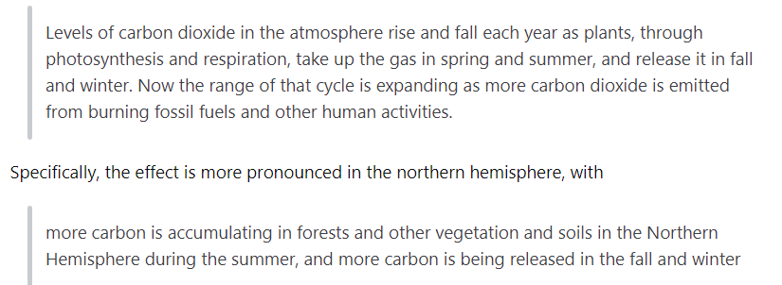

3.

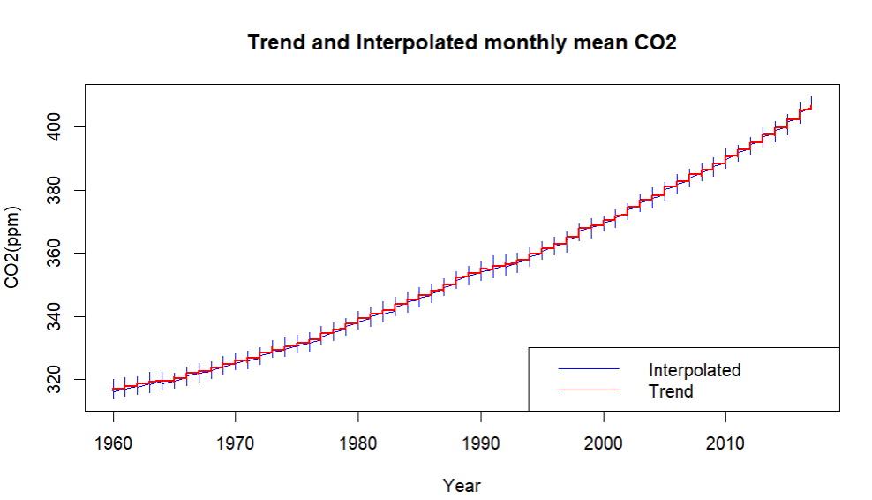

**4** The (Pearson) correlation coefficient is 0.88, indicating a strong positive linear association between the two variables. When CO2 levels increase, temperatures increase.

1. 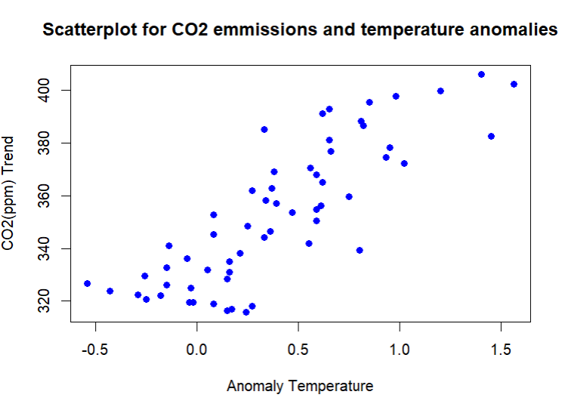
2. an inability to detect non-linear relationships between variables. an inability to determine whether there is a causal relationship between the variables.

6. Spurious correlation is a correlation that is out of co-incidence or other unseen factors.

Correlation is statistically how the two variables are related, does not guarantee that one variable causes the other. But in causation, there is a defined mechanism for why one variable causes the other.