

**Project Report   
on   
Age and Gender Detection Model**

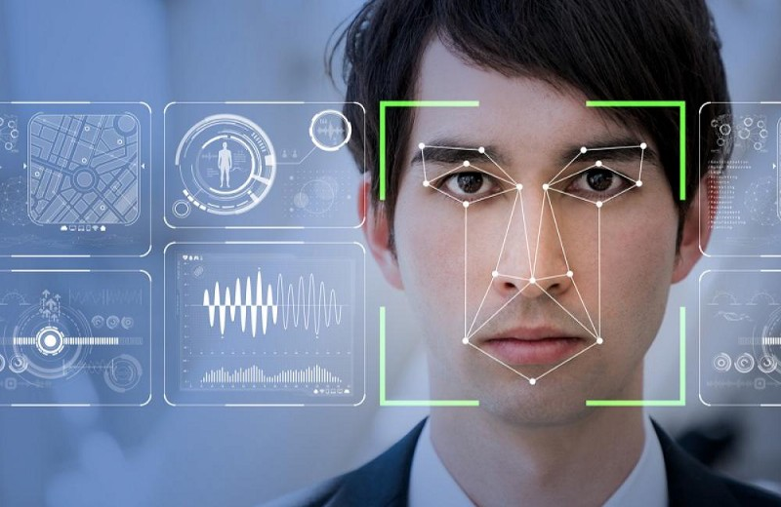

**Submitted By:**

**Nikhil Chawla (18csu140)**

**Palak Dhingra (18csu151)**

**Pranav Goel (18csu158)**

**A Project Report**

**On**

Age and Gender detection Model

*Submitted in partial fulfilment of the requirement for the award of the degree*

*of*

Bachelor of Technology

In Computer Science Engineering and Information Technology

*by*

**Nikhil Chawla, 18CSU140**

**Palak Dhingra, 18CSU151**

**Pranav Goel,18CSU158**

Under supervision of

Mr. Arpit Yadav

Dr. Shaveta Arora

**ACKNOWLEDGEMENT**

As it is rightly said “The successful realization of the project is an outgrowth of a consolidated effort of the people from disparate fronts. It is only with their support and guidance that the developer could meet the end. The completion of any task is not only the reward to the person actively involved in accomplishing it, but also the person involved in inspiring & guiding. I am highly indebted to my supervisors for their invaluable support and guidance throughout the work.

I wish to extend my sincere gratitude towards **Mr. Arpit Yadav and Dr. Shaveta Arora** for giving me this opportunity and support to make this project happen.

Nikhil Chawla 18CSU140

Palak Dhingra 18CSU151

Pranav Goel 18CSU158

**ABSTRACT**

Machine learning is the rage these days. But the machine learning technique that shines the most brightly is deep learning. Deep learning is all about how a computer program can learn through observation and make decisions based on its experience. Deep learning methods are useful for computer vision, natural language processing, speech recognition and processing, and so much more.

Neural networks form the base of deep learning, where the structure of the human brain inspires the algorithms. Neural networks take input data, train themselves to recognize patterns found in the data, and then predict the output for a new set of similar data. Therefore, a neural network can be thought of as the functional unit of deep learning, which mimics the behaviour of the human brain to solve complex data-driven problems.

Most commercial deep learning products use “supervised learning” to achieve their objective. For instance, in order to recognize a person in a photo, a neural net will need to be trained with a set of labelled data. This tells the algorithm that there is a “Woman” represented in this image, or there is not a “Woman” in this photo. If you throw enough images at the neural network, it will, indeed, learn to identify a “Woman” in an image.

In the past few decades, Deep Learning has proved to be a very powerful tool because of its ability to handle large amounts of data. The interest to use hidden layers has surpassed traditional techniques, especially in pattern recognition. One of the most popular deep neural networks is Convolutional Neural Networks. In deep learning, a convolutional neural network (CNN/ConvNet) is a class of deep neural networks, most commonly applied to analyze visual imagery.

*Keywords:- CNN(Convolutional Neural Network), DL(Deep Learning), VGG16(Visual Geometry Group), ML(Machine Learning)*

**TABLE OF CONTENTS**

**Acknowledgement……………………………………………...……3**

**Abstract…………………………………………………………………..4**

1. **Introduction……………………………………………………………….6**
2. **Literature Review…………………………………………………………8**
3. **Dataset…………….……………………………………………………….10**
4. **Flow of Code………………………………………………………………11**
5. **Steps Involved……..………………………………………………………12**
6. **Working of Project….…………………………………………………….14**
7. **Conclusion…….…………………………………………………………...16**
8. **Future study……………….………………………………………………17**
9. **INTRODUCTION**

Although a new technological advancement, the scope of Deep Learning is expanding exponentially. Deep Learning technology aims to imitate the biological neural network, that is, of the human brain. While the origins of Deep Learning dates back to the 1950s, it is only with the advancement and adoption of Artificial Intelligence and Machine Learning that it came to the limelight. While traditional learning models analyse data using a linear approach, the hierarchical function of Deep Learning systems is designed to process and analyse data in a nonlinear approach.

Deep Learning architectures like deep neural networks, recurrent neural networks, and deep belief networks have found applications in various fields including natural language processing, computer vision, bioinformatics, speech recognition, audio recognition, machine translation, social network filtering, drug design, and even board game programs. As new advances are being made in this domain, it is helping ML and Deep Learning experts to design innovative and functional Deep Learning projects.

Automatic age and gender classification has become relevant to an increasing amount of applications, particularly since the rise of social platforms and social media.. With the advancement of technologies new features are added to our current using applications. One of such fun feature is to detect gender and age of a person who faces the camera at any instance. With the help of this project we tried to create a similar experience. In this project an Age and Gender prediction model is build. The basic idea behind this project was to be able to understand the concepts of deep learning and neural networks.

For basic training of the model we have used the VGG16 neural network architecture. VGG16 is a convolution neural net (CNN ) architecture which was used to win ILSVR(Imagenet) competition in 2014. It is considered to be one of the excellent vision model architecture till date. Most unique thing about VGG16 is that instead of having a large number of hyper-parameter they focused on having convolution layers of 3x3 filter with a stride 1 and always used same padding and maxpool layer of 2x2 filter of stride 2. It follows this arrangement of convolution and max pool layers consistently throughout the whole architecture. In the end it has 2 FC(fully connected layers) followed by a softmax for output. The 16 in VGG16 refers to it has 16 layers that have weights. This network is a pretty large network and it has about 138 million (approx) parameters.

1. **Literature Review**

Kawai et al. has attribute information such as age and gender improves the performance of face recognition. The paper proposes an age and gender prediction method from face images using convolutional neural network. The dataset used is Imdb Wiki. Models used in the datasets are CNN and VGG16. Through a set of experiments using public face databases, it demonstrate that the proposed method exhibits the efficient performance on age and gender prediction compared with conventional methods[1]. Chao et al. has provides a new age estimation approach, which distinguishes itself with the following three contributions. First, they combine distance metric learning and dimensionality reduction to better explore the connections between facial features and age labels. Second, to exploit the intrinsic ordinal relationship among human ages and overcome the potential data imbalance problem, a label-sensitive concept and several imbalance treatments are introduced in the system training phase. Finally, an age-oriented local regression is presented to capture the complicated facial aging process for age determination. The simulation results show that our approach achieves the lowest estimation error against existing methods[2]. Khaung Tin et al. has given a fast and efficient gender and age estimation system based on facial images is developed. There are many methods have been proposed in the literature for the age estimation and gender classification. However, all of them have still disadvantage such as not complete reflection about face structure, face texture. This technique applies to both face alignment and recognition and significantly improves three aspects. First, we introduce shape description for face model. Second, the feature extraction phase, two geometric features are evaluated as the ratios of the distances between eyes, noses, and mouths. Finally, we classified the gender and age based on the association of two methods: geometric feature based method and Principal Component Analysis (PCA) method for improving the efficiency of facial feature extraction stage. The face database contains the 13 individual groups. Within a given database, all weight vectors of the persons within the same age group are averaged together. A range of an age estimation result is 15 to 70 years old, and divided into 13 classes with 5 years old range[3]. Wang et al. In this paper, we introduce an approach to classify gender and age from images of human faces which is an essential part of our method for autonomous detection of anomalous human behaviour. Human behaviour is often uncertain, and sometimes it is affected by emotion or environment. Automatic detection can help to recognise human behaviour which later can assist in investigating suspicious events. Central to our proposed approach is the recently introduced transfer learning. It was used on the basis of deep learning and successfully applied to image classification area. This paper is a continuous study from previous research on heterogeneous data in which we use images as supporting evidence. We present a method for image classification based on a pre-trained deep model for feature extraction and representation followed by a Support Vector Machine classifier. Because very few data sets with labels of gender and age exist of face images, we build one dataset named GAFace and applied our proposed method to this dataset achieving excellent results and robustness (gender classification: 90.33% and age classification: 80.17% accuracy) approaching human performance[4].

Table1: Summary of Literature review

|  |  |  |  |
| --- | --- | --- | --- |
| S.NO | TITLE | YEAR | Model |
| [1] | Age and Gender Prediction from Face Images Using Convolutional Neural Network | 2018 | CNN, VGG16 |
| [2] | Facial age estimation based on label-sensitive learning and age-oriented regression | 2013 | CNN,SVM |
| [3] | Gender and Age Estimation Based on Facial Images | 2011 | CNN, PCA |
| [4] | Gender and Age Classification of Human Faces for Automatic Detection of Anomalous Human Behaviour | 2017 | CNN,SVM |

1. **DATASET**

**The Adience dataset, published in 2014, contains 26,580 photos across 2,284 subjects with a binary gender label and one label from eight different age groups, partitioned into five splits. The key principle of the data set is to capture the images as close to real world conditions as possible, including all variations in appearance, pose, lighting condition and image quality, to name a few. The dataset was taken from kaggle. Initially there were five text files which were merged during pre-processing.**

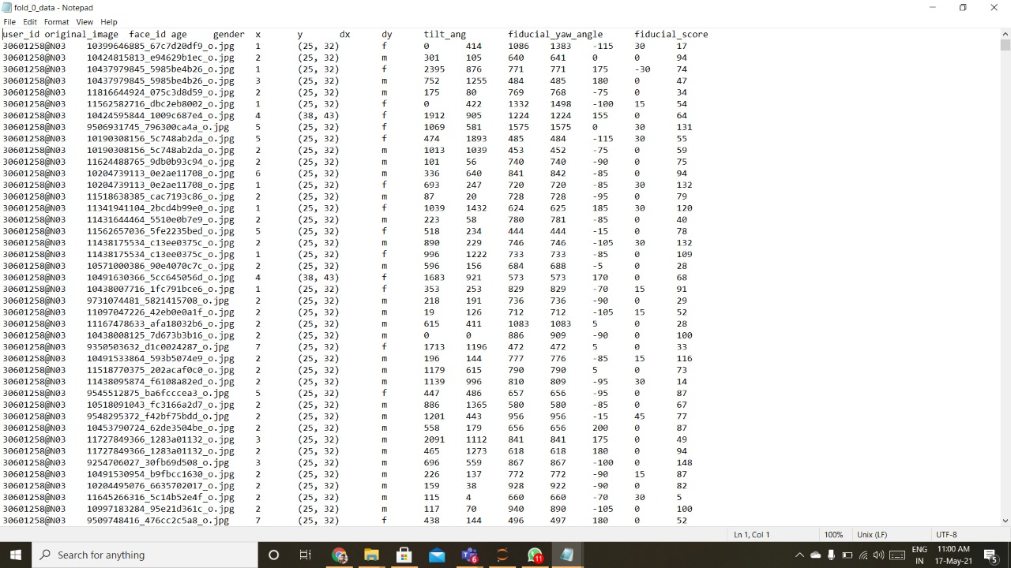

Fig:3.1 Dataset Structure

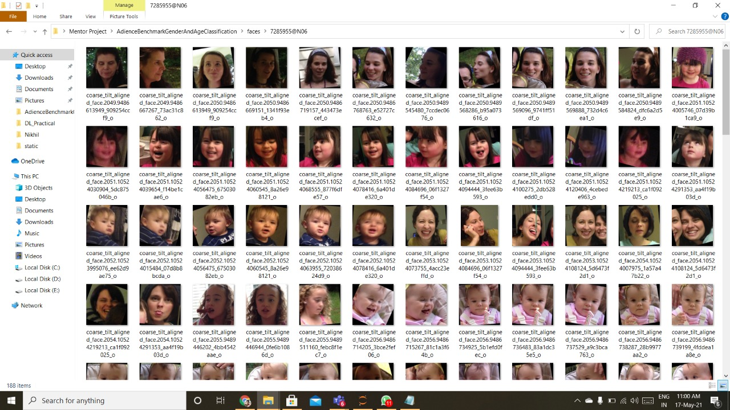

Fig:3.2 Dataset Images

1. **Flow of Code**

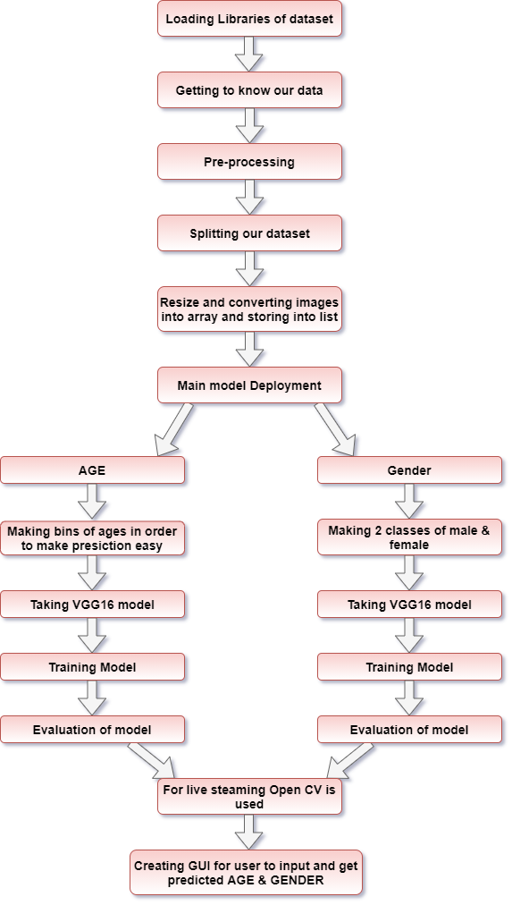

1. **STEPS INVOLVED**
2. **Importing libraries and dataset:- We need various libraries in order to work in python. Hence loading them is the first step. Also loading our dataset in order to proceed.**
3. **Getting to know the data : Before actually working on a dataset it is very important to know about the data it holds. Various functions are used to find the distribution of data in our dataset.**

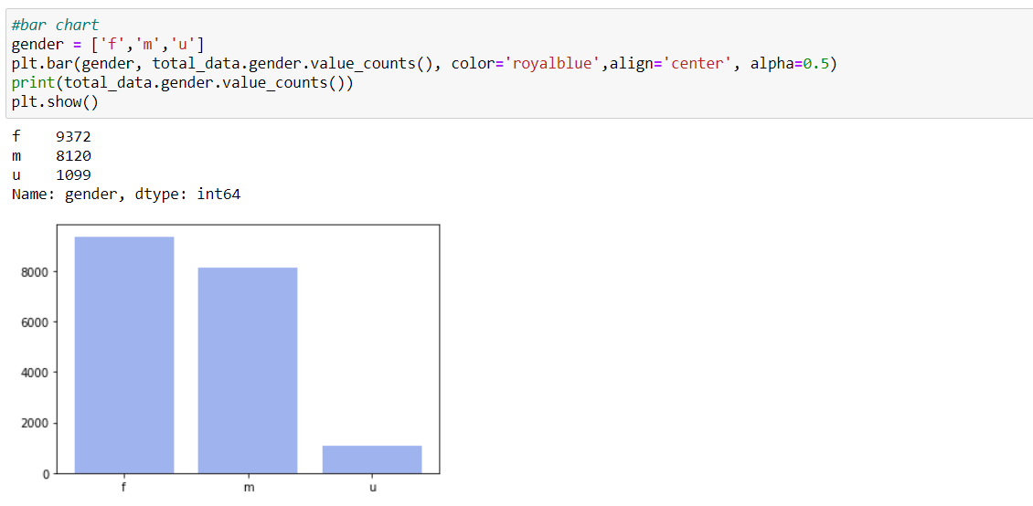

Fig:5.1 Gender Distribution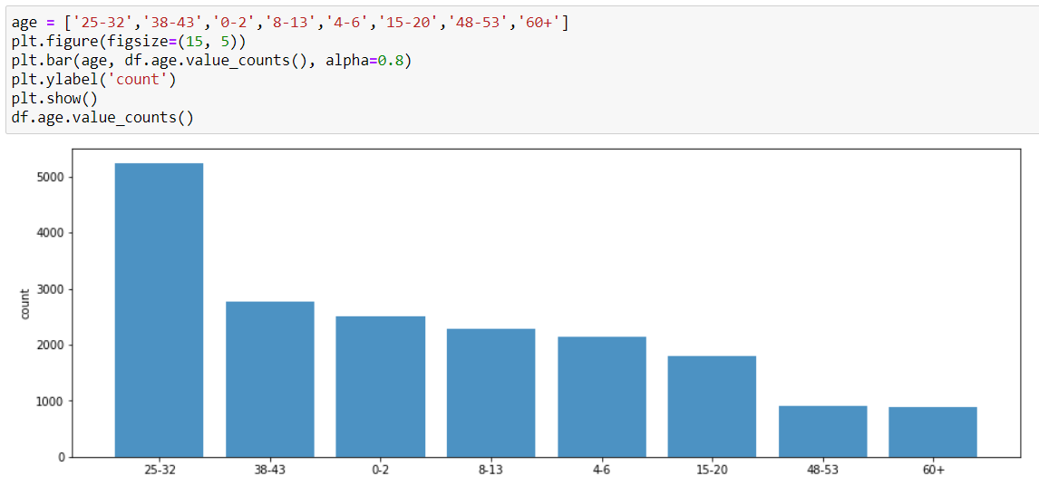

Fig:5.2 Age Distribution

1. **Data pre-processing : It is very important to pre-process our data and convert it into a format that can be used in order to continue with our project.**
2. **Splitting dataset : It is important to split data into train and test data in order to minimize the effects of data discrepancies and for better understanding of model.**
3. **Applying VGG16 model for Gender: Then we took a VGG16 model and trained our gender data using this model.**
4. **Applying VGG16 model for Age : Then we took a VGG16 model and trained our age data using this model.**
5. **Model evaluation: We calculated the accuracy for both models.**
6. **Open CV: For capturing live photos we have used open cv.**
7. **Creation of GUI: We created a GUI for user to input their images and get a prediction for age and gender of given image.**
8. **WORKING OF PROJECT**

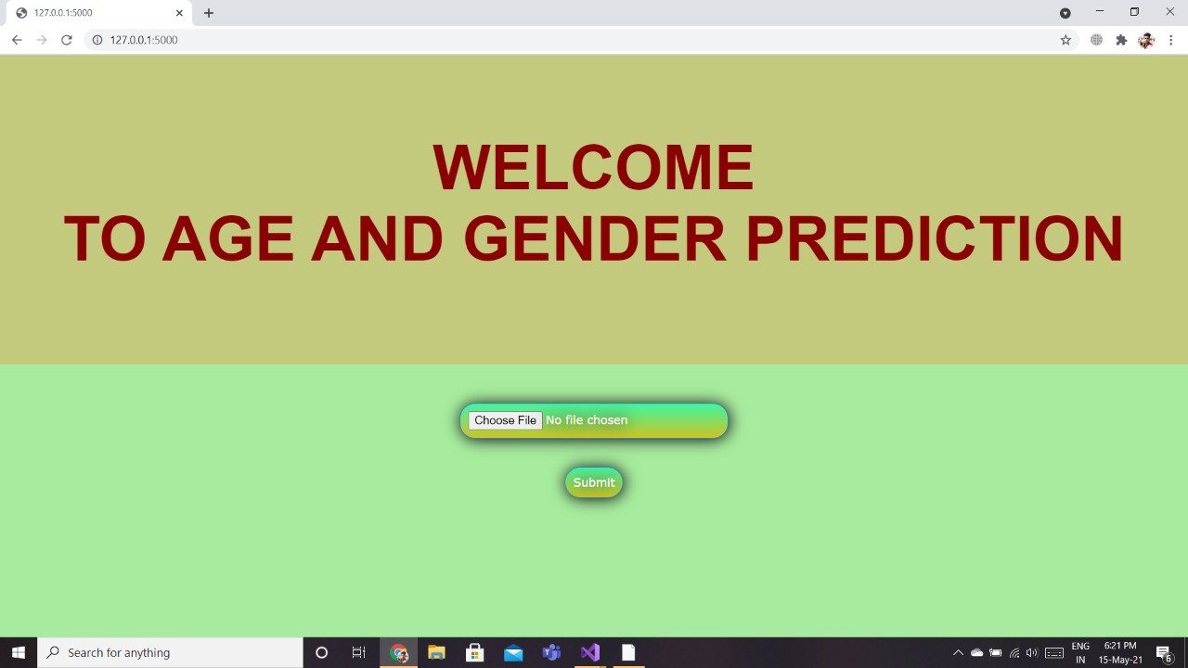

Click on “Choose File” to select an image from system

Fig:6.1 GUI

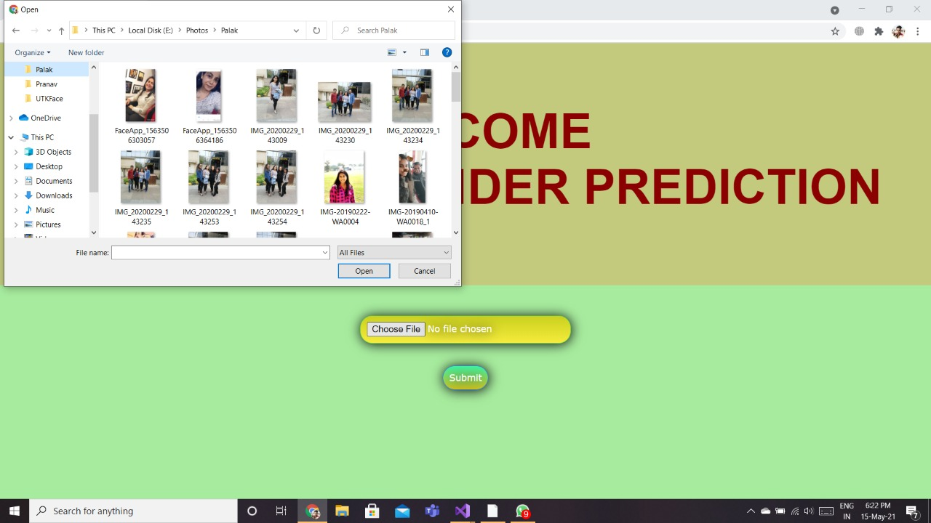

Selecting image for making predictions

Fig:6.2 Taking Inputs

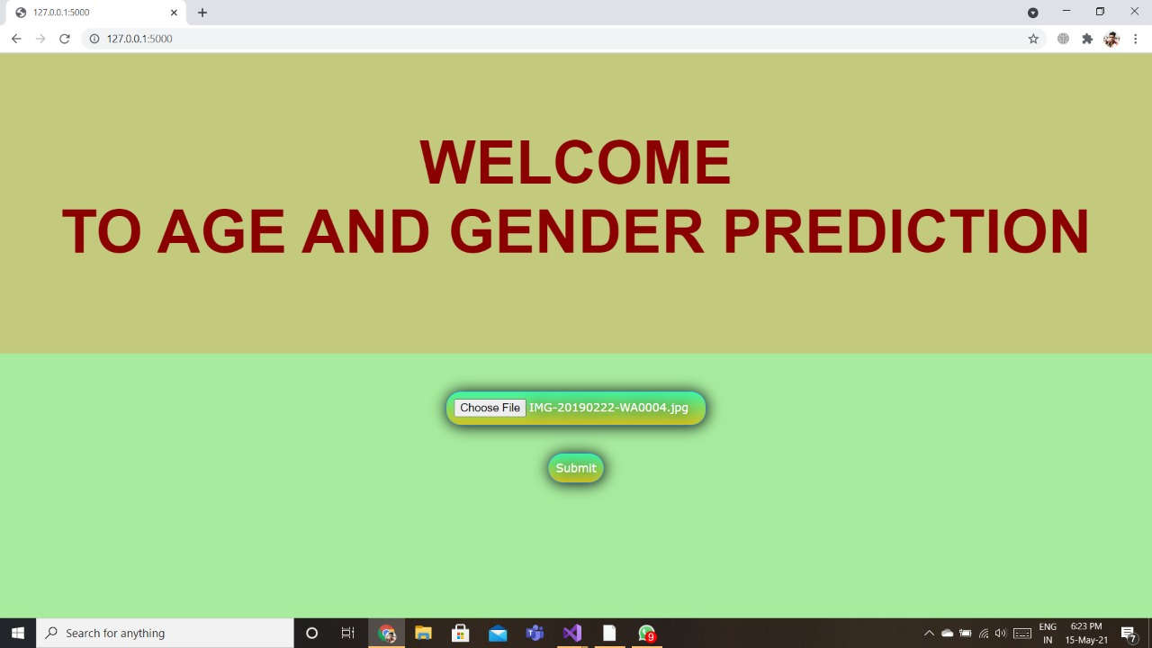

Click on submit button for making predictions

Fig:6.3 Submitting For Output

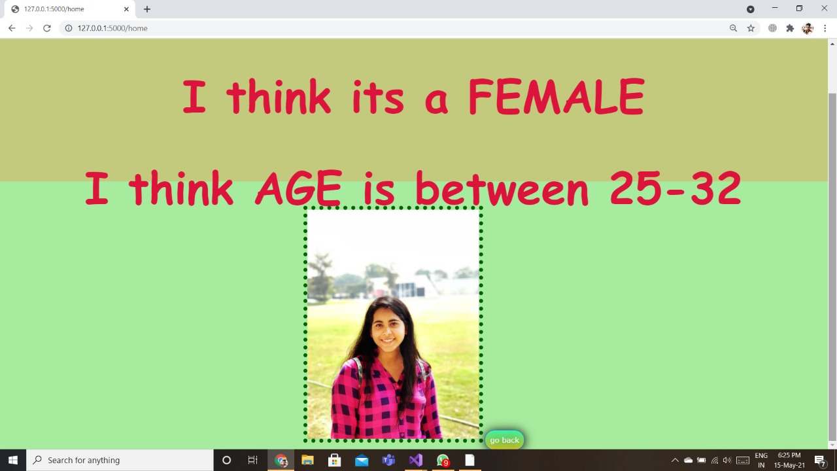

Predicted age and gender is displayed with the image given as input

Fig:6.4 Age and Gender Prediction

1. **CONCLUSION**

As we say “What we learn with pleasure, we never forget”, and the joy we had making this project was boundless.

Our objective to take on this project was to fabricate a working age and gender prediction model. We used VGG16 model in order to make predictions on a given image. Further with the help of GUI we created an interactive page where the user can give inputs (image) and our model foretells the age and gender of the person in that image. Accuracy for our model came out to be 90% for Gender and 59% for Age. Other models were used for the training purpose but accuracy did not came out well. For ResNet to be 40% and Efficient Net to be 50%. So decided to stick to VGG Net only.

By the end of this project we were able to have a good understanding of how images are processed in neural networks. With the means of this project we also learned how to make a GUI using HTML and further connect it with our python model. With all the knowledge we gained from this project, we now can easily make many more image processing projects.

1. **FUTURE STUDY**

As it is said “Knowledge is power - never stop learning”, we aim to do the same. With the means of this project we gained plenty of knowledge, but there is yet a lot to learn. In future we would like to use different models like AlexNet, inception model, etc. By using different models our main aim would be to increase the accuracy.

Another major step we wish to add to our project is to deploy our model on web.