

Harmonic Analysis Dashboard
  - User Guide
  - Load harmonic results, compare cases and export charts

Open the dashboard
https://murakami-harmonic-analysis-dashboardgit.streamlit.app/

Contents
1 Introduction 4
2 Quick Start 4
3 Application Interface 5
4 Input Data and Workbook Requirements 6
4.1 Workbook roles and filenames 6
4.2 Result workbook 7
4.3 Case-mapping workbook 7
4.4 Limits workbook 8
4.5 Upload constraints 8
5 Loading and Managing Workbooks 9
5.1 Add workbooks 9
5.2 How uploads interact with project workbooks 9
5.3 Clear or reload 10
5.4 Session boundary 10
6 Configuring the Analysis 10
6.1 Choose a result dataset 10
6.2 Choose a location 10
6.3 Choose a limit 11
6.4 Set the y-axis and harmonic labels 11
7 Selecting and Comparing Cases 12
7.1 Group views 12
7.2 Use the case selector 12
7.3 Select a case from the chart 13
7.4 Read case descriptions 13
8 Harmonic Spectrum Analysis 13
8.1 Read the hover 14
8.2 Interpret the limit display 14
8.3 Use the Plotly chart controls 15
8.4 Check axes and missing values 15
9 Voltage THD Analysis 15
10 Custom Case Selections 16
10.1 What a custom selection does 16
10.2 Build a rule 16
10.3 Preview and save 18
10.4 Activate and manage saved selections 18
10.5 Back up or import rules 19
11 Downloading Individual Results 19
12 Batch Chart Export 19
12.1 Select result datasets 20
12.2 Select locations, groups and cases 20
12.3 Add saved custom selections 21
12.4 Set limits and chart options 21
12.5 Set export y-axis limits 22
12.6 Choose ZIP contents and folders 23
12.7 Review, prepare and download 23
12.8 Image dimensions and hosted rendering 24
13 Validation and Troubleshooting 24
14 Reference and Limitations 26
14.1 Control reference 26
14.2 Definitions 28
14.3 Limitations 29
14.4 Keep this guide current 29

Introduction
The Harmonic Analysis Dashboard is a browser-based tool for reviewing harmonic-voltage distortion results supplied as Excel workbooks. Use it to compare result datasets and locations, inspect harmonic spectra, display selected harmonic limits, review calculated voltage total harmonic distortion (THD), define reusable case selections, and download charts or numerical data.
Open the application at the link on the cover. Use a modern browser. The hosted workflow does not require local Python, a batch file, or access to a development folder. If the hosting service displays an access restriction or asks the app to start, follow the on-screen instructions. The dashboard does not add a separate password system.
The dashboard presents and calculates values from supplied files. It does not run PSCAD simulations, verify modelling assumptions, select an applicable limit automatically, or issue an engineering compliance decision. You remain responsible for selecting the correct dataset, location, limit source and assessment basis. A value above a selected curve at one harmonic order is a local numerical exceedance only. It is not, by itself, a complete compliance conclusion.
For a first analysis, follow Section 2. Use Sections 3–14 to learn the interface, workbook rules, chart behaviour, saved case selections, exports and recovery steps.

Quick Start
Use this procedure to reach the first comparison chart.
- Open the hosted dashboard from the cover link.
- In the left Analysis setup sidebar, expand Add Excel workbooks. Upload at least one result workbook. You can upload separate .xlsx files, a .zip bundle containing workbooks, or both. Add a case-mapping workbook and limit workbook when you need them; both are optional.
- Select a Result dataset and a Busbar / location. The location names come from worksheet names in that result workbook.
- Under Limit series, choose the relevant series or No limit. If you choose a series, choose Bars or Dashes under Limit display.
- In Groups, choose a standard group or All. Use Cases to compare to reduce the case list. The spectrum and separate THD chart update for the selected cases.
- Hover over a marker to inspect its value and case description. Use Download plotted data (CSV) for the current numerical spectrum, the chart camera icon for one PNG, or Download charts for a configurable ZIP.
See Section 4 for workbook formats, Section 10 for description-based case selections, and Section 12 for the ZIP workflow.

Application Interface
The workspace has three main areas.
Area | What it contains
Analysis setup — left sidebar | Workbook upload and reset controls; dataset and location selection; limit source, series and display; live axis settings; harmonic labels and group layout; Download charts.
Context and status — above the charts | Result and mapping counts; dataset conditions decoded from the mapping workbook where available; harmonic-order range; current location and limit; Data validation and sources.
Analysis views — main workspace | Group views, All, conditional Unmapped, and Custom selections; Cases to compare; harmonic spectrum; THD chart; selected-case descriptions; plotted-data CSV action.
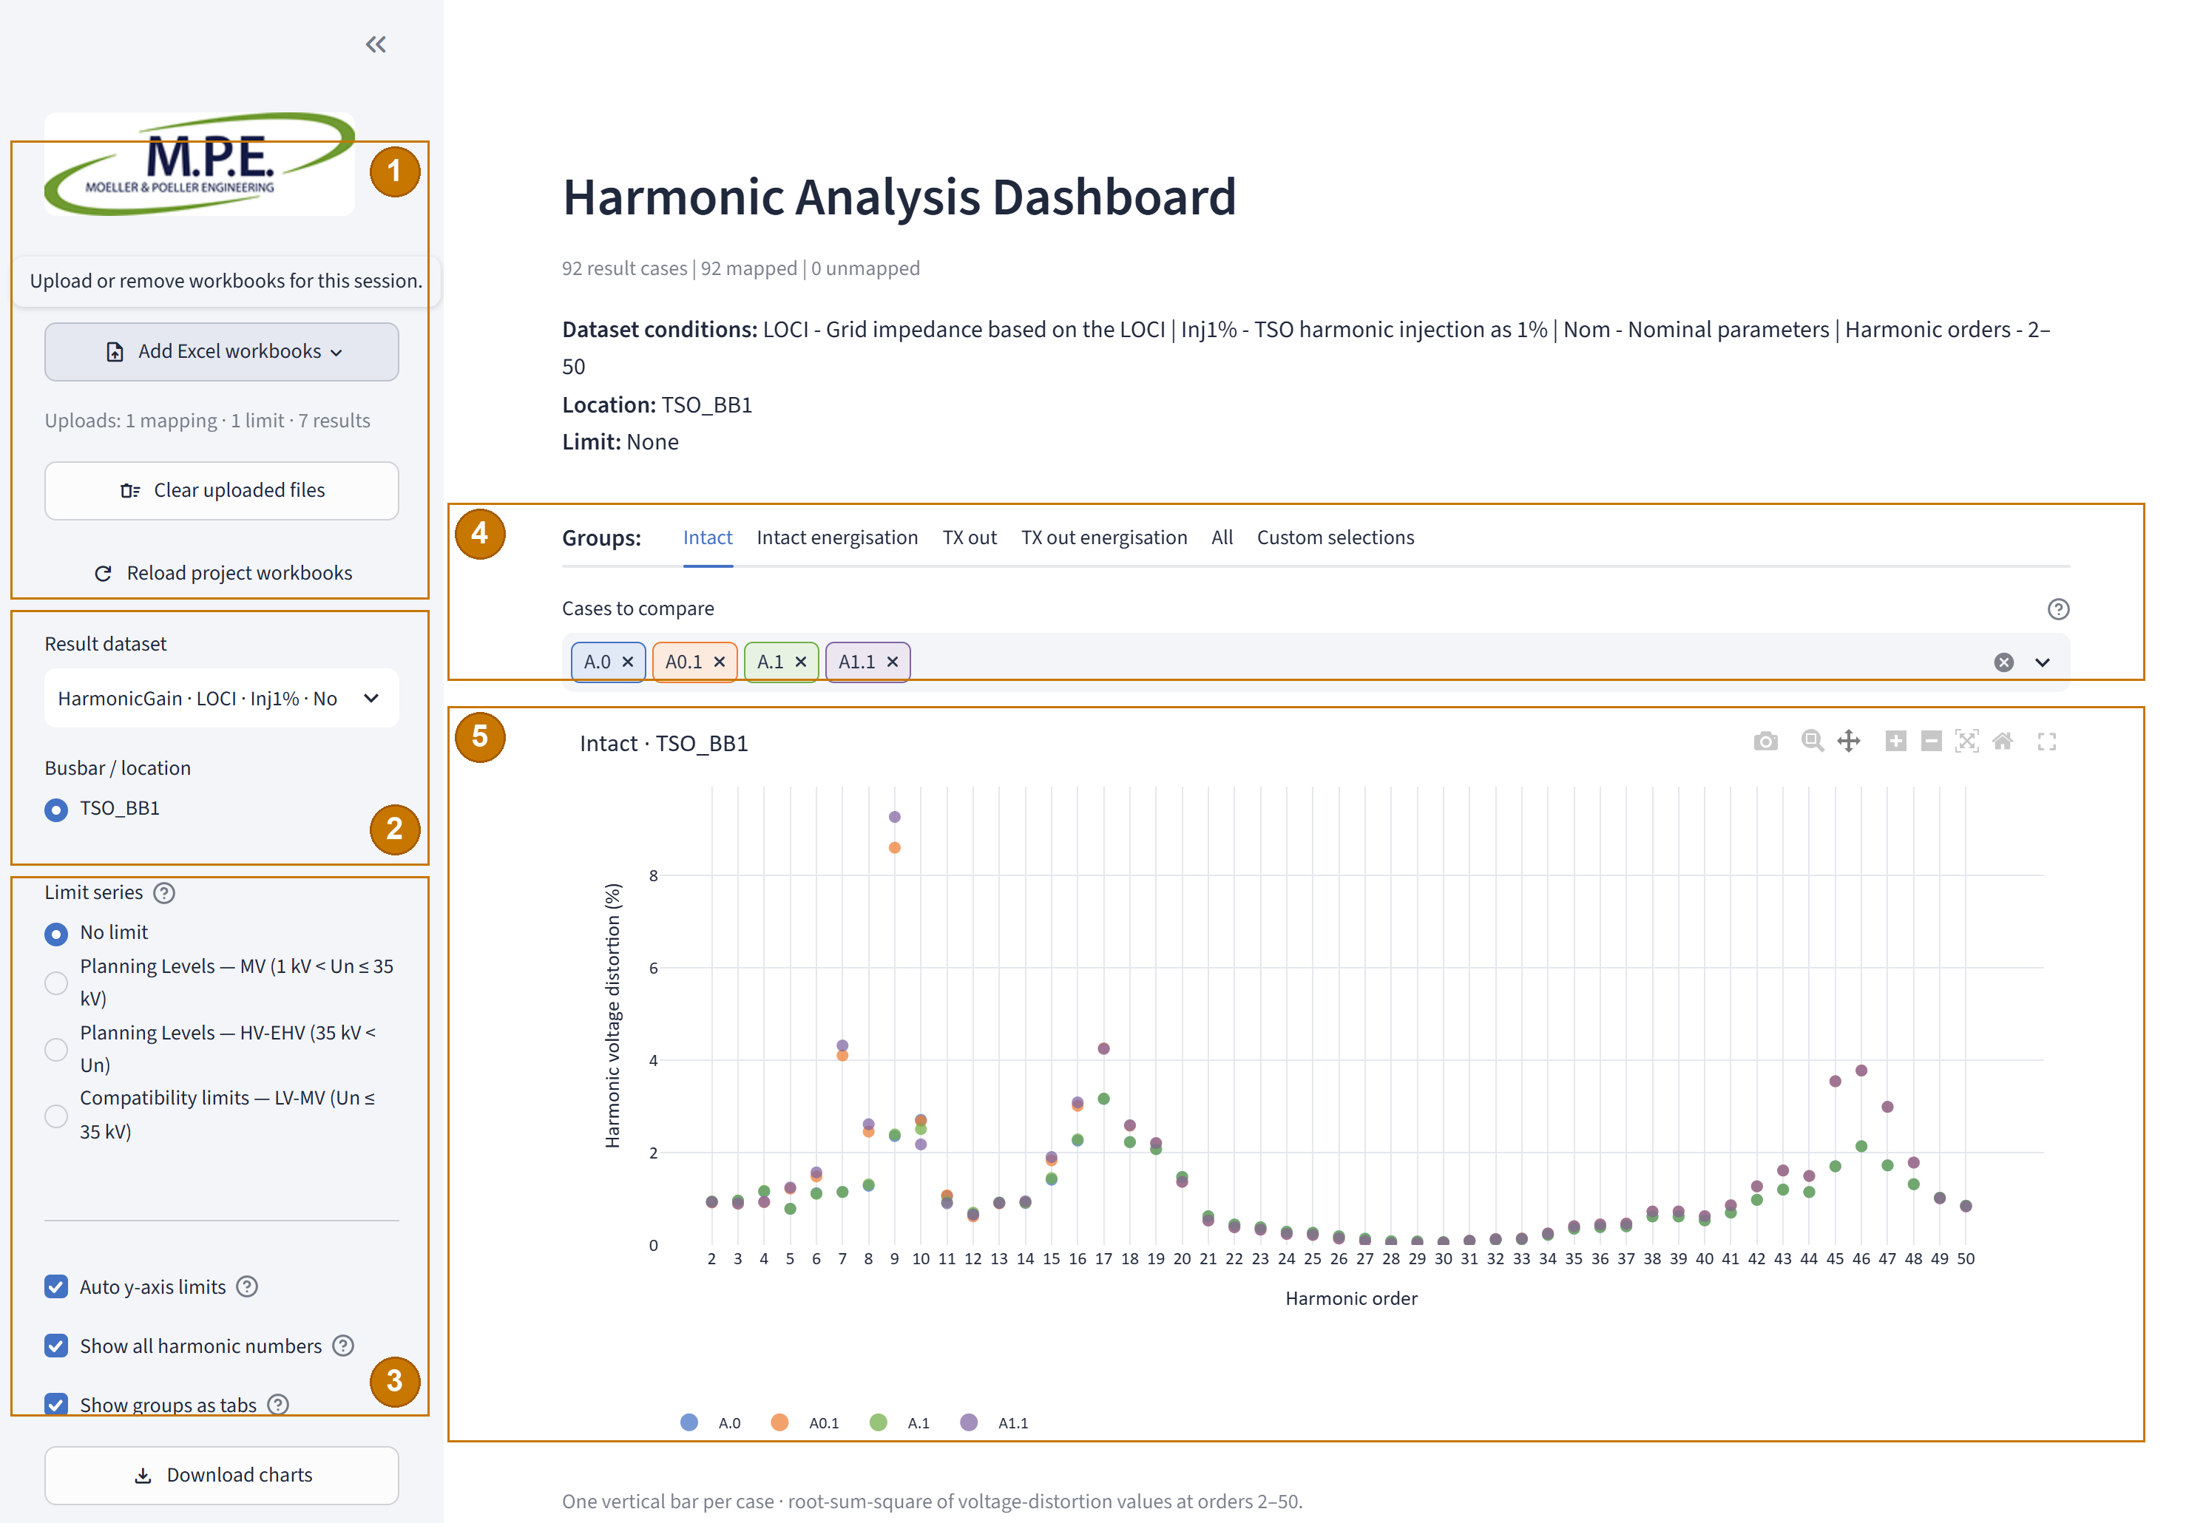
Figure 1 — Dashboard overview with illustrative data loaded.
Callouts — 1 upload/session controls; 2 result dataset/location; 3 limit/chart controls; 4 group tabs/case selection; 5 harmonic spectrum. The separate THD chart is below.
The available controls depend on the loaded files. A valid result workbook is required. Mapping and limit workbooks are optional. Without mapping, the dashboard still provides All and Custom selections, but a text rule cannot find cases without mapped descriptions. See Sections 4–6.
The Data validation and sources expander lists the active source files and reports validation by location. Open it when a chart is missing or a warning appears. Section 13 explains how to act on its messages.

Input Data and Workbook Requirements

Workbook roles and filenames
The dashboard identifies workbook roles from each workbook's filename. This rule also applies to .xlsx files inside a ZIP archive.
Role | Recognised filename | Required? | Purpose
Result | Any .xlsx file not recognised as mapping or limits. Total distortion_…xlsx is common, but not required. | Yes — at least one | Harmonic values for cases and locations.
Case mapping | Cases_description…xlsx; the prefix is case-insensitive. | Optional — one active mapping | Case groups, descriptions and condition-token definitions.
Limits | Limits_…xlsx; the prefix is case-insensitive. | Optional — one or more sources | Named harmonic-limit series. Choose No limit when no limit is needed.
Duplicate basenames within the uploaded set are rejected, including workbooks stored in different ZIP folders. An uploaded workbook with the same filename as a preloaded workbook overrides the preloaded workbook during the session. The dashboard does not require text after a recognised mapping or limits prefix.

Result workbook
Each worksheet represents one busbar or measurement location. The worksheet name appears in Busbar / location. The first row contains headers. The first column must be Harmonic Order. Each column after the first has a unique, non-blank case code as its header. Each value below that header must be numeric or blank.
Illustrative worksheet layout — values are not study results.
Harmonic Order | A.0 | A0.1
2 | 1.20 | 0.80
3 | 0.45 | 0.52
5 | 0.13 | 0.09
Enter harmonic-voltage distortion values as percentages. For example, enter 1.20 for 1.20%. Do not multiply the values by 100. Harmonic orders must be numeric and unique. Do not leave a case header empty. A value may be blank, but blank values can prevent a THD result. The spectrum uses the harmonic orders in the sheet. It is not limited to order 50.

Case-mapping workbook
The mapping workbook must contain two separate worksheets in the same workbook: Cases and Conditions.
- Cases — exact columns: Case number, Group, Description.
- Conditions — exact columns: Token, Description.
Case numbers must match result-workbook headers exactly. Group labels determine the standard group views. The standard groups are Intact, Intact energisation, TX out, and TX out energisation.
Illustrative worksheet layouts — values are not study results.

Cases worksheet
Case number | Group | Description
A.0 | Intact | with 154 kV Filters and WTGs
A0.1 | Intact | no 154 kV Filters and with WTGs

Conditions worksheet
Token | Description
LOCI | Grid impedance based on the LOCI
Inj1% | TSO harmonic injection as 1%
Other group labels produce a warning. The dashboard does not infer a standard group from a case code. Unmapped result codes remain available under Unmapped and All; they are not discarded. Blank descriptions produce a warning and cannot match a custom text rule. The Conditions sheet can explain tokens found in dataset filenames. Unknown tokens remain unexplained.

Limits workbook
The first worksheet must contain a Harmonic Order column and at least one named limit series. The parser searches the first ten rows for the harmonic-order heading and supports multi-row or merged series headings.
Illustrative format only — values are not applicable engineering limits.
Harmonic Order | Planning series | Compatibility series
2 | [limit value] | [limit value]
3 | [limit value] | [limit value]
5 | [limit value] | [limit value]
This table only shows the relationship between order and series. It does not identify which engineering curve applies to a location. Choose the limit source and series deliberately. The dashboard does not assign a voltage class automatically.
The dashboard aligns a limit with the same numeric harmonic order. It does not align by worksheet row. A blank or missing limit at an order is undefined. The dashboard does not replace it with zero, interpolate it, or extrapolate it.

Upload constraints
The upload control accepts .xlsx workbooks and .zip archives. It does not accept .xls or .csv as input. ZIP archives can contain workbooks in subfolders. The dashboard reads supported workbooks from the archive without extracting them to a user folder.
One ZIP archive can contain up to 100 entries and up to 100 MiB of total uncompressed content. This archive limit is separate from the per-file upload limit displayed by the browser control. Unsupported ZIP entries and Excel lock files are ignored. Encrypted or corrupt archives are rejected.

Loading and Managing Workbooks

Add workbooks
- Expand Add Excel workbooks in the sidebar.
- Choose one or more .xlsx workbooks, one or more .zip bundles, or a mixture.
- Check the selected-file list when you need to confirm how each workbook was classified.
- Select the result dataset to analyse. Add mapping and limits only when the analysis needs them.
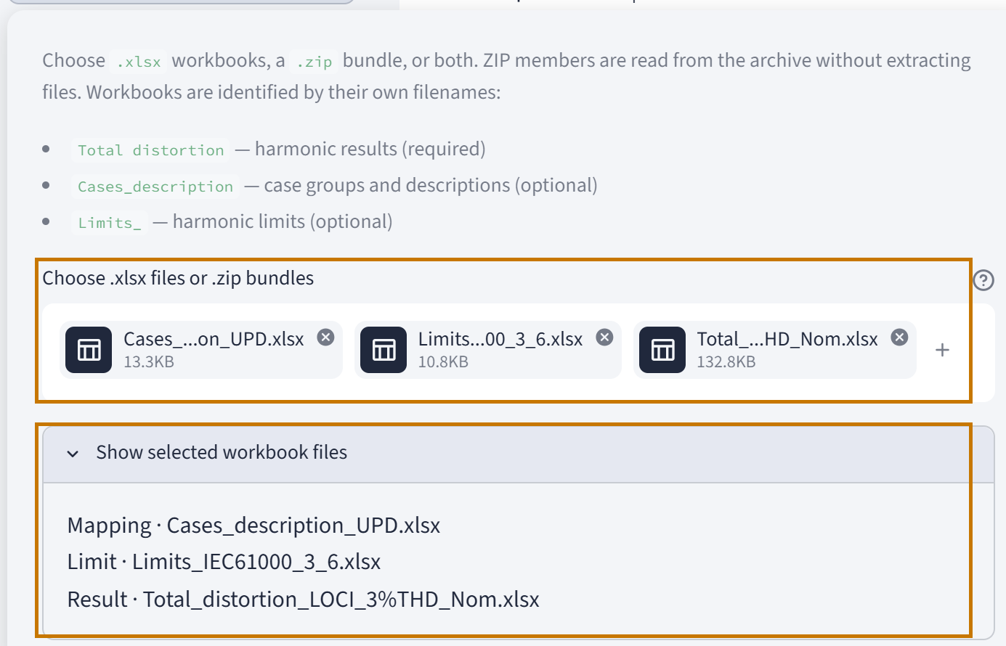
Figure 2 — Upload roles and the selected workbook list.
Uploads stay in the current Streamlit session. The dashboard does not save an uploaded workbook as a permanent project input file. You do not need a shared folder.

How uploads interact with project workbooks
An uploaded mapping workbook replaces any preloaded mapping workbook for the current session. Uploaded result and limit workbooks are added to the available choices. An uploaded workbook overrides a preloaded workbook with the same filename for the session. Only one mapping workbook can be active.
When uploads are cleared, any remaining preloaded workbooks become available again.

Clear or reload
Control | Action
Clear uploaded files | Removes workbooks uploaded in the current session. It does not delete project input files.
Reload project workbooks | Re-scans the app's preloaded inputs and clears the related data cache. It keeps current session uploads.
Select Reload project workbooks to re-scan workbooks supplied with the app, if any, and clear the related cache. It retains session uploads. It does not read a folder on your computer or retrieve another file from your computer. Reloading inputs can reset dataset or case selections when the earlier selection no longer applies.

Session boundary
Uploaded files and saved custom selections are session data. A new session can require you to upload workbooks again and import any rules you need. Section 10.5 explains how to back up saved selections.

Configuring the Analysis

Choose a result dataset
Use Result dataset to choose a result workbook. The dashboard uses filename tokens to create a shorter label. For example, a workbook beginning with Total distortion_ does not repeat that prefix in the selector. When matching definitions are present in the mapping workbook's Conditions sheet, the context line explains those tokens. Unknown tokens are not translated automatically.
The selector may appear as a list or a dropdown, depending on the number of available choices. The label and selection meaning stay the same.

Choose a location
Use Busbar / location to choose one worksheet in the selected dataset. The choices and number of harmonic rows can differ by dataset. The dashboard does not combine data from different locations in the live chart.

Choose a limit
When more than one limits workbook is available, first select a Limit source. Then select a Limit series, or choose No limit. A source can contain several planning or compatibility series. The dashboard does not decide which one applies.
The live dashboard remembers the selected limit series separately for each location and limit source. A location that has no saved choice starts with the currently active series. Changing the choice changes the displayed reference, not the result values.
When a limit is active, use Limit display to choose:
- Bars — translucent vertical columns indicate the selected limit value at each available harmonic order.
- Dashes — short red horizontal markers show the limit value at each harmonic order.

Set the y-axis and harmonic labels
Auto y-axis limits is on by default. In this mode, each live chart fits its plotted values. Turn it off to enter separate Spectrum maximum (%) and THD maximum (%) values.
Live manual maxima are saved per result dataset. They apply across that dataset's locations and groups. Spectrum and THD use separate maxima. Both axes start at zero. If a fixed maximum is below a plotted value, the chart clips the value and displays a warning. It does not change the source value or calculation. The initial manual maxima are rounded up from the dataset values and the selected limit values where relevant.
Show all harmonic numbers is on by default. When it is off, the axis uses fewer labels; the data points remain. Show groups as tabs is on by default. Turn it off to show the group sections vertically.
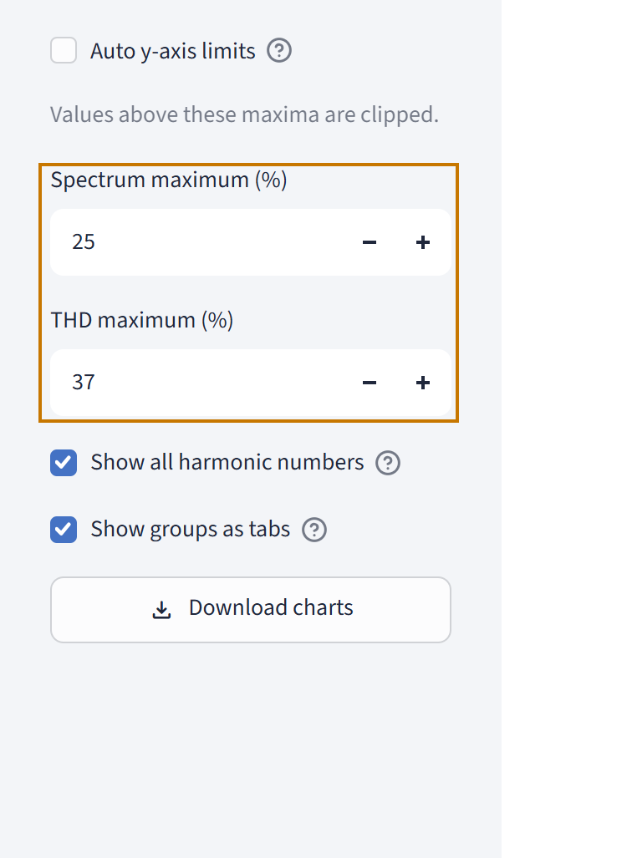
Figure 3 — Example user-entered maxima: 25% for the spectrum and 37% for THD. These are not defaults.

Selecting and Comparing Cases

Group views
With a mapping workbook, the dashboard provides the four standard groups, All, Custom selections, and Unmapped when result codes are missing from the mapping. Without mapping, All and Custom selections remain. The text-based custom rule cannot match case descriptions until mapping data is available.
All combines cases available at the selected location. It is a live comparison view. Group assignment comes from the mapping workbook, not from case-code order or numbering.

Use the case selector
Cases to compare selects all eligible cases by default. Remove a case chip to hide that case. Open the selector to choose individual codes or use Select all and Clear all. If no cases remain selected, the view shows an instruction instead of a chart.
Case colours remain stable when you reduce the selection. Case choices are remembered for the current dataset, location and group during the session. Switching to another context does not apply the previous context's case-chip state.

Select a case from the chart
Click a spectrum data point to narrow the case selection to that case. To restore all available cases in the group, Shift-click the selected point. In Custom selections, this restores all current rule matches.
Use the case chips when you want to make several changes. A Plotly legend action changes trace visibility; it does not replace the saved case selection.

Read case descriptions
Mapped case codes and descriptions appear in the spectrum hover. The Selected case descriptions table lists the current selected cases with Case first and Description second. An unmapped result is identified by its exact case code. The dashboard does not invent a description or group.

Harmonic Spectrum Analysis
The spectrum shows harmonic voltage distortion at each harmonic order for each selected case. It is not a THD chart.
- Horizontal axis — Harmonic order.
- Vertical axis — Harmonic voltage distortion (%).
- Each case — coloured markers. The markers are not joined by lines.
- Order range — the orders in the selected result worksheet, including orders above 50 when supplied.
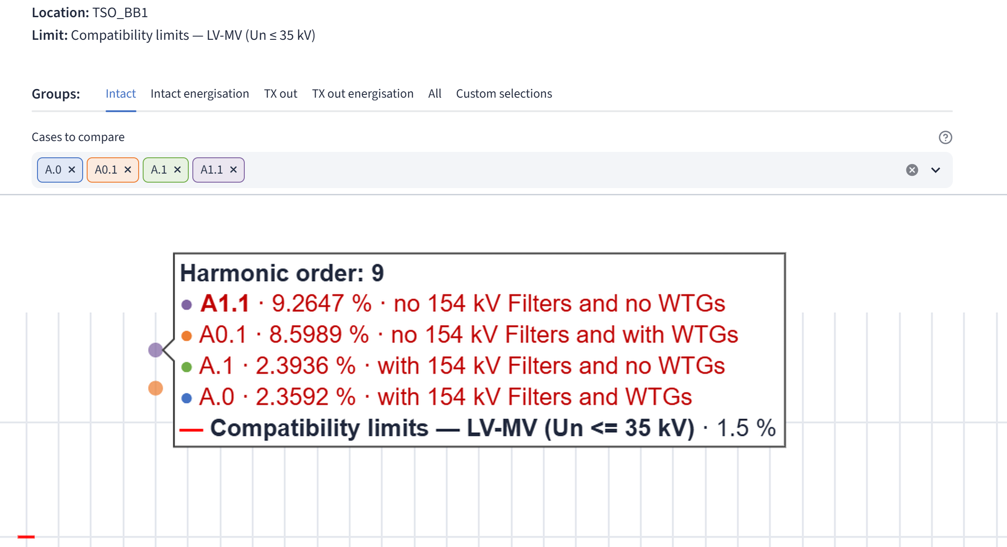
Figure 4 — Spectrum context with an enlarged hover detail at harmonic order 9.

Read the hover
Hover over a case marker. The hover shows the harmonic order and the hovered case's code, value and mapped description where available. When a limit is selected, the hover can also show other selected cases above that limit at the same order. Those values are ordered from highest to lowest and highlighted in red. The hovered case is visually distinguished from the other affected cases. The selected limit appears last and uses a red dash symbol.
A blank limit at an order is undefined, not zero. Dense views may summarise other exceedances to keep the hover readable.

Interpret the limit display
Bars and dashes are two ways to display the same selected limit series. They do not change the values. A case value above the selected limit at one harmonic is a local curve exceedance at that order. It does not show that all other orders exceed or pass, and it does not confirm that the chosen limit applies to the study.

Use the Plotly chart controls
The chart toolbar provides the visible Plotly actions, which can include zoom, pan, autoscale or reset, and Download plot as a PNG on the camera icon. Hover over an icon to read its tooltip. Use the legend to show or hide traces.
The camera action saves the chart currently displayed. It is separate from Download plotted data (CSV) and the multi-chart ZIP in Section 12.

Check axes and missing values
If a manual y-axis maximum is too small, the chart clips higher values and shows a warning. Increase the maximum or restore Auto y-axis limits. A blank source value remains blank; it is not plotted as zero.

Voltage THD Analysis
The separate Voltage THD chart appears below the harmonic spectrum for a selected group. It uses one vertical bar per case. The bars are sorted from highest calculated THD to lowest. Each case keeps its case colour. The bar labels show two decimal places. Hover can show greater precision and the case description.
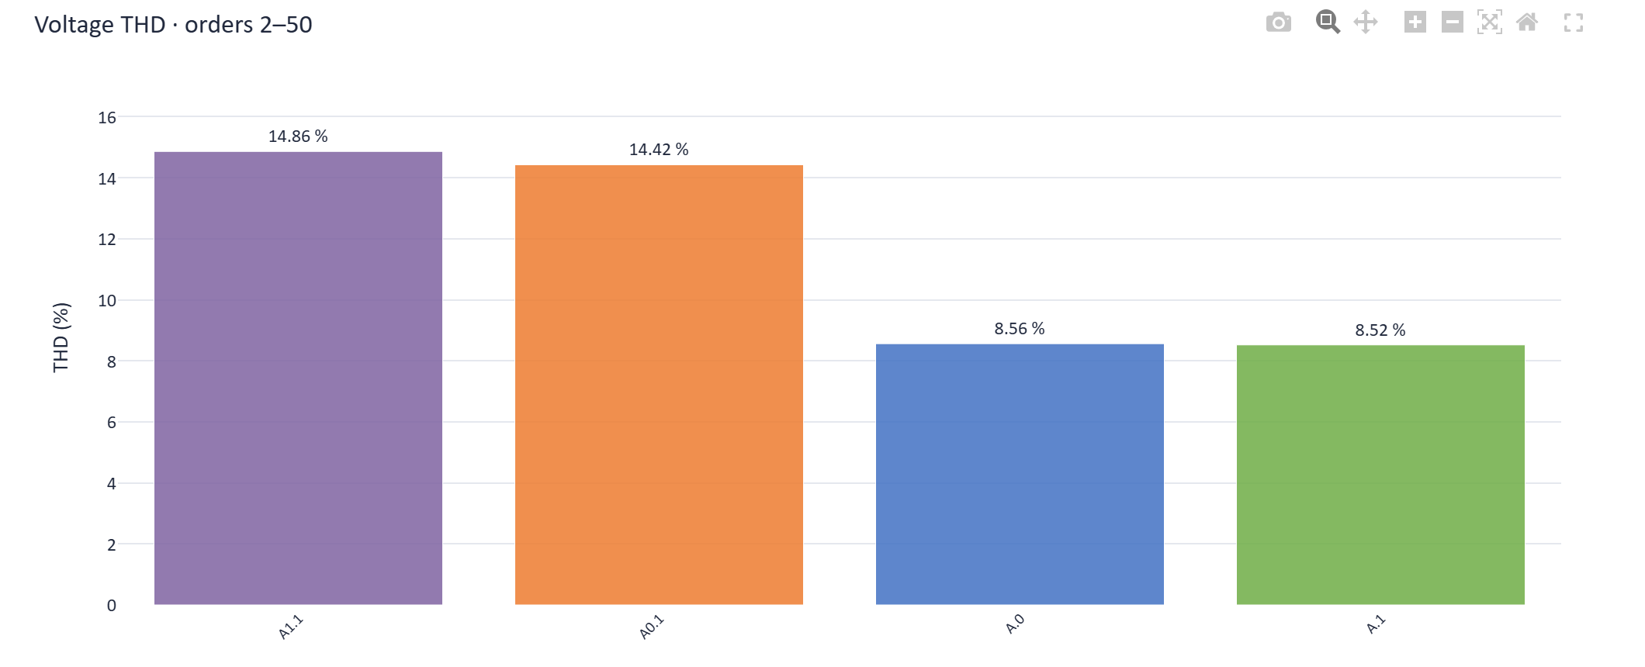
Figure 5 — Separate voltage THD chart with values to two decimal places.
For each case, the dashboard calculates:
THDᵤ (%) = √(∑ₕ₌₂ᴴ [uₕ (%)]²)
The summation uses every supplied harmonic-voltage percentage from order 2 to H. H is the lower of 50 and the highest integer harmonic order available. The spectrum can show higher orders; this THD calculation stops at order 50.
Every order and numeric case value in the required calculation range must be present. The dashboard does not replace a missing order or value with zero and does not calculate a partial THD. It omits that case's bar and lists missing orders. The spectrum can still be available. If no selected case has complete data, the dashboard shows a message instead of bars.
The selected harmonic limit does not apply to THD. The THD chart does not imply a THD limit or compliance result.

Custom Case Selections

What a custom selection does
A custom selection is a saved description-based rule. It is not a fixed list of case codes. The rule searches the mapping workbook's Description column and matches only result case codes available in the current dataset and location. The mapping workbook is required for text matches.
The same rule is recalculated when you change the dataset or location. It selects cases across standard groups. Use the case chips to narrow the matched cases further.

Build a rule
- Open Custom selections and choose New selection.
- Enter a Name or leave it blank. If blank, the dashboard generates a name from the rule.
- Add one or more phrases to the relevant boxes. Type a phrase and press Enter to add it as a chip.
- Review the resulting rule and matched-case count before you select Save selection.
Box | Rule
Must contain ALL | Every phrase in this box must appear in the case description.
Must contain ANY | At least one phrase must appear when this box contains entries. Leave it empty to skip this condition.
Must NOT contain | Exclude a case if any phrase in this box appears in its description.
All non-empty boxes are combined with AND. Phrases within the ANY and NOT boxes act as alternatives. A rule must contain at least one phrase.
Matching is case-insensitive and uses complete ordered phrases. The dashboard normalises supported variants such as 154 kV and 154kV, Filter and Filters, and string and strings. It does not match 5 strings to 15 strings by substring. It does not infer synonyms. Rules search descriptions only; they do not search case codes, group names or workbook filenames. Enter separate phrases as separate chips. A comma in a description does not split a phrase automatically.
Illustrative logic — this is not a result count.
Box | Phrase
ALL | 1 string
ANY | no 154kV Filters; no WTGs
NOT | with 154kV Filters
This example means the mapped description must contain 1 string. It must contain at least one of no 154kV Filters or no WTGs. It must not contain with 154kV Filters. A real match count depends on the current mapping, dataset and location.
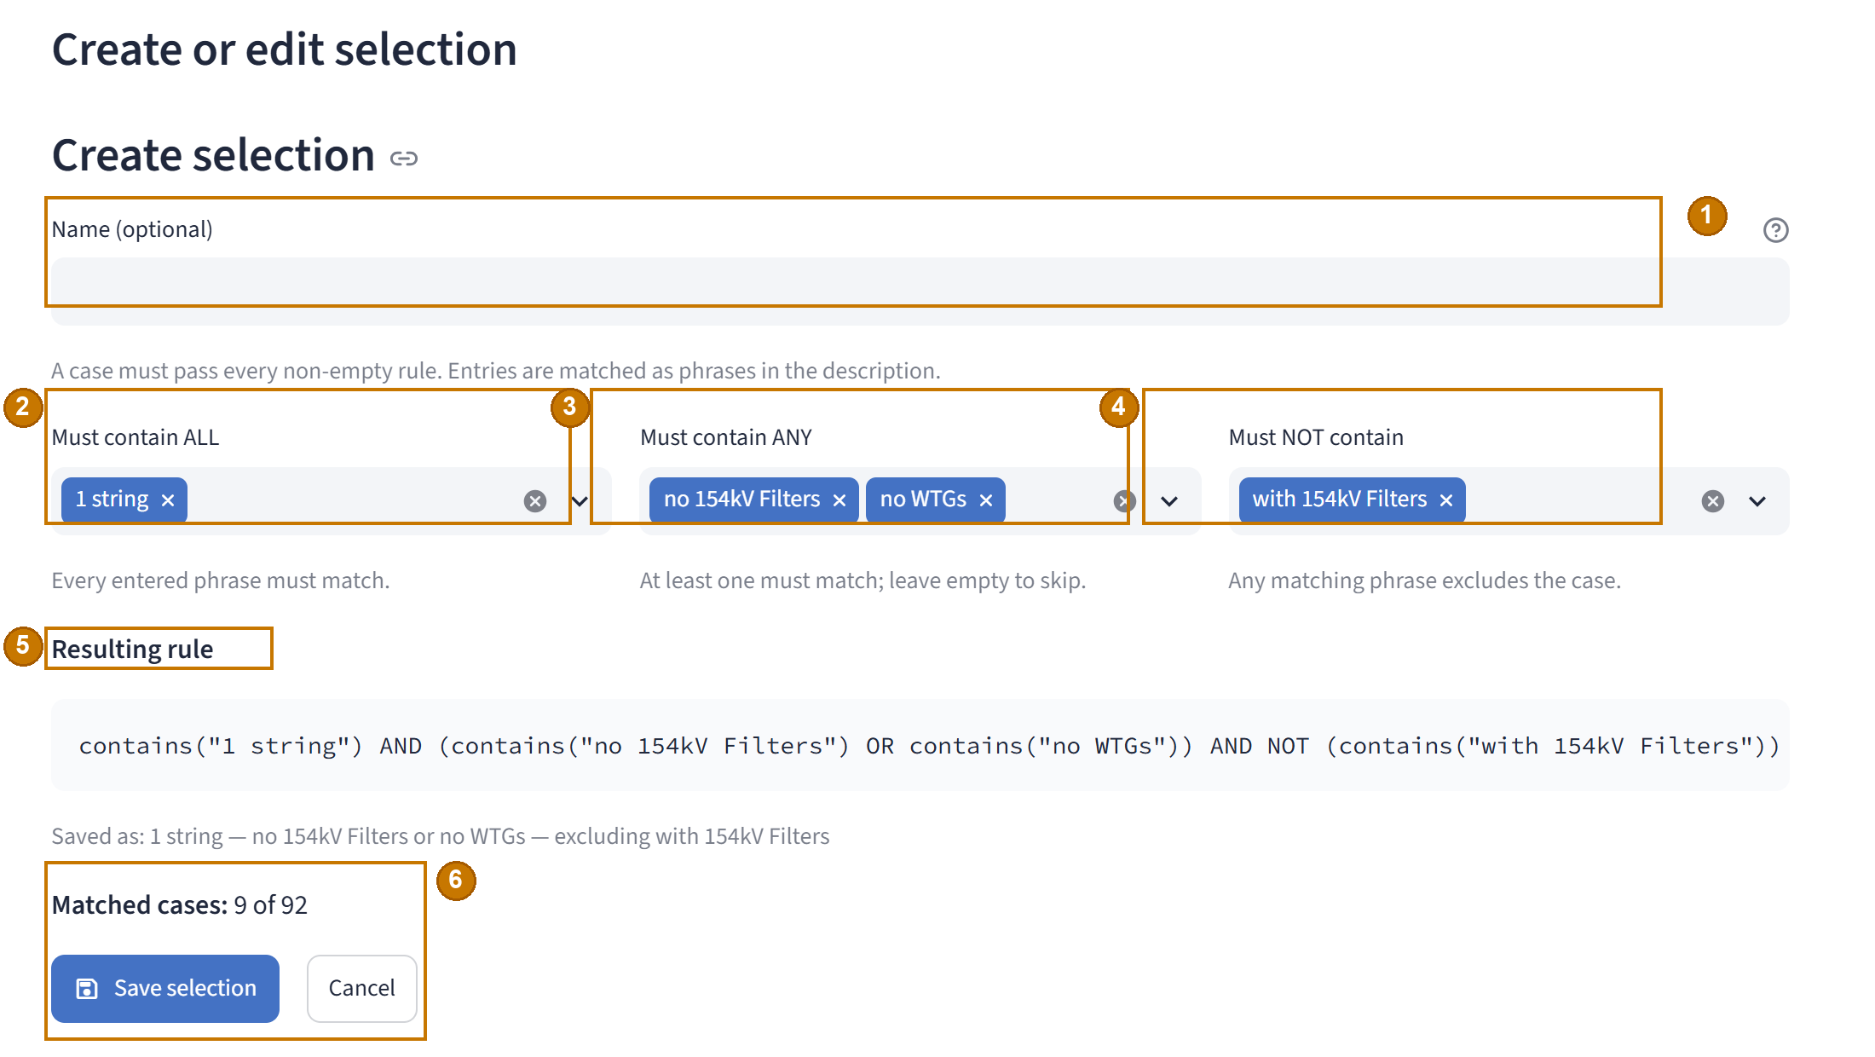
Figure 6 — Create a rule, read the expression and review matched cases.
Callouts — 1 Optional selection name; 2 every ALL phrase must match; 3 at least one ANY phrase must match; 4 NOT phrases exclude cases; 5 generated rule; 6 matched-case count and Save selection or Cancel.

Preview and save
The editor displays a readable Resulting rule and Matched cases count for the current dataset and location. Cases with no description cannot match. Select Save selection to add the rule to the current session. Select Cancel to discard an unsaved edit. The workflow does not use a separate Apply button.

Activate and manage saved selections
The Saved selections table shows each rule's name, rule summary and current match count. Select a row to activate it. The dashboard then updates the case chips and charts. Only one saved selection can be active at a time. Select Clear active to stop applying the rule and return to normal case selection. This resets the custom view's case chips to all cases eligible at the current dataset and location. The saved rule remains in the table.
Action | Result
Edit | Opens the selected rule for changes. Changes take effect after Save selection.
Restore matches | Resets manual case-chip reductions to all cases that match the active rule.
Clear active | Stops applying the rule and restores all cases eligible for the current dataset and location. The saved rule remains in the table.
Delete | Removes the saved rule from this session after confirmation. It does not change a workbook.
If a rule has no matches, the dashboard shows its no-match message. It does not create a zero-valued chart.
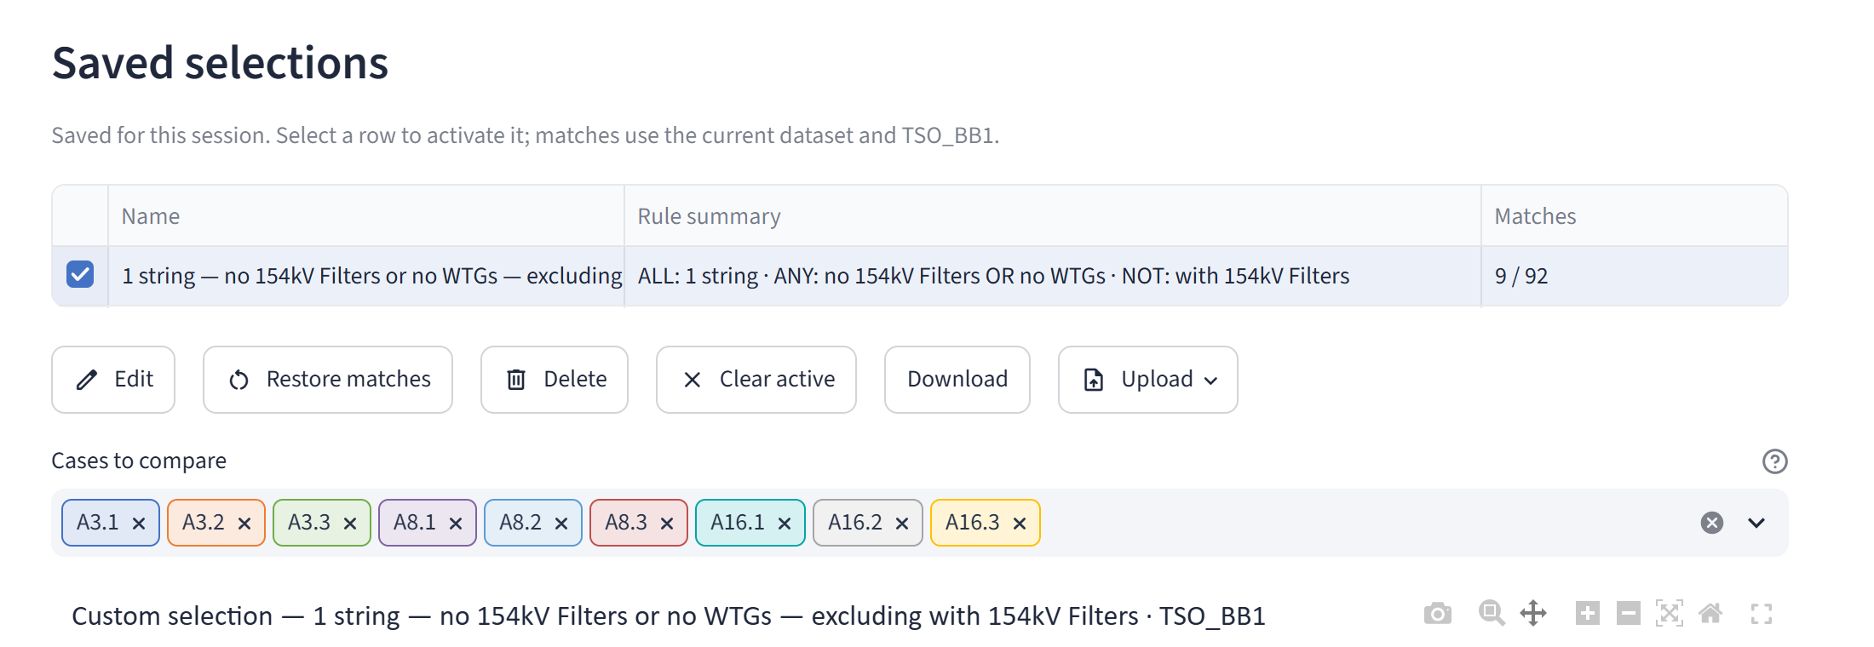
Figure 7 — Saved rule row, management actions and matched case chips.

Back up or import rules
Saved selections belong to the current session. Select Download to save a JSON backup named murakami_saved_selections.json. The file contains the rule library, not uploaded workbooks.
To reuse rules, select Upload, choose a valid JSON backup, then select Import selections. Import replaces the rule library in the current session; it does not merge lists. An invalid JSON file leaves the current library unchanged. Importing rules does not guarantee matches in another dataset. The case descriptions must contain the rule phrases.

Downloading Individual Results
Use these actions for one current view or its displayed numerical spectrum.
Action | Output | Scope
Chart toolbar camera | PNG image | The currently displayed spectrum or THD chart.
Download plotted data (CSV) | CSV table of selected harmonic orders and case values; includes the selected limit column when applicable. | Current dataset, location, group and case selection.
Download charts | ZIP archive of selected chart sets, with optional THD images and case-description CSV files. | Batch plan configured in Section 12.
The plotted-data CSV preserves the numeric spectrum values. It does not add a calculated THD column. The chart ZIP does not contain the plotted harmonic-data CSV.
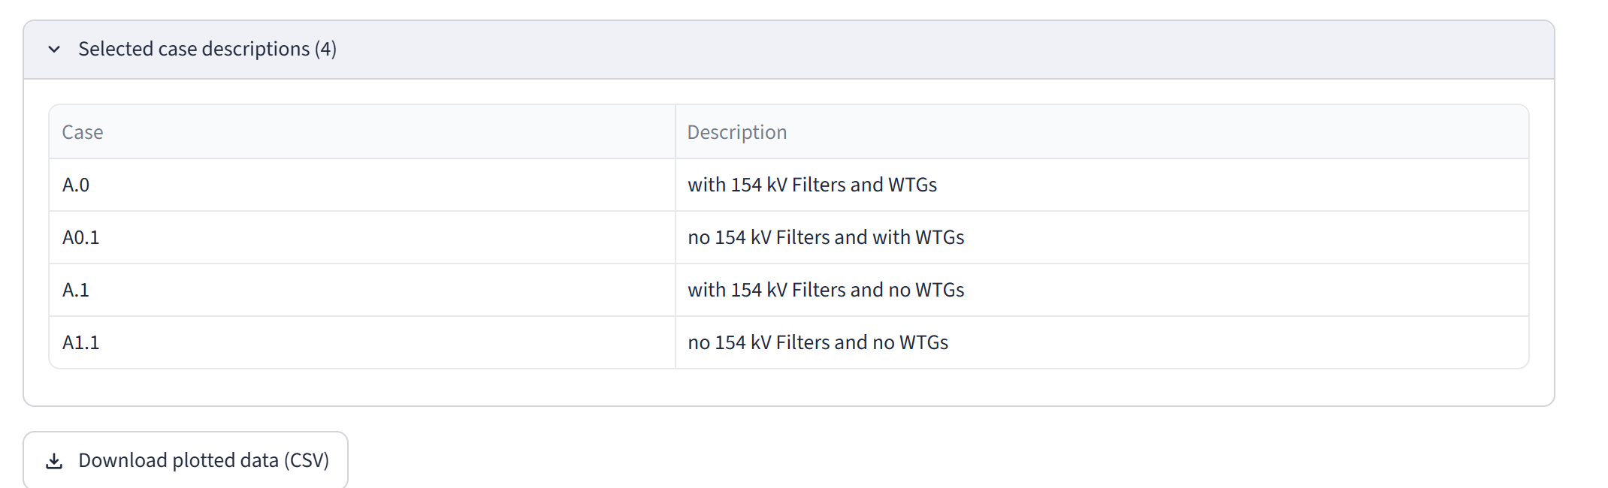
Figure 8 — Case descriptions and the plotted-data CSV action.

Batch Chart Export
Select Download charts in the sidebar to open Download chart set. Work through its sections in order: Data to export, Chart settings, ZIP layout, and Review and download.
Export options are separate from the live chart state in some areas. In particular, the export axes, harmonic labels and selected chart sets are controlled in the dialog.

Select result datasets
The Result datasets selector starts with all available datasets selected. Use Select all or Clear all in multiselects when needed. Expand a dataset row to set its locations, groups and cases. A dataset only produces charts for its selected locations.
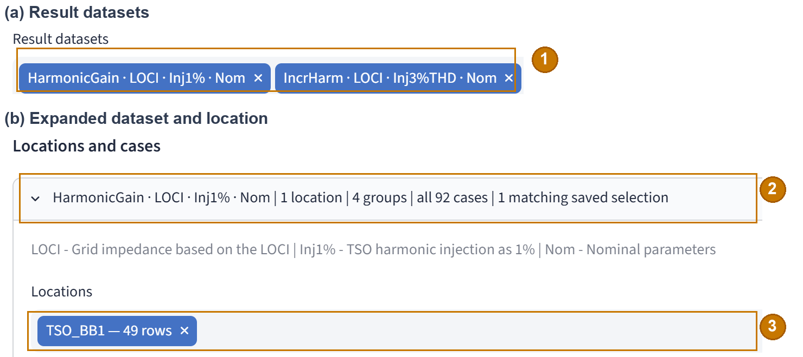
Figure 9 — Selected result datasets and one expanded location selector.
Callouts — 1 Select result datasets; 2 expand a dataset row; 3 choose its locations. Case groups and cases appear lower in the same dataset section.

Select locations, groups and cases
In each dataset, select one or more Locations and Case groups. A case must be present at every selected location to be eligible. When you select several locations, only their shared eligible cases can be selected.
With mapping, choose from the standard groups and Unmapped when required. All is a live comparison view; it is not another standard export group. Without mapping, the export uses a single Cases group based on the result case codes.
All cases is selected by default. Clear it to select individual case codes for the chosen groups. The chart-set preview changes when you change the locations, groups or case choices.

Add saved custom selections
When a mapping and saved rules are available, the dataset section provides Additional custom chart sets and Saved selections to include. Available rules start selected. Each rule that matches eligible cases adds a separate chart set for each selected location, alongside the standard group charts. A rule with no eligible cases is skipped.
Only rules used for exported custom charts are included in the ZIP root as custom_selections.json. The rule can then be imported into another session. A case-description CSV in a custom chart set lists the selected matching cases.

Set limits and chart options
Choose one Limit source for the whole export. Then choose one Limit series for each location. That location's series applies to every selected dataset that contains the location. Choose No limit where appropriate. Limit display chooses Bars or Dashes for the exported charts.
Include THD plots and Show all harmonic numbers are selected by default. These options apply to exported charts. They are independent of the corresponding live chart display.
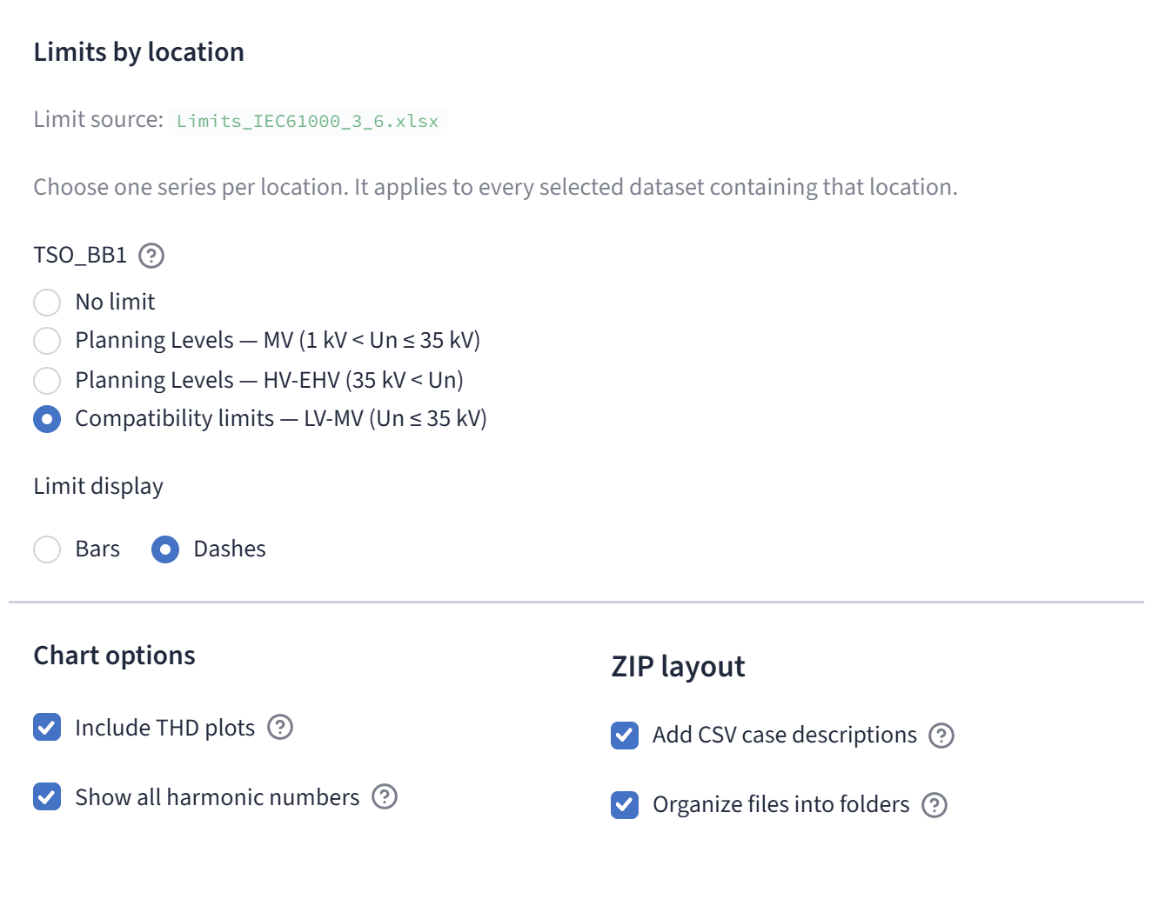
Figure 10 — Limit series by location, chart options and ZIP layout.

Set export y-axis limits
Export Auto y-axis limits is one mode switch for the complete ZIP and is on by default. Automatic maxima are calculated separately for each dataset. Charts from the same dataset use consistent maxima. Different datasets do not have to share one scale.
Turn Auto off to set a Spectrum maximum (%) and a THD maximum (%) for each selected dataset. The THD maximum appears when THD charts are included. These values apply across the dataset's selected locations, groups and custom charts. Export maxima do not change the live charts. If a maximum clips data, the dialog reports it; the source data remains unchanged.

Choose ZIP contents and folders
Add CSV case descriptions is selected by default. With mapping, the ZIP contains a case_descriptions.csv for each chart set, with Case and Description columns. Without mapping, it uses Add CSV case list and leaves descriptions blank.
Organize files into folders is selected by default. It creates folders in this order:
dataset / location / group /
When you clear this option, filenames identify the dataset, location, group and chart type. The dashboard normalises names and adds a suffix if output paths collide.
The ZIP can contain:
- harmonic_spectrum.png for each chart set.
- voltage_thd_orders_<lower>-<upper>.png when complete data allow a THD chart. The lower order is 2; the upper order depends on available data and is capped at 50. For example, voltage_thd_orders_2-50.png is used when the full range is available.
- case_descriptions.csv when case CSV output is enabled.
- custom_selections.json when saved rules produce exported charts.
The ZIP does not contain the plotted harmonic-data CSV.

Review, prepare and download
Read Review and download before preparing the archive. It reports the number of chart sets, harmonic spectra, maximum possible THD charts, case CSVs, custom sets and folder layout. THD images can be omitted when the data are incomplete.
- Select Prepare ZIP.
- Follow the progress and status message.
- When the dialog reports that the chart set is ready, select Download ZIP.
Changing the plan invalidates a prepared archive. Prepare it again after any change. An input error in a selected dataset or location can block the ZIP; correct the workbook or remove the invalid selection. The prepared file remains in the current session. Download it before the session ends.
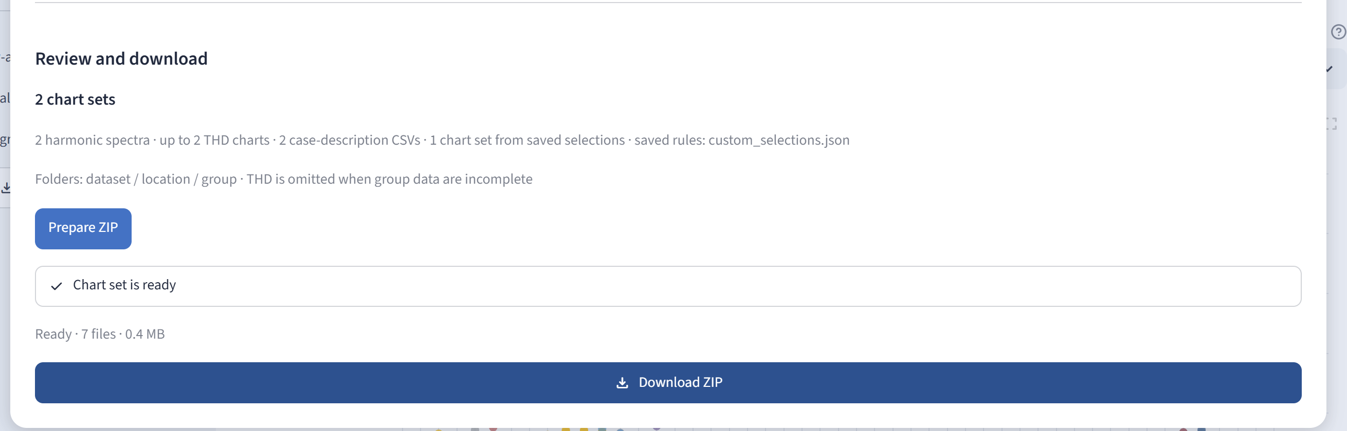
Figure 11 — Review, preparation status and the ready-to-download archive.

Image dimensions and hosted rendering
Batch chart PNGs use a fixed 1400 × 505 CSS-pixel design at 2× scale. Each image is 2800 × 1010 pixels. The output dimensions do not change with the user's screen resolution.
The chart-rendering service runs where the app executes. A hosted user does not need to install a separate local rendering tool. If preparation reports that chart rendering is unavailable, keep the message and report it to the application owner. Do not treat this message as a workbook-format error without checking the details.

Validation and Troubleshooting
Open Data validation and sources to see the active mapping, dataset and limit sources. The location table reports case counts, harmonic-order counts and validation status. Review any warnings or errors before changing workbooks.
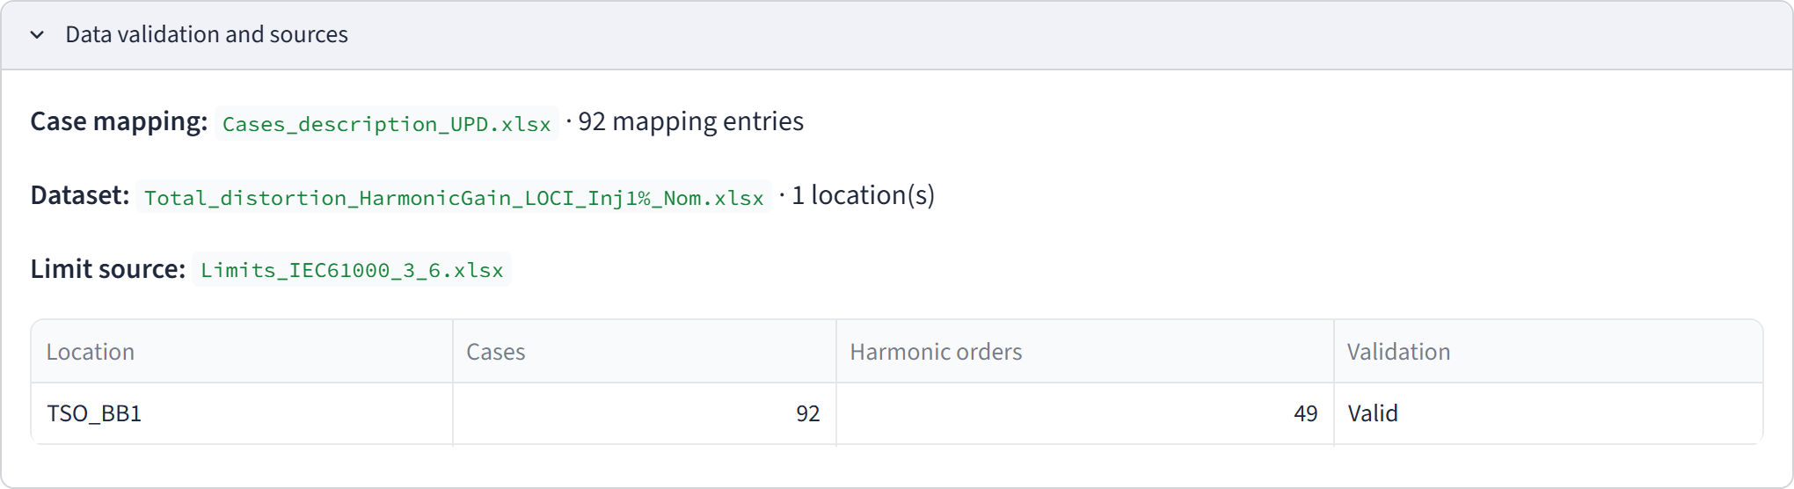
Figure 12 — Validation summary for the current result location.
Symptom | Why it happens | What to do
No result dataset is available | No valid result workbook has been loaded or recognised. | Upload a valid result .xlsx workbook or a ZIP that contains one, then select the dataset.
The current view has no chart | The location may be invalid, no cases may be selected, or an active custom rule may match no cases. | Check Data validation and sources and choose a valid location. Select cases, or edit or clear a zero-match rule.
Mapping workbook error | The required worksheets or columns are missing, or case numbers are duplicated. | Check Cases and Conditions, use the exact required column names, and keep one active mapping workbook.
Cases appear under Unmapped | Result case codes are missing from the mapping workbook. | Add exact matching case numbers when you need descriptions or groups. Otherwise, analyse them under Unmapped or All.
A location cannot be plotted | Its result worksheet has invalid harmonic orders, duplicate headers, or another structural error. | Correct that worksheet. Other valid locations can remain usable.
No limit appears | No limit is selected, or the chosen source or series has no value at the displayed harmonic order. | Choose No limit intentionally to continue without a curve. To display a limit, select a valid source and series and check the displayed orders. Missing values remain undefined.
A custom rule returns no cases | Its phrases do not match descriptions at the current dataset and location. | Check the description text and ALL, ANY and NOT conditions. Clear or edit the rule when needed.
A case has no THD bar | At least one required order or numeric value is missing. | Review the missing-order message and source workbook. A missing bar does not mean THD equals zero.
A chart value is clipped | A fixed y-axis maximum is below one or more values. | Enable Auto y-axis limits or increase the relevant maximum.
ZIP preparation fails | A selected input is invalid, no valid chart set remains, or rendering is unavailable. | Read the message in the dialog. Correct the input or remove it. Report rendering errors to the application owner.
Prepared ZIP is unavailable | The plan changed or the session ended. | Select Prepare ZIP again and download the archive in the current session.
Saved rules are missing in a new session | Saved rules are session-only. | Import the JSON backup with Upload → Import selections.
A filename conflict appears | Two uploaded workbooks have the same basename, including files inside ZIP folders. | Rename or remove one workbook, then upload the files again.
ZIP upload is rejected | The archive is corrupt, encrypted, or above an archive limit. | Rebuild the ZIP and keep it within the entry-count and uncompressed-size limits in Section 4.5.
An error blocks the affected operation. A warning identifies a condition that may still allow the spectrum to be viewed. For example, unmapped cases remain numerical results, but they have no mapping description. A structural error can block one result location while other valid locations remain available. Invalid or missing limits can be bypassed by choosing No limit.
An unavailable or sleeping hosted app is a hosting or connection condition. It is separate from workbook validation.

Reference and Limitations

Control reference
Control | Purpose and scope | Starting state
Add Excel workbooks | Upload .xlsx files or ZIP bundles for this session. | Empty when no uploads exist.
Clear uploaded files | Remove session uploads; keep preloaded project files. | Shown when uploads exist.
Reload project workbooks | Re-scan app-supplied workbooks, if any, and clear related cache; keep session uploads. | Available in the sidebar.
Result dataset | Choose one result workbook. | First valid available dataset.
Busbar / location | Choose one worksheet in that dataset. | First valid available location.
Limit source | Choose a limits workbook when more than one source is available. | Current or first available source.
Limit series | Choose one named curve or No limit. | No limit, unless a session choice is remembered.
Limit display | Show a selected curve as Bars or Dashes. | Bars when a limit is active.
Auto y-axis limits | Let charts fit values or show manual maxima. | On.
Spectrum maximum (%) | Set the live spectrum y-axis maximum. | Hidden while Auto is on.
THD maximum (%) | Set the live THD y-axis maximum. | Hidden while Auto is on.
Show all harmonic numbers | Label every supplied harmonic order. | On.
Show groups as tabs | Show one group view at a time or stack group sections. | On.
Cases to compare | Select plotted cases. | All eligible cases selected.
Select all / Clear all | Select or clear the cases in a multiselect. | Use when required.
Selected case descriptions | Review the current mapped case codes and descriptions. | Available when descriptions exist.
Download plotted data (CSV) | Download the current selected harmonic data. | Available below the view.
New selection | Open a custom-rule editor. | Available on Custom selections.
Save selection / Cancel | Save the current rule or discard the unsaved edit. | In the custom-rule editor.
Edit | Open the selected saved rule. | Requires a selected row.
Restore matches | Restore all cases that match the active rule. | Requires an active rule.
Delete | Delete the selected rule after confirmation. | Requires a selected row.
Clear active | Stop applying the rule and restore all eligible cases for the current dataset and location; keep the saved rule in the table. | Requires an active rule.
Download | Save the current rule library as JSON. | Available in Saved selections.
Upload / Import selections | Import a valid JSON rule library, replacing the current session library. | Available in Saved selections.
Download charts | Open the batch chart-export dialog. | Available in the sidebar.
Prepare ZIP | Build the archive from the reviewed export plan. | Select after reviewing the plan.
Download ZIP | Save the prepared archive. | Available when preparation succeeds.
Data validation and sources | Review source files and validation by location. | Collapsed or expanded by the user.

Definitions
Term | Meaning in this guide
Dataset | One result workbook.
Busbar / location | One result worksheet.
Case | A result column identified by its case code.
Case group | The value in the mapping workbook's Group column.
Spectrum | Harmonic voltage distortion plotted separately for each harmonic order.
THD | Root-sum-square of the defined harmonic-voltage percentages from order 2 through H, where H is no higher than 50.
Limit series | A user-selected curve of limit values aligned by harmonic order.
Saved selection | A reusable Boolean rule that searches case descriptions. It is not a static case-code list.
Chart set | One exported spectrum and its optional THD chart and case metadata.

Limitations
- The dashboard does not generate simulations or validate model assumptions.
- It does not select a limit series automatically by voltage level or location.
- It does not replace missing harmonic or limit values with zero.
- It does not interpolate or extrapolate limit values.
- It does not issue a compliance certificate or an overall engineering pass/fail conclusion.
- THD uses the defined range through order 50; the spectrum can include higher orders.
- Saved selections and uploaded workbooks are session-only unless the user retains and reuses the applicable files or JSON backup.
- Case colours identify traces for visual comparison. They do not classify engineering outcomes.
- A fixed y-axis can clip chart values. It does not change calculations or source data.

Keep this guide current
This guide describes the dashboard’s current behaviour and controls. Review it after app changes. Use the hosted URL on the cover. Do not use development folders or old example-workbook locations.

