FUNCTION
Ex:1
#include<stdio.h>
Void sum();//Function Declaration
Int main()//Calling Function
{
Sum();
Sum();
}
Void sum()//Called Function
{
Int a,b,c:
Printf(“Enter First number:”);
Scanf(“%d”,&a);
Printf(“Enter Second number:”);
Scanf(“%d”,&b);
Printf(“Enter Third number:”);
Scanf(“%d”,&c);
Printf(“Sum of %d,%d & %d is %d”,a,b,c,a+b+c);
}

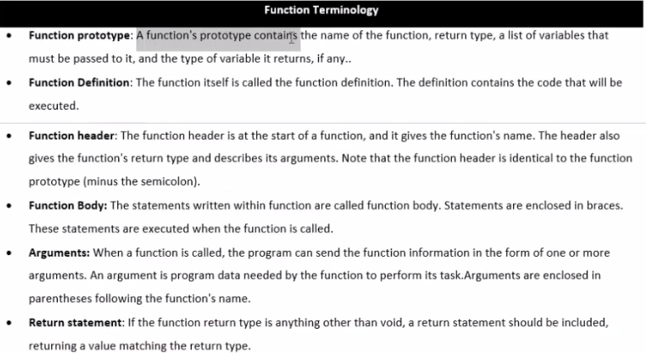
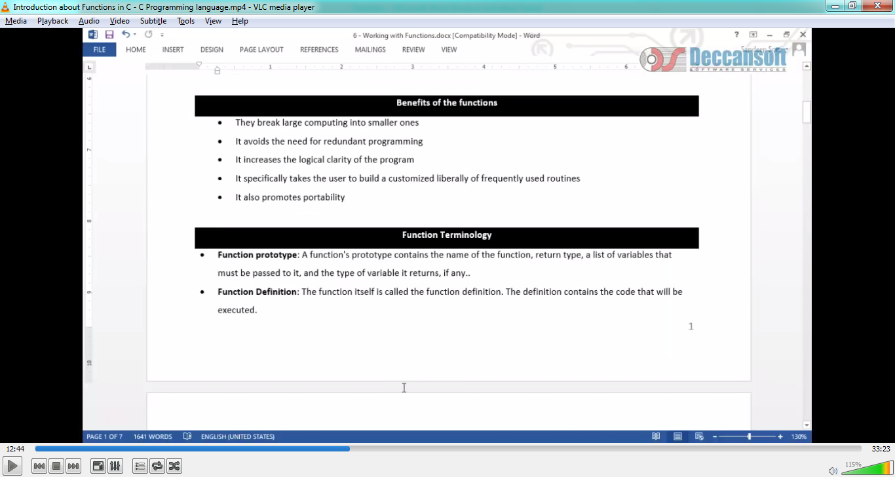
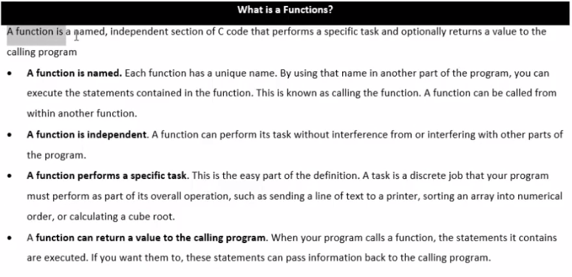
Ex:2:Function
#include<stdio.h>
int sum();//Function Declaration
Int main()//Calling Function
{
Int r1,r2;
R1=Sum();
R2=Sum();
Printf(“%d %d”,r1,r2);
}
int sum()//Called Function
{
Int a,b,c:
Printf(“Enter First number:”);
Scanf(“%d”,&a);
Printf(“Enter Second number:”);
Scanf(“%d”,&b);
Printf(“Enter Third number:”);
Scanf(“%d”,&c);
Return a+b+c;
}

Ex:3:Function Terminology
#include<stdio.h>
Int greatest(int a,int b,int c);// Function Declaration(or)Protype
int sum();//Function Declaration
Int main()//Calling Function
{
Int r1,r2;
R1=Sum();
R2=Sum();
Printf(“%d %d”,r1,r2);
//int n1,n2,n3;
//n1=10;
//n2=15;
//n3=16;
//r1=greatest(n1,n2,n3);
R1=greatest(10,23,15);//10,23,15 are arguments/Actual Arguments
Printf(“\n%d is greatest”,r1);
}
int sum()//Called Function
{
Int a,b,c:
Printf(“Enter First number:”);
Scanf(“%d”,&a);
Printf(“Enter Second number:”);
Scanf(“%d”,&b);
Printf(“Enter Third number:”);
Scanf(“%d”,&c);
Return a+b+c;
}
Int greatest(int a,int b,int c)//int a,int b,int c are parameters & its is function definition or function header (and also int a,b,c are formal arguments)
{
If(a>b)
If(a>c)
Return a;
Else
Return c; Function Body
Else
If(b>c)
Return b;
Else
Return c;
}

