TIBCO ESB Framework Reference Guide

APPROVAL LIST
Name | Company | Function | Date

MODIFICATIONS
Issue | Date | Modified by | Observations
0.5 | 22/05/2017 | Florent Cazalaa | Initial version.  Missing Router and Transco sections.
1.0 | 07/07/2017 | Florent Cazalaa | Updated framework types with SANOFI service classification / design:  . replace “flowName” by “flowCode”  . replace “serviceName” by “taskCode” (and “serviceId” by “taskId”)  . replace “operation” by “serviceName”  . Updated serviceContext structure  Added core_router documentation.
© EADS 2017. All rights reserved. Confidential and proprietary document.

© EADS 2017. All rights reserved. Confidential and proprietary document.

TABLE OF CONTENT
1 Introduction 6
2 Scope of the document 6
3 Framework Architecture 7
3.1 Architectural drivers and framework features 7
3.2 ESB Framework exchange scope 8
3.3 Framework logical architecture 9
3.3.1 Components 9
3.3.2 Core utilities and schema library 9
3.3.3 Audit, Message Resubmission and Remediation 10
3.3.4 Routing 11
4 Project components and dependencies 12
4.1 Framework components 12
4.1.1 [framework] business module 12
4.1.2 [remediation] business module 13
4.1.3 [transco] business module 13
4.2 Components dependencies 14
5 [core_common.sharedmodule] utilities and schema 15
5.1 Messaging structures 15
5.1.1 Service types 15
5.1.2 Message Header 16
5.1.3 XmlMsg message envelope 17
5.2 Process Context and Audit policies 18
5.2.1 Introduction 18
5.2.2 Asynchronous message receiver service 18
5.2.3 Synchronous request/reply message receiver service 19
5.2.4 Process Context structure 20
5.2.5 Process Context activities 22
5.2.5.1 Introduction 22
5.2.5.2 GenCtx activity 22
5.2.5.3 xmlMsgCtx activity 25
5.2.5.4 soapCtx activity 26
5.2.5.5 ErrCtx activity 28
5.2.6 Audit Policy activities 30
5.2.6.1 Introduction 30
5.2.6.2 LogEntry activity 31
5.2.6.3 LogExit activity 31
5.2.6.4 LogInfo activity 32
5.2.6.5 LogDebug activity 32
5.2.6.6 LogError activity 33
5.2.6.7 LogWarning activity 33
5.2.6.8 [FlushAudit] activity 34
5.2.6.9 SetOnErrorMonitLogicData activity 34
5.3 Exception schema and utilities 34
5.3.1 SvcException schema 35
5.3.2 SvcException process utility 36
5.4 Exception handling process design practice 37
5.4.1 Exception handling in BusinessWorks sub-processes 37
5.4.2 Exception handling at the service top level process 38
5.5 [core_common.sharedmodule] properties 39
6 [core_audit] application 41
6.1 Introduction 41
6.2 [LogAudit] service 42
6.2.1 Introduction 42
6.2.2 [auditMsg] structure 42
6.2.3 [LogAudit] Process 44
6.3 Monitoring Logic Lookup (or remediation lookup) 47
6.3.1 Monitoring Lookup 47
6.3.2 Rule source and cache initialization 50
6.4 Message resubmission service 51
6.4.1 Principle 51
6.4.2 Message resubmission request 52
6.4.3 Message resubmission processes 52
6.5 [core_audit] configuration (global variables) 54
6.6 AUDIT database 55
6.6.1 Overall schema view 55
6.6.2 Table description 56
7 Remediation channels (CORE_REMEDIATION) 58
7.1 Introduction 58
7.2 REMEDIATION CHANNEL generic interface 59
7.3 Remediation service properties 59
7.4 REMEDIATION channels 60
7.4.1 EmailCache channel 60
7.4.1.1 Service description 60
7.4.1.2 Properties 61
7.4.2 Resubmission channel 62
7.4.2.1 Service description 62
7.4.2.2 Properties 63
7.4.3 GenericEmail channel 63
7.4.3.1 Service description 63
7.4.3.2 Properties 64
7.5 CORE_REMEDIATION global variables 64
8 Functional monitoring application 66
8.1 ElasticSearch storage design 66
8.2 Kibana UI 66
9 Routing service (bw.core_router.sharedmodule) 67
9.1 Introduction 67
9.2 Message routing implementation 68
9.2.1 Interface 68
9.2.2 Routing process 70
9.2.2.1 Main flow 70
9.2.2.2 Rule lookup 71
9.2.3 Rules initialization process 73
9.3 Router Rules 75
9.3.1 Rule structure 75
9.3.2 Rule example 76
9.4 Router database 79
9.4.1 Overall schema 79
9.5 CORE_ROUTER Global Variables 80

Introduction
The SANOFI ESB platform is a shared infrastructure asset for the development and the deployment of ESB services for the purpose of data integration and service orchestration.
The EvENT ESB framework includes number of schema, libraries and services providing a strong optimization to messaging and orchestration services development and runtime across the SANOFI infrastructure.
This document describes the EvENT ESB framework foundation architecture and designs from both functional and technical perspectives.

Scope of the document
- Architectural drivers supporting the framework foundation.
- Framework Components
- ESB Services Audit feature
- Message routing feature
- Remediation
- Message Routing
- Transcodification
TIBCO BusinessWorks Process templates and detailed development practices are out of scope of this document.

Framework Architecture

Architectural drivers and framework features
The most significant drivers for building an ESB framework is the optimization of the platform reliability and performance as well as the decrease of the total cost of ownership for the deployed IT services.
The use of an ESB framework enforces service implementations compliancy with the global enterprise architecture direction. The standard services design can be captured in predefined policies and process templates leading to faster development, proven pattern usage, easier assets maintenance and runtime operation efficiency.
Below is an overview of the EvENT ESB framework features and benefits:
Messaging:
- Message format: use of Common message headers with added value attributes to respond to most enterprise messaging needs (exchange patterns, message correlation and audit).
- Exception Handling: uniform exception handling format and logic. This allows for a common approach to exception handling and recycling.
- Message routing: standard configurable message routing library.
Auditing capability:
- ESB service Audit: common process audit policies:
  - Traces for main steps (start, end, error, and warning).
  - Customized steps (information, debug, warnings).
  - Provision of technical and business key properties for the correlation of technical traces with functional properties (application context).
  - End to end flow traces correlation.
  - Collection of services and flows statuses.
- Message resubmission: JMS messages resubmission capability to support exception recycling scenarios.
- Standard and custom monitoring logic processing: configure monitoring logic through a configurable event post processing action (REMEDIATION channels), for alerting, exception recycling logic, or advanced monitoring logic activation.
- Flow activity analytic: quality and performance evaluation through Audit traces analytic reporting.

Transverse utilities:
- Transcodification library offering generic data code mapping for managed entities, participants and relationships.

Accelerated development and design compliancy:
- Templates process library: Standard service interface design and implementation patterns within the BW processes.
  - Accelerates generation of standard interfaces and process implementations
  - Enforces design best practices
  - Enforce compatibility

ESB Framework exchange scope
The current ESB framework supports stateless messaging and orchestration services for the purpose of data integration and services process automation.
Mass DB/File processing and bulk transfer may be operated by alternate ETL solutions (not in scope in ESB). Some limited ETL functionality may be achieved using proper block processing design in the TIBCO BusinessWorks processes but data transport through JMS and WS/HTTP protocols must keep the message volume limited: message size under a few MB is recommended.
TIBCO CEP (complex event processing) is in use in some SANOFI projects and may be also used with the BW6.x ESB stack.

Framework logical architecture

Components
The ESB framework includes libraries and runtime services supporting the development and deployment of messaging and orchestration services on The ESB platform. Services can be developed using predefined templates relying on prebuilt core functionality.
Note: Process template documentation is out of the scope of this document.
The ESB components distribution is further documented in section 4.
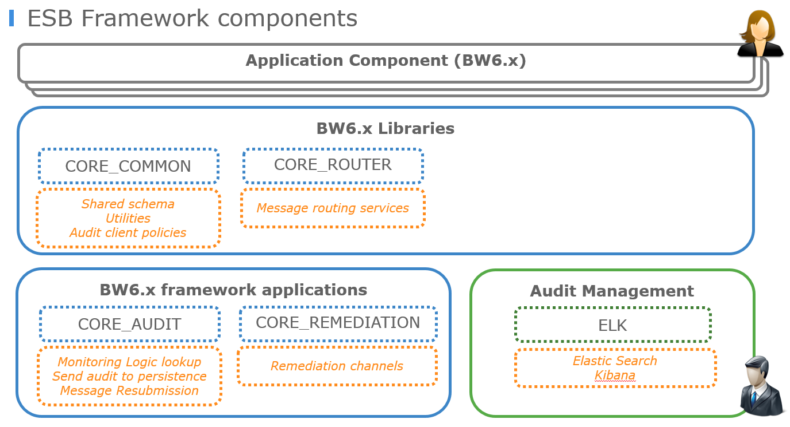

Core utilities and schema library
The core library (CORE_COMMON component) contains shared process utilities and schemas that may be used by any components such as AUDIT, ROUTING, REMEDIATION. In particular the core schema library includes the standard messaging envelope used by most message exchanges on the ESB, as well as all the AUDIT policy client processes.
The core utilities and schema library is documented in section 5.

Audit, Message Resubmission and Remediation
The framework AUDIT solution enables the capture of log information at predefined and custom steps of a service execution.
- The AUDIT utilities are packaged in the CORE_COMMON shared module.
- The log information is sent asynchronously from the service process into a JMS queue.
- The AUDIT server component consumes AUDIT messages and integrates the information with the remote ElasticSearch storage platform.
- The AUDIT Server also manages the optional monitoring logic actions by checking in the event catalog for notifications to be sent to the REMEDIATION channels.
- When messages persistence is activated in the ESB service implementation, ESB JMS standard messages may be manually resubmitted by operations or via Remediation channels.
The framework architecture privileges the decoupling of services activity, tracing and exception recycling features
The AUDIT solution is further documented in section 5.2.

Routing
ESB message ROUTING allows connectors and orchestration services to send JMS messages to configurable destination based on rules. Routing rules criteria include message metadata such as {source component, area, taskCode and service name } or conditions on custom message routing properties.
Routing is further documented in section 8.

Project components and dependencies

Framework components
The framework components are stored in the SANOFI GIT repository under a business module hierarchy.
Business Modules | Description
framework | ESB foundation common services and libraries
remediation | REMEDIATION services (post processing service actions and alerting solution)
transco | Transco utilities
template | Predefined process templates
SVN structure overview:
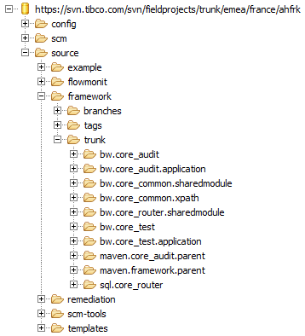

[framework] business module
[Framework] Business Module
SVN repository | TIBCO_ESB
Business Module | framework
Module SVN path | source/framework
Eclipse PSF | scm/psf/source/framework.psf
Module Description | Contains the ESB framework foundation utilities and services supporting functionality such as AUDIT, RESUBMISSION, REMEDIATION, ROUTER

The table below lists all the current components with a quick description.
Business module | Component type | Component name | Description
framework | maven | maven.framework.parent | Parent maven project grouping all components for the framework business module.
framework | bw shared module | bw.core_common.sharedmodule | BW Shared module for base type and utilities, including all audit policies.
framework | bw xpath function | bw.core_common.xpath | Shared BW xpath functions.
framework | bw application | bw.core_audit.application | BW application wrapper for the core_audit module.
framework | bw module | bw.core_audit | BW module containing the Audit application implementation: such as remediation lookup and connector to ElasticSearch data persistence layer.
framework | maven | maven.core_audit.parent | Parent maven project for the core_audit application.
framework | bw shared module | bw.core_router.sharedmodule | BW shared module for routing functionality.
framework | sql scripts | sql.core_router | SQL scripts for the router database schema and logic.
framework | bw application | bw.core_test.application | BW application supporting local unit tests of the framework asset.
framework | bw module | bw.core_test | BW module implementing the local unit tests for the framework asset.

[remediation] business module
[remediation] Business Module
SVN repository | TIBCO_ESB
Business Module | remediation
Module SVN path | source/remediation
Eclipse PSF | scm/psf/source/remediation.psf
Module Description | Contains implementation for shared remediation channels.
The table below lists all the current components with a quick description.
Business module | Component type | Component name | Description
remediation | maven | maven.remediation.parent | Parent maven project grouping all components for remediation business module.
remediation | bw application | bw.core_remediation.application | BW application wrapper for the core_remediation module.
remediation | bw module | bw.core_remediation | BW module containing the remediation channels implementation.
remediation | maven | maven.core_remediation.parent | Parent maven project for the core_remediation application.

[transco] business module
[transco] Business Module
SVN repository | TIBCO_ESB
Business Module | transco
Module SVN path | source/transco
Eclipse PSF | scm/psf/source/transco.psf
Module Description | Contains implementation for Transco utilities.
The table below lists all the current components with a quick description.
Business module | Component type | Component name | Description
transco | maven | maven.transco.parent | Parent maven project grouping all components for transco business module.
transco | bw shared module | bw.core_transco. sharedmodule | BW shared module containing the transco utility implementation.
transco | bw xpath | bw.core_transco.xpath | Transco xpath function implementation
transco | misc | vb.core_transco | Project containing the VB scripts for managing Transco collection

Components dependencies
The diagram below shows an abstract of the main TIBCO BW shared module component dependencies in context with their business modules.

[core_common.sharedmodule] utilities and schema

Messaging structures

Service types
The ESB platform supports the following types of services and message formats:
- JMS messaging: the framework uses a custom envelope [xmlMsg] that includes the common [msgHeader] and a generic body element.
- WebServices soap exposition (HTTP and JMS transport): the framework [msgHeader] structure is used in the standard SOAP envelope as a SOAP Header.
- WebServices REST exposition (HTTP): currently REST services are in scope for external service exposition (no framework header).
- Any other message formats or protocols may use to integrate source applications (typically connector services acting as flow starters).
The messaging structure is defined in the [core_common.sharedmodule] BusinessWorks component of the [framework] business module. This section describes the semantic of the messaging structure elements. The detailed data type can be consulted directly from the XSD schema in the project.
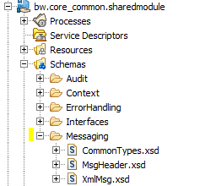

Message Header
The [msgHeader] structure defines the common message properties that must be associated with any ESB exchange, except for external application integration channels and external orchestration services.
The [msgHeader] schema can be found in the [framework/bw.core_common.sharedmodule] component:
[bw.core_common.sharedmodule/schemas/Messaging/MsgHeader.xsd]
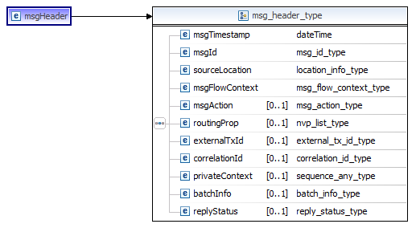
The table below provides the detailed description of the information contained in the {msgHeader] schema.
Message Header
Field | Card | Description
msgTimestamp | 1 | Message timestamp as set by the sender.
msgId | 1 | Unique id of the message (every sent msg is associated with a unique message id).
sourceLocation/area | 1 | Name of the infrastructure area the message was sent from.
sourceLocation/layer | 1 | Name of the logical component type having sent the message.  MC: Middleware Connector  MCI: Middleware Connector IN (receives from external application)  MCO: Middleware Connector OUT (sends to external application)  MCS: Middleware Connector service (exposes a request reply in the ESB)  TA : Technical adapter  TAI: Technical Adapter Inbound service (from esb to external application)  TAO: Technical Adapter Outbound service (from external application to esb)  MS: Middleware service (ESB orchestration service)  EXT: external (external application)  FRK: internal framework component
sourceLocation/component/componentName | 1 | The name of the component having sent the message.
sourceLocation/component/componentInstance | 1 | The name of the component instance having sent the message.
msgFlowContext/flowCode | 1 | The code of the ESB flow as set by the sending application.
msgFlowContext /flowId | 1 | The instance of the ESB flow as set by the sending application.
msgFlowContext /taskCode | 1 | The name of the ESB task the message is sent from.
msgFlowContext /taskId | 1 | The taskId from the service context the message is issued from.  A given taskId instance will propagate itself across service context execution that are linked to a same ESB task instance execution (the links is based on the flow specification).
msgFlowContext /serviceName | 1 | The name of the ESB service the message is issued from.
msgFlowContext/ctxId | 1 | The framework contextId of the service having sent the message.
msgAction | ? | The msgAction name relates to the data being sent and the purpose of the publication; example “Order-1.0-New”. This field may be used to differentiate some message content especially for routing purpose.
routingProp/nvpList/nvpElement | * | Optional custom routing properties.
externalTxId | ? | Correlating transaction id as defined by the sending external application. The externalTxId may be used to link an external transaction id to the actual ESB flowId instance.
correlationId | ? | ESB generic message correlation – may be used for any messaging correlation needs across the ESB.
privateContext/* | ? | Holds optional opaque data that may need to be transported as a context across ESB components (often in state less asynchronous request/reply scenarios) .
batchInfo | ? | Used when message flow originates from a referenced batch collection (such as from a file or a DB data collection).
replyStatus | ? | Status used for request/reply orchestration interactions.  ERROR  SUCCESS

XmlMsg message envelope
Every JMS message exchanged in the DSIP ESB uses the [XmlMsg] envelope structure. The envelope contains a reference to the [msgHeader] element (see above), and a body section where any element type may be attached.
The [msgHeader] schema can be found in the [framework/bw.core_common.sharedmodule] component:
[bw.core_common.sharedmodule/schemas/Messaging/xmlMsg.xsd]
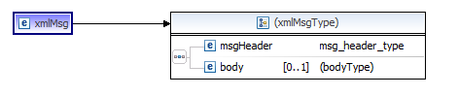

XmlMsg Envelope
Field | Card | Description
msgHeader | 1 | Standard ESB msgHeader structure
Body/* | ? | Any message element carrying the business data transported in the message.

Process Context and Audit policies

Introduction
The Audit client functionality is defined in the [framework/core_common.sharedmodule] BusinessWorks component as a set of schemas and utilities referred as “Audit Policies”. The framework Audit Policies ensure consistent process activity tracing and end-to-end traces correlation.
The Audit Policy framework relies very much on a “Process Context” that must be set as early as possible in the ESB service execution. The [ProcessContext] defines two important pieces of information:
- What is currently executed: Information related to the service being executed (location, service name, component…). This information is used in particular to identify precisely the current process activity. The process context is stored in the process memory and is automatically referenced by all subsequent audit activities.
- What is the trigger/source of this action: Information related to the message having triggered the service execution (this contains all the inbound message headers, if provided). This information is used in particular to audit the inbound data and propagate, as needed, some correlation information so that the ESB flow audit can spread across many service executions.
As introduced in section 5.1.1, the ESB may implement various kinds of services (such as connectors in/out and orchestration). Every type of service may use specific framework context activities to capture specific information but the overall logical steps present in a service implementation are similar and can be abstracted (see below section 5.2.2 and 5.2.3).

Asynchronous message receiver service
A typical asynchronous message receiver service will:
- [Start]: Receive a message: this can be from JMS, or any other protocol (like in the case of external application integration via channel).
- [CaptureContext]: setup a process context containing current service/flow metadata, input message properties (transport,headers) and message body content.
- [LogEntry]: audit policy indicating the service has started.
- [Main]: Execute the service main process steps (business service implementation)
- [LogExit]: audit policy indicating the service has terminated.
- [Optional Confirm]: for JMS messaging only (client ack mode), acknowledge the inbound message.
- [FlushAudit]: Collects all the Audit information for the process and send the resulting AuditMsg to he audit server.

The below diagram summarizes the typical process happy path in Green.
The Error path is shown in Red color. Errors raised within the top level process will generate standard [SvcException] log in turn by the [LogError] Audit policy. Error raised in lower level process (example here main process) are caught and also traced via the [LogError] Audit policy.
A [ProcessContext] is required for any audit activity to run. In the exceptional situation where an error occurred before the [ProcessContext] is set, a generic and minimal [ProcessContext] is built as part of the Error path flow (See Gen ErrorCtx).

Synchronous request/reply message receiver service
Request/Reply services may be implemented via messaging ([xmlMsg] format over JMS), or WebServices interfaces. The overall process is similar to the asynchronous model with the addition of a reply being sent.

Process Context structure
The [ProcessContext] structure is designed in the [framework/core_common.sharedmodule] BW component:
[bw.core_common.sharedmodule/schemas/Schemas/Context/ProcessContext.xsd]
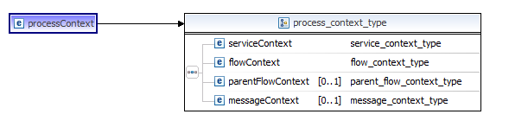
A [ProcessContext] structure needs to be associated with any service execution in order to capture inbound message metadata (message header) and body, as well as all current service metadata. The [ProcessContext] information is captured at the earliest process step, and referenced in any process subsequent logging policy execution.
A [ProcessContext] may be initiated from different kind of services (Connectors, Orchestration…). However, the [ProcessContext] structure is common to all kind of services types.
ProcessContext
Field | Card | Description
flowContext/serviceName | 1 | Name of the ESB service being executed.
serviceContext/contextId | 1 | Automatically generated (java UUID). One unique contextId is generated for each distinct service execution.
serviceContext/contextTimestamp | 1 | Automatically generated timestamp at the time the context is created.
serviceContext/location/area | 1 | Infrastructure area name where the service is executed.
serviceContext/location/layer | 1 | Name of the logical component type having sent the message.  MC: Middleware Connector  MCI: Middleware Connector IN (receives from external application)  MCO: Middleware Connector OUT (sends to external application)  MCS: Middleware Connector service (exposes a request reply in the ESB)  TA : Technical adapter  TAI: Technical Adapter Inbound service (from esb to external application)  TAO: Technical Adapter Outbound service (from external application to esb)  MS: Middleware service (ESB orchestration service)  EXT: external (external application)  FRK: internal framework component
serviceContext/location/component/componentName | 1 | Name of the logical component running the service.
serviceContext/location/component/componentInstance | 1 | Name of the specific instance of the service (for default, use 1).
serviceContext/servicePath | 1 | Full path of the service process resource in the current project component.
serviceContext/messagingType | 1 | Type of messaging for the service.  XMLMSG_JMS: standard xmlMsg envelope over JMS transport.  ANY_JMS: generic text over JMS transport.  SOAP_JMS: SOAP over JMS transport.  SOAP_HTTP: SOAP over HTTP transport.  ANY_ANY: any text over any protocol.  JSON_HTTP: REST/JASON over HTTP transport.
serviceContext/isFlowInitiator | ? | If the service is an ESB flow initiator (typically connector or top level orchestration service), then set to “true”, otherwise set to “false” (default “false”).
serviceContext/resubmitInd | ? | Capture the ESB message resubmission id if provided in inbound service message.
serviceContext/resubmitCount | ? | Capture the ESB message resubmission count if provided in inbound service message.
flowContext/flowCode | 1 | Code of the end-to-end ESB flow (from specification).
flowContext/flowId | 1 | Instance of the ESB flow execution (java UUDI).
flowContext/taskCode | 1 | The name of the ESB task the service execution is linked to.  An ESB “flow” may be divided in “tasks”. Every service starting a task must specify a taskCode. taskCode may be inherited in subsequent services based on the scope of the task (from flow specification).
flowContext/taskId | 1 | Instance of the ESB task execution (java UUID).  A taskId is typically generated in a service at the beginning of a logical ESB task. The given taskId instance will propagate itself across service context execution that are linked to a same ESB task instance execution (the links is based on the flow specification).
parentFlowContext/parentFlowId | ? | Reference to the incoming message ESB flowId if provided.
parentFlowContext/parentTaskId | ? | Reference to the incoming message ESB taskId if provided.
parentFlowContext/parentCtxId | ? | Reference to the incoming message ESB contextId if provided.
messageContext | ? | The message context capture the service inbound message metadata and data as set by the message sender.
messageContext/msgTimestamp | ? | Timestamp at which the message was sent.
messageContext/msgId | ? | Unique id of the message.
messageContext/msgSourceInfo | ? | Information regarding the sender of the message.
messageContext/msgSourceInfo/area | 1 | Name of the infrastructure area the message was sent from.
messageContext/msgSourceInfo/layer | 1 | Name of the logical component type having sent the message.  MC,MCI,MCO,MCS,TA,TAI,TAO,MS,EXT,FRK
messageContext/msgSourceInfo/component/componentName | 1 | The name of the component having sent the message.
messageContext/msgSourceInfo/component/componentInstance | 1 | The component instance reference having sent the message.
messageContext/msgFlowContext/flowCode | ? | The code of the ESB flow as set by the sending application.
messageContext/msgFlowContext/flowId | ? | The instance of the ESB flow as set by the sending application.
messageContext/msgFlowContext/taskCode | ? | The name of the ESB task the message was sent from.
messageContext/msgFlowContext/taskId | ? | The taskId of the service context the message is issued from.
messageContext/msgFlowContext/serviceName | ? | The name of the service the message is issued from from.
messageContext/msgFlowContext/ctxId | ? | The framework contextId of the service having sent the message.
messageContext/msgAction | ? | The msgAction name relates to the data being sent and the purpose of the publication; example “Order-1.0-New”. This field may be used to differentiate some message content especially for routing purpose.
messageContext/routingProp/nvpList/nvpElement | * | Optional custom routing properties set by the sending application.
messageContext/externalTxId | ? | Correlating transaction id as defined by the sending external application. The externalTxId may be used to link an external transaction id to the actual ESB flowId instance.
messageContext/correlationId | ? | ESB generic message correlation as set by the message sender – may be used for any messaging correlation needs across the ESB.
messageContext/privateContext/* | ? | Holds optional opaque data as set by the message sender.  Private Context may be needed to propagate a private context across ESB components (often in state less asynchronous request/reply scenarios).
messageContext/batchInfo | ? | Used when inbound message originates from a referenced batch collection (example a file or a DB table).
messageContext/batchInfo/batchName | ? | Name of the source batch. Common to every message issued from the same batch.
messageContext/batchInfo/recordNo | ? | Number of the record within the source batch.
messageContext/batchInfo/recordRef | ? | Reference of the message within the source batch.
messageContext/batchInfo/batchSize | ? | Total number of messages in the source batch.
messageContext/transportProp/nvpList/nvpElement | * | Captures the transport properties for the current service execution, as a set of name/value pairs.
messageContext/msgSequencingKey | ? | Message sequencing key as provided in the inbound service message header.
messageContext/otherSoapHeaders | ? | Holds optional third party (non-framework) inbound message soap headers

Process Context activities

Introduction
The [ProcessContext] structure is common to all kind of services. However, different utilities are used to setup the [ProcessContext] depending on the kind of service being implemented. This section describes the various utilities and related interfaces.
All [ProcessContext] creation activities are designed in the framework/core_common.sharedmodule BW component:
/ core_common.sharedmodule/Processes/ProcessUtilities/Context
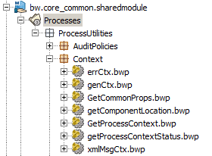

GenCtx activity
The [genCtx] activity is used to set a [ProcessContext] in an integration channel where the inbound data comes from an external/native data format and protocol. [GenCtx] is typically used in channel services for the purpose of generic data integration or external service exposition for the purpose of initiating an ESB flow.
Using the [genCtx] activity, the developer can transmit the accurate ESB flow information, custom message metadata and body information into the [ProcessContext] structure.
For generic (unqualified) service input, the framework has limited correlation capability in the sense that no automated correlation can be achieved with past activities (because no known correlation header can be extracted from the inbound data format). Therefore, the [genCtx] activity input includes most of the [ProcessContext] field (many fields are optional).
GenCtx
Field | Card | Description
flowContext/flowCode | 1 | Code of the end-to-end messaging flow initiated by this service (based on specification).
flowContext/flowId | ? | Instance id of the messaging flow. If not provided it is automatically generated (JAVA UUID).
flowContext/taskCode | 1 | The name of the ESB task the service execution is linked to (from flow specification)
flowContext/taskId | ? | Instance id of the step execution. If not provided it is automatically generated (JAVA UUID).  Usually, taskId for a genCtx is not provided and will generate itself (assuming a new ESB task startup).
flowContext/layer | 1 | Name of the logical component type having sent the message. For genCtx, the source layer is likely EXT.
serviceName | 1 | Name of the service being executed.
messagingType | 1 | Type of messaging for the service.  XMLMSG_JMS: standard xmlMsg envelope over JMS transport.  ANY_JMS: generic text over JMS transport.  SOAP_JMS: SOAP over JMS transport.  SOAP_HTTP: SOAP over HTTP transport.  ANY_ANY: any text over any protocol.  JSON_HTTP: REST/JASON over HTTP transport.
messageContext/msgTimestamp | ? | Input message timestamp if applicable.
messageContext/msgId | ? | Input message id if applicable.
messageContext/msgSourceInfo | 0 | Message source information (if applicable).
messageContext/msgSourceInfo/area | 1 | Source message or system area.
messageContext/msgSourceInfo/layer | 1 | Source layer type. For external applications, set to EXT.  If not known set to EXT.  For internal Framework flows, set to FRK.
messageContext/msgSourceInfo/component/componentName | 1 | Qualifies the message source system name.
messageContext/msgSourceInfo/component/componentInstance | 1 | Qualifies the message source system instanceId (default “1”).
messageContext/msgFlowContext | ? | Source message flow context (if applicable).
messageContext/msgFlowContext/flowCode | 1 | Source message flow code (if applicable).
messageContext/msgFlowContext/flowId | 1 | Source message flow id (if applicable).
messageContext/msgFlowContext/taskCode | 1 | The name of the ESB task the message was sent from (if applicable).
messageContext/msgFlowContext/taskId | 1 | Source message task id (if applicable).
messageContext/msgFlowContext/serviceName | 1 | Source message serviceName (if applicable).
messageContext/msgFlowContext/ctxId | ? | Source message ESB contextId (if applicable).
messageContext/msgAction | ? | Input message msgAction if available (if applicable).
messageContext/externalTxId | ? | External application Transaction id associated with the inbound message (if applicable).
messageContext/correlationId | ? | Correlation Id associated with the inbound message (if applicable).
messageContext/privateContext/* | ? | Private context data associated with the inbound message (if applicable).
messageContext/batchInfo/batchName | ? | Name of the batch from which the inbound message originated.
messageContext/batchInfo/recordNo | ? | Record number in the batch from which the inbound message originated.
messageContext/batchInfo/recordRef | ? | Record reference in the batch from which the inbound message originated.
messageContext/batchInfo/batchSize | ? | Total number of records in the batch from which the inbound message originated.
messageContext/transportProp/nvpList/nvpElement | * | Custom transport properties from the received message (if applicable).
messageContext/otherSoapHeaders/* | ? | Optional soap headers for generic inbound soap calls (if applicable).
messagebody | ? | Full text representation of inbound message (if applicable).
isFlowInitiator | ? | Set to “true” if the current service acts as a flow initiator.  Typical [GenCtx] usage in process implementation are Flow Initiator (confirm usage from process specification). Default is “false”.
Process Example:
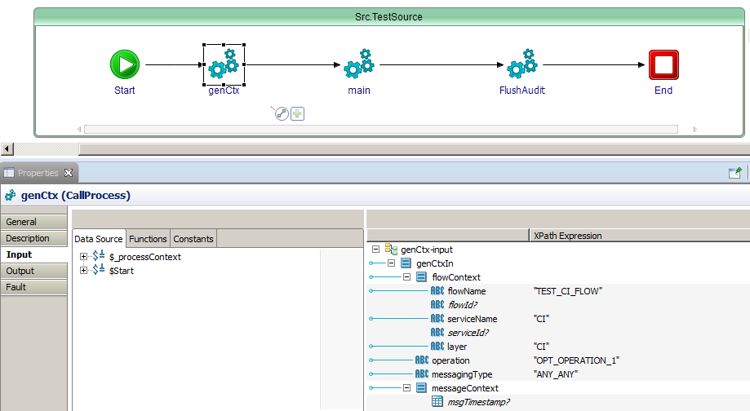

xmlMsgCtx activity
The [xmlMsgCtx] activity is used to set a [ProcessContext] in services receiving standard [xmlMsg] messages. [GenCtx] is typically used in messaging for inbound connectors services (connector reading messages from the ESB to integrate to applications).
Using the [xmlMsgCtx] activity, the developer provides the minimum set of context information, as most of the inbound message metadata is captured automatically by the utility from message headers.
Note: while [xmlMsg] format is often used on JMS transport, the [xmlMsgCtx] activity may technically be used for any kind of transport.
xmlMsgCtx
Field | Card | Description
flowContext/flowCode | ? | ESB flow code. Do not input value to inherit from inbound message header.
flowContext/flowId | ? | ESB flow id. Do not input value to inherit from inbound message header.
flowContext/taskCode | ? | The name of the ESB task the service execution is linked to.  An ESB “flow” may be divided in “tasks”. Every service starting a task must specify a taskCode. taskCode may be inherited in subsequent services based on the scope of the task (from flow specification).  If you want to inherit from the sender’s task code, just input nothing. The framework will copy the inbound message task code to this service context.
flowContext/taskId | ? | ESB trask id for the current service execution.  Don’t input value to inherit from inbound message header in the case a service spreads across many services calls.
layer | 1 | Name of the logical component type having sent the message. For xmlMsgCtx, the source layer is likely MCO, MCS,or MS.
serviceName | 1 | Name of the current service.
transportProp/nvpList/nvpElement | * | Map all inbound transport properties – depending on the type of inbound transport.
messagingType | 1 | For JMS transport, messaging type must be XMLMSG_JMS.  (Other transport for XMLMSG may be supported in the future).
messagebody | 1 | Required full [xmlMsg] text message.
isFlowInitiator | ? | [xmlMsgCtx] is used in services consuming already initiated ESB flows. So “isFlowInitiator” will be set to “false” in most cases.  Default is “false”. Set to “true” if the current service acts as an ESB flow initiator.  (Confirm usage from process specification)
noLogEntry | ? | Tell the context utility to NOT do LogEntry trace. Default is false, meaning the context utility will perform an automatic LogEntry audit.
noLogExit | ? | Tell the context utility to NOT do LogExit trace. Default is false, meaning the context utility will perform an automatic LogExit audit.
LogMsgBodyPolicy | ? | Default is set in the Module property [Services/AuditClient/Properties/DefaultMsgBodyPolicy].  Set to 0 to overwrite to: do not audit body payload.  Set to 1 to overwrite to: always log body payload  Set to 2 to overwrite to: log body payload only if ERROR
Process Example:
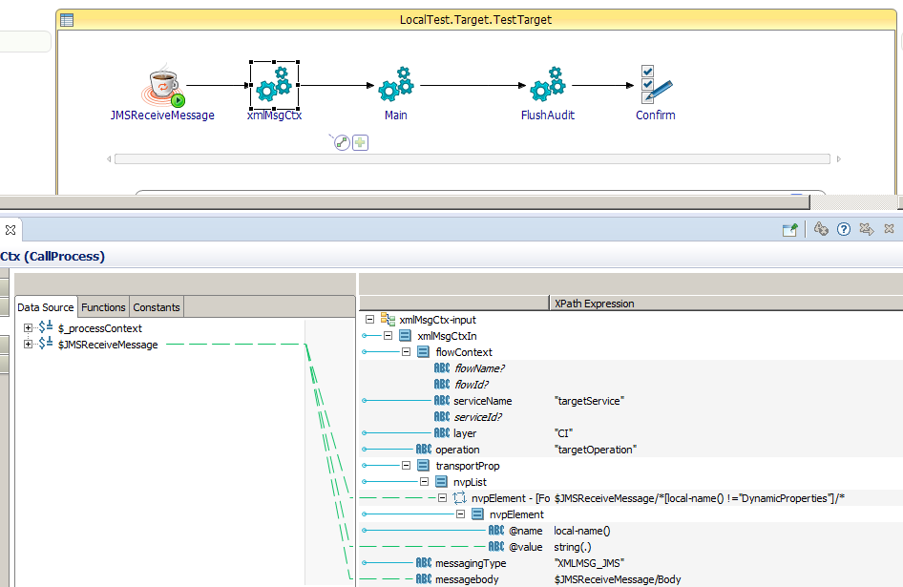

soapCtx activity
The [soapCtx] activity is used to set a [ProcessContext] in standard ESB WebServices (SOAP envelope). [soapCtx] is typically used in orchestration services exposing WebService interface.
Using the [soapCtx] activity, the developer provides the minimum set of context information, as most of the inbound message metadata is captured automatically by the utility.
Note: while WebServices SOAP format is often used on HTTP transport, the [soapCtx] activity may technically be used for SOAP over HTTP and JMS transport.
soapCtx
Field | card | Description
flowContext/flowCode | ? | ESB flow code. Do not input value to inherit from inbound message header.
flowContext/flowId | ? | ESB flow id. Do not input value to inherit from inbound message header.
flowContext/taskCode | ? | ESB task code linked to the current service execution.  Don’t input value to inherit from inbound message header in the case a ESB task spreads across many services executions. The task code will be inherited from the message sender task code.
flowContext/taskId | ? | ESB service id for the current service execution.  Don’t input value to inherit from inbound message header in the case a service spreads across many services calls.
serviceName | 1 | Soap service name being executed.
layer | 1 | Name of the logical component type having sent the message. For soapCtx, the source layer is likely MCS or MS.
soapServiceContext | 1 | Complete soap service context as read from the service [getContext] activity.  Note: in BW6.x the [getContext] activity cannot be run in the library because it requires specific service/port/operation configuration. Therefore the [getContext] activity must be invoked in the service top level process and the result is passed into this soapServiceContext (copy-of).
body/* | ? | Map WebService body element from the input message.
isFlowInitiator | ? | Set to “true” if the current service acts as an ESB flow initiator. Otherwise leave default (“false”) to indicate the current service execution take place in the context of the same flow of the inbound invocation.  (Confirm usage from process specification)
noLogEntry | ? | Tell the context utility to NOT do LogEntry trace. Default is false, meaning the context utility will perform an automatic LogEntry audit.
noLogExit | ? | Tell the context utility to NOT do LogExit trace. Default is false, meaning the context utility will perform an automatic LogExit audit.
LogMsgBodyPolicy | ? | Default is set in the Module property [Services/AuditClient/Properties/DefaultMsgBodyPolicy].  Set to 0 to overwrite to: do not audit body payload.  Set to 1 to overwrite to: always log body payload  Set to 2 to overwrite to: log body payload only if ERROR

Process Example:
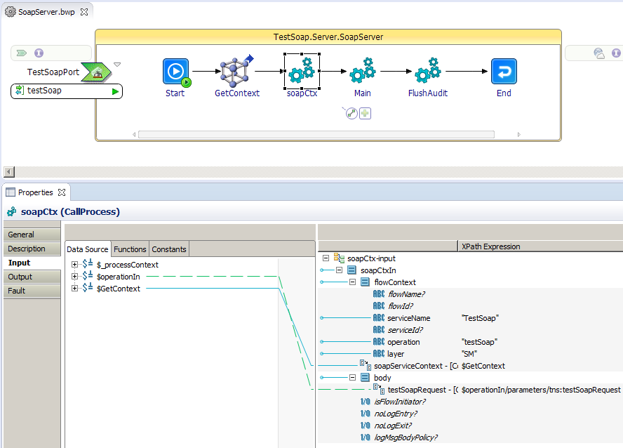

ErrCtx activity
The [errCtx] activity is designed to generate a MINIMAL [ProcessContext] in the occurrence of unexpected exceptions in the service before a fully qualified [ProcessContext] could even be established. The [errCtx] contains little information to support minimum Audit policies but correlation with service inbound data (message) cannot be established.
errCtx
Field | card | Description
flowContext/flowCode | ? | ESB flow code.
flowContext/taskCode | 1 | ESB task code linked to the service execution.  If you intended to dynamically inherit from the inbound message task code and you get an error leading to the errCtx, then you may specify “UNKNOWN” (because you would not know the value).
layer | 1 | Name of the logical component type having sent the message.  MC,MCI,MCO,MCS,TA,TAI,TAO,MS,EXT,FRK
serviceName | 1 | Name of the current service.
messagingType | 1 | Type of messaging for the service.  XMLMSG_JMS: standard xmlMsg envelope over JMS transport.  ANY_JMS: generic text over JMS transport.  SOAP_JMS: SOAP over JMS transport.  SOAP_HTTP: SOAP over HTTP transport.  ANY_ANY: any text over any protocol.
messagebody | ? | If available (depending on the actual process error conditions), map the inbound message body.
Process Example:
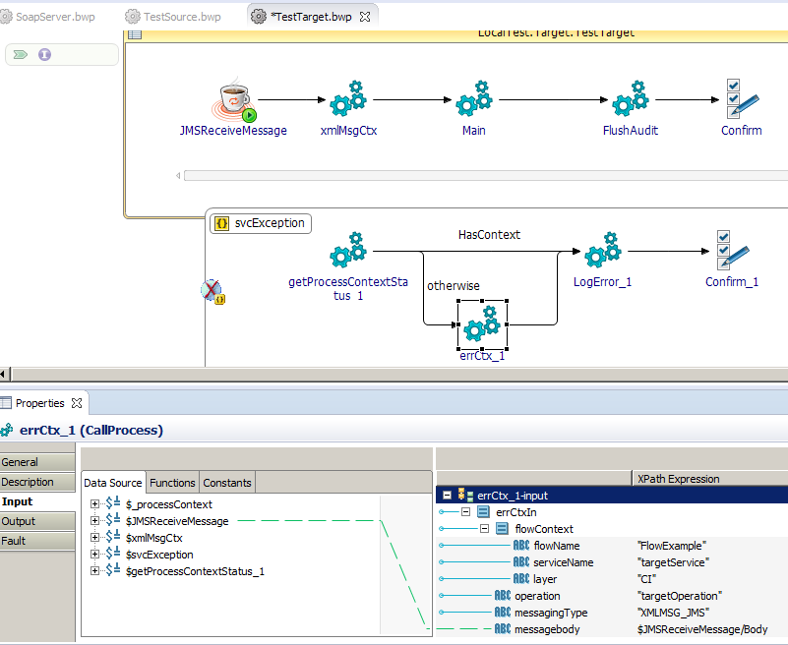

Audit Policy activities

Introduction
This section describes the audit policies activities and input parameters. The Audit policy activities are in the [framework/core_common.sharedmodule] BW component:
/Processes/ProcessUtilities/AuditPolicies
Below is the CORE_COMMON project content where Audit and context utilities can be found:
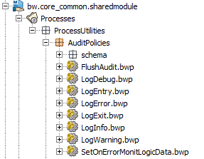
As a matter of performance optimization, the Audit client policies do not send the audit information to the server for every step. Instead, the audit information is collected in memory and sent as an AuditMsg at the very end of the process using the [FlushAudit] utility.
The various LogXXXX activities use internally a custom BW6 plugin implementing two primitives in the custom ESBAudit palette:
- logEvent: stores a generic LogEvent element in memory (Java Vector in a hash map indexed by the contextId).
- getLogEvents: read the sequence of logEvent from memory to the BW process, as XML object.
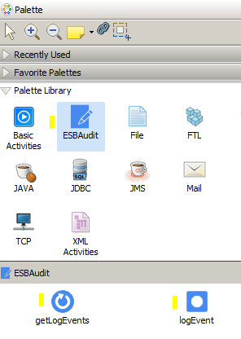

Remark: the [ESBAudit] palette is not exposed for use by the BW6.x business processes. It is only used by the framework utilities for the internal logging policies implementation.
The reason for having used such a custom palette was to optimize the performance for data to be stored and retrieved in memory with minimum parsing overhead. Any other solution allowing for storing or reading XML object in and out of memory would have been suitable. So far, only BW PDK API can manage BW objects.
Remark: there have been questions on the possibility to use the internal BW6.x OSGi bus to track process Audit. Such approach was not mature at the time of this framework release. It may be considered as evolution if proven efficient and reliable in the future.

LogEntry activity
The [LogEntry] activity generates an AUDIT log indicating the service execution has started. The utility can be used directly on the top level process, or it may be called automatically by the context activity (default behavior).
LogEntry
Field | Card | Description
logCode | ? | Associates an optional logCode to the AUDIT entry. LogCode may be used as matching criteria in rules for the purpose of REMEDIATION processing.
appContext/nvpList/nvpElement | * | Optional business application context key/value pairs.  AppContext properties are attached to the ESB flow Id execution and may be used to lookup AUDIT traces in the audit storage, from specific business key properties.
monitoringLogic/monitoringProperties/nvpList/nvpElement | * | Optional business key/value pairs to push to the monitoring logic for the purpose of REMEDIATION processing.
monitoringLogic/monitoringBody/* | ? | Optional business element to push to the monitoring logic for the purpose of REMEDIATION processing.
fileTrace | ? | Set to “true” if you want the AUDIT to be locally written to file (default is set in process property).
jmsTrace | ? | Set to “false” if you want to disable AUDIT through JMS (default is set in process property).
ovrCallerProcessPath | ? | The LogEntry process automatically identifies its caller process path (for the purpose of tracking). The caller process path can still be overwritten explicitly if needed. For example when LogEntry is called from the context activity rather than directly from the top level service implementation.

LogExit activity
The [LogExit] activity generates an AUDIT log indicating the service execution has terminated.
LogExit
Field | Card | Description
logCode | ? | Associates an optional logCode to the AUDIT exit. LogCode may be used as matching criteria in rules for the purpose of REMEDIATION processing.
appContext/nvpList/nvpElement | * | Optional business application context key/value pairs.  AppContext properties are attached to the ESB flow Id execution and may be used to lookup AUDIT traces in the audit storage, from specific business key properties.
monitoringLogic/monitoringProperties/nvpList/nvpElement | * | Optional business key/value pairs to push to the monitoring logic for the purpose of REMEDIATION processing.
monitoringLogic/monitoringBody/* | ? | Optional business element to push to the monitoring logic for the purpose of REMEDIATION processing.
fileTrace | ? | Set to “true” if you want the AUDIT to be locally written to file (default is set in process property).
jmsTrace | ? | Set to “false” if you want to disable AUDIT through JMS (default is set in process property).
ovrCallerProcessPath | ? | The LogExit process automatically identifies its caller process path (for the purpose of tracking). The caller process path can still be overwritten explicitly if needed. For example when LogEntry is called from the context activity rather than directly from the top level service implementation.

LogInfo activity
The [LogInfo] activity generates an AUDIT log for the purpose of tracing any useful information during the main business process execution.
LogInfo
Field | Card | Description
logTxt | ? | Short text to be sent to the AUDIT (2048 characters)
logBodyTxt | ? | Large text to be sent to the AUDIT such as specific message bodies or complex XML elements.
logCode | ? | Associates an optional logCode to the AUDIT entry. LogCode may be used as matching criteria in rules for the purpose of REMEDIATION notification.
customLogStep | ? | Custom AUDIT step to be associated with this particular log entry. Useful for searching specific AUDIT information steps in the AUDI storage.
appContext/nvpList/nvpElement | * | Optional business application context key/value pairs.  AppContext properties are attached to the ESB flow Id execution and may be used to lookup AUDIT traces in the audit database, from specific business key properties.
monitoringLogic/disableMonitoringLookup | ? | Set to “true” to disable monitoring logic to be evaluated part of the REMEDIATION capability (AUDIT server side).  Default is “false”
monitoringLogic/monitoringProperties/nvpList/nvpElement | * | Optional business key/value pairs to push to the monitoring logic for the purpose of REMEDIATION processing.
monitoringLogic/monitoringBody/* | ? | Optional business element to push to the monitoring logic for the purpose of REMEDIATION processing.
fileTrace | ? | Set to “true” if you want the AUDIT to be locally written to file (default is set in process property).
jmsTrace | ? | Set to “false” if you want to disable AUDIT through JMS (default is set in process property).

LogDebug activity
The [LogDebug] activity generates an AUDIT log for the purpose of tracing DEBUG information. The DEBUG should be reserved for unitary tests in development.
LogDebug
Field | Card | Description
logTxt | ? | Short text to be sent to the AUDIT (2048 characters)
logBodyTxt | ? | Large text to be sent to the AUDIT such as specific message bodies or complex XML elements.
customLogStep | ? | Custom AUDIT step to be associated with this particular log entry. Useful for searching specific AUDIT information steps in the AUDI database.
fileTrace | ? | Set to “true” if you want the AUDIT to be locally written to file (default is set in process property).
jmsTrace | ? | Set to “false” if you want to disable AUDIT through JMS (default is set in process property).

LogError activity
The [LogError] activity generates an AUDIT log tracing a service exception as captured by the process implementation.
LogError
Field | Card | Description
svc_ex:svcException |  | See section 5.3.1
customLogStep | ? | Custom AUDIT step to be associated with this particular log entry. Useful for searching specific AUDIT information steps in the AUDI storage.
appContext/nvpList/nvpElement | * | Optional business application context key/value pairs.  AppContext properties are attached to the ESB flow Id execution and may be used to lookup AUDIT traces in the audit database, from specific business key properties.
monitoringLogic/disableMonitoringLookup | ? | Set to “true” to disable monitoring logic to be evaluated part of the REMEDIATION capability (AUDIT server side).  Default is “false”
monitoringLogic/monitoringProperties/nvpList/nvpElement | * | Optional business key/value pairs to push to the monitoring logic for the purpose of REMEDIATION processing.
monitoringLogic/monitoringBody/* | ? | Optional business element to push to the monitoring logic for the purpose of REMEDIATION processing.
fileTrace | ? | Set to “true” if you want the AUDIT to be locally written to file (default is set in process property).
jmsTrace | ? | Set to “false” if you want to disable AUDIT through JMS (default is set in process property).
isNonTerminal | ? | Usage of LogError at service top level process leading to the service termination should have isNonTerminal set to “false” (that is the default).  LogError may be used in a sub process without causing the process to end. For such cases, set isNonTerminal to true.

LogWarning activity
The [LogWarning] activity generates an AUDIT log tracing warning information (in the form of free text or structured service exception).
LogWarning
Field | Card | Description
logTxt | ? | Short Error message (max 2048 characters)
logBodyTxt | ? | Large text to be sent to the AUDIT such as specific message bodies or complex XML elements.
logCode | ? | Optional logCode.  LogCode may be used as matching criteria in rules for the purpose of REMEDIATION notification.  If not provided, and IF a SvcException is provided, then the SvcException/code is used as logCode in the related logEvent.
svcException | ? | See section 5.3.1
customLogStep | ? | Custom AUDIT step to be associated with this particular log entry. Useful for searching specific AUDIT information steps in the AUDIT storage.
appContext/nvpList/nvpElement | * | Optional business application context key/value pairs.  AppContext properties are attached to the ESB flow Id execution and may be used to lookup AUDIT traces in the audit database, from specific business key properties.
monitoringLogic/disableMonitoringLookup | ? | Set to “true” to disable monitoring logic to be evaluated part of the REMEDIATION capability (AUDIT server side).  Default is “false”
monitoringLogic/monitoringProperties/nvpList/nvpElement | * | Optional business key/value pairs to push to the monitoring logic for the purpose of REMEDIATION processing.
monitoringLogic/monitoringBody/* | ? | Optional business element to push to the monitoring logic for the purpose of REMEDIATION processing.
fileTrace | ? | Set to “true” if you want the AUDIT to be locally written to file (default is set in process property).
jmsTrace | ? | Set to “false” if you want to disable AUDIT through JMS (default is set in process property).

[FlushAudit] activity
The [FlushAudit] activity collects all recorded process logs and sends the information together with the process context to the audit server in a [AuditMsg] JSON structure.
FlushAudit
Field | Card | Description
NO INPUT

SetOnErrorMonitLogicData activity
The [SetOnErrorMonitLogicData] activity allows the developer to pre-set logical monitoring data to be sent to the AUDIT server in the case an exception would occur. The logical monitoring data is inherent to the CORE_REMEDIATION framework functionality.
When [SetOnErrorMonitLogicData] is used, then any call to [LogError] will automatically associate the monitoring logic data as pre-set (without the need to pass the information to the [LogError] activity).
LogError
Field | Card | Description
setMode | 1 | R: Replace monitoring logic data with the new provided one (complete overwrite of onErrorMonitoringData variable).  A: Add monitoring data NVP to potentially existing onErrorMonitoringData variable if NVP name not already present. Set monitoringBody if provided and not already exists in variable.  U: Update any existing named monitoring data NVP if exists. Otherwise add. Update monitoringBody if provided and already set in variable.
monitLogicData/monitoringProperties/nvpList/nvpElement | * | Monitoring Logic properties to Replace/Add/Update
monitLogicData/monitoringBody/* | ? | Monitoring Logic body to Replace/Add/Update

Exception schema and utilities
The standard exception handling in the TIBCO BusinessWorks process is based on:
- A pre-defined service exception schema: [core_common.sharedmodule/Schemas/ErrorHandling/SvcException.xsd].
- An exception generation utility: [core_common.sharedmodule/Processes/ProcessUtilities/ErrorHandling/SvcException.process].
- A common Exception Handling practice.
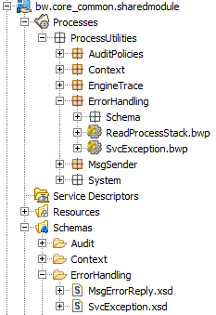

SvcException schema
Every handled process exception result in the construction of a [SvcException] element that provides a rich and structured description of the exception. The table below lists all the [SvcException] fields. Detailed data types can be consulted directly from the XSD schema.
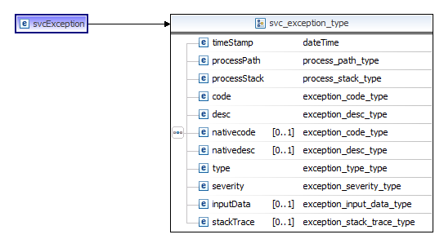
SvcException
Field | Card | Description
timeStamp | 1 | Timestamp at which the exception was built.
processPath | 1 | Full process path having generated the exception, as referenced in the TIBCO BusinessWorks project.
processStack | 1 | TIBCO BusinessWorks process stack showing all processes and sub-processes calls. Process paths are separated by “>”
code | 1 | Exception Code (based on specification).
desc | 1 | Text description of the exception.
nativecode | ? | Error native code – if available.
nativedesc | ? | Error native description – if available.
type | 1 | T: technical exception  B: business (or logical) exception
severity | 1 | Exception severity in the form of an integer.  4: low  3: medium  2: high  1: fatal
inputData | ? | Optional input data (string) to be linked to the exception.
stackTrace | ? | Optional native stack trace (string) to be linked to the exception.

SvcException process utility
Generating [SvcException] structures is made easier with the [SvcException.process] utility, where some information is automatically generated.
SvcException Field | Auto Generated by SvcException utility
timeStamp | yes
processPath | yes
processStack | yes
code | No
desc | No
nativecode | No
nativedesc | No
type | No
severity | No
inputData | No
stackTrace | No
Therefore, the [SvcException] utility takes the following parameters as input (referred as a “base_exception” type).
SvcException process utility
Field | Card | Description
code | 1 | Exception Code (based on specification).
desc | 1 | Text description of the exception.
nativecode | ? | Error native code – if available.
nativedesc | ? | Error native description – if available.
type | 1 | T: technical exception  B: business (or logical) exception
severity | 1 | Exception severity in the form of an integer.  4: low  3: medium  2: high  1: fatal
inputData | ? | Optional input data to be linked to the exception.
stackTrace | ? | Optional native stack trace to be linked to the exception.

Exception handling process design practice

Exception handling in BusinessWorks sub-processes
Exception may be generated in any of the BusinessWorks sub processes by invoking the [SvcException] utility followed by a TIBCO BusinessWorks [GenerateError] standard activity referencing the [SvcException] schema. Enabling [GenerateError] to generate a predefined exception schema type requires the Exception schema to be set in the process END activity Error Schema.
Also, every BusinessWorks process must catch all kinds of exception using the TIBCO BusinessWorks [catch] activity.
- Catch All: for catching native [$FaultDetails] BW exceptions. Such [$FaultDetails] native errors need to be converted immediately into standard [SvcException].
- Catch [SvcException]: assuming the current process raises some [SvcException], or calls sub-processes raising such [SvcException]. Catching [SvcException] must result in a re-throw at upper process level.
Below is an example of a typical error handling practice within a TIBCO BusinessWorks subprocess.
- Generated [SvcException] are re-thrown via the [svcException] block.
- Unexpected native error are caught via the [Exception] block leading to the generation of qualified [SvcException] (here SE_00801).
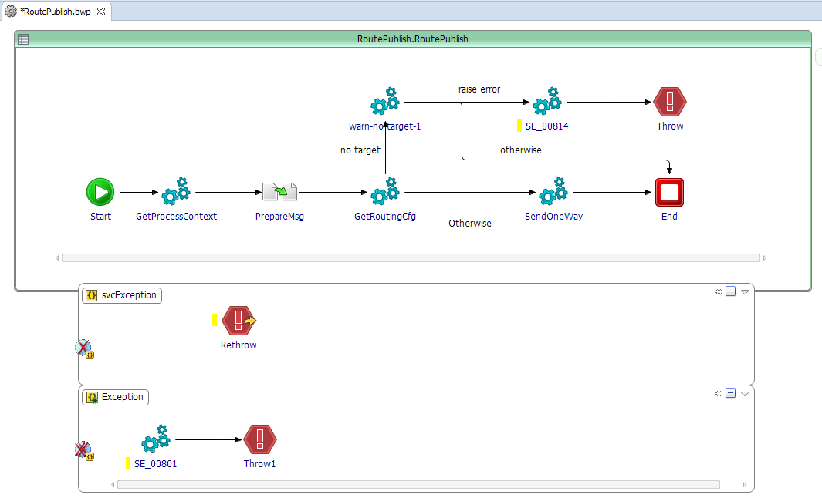
A sub process indicates it is raising [SvcException] type in the [End] activity.
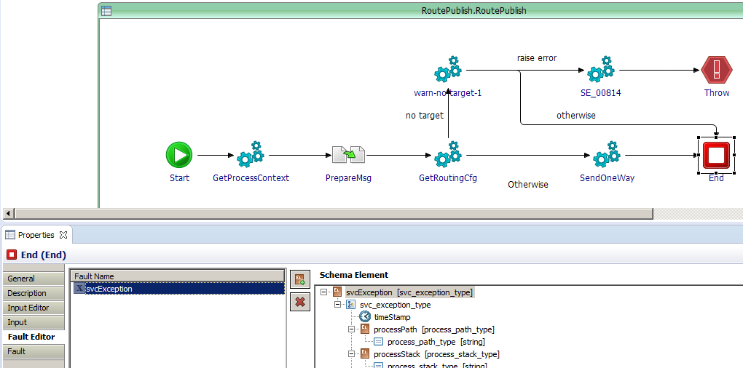

Exception handling at the service top level process
Regardless the choice of service layers, the BusinessWorks top level service process must handle any exceptions and perform a final AUDIT [LogError] call. Also, a test on the existence of a process context is required to manage exceptional failures raised before a process context is even initialized. The overall logic is also described in section 5.2.2 and 5.2.3.
Below is an example of top level Exception handling practice that should be managed in process templates and libraries.
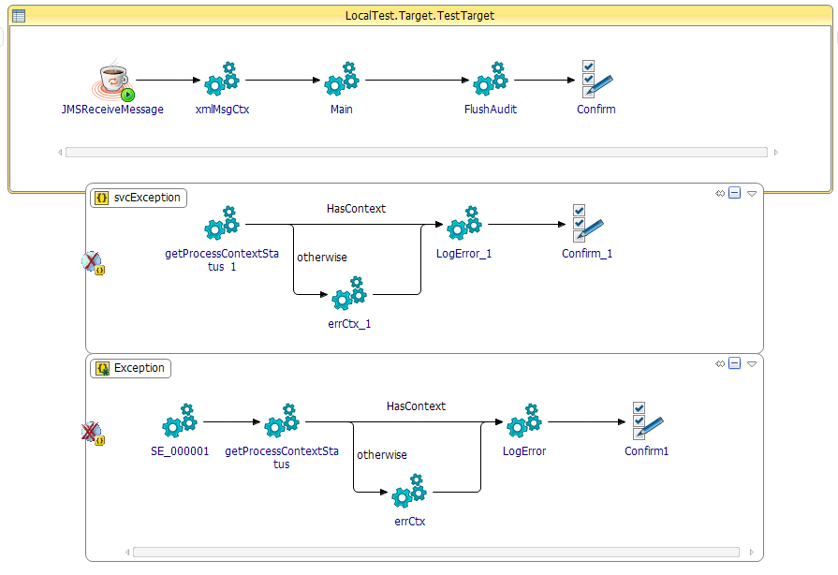
The standard error handling pattern is:
- Handled exceptions in the form of [SvcException] are directly logged via [LogError].
- Native TIBCO BW errors are first converted to a global [SvcException] (see SE000001 in the example), and then logged via [LogError].
In, any case, if it happens that the process context is not set, then a minimal process context must be set using the [errCtx] utility, prior to logging the Error with [LogError].

[core_common.sharedmodule] properties
CORE_COMMON Global Variables
GV | Description
/SharedConnections/JMS/EMS_LOG/password | JMS user password for the AUDIT bus
/SharedConnections/JMS/EMS_LOG/url | JMS server url for the AUDIT bus
/SharedConnections/JMS/EMS_LOG/user | JMS user name for the AUDIT bus
/SharedConnections/JMS/EMS_MSG/password | JMS user password for the MESSAGE bus
/SharedConnections/JMS/EMS_MSG/url | JMS server url for the MESSAGE bus
/SharedConnections/JMS/EMS_MSG/user | JMS user name for the MESSAGE bus
/SharedConnections/RV/HAWK/Daemon | TIBCO Rendezvous TCP daemon port for Hawk (used for some packaged TIBCO adapters sessions – use DSIP default values)
/SharedConnections/RV/HAWK/Network | TIBCO Rendezvous network for hawk (used for some packaged TIBCO adapters sessions – use DSIP default values)
/SharedConnections/RV/HAWK/Service | TIBCO Rendezvous UDP service port for hawk (used for some packaged TIBCO adapters sessions – use DSIP default values)
/SharedConnections/RV/MSG/Daemon | TIBCO Rendezvous TCP daemon port for messaging (used for some packaged TIBCO adapters sessions – use DSIP default values)
/SharedConnections/RV/MSG/Network | TIBCO Rendezvous network for messaging (used for some packaged TIBCO adapters sessions – use DSIP default values)
/SharedConnections/RV/MSG/Service | TIBCO Rendezvous UDP service port for messaging (used for some packaged TIBCO adapters sessions – use DSIP default values)
/FileTracing/TraceTags/ShutdownSysFailure | Tag used in file tracing for critical failures. Can be used by technical monitoring to match such issue.  Default: FATAL_SYS_FAILURE
/FileTracing/TraceTags/SvcException | Tag used in file tracing for SVC_EXCEPTION that could not be sent to monitoring. Can be used by technical monitoring to match such content.  Default: SVC_EXCEPTION
/Services/LogAudit/destination | Audit message queue destination.  Default: AH.LOCAL.ESB.AuditLogging.LogEvent
/Services/AuditClient/Properties/DefaultMsgBodyLogPolicy | Default message body logging policy (unless overwritten in audit policy activity inputs).  0: never AUDIT message body  1: always AUDIT message body on LogEntry  2: AUDIT message body only if LogError
/Services/AuditClient/Properties/RaiseExceptionOnAuditFailure | When set to “true”, a failure to execute an AUDIT step will generate an error for the current process execution.  When set to “false”, a failure to execute an AUDIT step will not generate an error. Both original logEvent and actual error may be written to the Engine log file, while the current process continues without raising an exception.  The default setup for the variable is “false”.
/Services/AuditClient/Properties/FileTraceDir | Physical directory path where AUDIT can be written to.
/Services/AuditClient/Properties/TraceToFile | “true” to activate auditing to local file. “false” to disable.  Default should be false, as tracing to local file reduces performance.
/Services/AuditClient/Properties/TraceToJMS | “true” to activate auditing to JMS. “false” to disable.  Default is “true” to enable centralized AUDIT in the CORE_LOG component.
/Services/AuditClient/Roles/DisableCustomSteps | List of customStep names for which AUDIT must be disabled. Only applicable to AUDIT policies where the “customLogStep” has been set with such predefined values.
/Services/AuditClient/Roles/TraceDebug | Enable or disable tracing of LogDebug information.
/Services/AuditClient/Roles/TraceEntry | Enable or disable tracing of LogEntry information.
/Services/AuditClient/Roles/TraceError | Enable or disable tracing of LogError information.
/Services/AuditClient/Roles/TraceExit | Enable or disable tracing of LogExit information.
/Services/AuditClient/Roles/TraceInfo | Enable or disable tracing of LogInfo information.
/Services/AuditClient/Roles/TraceWarning | Enable or disable tracing of LogWarning information.
Remark on the Source properties: the Source/* properties part of the [core_common.sharedmodule] module need to be set with the values related to the application using the shared module. For example, “/Source/ComponentName=bw.customer_billing”.
/Source/Area | (Applies to the BW application using core_common)  Component infrastructure Area name (where it is deployed).  Default: LOCAL
/Source/ComponentInstance | (Applies to the BW application that is using core_common)  Instance name for the component runtime.  Default: 1
/Source/Layer | (Applies to the BW application that is using core_common)  MC, TA, MS, EXT, FRK
/Source/ComponentName | (Applies to the BW application that is using core_common)  Name of the BusinessWork application. This can be the BW application name or other application naming standards as required by enterprise practices.

[core_audit] application

Introduction
The [core_audit] BusinessWorks application implements the following features:
- LogAudit: reads AUDIT events from JMS queue and sends the audit information to the ElasticSearch storage.
- REMEDIATION lookup: every audit event may be checked against simple rules to identify if a specific REMEDIATION notification must be sent to a REMEDIATION channel.
  - The purpose of REMEDIATION is to asynchronously trigger a specific action base on the occurrence of particular audit information. REMEDIATION is closely related to error handling and alerting functionality, but could be used for any post processing action purpose. The REMEDIATION rules are simple matching expressions based on the incoming audit event metadata and some predefined entries from a database. Rule data are initially loaded from the database and stored in a memory cache to optimize the lookup process.
- Message Resubmission: message resubmission capability based on the data captured during the service auditing. Message resubmission (currently) only applies to services using standard xmlMsg JMS messages, for which the body payload was captured. The message resubmission functionality consists in the generation of a new message based on the captured service data and the publication of the built message to the original service JMS queue.
  - Note: resubmission support for other formats than [xmlMsg] can be considered at a later stage via proper extension.

[LogAudit] service

Introduction
The [LogAudit] service reads the AUDIT messages from a JMS queue. The audit message is checked for remediation rules in the event catalog (section 6.3), then audit information is mapped to ElasticSearch space for storage, using HTTP service calls.
The AUDIT information is transported as a JSON message containing all the log activity performed by one service execution.

[auditMsg] structure
The inbound [auditMsg] message is a JSON message rendered from XML element built in the audit client library.
[framework/bw.core_common.sharedmodule/Schemas/Audit/AuditMsg.xsd]
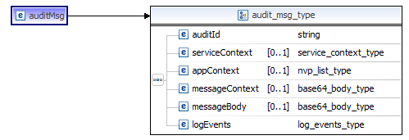
The table below describes the [logEvent] element.
LogEvent element
Field | Card | Description
auditId | 1 | Unique id for the auditMsg
serviceContext | ? | Structure containing all process context information except message body.
serviceContext/contextTimestamp | 1 | Timestamp the process context is created.
serviceContext/flowId | 1 | Id of the ESB flow
serviceContext/seviceId | 1 | Id of the service instance
serviceContext/contextId | 1 | Id of the context (corresponds to the unique service/serviceName execution instance)
serviceContext/flowCode | 1 | Code of the ESB flow
serviceContext/taskCode | 1 | The name of the ESB task the service execution is linked to.
serviceContext/serviceName | 1 | Name of the ESB service
serviceContext/processPath | 1 | Path of the top level process implementing the service
serviceContext/layer | 1 | Type of component implementing the service.  MC,MCI,MCO,MCS,TA,TAI,TAO,MS,EXT,FRK
serviceContext/area | ? | Name of the infradtructure area the service is deployed in.
serviceContext/componentName | ? | Name of the component implementing the service.
serviceContext/componentInstance | ? | Name of the instance of the component implementing the service.
serviceContext/parentFlowId | ? | Parent flow id.
serviceContext/parentTaskId | ? | Parent service id = the id of the task instance the message is coming from.
serviceContext/parentCtxId | ? | Parent context id = the id of the context instance the message is coming from.
serviceContext/domainName | ? | BusinessWorks domain name.
serviceContext/appName | ? | BusinessWorks application name.
serviceContext/appNodeName | ? | BusinessWorks domain app node name
serviceContext/host | ? | Hostname the audit id sent from.
serviceContext/engineName | ? | BusinessWorks engine Name.
serviceContext/beginTS | ? | Timestamp of the process startup.
serviceContext/endTS | ? | Timestamp of the process end.
serviceContext/contextStatus | ? | Status of the service: SUCCESS or ERROR.
serviceContext/isFlowInitiator | ? | True if the service is a flow initiator. Otherwise false.
serviceContext/messageType | ? | Type of messaging for the service.  XMLMSG_JMS: standard xmlMsg envelope over JMS transport.  ANY_JMS: generic text over JMS transport.  SOAP_JMS: SOAP over JMS transport.  SOAP_HTTP: SOAP over HTTP transport.  ANY_ANY: any text over any protocol.
serviceContext/resubmitInd | ? | Id of the resubmission (if message is a resubmission).
serviceContext/resubmitCount | ? | Number of the retransmission (if message is a resubmission).
appContext/nvpList/nvpElement | * | Optional business application context key/value pairs.  AppContext properties are attached to the ESB flow Id execution and may be used to lookup AUDIT traces in the audit storage, from specific business key properties. The [auditMsg] message contains the appContext elements added in any of the logging activities.
messageContext | ? | Base64 encoded string representing the process context XML document. See section 5.2.4 for details on messageContext content.
messageBody | ? | Base64 encoded string of the service input message body (if required in the audit policy).
logEvents | 1 | All lof events collected during the service execution.
logEvents/logEvent | * | logEvent element
logEvents/logEvent/index | 1 | Index of the logEvent record in the list (starts at 1).
logEvents/logEvent/contextId | 1 | Process context id reference.
logEvents/logEvent/timestamp | 1 | Timestamp the log was recorded.
logEvents/logEvent/processPath | 1 | Path pf the process having recorded the log.
logEvents/logEvent/role | 1 | Role of the log (ERROR, INFO, DEBUG, WARNING)
logEvents/logEvent/code | ? | Optional log code, or error code (if error)
logEvents/logEvent/txt | ? | Log text description
logEvents/logEvent/bodyTxt | ? | Lon text description (base64 encoded).
logEvents/logEvent/customStep | ? | Optional custom log step.
logEvents/logEvent/error | ? | Error specific information.
logEvents/logEvent/error/errType |  | B: business, T: technical
logEvents/logEvent/error/errSeverity |  | 1,2,3,4 (4 less severe).
logEvents/logEvent/error/errProcessStack |  | Excpetion process stack (process calls stack).
logEvents/logEvent/error/errInputData |  | Optional input data for the error.
logEvents/logEvent/error/errStackTrace |  | Error stack trace if provided.
logEvents/logEvent/error/errIsNonTerminal |  | True if the error is considered not terminal (did not cause the process to end).
logEvents/logEvent/disableMonitoringLookup | ? | True to indicate that remediation lookup must not be done.
logEvents/logEvent/monitoringLogicProps | ? | Optional monitoring logic dynamic properties (for remediation processing).
logEvents/logEvent/monitoringLogicBody | ? | Optional monitoring logic dynamic body (for remediation processing).

[LogAudit] Process
The [LogAudit] process is hosted in the [framework/bw.core_audit] BusinessWorks project component;
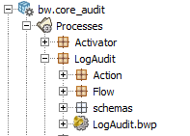
The process receives a JSON message on a JMS queue and parses the content as a [auditMsg] element. The [auditMsg] is sent to the ElasticSearch storage and the remediation lookup is executed.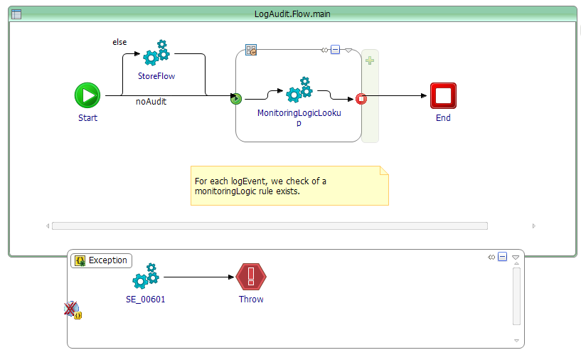
Exception will result in two possible scenarios:
- If the exception is related to a specific data issue, then the [SvcException] and original [logEventSeq] are written to the engine log file, and the error will be detected by the technical monitoring.
- If the exception is related to the unavailability of the ElasticSearch database, then the main process will retry N times and finally raise a fatal exception leading to the application exit. In this case, a specific SHUTDOWN message is also written to the Engine log file for the technical monitoring.
The detection of the fatal HTTP exception type uses the utility:
[framework/bw.core_common.sharedmodule.ProcessUtilities.System.SysUnavailability.CheckSys_SOAP_HTTP]
Note: If you discover wrong application shutdown behavior, you may need to tune the utility part of the framework maintenance effort. The exit of the core audit application must only be performed because of fatal sub-system unavailability.
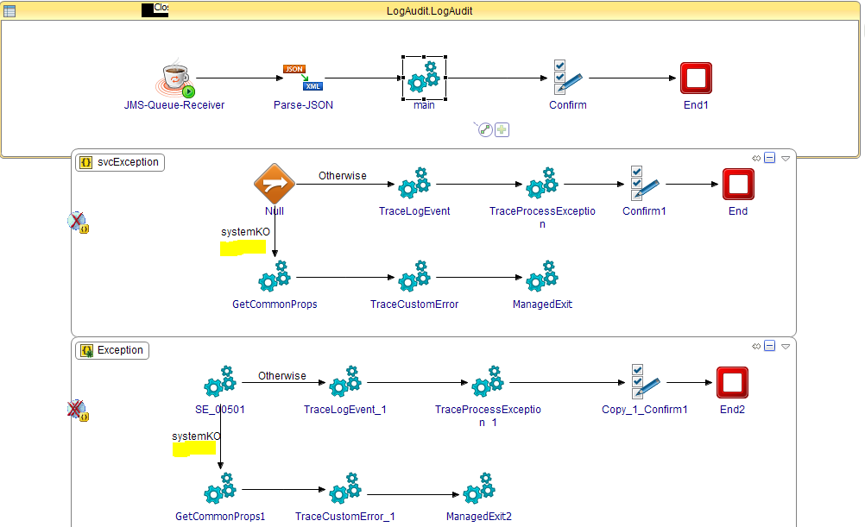

The [auditMsg] data is sent to the ElasticSearch storage using http calls. The mapping of audit data to the ElasticSearch space depends on the definition of ElasticSearch indexes. Currently, we perform 3 calls:
- StoreServiceContext: Stores the complete service context data AND all log entries as part of a single index for ElasticSearch.
- StoreMsgContext: Store the whole MessageContext data including message body (if provided).
- StoreAppcontext: stores the optional application context properties in a separate ElasticSearch index.
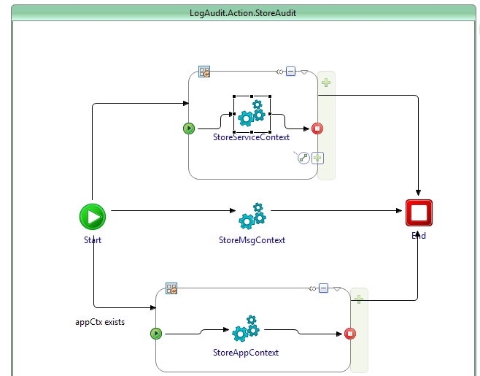
In order to manage the proper decoupling between the [AuditMsg] and the ElasticSearch structures, we make use of a specific schema to carry the various indexed structures:
[framework/bw.core_audit /Schemas/LogAudit/StoreAudit/AuditMsgES.xsd]
The [AuditMsgES] structures represent the specific information input in ElasticSearch. The mapping from the inbound [AuditMsg] is evident (refer to section 6.2.2).
The [payload] and [appContext] indexes:
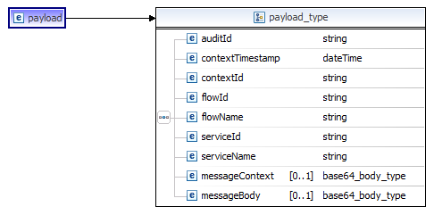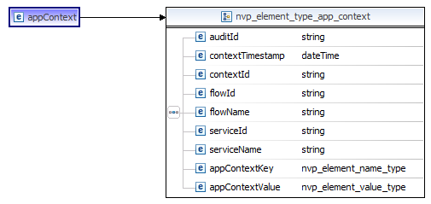

The serviceContext index:
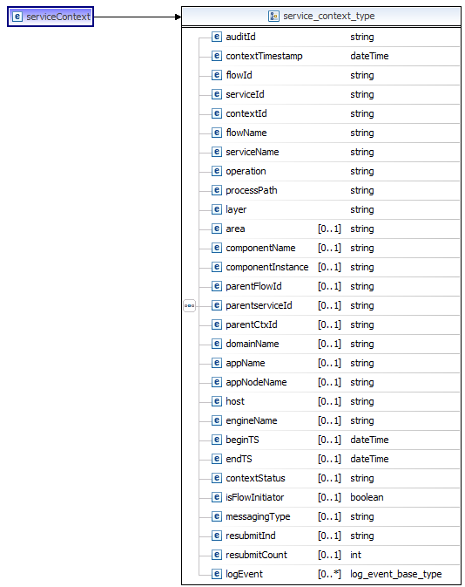

Monitoring Logic Lookup (or remediation lookup)

Monitoring Lookup
The REMEDIATION solution allows asynchronous actions to be executed based on incoming AUDIT events.
The [LogAudit] service triggers the [MonitoringLogicLookup] sub-process in order to evaluate if the inbound event matches pre-defined conditions leading to the dispatch of a notification to external REMEDIATION channels. As such the MonitoringLogic lookup acts as a content-based router for the inbound AUDIT events.
The monitoring logic routing rules are stored in a database table and loaded in cache using HSQLDB (http://hsqldb.org/) in-memory storage. The persistent database schema is described in section 6.6 (tables EVT_CATALOG, CATALOG_UPDATE_NOTIF).
The monitoring logic lookup reads all rules matching the following conditions:
SELECT
RULEID,
RULELABEL,
SOLUTIONHINT,
DOCLINK,
DESTINATION
FROM
EVT_CATALOG
WHERE
(S_COMPAREA=? OR S_COMPAREA='*')
AND (S_COMPNAME=? OR S_COMPNAME='*')
AND (S_COMPINST=? OR S_COMPINST='*')
AND (S_FLOWCODE=? OR S_FLOWCODE='*')
AND (S_STEPNAME=? OR S_STEPNAME='*')
AND (S_SERVICENAME=? OR S_SERVICENAME='*')
AND (S_LOGROLE=? OR S_LOGROLE='*')
AND (S_LOGCODE=? OR S_LOGCODE='*')
AND (S_CUSTOMLOGSTEP=? OR S_CUSTOMLOGSTEP='*')
ORDER BY RULEPRIORITY DESC
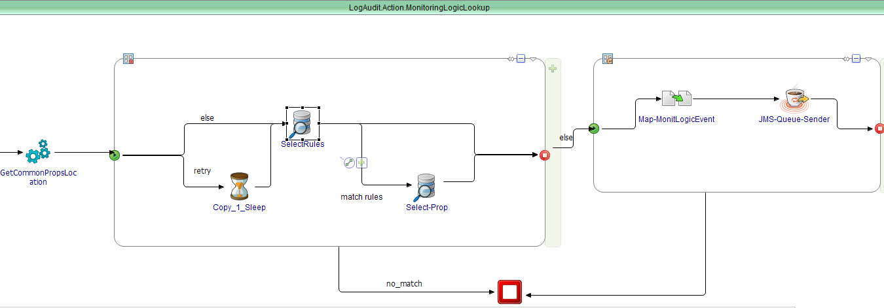
Every match defines a target DESTINATION leading to the publication of a [monitoringLogicEvent]. Automated rule lookup retry is executed in the case the rule set is temporarily unavailable (such as in the case or DB re-sync for example). [MonitoringLogicEvent] are consumed by REMEDIATION channel services performing predefined logic processing see section 7.
In addition to the rule entry (defining the target REMEDIATION queue/destination), the monitoringLogic Lookup function reads optional generic properties associated with the rule. MonitoringLogic rule properties allow specific behavior to be specified as input to the target remediation channel. Example, a remediation channel for automated message resubmission may specify custom monitoringLogic rules such as “MaxRetryCount”, or “delayBetweenRetry”. The properties are associated to the rule instance that is matched during the lookup. So different rules may be recorded with different properties for a same REMEDIATION channel destination, based on specific log codes for example…
The table below describes the [monitoringLogicEvent] structure:
[framework/bw.core_common.sharedmodule/Schemas/Audit/MonitoringLogicEvent.xsd]
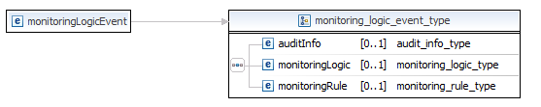
[monitoringLogicEvent]
Field | Card | Description
auditInfo | ? | Information from the AUDIT message (logEvent).
auditInfo/logEventTS | 1 | Log timestamp (from client service side) .
auditInfo/logCode | ? | Log code, as set by the client service.
auditInfo/logTxt | ? | Log text.
auditInfo/logRole | ? | Log role (INFO, ERROR, WARNING, ENTRY, EXIT, DEBUG) .
auditInfo/customLogStep | ? | Custom log step name.
auditInfo/logProcessPath | ? | Process path having generated the log.
auditInfo/contextId | 1 | Id of the current process context
auditInfo/location/area | 1 | Infrastructure area where the service is executed
auditInfo/location/layer | 1 | Layer name from the component executing the service  MC,MCI,MCO,MCS,TA,TAI,TAO,MS,EXT,FRK
auditInfo/location/component/componentName | 1 | Name of the component executing the service
auditInfo/location/component/componentInstance | 1 | Name of the instance of the component executing the service
auditInfo/flowId | 1 | End-to-end ESB flowId
auditInfo/taskId | 1 | Process current taskId
auditInfo/flowCode | 1 | Code of the ESB flow in context with the service execution.
auditInfo/taskCode | 1 | The name of the ESB task the service execution is linked to.
auditInfo/serviceName | 1 | Current service name.
auditInfo/resubmitCount | ? | ESB message resubmission count.
auditInfo/svcException | ? | Exception details (as defined in section 5.3.1)
monitoringLogic | ? | Specific monitoring logic information provided by the client service (together with logging information).
monitoringLogic/enableMonitoringLogic | ? | “True”
monitoringLogic/monitoringProperties/nvpList/nvpElement | * | Optional monitoring logic application properties.
monitoringLogic/monitoringBody/* | ? | Optional monitoring logic application element.
monitoringRule/ruleId | ? | Id of the matched monitoring logic rule
monitoringRule/ruleLabel | ? | Monitoring logic rule label.
monitoringRule/ruleSolutionHint | ? | Monitoring logic rule action hint (used for support channels)
monitoringRule/ruleDocLink | ? | Monitoring logic rule action document (used for support channels)
monitoringRule/destination | ? | JMS queue destination for the REMEDIATION notification.
monitoringRule/ruleProperties | ? | Monitoring logic rule pre-configured properties.
monitoringRule/ruleProperties/nvpList/nvpElement | * | Monitoring logic rule pre-configured properties element.

Rule source and cache initialization
The MonitoringLogic lookup also comes with a set of utilities in order to manage the loading of rules into the in-memory database, and the reload of rules in the event of rules updates in the persistent DB storage.
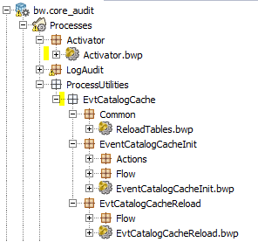
[Activator]
The [Activator] process runs during the application initialization. The process calls the catalog loading process: [EvtCatalogCacheInit]
[EvtCatalogCacheInit]
The [EvtCatalogCacheInit] services starts on BusinessWorks application startup (called by the Activator). It reads the persistent rules from the DB storage, and initializes the in-memory rule database (HSQLDB database).
[EvtCatalogCacheReload]
The persistent database also manages modification triggers to capture any update made to the rule collection. On update, a record is written to a notification table that can be detected by the [EvtCatalogCacheReload] utility. The in memory cache is then reloaded and the notification is cleared.

Message resubmission service

Principle
Asynchronous services reading from JMS queues can beneficiate from message resubmissions, with the condition of enabling the message body capture in the AUDIT policies.
Message body capture may be activated on [LogEntry] audit activity or (LogError]. When body capture is activated, the AUDIT framework sends a copy of the full service message to the CORE_LOG component and the message body is written in persistence together with the message metadata (MSG_BODY and PROCESS_CONTEXT audit tables).
(1): A user (or other application) requests a resubmission providing a [contextId].
(2): The [fetchMessage] service reads references of messages to fetch, and (3) requests the data to ElasticSearch, and (4) writes the original message metadata and body to the resubmission database.
(5): The Resubmission service reads records of messages ready to be resubmitted.
(6): Messages are assembled and sent to the original message queue.

Message resubmission request
The Resubmission request is based on the execution of a stored procedure that performs a copy of the original message data into a RESUBMISION table. The stored procedure prototype is:
PROCEDURE spResubMsgCtxId
@ctxId nvarchar(64): Framework [contextId] reference to resubmit.
@resubDate datetime = NULL: date for resubmission. NULL means now.
@resubStatus nvarchar(64) = NULL: initial status for the resubmission?
- NULL defaults to ‘FETCHMSG_READY’: records can be fetched from ElasticSearch, and then READY to be
- ‘FETCHMSG_WAIT’: records can be fetched from ElasticSearch, but will stay in WAIT status; pending some custom actions (for example an edition…). The status may be put to READY via operation.
The other statuses are:
- READY: the record will be read by the resubmission service for publication (it is expected that the full message content is provided in the DB).
- WAIT: the record is left untouched in the DB.
- ERROR: the record was selected for processing but there was an error.
- SUCCESS: Resubmission comleted OK.
Example of message resubmission request:
-- EXEC EXAMPLES

EXEC spResubMsgCtxId 'xxxxxxxxxxxxxxxxxxxxxxxxxxxxxxxx', '2017/01/02 13:00:00','FETCHMSG_READY';
GO
EXEC spResubMsgCtxId 'xxxxxxxxxxxxxxxxxxxxxxxxxxxxxxxx', '2017/01/02 13:00:00'
GO

EXEC spResubMsgCtxId 'xxxxxxxxxxxxxxxxxxxxxxxxxxxxxxxx'
GO

EXEC spResubMsgCtxId 'xxxxxxxxxxxxxxxxxxxxxxxxxxxxxxxx', '2017/01/02 13:00:00','FETCHMSG_WAIT';
GO

Message resubmission processes
The resubmission services are implemented in: [framework/bw.core_audit/Processes/Resubmission]
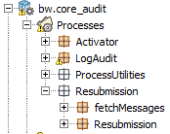

The [fetchMessages] service is responsible for retrieving message data from the ElasticSearch platform, for the resubmission record in the FETCHMSG_READY state.
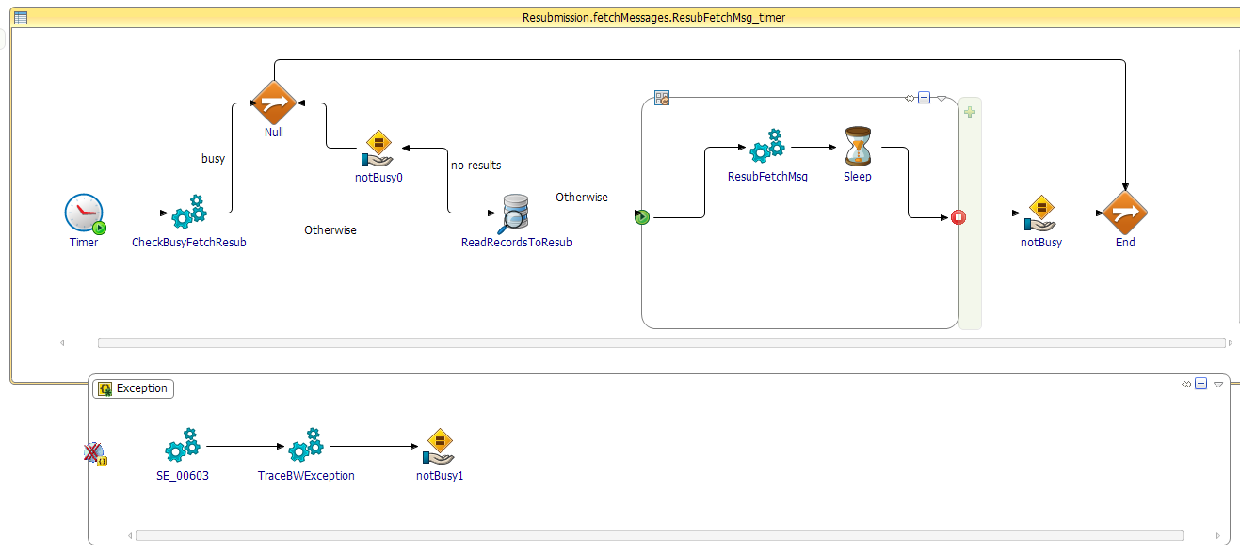
A single process context is associated with each resubmission record, and may be tracked in the audit system (separate flowId, because the message flowId is not known yet).
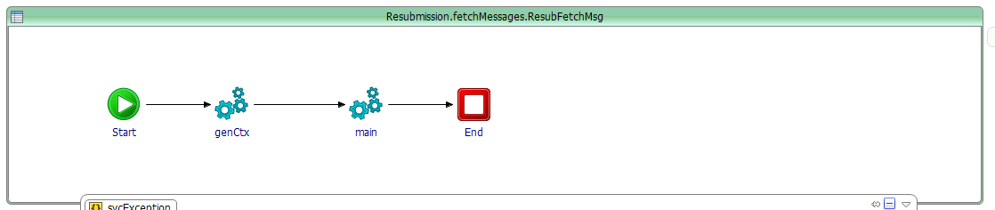
The message metadata and body is read from ElasticSearch platform using REST calls and the data is staged into the Resubmission DB.
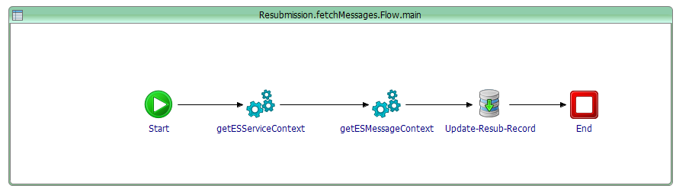

[core_audit] configuration (global variables)
This section describes all the CORE_LOG component global variables
CORE_LOG Global Variables
GV | Description
/Services/LogAudit/destination | Destination queue where to read [auditMsg] from.
/Services/LogAudit/maxSession | JMS max sessions for the [LogAudit] service.
/Services/LogAudit/StoreAudit/serviceContextPath | REST resource path for serviceContext upload.
/Services/LogAudit/StoreAudit/maxRetry | Number of Retry if the call to ElasticSearch fails.
/Services/LogAudit/StoreAudit/delayBetweenRetryMS | Delay between Retry if the call to ElasticSearch fails.
/Services/LogAudit/StoreAudit/hostname | Hostname of the target ElasticSearch REST HTTP service.
/Services/LogAudit/StoreAudit/port | TCP Port of the target ElasticSearch REST HTTP service.
/Services/LogAudit/StoreAudit/payloadPath | REST resource path for payload upload.
/Services/LogAudit/StoreAudit/appContextPath | REST resource path for appContext upload.
/Services/LogAudit/StoreAudit/DisableStoreAudit | Set to true to disable the AUDIT to ElasticSearch.
/Services/LogAudit/MonitoringLogicLookup/lookupRetryDelayMS | Delay between Retry if the monitoring logic lookup fails.
/Services/LogAudit/MonitoringLogicLookup/lookupRetryNo | Number of Retry if the monitoring logic lookup fails.
/Services/PublishMonitLogic/taskCode | MonitoringLogic (the name of the ESB task the service execution is linked to.)
/Services/PublishMonitLogic/serviceName | MonitLogicNotification (name of the monitoring logic publication service)
/Services/EvtCatalogRuleCache/CacheRefreshDelayMS | Frequency (ms) for the monitoring rule cache refresh.
/Services/EvtCatalogRuleCache/ExitOnRuleReloadError | Set to true to Exit the application if the catalog cannot be reloaded (error).
/Services/ResubFetchMsg/pollDelayMS | Frequency (ms) for polling the Resubmission table for read message to fetch.
/Services/ResubFetchMsg/blockSize | Size of the bloc of records (message fetch) to read from the resubmission database.
/Services/ResubFetchMsg/statusFetchMsgThenReady | FETCHMSG_READY
/Services/ResubFetchMsg/statusFetchMsgThenWait | FETCHMSG_WAIT
/Services/Resub/blockSize | Size of the bloc of records (message send) to read from the resubmission database.
/Services/Resub/pollDelayMS | Frequency (ms) for polling the Resubmission table for read message to send.
/Services/Resub/statusError | ERROR
/Services/Resub/statusReady | READY
/Services/Resub/statusSuccess | SUCCESS
/Services/Resub/statusWait | WAIT
/SharedConnections/JDBC/CORE_AUDIT/JDBCURL | url for the core audit database.
/SharedConnections/JDBC/CORE_AUDIT/MaxConnections | max connection No for the core audit v.
/SharedConnections/JDBC/CORE_AUDIT/MaxRows | default max row to read for the core audit database.
/SharedConnections/JDBC/CORE_AUDIT/Password | Not used (sqlServer integrated security)
/SharedConnections/JDBC/CORE_AUDIT/Timeout | default timeout for queries for the core audit database.
/SharedConnections/JDBC/CORE_AUDIT/User | Not used (sqlServer integrated security)
/SharedConnections/JDBC/CORE_AUDIT_CACHE/JDBCURL | url for the event catalog in-memory database.
/SharedConnections/JDBC/CORE_AUDIT_CACHE/MaxConnections | max connection No for the event catalog in-memory database..
/SharedConnections/JDBC/CORE_AUDIT_CACHE/MaxRows | default max row to read for the event catalog in-memory database..
/SharedConnections/JDBC/CORE_AUDIT_CACHE/Password | na
/SharedConnections/JDBC/CORE_AUDIT_CACHE/Timeout | default timeout for queries for the event catalog in-memory database.
/SharedConnections/JDBC/CORE_AUDIT_CACHE/User | na
/TraceTags/EVTCATALOG_RULE_CACHE_INIT_FAILURE | Fatal trace tag written to engine log in case of event catalog rule cache init failure.
/TraceTags/AUDIT_MSG | Trace tag written to engine log in case of processing issue with [auditMsg] data being then written to the engine log for investigations.

AUDIT database

Overall schema view
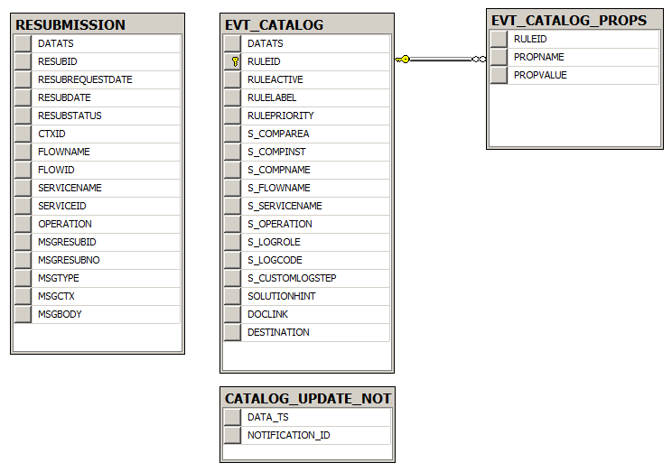

AUDIT database
TABLE | Description
RESUBMISISON | Contains resubmission requests and associated messages.
EVT_CATALOG | Contains all the monitoring logic rules for dispatching to REMEDIATION channels.
EVT_CATALOG_PROPS | Contains properties (NVP) for EVT_CATALOG records.
CATALOG_UPDATE_NOTIFICATION | Contains notification records to indicate a change was performed in the EVT catalog rules or properties.

Table description
The AUDIT database contains a few tables described below. There is no relational integrity constraints applied in any column in order to maximize the de-normalization and keep some agility in log information management.
AUDIT Database
TABLE_NAME | COLUMN_NAME | DATA_TYPE | DATA_LEN  (bytes) | Description
CATALOG_UPDATE_NOTIF | DATA_TS | DATETIME | - | Timestamp the record is inserted.
CATALOG_UPDATE_NOTIF | NOTIFICATION_ID | NVARCHAR | 64 | Unique id for the notification record that the EVT CATALOG was updated.
EVT_CATALOG | DATATS | DATETIME | - | Timestamp the record is inserted.
EVT_CATALOG | RULEID | NVARCHAR | 64 | Unique rule Id (UUID)
EVT_CATALOG | RULEACTIVE | CHAR | 1 | Y for active, N for inactive.
EVT_CATALOG | RULELABEL | NVARCHAR | 255 | Name of the rule (descriptive)
EVT_CATALOG | RULEPRIORITY | INT | - | Rule priority – useful in case many rules match a same destination. 1 is higher priority.
EVT_CATALOG | S_COMPAREA | NVARCHAR | 64 | Rule matching criteria – Component area name.  Use * for any value.
EVT_CATALOG | S_COMPNAME | NVARCHAR | 32 | Rule matching criteria – Component name.  Use * for any value.
EVT_CATALOG | S_COMPINST | NVARCHAR | 32 | Rule matching criteria – Component instance name.  Use * for any value.
EVT_CATALOG | S_FLOWCODE | NVARCHAR | 128 | Rule matching criteria – ESB flow code.  Use * for any value.
EVT_CATALOG | S_TASKCODE | NVARCHAR | 128 | Rule matching criteria – ESB task name.
EVT_CATALOG | S_SERVICENAME | NVARCHAR | 128 | Rule matching criteria – ESB service name  Use * for any value.
EVT_CATALOG | S_LOGROLE | NVARCHAR | 16 | Rule matching criteria – AUDIT log role (INFO, ERROR, WARNING, ENTRY, EXIT)  Use * for any value.
EVT_CATALOG | S_LOGCODE | NVARCHAR | 32 | Rule matching criteria – AUDIT log code.  Use * for any value.
EVT_CATALOG | S_CUSTOMLOGSTEP | NVARCHAR | 64 | Rule matching criteria – AUDIT custom log step name.  Use * for any value.
EVT_CATALOG | SOLUTIONHINT | NVARCHAR | 255 | Solution recommendation (if the rule is used in the context of a known exception condition).
EVT_CATALOG | DOCLINK | NVARCHAR | 255 | Document link related to the notification (may be a support doc).
EVT_CATALOG | DESTINATION | NVARCHAR | 255 | The target JMS q name for sending a Monitoring Logic event to a matched REMEDIATION channel.
EVT_CATALOG_PROPS | RULEID | NVARCHAR | 64 | Id of the rule referenced for this property.
EVT_CATALOG_PROPS | PROPNAME | NVARCHAR | 64 | Rule property name.
EVT_CATALOG_PROPS | PROPVALUE | text | - | Rule property value.
RESUBMISSION | DATATS | DATETIME | - | Timestamp the record is inserted.
RESUBMISSION | RESUBID | NVARCHAR | 64 | Unique resubmission id (UUID).
RESUBMISSION | RESUBREQUESTDATE | DATETIME | - | Requested Date of the resubmission.
RESUBMISSION | RESUBDATE | DATETIME | - | Actual Date of the resubmission.
RESUBMISSION | RESUBSTATUS | NVARCHAR | 32 | Status of the resubmission:  FETCHMSG_READY: indicate the record must be processed for fetching message content and metadata. Then move to READY status.  FETCHMSG_WAIT: indicate the record must be processed for fetching message content and metadata. Then move to WAIT status, where it will have to be manually set to READY when needed (maybe pending edition).  READY: Record message is ready to be sent.  WAIT: Waiting, till it will have to be manually set to READY when needed (maybe pending edition).  ERROR: record processing error.  SUCCESS: Resubmission completed.
RESUBMISSION | CTXID | NVARCHAR | 64 | Original message ctxId
 | FLOWCODE | NVARCHAR | 128 | Code of the flow of the context being resubmitted.
 | FLOWID | NVARCHAR | 64 | FlowId of the context being resubmitted.
 | TASKCODE | NVARCHAR | 128 | Name of the ESB task code from the context being resubmitted.
 | TASKID | NVARCHAR | 64 | TaskId of the context being resubmitted.
 | SERVICENAME | NVARCHAR | 128 | Name of the service in the context being resubmitted.
 | MSGRESUBID | NVARCHAR | 64 | Original Resub Id of the message.
 | MSGRESUBNO | int | - | Original Resub No of the message.
 | MSGTYPE | NVARCHAR | 64 | Type of the message recorded for resubmission.
 | MSGCTX | text | - | Full xml representation of the original message context.
 | MSGBODY | text | - | Full text representation of the original message body.

Remediation channels (CORE_REMEDIATION)

Introduction
The REMEDIATION solution (also referred as Monitoring Logic) enables the execution of predefined services using asynchronous notification issued from the logical routing of the ESB services AUDIT activity. It is a generic framework solution for business service to beneficiate from a configurable post-processing capability usually dedicated o error handling and functional monitoring and alerting logic.
The solution is introduced in section 3.3.3. The REMEDIATION architecture includes two components:
- The Monitoring Logic lookup is the routing of the AUDIT events based on predefined rules. This function is implemented in the ESB_CORE/CORE_LOG component (see section 6.3).
- The remediation channels are the services consuming the routed [MonitoringLogicEvent] for executing the actual post processing logic.
Remediation channels may be developed as common services that can be used with any service implementation. Such Remediation channels are implemented in the [remediation/bw.core_remediation] component. Beside “shared channels”, a particular ESB flow may implement specific REMEDIATION channels in its own application, responding to particular functional monitoring needs.
The EvENT framework baseline comes with three shared REMEDIATION channels. More shared channels will be added depending on the platform needs.

REMEDIATION CHANNEL generic interface
A remediation channel is essentially a logical information subscriber of a generic [MonitoringLogicEvent] structured message. Every REMEDIATION channel uses the same subscription interface. The [MonitoringLogicEvent] event schema is documented in section 6.3.1.
Remediation channels services may use the same top level process definition, as shown in the below channel example. A remediation service uses standard ESB [xmlMsg] message envelope and can beneficiate from AUDIT policy usage, as a conventional business service implementation.
Note: Because REMEDIATION can use AUDIT policies, it may be important you ensure you do not create “loop” effects in the REMEDIATION channel. For example, a remediation channel handling all “Errors” may receive notifications for its own errors and start a loop if the error is reproduced on every occurrence… In the example below (channel EmailCache), we detect that the inbound message comes from REMEDIATION itself, and we ensure that monitoring logic is disabled in case of such error (in LogError mapping), so that we do not get notification for our own errors.
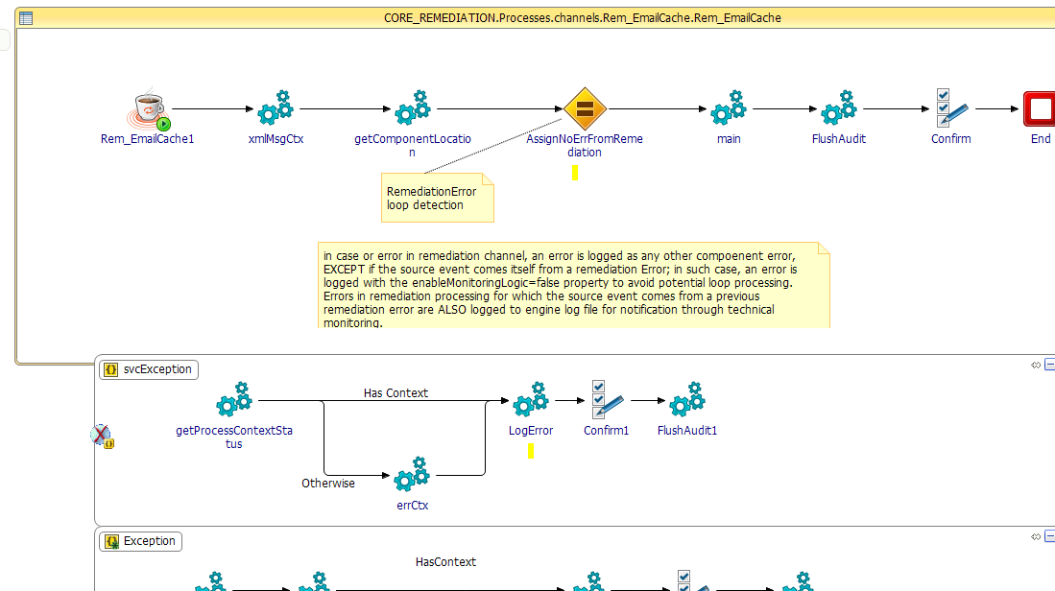

Remediation service properties
The remediation channels are often built as generic services used by many ESB flows. Remediation services usually accept variable properties that can be set from different input:
- GLOBAL VARIABLE: default values for all service invocation, defined in the CORE_REMEDIATION BW project for the particular channel.
- Monitoring rule property: specific for a given rule, it is defined in the monitoring rule properties catalog (from DB). Overwrite properties values specified by global variable.
- Dynamically: provided by the business service during the AUDIT step, using the monitoring logic properties. Overwrite monitoring rule properties values.

REMEDIATION channels

EmailCache channel

Service description
The [Rem_EmailCache] remediation channel sends a generic monitoring event email to a predefined email address. It is typically used to send operational notifications to the project support teams based on particular flow conditions and exceptions.
The [Rem_EmailCache] channel receives a [MonitoringLogicEvent] notification and converts the content to a predefined email body (xslt conversion) sent to a static or dynamic email address.
In addition, a notification CACHE may be used to limit the number of email sent for a particular source. All notification matching a same set of properties that are received within a configured time period will lead to only one email generation. Basically, the first notification triggers an email and put in cache its signature. All new notification matching signature in the cache are discarded. The signature is removed from the cache after configurable delay expiration. The cache can be defaulted to 0 to indicate no cache usage, where every notification would lead to an email to be sent.
See below the properties section for all configurable service properties.
The cache signature (hash map) is built from of the following [MonitoringLogicEvent] attributes:
ruleId, area,, componentName, componentInstance, flowCode,, taskCode, logRole, logCode
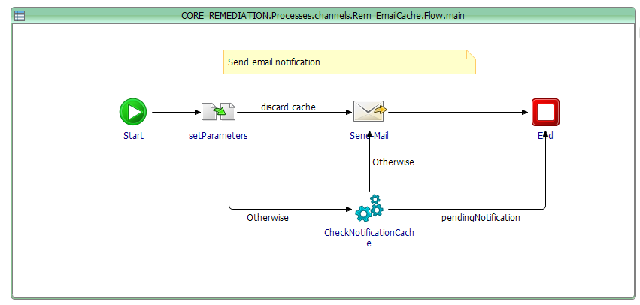
The [ClearExpiredNotificationCache] service periodically checks for expired cache items and remove them from the cache.
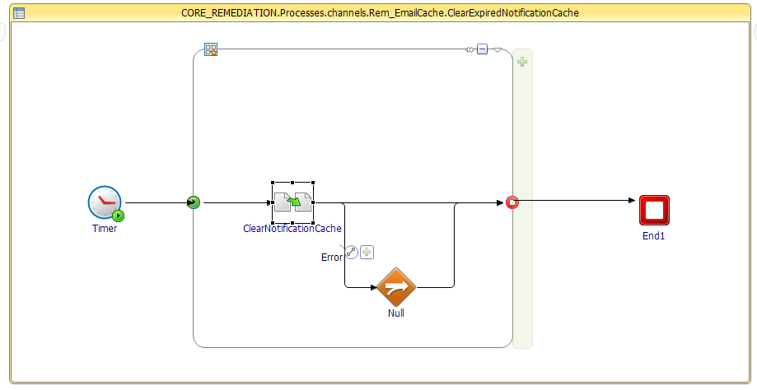
Below is the picture of a standard email cache notification. Currently, the template is just part of the hardcoded mapping.
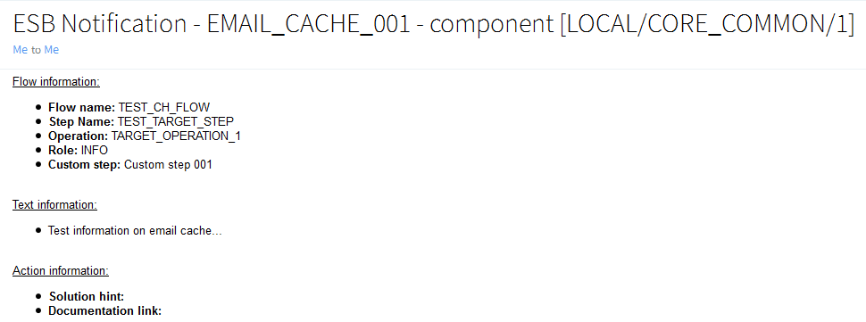

Properties
Remediation – EmailCache channel service properties
Property | Static default GV | Monitoring  rule property | Dynamic  monitoringLogic  property | Description
CACHE_RETENTION_DELAY | CORE_REMEDIATION/SvcProps/Rem_EMAILCache/DefaultCacheRetentionDelayMS | yes | yes | Cache retention delay. After expiration, new notification trigger email.
EMAIL_CONTENT_TYPE | CORE_REMEDIATION/SvcProps/Rem_EMAILCache/Properties/EMAIL_CONTENT_TYPE | yes | yes | “text/html” (default)  Or  “text/plain”
EMAIL_FROM | CORE_REMEDIATION/SvcProps/Rem_EMAILCache/Properties/EMAIL_FROM | yes | yes | Email sender identification
EMAIL_TO | CORE_REMEDIATION/SvcProps/Rem_EMAILCache/Properties/EMAIL_TO | yes | yes | Email recipient valid email address)

Resubmission channel

Service description
The [Resubmission] remediation channel automates the resubmission of ESB JMS messages based on monitoring logic rule static and/or dynamic properties.
Currently, the message resubmission framework capability can only resubmit the messages received on a standard framework (xmlMsg] on a jms transport (queue).
The remediation channel [Rem_Resubmission] relies on the Resubmission service defined in the [framewofk/bw.core_audit] BW component described in section 6.4.
The message to be resubmitted is identified by the inbound process context Id. The value of the process context can however be read from different source:
- By default, the process context id is the [CtxId] information coming from the inbound [MonitoringLogicEvent] that is related to the actual current ESB service having triggered an AUDIT notification leading to this remediation channel invocation.
- The process context id can however be overwritten by dynamic monitoring logic property set by the ESB service, for the purpose of requesting a message resubmission from another point (other service) fom the one currently executing.
Beside the context id, other properties such as resubmission delay and maximum number of resubmission can be set by global variables, monitoring logic rule properties, or dynamic monitoring logic property from the AUDIT client interface (see property section below).
The remediation channel [Resubmission] records the resubmission request by invoking the required stored procedure on the AUDIT database.
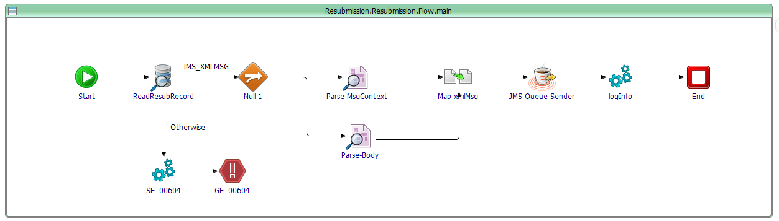

Properties
Remediation – Resubmission channel service properties
Property | Static default GV | Monitoring  rule property | Dynamic  monitoringLogic  property | Description
OVERWRITE_RESUB_CTXID | no | no | yes | Allows the ESB service to request a resubmission for another message (contextId) than the current one.
RESUB_DELAY | CORE_REMEDIATION/SvcProps/RemSvc_Resubmission/Properties/RESUB_DELAY | yes | yes | Delay after which the resubmission should be run.
RESUB_MAX_COUNT | CORE_REMEDIATION/SvcProps/RemSvc_Resubmission/Properties/RESUB_MAX_COUNT | yes | yes | Max number of consecutive resubmission allowed for the message (every resubmission sends the current resubmission count with the message as a JMS property).

GenericEmail channel

Service description
The [Rem_GenericEmail] remediation channel sends an email with configurable body and email fields based on Monitoring Logic rule template and dynamic MonitoringLogic properties match/replacement. The template/replace behavior follows a particular logic:
- The email body, from, to and subject *MUST* be provided in the monitoring logic RULE catalog (in the DB). The values may be static values or include tokens in the form %%TOKEN_NAME%%. For example, you may specify the rule property: EMAIL_BODY_TMPL=”Hi Mr %%CustomerName%%, thank you for your order”. This defined an email body where the token %%CustomerName%% should be replaced by dynamic values provided by the service policy (MonitoringLogic/MonitoringProperties data). The list of properties supporting template keywords are:
  - EMAIL_BODY_TMPL
  - EMAIL_REPLYTO
  - EMAIL_SUBJECT
  - EMAIL_TO
- Every template expression is then matched against the list of dynamic monitoring properties initiated from the AUDIT client, and transmitted to the REMEDIATION channel in the [monitoringLogicEvent/monitoringLogic/monitoringProperties/vpList/nvpElement]
  - Rules properties not containing any %% template are just unchanged.
  - Email body, from, to and subject properties that are not found at all in the monitoring rule properties will lead to a value of “not found” (this behavior may need to be changed to error generation for a better process control, in the future).
- After the optional template keyword replacement, the email is created and sent.
The picture below shows the main process with the monitoring rule parsing [setParameters] and the optional substitution step [Load_message-data].
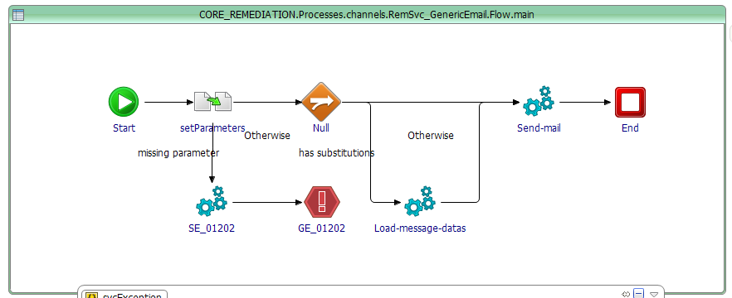

Properties
Remediation – GenericEmail service properties
Property | Static default GV | Monitoring  rule property | Dynamic  monitoringLogic  property FOR template substitution | Description
EMAIL_BODY_TMPL | no | Yes  Support template | yes | Template email body
EMAIL_CONTENT_TYPE | no | Yes  No template | No | Fixed email format (text/plain or text/html
EMAIL_REPLYTO | no | Yes  No Template | no | Fixd email replyTo value
EMAIL_SUBJECT | no | Yes  Support template | yes | Template email subject
EMAIL_TO | no | Yes  Support template | yes | Template email recipient
EMAIL_FROM | no | Yes  Support template | yes | Template email sender

CORE_REMEDIATION global variables
CORE_LOG Global Variables
GV | Description
Services/RemSvc_GenericEmail/Destination | JMS Queue name for the GenericEmail remediation service.
Services/RemSvc_GenericEmail/MaxClient | Max number of JMS session
Services/RemSvc_GenericEmail/Properties/EMAIL_BODY_TMPL | Name of the monitoring logic rule property for the template text.
Services/RemSvc_GenericEmail/Properties/EMAIL_CONTENT_TYPE | Name of the monitoring logic rule property for the email content type to be specified the email activity.
Services/RemSvc_GenericEmail/Properties/EMAIL_FROM | Name of the monitoring logic rule property for the email sender.
Services/RemSvc_GenericEmail/Properties/EMAIL_REPLYTO | Name of the monitoring logic rule property for the email reply-to field.
Services/RemSvc_GenericEmail/Properties/EMAIL_SUBJECT | Name of the monitoring logic rule property for the email subject.
Services/RemSvc_GenericEmail/Properties/EMAIL_TO | Name of the monitoring logic rule property for the email recipient address.
Services/Rem_EMAILCache/Destination | JMS Queue name for the EmailCache remediation service.
Services/Rem_EMAILCache/MaxClient | Max number of JMS session for the EmailCache remediation service.
Services/Rem_EMAILCache/ClearExpiredNotificationTimerMS | Timer delay for the email cache cleaner to kick (millisec).
Services/Rem_EMAILCache/DefaultCacheRetentionDelayMS | Default cache retention delay for the notifications in the Email Cache remediation channel (millisec).
Services/Rem_EMAILCache/DefaultContentType | Default email content type for the Email Cache remediation channel. Values must be text/plain or text/html.
Services/Rem_EMAILCache/DefaultSMTPFrom | Default email sender address for the Email Cache remediation channel.
Services/Rem_EMAILCache/DefaultSMTPTo | Default email recipient for the Email Cache remediation channel.
Services/Rem_EMAILCache/NotificationCacheAlias | Internal cache reference name for the caching tool.
Services/Rem_EMAILCache/Properties/CACHE_RETENTION_DELAY | Name of the monitoring logic property (dynamic or in the rule) for setting up the cache retention delay for the email cache channel.
Services/Rem_EMAILCache/Properties/EMAIL_CONTENT_TYPE | Name of the monitoring logic property (dynamic or in the rule) for setting up the email content type.
Services/Rem_EMAILCache/Properties/EMAIL_FROM | Name of the monitoring logic property (dynamic or in the rule) for setting up the email sender for the email cache channel.
Services/Rem_EMAILCache/Properties/EMAIL_TO | Name of the monitoring logic property (dynamic or in the rule) for setting up the email recipient for the email cache channel.
Services/RemSvc_Resub/Destination | JMS Queue name for the Resubmision remediation service.
Services/RemSvc_Resub/MaxClient | Max number of JMS session for the Resubmision remediation service.
Services/RemSvc_Resub/DefaultResubDelayMS | Default value for setting up the delay to observe before resubmitting message.  (millisec).
Services/RemSvc_Resub/DefaultResubMaxCount | Default max number of resubmission for a given message.
Services/RemSvc_Resub/Properties/OVERWRITE_RESUB_CTXID | Name of the dynamic monitoring logic property for overwriting the contextId value for the resubmission remediation channel.
Services/RemSvc_Resub/Properties/RESUB_DELAY | Name of the monitoring logic property (dynamic or in the rule) for setting up the delay to observe before resubmitting message (millisec).
Services/RemSvc_Resub/Properties/RESUB_MAX_COUNT | Name of the monitoring logic property (dynamic or in the rule) for setting up the max number of retry for resubmitting a given message.
SharedConnections/JDBC/CORE_AUDIT/JDBCURL | JDBC url for the AUDIT database (purpose of resubmission staging table access).
SharedConnections/JDBC/CORE_AUDIT/MaxConnections | Max number of connexions for the AUDIT database.
SharedConnections/JDBC/CORE_AUDIT/MaxRows | Default max number of rows to read from AUDIT DB queries.
SharedConnections/JDBC/CORE_AUDIT/Timeout | Default timeout (second) for requests to the AUDIT DB..
SharedConnections/SMTP/host | Static email server host.
SharedConnections/SMTP/user | Static email server user name.
SharedConnections/SMTP/password | Static email server user password.
SharedConnections/SMTP/port | Static email server port.
SharedConnections/SMTP/timeoutMS | Timeout for SMTP connection (millisecond)

Functional monitoring application

ElasticSearch storage design

Kibana UI

Routing service (bw.core_router.sharedmodule)

Introduction
The core ESB Router (“bw.core_router” component) is an extension to the core TIBCO ESB framework. It enables a flexible content-based message routing service to support the routing logic involved in the asynchronous message propagation pattern. The service implementation is maintained in a TIBCO BusinessWorks6.x shared module that can be referenced by any framework-enable BusinessWorks6x service implementation.
The ESB router manages asynchronous message routing in applications logical connectors (referred as “Middleware Connectors” or MC) or also from orchestration services (referred as “Middleware Service” or MS). The router acts as a message sender where the destination is automatically resolved from logical rules execution using the information contained in the message metadata (header) and/or body properties.
The CORE_ROUTER library performs rule lookup in-memory using an internal HSQLDB (http://hsqldb.org/). The rules are managed in a persistent ORACLE database, and then loaded in memory for the runtime component execution, at startup.
After initialization, the routing activity is stateless

Message routing implementation

Interface
Message routing is a straight forward functionality and is made available with a simple BusinessWorks process packaged into the [bw.core_router.sharedmodule] BusinessWorks project in the [framework] module.
[bw.core_router.sharedmodule/Processes/RoutePublish/RoutePublish.bwp]
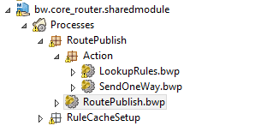
The process exposes an interface similar to a framework message sender utility, including the ability to automatically read all the process context data to manage the outbound message header details.
In addition, developers may add custom routing properties for the purpose of a specific routing logic that could not be directly derived from the message body. The process input is defined in the schema:
[bw.core_router.sharedmodule/Schema/Interfaces/RouteeInterface.xsd]
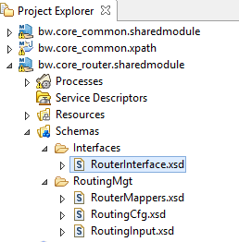
Below is a view and a description of the message routing utility interface.

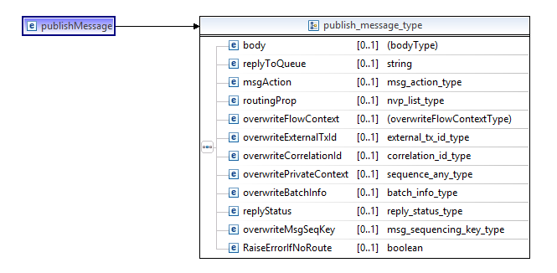
[routeMessage] utility interface
Field | Card | Description
body/* | 0 | Message body element (the business payload as XML element).
replyToQueue | 0 | JMS reply to destination optional property
msgAction | 1 | The ESB message action to be set in the message header.
routingProp/nvpList/nvpElement | 0..n | Optional routing name/value pair properties to be evaluated in the routing rules.
overwriteFlowContext/flowCode | 0 | Optional ESB flow code. If not provided, the value is taken from the existing process context.
overwriteFlowContext/flowId | 0 | Optional ESB flow id. If not provided, the value is taken from the existing process context.
overwriteFlowContext/taskCode | 0 | Optional ESB step name. If not provided, the value is taken from the existing process context.
overwriteFlowContext/taskId | 0 | Optional ESB step id. If not provided, the value is taken from the existing process context.
overwriteExternalTxId | 0 | Optional application transaction id. If not provided, the value is taken from the existing process context (if set).
overwriteCorrelationId | 0 | Optional ESB message correlation Id. If not provided, the value is taken from the existing process context (if set).
overwritePrivateContext/* | 0 | Optional ESB message private context. If not provided, the value is taken from the existing process context (if set).
overwriteBatchInfo | 0 | Optional ESB message batch information. If not provided, the value is taken from the existing process context (if set).
replyStatus | 0 | Optional ESB message reply status (assuming the message is routed in a context of an async ESB reply).
overwriteMsgSeqKey | 0 | Optional ESB message sequencing key. If not provided, the value is taken from the existing process context (if set).
raiseErrorIfNoRoute | 0 | Set to true to raise an ERROR if no route is found. Otherwise the router will just issue a warning.

Routing process

Main flow
The routing process follows the step below:
- The router pre-formats the message header structure based on the input information ([PrepareMsg] activity).
- The router performs a lookup on the database to fetch the matching rules and determine the list of named targets ([GetRoutingCfg] process).
- If one or many targets are found, then the router sends a one way async JMS message for each matched target ([SendOneWay]process).
Process [RoutePublish]
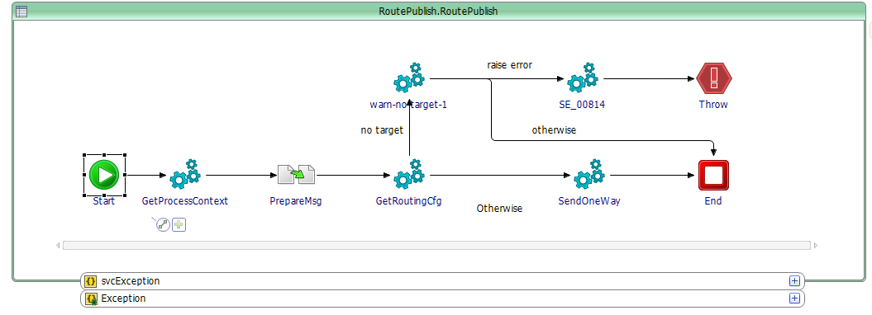
Process [SendOneWay]
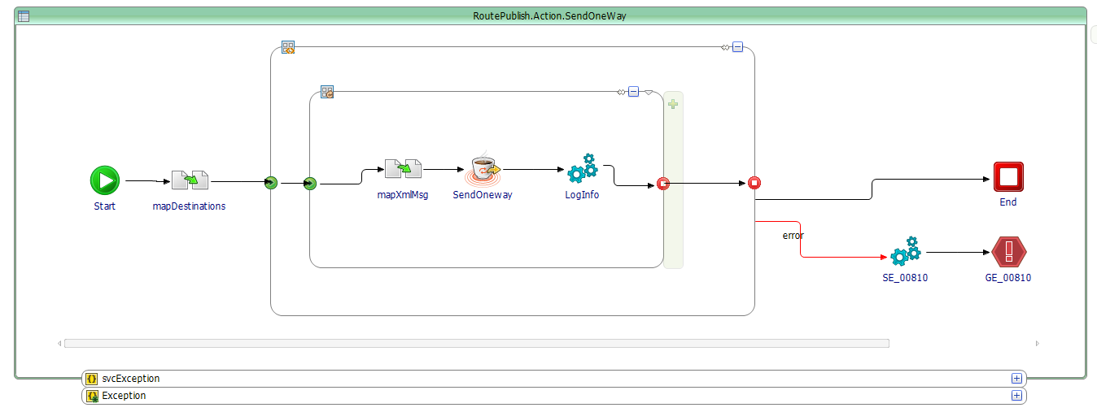

Rule lookup
The evaluation of the routing rules on the inbound message data is performed in the process [RouteMessage/Action/LookupRules]. The process performs the following steps:
- Reads all matching rules from the rule cache database. The following SQL is executed to read all candidate rules matching the conditions.

IMPORTANT: the Rule cache initialization only loads in the cache the rules that have the current BW application as the “source”. This significantly reduces the amount of rules to load in memory and simplify the lookup. Finally, the lookup for candidate rule only filters on ESB flow name, ESB step name and message action.
SELECT
RT_ROUTING_ID,
AP_SRC_APPLICATION,
EX_FLOW_CODE,
EX_SRC_TASK_CODE,
EX_SRC_SERVICENAME,
EX_TGT_TASK_CODE,
EX_TGT_SERVICENAME,
RT_MSG_ACTION,
RT_PROP_FILTER,
RT_BODY_FILTER,
EP_ADDR,
EP_ADDR_IDX,
Rt_ENABLED,
RT_VALID_FROM,
RT_VALID_TO
FROM
SVC_ROUTING_MEM
WHERE
(EX_FLOW_CODE = ? or EX_FLOW_CODE='*')
AND (EX_SRC_TASK_CODE = ? or EX_SRC_TASK_CODE='*')
AND (EX_SRC_SERVICENAME = ? or EX_SRC_SERVICENAME='*')
AND (RT_MSG_ACTION = ? or RT_MSG_ACTION='*')
AND RT_VALID_FROM <= ?
AND RT_VALID_TO >= ?
- After having identified the rule candidates, the process established an “Unfiltered Rule Result” containing all the structured rules before evaluating the optional custom routing properties and message content xPath filtering.
- The process then evaluates the optional custom routing properties and message content xPath filtering if such conditions exist in some of the candidate rules. This may lead to the exclusion of some or the entire rule candidate set.
- Finally, rules that match a same destination are grouped into a single one (duplicates are removed). In such case, ONLY the first matching rules properties are kept. The duplicated destination rules are entirely discarded.
The final result of the rule lookup process is an exhaustive routing configuration containing all the matched rules, their properties and the target definition for every referenced target. The structure is managed in the [routingCfg] element.
GetRoutingCfg process overview
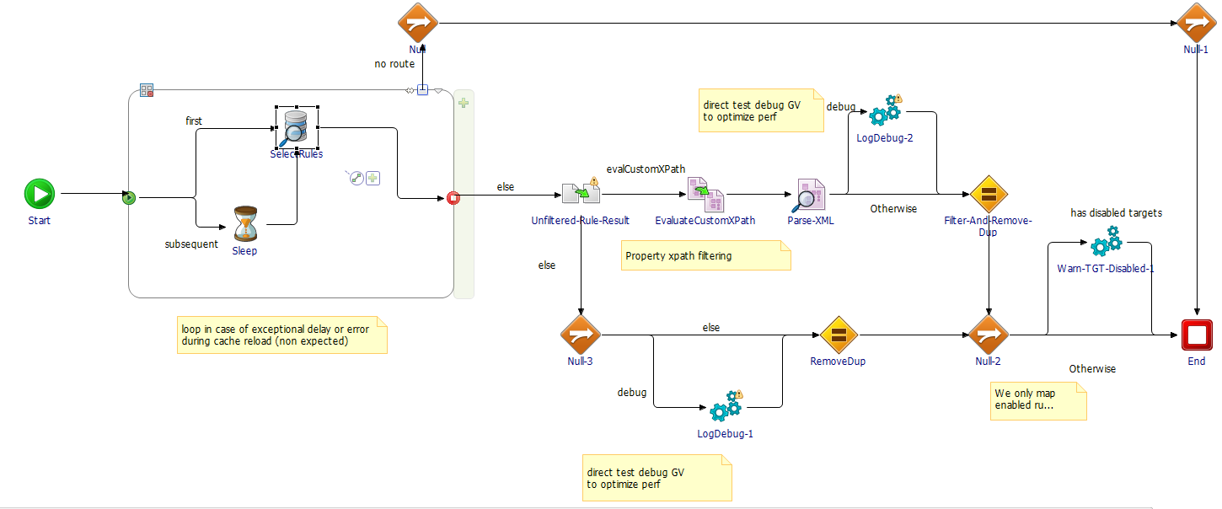
[routingCfg] structure
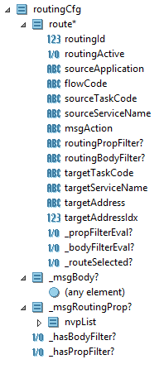

Rules initialization process
The rules are initially maintained in a central persistent routing database (ORACLE). The CORE_ROUTER project incorporates the rules initialization services as well as a rule cache synchronization service to ensure any rules modifications in the persistent database can be replicated in the rule cache for EACH ESB service that is concerned by the change.
Note: as discussed with SANOFI, the rule cache synchronization utility may be reviewed and be replaced by a topic based notification service.
The rules initialization and reload functions can be found in the project folder:
[bw.core_router.sharedmodule/Processes/RuleCacheSetup]
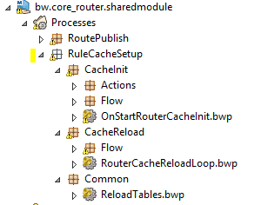
Process [OnStartupRouterCacheInit]
The [OnStartupRouterCacheInit] process needs to be triggered by a BW Application Activator. So the application using the router will be responsible for running the activator (TIBCO BW 6.x shared modules cannot run services). This procedure may be embedded in process template.
Example of application Ativator process, calling [OnStartupRouterCacheInit]:
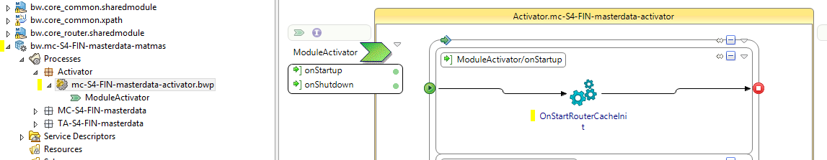
The [OnStartupRouterCacheInit] process creates the RULES and TARGETS table in memory (use of HSQLDB in memory database). The data is only loaded for the specific BusinessWorks source application. Therefore, only rules in scope for “this” application are loaded.
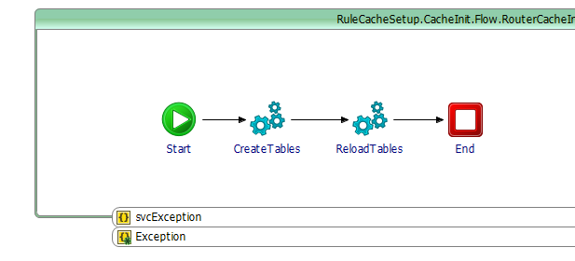
Process [RouterCacheReloadLoop]
The [RouterCacheReloadLoop] process will periodically loop forever at a given rate and check if a rule refresh is required based on the polling of a persistent router update notification table. This process may be put into the application Activator, with a “Spawn” option on. This way, the process is started while the activator continues and terminates so that the principal application can start.
Note: as discussed with SANOFI, the rule cache synchronization utility may be reviewed and be replaced by a topic based notification service.
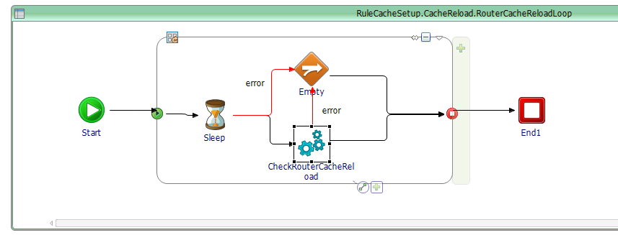

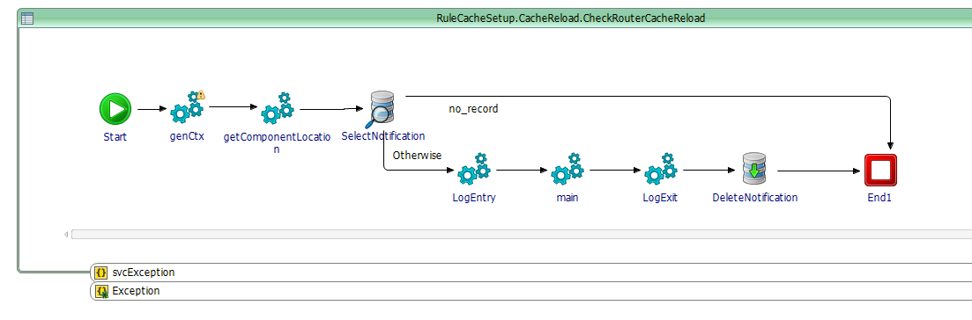

Router Rules

Rule structure
The router rules are stored in the persistent Router oracle database. The actual Router database includes one TABLE. The Routing table may be linked to other “Service classification” repositories/registries in the future to link with a service catalog approach. However, the routing table has been kept simple so that it can be used for message routing in the first place with a minimal coupling to other features.
TABLE SVC_ROUTING: contains all the ROUTER rules.
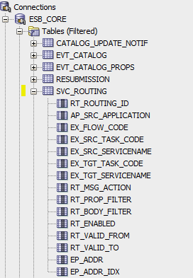
The table below explains the SVC_ROUTING structure:
Router rules attributes
Rule field | Description
RT_ROUTING__ID | Id of the rule (from sequence)
AP_SRC_APPLICATION | Name of the Application calling the message routing.
The fields prefixed by “EX_” refer to EXCHANGE information (link between to service endpoint).
EX_FLOW_CODE | The flow code the message is issued from.  Use * for any.
EX_SRC_TASK_CODE | The task code from the service invoking the router.  Use * for any.
EX_SRC_SERVICENAME | The name of the ESB service invoking the router.  Use * for any.
EX_TGT_TASK_CODE | Expected target Task code. This is currently optional and may be used later for constraints from a referential.  Use * for any.
EX_TGT_SERVICENAME | Expected target serviceName. This is currently optional and may be used later for constraints from a referential.  Use * for any.
RT_MSG_ACTION | Matching criteria: message MsgAction as set by the service invoking the router (based on specification)  Use * for any.
RT_ PROP_FILTER | XPath expression to evaluate conditions in the message custom routing properties. Xpath must evaluate to true or false. Use a typical square bracket xpath expression with no element name with @name and @value attributes.  Example:  '[@name="COLOR" and @value="GREEN"]'
RT _BODY_FILTER | XPath expression to evaluate conditions in the message body. Xpath must evaluate to true or false. The inbound message must be reference from the ROOT. Use * for unqualified namespaces.  Example:  '/*:input_router_body/*:PurchaseOrder/*:BillTo[*:street="DEMO BILLTO STREET"]'
RT_ENABLED | ‘Y’ if the rule is enabled, else ‘N’
RT_VALID_FROM | Rule start validity date
RT_VALID_TO | Rule end validity date
EP_ADDR | JMS Queue name where the router must send the message to.
EP_ADDR_IDX | Index of the logical sequencing partition of the target service. Use 1 for a service using one only queue.  The logical sequencing queue partitioning is a technic allowing for sending all messages resolving to a same sequencing key to a same queue INDEX. This is used when the target service exposes many queues for scalability purpose but message sequence (based on sequencing key) need to be respected for a given seq key. The router supports sending a same sequence key to a same queue index (via hash map).

Rule example
---------------------------------------------
-- SAMPLE MESAGE ROUTING RULES
---------------------------------------------
DELETE FROM SVC_ROUTING WHERE RT_ROUTING_ID in (1000000, 1000001);

---------------------------------------------
-- RULE 1 : no ROUTING PROPS, no Body XPATH
---------------------------------------------
INSERT INTO SVC_ROUTING
(
RT_ROUTING_ID,
AP_SRC_APPLICATION,
EX_FLOW_CODE,
EX_SRC_TASK_CODE,
EX_SRC_SERVICENAME,
EX_TGT_TASK_CODE,
EX_TGT_SERVICENAME,
RT_MSG_ACTION,
RT_PROP_FILTER,
RT_BODY_FILTER,
RT_ENABLED,
RT_VALID_FROM,
RT_VALID_TO,
EP_ADDR,
EP_ADDR_IDX
) VALUES (
1000000,
'APP1-TEST',
'SrcApp.Object1',
'MCI-00001',
'SrcApp.Object1.Publish',
'MCO-00001',
'TgtApp1.Object1.Receive',
'*',
NULL,
NULL,
'Y',
to_date('2000/01/01','yyyy/mm/dd'),
to_date('2099/12/31','yyyy/mm/dd'),
'TgtApp.Object1.Receive',
1
);

---------------------------------------------
-- RULE 1 : with ROUTING PROPS, with Body XPATH
---------------------------------------------
INSERT INTO SVC_ROUTING
(
RT_ROUTING_ID,
AP_SRC_APPLICATION,
EX_FLOW_CODE,
EX_SRC_TASK_CODE,
EX_SRC_SERVICENAME,
EX_TGT_TASK_CODE,
EX_TGT_SERVICENAME,
RT_MSG_ACTION,
RT_PROP_FILTER,
RT_BODY_FILTER,
RT_ENABLED,
RT_VALID_FROM,
RT_VALID_TO,
EP_ADDR,
EP_ADDR_IDX
) VALUES (
1000001,
'APP1-TEST',
'SrcApp.Object1',
'MCI-00001',
'SrcApp.Object1.Publish',
'MCO-00002',
'TgtApp2.Object1.Receive',
'*',
'[@name="COLOR" and @value="GREEN"]',
'/*:input_router_body/*:PurchaseOrder/*:BillTo[*:street="DEMO BILLTO STREET"]',
'Y',
to_date('2000/01/01','yyyy/mm/dd'),
to_date('2099/12/31','yyyy/mm/dd'),
'TgtApp.Object1.Receive',
1
);

Router database

Overall schema
Curently, the router has one only table;
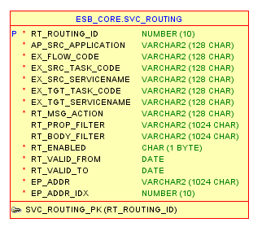

CORE_ROUTER Global Variables
[bw.core_router.sharedmodule] Global Variables
GV | Description
SharedConnections/JDBC/CORE_ROUTER/JDBCURL | JDBC url for the ROUTER persistent database.
SharedConnections/JDBC/CORE_ROUTER/LongTimeout | Long JDBC request timeout.
SharedConnections/JDBC/CORE_ROUTER/MaxConnections | Max number of connections for the ROUTER persistent database.
SharedConnections/JDBC/CORE_ROUTER/MaxRows | Default max number of rows to read from DB queries.
SharedConnections/JDBC/CORE_ROUTER/Password | JDBC user password for the ROUTER persistent database
SharedConnections/JDBC/CORE_ROUTER/Timeout | Default timeout for JDBC queries calls on the ROUTER persistent database
SharedConnections/JDBC/CORE_ROUTER/User | JDBC user for the ROUTER database.
SharedConnections/JDBC/CORE_ROUTER/Password | JDBC user password for the ROUTER database.
SharedConnections/JDBC/CORE_ROUTER_CACHE/JDBCURL | HSQLDB database url for the ROUTER rule cache.
CORE_ROUTER/SharedConnections/JDBC/CORE_ROUTER_CACHE/MaxConnections | HSQLDB database max number of active connections for the ROUTER rule cache.
SharedConnections/JDBC/CORE_ROUTER_CACHE/MaxRows | HSQLDB database max number of row to return from queries.
CORE_ROUTER/SharedConnections/JDBC/CORE_ROUTER_CACHE/Password | HSQLDB database user password for the ROUTER rule cache.
SharedConnections/JDBC/CORE_ROUTER_CACHE/Timeout | HSQLDB database request timeout for the ROUTER rule cache.
CORE_ROUTER/SharedConnections/JDBC/CORE_ROUTER_CACHE/User | HSQLDB database user for the ROUTER rule cache.
Services/LookupRules/lookupRetryDelayMS | Delay between lookup retry (in the case of DB access issue)
Services/LookupRules/lookupRetryNo | Max number of rule lookup retry before a fatal error is raised.
Services/RuleCacheSetup/CacheRefreshDelayMS | Delay between ROUTER rule CACHE synchronization check.
Services/RuleCacheSetup/ExitOnRuleReloadError | Set to true to shut down IF the ROUTER rule CACHE reload process failed (leading to potentially non-synchronized rules).
TraceTags/ROUTING_DEBUG_RULES | AUDIT logInfo custom tag to trace the debug of rules.
TraceTags/ROUTING_DONE | AUDIT logInfo custom tag to trace a routing completion.
TraceTags/ROUTING_NO_TARGET | AUDIT logInfo custom tag to trace that no routing rule was matched.
TraceTags/ROUTING_RULE_CACHE_INIT_FAILURE | AUDIT logInfo custom tag to trace routing rule cache initialization failure.
TraceTags/ROUTING_TARGET_DISABLED | AUDIT logInfo custom tag to trace that a DISABLED rule was matched.
Connection.DB.CORE_ROUTER | Property storing the persistent Router database connection
Connection.DB.CORE_ROUTER_CACHE | Property storing the in-memory Router database cache connection

