- You have three Queues named Q1 with S1 subscriber, Q2 with s2 subscriber and Q3 with S3 subscriber. There is a bridge “B1” between Q1 and Q2 and bridge “B2” bridge between Q2 and Q3. If a producer produces a message on Q1 queue which subscribers will get the message?

Ans: - Since destination bridging is not transitive only S1 and S2 subscribers will get the messages (Not S3)

- Server A and Server B are in FT mode and with this FT pair Server C is in LB mode. Then how you need to set the client application connection URL.

Ans: - (tcp://serverA:<port>, tcp://serverB:<port>) | tcp://serverC:<port>

Note: “, “comma is for FT
“|” pipeline is for LB
Similarly if servers A, B are in FT; servers C, D are in FT; and these two pairs are in LB mode. Then the client URL will be in
(Tcp: //serverA :< port>, tcp: //serverB :< port>) | (tcp: //serverC :< port>, tcp: //serverD :< port>)

- What is static Queue and what is dynamic Queue. Compare them.

Static Queue | Dynamic Queue
- Queues which are created explicitly by using EMS administration CUI tool.  Create queue < queue-name > | - Queues which are created implicitly when ever the client application tries to put a message in a Queue which is not exists in the server but if there is corresponding matching wild card destination in queues.conf.  Example: - If a producer is trying to put a message in a queue named “hcl.chennai” which is not exists in server and there is corresponding wild card destination like “hcl.*” or “hcl.>” in queues.conf then queue “hcl.chennai” will be created on the fly which is a dynamic queue.
2) Queues will be still in server when you restart the server even though queue don’t had any messages | 2) Queue won’t be in server when you restart the server if the queue is empty.
3) You are able to see the static queues in queues.conf file | 3) you cannot see dynamic queue in queues.conf
4) When you gave the “show queues” command in EMS admin CUI; static queues won’t have any “*” indication before them. | 4) When you gave the “show queues” command in EMS admin CUI; dynamic queues will have “*” before the queue name.

- What are exclusive queues and what are non-exclusive queues?

Ans: - You can have more than one subscriber pointing to a queue. When you have more than one subscriber, EMS server will distribute the inbound messages in Round-Robin fashion to all subscribers in case of Non-exclusive queues. You can implement message level load balancing by using Non-exclusive queues.

In case of exclusive queues which ever be subscriber created the Session first, that subscriber only will get the all messages.

By default queues are Non-exclusive. If you want to change it as exclusive queues

Addprop queue <<queue-name>> exclusive

- What is the disadvantage of using foreign JNDI provider in EMS?

Ans: - You cannot perform fault tolerant lookups

- You have one wild card destination “hcl.*” with exclusive property. Can we change the inherited destination like “hcl.chennai” as Non-exclusive?

Ans: - No. We cannot change the child destination properties which are inherited s from wild card destination.

- What are the delivery modes available in EMS?

Ans: - PERSISTENT
NON_PERSISTENT
RELIABLE_DELIVERY

- What are durable subscribers?

Ans: - If durable subscribers are subscribed on a topic, even though the durable subscriber is down; EMS server will hold the messages on behalf of disconnected durable scriber. The Durable Subscriber will get the message whenever it is up.

- In Reliable QoS from TIBCO Rendezvous when there is a chance to loose the messages?

Ans: - When there is a network outage between publisher and subscriber that lasts more than the reliability window size.

- How do you separate Rendezvous buses for each environment so that one environment messages cannot get conflict with other environment?
Ans: - i) Unique service port for each environment
ii) Unique service Group (service + multicast groups)
iii) Environment specific subject names for each environment.

- What is Direct Communication?
Ans: - It is a communication mechanism used for point-to-point communication using RVD. Still you have to specify _INBOX subject names. Message Latency and context switching will be reduced by using this.

- What are the parameters of Rendezvous Transport?
Ans: - i) Daemon
ii) Service
iii) Network

- You have two subnets S1 and S2; RVRD is configured for both subnets. When a publisher from S1 subnet sends a message; when the RVRD which is configured for S2 will import it from the RVRD which is configured for S1?

Ans: - When there is at least one subscriber from S2 subnet then only RVRD of S2 subnet will establish a TCP connection with RVRD of S1 subnet.

- What are the components of Business Works?

Ans: - i) Designer (Comes with TRA installation)
ii) BW Engine (Comes with BW installation)
iii) Administrator (Comes with admin-epe or admin-rpe editions)
iv) TRA (Its prerequisite to install any BW Component)
v) Other like EMS server, BW-Smart mapper and Adapters

- What does the term scale out?

Ans: - Your Integration Project Components should be able to deploy on different machines in your domain so that they can work in Load balancing fashion.

Transport | Scale Out Feature
Rendezvous | Distributed Queues
EMS | JMS Queues
HTTP | IP Redirector

- If i deployed a process with HTTP receiver on 4 machines in FT mode. The client application doesn’t have any idea about on which IP machine the process instance is running. How you will make sure the client application request will go appropriate machine where process instance is running?

Ans: - IP redirector

- I have a database which doesn’t support triggers can I configure ADB adapter?

Ans: - NO. You can configure ADB to only triggers supporting databases.

- What are the possible transports between adapters and Business process?
Ans: - i) Rendezvous
ii) JMS

- What are the possible transports between Web service and Client in Tibco?
Ans: - i) HTTP
ii) JMS

- What are the possible transports between deployed applications and Tibco Administrator?
Ans: - i) Rendezvous
ii) HTTP
iii) HTTPS

- What is the prerequisite product you need to install before installing any BW Component?
Ans: - TRA is the prerequisite. You need to install it before installing any BW components. It includes
  - Rendezvous
  - Third Party Core libraries
  - Hawk Agent
  - Designer with Native Palettes
  - JRE
  - Runtime Agent & SDK
- If you install TRA only what are the tab sheets you will get in designer?
Ans: - i) Global variables
ii) Project
iii) Palettes

NOTE: - since you installed only TRA you won’t get bw-engine. Bw-Engine
Comes with BW installation. So are not able to see Tester Tab.

- What are the two files where the installer will maintain the registry of TIBCO components?
Ans: - i) VPD.Properties
ii) VPD.Properties.tibco. <<System-name>>

- If you administration domain spans multiple subnets what is the mandatory setting you need for monitoring?

Ans: - You should have at least One RVRD for each subnet

- With which Product Business Works cooperatively work when ever there is
a human interaction is to be involved in your process?
Ans: - TIBCO InConcert Server

- What are the products you need to install on a machine to execute process engines?
Ans: - i) TRA (It is a prerequisite)
ii) Business Works (By installing this you will get BW engine)
- What are the default root installation directories on windows and UNIX that tibco will consider?
Ans:-
  - %System Root% on windows
  - $HOME on UNIX

- To install BW 5.3 what is the mandatory product you need to install and specify version?
Ans: - For BW5.3.0 you need to install TRA 5.3.0
- How can I install BW in Console Mode with out recording the input values in a file?
Ans: -
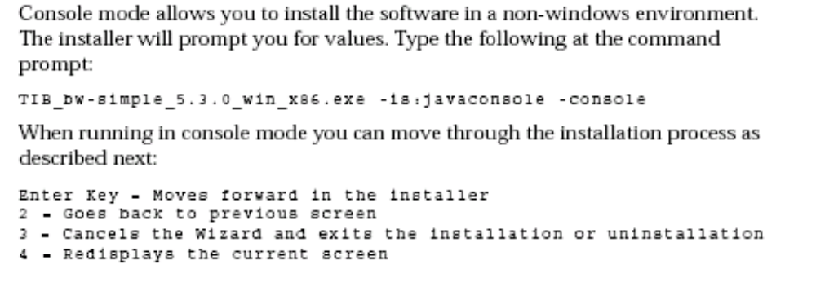
- How can I install BW in silent mode from command line so that it will take default values?
Ans: -

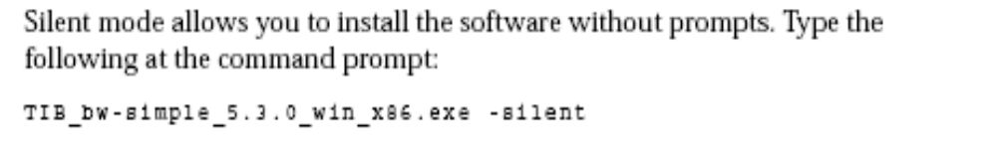
- How to install BW in Console mode and record the values in a file. So that file can be used for further installations of console mode?
Ans: -

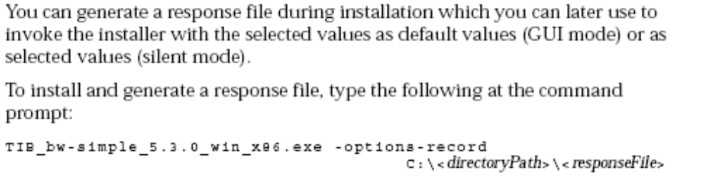
- How to install BW in Console mode by taking installing options which are already recorded in a file?
Ans:-

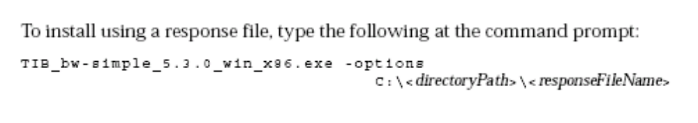
(OR)

TIB_bw_simple_5.3.0_win_x86.exe –options <<filename> -silent

- What is the Activity used to Retrieve or Get the WSDL?
Ans: - Retrieve Resources

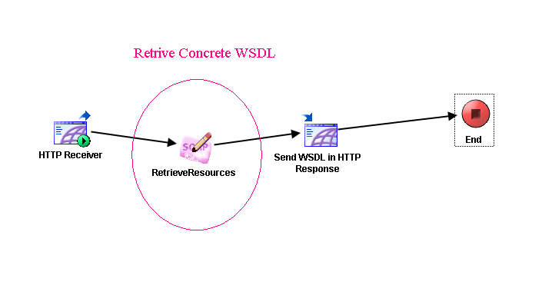

- What is the implicit transformation Process between Activities in a Process?
Ans: - XSLT

- What are the Revision Control systems the designer will support?
Ans: - i) XML Cannon
ii) CVS
iii) PVCS
iv) VSS
v) Clear Case
vi) PVCS

- If your project has 10 adapters and 10 processes how may minimum number of shared archives, process archives, and adapter archives you need to place in an enterprise archive resource?

Ans: - 1-shared archive, 1-process archive, and 10-adapter archives

Note: one adapter archive resource can hold only one adapter where as one process archive can hold many number of processes.

- Please see the given below diagram you are getting 2 integer values from
Http receiver and you are parsing those values from strings to integers and then you are calculating a+b, a-b, and a*b with 3 java code activities. If three
Results are positive values then I would like to write the result in one file other wise in another file.
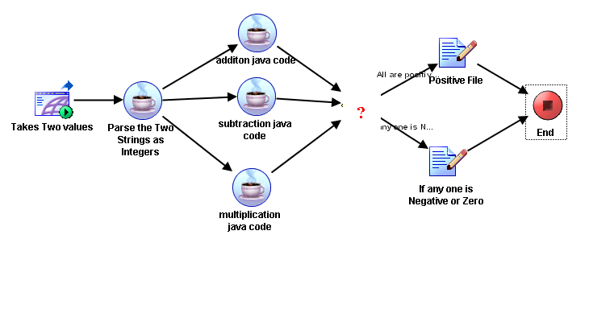
How do you combine the three process flows as two conditional process flows? What is the suitable activity you can place here? (Imp)
Ans: - Null Activity
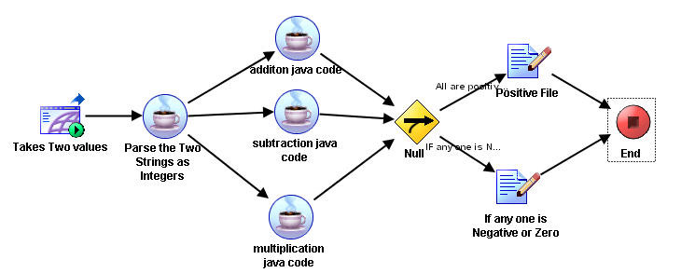

NOTE: -
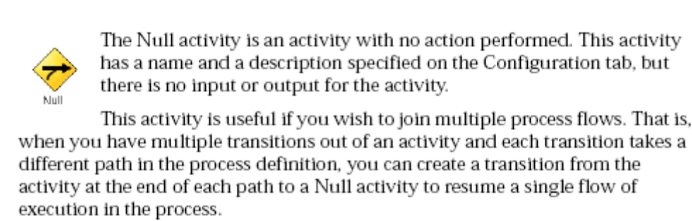

- You have to define a partially configured common Project which is use full by many Projects so that you can take that common partial project and continue for further remaining work what is the best option for this?
Ans: - Templates

Note: - After Configured partially configure project you can save that as template from Project/Save as Template. Whenever you are creating a new you can go through new project from template option in start up panel.

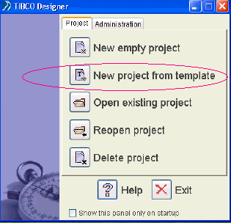

- Describe various levels of reusability’s in TIBCO Business Work Projects?

Level | Reusability
Project Level | Templates
Component Level | Design Time Libraries using Library Builder
Activity Level Or  Palette Level | My Palettes or Custom palettes

- What are the possible ways that you can convert a multifile project as single
“. Dat” file (which is in legacy format)?

Ans: - i) from start up panel you are able to convert multifile as single legacy based project
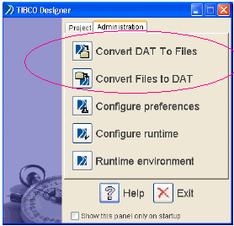
ii) By using bw20migrate command line utility which is in <root>/tra/<n.n>/bin folder you can change for example
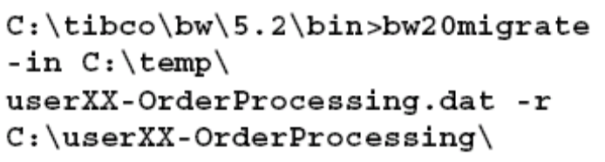

- You have a shell file on your UNIX operating system or a “. Bat” files on windows. What is the suitable activity to call those? (Imp) (B)

Ans: - External Command

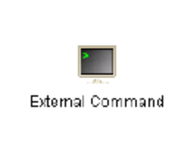
- What is spawn process explain. (VVVVVVVVimp) (B)
Ans: - You are able to call a sub process using call process activity (which is in general activities) .In the call process activity you have the option spawn. If you want to call the sub process as a separate thread and you are not expecting any out put from the sub process select the option spawn. If you select the option spawn the parent process will invoke sub process as a separate thread both processes will execute simultaneously. Conversely if you deselect the spawn option means you are expecting output from the sub process. The parent process, which will call the sub process, has to wait till the Sub process has completed the task and returns the result. After getting the result the Parent process will resume the task.

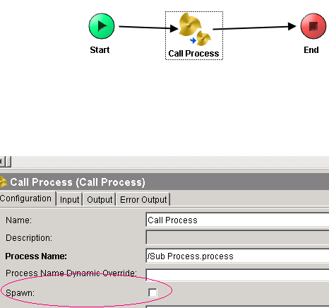

- What are the facilities provided in Tibco Designer for Documenting purpose?
Ans: - i) you can create HTML Report of your project (Project Menu /create
HTML Report)
ii) You can save a process or Component as Image so that it will help in
Documentation

- When you validate the project or while testing for design time checking where you can see the error messages?

Ans: - i) In Designer Go through Window/Console
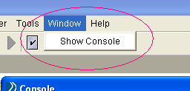

ii) You can go through designer. Log, which is in user home directory

…/<Documents and settings>/userid/. TIBCO/logs/designer.log
- If you want set the constraints on your global variables how you will achieve this?
Ans: - In the Advanced Global variable editor you are able to define the global variables, their data types, value of global variables and the constraints on global variables.
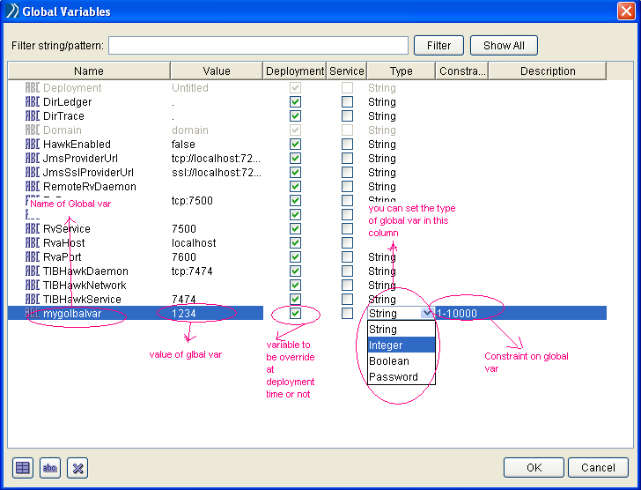

- Please select what are the shared resources you need to work with manual work palettes?

Ans: - i) Work Flow Schema
ii) Work Flow Connection

- To work in a design time environment when multiple developers are working on project with RCS first the user should__________?

Ans: - Acquire the resource

- While working with XML Cannon as RCS if you want to delete the project what is the product you need to have?

Ans: - WebDAV client

- What is the difference between palette mode and non-palette mode?
Ans: -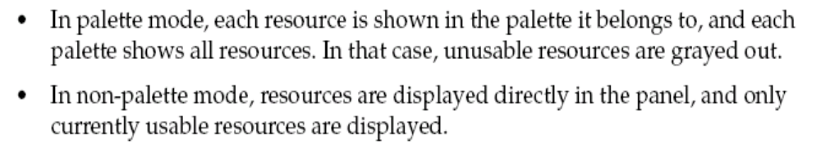

- What is the tool you need to remove a machine from the domain?
Ans: - Administrator

Note: - before removing a mahice you need to remove all the dependencies like deployed processes and like secondary servers. You need to remove all except hawk agent should be running on that pc.

- What is the tool you need to add a machine to administration domain?
Ans: - Domain Utility

- Which three are parts of a valid WSDL configuration?
Ans: - i) Message
ii) Port Type
iii) Operation

- Using domain utility what are the possible settings you can make?

Ans: - i) you Can enable your domain communication as HTTPS

ii) Upgrade domains from 5.1 to 5.2
iii) Add a servelt engine to your domain
iv) Add a machine to your domain
V) Remove a Servlet Engine
vi) Create an administration domain
Vii) Add a secondary server to administration domain
Viii) Change the Server settings
ix) Change the Transport parameters

- In TIBCO for every BW component installations and uninstalations where it will maintain the logs?

Ans: - <installation-path>/tibco/logs/

- What is the command line utility you need to create a “. Ear” file?

Ans: - buildear.exe

Note: - this utility will be in <installation path> /tibco/tra/n.n/bin/

- Your tibco project is in “C:\jafar\” directory and in your project you have an Enterprise archive resource with name “MYEAR.archive ”
. Then how you will generate “. ear” file in hard disk? (VVVimp)

Ans: - buildear -ear /MYEAR.archive
-O c:\jafarvali\MYEAR.ear
-P c:\jafar

Note: - -p → is the project path
-O → is the path where “. Ear” file to be created
-Ear→ is the relative path from your project to Enterprise archive

- After executing above command you will get “. Ear” file. You did some modifications to your project and now you want to create another version of “. Ear” file with out over writing previous version of “. Ear” file. How you will accomplish this?

Ans: - buildear -s -ear /MYEAR.archive
-O c:\jafarvali\MYEAR.ear
-P c:\jafar

Note: - -s → saves the archive as another version

- What is the command line utility used to deploy an ear file?
Ans: - AppManage.exe

NOTE: - this utility will be located in <instalationpath>/tibco/tra/n.n/bin/

- Please list what are the possible options you can do with AppManage?

Ans: -
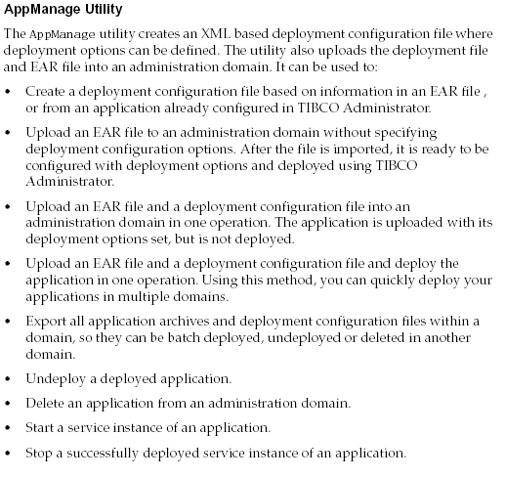
- You have an ear file in path “c:\jafar\MYEAR.ear” .how can you create configuration XML file from the given ear file?
Ans: -
AppManage – export – ear c:\jafar\MYEAR.ear
-out c:\jafar\MYEAR.xml

Note: - Each deployment should have configuration XML. After uploading the ear file then also you are able configure in administrator. Or you can create the configuration XML and update it with configuration specific information and then upload and deploy both XML and ear file.

- By executing the above command you got configuration XML. You opened the XML and modified as per configuration. Now you need to deploy the application in administrator. How you will accomplish this?
Ans: - AppManage –deploy – ear c:\jafar\MYEAR.ear
-deployconfig c:\jafar\MYEAR.xml
-app common-sap
-domain bwdev2
-user B00857
-pw cola987

- Les us assume you uploaded the ear file and through admin GUI you configured the application such as overriding global variables, configuring events and Hawk rule bases. Now you need to retrieve that configuration information in a XML file so that you deploy the same application in another domain. How can you get that configuration XML?
(Or)
How to retrieve the configuration file, which is already uploaded and configured in
Administrator?

Ans: - AppManage -export -out c:\jafar\MYEAR.xml
-app common-sap
-domain bwdev2
-user B00857
-pw cola987

- You have 10 applications deployed in bwdev2 domain. Now you need to export about all the deployed application to a batch file and then how to deploy in another domain?

Ans: - AppManage -batchExport - domain bwdev2
- user B00857
-pw cola987
-dir c:\temp\

NOTE: - the above command will create a batch file “c:\temp\AppManage.batch” which contains all deployed application in bwdev2. Now if you want to deploy in another domain please go through following command

AppManage -batchDeploy - domain bwdev3
- user B00857
-pw cola987
-dir c:\temp\ - nostart

- What is significance of -batchUndeply in AppManage.exe?
Ans: -
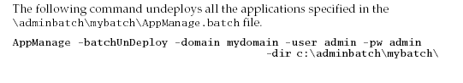

- If you need to only upload the ear and you want to configure in administrator how you will accomplish this?

Ans: - AppManage -upload -ear c:\jafar\MYEAR.ear
-domain bwdev2
-user B00857
-pw sprite123

- How to undeploy an application?

Ans: - AppManage -undeploy -app common-sap
-domain bwdev2
-user B00857
-pw cola987

Note: - The application still will there in administrator as uploaded application but it is not deployed.

- How to remove the deployed application?
Ans: - You want to remove a deployed application first you need to undeploy that application with -undeploy option then by using –delete option you can remove application. You can do both options in a single step with –force Option.

AppManage -delete -app common-sap
-domain bwdev2
-user B00857
-Pw sprite123 -force

- How to start an application which is already deployed?

Ans: - AppMange -start -app common-anysys
-domain bwdev2
-user B00858
-pw coca789

Similarly you can stop an application

AppManage –stop -app common-anysys
-domain bwdev2
-user B00857
-pw coca789

- How to maintain a batch of deployed application in start stop issues?

Ans:-
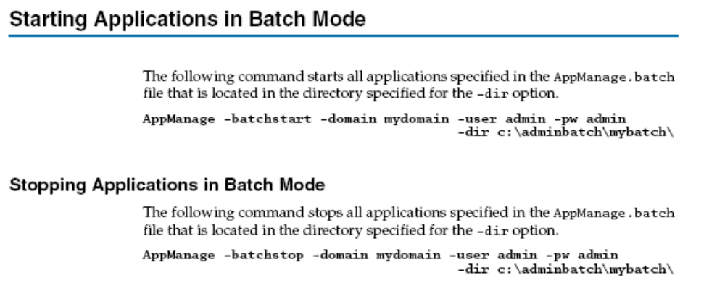
- How remove deployed applications with batch setup in a single step?

Ans:-
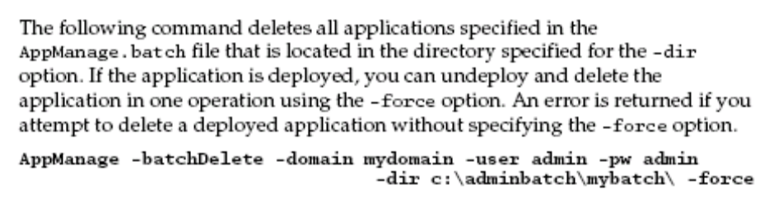
Note:- if you are not using –force option ; first you need to undeploy the applications with –undeploy option and remove the applications with –delete option it’s a two step process.

- If you want to throw a custom exception from a sub process what is the mandatory setting you need to make?

Ans: - i) Configure the sub process end activity with custom exception.
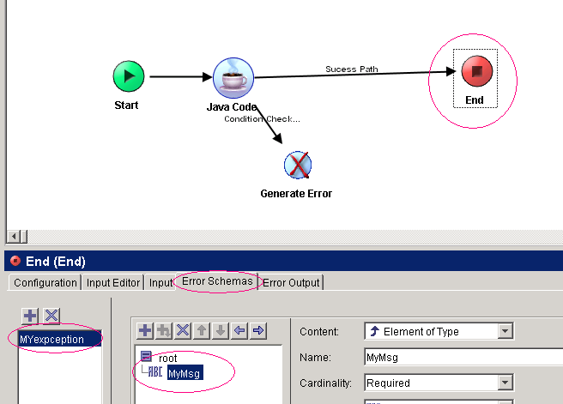

Then automatically the generate error activity will get that exception in its list.
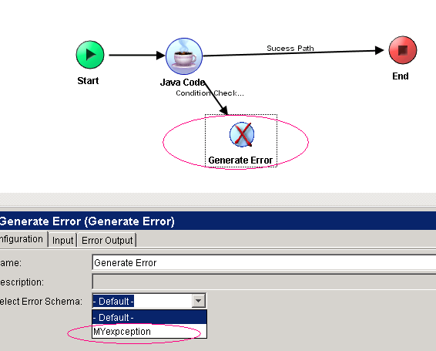

- The scope of user defined process variable is-----------?
Ans: - Only to the process definition where the user defined process variable are defined.

Note: - note that the process level variables only available to process not even to the sub process.

- Which three strategies are available for TIBCO Administrator server high availability and failover?
Ans: - i) Primary/Sedendary server with peer synchronization
ii) Failover using intelligent IP traffic switch (i.e. Big IP, Cisco Local Director)
iii) Cold stand by using disk mirroring

- What must be true $_error object to be available at runtime in business works process definition?

Ans: - The activity which has an exception must also have an error transition

- What conditions you must implement for a sub process in your project?

Ans: - i) the sub process should not be a process starter
ii) The sub process should any where but in the project directory

- What is the activity used document in a process definition?

Ans: - Label from General Activities palette.

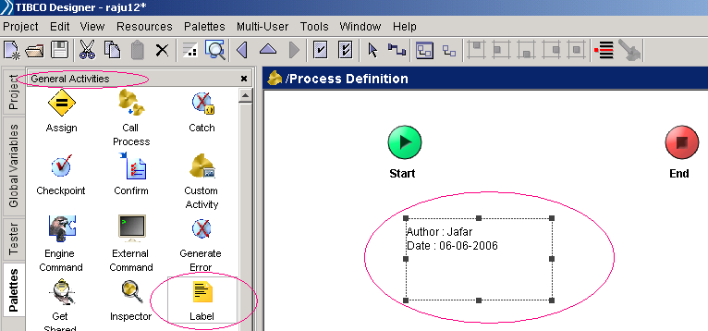

- What is the activity which acts as a Process starter and polls for a directory
Or file?

Ans: - File Poller
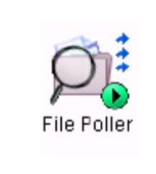
- You have a process starter with file poller, which is polling for a directory. What are possible events so that process starter can create process instance?
Ans:-
    - Create Events (when the file is created in the directory)
    - Modify Events (when the file is modified)
    - Delete Events (when the file is deleted in polling dir)

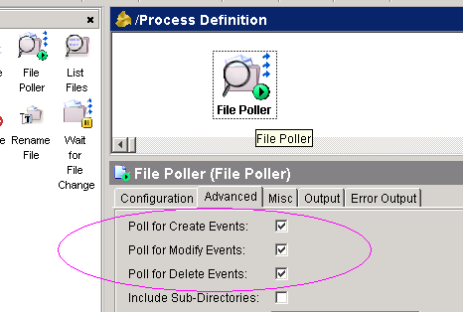

- What is option from call process activity to dynamically call a sub process depend upon the condition?

Ans: - Process name dynamic Overriding option from configuration panel of Call process activity.

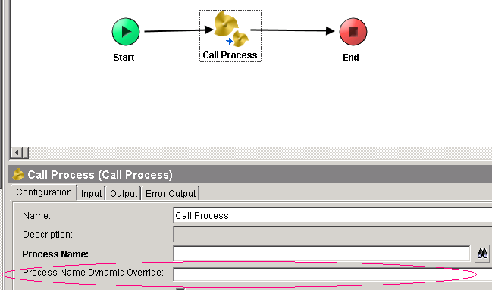

- What is the field you can use to describe the activity and in configuration panel on which tab it will reside?

Ans: - The field name is description and it will reside on configuration tab

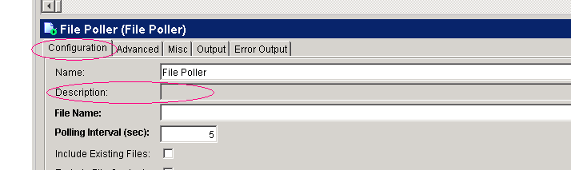

- Please specify how many ways you can apply brake points? (VVVimp) (B)

Ans: -
  - You can apply bake points directly with out any conditions
  - You can apply condition (using x-path) for brake points

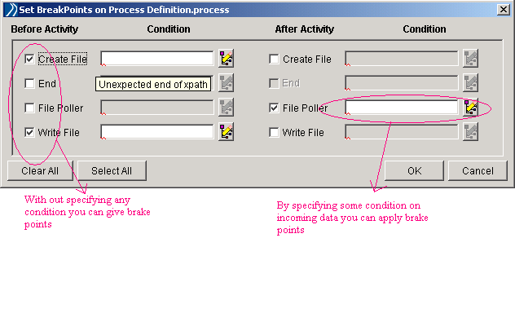
- What are the possible settings you can configure for a group?
Ans: - i) None
ii) If
iii) Critical section
IV) Iteration
v) Repeat-Until true
vi) Repeat-OnError_until true
vii) Pick-first
viii) while-true
ix) Transaction

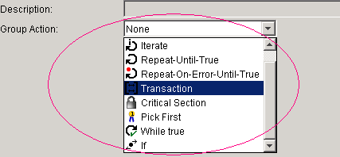

- What is the activity used to assign a process level variables?(Vimp)

Ans: - Assign from General Activity

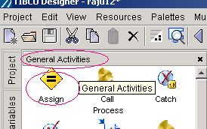

- How many successes with no matching you can take from an activity?

Ans: - zero or exactly one

- How many error transition you can take from an activity?

Ans: - zero or exactly one

- How many success transitions you can take from an activity?

Ans: - zero or as many as you wish

- How many successes with condition transition you can take from an activity?

Ans: - zero or as many as you wish

- What are the facilities provide by Group with None setting?
Ans: - i) You can have common error transition for more than one activity in the Group.

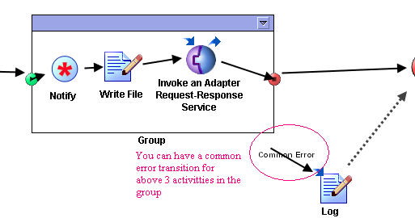
ii) You can minimize the Group so that it will collapse as a small box.

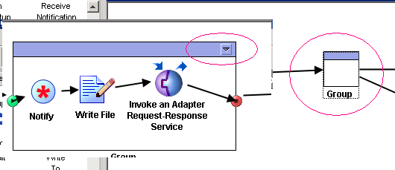

- What is the activity used to load the files which are in file system to tibco project?
Ans: - Alias Library

- What are the variables that available to every process?

Ans:- 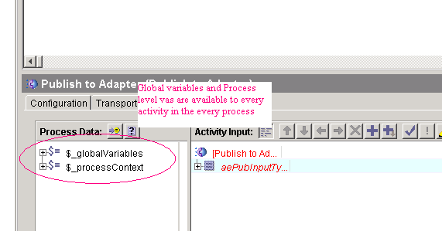

- What is Candidate Key?
Ans: - Activities like Wait for HTTP Request, Wait for Rendezvous request etc..
Are waiting for the incoming events, for such activities you can check weather incoming event is suitable or not. On the Event Tab of such wait activities you are able to define xpath to check weather incoming event is suitable or not. Basically it is used to filter incoming events.

- What is sequencing key?
Ans: - Activities like HTTP Receiver, File poller etc… will contain this option on MISC tab. On this tab you have option sequencing key.
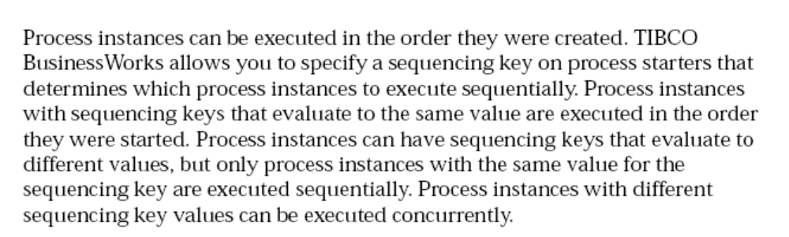

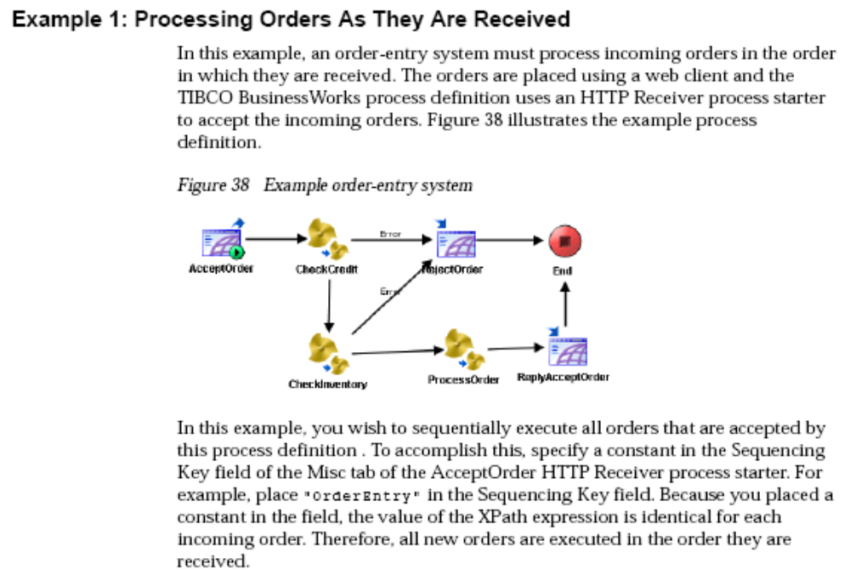
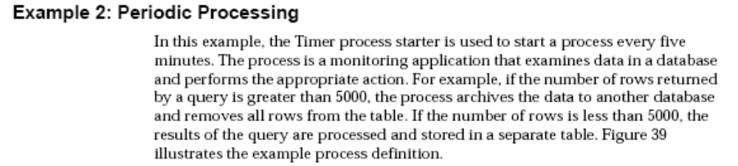
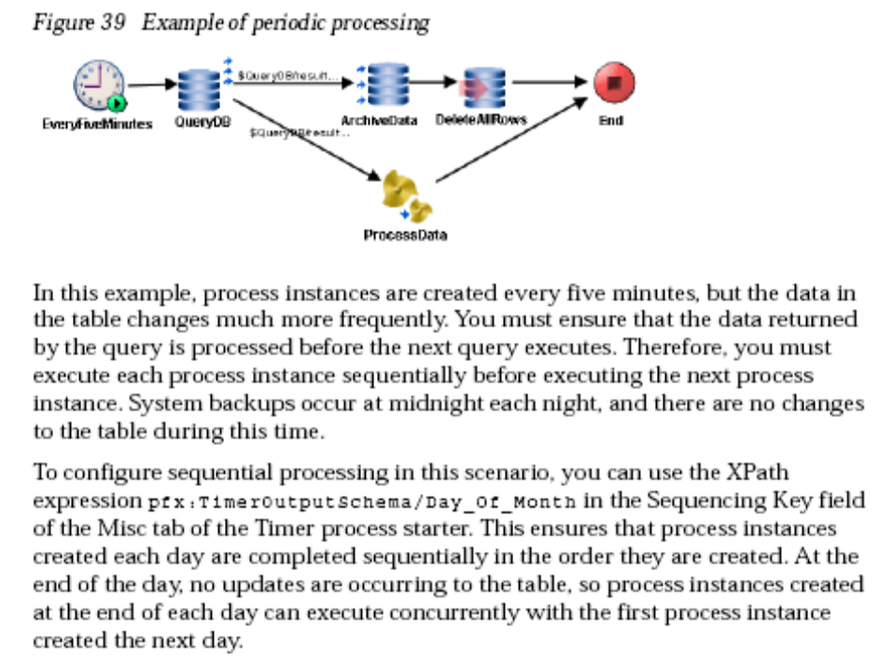

- What are the two error process variables available to your activities which are after error transition?
Ans: - i) $_error
ii) $_error_<activity-name>

- What is the resource used to create custom xpath function and state necessary conditions?

Ans: - i) Java custom function resource is used to create custom xpath functions.

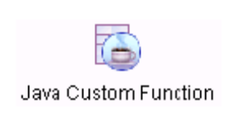
ii) Methods should be public and static
iii) Methods return type should not be void.
iv) Method signature should not include any “throws <some-exception>”
v) Method should not be overloaded.

- What are conditions regarding Java Schema?

Ans :- i) The Class should implement java.io.Serilizable interface
ii) Java schema can be used in JavaToXml and XmlToJava
iii) Only public members of java class are mapped to xml elements

- Please see the given below diagram
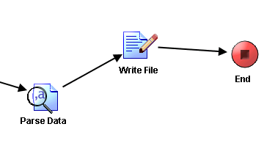
From the parse data activity you are getting a series of strings

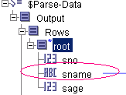 And you would like to place all the names in a file with pipe line separated as jafar|anil|raju what is suitable xapth you need to use?

Ans: - concat-sequence-format ($Parse-Data/Output/Rows/root/sname, "|")

- You have one FTP server which is periodically going down and up. When ever your BW process is trying to put a file using FTPput activity; by the time if the server is down or if the network goes down then FTPput may throw an exception. Even though your FTPput is throwing an exception; I want to try up to specific number of attempts. What is the Group setting I need to place for FTPput activity?
Ans: - Repeat-On-Error...Until_true

