Online Portfolio Template Generator - EverLeaf
1. PROJECT TITLE
Online Portfolio Template Generator - EverLeaf
2. PROJECT DESCRIPTION
EverLeaf is a web-based portfolio template generator that lets users enter and manage their professional information, choose from three portfolio templates, preview their portfolio, and publish a shareable page. Owners can keep a portfolio private or publish it, according to the application’s available controls.
3. TECHNOLOGIES USED
A. Frontend Development Tools
Technology/Tool | Purpose
Next.js 16.3.8 | Active web framework. Provides the App Router, pages, routes, and server features in next-app/.
React and React DOM 19.2.8 | Active user-interface components and browser rendering.
TypeScript 5.9.3 | Active typed application source and type checking.
Tailwind CSS 4.3.3 and custom CSS | Active styling for responsive layouts and the EverLeaf visual design.
HTML, CSS, and JavaScript | Markup, styling, and browser/runtime language technologies used by the application.
PostCSS with @tailwindcss/postcss 4.3.3 | Active Tailwind CSS integration in the Next.js build.
Vite 7.3.6 | Legacy Laravel asset and development tooling at the repository root; it does not build the Next.js application.

B. Backend Development Tools
Technology/Tool | Purpose
Next.js Server Actions 16.3.8 | Active server-side application logic in the Next.js App Router.
Supabase Auth | Active authentication service integration in the Next.js application; remote project settings were not inspected.
Supabase Storage | Active image-storage integration for portfolio profile and project images; remote bucket settings were not inspected.
@supabase/ssr 0.12.7 | Active browser/server client setup and cookie-based session support.
@supabase/supabase-js 2.117.2 | Active client library for Supabase authentication, database APIs, and file storage.
Laravel 12.69.2 (Legacy) | Earlier Laravel/Blade implementation retained at the repository root; not the active Next.js application backend.
PHP ^8.2 (Legacy) | PHP requirement in the root Composer manifest for the earlier Laravel implementation; this does not establish an exact installed PHP version.

C. Database Development Tools
Technology/Tool | Purpose
Supabase-hosted PostgreSQL | Active database service used by the Next.js application. PostgreSQL server version and remote migration status were not independently checked.
SQL migrations and Row Level Security | Active schema and access-policy definitions stored in next-app/supabase/migrations/; remote application status is unverified.
SQLite (Legacy Laravel default) | The root .env.example and config/database.php use SQLite as the legacy Laravel example default; it is not used by the active Next.js/Supabase application.
MySQL (Legacy/local option) | The legacy Laravel configuration includes a MySQL connection. The project reports local use with XAMPP, but the checked-in .env.example defaults to SQLite and does not verify XAMPP use.

D. Storage Tools
Technology/Tool | Purpose
Supabase Storage - portfolio-media | Active application integration for profile and project images. Source migrations define the bucket and policies; remote bucket state was not inspected.
AWS S3-compatible storage | Optional capability in the legacy Laravel implementation through its Composer adapter and environment placeholders; not the active Next.js storage service.
E. General Development and Version Control Tools
Technology/Tool | Purpose
Node.js and npm | Used to install and run the Next.js app. The project does not pin exact versions; Next.js 16.3.8 requires Node.js 20.9.0 or newer.
Visual Studio Code | Project-reported development editor; not part of the deployed application.
Git and GitHub | Version control and source-code hosting for the nextjs-vercel branch.
Composer | Dependency manager for the earlier Laravel/PHP implementation; not needed to build the Next.js application.
XAMPP | Project-reported local-development tooling for MySQL/Laravel; not established by the repository configuration and not part of production hosting.
Docker | A root-level Dockerfile builds the earlier PHP/Laravel application and its Vite assets; it is not the Next.js/Vercel deployment configuration.

F. Deployment and Hosting Tools
Technology/Tool | Purpose
Vercel | Primary hosting platform associated with the published Next.js website. The project dashboard configuration was not independently inspected.
GitHub | Hosts the project source repository; it is not the application hosting platform.
Render (Legacy/alternative) | A root render.yaml describes a Docker/Laravel service on the legacy master branch. This is an alternative/legacy configuration, not the active Next.js deployment.

4. DATABASE PLATFORM
Supabase is the managed backend platform used by the application. PostgreSQL is its relational database engine and stores portfolio records. Supabase Auth handles account sessions, while Supabase Storage is used for profile and project image files. Supabase is the database/backend provider; Vercel is the application hosting platform. The earlier Laravel configuration also offers MySQL, while its checked-in example defaults to SQLite; the project reports XAMPP for local MySQL development, but that use is not established by repository configuration.
5. HOSTING/DEPLOYMENT PLATFORM
Vercel is the hosting and deployment platform associated with the deployed Next.js application. The application directory in the repository is next-app/. The live site address is listed in Section 9. The URL and project context identify Vercel, but this document-generation run did not independently inspect the Vercel dashboard or verify current deployment status.
6. DATABASE STRUCTURE
The repository’s Supabase SQL migrations define the tables below. These files show the intended schema; whether every migration has been applied to the remote database was not confirmed.
Table | Important columns | Keys and relationship
portfolios | id, user_id, slug, full_name, email, role, about_me, contact_number, address, template_key, profile_photo_path, skills (JSONB), projects (JSONB), is_published, deleted_at, created_at, updated_at | id is primary key; user_id references auth.users(id); slug is unique.
portfolio_education | id, portfolio_id, school, degree, field_of_study, start_date, end_date, currently_studying, description, sort_order, created_at | id is primary key; portfolio_id references portfolios(id) with cascade delete.
portfolio_experiences | id, portfolio_id, position, company, start_date, end_date, currently_working, description, sort_order, created_at | id is primary key; portfolio_id references portfolios(id) with cascade delete.
portfolio_social_links | id, portfolio_id, platform, url, sort_order, created_at | id is primary key; portfolio_id references portfolios(id) with cascade delete.

Each portfolio can have multiple education entries, work-experience entries, and social links. Skills and projects are JSONB fields on the portfolio row. The migrations define indexes and Row Level Security policies; their hosted deployment status remains unverified.
7. SCREENSHOTS OF THE SYSTEM
These genuine EverLeaf system screenshots are available in the project documentation folder. The existing collection does not include a login or registration screenshot.
Home page

Portfolio management
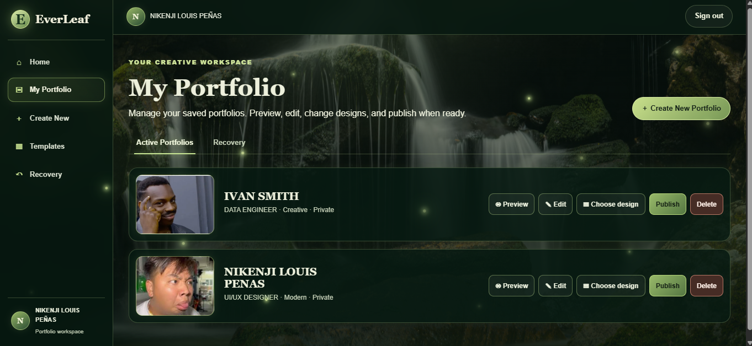

Portfolio creation form - upper section
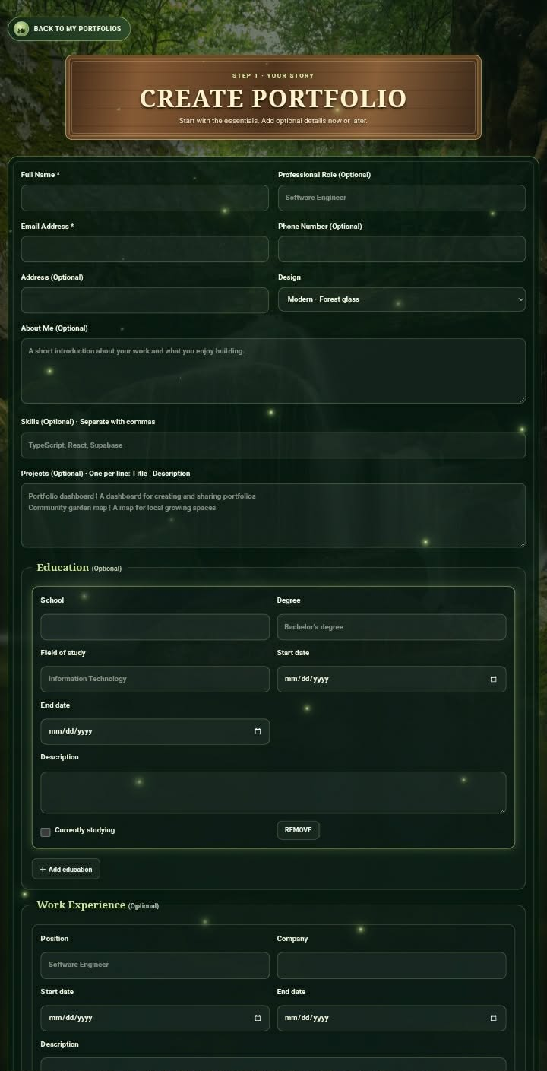

Portfolio creation form - lower section
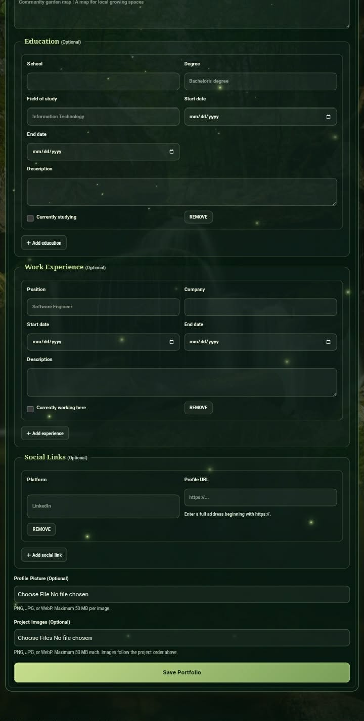

8. SCREENSHOTS OF THE 3 TEMPLATES
Each image is labeled with the matching implemented portfolio template name.
Simple template
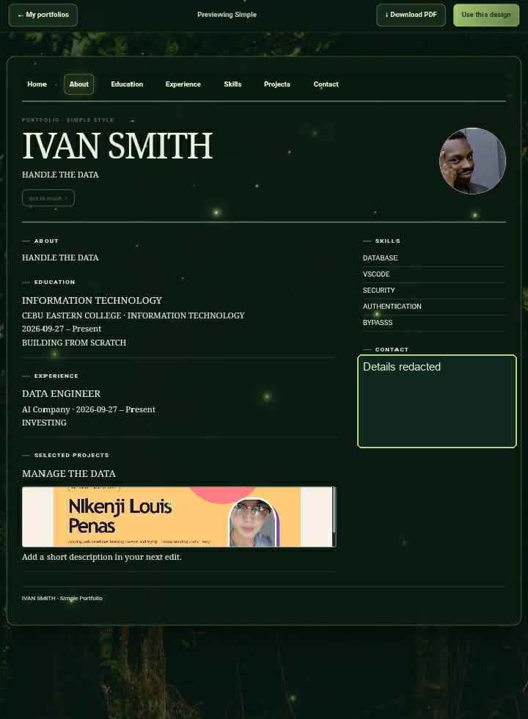

Modern template
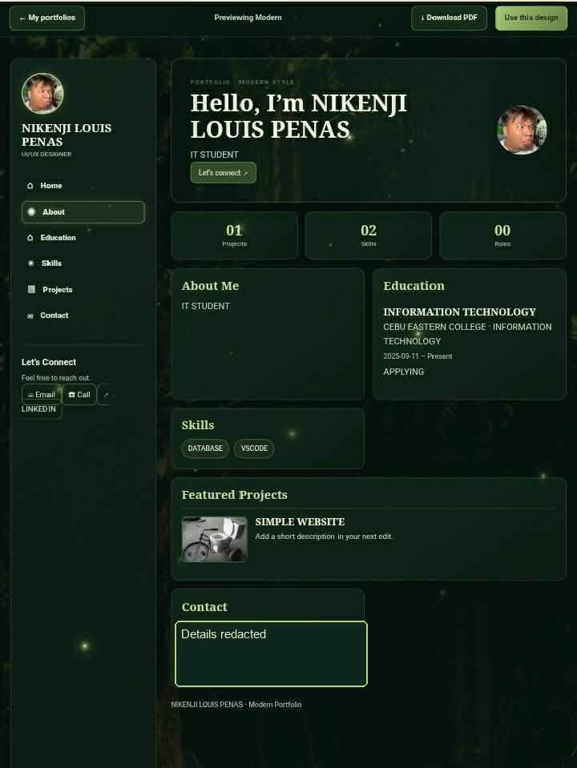

Creative template
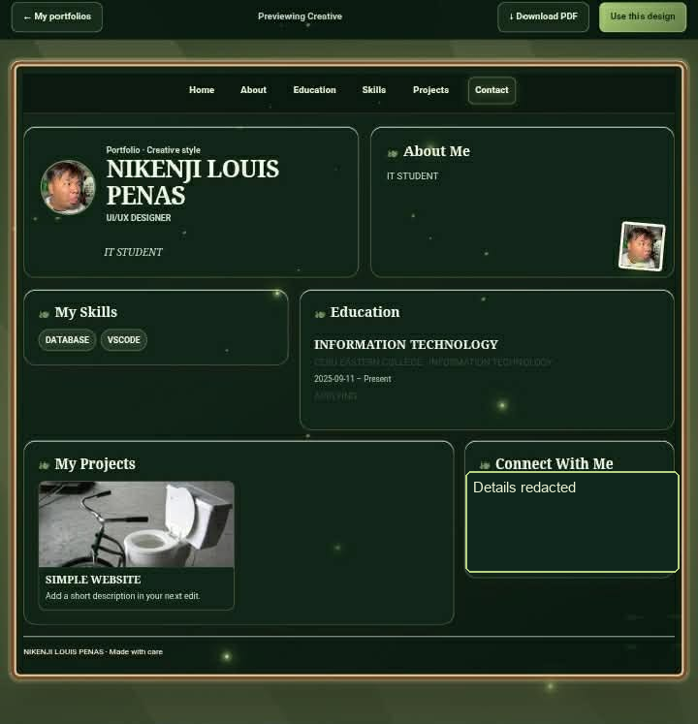
9. PUBLISHED WEBSITE URL
https://everleaf-portfolio-generator.vercel.app/home

