EverLeaf Online Portfolio Template Generator

1. Project Title
EverLeaf Online Portfolio Template Generator

2. Project Description
EverLeaf is an online portfolio generator for students and professionals. It lets users create and manage portfolio profiles, add education, experience, skills, projects, and social links, then preview and publish their work using one of three distinct designs.

3. Technologies Used
Technology | Use in the project
Next.js 16.3.8 and Server Actions | Active application framework, pages, and server-side actions.
React/React DOM 19.2.8; TypeScript 5.9.3 | UI components and typed application source.
Tailwind CSS 4.3.3; HTML, CSS, and JavaScript | Active styling and browser-facing application technologies.
Supabase Auth and Supabase Storage | Authentication and profile/project image storage for the active app.
PostgreSQL (Supabase) | Active database platform for the Next.js application.
MySQL (Legacy/local option) | Configured as a Laravel option; local XAMPP use is project-reported. The Laravel example defaults to SQLite.
Laravel 12.69.2 and PHP ^8.2 (Legacy) | Earlier Laravel implementation and PHP requirement.
Node.js and npm | Next.js development tools; no exact versions are pinned. Next.js 16 requires Node.js >=20.9.0.
Composer and XAMPP | Composer manages the legacy Laravel app; XAMPP is project-reported local tooling and is not verified in repository configuration.
Visual Studio Code | Project-reported editor.
Git and GitHub | Version control and source-code hosting.
Vercel | Hosting for the active Next.js application.

4. Database Platform
Supabase-hosted PostgreSQL is the database platform. Supabase Storage holds profile and project images in the portfolio-media bucket.

5. Hosting and Deployment Platform
The Next.js application is hosted on Vercel. The Next.js app folder is next-app/.

6. Database Structure
Table or resource | Purpose and principal data
portfolios | Portfolio owner, public slug, contact/profile details, selected template, skills and projects (JSONB), profile image path, publication status, and timestamps.
portfolio_education | Education records related to a portfolio: school, degree, field, dates, study status, description, and order.
portfolio_experiences | Work records related to a portfolio: position, company, dates, current-work status, description, and order.
portfolio_social_links | Social platform, profile URL, and display order for each portfolio.
portfolio-media storage bucket | Profile and project image files. Portfolio records reference image paths stored in this bucket.

A user can own multiple portfolios. Education, experience, and social-link records belong to a portfolio and are ordered with sort_order. Skills and projects are stored as JSONB arrays on the portfolios record.

7. Screenshots of the System
The following screenshots show the homepage, portfolio form, and portfolio management screen.

Figure 1. EverLeaf homepage
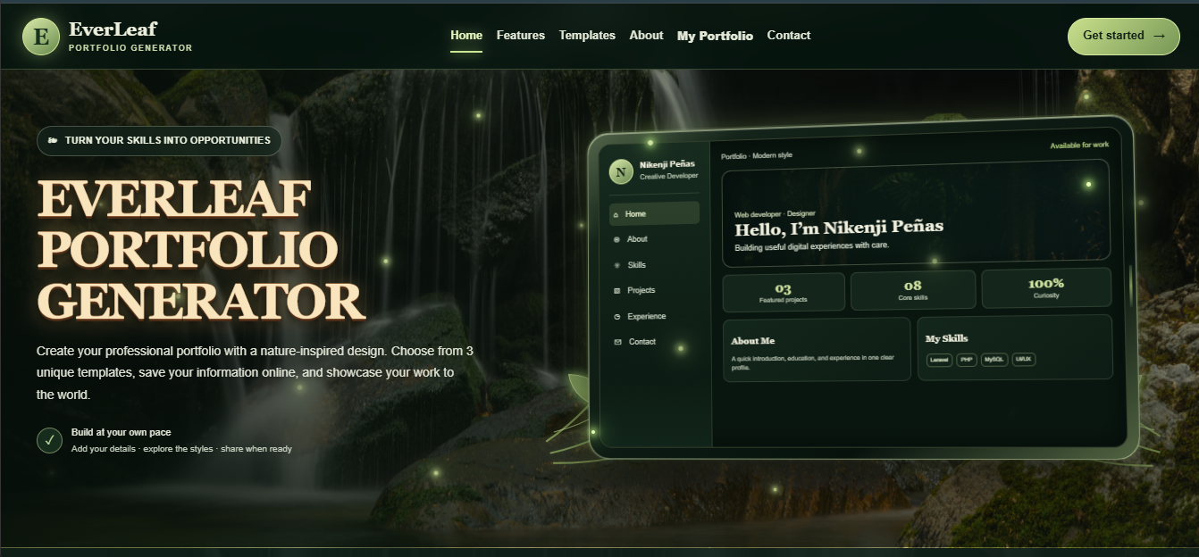

Figure 2. Portfolio form, upper section
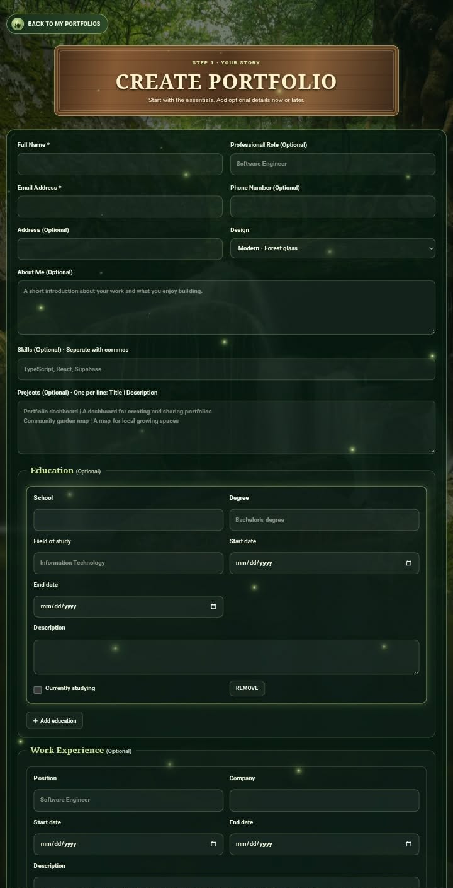

Figure 3. Portfolio form, lower section
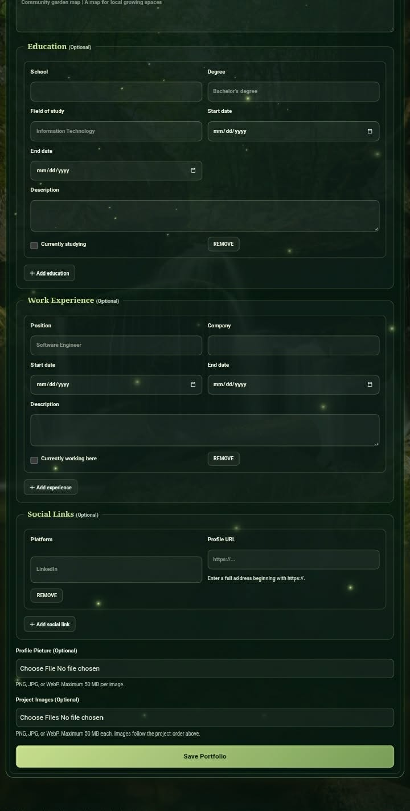

Figure 4. Portfolio management screen
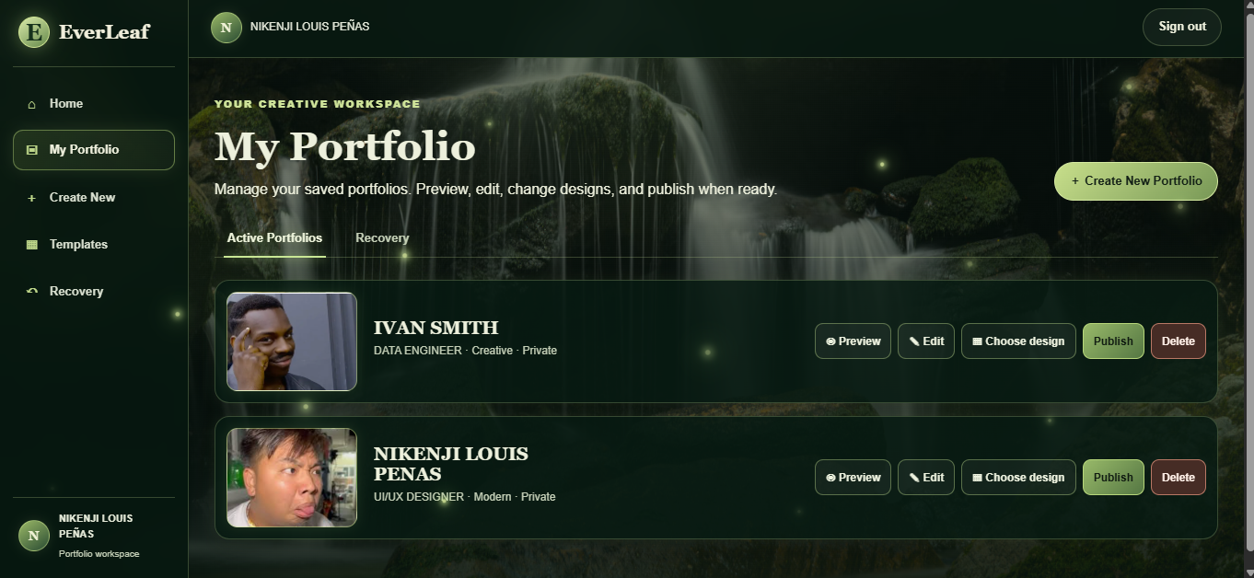

8. Screenshots of the Three Portfolio Templates
EverLeaf provides three separate portfolio template designs: Simple, Modern, and Creative.

Figure 5. Simple template
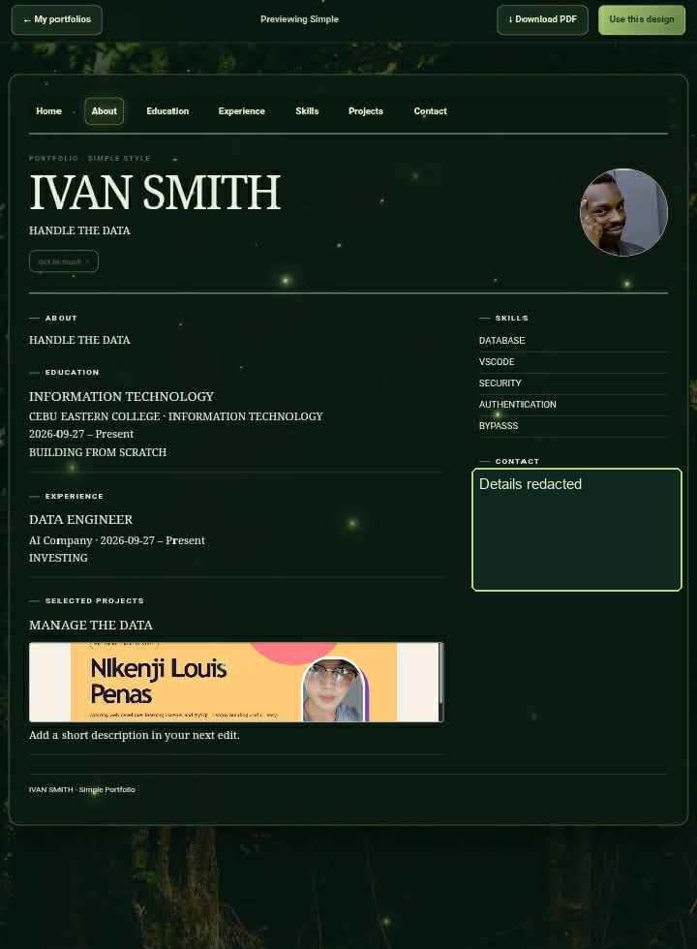

Figure 6. Modern template
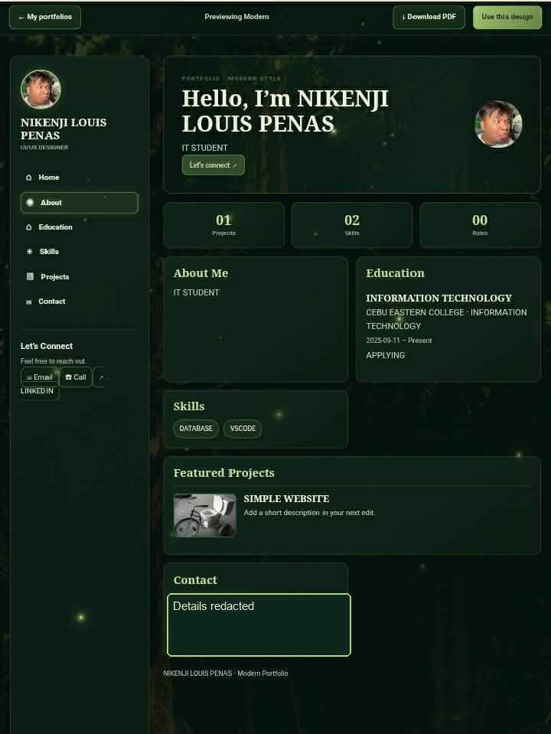

Figure 7. Creative template
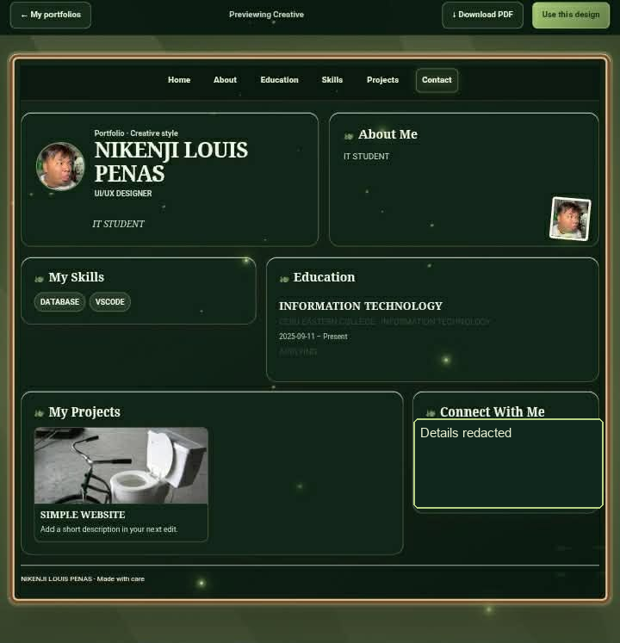

9. Published Website URL
https://everleaf-portfolio-generator.vercel.app/home

