EVERLEAF

Online Portfolio Template Generator

PROJECT DOCUMENTATION

Prepared by :
GROUP 7:
Nikenji Louis Peñas
Anthony Pedroza
Jayward Perater
Jay boy Gabunada
Jaymark Pahiculay

Course and section: BSIT 2ND YEAR SECTION -2

Instructor:
Mancilla, Jeorge Rey
Alangcas, Arjay
Quibol, Hazel Queen

Submission date: October 9, 2026

Contents

B. Project Description 3

C. Project Objectives 3

D. Technologies Used 3

E. System Pages and Features 4

F. Three Portfolio Templates 7
Simple (stored key: minimal) . . . . . . . . . . . . . . . . . . . . . . . . . . . . . . . . . . . . . . . . . . . . . . . . . . . . . . . 7
Modern . . . . . . . . . . . . . . . . . . . . . . . . . . . . . . . . . . . . . . . . . . . . . . . . . . . . . . . . . . . . . . . . . . 9
Creative . . . . . . . . . . . . . . . . . . . . . . . . . . . . . . . . . . . . . . . . . . . . . . . . . . . . . . . . . . . . . . . . . 10

G. Online Database and Database Structure 11

H. System Flow 11

I. Deployment Information 12

J. Testing and Results 13

K. Limitations and Recommendations 14
Verified limitations and open checks . . . . . . . . . . . . . . . . . . . . . . . . . . . . . . . . . . . . . . . . . . . . . . . . . . 14

L. Conclusion 14
Appendix: screenshots . . . . . . . . . . . . . . . . . . . . . . . . . . . . . . . . . . . . . . . . . . . . . . . . . . . . . . . . . 14

B. Project Description

EverLeaf is an online portfolio generator intended for students, early-career professionals, and other people who want a
simple way to present their profile and work. The application brings identity, biography, education, experience, skills,
projects, and social links together in a saved portfolio. An owner can preview one of three designs and choose whether to
publish a public portfolio page.
The interface uses a forest-inspired visual identity. The application code is a Next.js project in next-app/; Laravel files at
the repository root are retained as an earlier implementation. The root README identifies the Next.js app as the current
Vercel application.
Evidence boundary: this report describes source code, SQL migration files, the existing screenshot assets, and a successful
local production build. It does not claim that the live Supabase project, Vercel settings, or user workflows were
independently verified.

C. Project Objectives
Objective | Project intent
Portfolio information management | Collect and maintain profile, education, work experience, skills, projects, and social links.
Online persistence | Store portfolio records in Supabase PostgreSQL and image files in Supabase Storage.
Template selection | Offer Simple, Modern, and Creative views that render the same saved portfolio data.
Portfolio generation | Render a preview and a public page for an active portfolio when its owner publishes it.
Deployment | Serve the Next.js application from the provided Vercel URL and connect it to Supabase using  environment configuration.

These are documented objectives and code paths. Their end-to-end completion remains subject to the tests in Section J.

D. Technologies Used
Technology | Verified role in this repository
Next.js 16.3.8 and Server Actions | The active app framework, App Router, and server-side portfolio actions.
React and React DOM 19.2.8 | UI components and browser rendering.
TypeScript 5.9.3 | Typed application source and type checking.
Tailwind CSS 4.3.3; HTML, CSS, and JavaScript | Active styling and browser-facing markup/language technologies.
Supabase Auth | Authentication integration for the active Next.js application.
Supabase Storage | Active portfolio profile and project image storage integration.
Supabase PostgreSQL | Database platform used by the active Next.js application; remote configuration is not verified here.
MySQL (Legacy/local option) | MySQL is available in the Laravel config; project-reported local use with XAMPP is not established by repo configuration. Laravel's example defaults to SQLite.
Laravel 12.69.2 and PHP ^8.2 (Legacy) | Earlier Laravel/Blade application and its PHP requirement; not the active Next.js backend.
Node.js and npm | Next.js development/build tools. No exact Node.js or npm version is pinned; Next.js 16 requires Node.js >=20.9.0.
Composer | Dependency manager for the legacy Laravel/PHP application.
XAMPP | Project-reported local-development tooling; its use is not confirmed by checked-in configuration.
Visual Studio Code | Project-reported source-code editor.
Git and GitHub | Version control and source-code hosting.
Vercel | Application hosting platform associated with the published Next.js site.

Backend architecture: no separate API server is declared in the Next.js package. Next.js server actions and route handlers
mediate authentication and portfolio operations, while Supabase supplies managed authentication, PostgreSQL, and object
storage.

E. System Pages and Features
Route or section | What the source implements
/ | Welcome page with a Start Your Journey link to the home page.
/home | Landing page with navigation, hero, How It Works feature band, three template cards, About  section, and footer. Features is a home-page section, not a separate route.
/login, /signup | Email/password sign-in and account creation; optional template choice is carried in the URL.
/forgot-password, /reset-password, /auth/callback | Password recovery, new password submission, and email code/session callback.
/goodbye, /contact | Post-sign-out confirmation page and contact page route.
/dashboard | Authenticated portfolio list, visibility controls, preview/edit/design links, recovery mode, and  delete/restore actions.
/dashboard/new | Portfolio information form and image upload flow.
/dashboard/[id]/edit | Owner edit form for a saved, active portfolio.
/dashboard/[id]/templates | Owner template chooser with Preview and Use design controls.
/dashboard/[id]/preview/[template] | Authenticated owner preview with preview toolbar.
/template-demo/[template] | Public sample preview with sample information.
/p/[slug] | Public portfolio render; query restricts to published, non-deleted records.

The route list was cross-checked against the successful Next.js production build output. This confirms route compilation, not
live behavior.
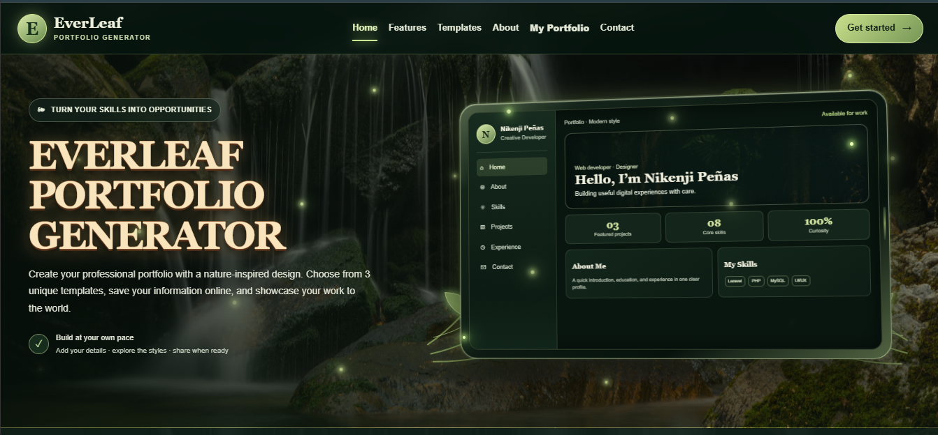
Figure 1. Existing repository desktop screenshot of the EverLeaf landing page.
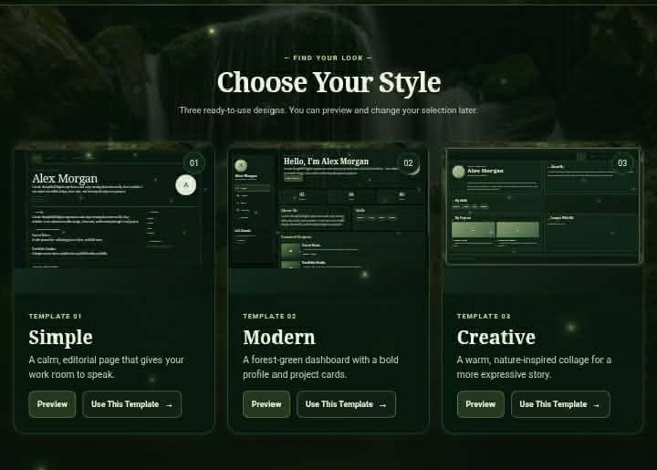
Figure 2. Crop of the landing page How It Works feature band; not a separate Features route.
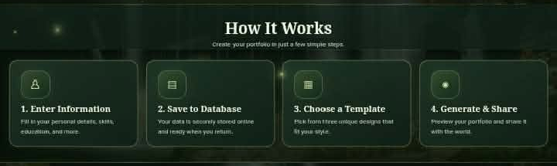
Figure 3. Existing template-card section from the landing-page screenshot; Preview and Use This Template controls are visible.
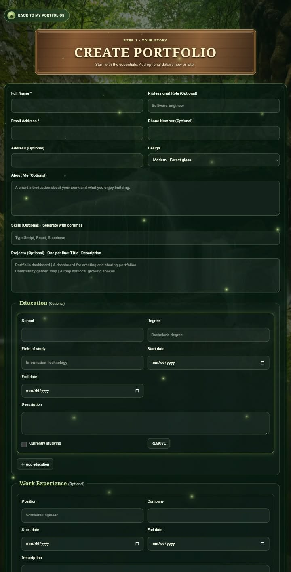
Figure 4. Existing portfolio form screenshot, upper section. A lower-section image is in the screenshot appendix folder.
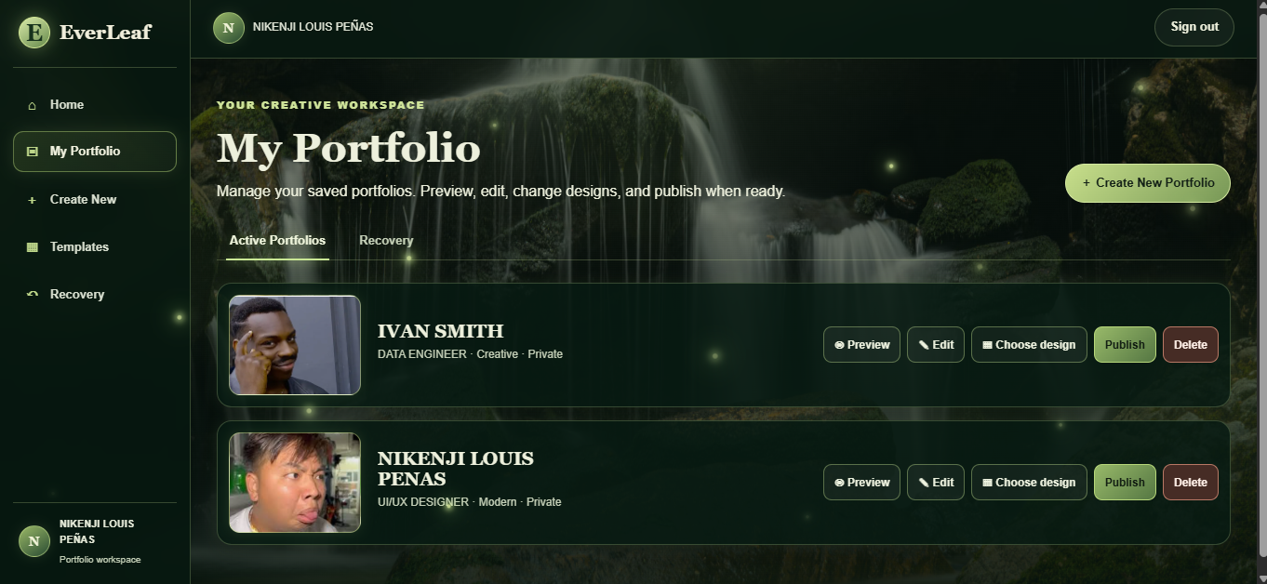
Figure 5. Existing portfolio management screenshot.
The separate portfolio preview capture is saved as 08-portfolio-preview.png. The template-specific preview
screenshots in Section F also show the preview toolbar.

F. Three Portfolio Templates
The stored template keys are minimal, modern, and creative. The user-facing label Simple maps to minimal. The
Next.js renderer selects three separate React components: MinimalTemplate, ModernTemplate, and CreativeTemplate.
Each component receives the saved portfolio data, resolved profile/project image URLs, and selected template key. The
descriptions below reflect the component names, chooser copy, styles, and existing screenshots; interactive differences
were not manually tested.

Simple (stored key: minimal)
An editorial layout with restrained spacing and clear profile sections. The source component displays identity, about,
education, experience, skills, selected projects, and contact information where data exists.
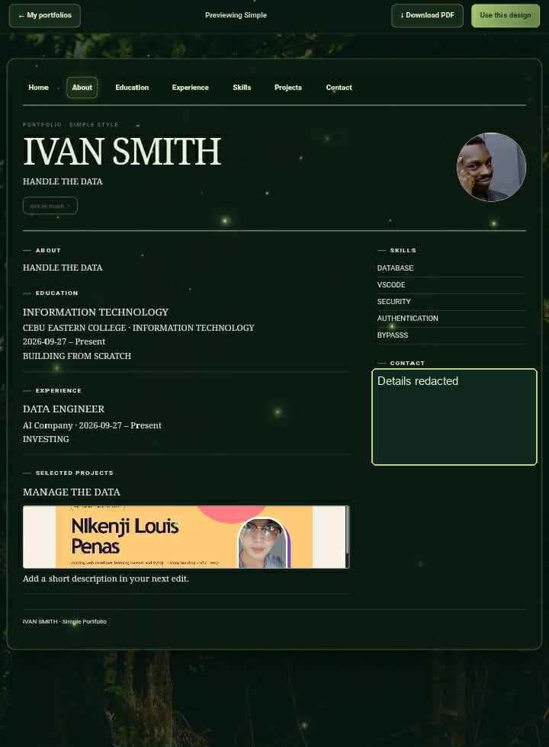
Figure 6. Existing Simple preview screenshot. Personal contact values are redacted in this documentation copy.

Modern
A forest-green dashboard composition with a prominent introduction, sidebar navigation, summary cards, and modular
profile/project panels. It is a separate component and stylesheet, not a generic variant of Simple.
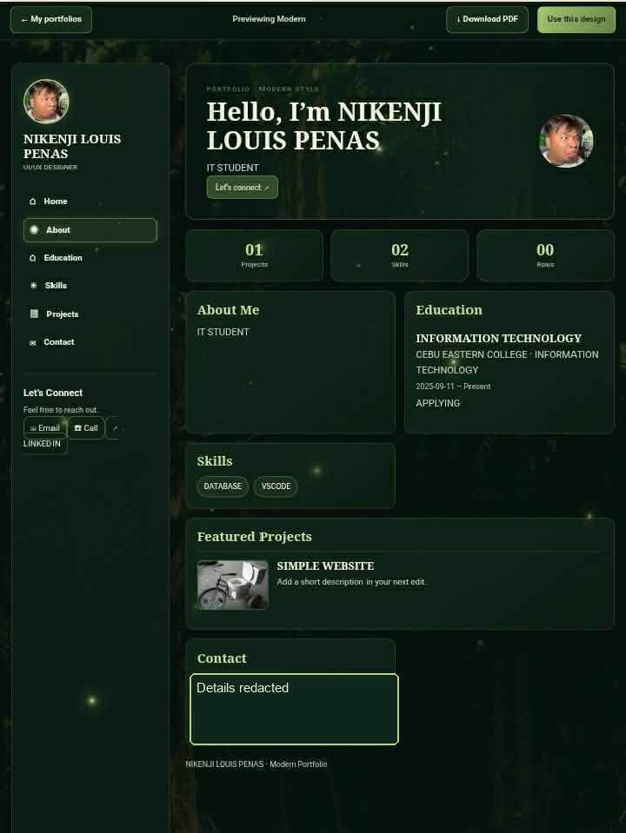
Figure 7. Existing Modern preview screenshot. Personal contact values are redacted in this documentation copy.

Creative
A framed, more expressive arrangement with a warm border treatment and an asymmetric content grid. It renders the same
portfolio data through its own CreativeTemplate component.
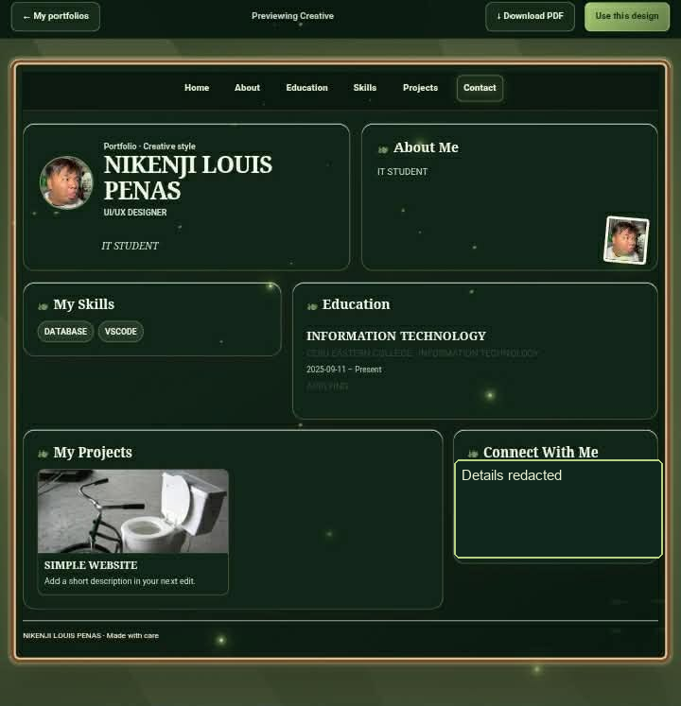
Figure 8. Existing Creative preview screenshot. Personal contact values are redacted in this documentation copy.
Template selection and preview are implemented separately: the chooser links to an owner preview route and submits the
selected key through a server action. The current stored key is constrained to the three supported values in the migration.

G. Online Database and Database Structure
Platform: the source contains Supabase SQL migrations that target PostgreSQL, plus Supabase client calls. This is
evidence of the intended/configured application data model, not direct confirmation of the live Supabase project's schema,
policies, bucket state, or data.
Table | Columns from migration definitions (name: type; key/default notes)
public.portfolios | id: uuid PK default gen_random_uuid(); user_id: uuid NOT NULL FK auth.users(id) ON DELETE  CASCADE; slug: text NOT NULL UNIQUE; full_name: text NOT NULL; email: text NOT NULL; role: text  NOT NULL default ''; about_me: text NOT NULL default ''; template_key: text NOT NULL default 'modern'  CHECK modern/creative/minimal; profile_photo_path: text nullable; skills: jsonb NOT NULL default [];  projects: jsonb NOT NULL default []; is_published: boolean NOT NULL default false; created_at,  updated_at: timestamptz NOT NULL default now(); contact_number, address: text nullable; deleted_at:  timestamptz nullable.
public.portfolio_education | id: uuid PK default gen_random_uuid(); portfolio_id: uuid NOT NULL FK portfolios(id) ON DELETE  CASCADE; school: text NOT NULL; degree, field_of_study: text nullable; start_date, end_date: date  nullable; currently_studying: boolean NOT NULL default false; description: text nullable; sort_order: integer  NOT NULL default 0; created_at: timestamptz NOT NULL default now().
public.portfolio_experiences | id: uuid PK default gen_random_uuid(); portfolio_id: uuid NOT NULL FK portfolios(id) ON DELETE  CASCADE; position: text NOT NULL; company: text nullable; start_date, end_date: date nullable;  currently_working: boolean NOT NULL default false; description: text nullable; sort_order: integer NOT  NULL default 0; created_at: timestamptz NOT NULL default now().
public.portfolio_social_links | id: uuid PK default gen_random_uuid(); portfolio_id: uuid NOT NULL FK portfolios(id) ON DELETE  CASCADE; platform, url: text NOT NULL; sort_order: integer NOT NULL default 0; created_at: timestamptz  NOT NULL default now().

Relationships and indexes: one Supabase Auth user can own multiple portfolios; each portfolio can have multiple education,
experience, and social-link rows. Child records cascade when their parent portfolio is removed. The three child tables have
portfolio/order indexes. Skills and projects are JSONB arrays on the parent table, not separate relational tables.
Row-level security in migration files: portfolio owners can select/insert/update/delete their own rows.
Anonymous/authenticated visitors can select only published portfolios whose deleted_at is null. Related education,
experience, and social-link records have owner-scoped operations and public reads only while their parent is published and
active. This description is from SQL source; applying and verifying the policies in the hosted database remains unconfirmed.
Storage: the migrations define a bucket named portfolio-media and permit PNG, JPEG, and WebP. A later migration makes
the bucket private and sets a 50 MB per-file limit. Upload paths begin with the authenticated user's UUID. Storage policies
allow owners to manage their own files and allow reads for owners or assets referenced by an active published portfolio.
Server code creates signed image URLs valid for 600 seconds.
CRUD path in code: create inserts a portfolio then upserts child rows; read queries filter by owner or published slug; edit
updates the portfolio and synchronizes child rows; deletion first sets deleted_at and turns publication off; recovery can
restore the record; permanent deletion removes the portfolio and then attempts to remove its associated image objects.
These flows were inspected in source but were not exercised against the live database for this report.
Live configuration boundary: no Supabase dashboard inspection or query was performed. Actual rows, applied migration
versions, Auth redirect allow-list, Storage bucket settings, and policies are therefore unverified.

H. System Flow
The diagram shows the intended user flow represented by the routes and action code. It does not imply that every external
integration was tested.
HOME
CREATE PORTFOLIO
ENTER INFORMATION
SAVE TO ONLINE DATABASE
SELECT ONE OF THREE TEMPLATES
GENERATE PORTFOLIO
PREVIEW PORTFOLIO
EDIT OR DELETE PORTFOLIO
The code also includes publication controls: an owner can make a saved portfolio public, after which its /p/{slug} page is
queryable; deleting it moves it to Recovery and removes it from public results.

I. Deployment Information
Item | Documented value and verification boundary
Live website | https://everleaf-portfolio-generator.vercel.app/home (URL supplied in the brief; live accessibility could not be  verified with the available page-fetch tool).
GitHub | NikenjiPenas/Everleaf-portfolio-generator/tree/nextjs-vercel; the inspected branch was nextjs-vercel at commit  27a06a3.
Hosting | Vercel, as supplied by the project owner and repository overview. Vercel dashboard Root Directory, build  settings, environment values, and latest deployment status were not inspected.
Application root | next-app/ contains package.json, next.config.ts, and the App Router source. Vercel Root Directory should be set  to next-app; this dashboard setting itself remains unverified.
Database | Supabase-hosted PostgreSQL is the platform represented by the checked-in migrations and application clients.  Live project linkage was not independently verified.
Connection | The app reads NEXT_PUBLIC_SUPABASE_URL and NEXT_PUBLIC_SUPABASE_PUBLISHABLE_KEY.  NEXT_PUBLIC_SITE_URL is used to construct confirmation and recovery callbacks;  NEXT_PUBLIC_SUPABASE_MEDIA_BUCKET defaults to portfolio-media.

The expected deployment environment variables are documented as names and placeholders in the root README and
next-app/env.example. The contents of the local .env.local file were not read or copied. Production Auth settings should
allow the production origin and /auth/callback redirect; the dashboard configuration requires owner verification.
Local build check: PASS. npm run build completed for Next.js 16.3.8 and TypeScript. The first run inside the restricted
sandbox failed while SWC canonicalized the project path (Access is denied); rerunning with filesystem access allowed
completed successfully. This build result is local and does not prove the remote Vercel build is current.

J. Testing and Results
The Next.js production build is the only runtime-oriented check performed during this documentation task. The interaction
tests below were not run, so none are marked PASS. Existing screenshots and source code are not substitutes for
end-to-end test evidence.
Test case | Expected result | Actual result | Status
Open published website | Home page loads at the published  URL. | Could not verify live accessibility from this  environment. | NOT TESTED
Register or log in | User account/session is created or  accepted. | Auth flow exists in source; not exercised. | NOT TESTED
Enter portfolio information | Valid profile fields can be entered. | Form route exists; not exercised. | NOT TESTED
Save portfolio information | Parent and detail records are saved. | Server action inspected; no live save performed. | NOT TESTED
Verify saved database  record | Saved values appear in Supabase. | Supabase project was not queried. | NOT TESTED
Retrieve an existing  portfolio | Owner can reopen their saved record. | Read paths exist; not exercised. | NOT TESTED
Select Simple template | Simple design is selected and saved. | minimal key/component exists; not exercised. | NOT TESTED
Select Modern template | Modern design is selected and saved. | modern key/component exists; not exercised. | NOT TESTED
Select Creative template | Creative design is selected and saved. | creative key/component exists; not exercised. | NOT TESTED
Generate and preview | Preview renders saved portfolio data. | Preview route exists; not exercised. | NOT TESTED
Edit existing portfolio | Owner can update portfolio data. | Update action exists; not exercised. | NOT TESTED
Verify updated information | Saved changes are reflected after  reload. | No edit/reload test performed. | NOT TESTED
Delete a portfolio | Portfolio moves to Recovery and is  unpublished. | Soft-delete action exists; not exercised. | NOT TESTED
Verify deleted record  unavailable | Deleted portfolio is not public or  active. | SQL and query filters inspected; not exercised. | NOT TESTED
Refresh and verify  persistence | Saved record remains available after  refresh. | No live persistence test performed. | NOT TESTED
Test mobile responsivenes  s | Pages remain usable at mobile widths. | Responsive CSS exists; no device/browser test  performed. | NOT TESTED

Build evidence: npm run build succeeded and printed the compiled App Router route list. The package also declares npm
run check (TypeScript no-emit). No claim of a successful CRUD test, Supabase verification, mobile visual test, or live
deployment test is made here.

K. Limitations and Recommendations

Verified limitations and open checks
Finding | Practical next step
Hosted Supabase schema and RLS state are not  verified. | Apply migrations in order to the intended project, then inspect tables, policies, and bucket  settings in Supabase.
Vercel dashboard settings are not verified. | Confirm Root Directory is next-app, build command is npm run build, and all required  variables are set for Production/Preview as intended.
Live website fetch was unavailable here. | Open the provided Vercel URL in a browser and capture a fresh, dated screenshot after  confirming current deployment.
Interaction tests were not run. | Use the test matrix in Section J with a dedicated demo account and safe sample data;  record actual results and evidence.
No dedicated Next.js test runner is declared in  next-app/package.json. | Add an automated test suite only if it is within project scope; otherwise record a manual  acceptance test session.
Existing screenshots may reflect earlier page versions  and sample profiles. | Replace them with current, consented demo captures before final academic submission;  keep contact details and private account data hidden.
The global stylesheet uses a remote Unsplash  background image URL. | Check production availability and licensing; consider a locally managed asset if stable  background rendering is required.
The submitted Supabase email redirect settings are  external to this repository. | Verify local and production Site URL/redirect allow-list settings without exposing  credentials.

The root includes Laravel application files and a Render configuration retained from an earlier implementation. The
checked-in README identifies next-app as the current Vercel app; only the live Vercel project settings can confirm which
source directory is actually deployed.

L. Conclusion
EverLeaf's current repository contains a Next.js portfolio generator with three distinct template components,
Supabase-backed authentication/data/storage code, portfolio management and recovery flows, and public portfolio
rendering. The checked-in migrations describe an owner-scoped PostgreSQL model with published-read policies, while
screenshots document several existing UI views.
The local production build passed. The hosted database configuration, live deployment settings, public-site accessibility,
and manual interaction/mobile tests remain unverified. The project should be described as implemented in source and
buildable, with the listed external checks and acceptance tests still to be completed.

Appendix: screenshots
Available repository screenshots are stored in documentation/screenshots/. The checklist identifies what is present, what
was cropped from an existing capture, and which database/edit/delete/mobile screenshots still need a real manual capture.
Contact values were redacted in the template screenshots embedded in this report.

