Online Portfolio Template Generator - EverLeaf
1. PROJECT TITLE
Online Portfolio Template Generator - EverLeaf
2. PROJECT DESCRIPTION
EverLeaf is a web-based portfolio template generator that lets users enter and manage their professional information, choose from three portfolio templates, preview their portfolio, and publish a shareable page. Owners can keep a portfolio private or publish it, according to the application’s available controls.
3. TECHNOLOGIES USED
A. Frontend Development Tools
Technology/Tool | Purpose
Next.js 16.3.8 | Active web framework. Provides the App Router, pages, routes, and server features in next-app/.
React and React DOM 19.2.8 | Active user-interface components and browser rendering.
TypeScript 5.9.3 | Active typed application source and type checking.
Tailwind CSS 4.3.3 and custom CSS | Active styling for responsive layouts and the EverLeaf visual design.
PostCSS with @tailwindcss/postcss 4.3.3 | Active Tailwind CSS integration in the Next.js build.
Vite 7.3.6 | Legacy Laravel asset and development tooling at the repository root; it does not build the Next.js application.

B. Backend Development Tools
Technology/Tool | Purpose
Next.js server features and Server Actions 16.3.8 | Active server-side application logic in the Next.js App Router.
Supabase Auth | Active authentication service integration in the Next.js application; remote project settings were not inspected.
@supabase/ssr 0.12.7 | Active browser/server client setup and cookie-based session support.
@supabase/supabase-js 2.117.2 | Active client library for Supabase authentication, database APIs, and file storage.
Laravel 12.69.2 and PHP 8.2+ | Earlier Laravel/Blade implementation retained at the repository root; not the active Next.js application backend.

C. Database Development Tools
Technology/Tool | Purpose
Supabase-hosted PostgreSQL | Active database service used by the Next.js application. PostgreSQL server version and remote migration status were not independently checked.
SQL migrations and Row Level Security | Active schema and access-policy definitions stored in next-app/supabase/migrations/; remote application status is unverified.
SQLite | Configured as the default local database in the legacy Laravel example configuration; not used by the active Next.js/Supabase application.
MySQL | Available as a legacy Laravel database connection option; no use by the active Next.js application was found.

D. Storage Tools
Technology/Tool | Purpose
Supabase Storage - portfolio-media | Active application integration for profile and project images. Source migrations define the bucket and policies; remote bucket state was not inspected.
AWS S3-compatible storage | Optional capability in the legacy Laravel implementation through its Composer adapter and environment placeholders; not the active Next.js storage service.
E. General Development and Version Control Tools
Technology/Tool | Purpose
Node.js 24.21.0 and npm 11.19.0 | Versions observed in the local audit environment; next-app/package.json does not pin these exact runtime versions.
Git and GitHub | Version control and source-code hosting for the nextjs-vercel branch.
Composer | Dependency manager for the earlier Laravel/PHP implementation; not needed to build the Next.js application.
Docker | A root-level Dockerfile builds the earlier PHP/Laravel application and its Vite assets; it is not the Next.js/Vercel deployment configuration.
XAMPP | Not verified in the active application or repository configuration; not identified as a required production technology.

F. Deployment and Hosting Tools
Technology/Tool | Purpose
Vercel | Primary hosting platform associated with the published Next.js website. The project dashboard configuration was not independently inspected.
GitHub | Hosts the project source repository; it is not the application hosting platform.
Render | A root render.yaml describes a Docker/Laravel service on the legacy master branch. This is an alternative/legacy configuration, not the active Next.js deployment.

4. DATABASE PLATFORM
Supabase is the managed backend platform used by the application. PostgreSQL is its relational database engine and stores portfolio records. Supabase Auth handles account sessions, while Supabase Storage is used for profile and project image files. Supabase is the database/backend provider; Vercel is the application hosting platform.
5. HOSTING/DEPLOYMENT PLATFORM
Vercel is the hosting and deployment platform associated with the deployed Next.js application. The application directory in the repository is next-app/. The live site address is listed in Section 9. The URL and project context identify Vercel, but this document-generation run did not independently inspect the Vercel dashboard or verify current deployment status.
6. DATABASE STRUCTURE
The repository’s Supabase SQL migrations define the tables below. These files show the intended schema; whether every migration has been applied to the remote database was not confirmed.
Table | Important columns | Keys and relationship
portfolios | id, user_id, slug, full_name, email, role, about_me, contact_number, address, template_key, profile_photo_path, skills (JSONB), projects (JSONB), is_published, deleted_at, created_at, updated_at | id is primary key; user_id references auth.users(id); slug is unique.
portfolio_education | id, portfolio_id, school, degree, field_of_study, start_date, end_date, currently_studying, description, sort_order, created_at | id is primary key; portfolio_id references portfolios(id) with cascade delete.
portfolio_experiences | id, portfolio_id, position, company, start_date, end_date, currently_working, description, sort_order, created_at | id is primary key; portfolio_id references portfolios(id) with cascade delete.
portfolio_social_links | id, portfolio_id, platform, url, sort_order, created_at | id is primary key; portfolio_id references portfolios(id) with cascade delete.

Each portfolio can have multiple education entries, work-experience entries, and social links. Skills and projects are JSONB fields on the portfolio row. The migrations define indexes and Row Level Security policies; their hosted deployment status remains unverified.
7. SCREENSHOTS OF THE SYSTEM
These genuine EverLeaf system screenshots are available in the project documentation folder. The existing collection does not include a login or registration screenshot.
Home page
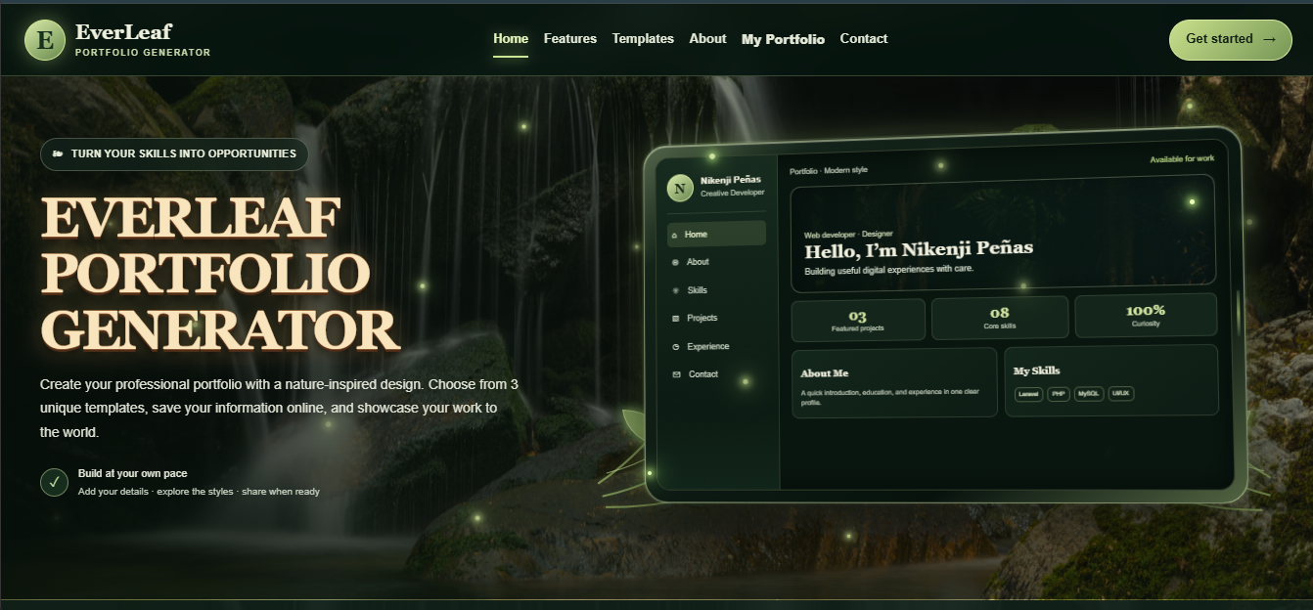
Portfolio management
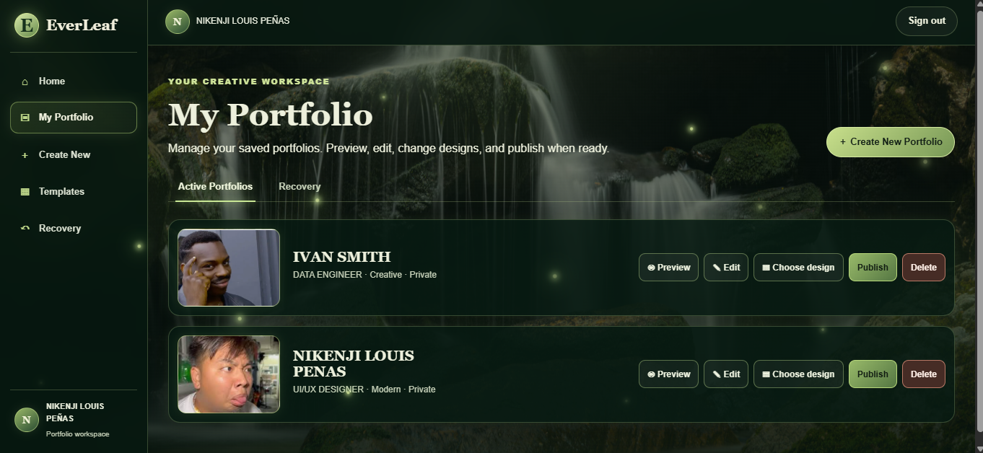

Portfolio creation form - upper section
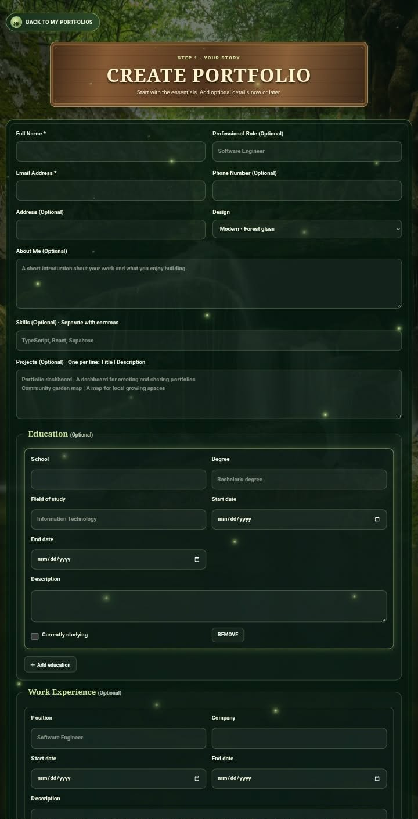

Portfolio creation form - lower section
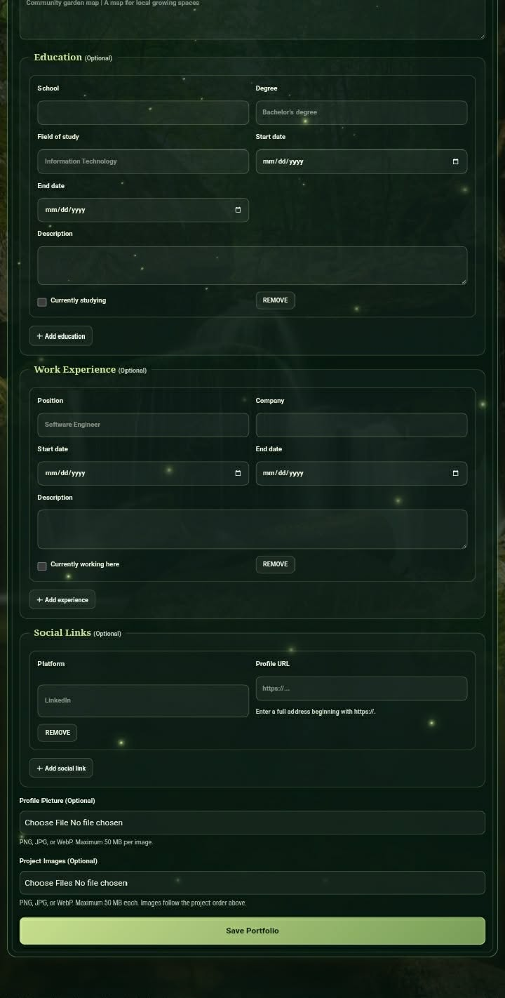

8. SCREENSHOTS OF THE 3 TEMPLATES
Each image is labeled with the matching implemented portfolio template name.
Simple template
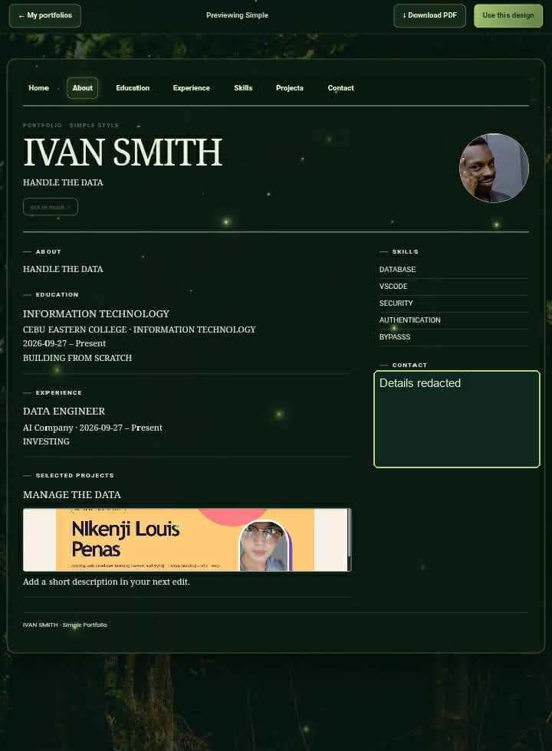

Modern template
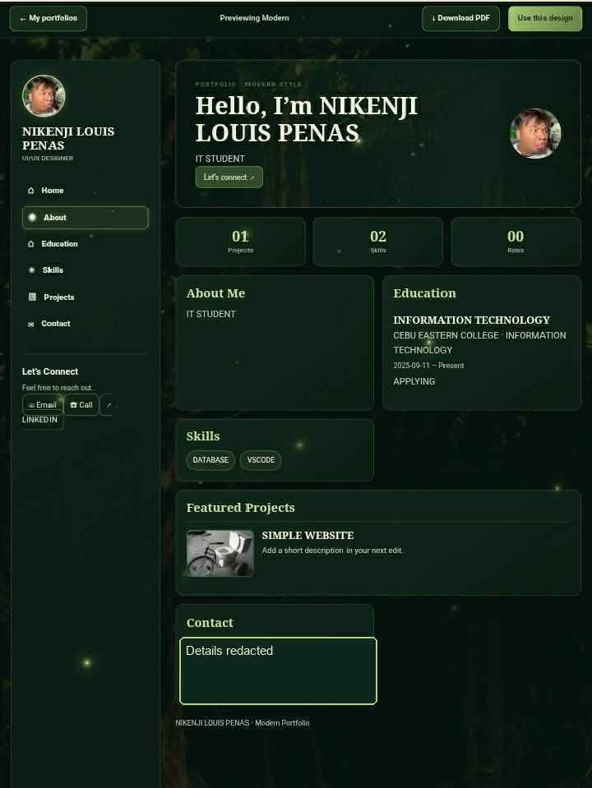

Creative template
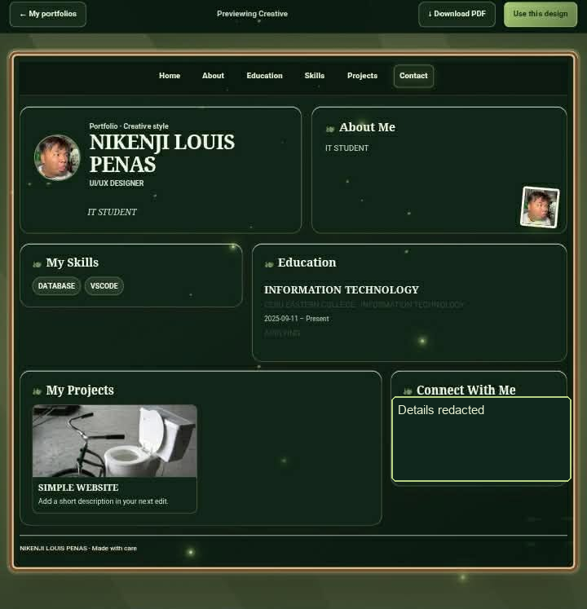
9. PUBLISHED WEBSITE URL
https://everleaf-portfolio-generator.vercel.app/home

