EVERLEAF
Online Portfolio Template Generator

PROJECT DOCUMENTATION

Prepared by :
GROUP 7:
Nikenji Louis Peñas
Anthony Pedroza
Jayward Perater
Jay boy Gabunada
Jaymark Pahiculay
Yassin Abdel Rahman
Course and section: BSIT 2ND YEAR SECTION -2
Instructor:
Mancilla, Jeorge Rey
Alangcas, Arjay
Quibol, Hazel Queen
Project Description
EverLeaf is a web application for creating online portfolios. Users can enter profile and work details, choose among three designs, preview sample layouts, and publish portfolio pages. The application provides account sign-in and registration, portfolio management, and public portfolio routes when supported by the saved portfolio and access settings.

Technologies Used
The active deployed EverLeaf application uses these main technologies.
Category | Main Technology | Purpose
  Frontend | HTML,CSS,Javascript ,Next.js, React, TypeScript, Tailwind CSS | Builds and styles the website and its portfolio interfaces.
Backend | Next.js Server Actions | Processes application requests and portfolio form actions.
  Database | Supabase PostgreSQL | Stores portfolio profiles and related information.
  Authentication and Storage | Supabase Auth and Supabase Storage | Supports user accounts and portfolio media files.
  Source Code | GitHub | Stores the project source code and version history.
  Deployment and Hosting | Vercel | Hosts the public EverLeaf web application.
Development Tools | VS Code,npm,Node.js, Git | Development tools for coding, managing packages, running JavaScript, and tracking changes.

Database Platform
The active EverLeaf application uses Supabase PostgreSQL to store portfolio profiles and their related education, work experience, and social-link records. Supabase Auth supports user sign-in, and Supabase Storage holds portfolio media; these are supporting services, not database engines.

Hosting/Deployment Platform
Vercel hosts the deployed EverLeaf website. GitHub stores the source code in the EverLeaf repository. Published website: https://everleaf-portfolio-generator.vercel.app/home

Database Structure
EverLeaf uses a Supabase PostgreSQL database to store users' portfolio information. It has four main tables:
Table Name | Information Stored | Purpose
portfolios | id (PK), user_id (FK), name, email, profile picture, skills, projects, and selected template | Stores the main portfolio information and its owner.
portfolio_education | id (PK), portfolio_id (FK), school, degree, and study dates | Stores the user's educational background.
portfolio_experiences | id (PK), portfolio_id (FK), job title, company, and work dates | Stores the user's work experience.
portfolio_social_links | id (PK), portfolio_id (FK), social media names, and URLs | Stores links to the user's online profiles.

Database Relationships
Each registered user has a unique user ID. Each portfolio also has its own unique ID. The user_id (FK) field connects a portfolio to its owner, while portfolio_id (FK) connects education, work experience, and social-link records to the correct portfolio.
(PK) Primary Key: A field that uniquely identifies each record.
(FK) Foreign Key: A field that connects a record to another table.
These tables work together to store and organize the information needed to create a complete online portfolio.

7. Screenshots of the System

Figure 1. EverLeaf Homepage Hero


Landing Page

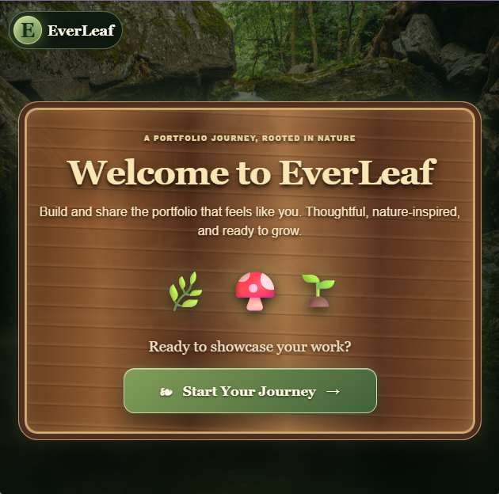

Figure 2. Sign-In Page
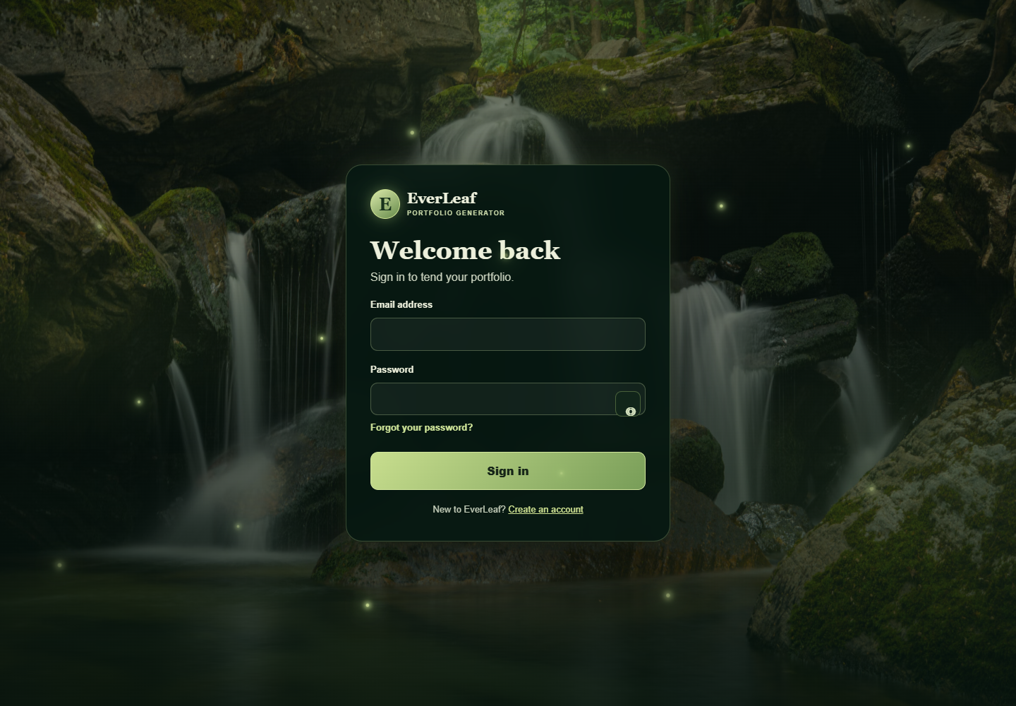

Figure 3. Account Registration Page
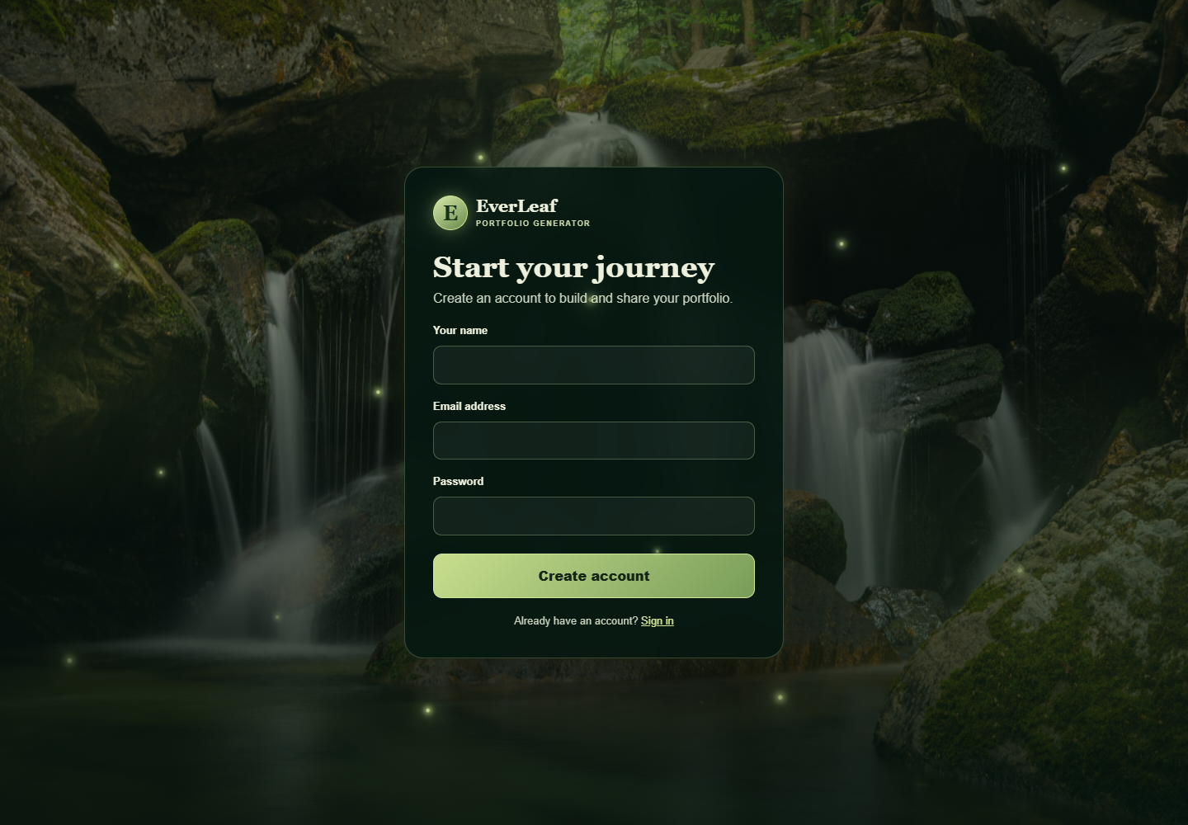

Figure 4. Full Homepage
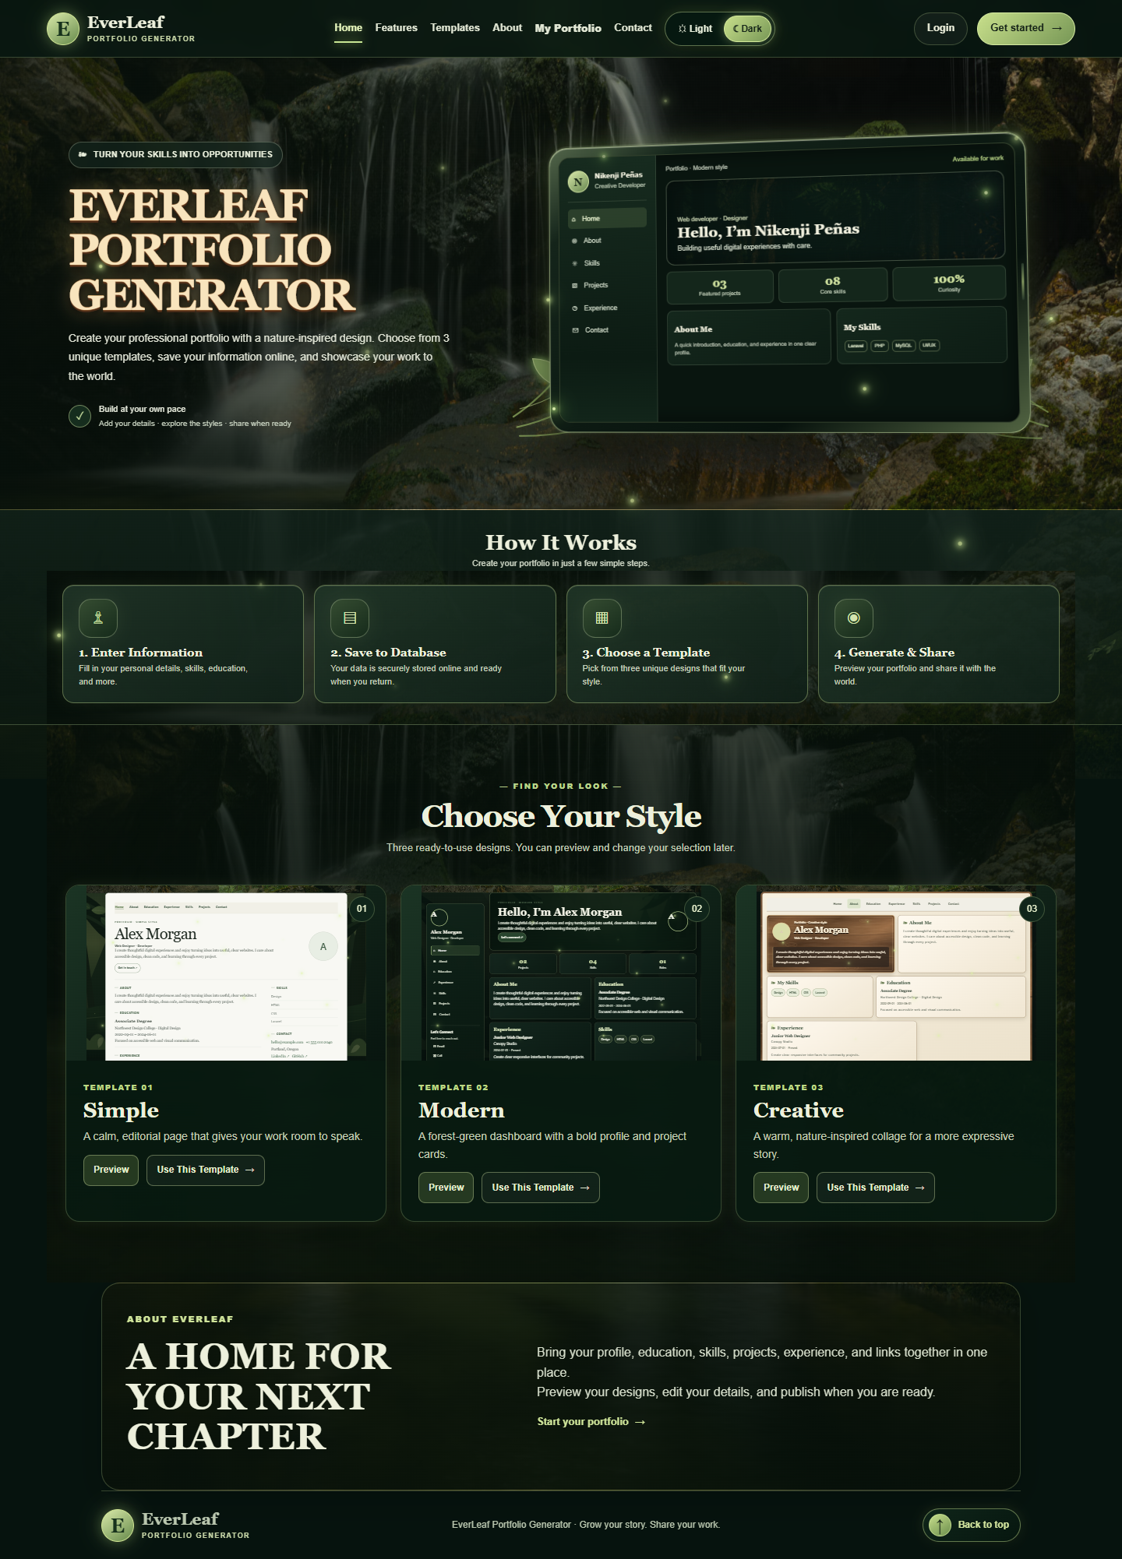

Figure 5. How It Works Section
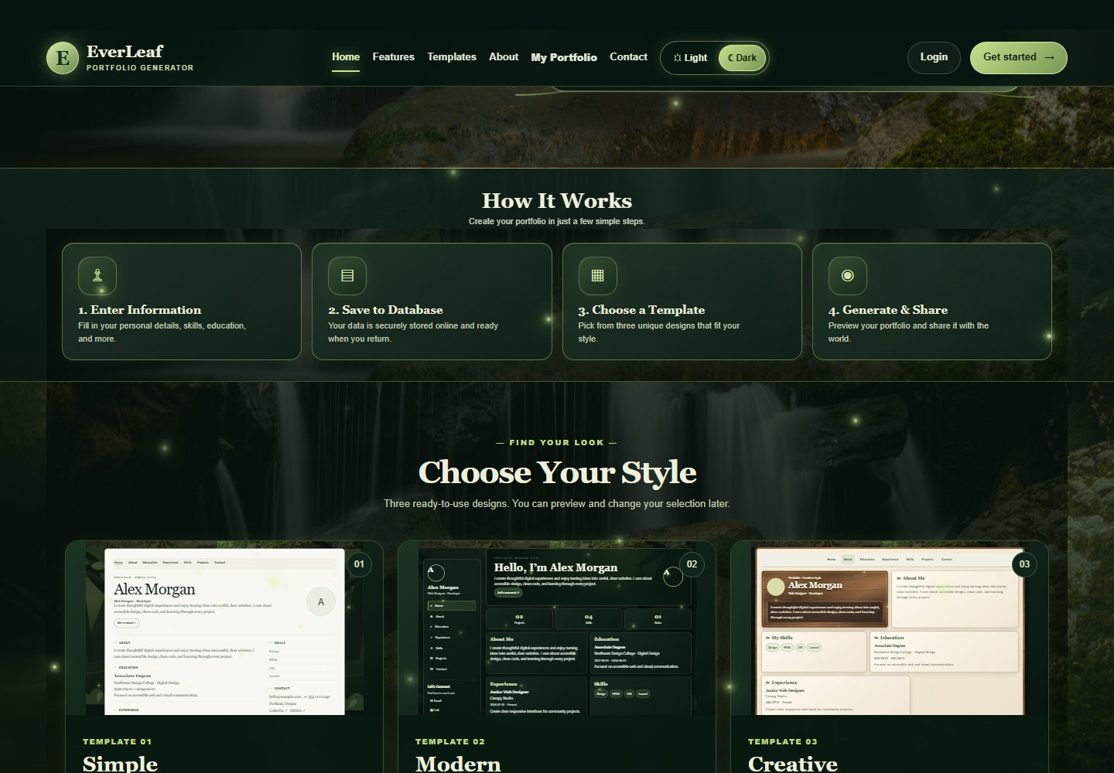

Figure 6. Template Gallery
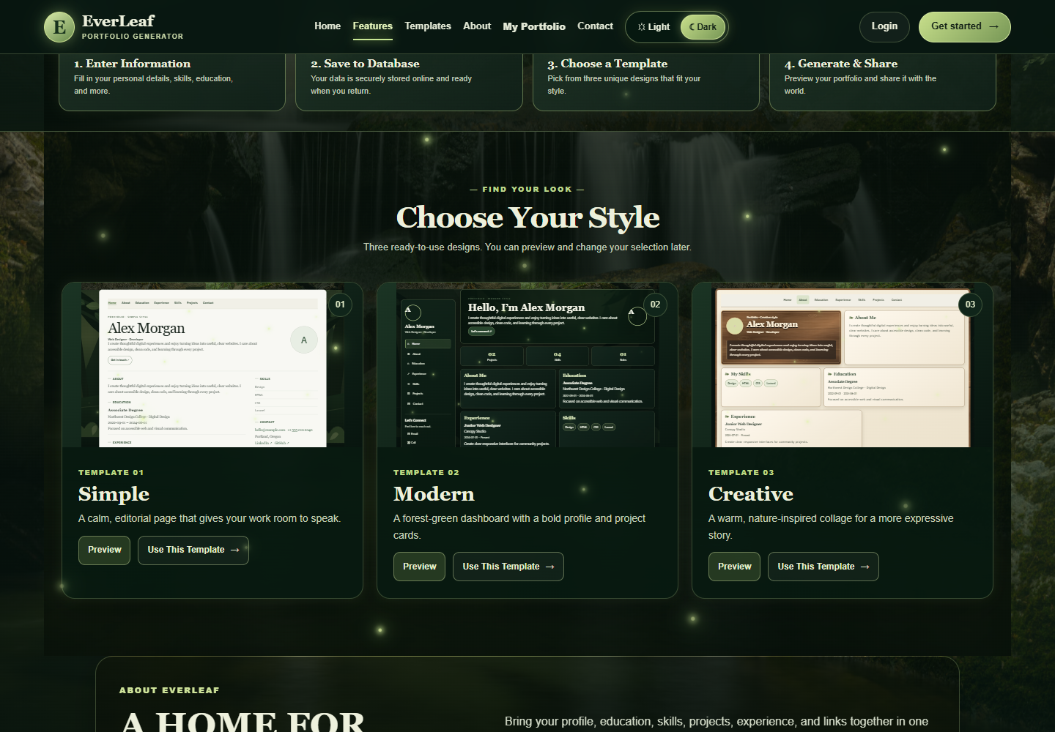

Figure 7. Portfolio Form - Main Information
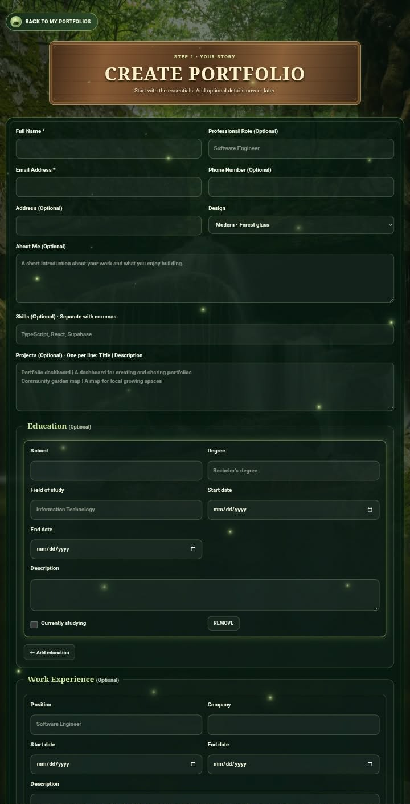

Figure 8. Portfolio Form - Education, Experience, and Links
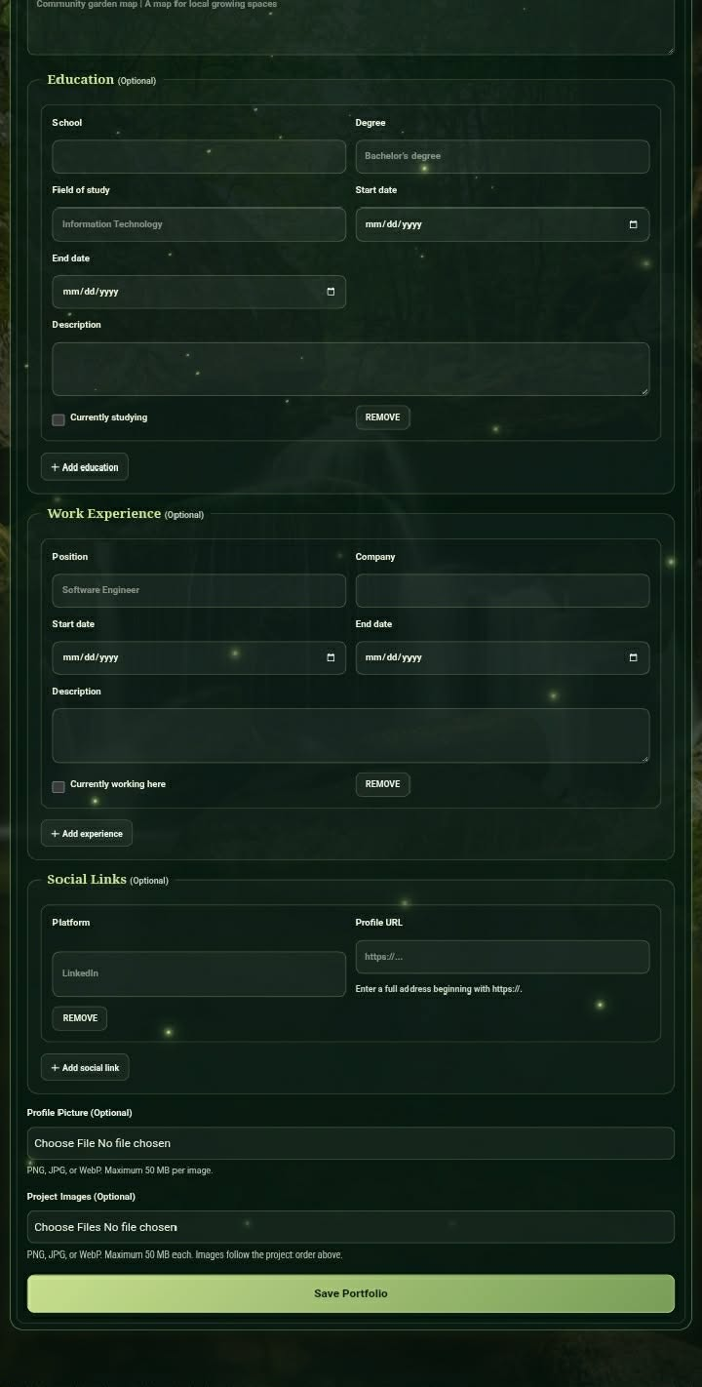

Figure 9. About Section
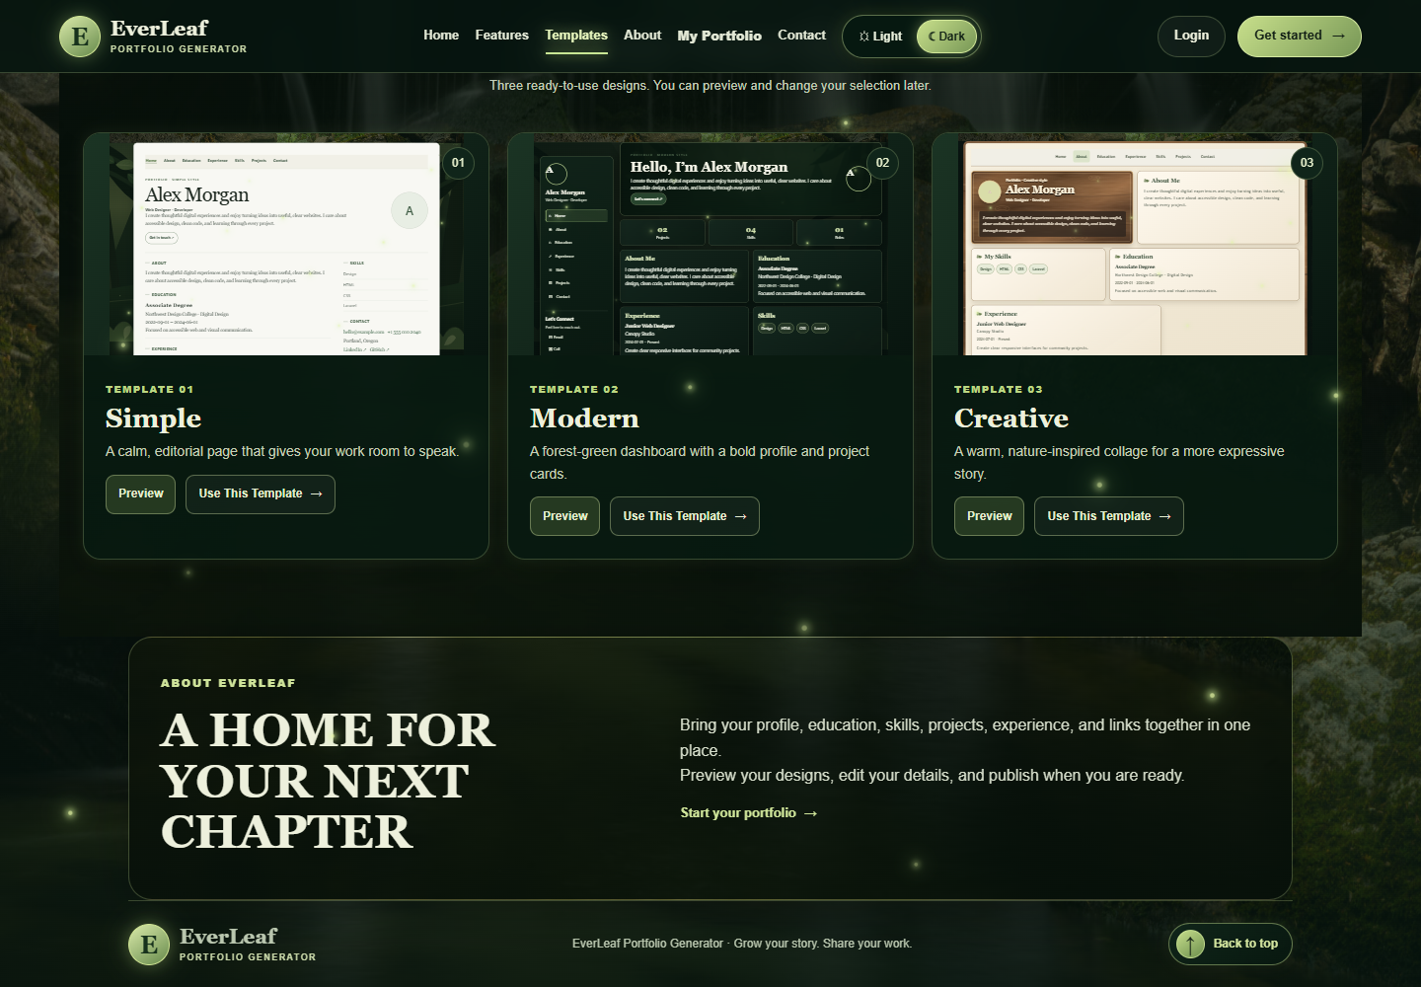

Figure 10. Portfolio Management Page

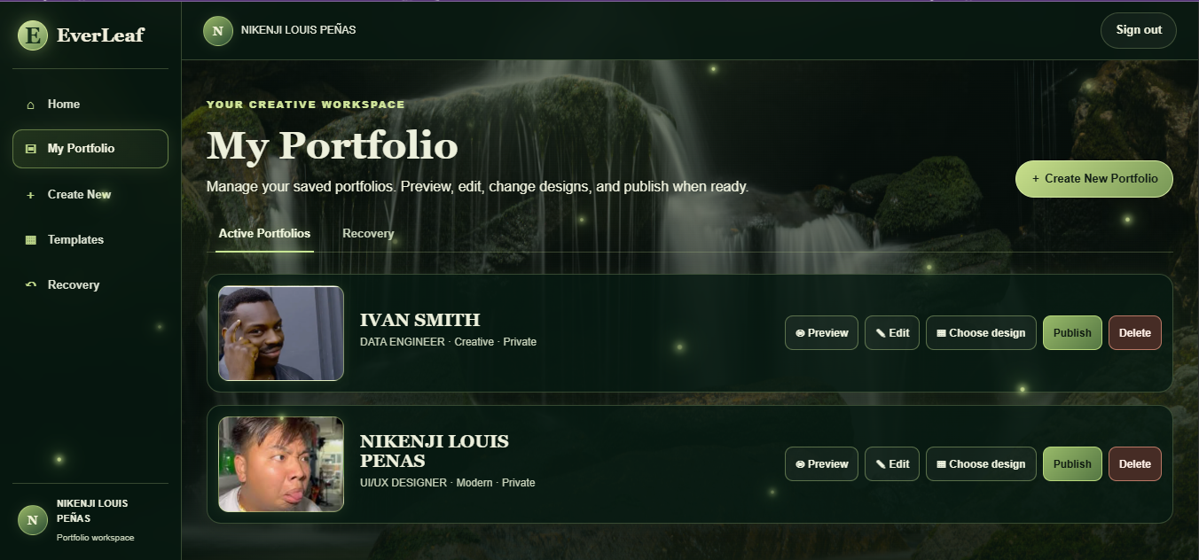

Figure 11. Contact Section
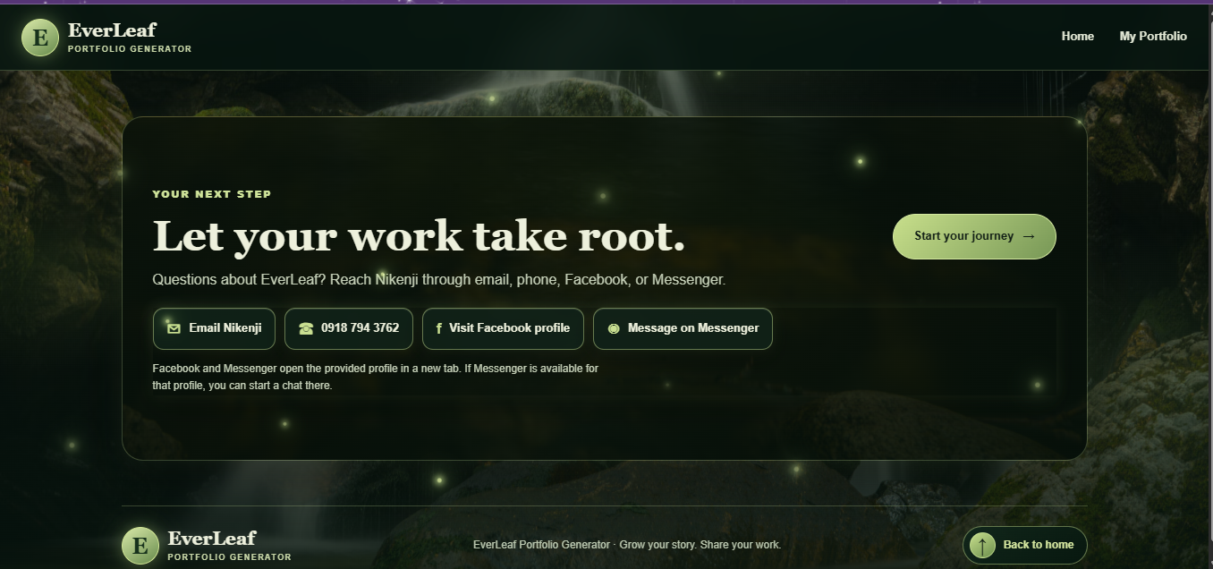

8. Screenshots of the 3 Templates
These public demo pages use the application’s sample portfolio content and show each design with its preview toolbar.

Simple Template
Figure 12. Simple Template
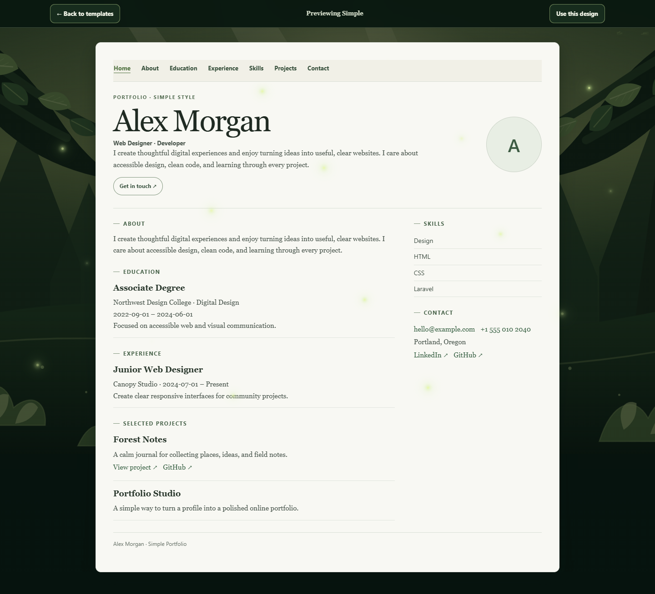

Modern Template

Figure 13. Modern Template
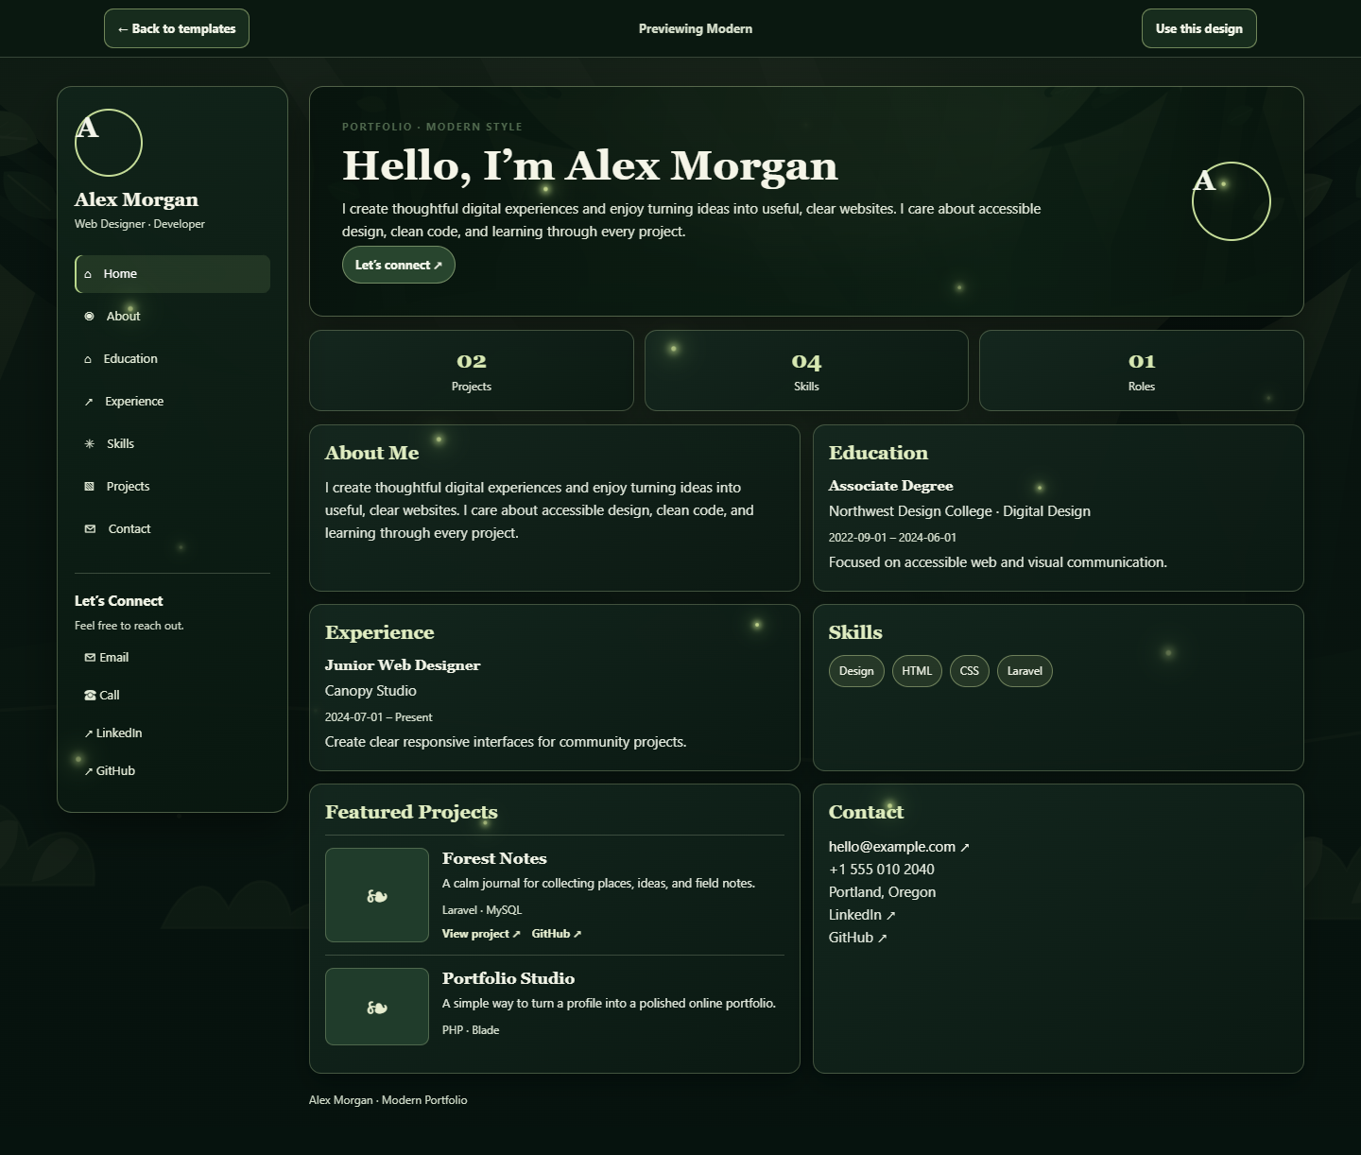

Creative Template

Figure 14. Creative Template
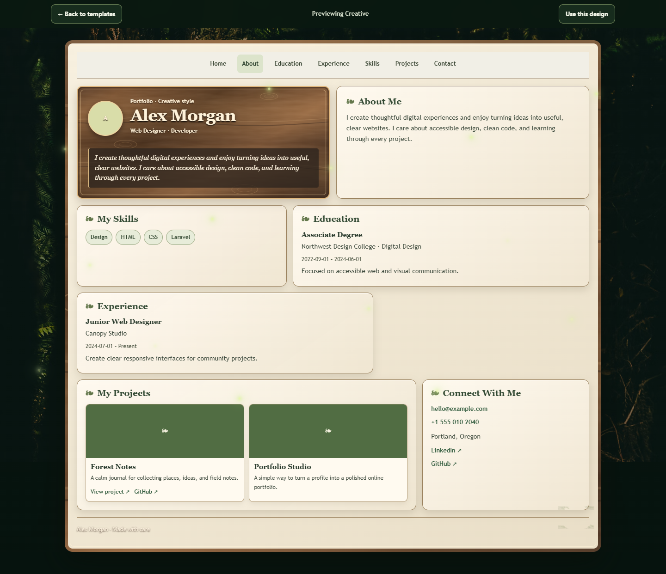

9. Published Website URL
Published website: https://everleaf-portfolio-generator.vercel.app/home
The published homepage, portfolio form, and three public template previews were reachable during this update on October 16, 2026.

