Analysis of the Human Development Index (HDI)

A Data-Driven Exploration of Global and Regional Development Patterns
Course: Concepts and Technologies of AI (5CS037)
Assignment: Assignment I – Statistical Interpretation and Exploratory Data Analysis
Student Name: Nikesh Deuja
Student ID: 2510296

Table of Contents
- Introduction
- Problem 1A – Single Year HDI Exploration (2022)
- Problem 1B – HDI Trend Analysis (2020–2022)
- Problem 2 – Advanced HDI Exploration (South Asia)
- Problem 3 – Comparative Regional Analysis (South Asia vs Middle East)
- Conclusion
- References

1. Introduction
The Human Development Index “HDI” is a compound measure developed by the United Nations Development Programmed “UNDP” that aims to evaluate a country’s level of development as a whole. The HDI captures a total of three core dimensions that define human development, which are health, as expressed by life expectancy; education; and living standards, as expressed by GNI per capita. The HDI provides a more holistic view compared to economic measures.

The purpose of this report is to provide a statistical interpretation and exploratory data analysis of the Human Development Index dataset. This shall include analysis for a variety of nations and a variety of years. The purpose of this analysis shall be the exploration of the trends of development and the interrelations of the Human Development Index and the factors it is comprised of. This analysis shall include four areas of the problem.

2. Problem 1A – Single Year HDI Exploration (2022)
Method

The data was limited to the latest year available in the dataset, which is 2022. Exploratory analysis included display of data samples, identification of data types, and determination of missing data. Data cleaning involved replacing missing data with placeholder information for data with missing information represented by special characters, changing numeric data represented as text, removing duplicates, and removing data with missing information in the variable of interest, HDI.

Key Results

The mean, median, and standard deviation for HDI for the year 2022 were calculated. Countries with the highest and lowest HDI scores were identified, highlighting the existence of great variations worldwide for human development.

Nations with HDI above 0.800 were filtered and sorted according to gross national income per capita. This showed that while many nations with high HDI also have high income levels, income alone does not explain human development.
HDI C

Another variable, “HDI Category,” was created based on the UNDP definitions: Low, Medium, High, and Very High Human Development. This variable enabled easier interpretation of the data. The final cleaned data set with the “HDI Category” variable was then stored for subsequent use.

3. Problem 1B – HDI Trend Analysis (2020–2022)
Method

For trend analysis, the data is filtered to consider observations from 2020 to 2022. The necessary variables like country, year, and HDI were cleaned and validated. Missing data on HDI is removed to provide consistency in trend observations.

Country-Level Trends

Line graphs were used to plot the HDI trend in the chosen countries over a period of three years. It can be observed that many countries were witnessing stagnation in their HDI in 2020 and 2021, followed by improvements in 2022.

Regional and Distributional Analysis

The Region-wise bar charts of the average HDI indicated that there were disparities in the performance of different regions, with Europe and North America performing better than other continents. Box plots of the HDI of countries indicated that there was variability in the spread of HDI, especially after the pandemic.

The scatter graph for HDI and gross national income per capita showed a positive correlation, but some noticeable exceptions emerged, indicating the importance of non-income variables such as health and education.

Impact of Global Events

The COVID-19 pandemic may have been the cause of the reported decrease and stagnation of the HDI value. However, the partial reversion that occurred in 2022 was a manifestation of learning and adaptation.

4. Problem 2 – Advanced HDI Exploration (South Asia)
South Asia Subset

A subset containing Afghanistan, Bangladesh, Bhutan, India, Maldives, Nepal, Pakistan, and Sri Lanka was defined to allow region-specific analysis. The subset was maintained as a separate data set to provide clarity and replicability.

A "Composite Development Score" was calculated based on weighted measures of life expectancy and Gross National Income per capita. The countries were ranked on the Composite Development Score, and the best-performing countries were represented in a horizontal bar graph. The differences between the country rankings for the two measures highlighted the role played by education, as well as other social variables that are incorporated in the HDI but are excluded from the composite measure.

Outlier Detection

The outliers in HDI and income data were determined by the 1.5 × IQR method. Scatter plots helped identify the nations that were deviating considerably from the normal pattern. The outliers could be due to the differing economic systems and paths of social development.

Metric Relationships

The correlation analysis showed that the relationship between life expectancy and HDI was stronger than other possible measures of longevity. Graphs of the relationship, including trend lines, further supported the strength and direction of those relationships.

GNI-HDI Gap

A metric related to the GNI-HDI gap was established for assessing incongruities between the levels of income and the achievements of human development. Countries showing large positive values indicated situations wherein economic wealth had not been entirely converted to human development.

5. Problem 3 – Comparative Regional Analysis: South Asia vs Middle East
Regional Subsets
On the basis of the dataset created during the period of 2020 to 2022, separate subsets were developed for South Asia and the Middle East. The subsets formed the basis of data for further comparative analysis.

Descriptive Statistics and Performance
In During the three-year period, the Middle East showed a relatively higher average value for HDI in comparison to South Asia. Nevertheless, the range for the variations in the two regions showed South Asia to have more disparity in terms of the HDI values.

Top and Bottom Performers
Countries with the highest and lowest averages for each region’s HDI were identified. Bar charts were used to show considerable divergences between each region’s leader and loser.
Metric Comparisons and Disparities
The group bar charts of life expectancy, gender development, and indices of income showed the existence of regional differences based on the largest variations of income inequality. Life expectancy and gender development were the contributing factors.

Correlation and Outliers
The correlation tests confirmed positive relations for HDI and life expectancy in each region. The outlier analysis revealed countries whose paths of development were considerably different from the regional patterns; in many cases, this has been caused by involvement in conflicts and economies motivated by natural resources.

6. Conclusion
This paper undertakes an extensive statistical analysis of the role of the Human Development Index in both international and regional settings. Analysis shows that while income is an important part of human development, health, education, and social aspects play equally important parts. Analysis over time shows the disruption caused by the COVID-19 pandemic in human development, while regional analysis brings out the inequality.
The limitations of this study include the use of aggregated indicators and failure to consider qualitative elements. In future studies, other social and environmental variables may be used to improve understanding in terms of development. The study revolves around the significance of inclusive policies for human development.

7. References
United Nations Development Programmed. (2023). Human Development Report. UNDP.

The similarity index

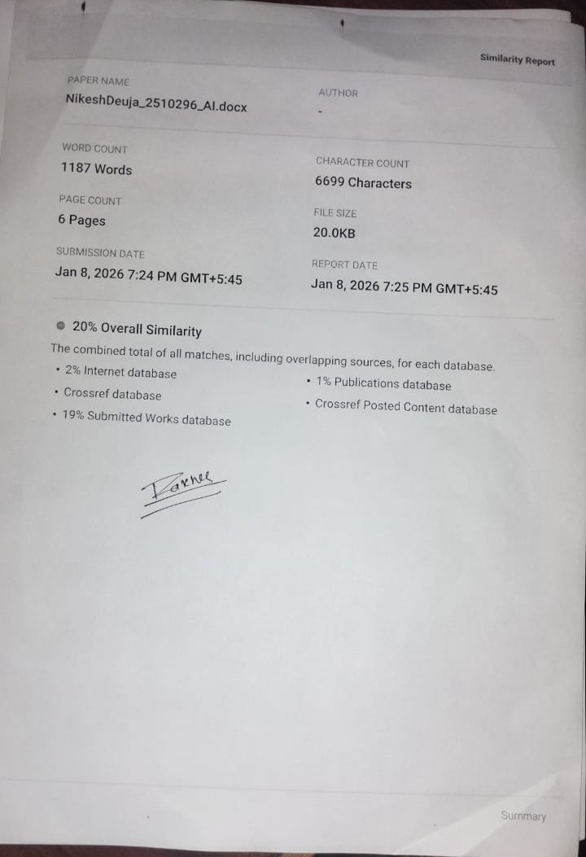

GITHUB REPO LINK: https://github.com/NikeshDeuja/Analysis-of-the-Human-Development-Index-HDI-

