Name: Nikesh Nepali.
Data Visualization.

Cyber Crimes Datasets.
1. Introduction
In this project, I will clean the large, synthesized data sets related to cybersecurity that I found on Kaggle. The term cybersecurity refers to the protection of computers, mobile phones, and servers from unauthorized access by Attackers. Here, I will use these topic-related datasets with different tools and software applications, such as Excel, Tableau and PowerBI, to clean datasets, create dashboards, and create a storyboard as per the goals that I will set. And make charts as per the goals to make it ready for analysis. After all of this is done, I will copy and paste my final work into this Word file, linking all the datasets that I have used and cleaned, and analyzed by using different tools, and give a finishing touch to this Word file.
2. Domains.
Attack-Type = These are the types of attacks that hamper the computer-related devices.
target_ system = It means the attackers or hackers are trying to enter the particular system in an unauthorized way.
Outcome = It shows whether the attack was a success or failure.
timestamp = It shows when the attack was initiated or started.
Data Compromised = It shows the amount of data that would have had to be compromised if the attack was successful, and when the attack was successful.
attack_duration = the time period that the attack lasted.
Security_tool_used = It shows the tool that was used to get rid of the attack or save the system from the attack.
user_role = Identifies who was affected by the attack?
Location = It shows where the attack took place.
Attack Severity = Shows how severe the attack was on a scale of 10.
Industry = Shows which industry had to face these attacks.
Response_Time = Shows how long it took to respond to the attack to be safe from it.
mitigation_method = It shows the method that was used to get safe from the attack.
3.Reference.
Shakirul_09 (2025). Cyber Crimes Datasets. Kaggle.com [DataSets]. https://www.kaggle.com/datasets/shakirul09/cyber-crimes-dataset
4.Descriptive statistics.
In my worksheet.
Columns are 14
Rows are 100,000
6.Visualiztion Tools Selected.
The tools that I have used for visualizing are I have Used Tableau for each of the solo charts and for Some of the Storyboard and Dashboard I will Use Tableau. Also, I will use PowerBI for visualizing the Dashboard.
5.Data Cleaning
- removed attacker_ip and targeted_ip and mitigation_method from the rows.
- after cleaning I have 12 Columns and 100,000 rows.
- My Cleaned data set is.
6. Different Goals
Goal 1: The different types and number of total attacks.
Goal 2: Countries that had to compromise on the amount of data.
Goal 3: Average Response Duration and Average Response Time.
Goal 4: The number of attacks in each month from September 2023 to September 2024.
Goal 5: The most popular security tool used for different types of attacks.
Goal 6: The Number of successful and failed attacks.

Goal 1: The different types and the number of total attacks.

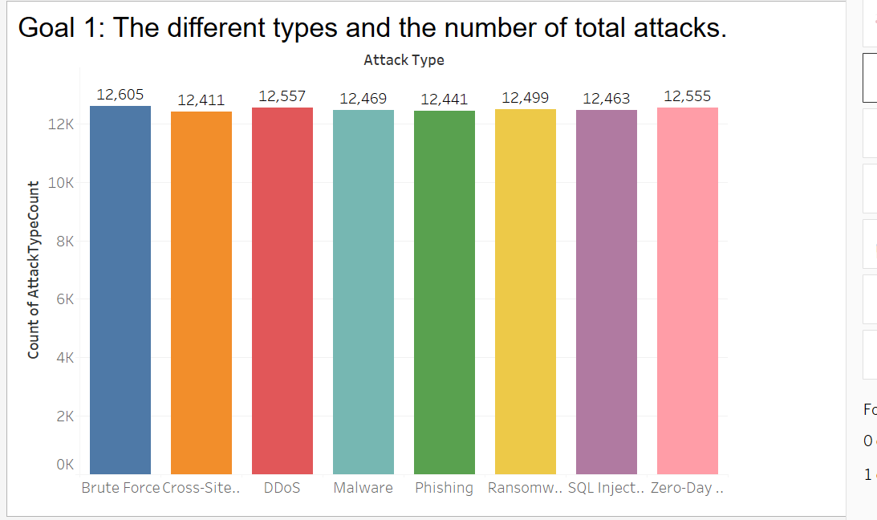

Story
To visualize the goal bar graph is the perfect match because it has only one category and one value so using bar graph it will be easier to compare the dataset along its category. Here in this dataset, we can see that Brute force attack has the maximum number of attack count 12605 compared to all of other attack whereas Cross Site Scripting was the attack that took place less it’s count is around 12,411.
In Conclusion from the above bar graph, we can observe that all of the attacks have count over 12 thousand. They have very less gaps of attack count to each other so from this it can be said that all attacks are getting used in likely similar or close to similar fashion.

Goal 2: Countries that had to compromise on the amount of data.

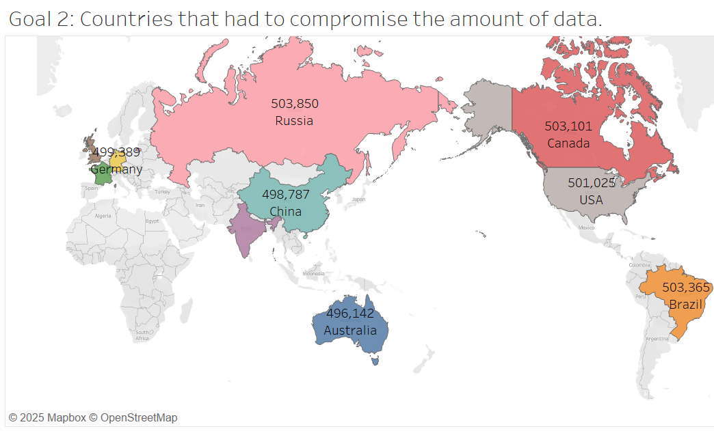

Story

The above chart is a filled map this is used for this dataset as there is involvement of countries which is a geographic location and with filled map it will be easier to identify each country and make comparison. The above filled map with label shows that among some of the countries that face cyber-attacks. 503,850 GB of data was lost from Russia and the lowest amount of data was lost from Australia 496,142.
In Conclusion, It can be said that most of the given countries like USA, Canada, UK, Brazil and Russia had the highest data loss greater then 500GB for each of the all country. And Other country like China, Australia, India, Germany and France had approximately 500 GB of data Loss.

Goal 3: Average Response Duration and Average Response Time.

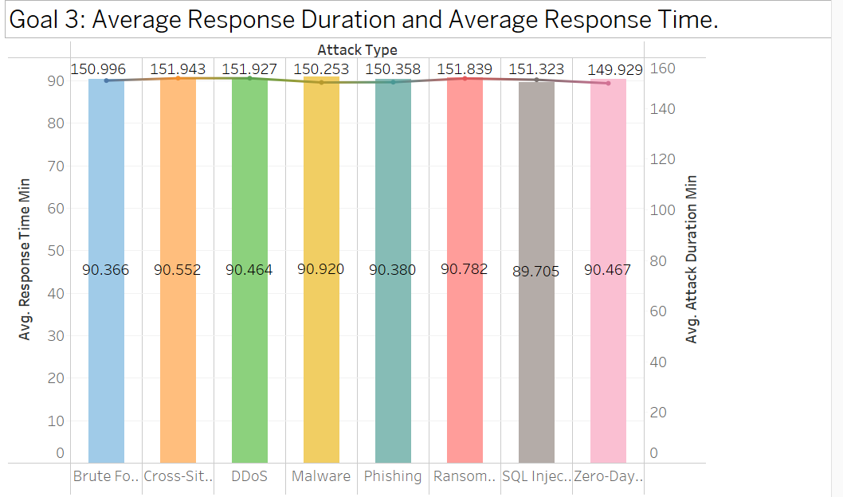
Story

This Figures represents a combination of Line and Bar Graph. It consists of one Category and two different value which will be easier to place into this graph and make comparison. The given data sets shows that the Cross Site Scripting had the highest average attack duration of 151.943. However, it didn’t have the fastest average response time. SQL Injection had the fastest response time.
In Conclusion, we can say that all of the above datasets had a similar kind of average time duration and similar kind of average response time. Even though in the above data the attack duration is long but the response time for those attack is not the fastest.

Goal 4: The number of attacks in each month from September 2023 to September 2024.

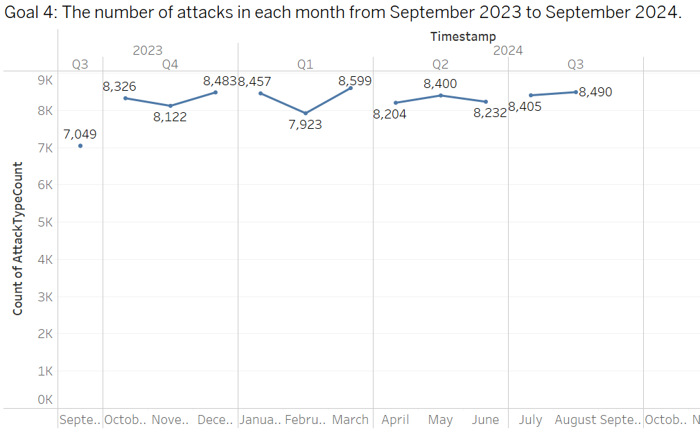

Story
The given Chart is a line chart the chart is suitable for this goal because it consists of time period especially month and it consists of the count of attacks so using this it will be easier to make comparison at which month the most attack took place. Using the line chart, it can be observed that on the month of March there were large number of attacks taking place and on the month of September there is a smaller number of attack that is 8599 and 7049 respectively.
In conclusion, the attack volume can be seen larger on Q4, Q1 and Q2 where the volume of the attack is around 24 thousand. From and Apart from the month of September almost every month got attacks around 8k. From which we can conclude that attacks volume is almost even throughout this one-year time frame.

Goal 5: The most popular security tool used for different types of attacks.

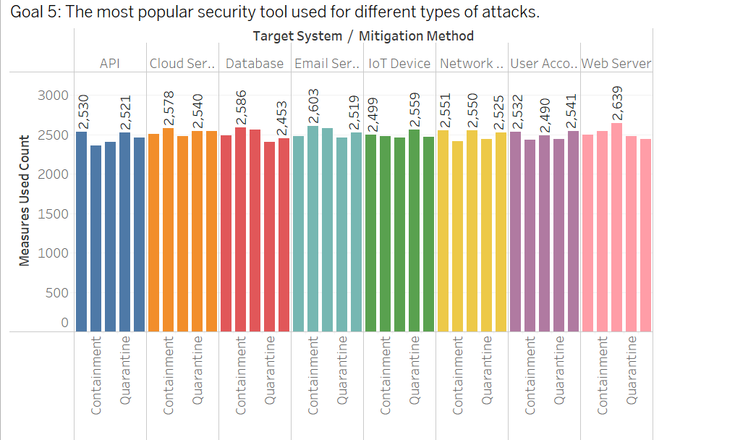

Story
The above data is the Grouped bar chart it is used because it consists of two categories, and one is the measure used. In the above dataset for Web Server to tackle it Patch was used by 2,639 company which is maximum use of that software from all of the above dataset. Similarly for API, Cloud Server, Database, Email Server, IoT Devices, Network Switch, User Account mitigation methods used are BlockingIP , Containment for 3 of the system, Quarantine and BlockingIP for remaining two was used. The Count of them is 2,530, 2,578, 2,586, 2,603, 2,599, 2,551 and 2,531respectively.
In conclusion, it can be concluded that for the different types of attack the most used mitigation method was Blocking IP and Quarantine. Patch was the method that was mostly used only for web development and All of the method were used for all of the attacked system to control it.

Goal 6: The Number of successful and failed attacks.

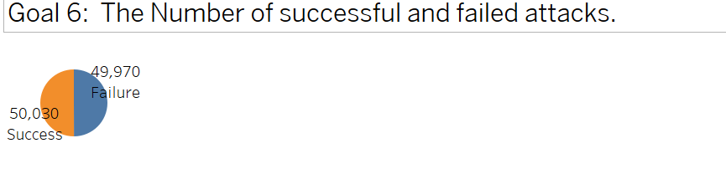
Story

The chart is a pie-chart it is used here because here the comparison of success and failure is happening and using pie-chart it will be easier to know the difference between these two for finding successful and failed attacks. From the pie-chart it can be observed that 50,030 are the number of successful attacks whereas the failed attack is 49,970. The successful attacks are higher than the failed attacks.
In conclusion, It can be said that the successful attack and the failed attack both of them were likely equal to each other because the difference for success and failed attack is only by 30 attacks. There are 30 more Successful attack and 30 less successful attack to be 50% for both attack.

Dashboard
Dashboard 1: Showing the overall data charts with their corresponding goal for every available country.
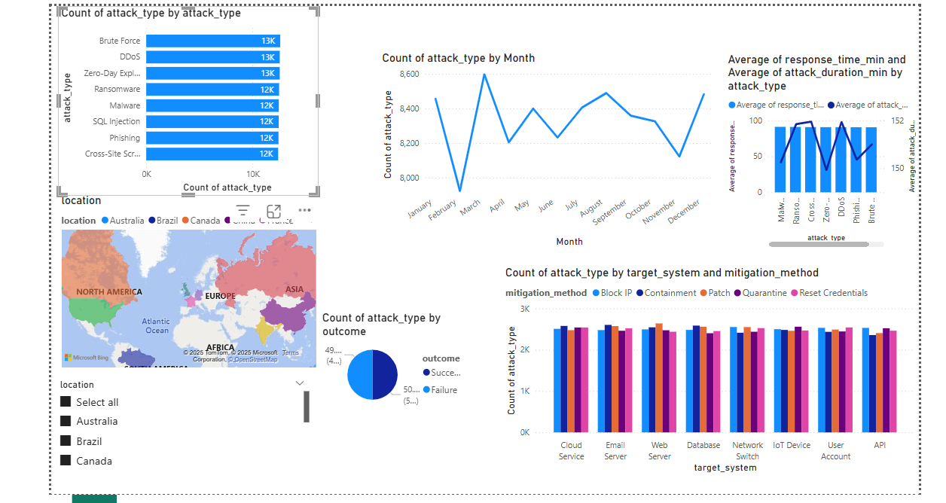
Dashboard 2: Showing the Canada and USA overall data charts with the above goals.

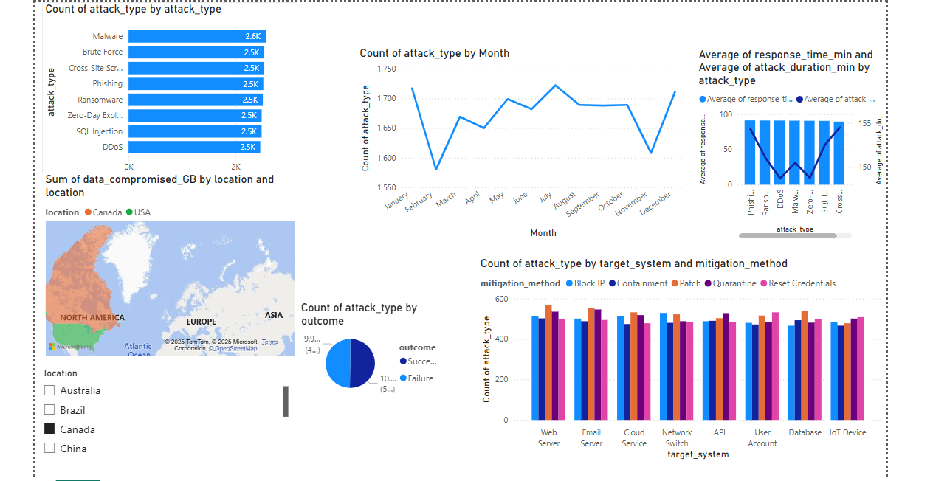

Storyboards
Storyboard 1: Russia Having the highest data loss.
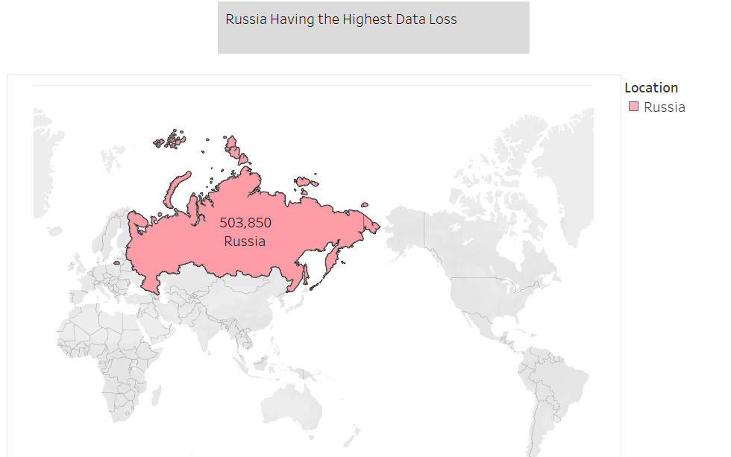

Storyboard 2: Month Of March Having Maximum Number of Attack.

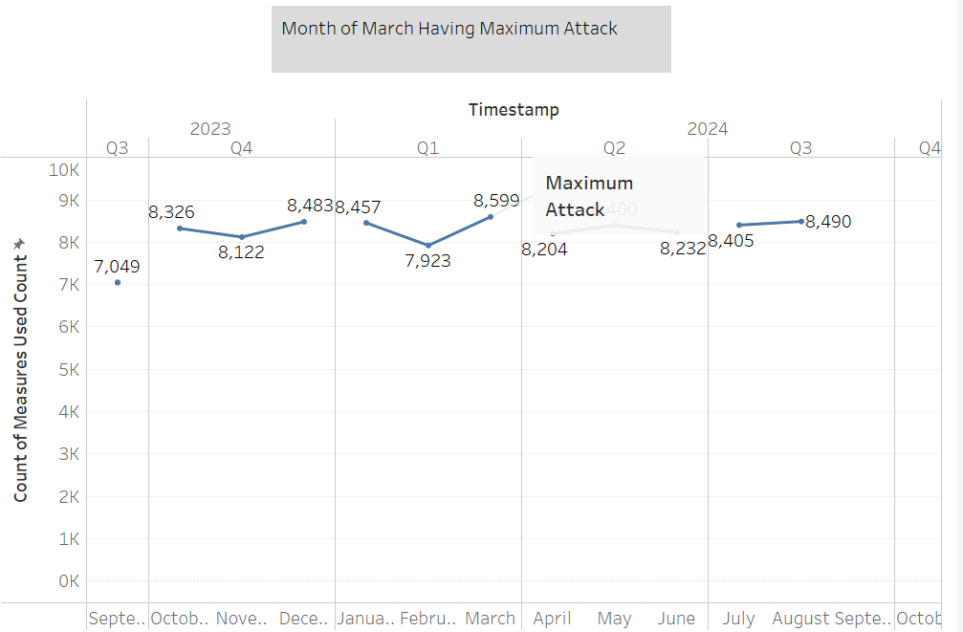
Storyboard 3: Western part of the countries had the greater number of attack count Compared to the Eastern Part.
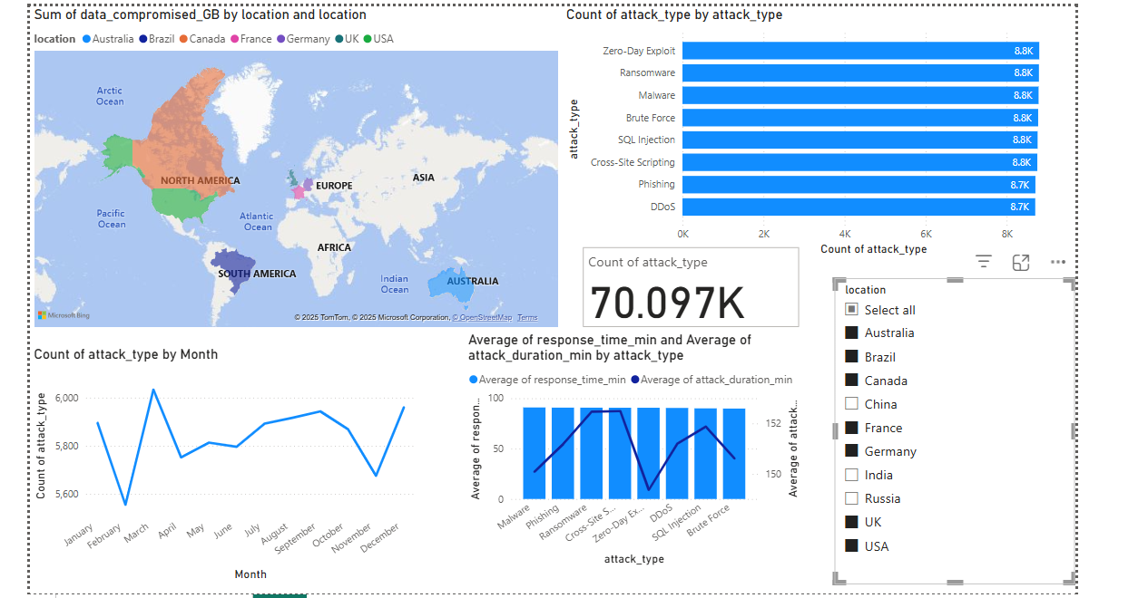
Conclusion
In conclusion, the overall works shows the data related to cybersecurity and with this data sets. As per this data sets Russia is the country that has lost the most amount of data, so the Russian government needs to focus much more on the security terms. Also, all the western country needs to focus much more for security terms. In each and every moment a country should be aware of the cyber-attacks.
This visualized data can be used by various Government Agent, Business Companies, Personal people, Cyber Security Experts etc. As with this agent can use this data to make the decision and do strategic planning to get safe from these types of cyber attack and find the solution measure on how to get safe from the attacks.
Overall, the project has helped me to Understand the different concepts related to Data Visualization and learned the strategies to do data cleaning, making goals, choosing appropriate charts for the required goals, creating Dashboard and Storyboard and how to make a strategy with the Visualized data.

