Name: Areena khan

Roll no : 2

Topic : Big Query

WHAT IS BIG QUERY ?

* Big Query is google’s fully managed , petabyte scale ,low cost analytics data warehouse.
* BigQuery is noOps –there is no infrastructure to manage and you don’t need a database administrator .
* Analyzing data to find meaningful insights ,use familiar SQL.

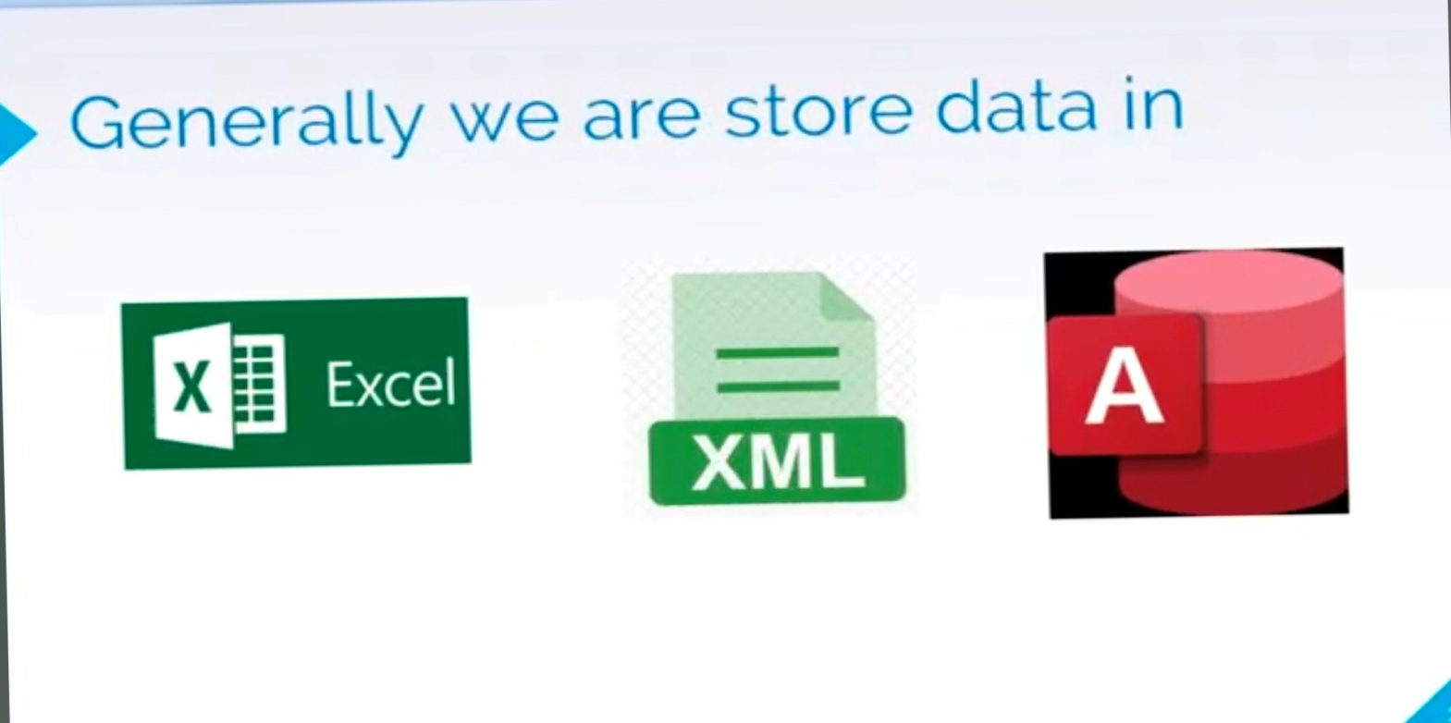

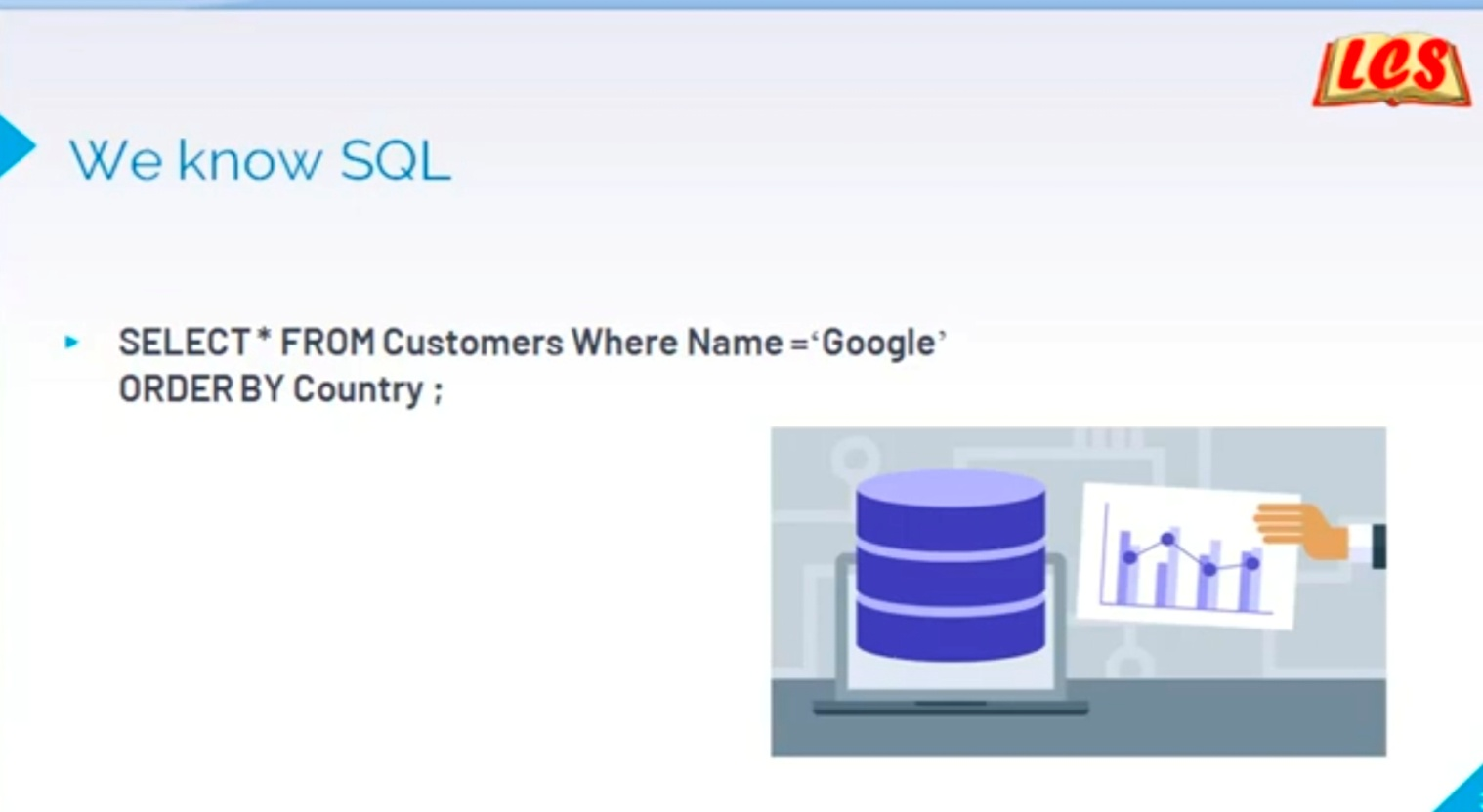

Google BigQuery is a fully managed, serverless data warehouse that enables super-fast SQL queries using the processing power of Google’s infrastructure. It’s designed to handle large-scale data analytics with ease.

Here’s how it integrates with Google App Engine:

**1. Overview of BigQuery**

* **Purpose**: BigQuery is ideal for analyzing large datasets and provides high-speed querying capabilities. It supports SQL-like syntax for queries.
* **Key Features**:
  + **Serverless Architecture**: No need to manage infrastructure.
  + **Scalability**: Automatically scales based on the data and query load.
  + **Real-Time Analysis**: Supports streaming data for near real-time analytics.
  + **Cost-Effective**: Pay only for the storage and queries you use.

**2. Google App Engine**

* **Purpose**: Google App Engine is a platform-as-a-service (PaaS) that allows developers to build and deploy web applications and services without managing the underlying infrastructure.
* **Key Features**:
  + **Automatic Scaling**: Automatically scales your application based on traffic.
  + **Integrated Services**: Seamlessly integrates with other Google Cloud services like BigQuery, Cloud SQL, and Cloud Storage.

**3. Integrating BigQuery with App Engine**

* **Accessing BigQuery from App Engine**: You can use BigQuery client libraries to interact with BigQuery from your App Engine application. The most common libraries are available for several programming languages, including Python, Java, Node.js, and Go.
* **Steps to Integrate**:
  1. **Set Up a BigQuery Dataset**: Create datasets and tables in BigQuery where your data will be stored.
  2. **Configure App Engine Environment**: Ensure your App Engine application has the necessary permissions to access BigQuery.
  3. **Install BigQuery Client Library**: Depending on your programming language, install the relevant client library (e.g., google-cloud-bigquery for Python).
  4. **Write Query Code**: Use the BigQuery client library to construct and execute SQL queries.
  5. **Handle Results**: Process and utilize the results of your queries within your application.

**4. Example Workflow**

Here’s a simple example of how you might set up and use BigQuery from an App Engine application:

1. **Create a BigQuery Dataset and Table**: Use the Google Cloud Console or BigQuery SQL to set up your data schema.
2. **Authenticate Your App Engine Service**: Ensure your App Engine service account has the appropriate IAM roles (e.g., BigQuery Data Viewer).
3. **Install Client Library**:
   * For Python: pip install google-cloud-bigquery
4. **Write Python Code to Query BigQuery**:

python

Copy code

from google.cloud import bigquery

def query_bigquery():

client = bigquery.Client()

query = """

SELECT name, COUNT(*) as total

FROM `your_project.your_dataset.your_table`

GROUP BY name

ORDER BY total DESC

LIMIT 10

"""

query_job = client.query(query)

results = query_job.result()

for row in results:

print(f"{row.name}: {row.total}")

1. **Deploy Your App**: Deploy your App Engine application, which will use the BigQuery API to run queries and process results.

**5. Security and Permissions**

* **IAM Roles**: Make sure your App Engine service account has the necessary permissions to access and query BigQuery.
* **API Access**: Enable the BigQuery API in your Google Cloud project.

**6. Cost Management**

* **Storage Costs**: Costs are incurred based on the amount of data stored in BigQuery.
* **Query Costs**: Charges are based on the amount of data processed by your queries. Use partitioned tables and optimization techniques to manage costs.

**7. Monitoring and Debugging**

* **Cloud Logging**: Use Google Cloud’s logging and monitoring tools to keep track of your queries and application performance.
* **BigQuery Query History**: Monitor and review the performance and execution of your queries within the BigQuery console.

BigQuery’s integration with App Engine provides a powerful way to leverage large-scale data analysis capabilities within your web applications.

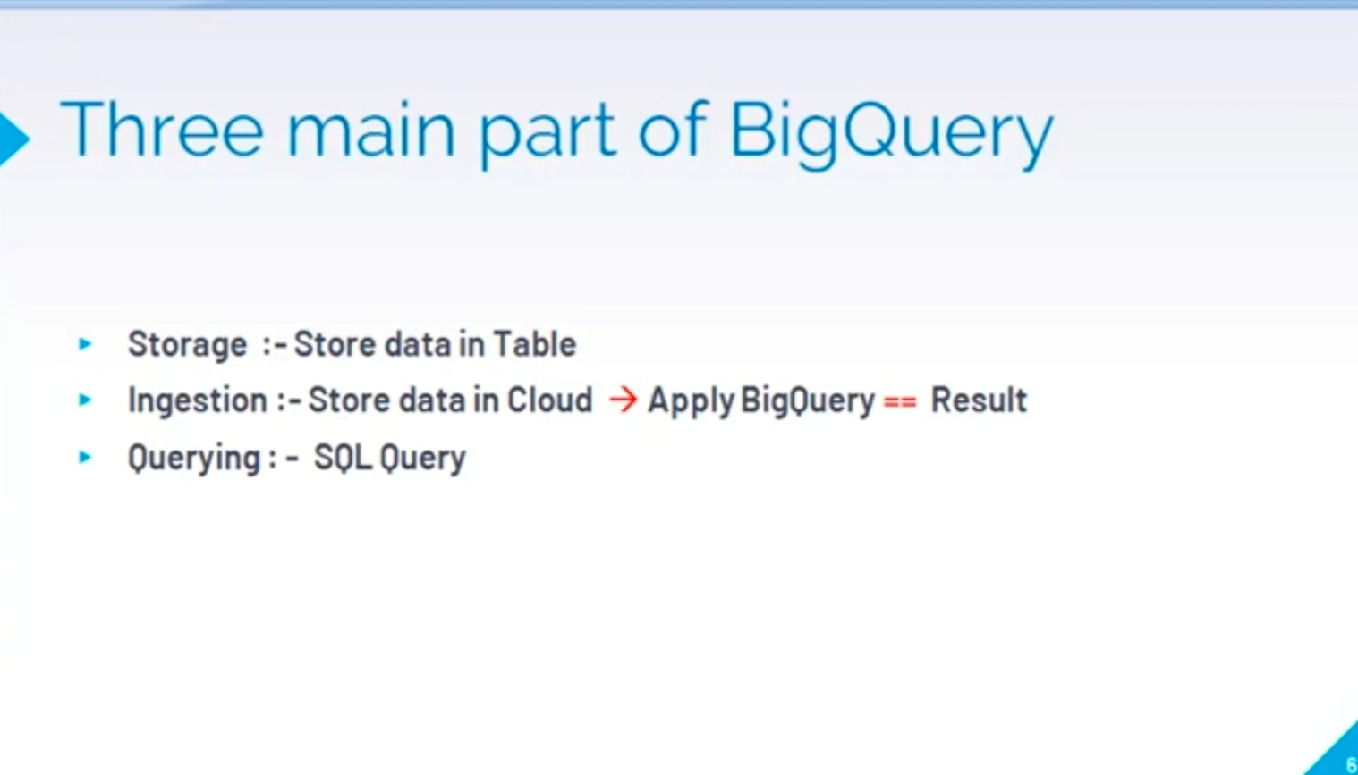

……..THANK YOU ….

Top of Form

Bottom of Form