**Name – Nikhil Kumar Singhvi**

**Roll No. – 22**

**Topic Name – Contact Center AI**

**Contact Center AI (CCAI) in Google Cloud Platform (GCP) is a set of tools designed to enhance customer service experiences using artificial intelligence. Here's a simple overview:**

**1. What is Contact Center AI?**

**- Purpose**: It helps businesses automate and improve customer interactions by integrating AI into their contact centers**.**

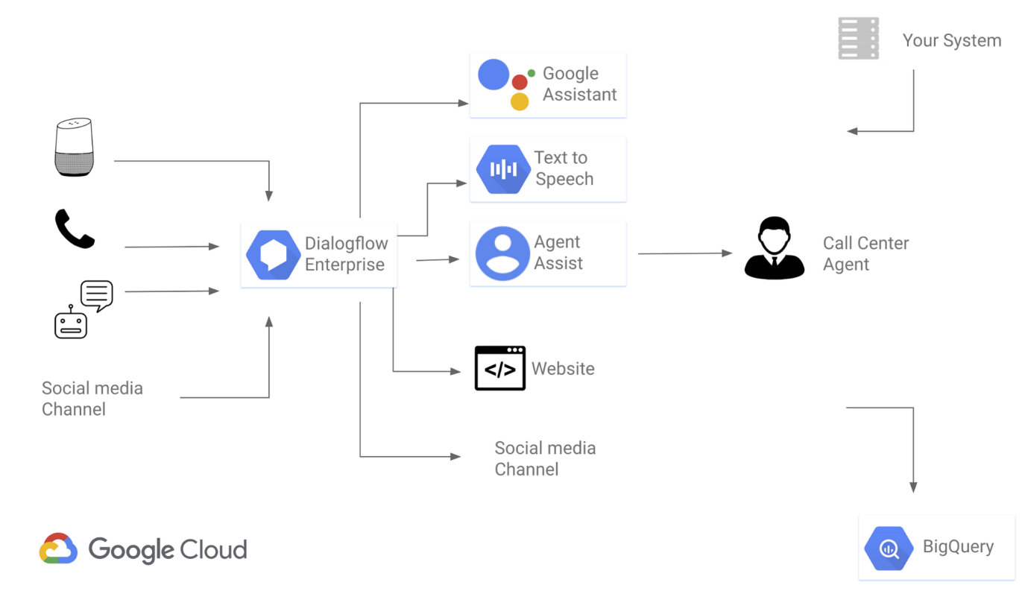

**Key Components:**

**- Virtual Agent:** An AI-powered chatbot that can handle customer inquiries via voice or text, providing answers, handling simple tasks, and routing more complex issues to human agents.

**- Agent Assist:** Provides live agents with real-time suggestions, relevant information, and answers while they are on a call or chat, making their job easier and more efficient.

**- Insights**: Analyzes customer interactions to find trends, common issues, and other valuable data to improve customer service strategies.

**2. How Does It Work?**

**- Virtual Agent**: When a customer contacts the center, the Virtual Agent can greet them, understand their query using Natural Language Processing (NLP), and provide an appropriate response. For example, if a customer asks about their order status, the Virtual Agent can check the system and give them an update.

**- Agent Assist:** If the Virtual Agent can't fully resolve the issue, it passes the conversation to a human agent. Agent Assist then provides the agent with suggested responses, relevant articles, and other helpful information to resolve the issue quickly.

**- Insights:** After interactions, the system collects and analyzes data to help the business understand customer needs, identify areas for improvement, and optimize their service**.**

**3. Why Use It?**

**- Improves Efficiency:** Automates routine inquiries, allowing human agents to focus on more complex issues.

**- Enhances Customer Experience**: Provides faster and more accurate responses to customers.

**- Cost-Effective:** Reduces the need for a large number of human agents by automating common tasks.

**4. How to Set It Up?**

**- Integration:** You can integrate CCAI with your existing contact center software or use it as part of a GCP-based contact center**.**

**- Customization**: The AI can be trained and customized to understand your specific industry and customer needs, ensuring accurate and relevant responses.

**- Scaling:** CCAI is scalable, meaning it can grow with your business, handling more inquiries as needed without requiring additional human resources.

**Contact Center AI simplifies customer interactions, making them more efficient and pleasant while reducing operational costs.**