**GCP Cloud Firewall**

Google Cloud Platform (GCP) is a suite of cloud computing services offered by Google, providing infrastructure as a service (IaaS), platform as a service (PaaS), and serverless computing environments. GCP offers a broad range of services that enable organizations to build, deploy, and scale applications and services effectively in the cloud.

Google Cloud Platform (GCP) Cloud Firewall enables organizations to control incoming and outgoing traffic to and from their virtual machine instances (VMs) and other resources hosted on GCP. Cloud Firewall allows administrators to define and enforce firewall rules that specify which connections are allowed or denied based on IP addresses, protocols, and ports.

GCP Cloud Firewall is a critical component of Google Cloud Platform, providing essential network security capabilities to protect resources from unauthorized access and cyber threats. By leveraging Cloud Firewall, organizations can enforce security policies, manage traffic effectively, and maintain compliance with regulatory requirements. It plays a pivotal role in securing applications and data hosted on GCP, making it suitable for a wide range of use cases across different industries

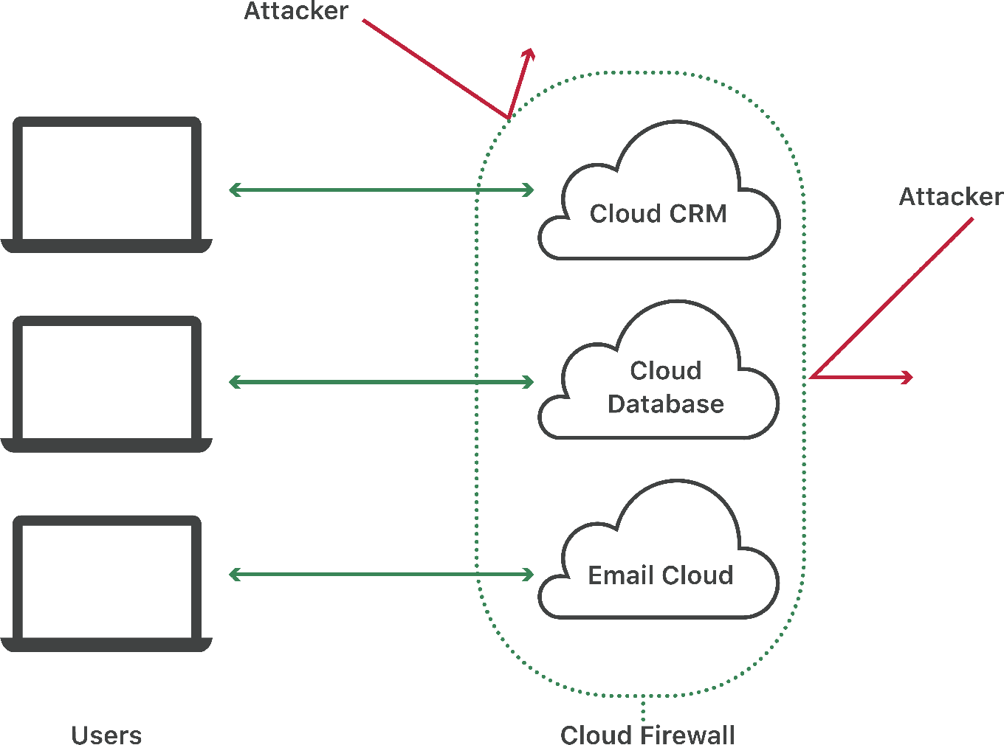

**1. What is GCP Cloud Firewall?**

GCP Cloud Firewall is a foundational component of network security within Google Cloud. It acts as a barrier between external networks (e.g., the internet) and internal networks (e.g., GCP Virtual Private Clouds), controlling traffic flow to protect resources from unauthorized access, attacks, and data breaches. It operates at both the project and instance level, providing granular control over network traffic.

**2. Why is GCP Cloud Firewall Used?**

* **Security:** The primary purpose of GCP Cloud Firewall is to enhance security by filtering incoming and outgoing traffic. It prevents unauthorized access to VM instances and other resources, thereby protecting sensitive data and applications from malicious attacks and unauthorized access attempts.
* **Control and Compliance:** Cloud Firewall allows organizations to enforce network policies and compliance requirements by defining precise rules for traffic. This ensures that only legitimate connections are allowed, maintaining the integrity and confidentiality of data.
* **Traffic Management:** It helps in managing network traffic efficiently by allowing administrators to prioritize and control traffic based on specific criteria such as source IP addresses, destination ports, and protocols. This capability is crucial for optimizing performance and resource utilization.
* **Scalability and Flexibility:** GCP Cloud Firewall scales automatically with your infrastructure and supports dynamic environments. It integrates seamlessly with other GCP services and tools, providing flexibility in designing and managing secure network architectures.

**3. How is GCP Cloud Firewall Used?**

* **Creating Firewall Rules:** Administrators define firewall rules using GCP Console, CLI (Command Line Interface), or API. Rules can specify allowed or denied connections based on IP ranges, protocols (TCP/UDP), ports, and tags applied to VM instances.
* **Applying Firewall Rules:** Rules are applied at the project or instance level. They are evaluated in order of priority, with higher priority rules taking precedence. This allows for fine-grained control over network traffic, ensuring that security policies are enforced effectively.
* **Monitoring and Logging:** Cloud Firewall provides visibility into network traffic through monitoring and logging features. Administrators can analyze logs to detect and investigate security incidents, compliance violations, and performance issues related to network traffic.
* **Integration with GCP Services:** It integrates with other GCP services such as Virtual Private Cloud (VPC), Identity and Access Management (IAM), and Security Command Center. This integration enhances overall security posture and simplifies management of network security policies.

**4. Where is GCP Cloud Firewall Used in Real Life?**

* **Enterprise Applications:** Organizations hosting critical enterprise applications on Google Cloud use Cloud Firewall to protect these applications from unauthorized access and potential cyber threats. For example, a finance company may use Cloud Firewall to secure customer transaction data stored in VM instances.
* **Multi-tier Web Applications:** Companies deploying multi-tier web applications (e.g., front-end, back-end, and database tiers) on GCP utilize Cloud Firewall to control traffic flow between these tiers. It ensures that only authorized communication occurs between components, enhancing application security.
* **Compliance and Regulatory Requirements:** Industries such as healthcare, finance, and government, which must adhere to strict compliance regulations (e.g., HIPAA, PCI DSS), leverage Cloud Firewall to enforce security controls and protect sensitive data in accordance with industry standards.
* **DevOps and Continuous Integration/Continuous Deployment (CI/CD):** Development teams implementing CI/CD pipelines on GCP use Cloud Firewall to secure infrastructure-as-code deployments and automate firewall rule management. This supports agile development practices while maintaining robust security measures.

Click on Link to know more about GCP Cloud Firewall

<https://help.sumologic.com/docs/integrations/google/cloud-firewall/>