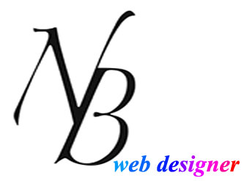

Contents

Topic

Description 3

Nav Bar Section 4

Colors Section 5

Typography section 6

Wireframes Section 7

Branding Section 9

Images

Image 1 4

Image 2 4

Image 3 6

Image 4 7

Image 5 8

Image 6 9

1. **Description:**

The NB Web designer Mobile Version is my portfolio website that contents all my projects from the last couple’s of years.

On each page there is company logo with menu bar and footer.

1. Home page: This page content company logo, menu bar, slideshow showing latest project images, and footer with copy write statement.
2. About me page: This page content my latest picture with my resume attach in PDF form.
3. Portfolio page: This page contents my all projects, when you click on images on this page then you can see the description of that project with their direct links.
4. Service page: This page listed all my services that I can provide. All services with small description and their importance nowadays.
5. Contact me page: This page content a form that is directly connected to my gmail (Using PHP). With Facebook and Gmail+ like button where anyone can connect with me through Gmail+ or Facebook.
6. **Nav Bar Section:**

Nav bar desktop website:

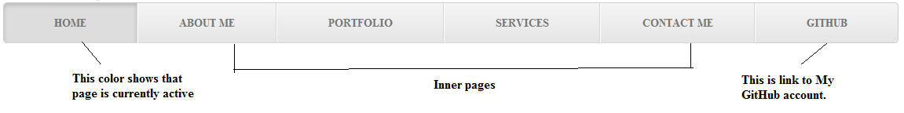

Image: 1

This is a navigation bar from my portfolio website.

That content all tabs for all pages that I have on my website. Home, About me, Portfolio, Services, Contact me, and GitHub. It's also having the CSS function that shows or active the tab which page you are looking.

Nav bar Mobile website:

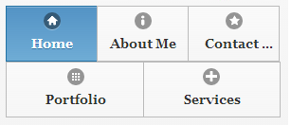

Image: 2

This is a navigation bar from my mobile version portfolio website.

That content all tabs for all pages that I have on my website. Home, About me, Portfolio, Services, and Contact me. It's also having the CSS function that shows or active the tab which page you are looking. Also having icon for each of tabs.

1. **Colors Section:**

Company logo h2 tag (content)

 #0098FA  #f80871

 #0026FC content h4 b

 #8F08F8  #298A08

 #FF00FF content h4 s

 #FF0096  #FF0000

 #FE0200

 #131313

1. **Typography section:**

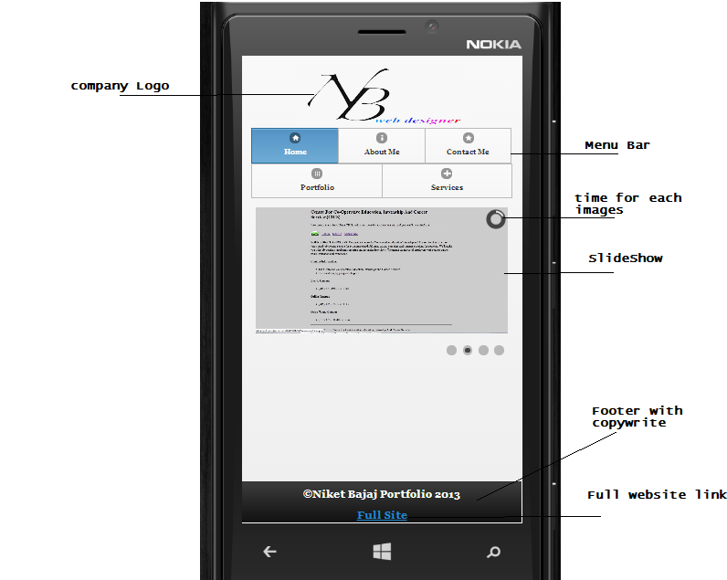

Image: 3

1. **Wireframes Section:**

Home page

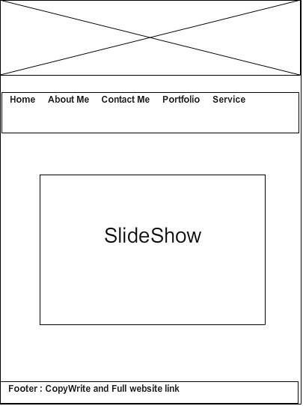

Image: 4

Inner Page:

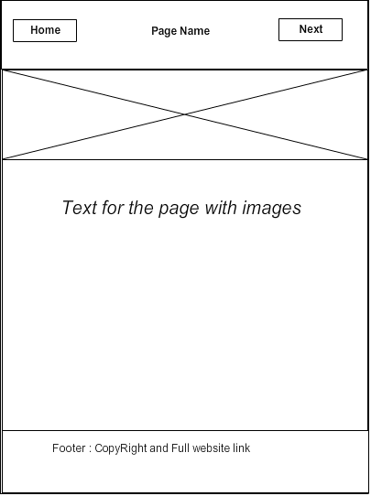

Image: 5

1. **Branding Section:**



Image: 6

In this logo colors used are: #0098FA, #0026FC, #8F08F8, #FF00FF, #FF0096, #FE0200, #131313