**NPM ASSIGNMENT**

**NPM PACKAGE:** Set-up of NPM packages in systemwith the help of “**sudo apt install npm”** in terminal.

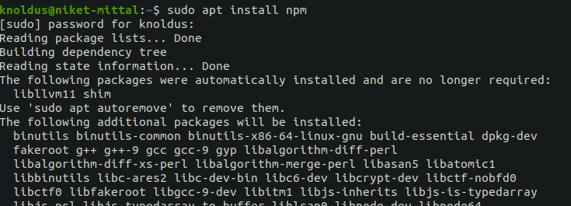

**NODE.js :** Set-up the Node.js environment by **“curl -fsSL https://deb.nodesource.com/setup_14.x | sudo -E bash -”** and after this we need **“sudo apt-get install -y nodejs”** to install.



**VUE :** Set-up the Vue environment by “**sudo‌ ‌npm‌‌**

**install‌ ‌-g‌ ‌@vue/cli”** and checking the version by **‌“vue‌ ‌--version”‌** .



**ANGULAR :** ‌Installed‌ ‌Angular‌ ‌by‌ ‌using‌ the‌ ‌**“sudo‌ ‌npm‌‌**

**install‌ ‌-g‌ ‌@angular/cli”‌** ‌command and checking version by

**“ng --version”** .

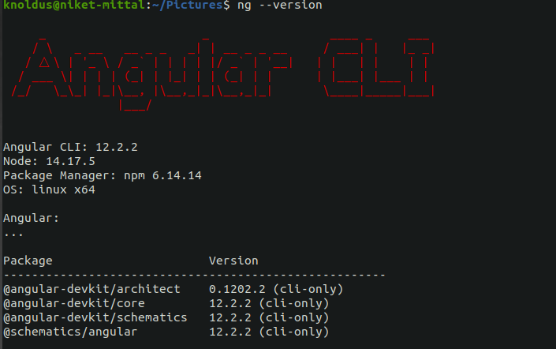

**REACT :** I‌ installed‌ ‌React‌ ‌by‌ ‌using‌ ‌**“ ‌ sudo‌ ‌npm‌ ‌-g‌ ‌install‌‌**

**create-react-app”‌** ‌and‌ ‌then‌ ‌I‌ ‌checked‌ ‌‌version by ‌the‌ ‌command‌ ‌**“create-react-app‌ --version”**.



**IONIC :** Installed Ionic by using ‌**“sudo‌ ‌npm‌ install‌ ‌-g‌‌**

**@ionic/cli”‌** ‌and‌ ‌then‌ ‌I‌ ‌checked‌ ‌version by‌ ‌using‌ ‌the‌ command‌ ‌**“ionic‌ ‌--version”**.

