NAME: Niketan Singh

STUDENT NUMBER: 500229018

LINK TO MY GITHUB PROFILE: <https://github.com/NiketanSingh>

PROJECT NAME:

Link to my project repository

<https://github.com/NiketanSingh/MongoDB.git>

GROUP MEMBERS:

[1]

[2]

…

SCREENSHOT OF FINAL GITHUB PROJECT:

Create the Database with the Name of SinghWallmart

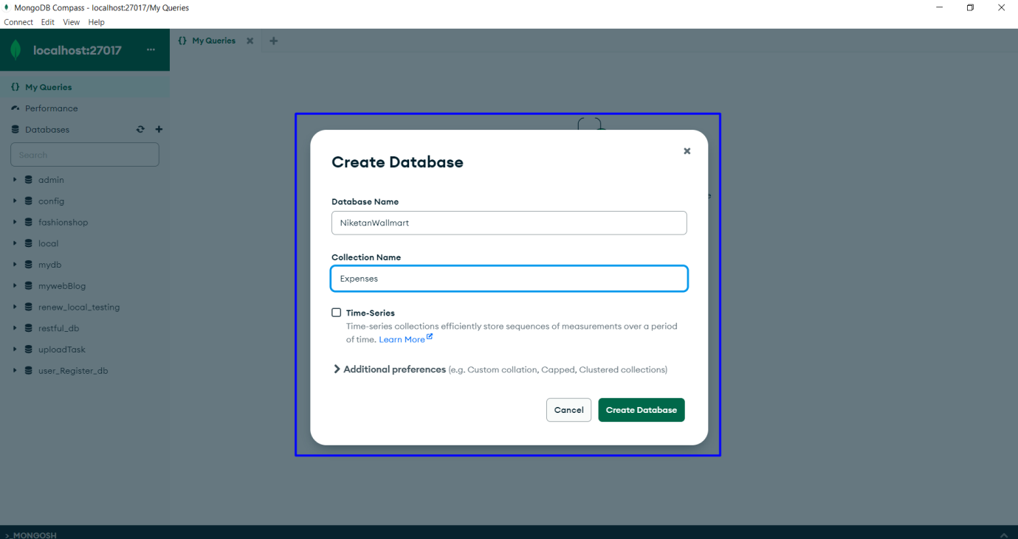

Here we can check that the database is stored

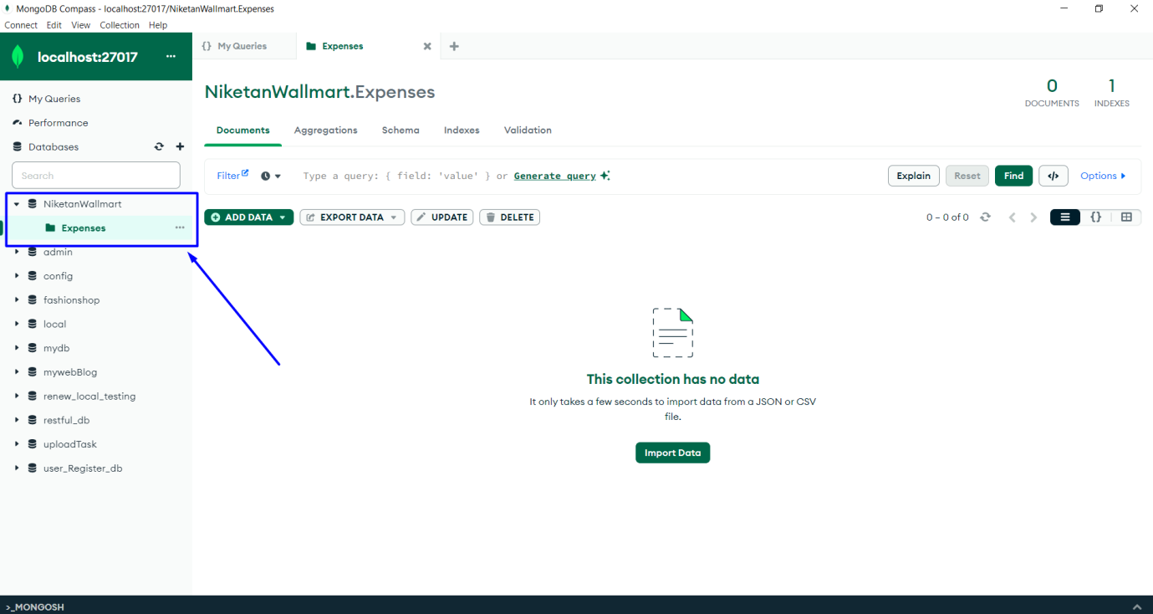

Here I have created five collections

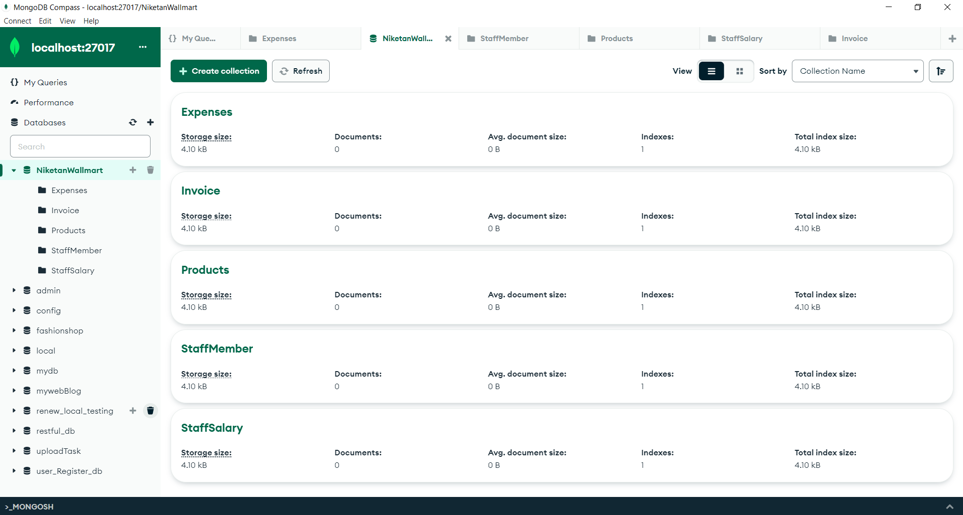

Insert one record into the product collections

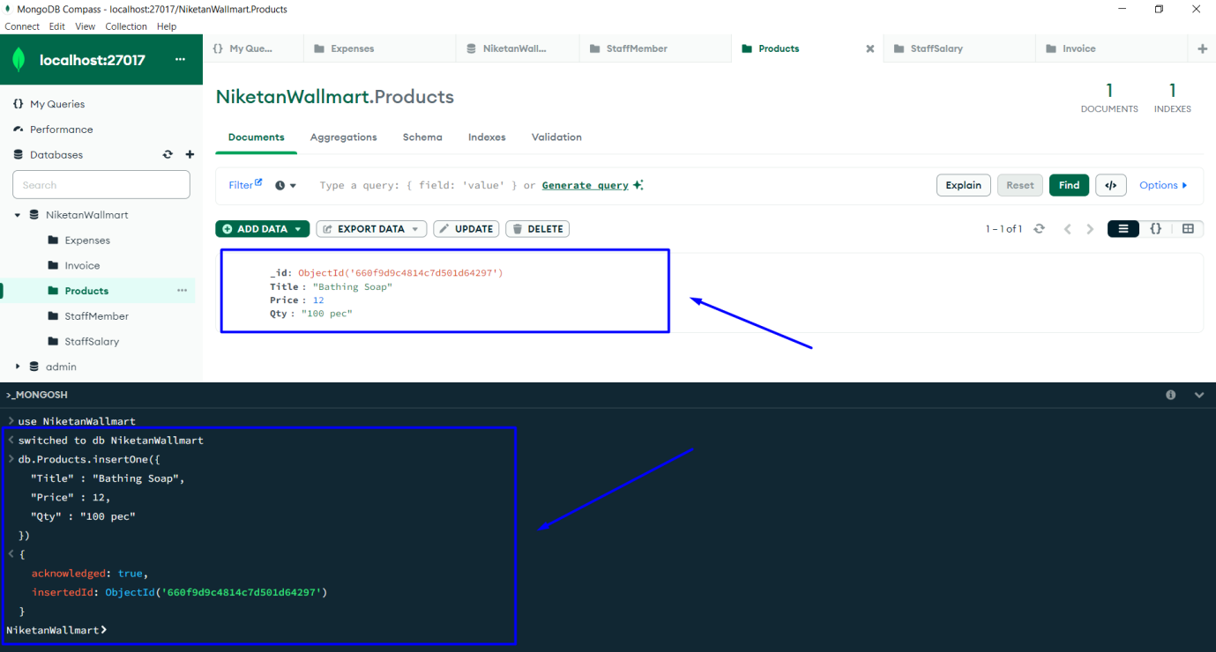

Insert Many record to add

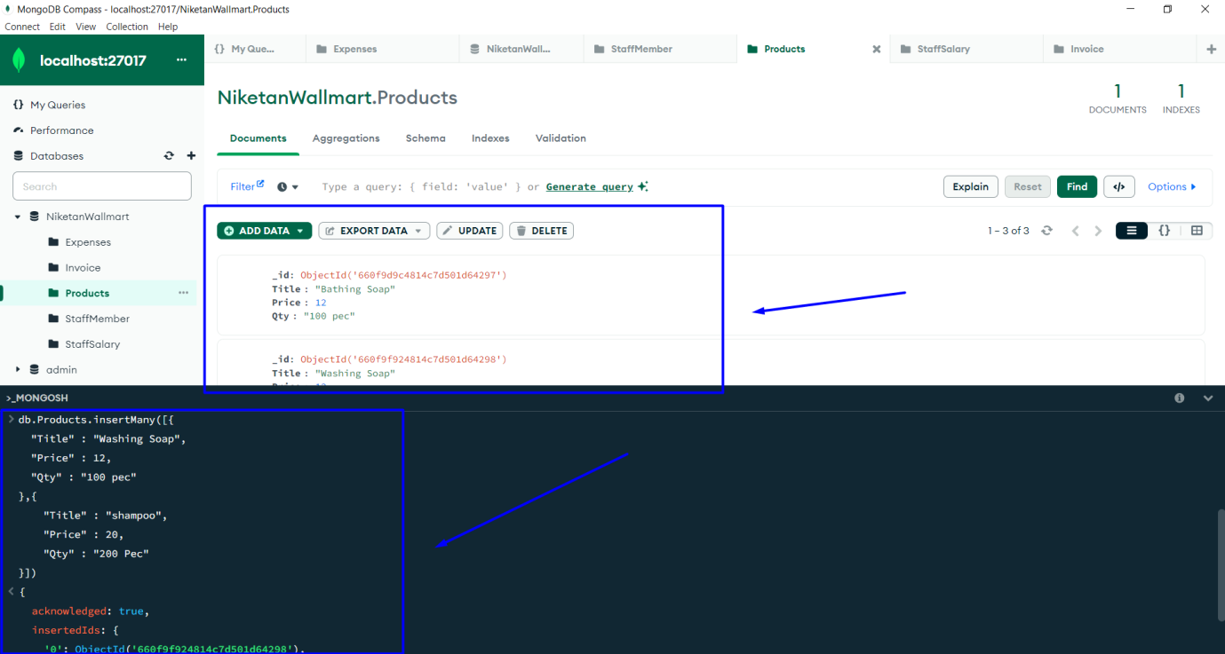

Here I have create an Excel file to import the data

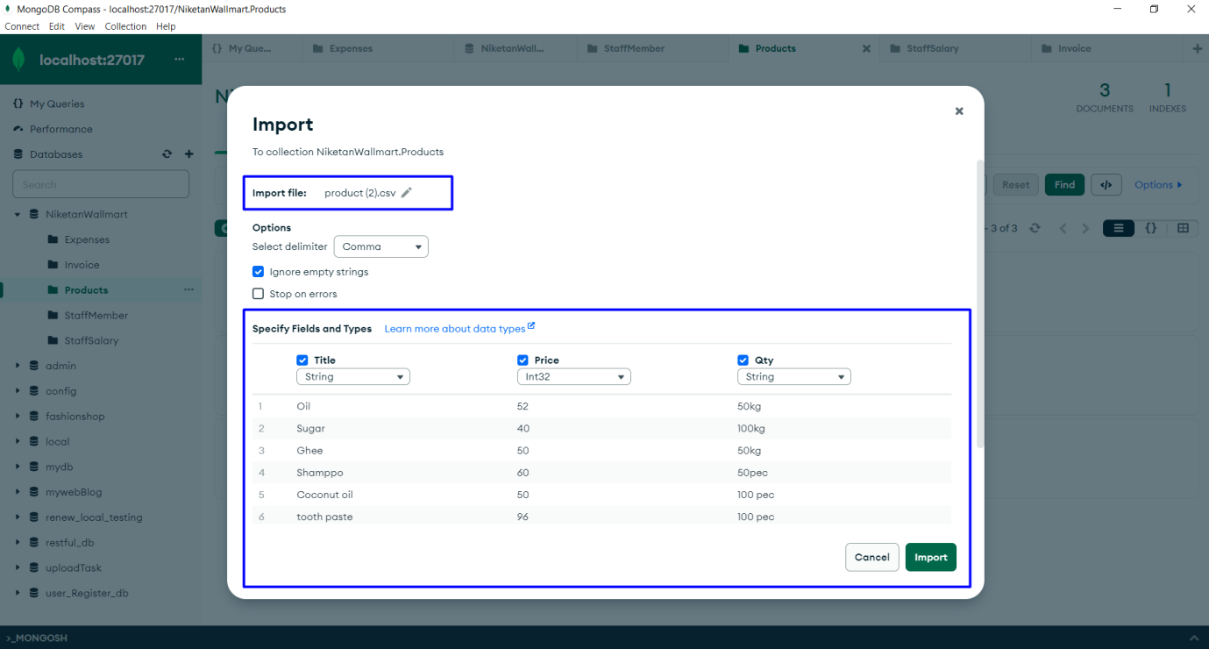

Here we got the success message after importing the record

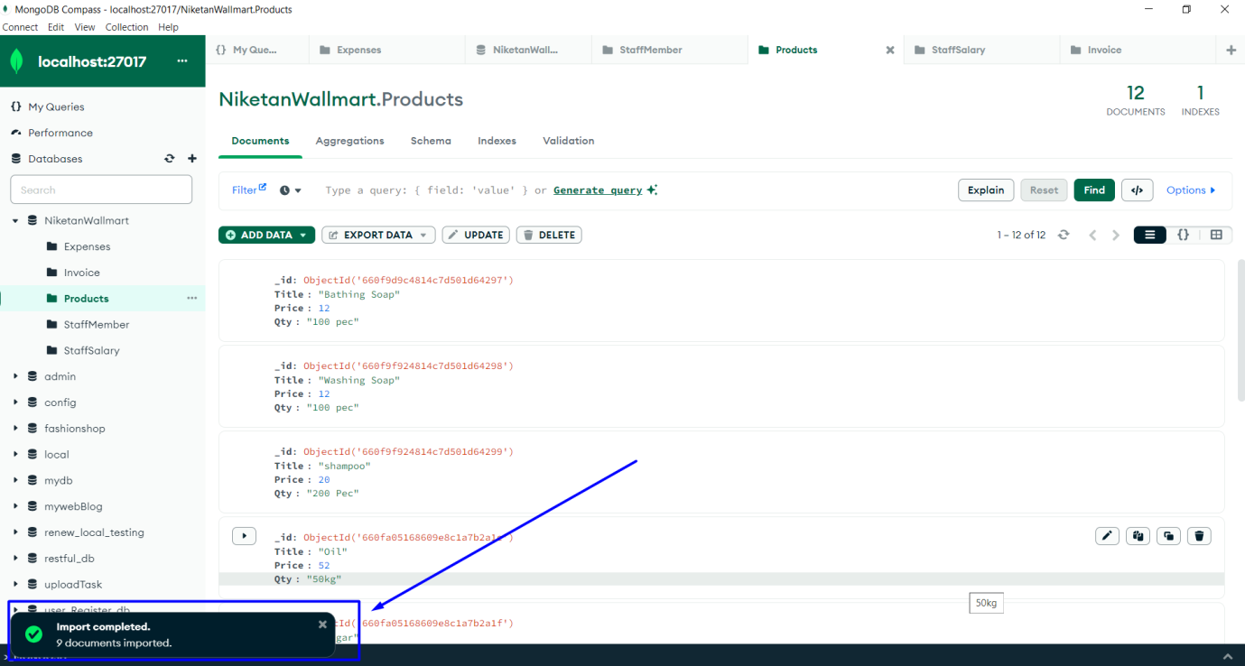

Each Collection with 10 Entries or Objects

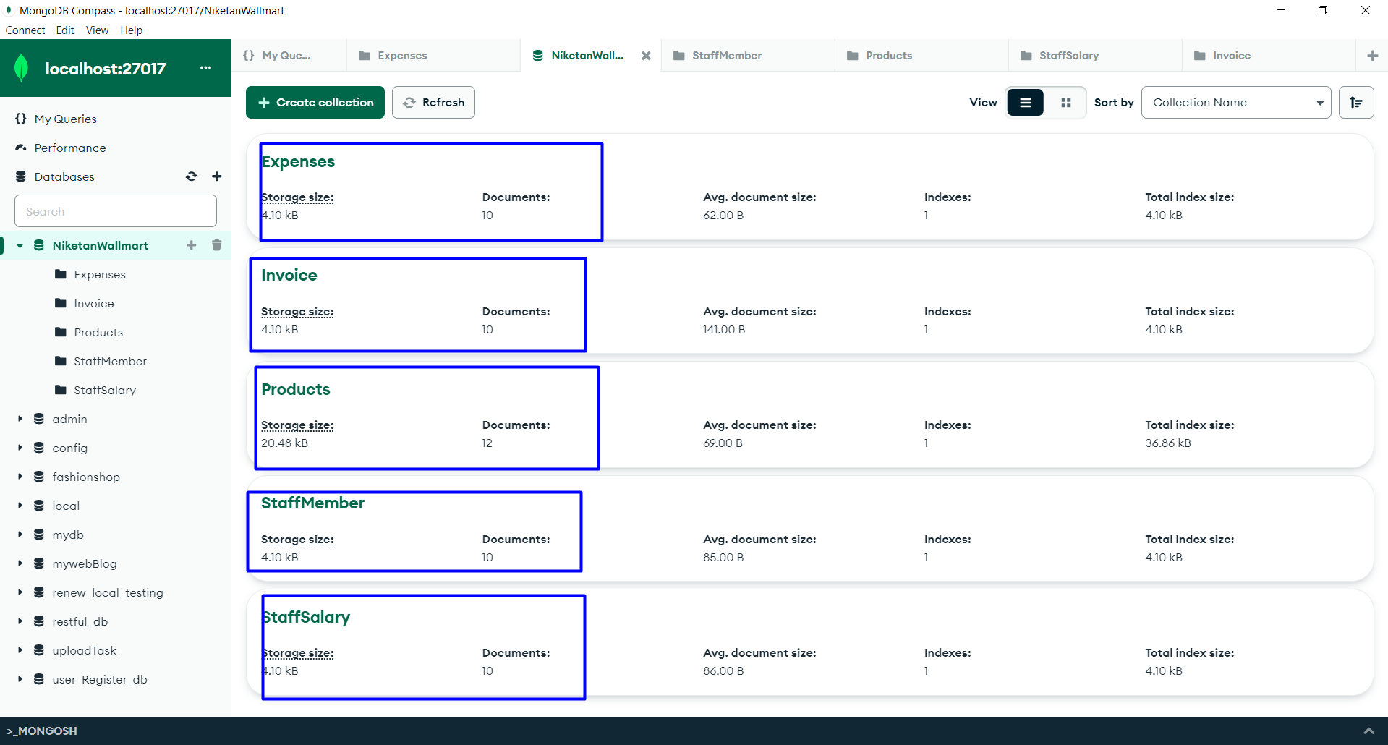

Update One command

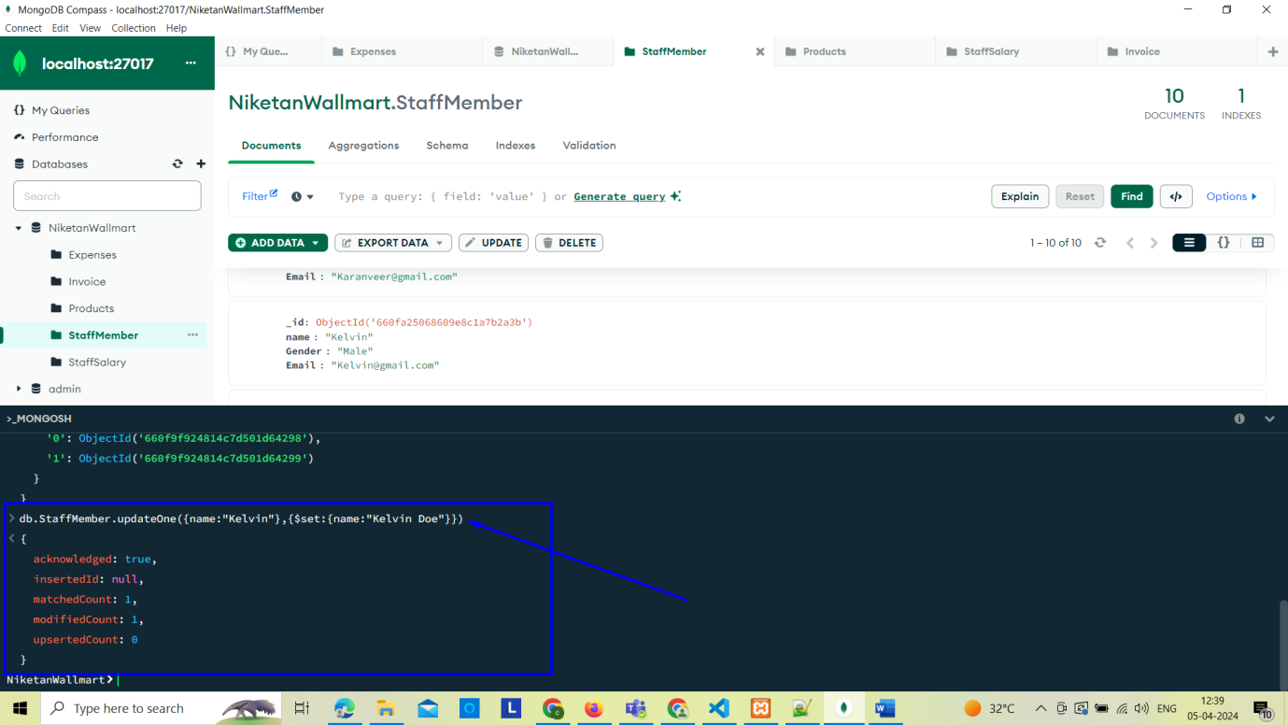

Update Many Record

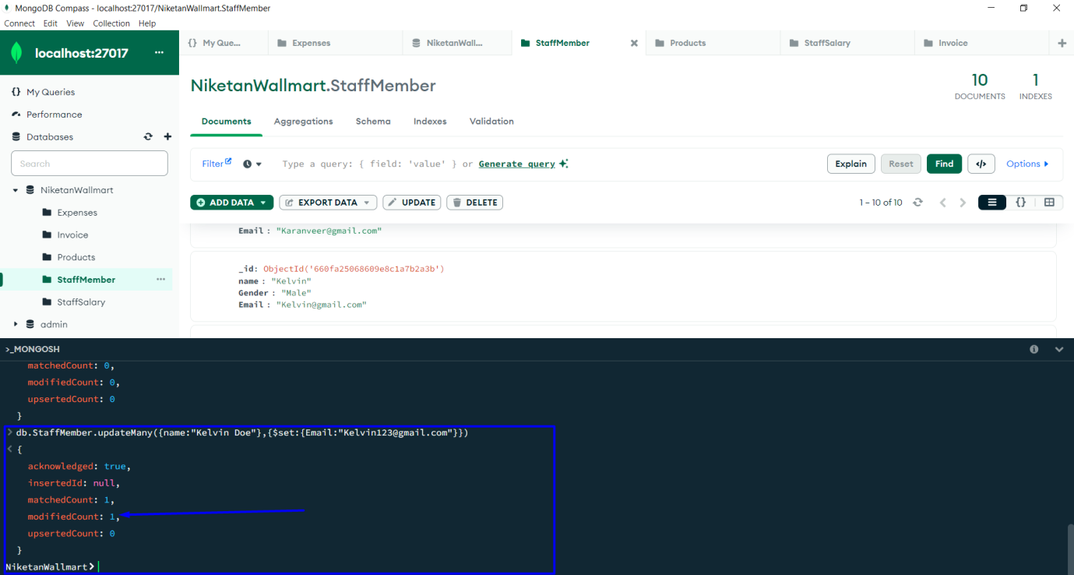

Find One

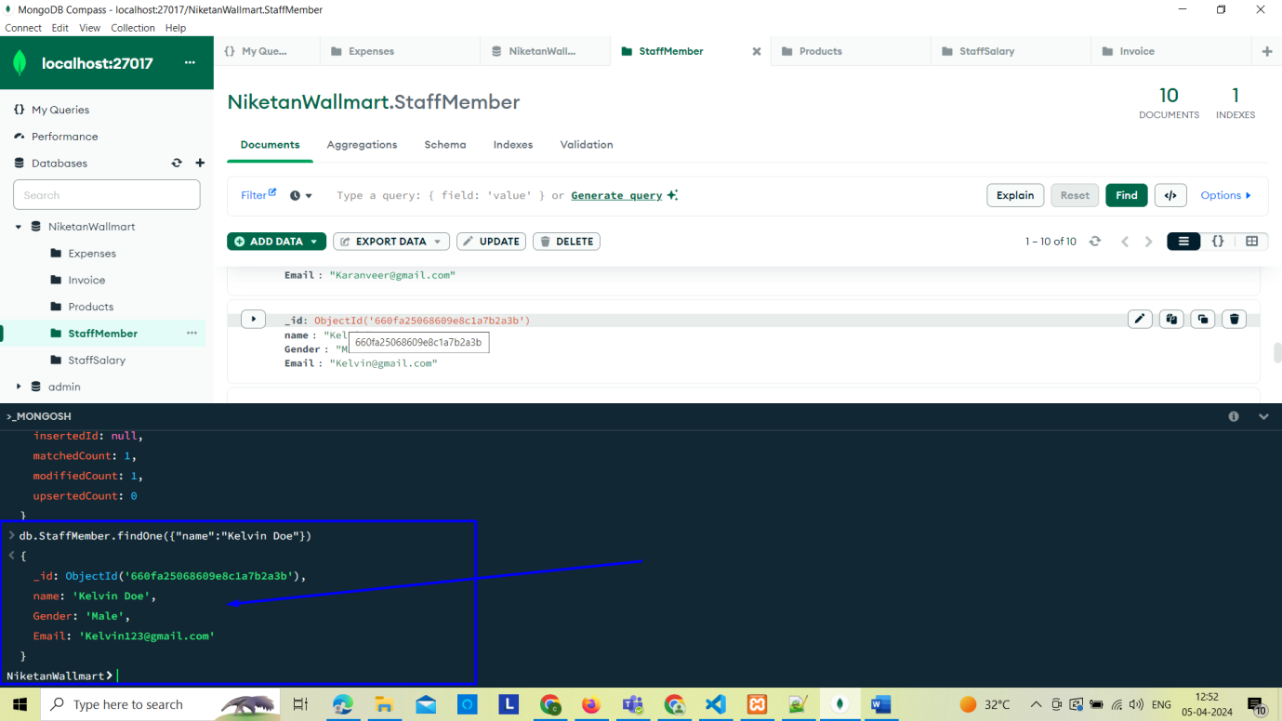

Find command

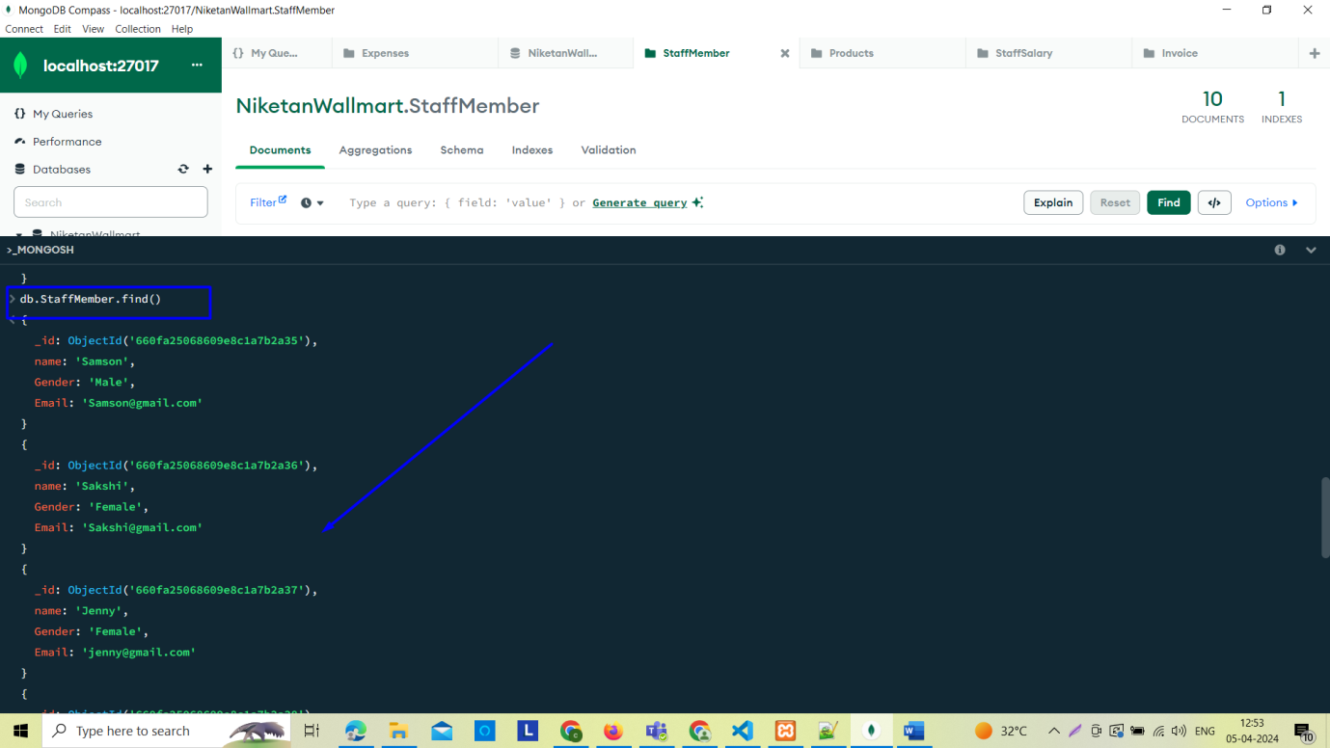

Delete One entry

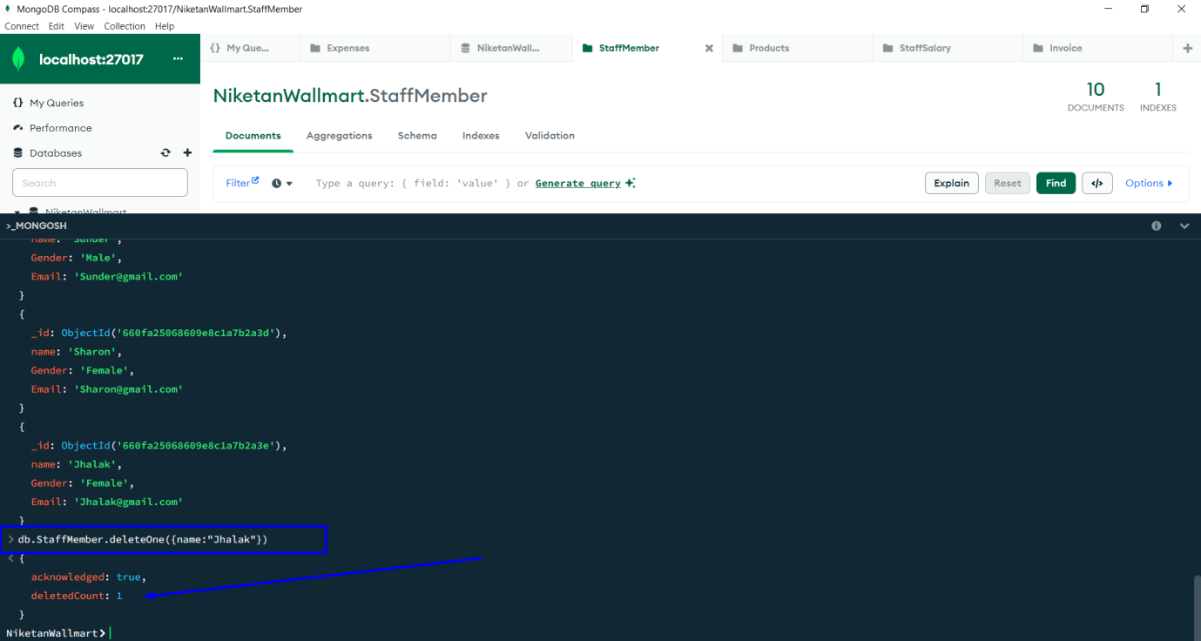

Delete Many entry

