**Aim:**

To generate the sinusoidal signal with Amplitude=1V,frequency=5Hz,phase=00.

**Matlab code:**

Built in function used: ***sin()***

%To generate sinusoidal signal

clc

clear all

close all

%Specify the parameters of the sine wave

t=linspace(0,1,100)

A=1;

f=5;

phi=0;

x=A*sin(2*pi*f*t+phi);

plot(t,x),xlabel('t'),ylabel('Amplitude')

title(['Sinusoidal signal' ' A=',num2str(A),'V'' ,f=',num2str(f),'Hz'',\phi=',num2str(phi)]);

***Figure 1 Matlab code to generate sinusoidal signal***

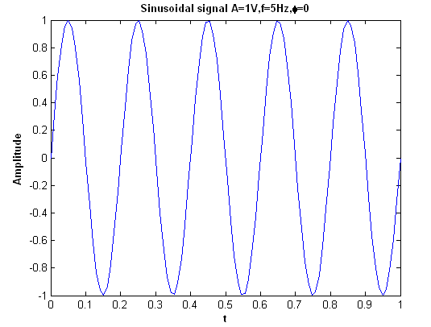

***Figure 2 Generated Sinusoidal signal***

**Inference:**

(i)As per specification sinewave of 5Hz frequency is generated