W2D1: Feature Engineering & Encoding
Cynaris Solutions Internship | Week 2 — Day 1 | 19 October 2026

1. Objective
Practise categorical encoding, numerical feature scaling, and feature selection. This report records the code files, output evidence, automated tests, and the remaining checks before the GitHub submission.

2. Tools and Libraries
- Python — runs the feature-engineering scripts.
- Pandas and NumPy — organise and prepare sample/student data.
- scikit-learn — provides LabelEncoder, OneHotEncoder, OrdinalEncoder, StandardScaler, MinMaxScaler, RobustScaler, and SelectKBest.
- Matplotlib — creates scaling comparison plots.
- pytest — runs automated checks.
- Git and GitHub — planned for version control, push, and pull request submission.

3. Work Completed
- Prepared the encoding.py, scaler.py, and feature_selection.py scripts.
- Demonstrated LabelEncoder, OneHotEncoder, and OrdinalEncoder for categorical grade values.
- Practised StandardScaler, MinMaxScaler, and RobustScaler and captured plot evidence.
- Prepared SelectKBest feature-selection code and a top-five feature report.
- Created run_all.py to run the three scripts in sequence.
- Created requirements.txt and README.md for dependencies and run instructions.
- Added three automated tests in tests/test_feature_engineering.py; the user reported that `python -m pytest -q` passed all three tests.

4. Implementation Summary
The work is organised into separate scripts so each concept can be understood and run independently. encoding.py demonstrates three ways to represent categories; scaler.py compares three numerical scaling methods; feature_selection.py demonstrates SelectKBest; and run_all.py coordinates execution. Short purpose descriptions were added at the start of the scripts without intentionally changing the original program logic.

5. Results and Evidence
The screenshots below are the available visual evidence for the scaling practice and project files. They show separate comparison plots for StandardScaler, MinMaxScaler, and RobustScaler.
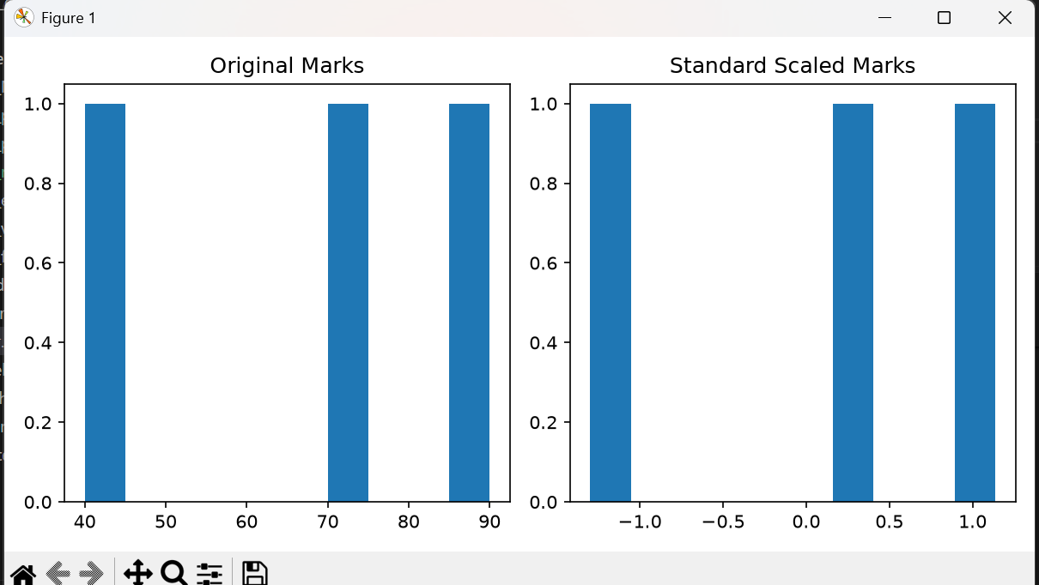
Figure 1. StandardScaler — original marks compared with scaled marks.
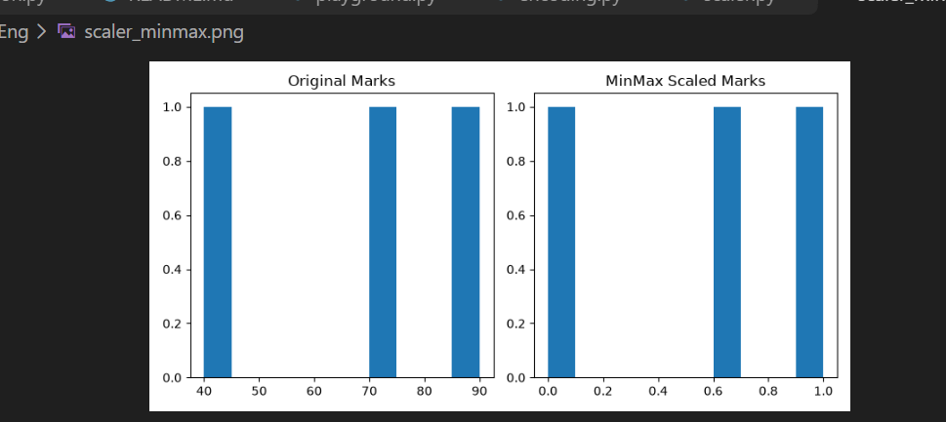
Figure 2. MinMaxScaler — original marks compared with scaled marks.
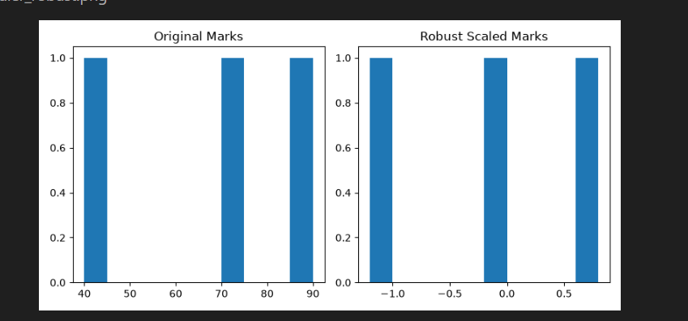
Figure 3. RobustScaler — original marks compared with scaled marks.

6. Test and Execution Summary
Check | Reported result | Notes
pytest — 3 unit tests | PASSED (reported) | Tests cover encoder output shape, scaler shape preservation, and SelectKBest output count.
encoding.py | Ran successfully in run_all.py | Encoding stage completed during the recorded run.
scaler.py | FAILED in run_all.py | A savefig path error was reported: multiple output paths were joined into one invalid filename.
feature_selection.py | Ran successfully in run_all.py | Feature-selection stage ran after the scaler failure in the recorded run.
Important: passing unit tests does not mean the full pipeline completed successfully. The scaling script's savefig path error must be resolved and the pipeline rerun before claiming an end-to-end successful run. This report does not claim that the Git push or pull request has been completed.

7. Learning Outcomes
- Understood the purpose and trade-offs of label, one-hot, and ordinal encoding.
- Practised how standard, min-max, and robust scaling transform numeric values differently.
- Used SelectKBest to demonstrate selecting a fixed number of features.
- Used pytest for basic automated checks and run_all.py to coordinate scripts.

8. Completion Status
Feature-engineering practice, documentation files, plot evidence, and three passing unit tests have been reported. The full pipeline is not yet verified because scaler.py encountered a savefig path error. Git status review, commits, push, and pull request remain to be completed.

