PRACTICAL REPORT

W4D2: Bias-Variance Tradeoff
& Regularisation
Hyperparameter Tuning using GridSearchCV and RandomizedSearchCV
Internship | AI/ML Internship
Organisation | Cynaris Solutions Private Limited
Practical | Week 4 – Day 2
Dataset / Model | Wine Recognition / Random Forest Classifier

1. Objective
To study the Bias-Variance Tradeoff and perform hyperparameter tuning using GridSearchCV and RandomizedSearchCV with a Random Forest Classifier. The experiment compares a baseline model with two search strategies on the Wine Recognition dataset.

2. Dataset Description
The practical uses Scikit-learn's built-in Wine Recognition dataset, loaded with load_wine(). It contains 178 samples, 13 numerical features and three target classes.
- Total samples: 178
- Features: 13
- Target classes: 3
- Training samples: 142
- Testing samples: 36

3. Concepts and Methods

3.1 Bias-Variance Tradeoff
Bias is error associated with a model that is too simple to capture important patterns. Variance is error associated with sensitivity to changes in training data. Underfitting occurs when a model does not learn patterns adequately; overfitting occurs when it fits training data too closely and generalises poorly.

3.2 Hyperparameter Tuning
Hyperparameters are configuration choices set before model fitting. This practical explores n_estimators, max_depth, min_samples_leaf, max_features and min_samples_split.

3.3 Search Strategies
GridSearchCV evaluates every combination in the specified parameter grid using cross-validation. RandomizedSearchCV samples a specified number of combinations from the supplied search space.

4. Implementation Workflow
- Dataset loading: Loaded the Wine dataset and stored its 13 features in a Pandas DataFrame.
- Train-test split: Created an 80:20 stratified split with random_state=42 (142 training and 36 testing samples).
- Baseline model: Trained a default RandomForestClassifier and evaluated test accuracy.
- Grid Search: Evaluated 18 combinations (3 × 3 × 2) with five-fold CV, for 90 model fits.
- Randomized Search: Sampled 20 combinations with five-fold CV, for 100 model fits.
- Comparison: Compared test accuracy, best parameters, best CV score and search execution time.

5. Experimental Results

5.1 Baseline Random Forest
Test accuracy: 1.0000 (100%).

5.2 GridSearchCV
Best parameters:
{'max_depth': 3, 'min_samples_leaf': 1, 'n_estimators': 200}
- Best CV score: 0.9791
- Test accuracy: 1.0000 (100%)
- Execution time: 7.4152 seconds

5.3 RandomizedSearchCV
Best parameters:
{'n_estimators': 200, 'min_samples_split': 2, 'min_samples_leaf': 5, 'max_features': 'log2', 'max_depth': 3}
- Best CV score: 0.9791
- Test accuracy: 0.9722 (97.22%)
- Execution time: 3.7822 seconds

5.4 Overall Comparison
Method | CV Score | Test Accuracy | Time
Baseline Random Forest | N/A | 100.00% | Not measured
Grid Search | 97.91% | 100.00% | 7.4152 s
Randomized Search | 97.91% | 97.22% | 3.7822 s
The baseline and Grid Search models both achieved 100% test accuracy. Randomized Search achieved 97.22%. Randomized Search completed faster in this run. Runtime depends on the machine and workload, so this result does not establish that one strategy is always faster. Baseline training time was not measured; the 0.000000 shown in the program's comparison table is a placeholder, not a measured runtime.

6. Automated Testing
Pytest tests check successful script execution, dataset dimensions, train-test sample counts, execution of all search methods and generation of the final comparison.
python -m pytest W4D2_BiasVariance_Regularisation\tests\test_hyperparameter_tuning.py -v
Observed result: 5 passed in 13.44s

7. Evidence Screenshots
Screenshots captured from the practical execution and automated test run:
Evidence 1 – Wine dataset, train-test split, baseline model and Grid Search results.
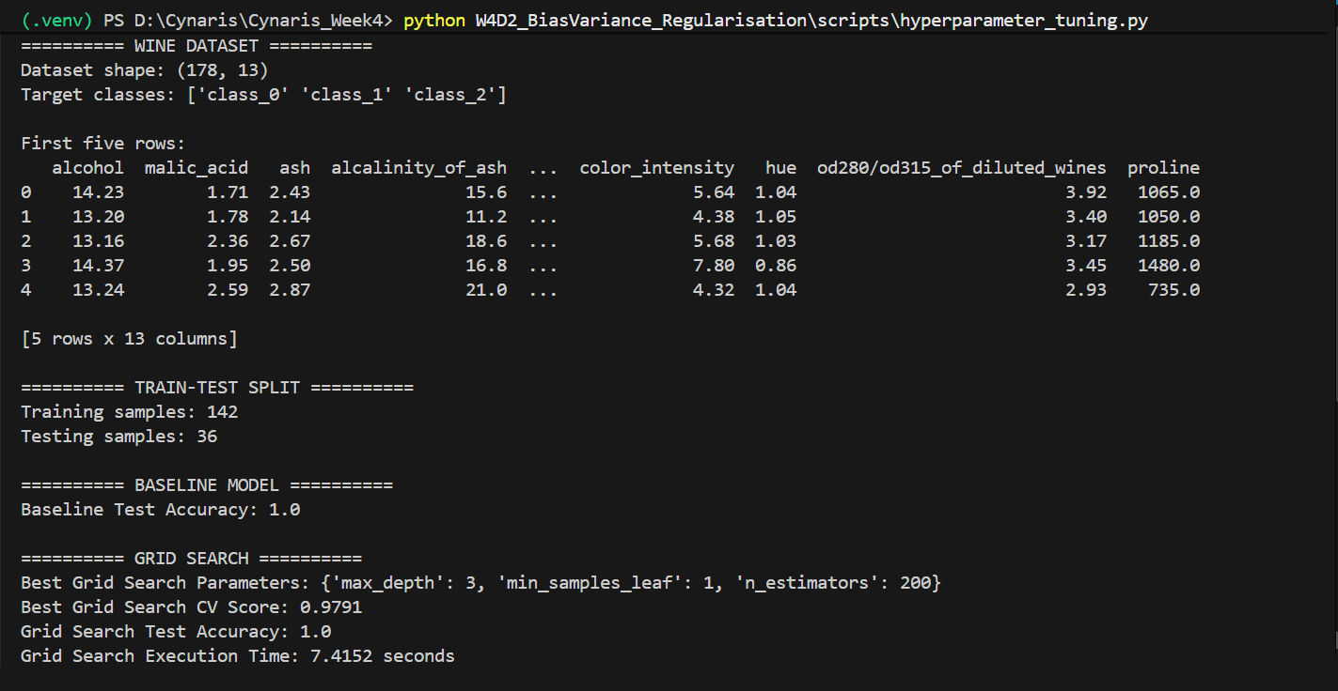

Evidence 2 – Randomized Search results and final performance comparison.
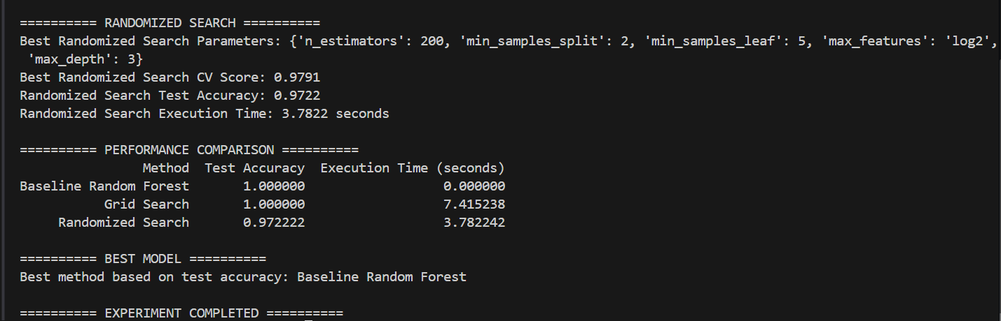

Evidence 3 – Pytest execution showing all five automated tests passed.
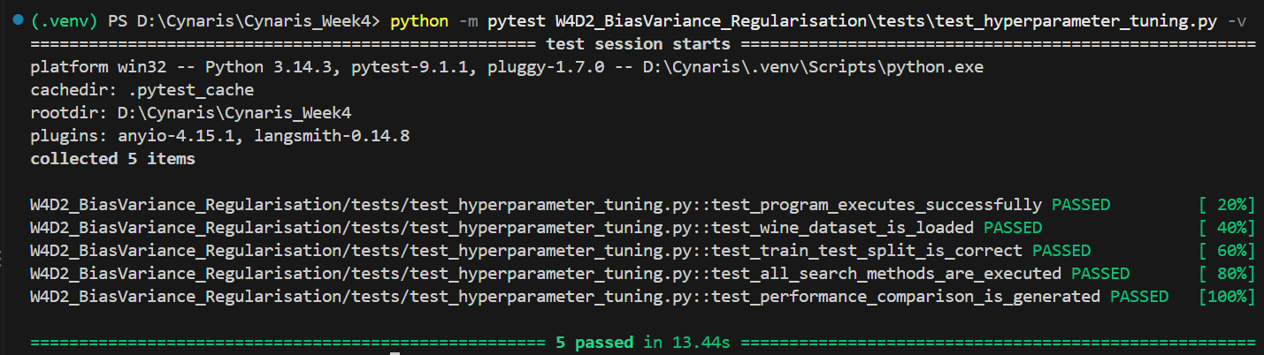

8. Conclusion
The practical demonstrated baseline Random Forest training and hyperparameter tuning with GridSearchCV and RandomizedSearchCV. The baseline achieved 100% test accuracy, and Grid Search matched that result; tuning did not improve observed test accuracy beyond the baseline. Randomized Search achieved 97.22% test accuracy and had a shorter measured search runtime in this execution. All five automated tests passed.

9. Project Structure
W4D2_BiasVariance_Regularisation/
├── scripts/
│ └── hyperparameter_tuning.py
├── tests/
│ └── test_hyperparameter_tuning.py
└── README.md

