CYNARIS SOLUTIONS PRIVATE LIMITED

Week 3 – Day 5
Hyperparameter Tuning
AI/ML Internship | Wine Classification Experiments

1. Objective
The objective of W3D5 was to compare multiple classification algorithms, study the effect of selected hyperparameters, tune a Random Forest model using GridSearchCV, evaluate model performance, save results to CSV, and record the experiment in MLflow.

2. Dataset and Preparation
The experiments used the Wine dataset provided by scikit-learn. The dataset contains 178 samples, 13 features, and 3 target classes. The observed class distribution was [59, 71, 48]. The workflow used a stratified 80/20 train-test split with random_state=42. StandardScaler was used inside pipelines where applicable to keep preprocessing within the model workflow.

3. Classifier Comparison
Six classifiers were evaluated using test accuracy, macro-F1, and 5-fold cross-validation (mean ± standard deviation). The values below are transcribed from the provided terminal output.
Classifier | Test Accuracy | Macro-F1 | 5-Fold CV (Mean ± SD)
Logistic Regression | 0.9722 | 0.9710 | 0.9791 ± 0.0277
Decision Tree | 0.9444 | 0.9457 | 0.9022 ± 0.0586
Random Forest | 1.0000 | 1.0000 | 0.9791 ± 0.0277
SVM (RBF) | 0.9444 | 0.9407 | 0.9931 ± 0.0138
KNN (K=5) | 0.9722 | 0.9718 | 0.9507 ± 0.0353
Gaussian Naive Bayes | 0.9722 | 0.9743 | 0.9722 ± 0.0259

4. KNN Hyperparameter Experiment
The number of neighbors K was varied across 1, 3, 5, 7, 11, 15, and 21. The terminal output reported the following test accuracies and cross-validation results:
K | Test Accuracy | 5-Fold CV (Mean ± SD)
1 | 0.9722 | 0.9227 ± 0.0335
3 | 0.9722 | 0.9369 ± 0.0254
5 | 0.9722 | 0.9507 ± 0.0353
7 | 1.0000 | 0.9579 ± 0.0405
11 | 1.0000 | 0.9579 ± 0.0405
15 | 1.0000 | 0.9579 ± 0.0336
21 | 1.0000 | 0.9579 ± 0.0405

5. SVM Experiments
The provided output includes an RBF SVM with C=100 and a linear SVM. Both achieved test accuracy of 0.9444. The RBF model reported macro-F1 0.9407 and CV 0.9931 ± 0.0138; the linear model reported macro-F1 0.9453 and CV 0.9862 ± 0.0276. These results alone do not prove overfitting; a training-score comparison and further validation would be needed to make that conclusion.

6. Random Forest GridSearchCV
GridSearchCV evaluated 12 parameter combinations using 5-fold stratified cross-validation. The search varied n_estimators (50, 200), max_depth (None, 10, 20), and min_samples_split (2, 5).
- Best parameters: max_depth=None, min_samples_split=2, n_estimators=200
- Best cross-validation accuracy: 0.9791
- Best model test accuracy: 1.0000
- Best model macro-F1: 1.0000
The results CSV was saved to W3D5_HyperparameterTuning/outputs/wine_tuning_results.csv. The MLflow experiment was named Cynaris-W3D5-Hyperparameter-Tuning.

7. Test Validation
The W3D5 test file was run with pytest. All three tests passed in 8.95 seconds:
- test_pipeline_can_fit_and_predict
- test_all_seven_knn_values_are_valid
- test_gridsearch_finds_best_parameters

8. Screenshots / Evidence
The following screenshots were supplied during the task and are included as evidence of the experiment output and test run.
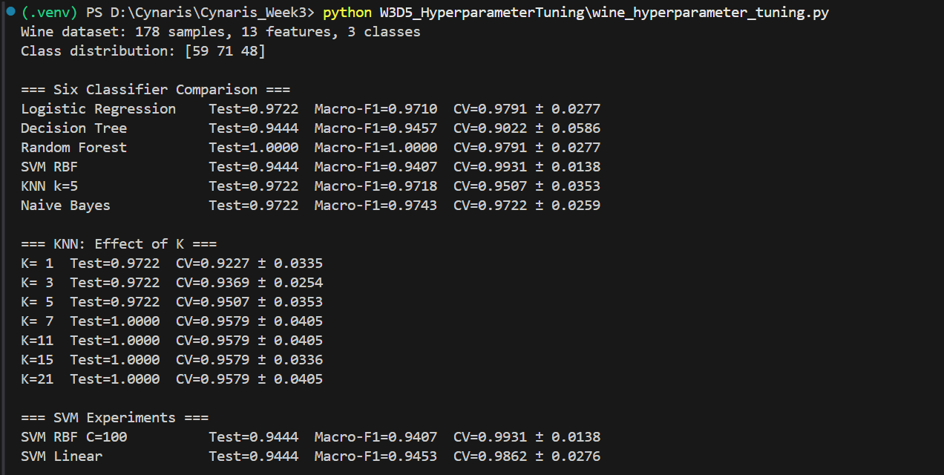
Figure 1. Classifier comparison, KNN values, and SVM experiment output.
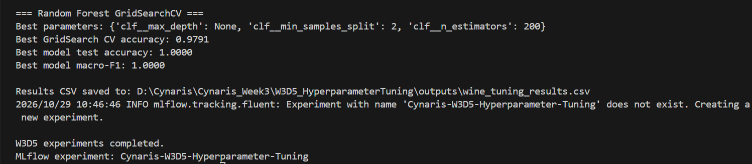
Figure 2. Random Forest GridSearchCV results, saved CSV, and MLflow experiment confirmation.
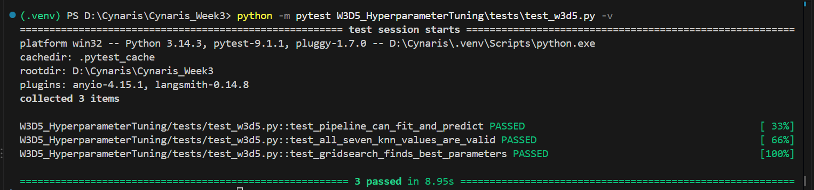
Figure 3. Pytest validation output: all three W3D5 tests passed.

9. Conclusion
The W3D5 workflow successfully compared six classifiers, explored KNN and SVM settings, performed Random Forest hyperparameter tuning with GridSearchCV, exported a CSV results file, logged an MLflow experiment, and passed all three automated tests. Random Forest and several larger KNN values achieved 1.0000 test accuracy on this split; these results should be interpreted alongside cross-validation because a single test split does not establish general performance on unseen data.

10. Reproduction Commands
python W3D5_HyperparameterTuning/wine_hyperparameter_tuning.py
python -m pytest W3D5_HyperparameterTuning/tests/test_w3d5.py -v

