WEEK 4 – DAY 4

FastAPI Model Serving Endpoint
Practical Report with Evidence
Organization | Cynaris Solutions Private Limited
Internship Role | AI/ML Intern
Task | W4D4 – FastAPI Model Serving Endpoint
Date | 3 November 2026

1. Objective
The objective of this practical was to build a REST API that serves a trained machine learning model. The model was trained using Scikit-learn, tracked with MLflow, saved with Joblib, and made available for inference through FastAPI.

2. Tools and Technologies
Python, Scikit-learn, FastAPI, Uvicorn, Pydantic, Pandas, MLflow, Joblib and Pytest.

3. Dataset and Model
The Breast Cancer Wisconsin diagnostic dataset available through Scikit-learn was used. It contains 569 samples and 30 numerical features for binary classification (malignant and benign). The data was split into 455 training samples and 114 testing samples using an 80:20 split with stratification.
A Scikit-learn Pipeline was created with StandardScaler followed by LogisticRegression. The classifier was trained with max_iter=5000. The model achieved an accuracy of 0.9825 (98.25%) on the held-out test set.

4. Model Training, Experiment Tracking and Serialization
The training script loads the dataset, performs the train-test split, trains the pipeline, and calculates test accuracy. MLflow records the experiment under the name W4D4-FastAPI-Model-Serving, including the model name, maximum iterations, test size, accuracy metric and model artifact. The trained pipeline is saved to models/breast_cancer.joblib using Joblib.
The saved artifact was loaded again and used to generate predictions on the test data. The original and reloaded model predictions matched, confirming successful serialization.

5. FastAPI Application
The FastAPI application loads the saved Joblib pipeline when the application starts. It exposes the following endpoints:
Method | Endpoint | Purpose
GET | /health | Returns the API health status.
POST | /predict | Accepts feature values and returns predictions and class labels.
GET | /docs | Provides interactive Swagger API documentation.
The prediction request is validated using a Pydantic request schema. The endpoint checks that all required feature names are present, converts values to numeric form, arranges features in the expected order, and then calls the trained model. The response includes the numeric prediction and its readable label (0 = malignant, 1 = benign).

6. Testing and Validation
Automated endpoint tests were written using FastAPI TestClient and Pytest.
- Health endpoint returns HTTP 200 and status 'ok'.
- A valid prediction request returns a prediction and label.
- A request with missing required features returns HTTP 422.
- An empty instances list returns HTTP 422.
- Invalid feature values return HTTP 422.
Test result: 5 passed in 1.82 seconds, with no warnings.

7. Execution Evidence
The following screenshots document model training, automated testing, and live API responses.

Evidence 1 – Model training and MLflow logging
The output confirms 569 samples and 30 features, an 80:20 split, Logistic Regression training, 98.25% test accuracy, successful MLflow logging, Joblib model saving, and matching predictions after reloading.
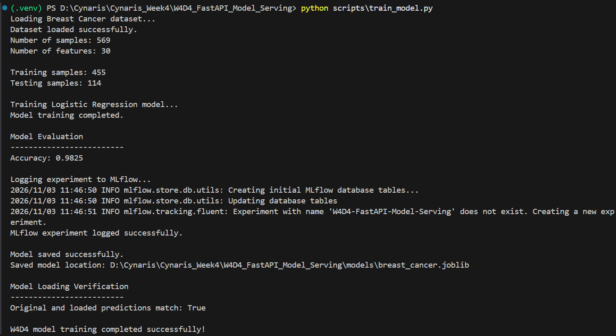

Evidence 2 – Automated Pytest results
All five API tests passed: health check, successful prediction, missing features, empty instances, and invalid input. This is the clean test run without warnings.
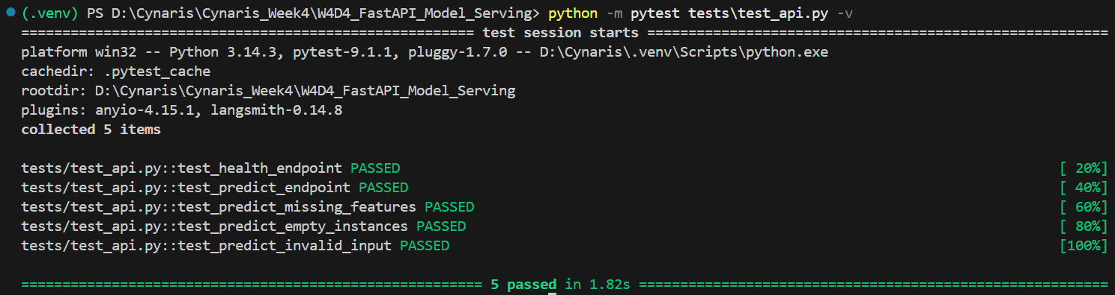

Evidence 3 – FastAPI health endpoint
The GET /health endpoint returned HTTP 200 with status 'ok' and the message that the model-serving application is running.
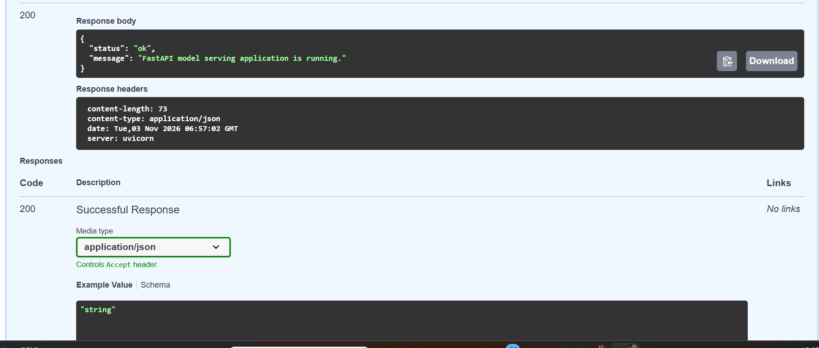

Evidence 4 – Successful model prediction
The POST /predict endpoint returned HTTP 200. For the tested sample, the response contained prediction 0 and label 'malignant'.
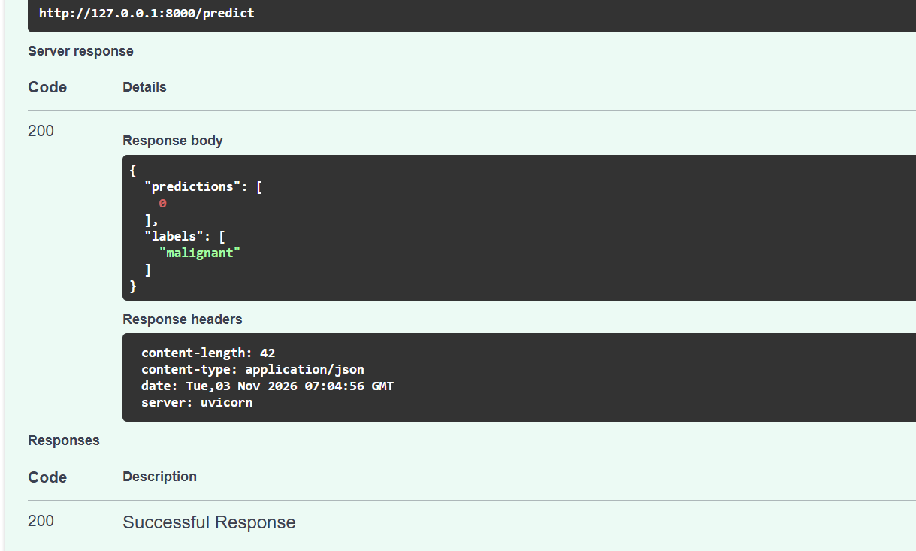

8. Project Structure
W4D4_FastAPI_Model_Serving/
├── app/
│ └── main.py
├── scripts/
│ └── train_model.py
├── models/
│ └── breast_cancer.joblib
├── tests/
│ └── test_api.py
└── README.md

9. Git and Documentation
The W4D4 implementation and documentation were committed to the weekly branch feat/aiml-W4-nikhita. The two commits created for this task were:
- 9b43323 – feat(w4d4): implement FastAPI model serving endpoint
- 7ee5fbf – docs(w4d4): document FastAPI model serving practical
Both commits were pushed successfully to the GitHub repository. A pull request was then created for the W4D4 work.

10. Conclusion
The W4D4 practical successfully demonstrated how to serve a trained machine learning model through a FastAPI application. The Logistic Regression pipeline achieved 98.25% accuracy, MLflow experiment tracking was completed, and the model was saved and reloaded successfully using Joblib. The health and prediction endpoints were verified through Swagger UI, and all five automated tests passed without warnings.

