CYNARIS SOLUTIONS — WEEK 1, DAY 2
Pandas for Data Manipulation — Output Evidence
Dataset inspection • Cleaning • Filter • GroupBy • Merge • Pivot table • CSV/Parquet export
Evidence compiled from the terminal screenshots provided. Overlapping portions were cropped where the same output appeared in consecutive screenshots. The screenshots document the observed outputs; code review and Git submission are tracked separately.

1. Dataset Inspection — Shape, Columns, Head and Data Types
The source CSV loads successfully and reports 2,201 rows and 21 columns. The first screenshot shows the first rows and the beginning of the data-type listing.
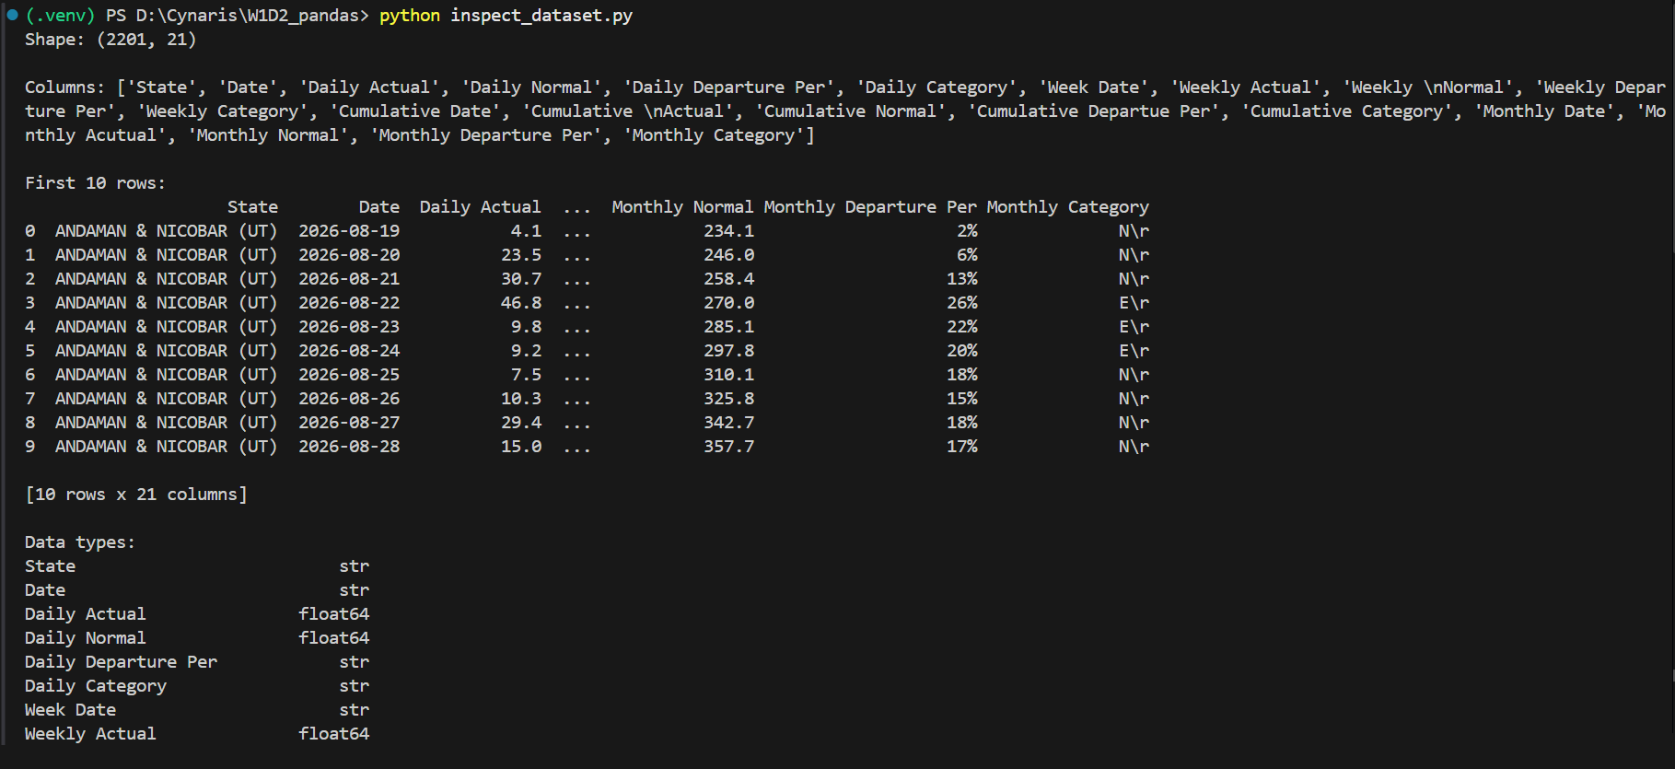

1. Dataset Inspection — Data Type Continuation
Continuation of the data-type listing; the repeated heading and already-shown entries have been removed.
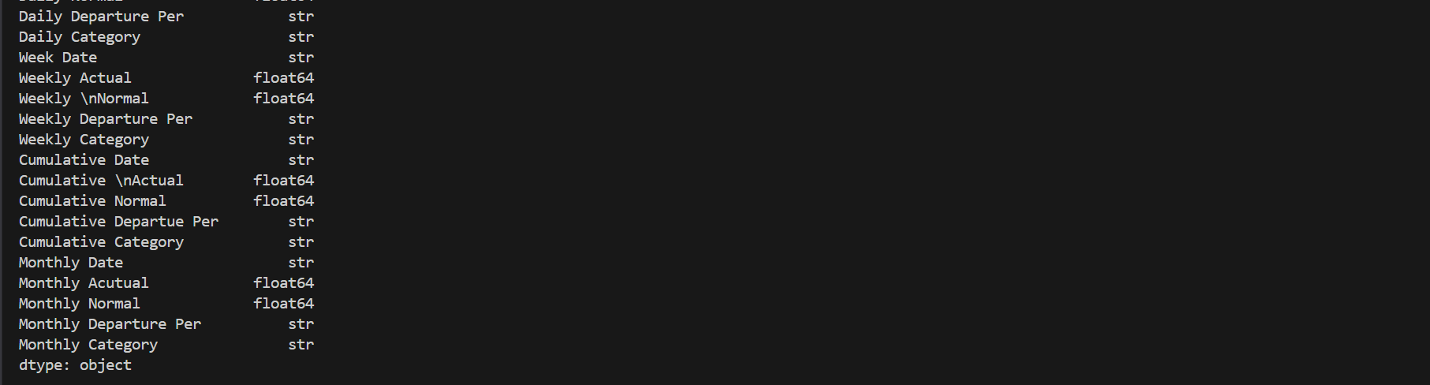

1. Dataset Inspection — Missing Values
Shows the missing-value count for each column. Missing values are preserved rather than deleted automatically.
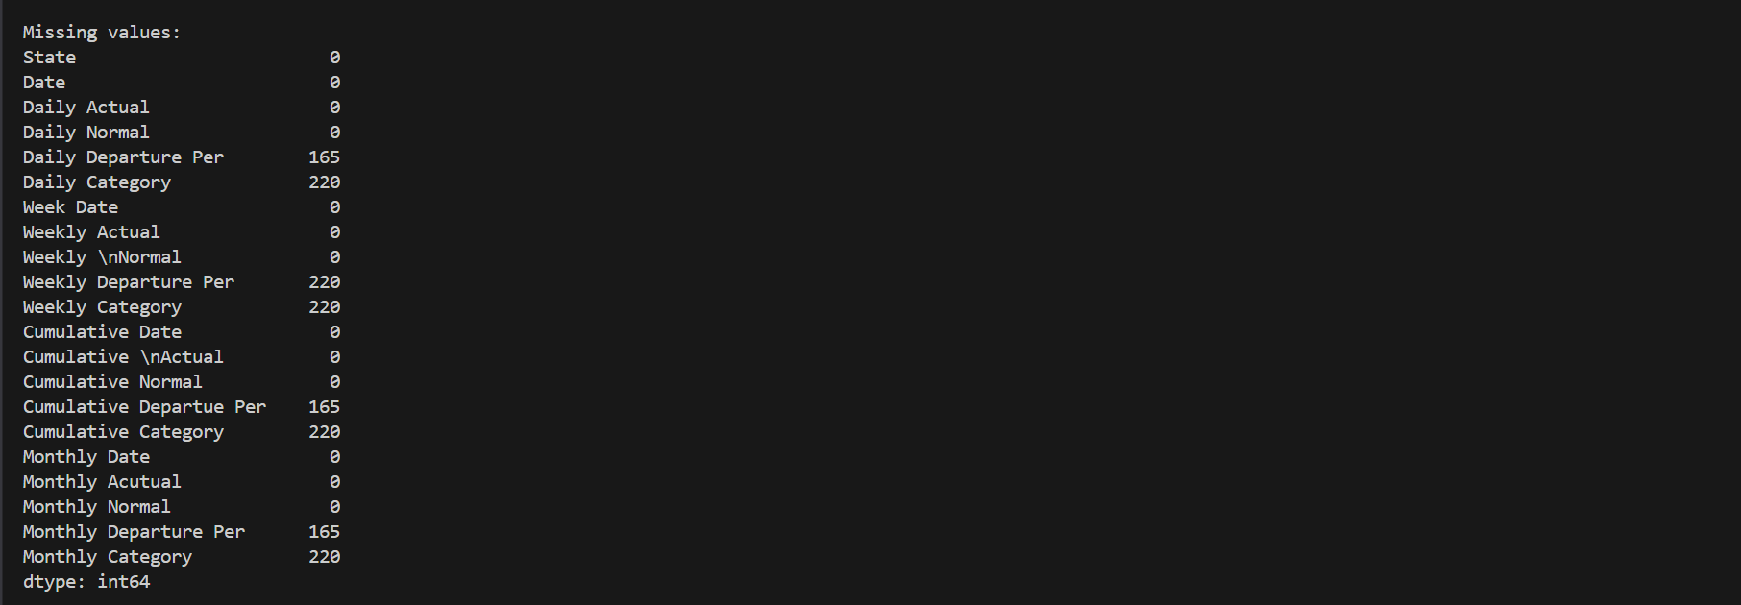

1. Dataset Inspection — Rows with Missing Daily Category
Shows the first 10 rows where Daily Category is missing; the national summary rows are visible in this output.
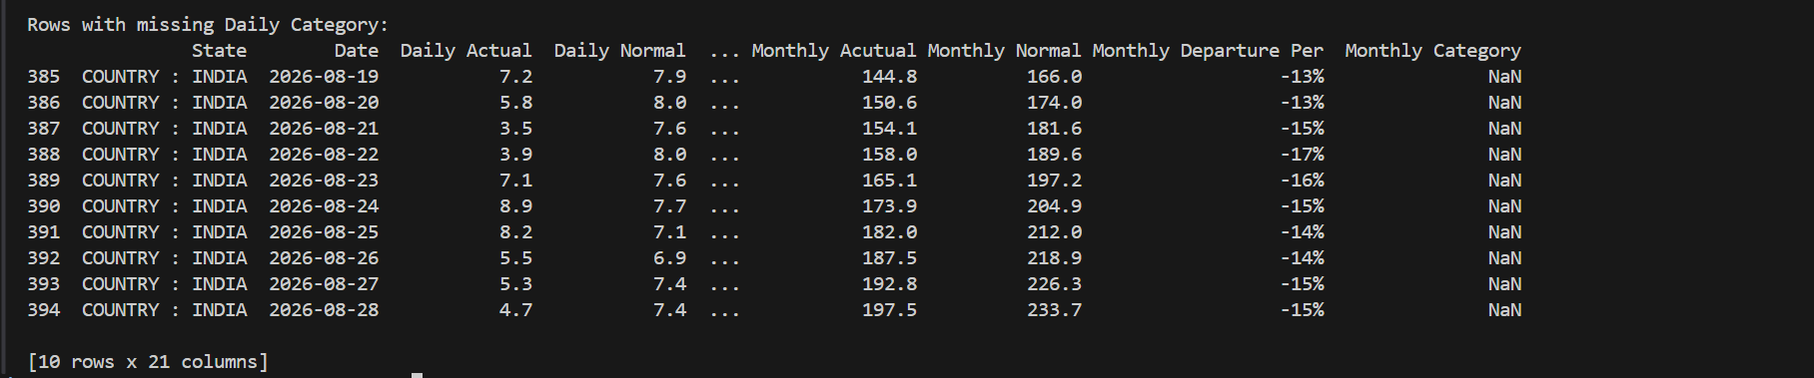

2. Dataset Cleaning
Cleaning output confirms zero duplicate rows, retains the 2,201 × 21 shape, reports remaining missing values, and saves data/rainfall_cleaned.csv.
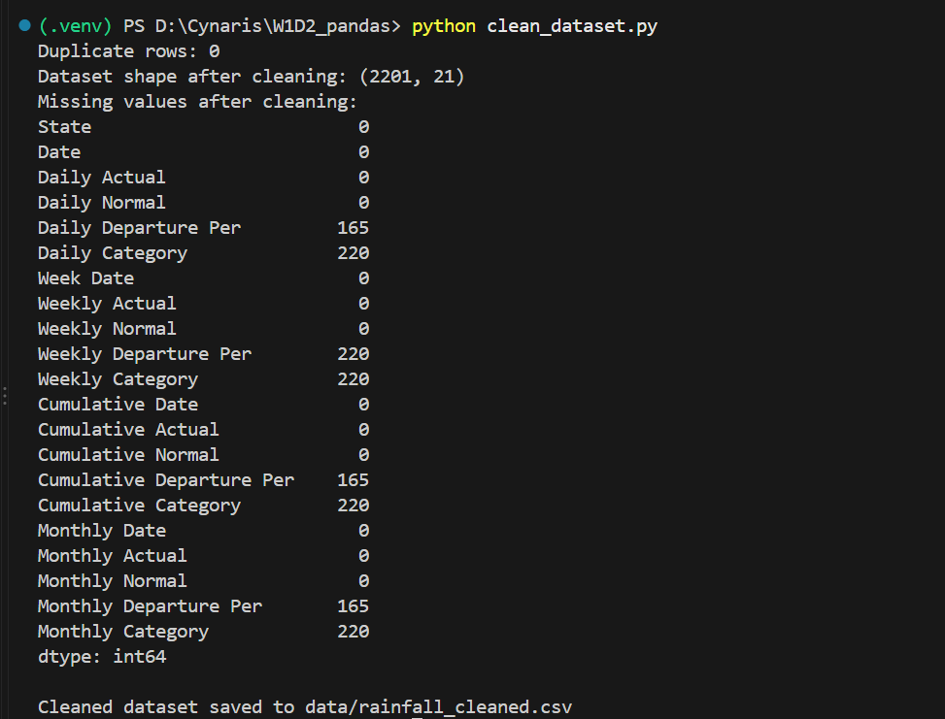

3. Pandas Operations — Filter and GroupBy
Filtering returns 111 rows where Daily Actual > 20. The output also shows average Daily Actual rainfall by state.
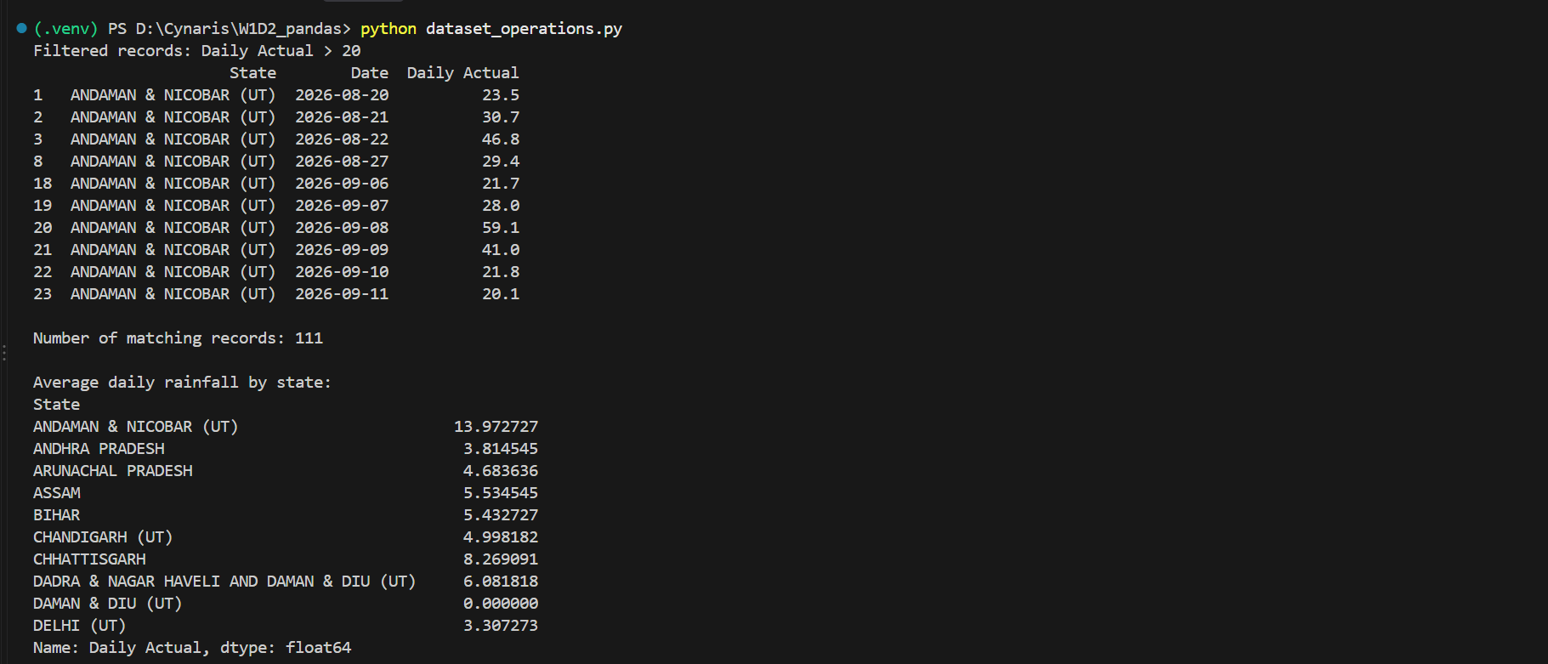

3. Pandas Operations — Merge and Month Extraction
The merge output includes the Region column. The date conversion and Month extraction are also shown.
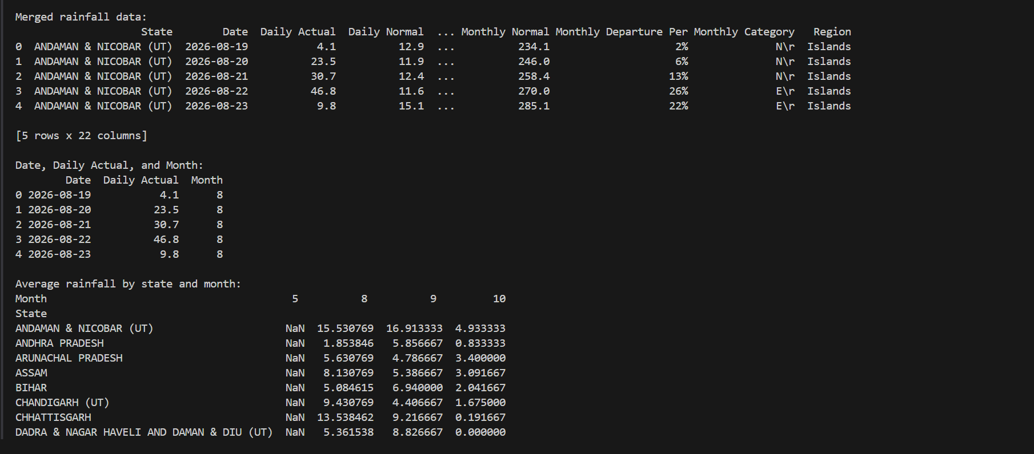

3. Pandas Operations — Pivot Table
Continuation of the pivot-table output. The table summarizes average Daily Actual rainfall by state and month; repeated rows from the prior screenshot were cropped.
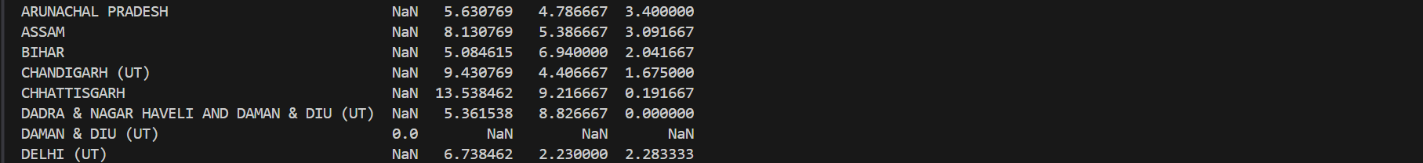

4. CSV and Parquet Export — File Size Comparison
Both exports succeed. CSV: 387,854 bytes. Parquet: 75,164 bytes. Parquet is smaller in this run.
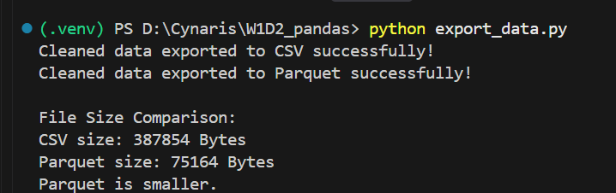

Evidence Summary
- Dataset inspection: shape, column names, first 10 rows, data types and missing-value counts.
- Cleaning: duplicate check and cleaned CSV export.
- Filtering: Daily Actual > 20; 111 matching rows reported.
- GroupBy: average Daily Actual rainfall by state.
- Merge: region lookup merged with rainfall records.
- Pivot table: average rainfall by state and month.
- Export: cleaned data saved as CSV and Parquet; file sizes compared.
Note: This evidence document is based on terminal output screenshots. Confirm the final source files are saved, reviewed, and committed to the correct Day 2 feature branch before opening/updating the pull request.

