W1D4 — Exploratory Data Analysis (EDA)
Cynaris Solutions | AI/ML Internship

1. Objective
Explore the rainfall dataset using Pandas, summarize its structure and data quality, visualize numerical distributions and correlations, and document findings for further analysis.

2. Dataset Overview
- Dataset: rainfall_statewise_daily_imd.csv
- Shape: 2,201 rows × 21 columns
- Data types: 8 numerical columns and 13 string columns
- Exact duplicate rows detected: 0

3. Five EDA Observations
- Dataset structure: The dataset contains 2,201 rows and 21 columns: 8 numerical columns and 13 string columns.
- Missing values: Missing values occur in departure-percentage and category fields. Daily Category, Weekly Category, Cumulative Category, and Monthly Category each contain 220 missing values; Daily Departure Per, Cumulative Departue Per, and Monthly Departure Per each contain 165.
- Daily rainfall distribution: Daily Actual has a mean of approximately 4.81 and a maximum of 99.2. Its distribution is right-skewed, suggesting a few observations are much higher than most values; these should be checked rather than automatically removed.
- Correlations: The heatmap shows strong positive correlations between Cumulative Actual and Cumulative Normal (0.89), Daily Normal and Weekly Normal (0.88), and Monthly Acutual and Monthly Normal (0.82). Correlation does not establish causation.
- Data quality: Some column names contain spelling errors or embedded newline characters, and category values visibly contain carriage-return characters such as N\r and E\r. These should be cleaned. The duplicate check found 0 exact duplicate rows.

4. EDA Narrative (Approximately 200 Words)
The rainfall dataset contains 2,201 rows and 21 columns, with information about daily, weekly, cumulative, and monthly rainfall across states and union territories in India. It includes eight numerical columns and thirteen string columns. The descriptive statistics show that the mean daily actual rainfall is approximately 4.81, while the maximum is 99.2. This difference, along with the distribution plot, suggests that daily rainfall is right-skewed, with some observations considerably higher than most others.
The correlation heatmap reveals strong positive relationships between cumulative actual and cumulative normal rainfall (0.89), daily normal and weekly normal rainfall (0.88), and monthly actual and monthly normal rainfall (0.82). These relationships indicate that several rainfall measurements vary together.
The main data-quality concerns are missing values in departure-percentage and category columns. For example, Daily Category has 220 missing values, while Daily Departure Per has 165. The dataset contains no exact duplicate rows. Some column names contain spelling mistakes, such as “Monthly Acutual” and “Cumulative Departue Per,” and others contain embedded newline characters. Category values also appear to contain unwanted carriage-return characters.
Before further analysis, column names and category text should be cleaned, date columns should be converted to appropriate date types, and missing values should be investigated. Unusually high rainfall observations should also be checked before deciding whether they are genuine extreme events or data errors.

5. Visualizations
Figure 1. Distribution of numerical columns
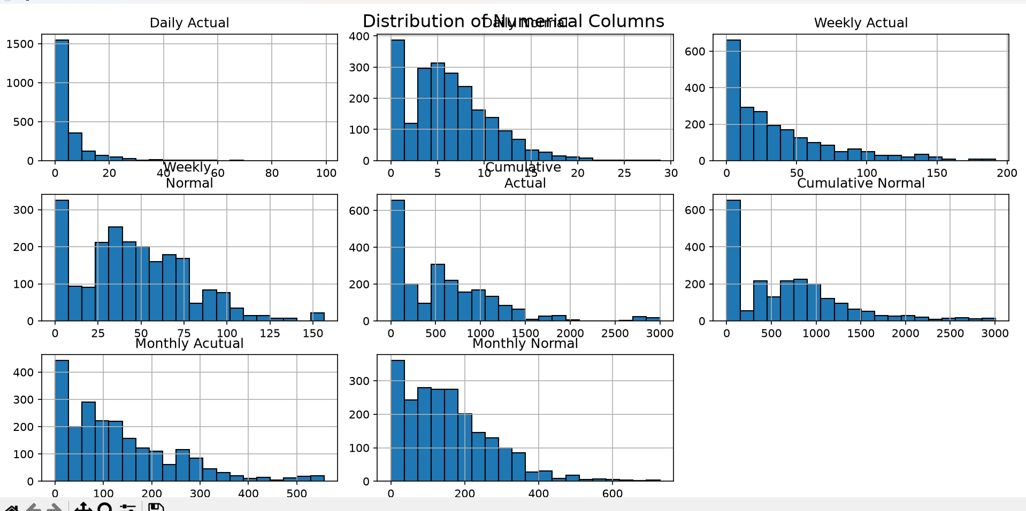
Figure 2. Correlation heatmap of rainfall variables
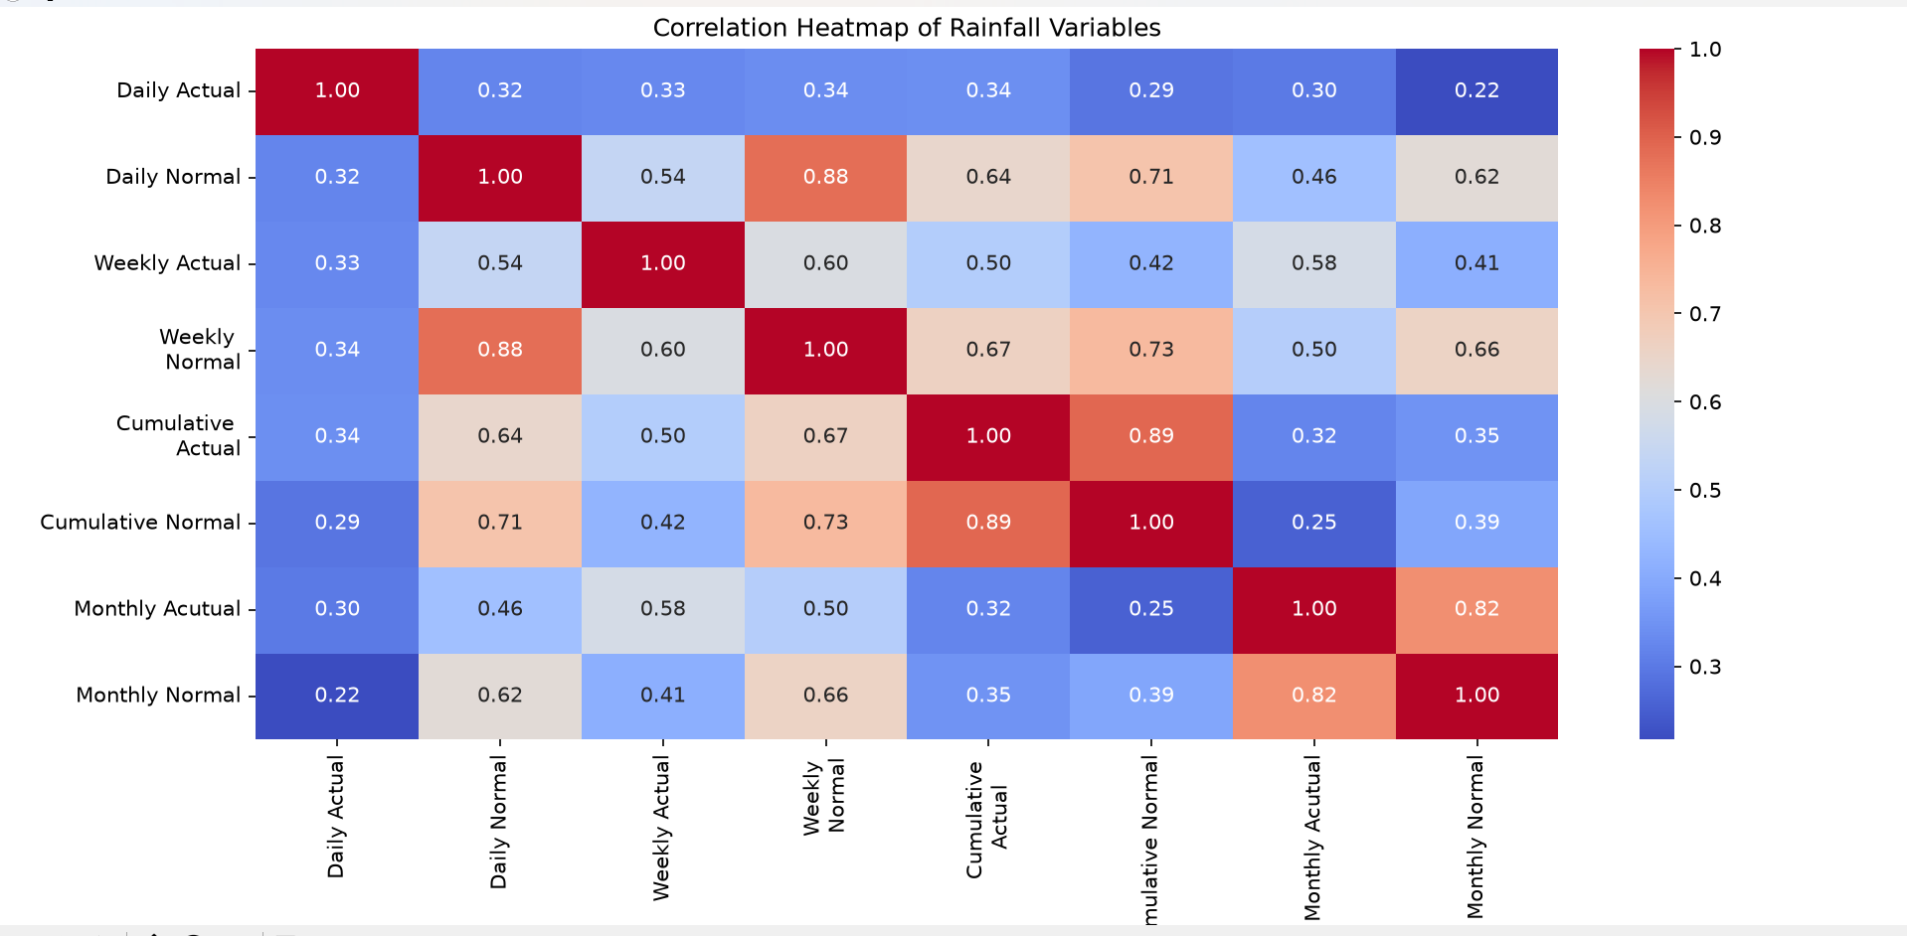
Figure 3. Top 10 states by number of records
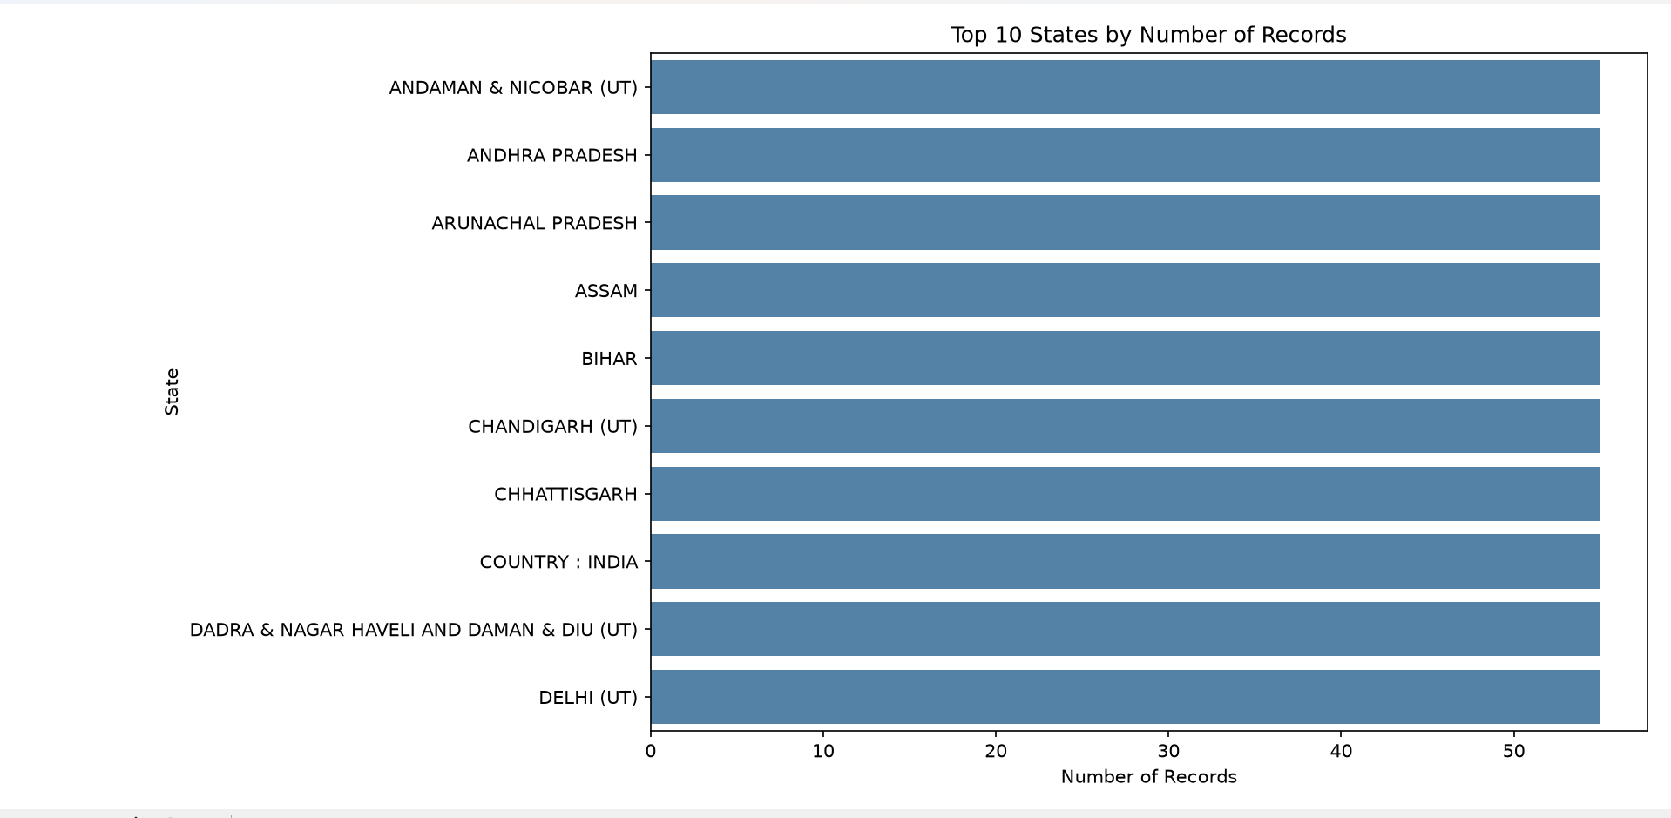

6. Terminal Output Evidence
Evidence A. Dataset preview and descriptive statistics
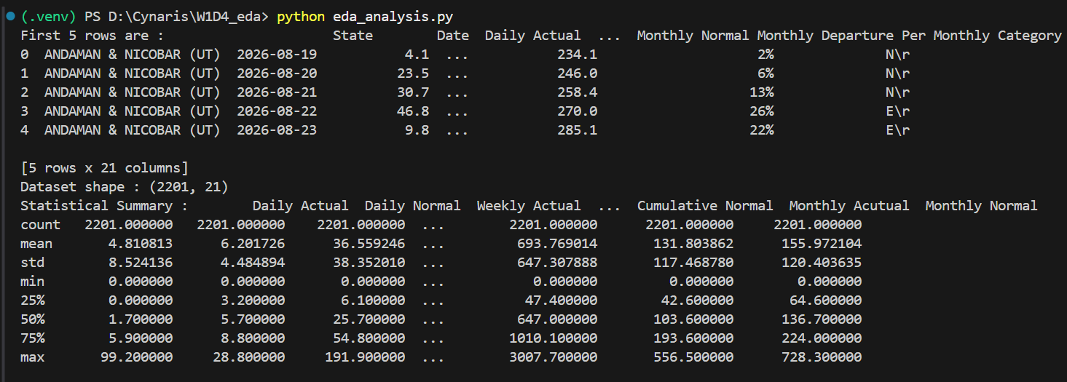
Evidence B. Dataset information and non-null counts
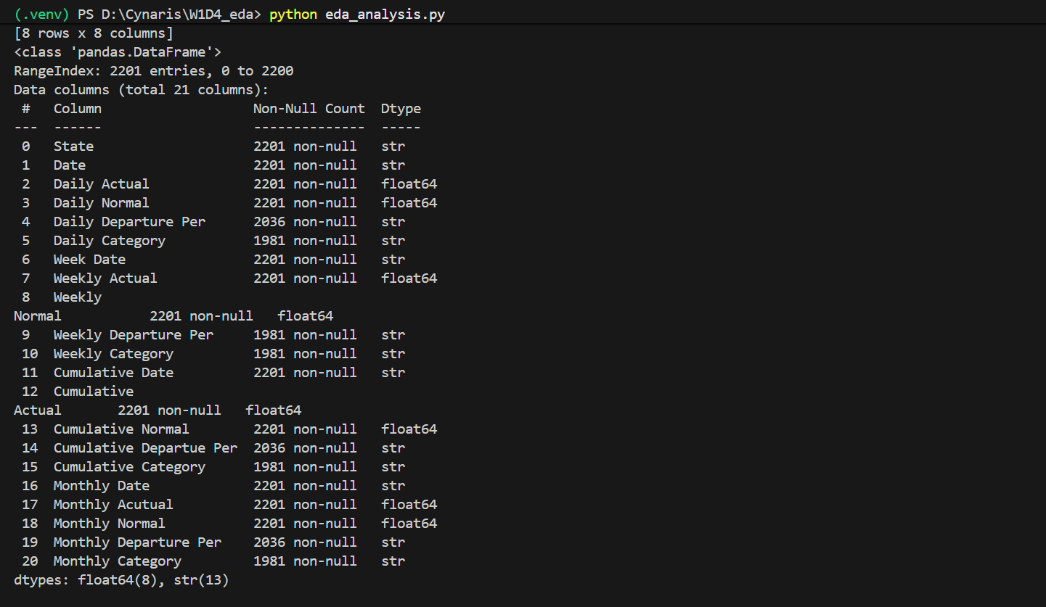
Evidence C. Missing-value counts and duplicate-row result
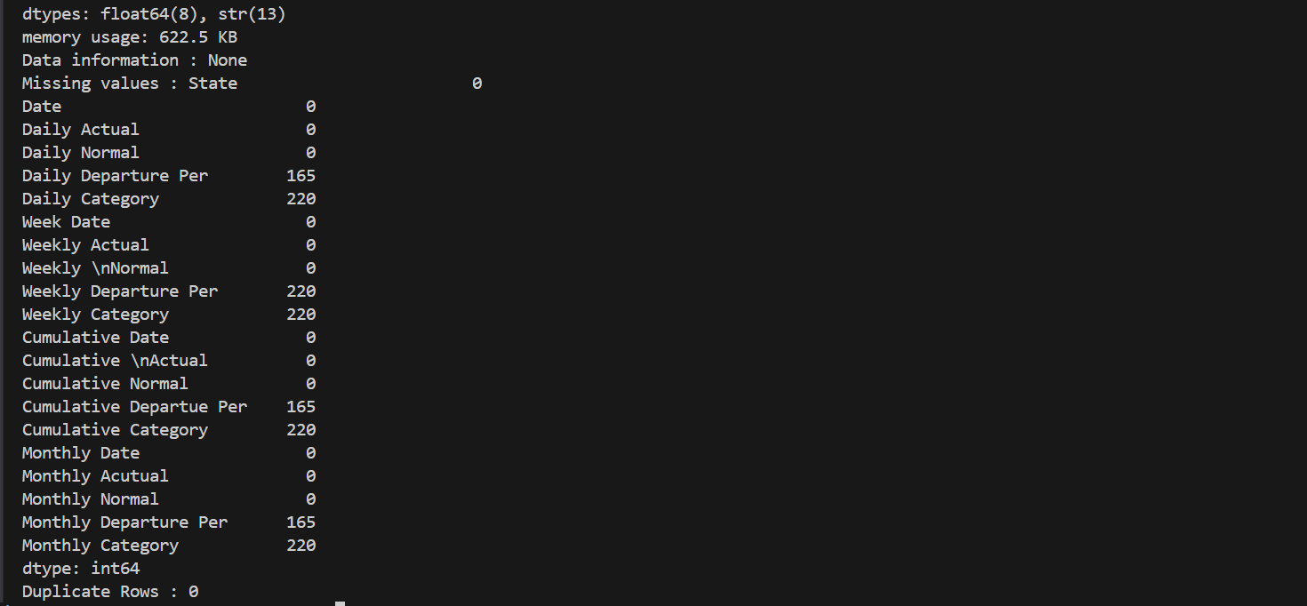

7. Self-Review Checklist
☐ Loaded the rainfall dataset and inspected the first five rows.
☐ Reviewed dataset shape, descriptive statistics, data types, and missing-value counts.
☐ Checked for exact duplicate rows (result: 0).
☐ Created numerical distribution, correlation heatmap, and top-10 state-count visualizations.
☐ Documented five observations and an EDA narrative.
☐ Identified data-cleaning tasks; this report does not modify the source dataset.

