W4D1 PRACTICAL REPORT
Model Evaluation Metrics — Precision, Recall and AUC
Cynaris Solutions Private Limited | AI/ML Intern | Week 4, Day 1

1. Objective
To implement classification model evaluation using Stratified 5-Fold Cross-Validation, Accuracy, Precision, Recall, F1-score and ROC-AUC; compare model configurations; and inspect possible overfitting or underfitting using a learning curve.

2. Tools and Technologies
- Python 3.14.3
- NumPy
- Scikit-learn
- Pytest
- Visual Studio Code
- PowerShell

3. Dataset Description
The Breast Cancer Wisconsin (Diagnostic) dataset from Scikit-learn was used.
Dataset information | Value
Total samples | 569
Features | 30
Malignant cases | 212
Benign cases | 357
Classes | 2

3.1 Target Label Preparation
The original dataset labels malignant cases as 0 and benign cases as 1. For this practical, the target was transformed so Malignant = 1 (positive class) and Benign = 0 (negative class).

4. Implementation Methodology

4.1 Stratified 5-Fold Cross-Validation
StratifiedKFold was configured with n_splits=5, shuffle=True and random_state=42. It preserves approximately the same class proportions across validation folds.
Fold | Malignant | Benign | Total
Fold 1 | 43 | 71 | 114
Fold 2 | 43 | 71 | 114
Fold 3 | 42 | 72 | 114
Fold 4 | 42 | 72 | 114
Fold 5 | 42 | 71 | 113
Total | 212 | 357 | 569

4.2 Models Evaluated
- Logistic Regression (C=0.01)
- Logistic Regression (C=1)
- Logistic Regression (C=100)
- Decision Tree (maximum depth=2)
- Decision Tree (unlimited depth)
- Random Forest (100 trees)

4.3 Evaluation Metrics
- Accuracy: Proportion of correctly classified samples.
- Precision: Proportion of predicted positive cases that were actually positive.
- Recall: Proportion of actual positive cases correctly identified.
- F1-score: Harmonic mean of Precision and Recall.
- ROC-AUC: Ability to distinguish positive and negative classes across thresholds.

4.4 Data Leakage Prevention
StandardScaler was combined with Logistic Regression in a Scikit-learn Pipeline. This ensures the scaler is fitted within each training fold rather than on the complete dataset before cross-validation. Decision Tree and Random Forest models were evaluated without scaling.

5. Model Evaluation Results
The following mean scores and standard deviations are the actual values from the program output.
Model | Metric | Mean | Std
Logistic Regression (C=0.01) | Accuracy | 0.9490 | 0.0170
 | Precision | 0.9949 | 0.0103
 | Recall | 0.8679 | 0.0484
 | F1-score | 0.9262 | 0.0264
 | ROC-AUC | 0.9939 | 0.0049
Logistic Regression (C=1) | Accuracy | 0.9737 | 0.0166
 | Precision | 0.9863 | 0.0182
 | Recall | 0.9436 | 0.0525
 | F1-score | 0.9633 | 0.0240
 | ROC-AUC | 0.9953 | 0.0053
Logistic Regression (C=100) | Accuracy | 0.9631 | 0.0170
 | Precision | 0.9570 | 0.0175
 | Recall | 0.9435 | 0.0320
 | F1-score | 0.9501 | 0.0231
 | ROC-AUC | 0.9876 | 0.0125
Decision Tree (depth=2) | Accuracy | 0.9052 | 0.0320
 | Precision | 0.8907 | 0.0665
 | Recall | 0.8592 | 0.0773
 | F1-score | 0.8709 | 0.0444
 | ROC-AUC | 0.9193 | 0.0326
Decision Tree (unlimited) | Accuracy | 0.9104 | 0.0279
 | Precision | 0.8963 | 0.0182
 | Recall | 0.8588 | 0.0737
 | F1-score | 0.8757 | 0.0430
 | ROC-AUC | 0.9000 | 0.0368
Random Forest (100 trees) | Accuracy | 0.9543 | 0.0128
 | Precision | 0.9463 | 0.0390
 | Recall | 0.9341 | 0.0543
 | F1-score | 0.9381 | 0.0186
 | ROC-AUC | 0.9885 | 0.0083

5.1 Result Analysis
Logistic Regression with C=1 achieved the strongest overall results among the six configurations: Accuracy 0.9737, Precision 0.9863, Recall 0.9436, F1-score 0.9633 and ROC-AUC 0.9953. Since malignant cases are the positive class, Recall indicates the proportion of actual malignant cases identified by the model.

6. Learning Curve Analysis
A learning curve was generated for a Random Forest classifier with 50 trees. Training accuracy and cross-validation accuracy were compared across eight training sizes.
Train size | Train accuracy | CV accuracy | Gap
45 | 1.0000 | 0.8507 | 0.1493
104 | 1.0000 | 0.9333 | 0.0667
162 | 0.9988 | 0.9385 | 0.0602
221 | 0.9991 | 0.9438 | 0.0553
279 | 1.0000 | 0.9543 | 0.0457
338 | 1.0000 | 0.9526 | 0.0474
396 | 1.0000 | 0.9578 | 0.0422
455 | 1.0000 | 0.9526 | 0.0474

Training accuracy remained close to 1.0, while validation accuracy improved as the training size increased. The gap decreased from 0.1493 to 0.0474, indicating improved generalisation with more training data, although the remaining gap suggests some overfitting. The learning-curve model uses 50 trees; the model-comparison Random Forest uses 100 trees.

7. Testing and Validation
Automated test | Result
Dataset shape and target labels | PASSED
Malignant is positive class | PASSED
Stratified five-fold configuration | PASSED
All samples used in validation folds | PASSED
Logistic Regression uses Pipeline | PASSED
Tree models do not use scaling Pipeline | PASSED

Pytest summary | Value
Total tests | 6
Passed | 6
Failed | 0
Execution time | 1.76 seconds

8. Key Technical Decisions and Learnings
- Mapped malignant cases to the positive class so the positive-class metrics focus on malignant-case detection.
- Used StratifiedKFold to preserve class proportions across folds.
- Used a Pipeline to prevent data leakage during Logistic Regression scaling.
- Did not scale tree-based models because scaling is not required for these algorithms.
- Used multiple metrics instead of relying only on Accuracy.
- Used a learning curve to examine training-validation behaviour and possible overfitting.

9. Conclusion
The practical successfully implemented model evaluation using Stratified 5-Fold Cross-Validation and five classification metrics. Six model configurations were compared, with Logistic Regression (C=1) achieving the strongest overall results. The Random Forest learning curve showed improving validation performance as training size increased, while also indicating some remaining overfitting. All six automated tests passed.

10. Evidence Screenshots
The following screenshots are captured from the actual PowerShell execution and Pytest run for W4D1. They provide evidence of dataset preparation, fold distribution, model evaluation, learning-curve output and successful automated tests.
Evidence 1. Dataset information, class distribution, stratified fold distribution and Logistic Regression (C=0.01) results.
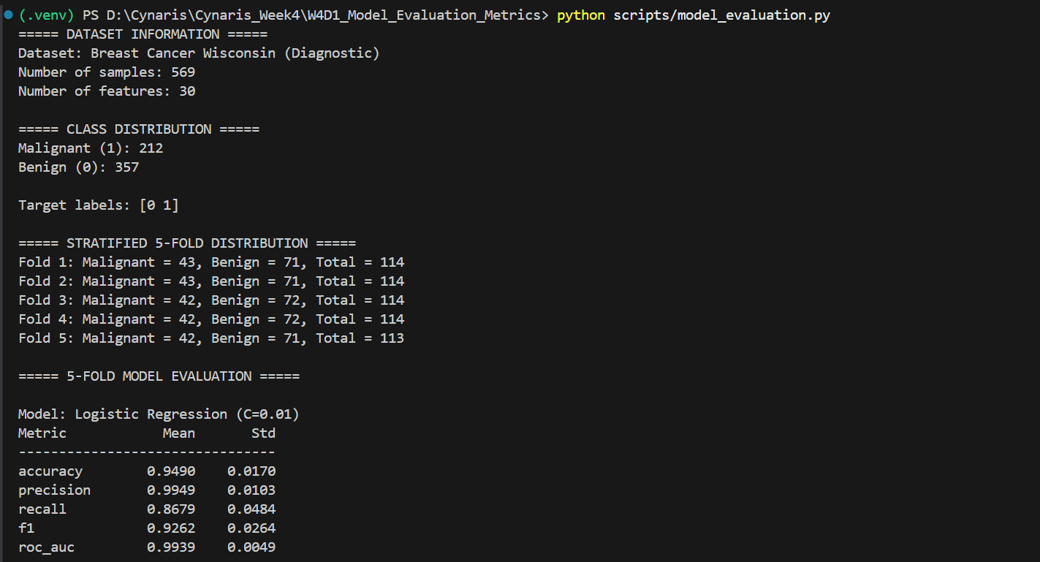

Evidence 2. Logistic Regression (C=1 and C=100) and Decision Tree (depth=2) evaluation results.
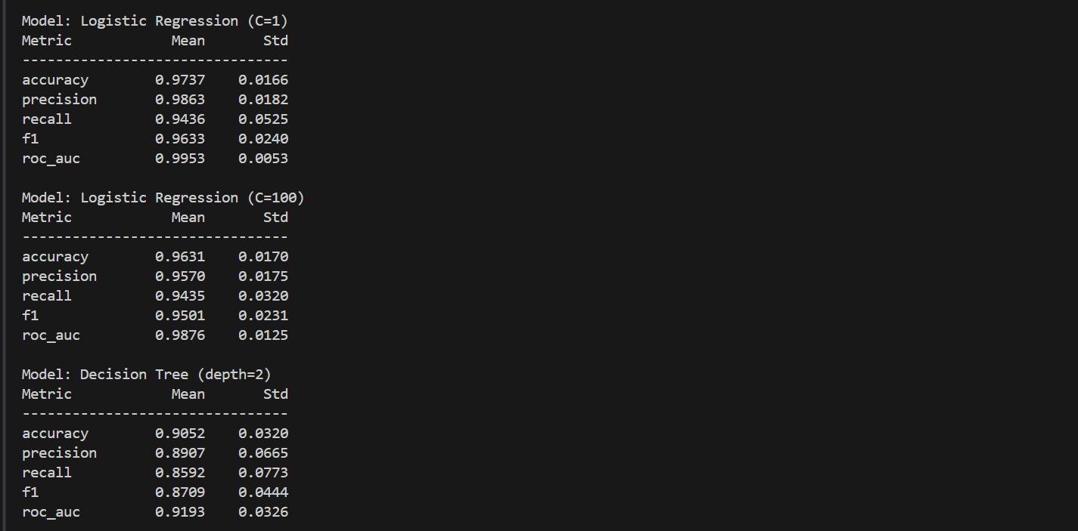

Evidence 3. Decision Tree (unlimited), Random Forest (100 trees) results and learning-curve values.
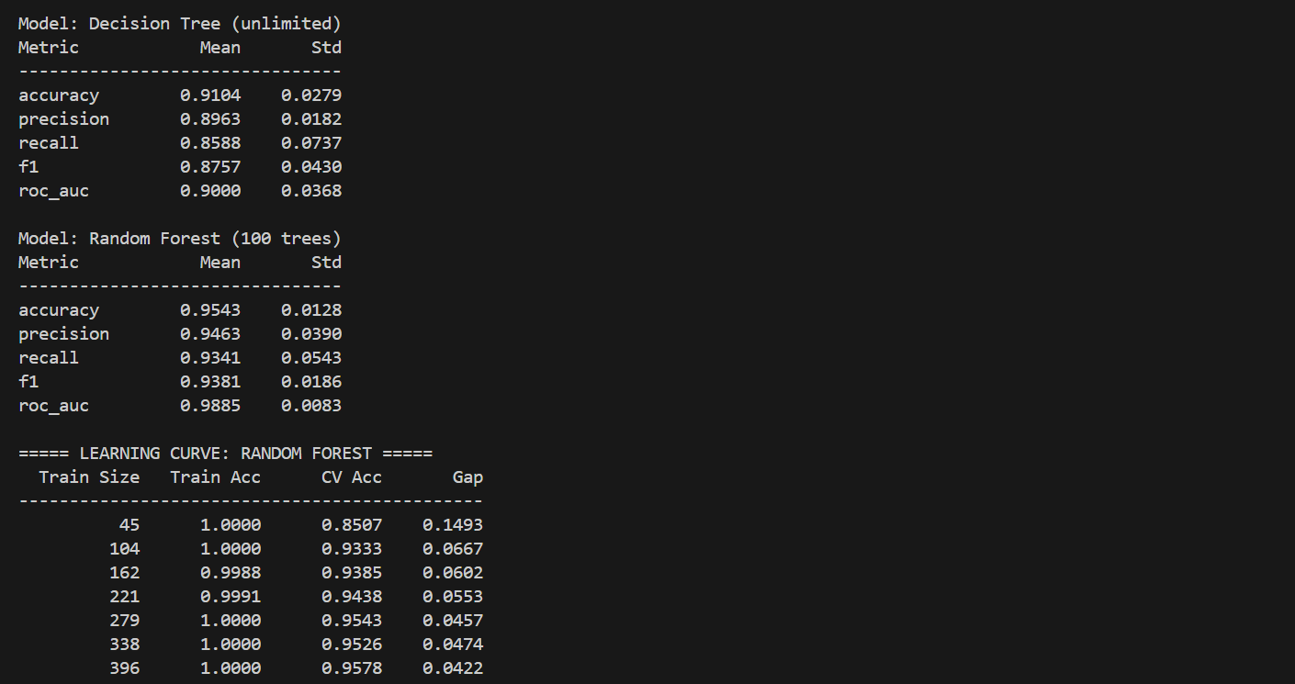

Evidence 4. Learning-curve interpretation and successful W4D1 execution completion.
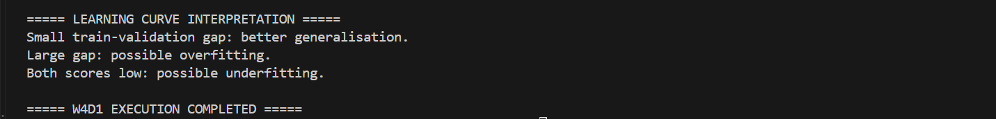

Evidence 5. Pytest output confirming that all six automated tests passed.


