CYNARIS SOLUTIONS — INTERNSHIP EVIDENCE

Week 1 — Day 3
NumPy Exercises & LangGraph Pipeline
Output Evidence Report

1. Work Summary
- NumPy array statistics: shape, mean, standard deviation, minimum, and maximum.
- Boolean masking to select values above the average.
- Matrix addition, matrix multiplication, and transpose.
- Column-wise z-score normalisation using broadcasting.
- LangGraph workflow: Load → Inspect → Clean → Log.
- Rainfall dataset loaded with 2,201 rows and 21 columns.
- Pipeline generated raw and cleaned CSV artifacts.

2. NumPy Exercises

Exercise 1: Array Statistics
Calculated the array shape, mean, standard deviation, minimum, and maximum.
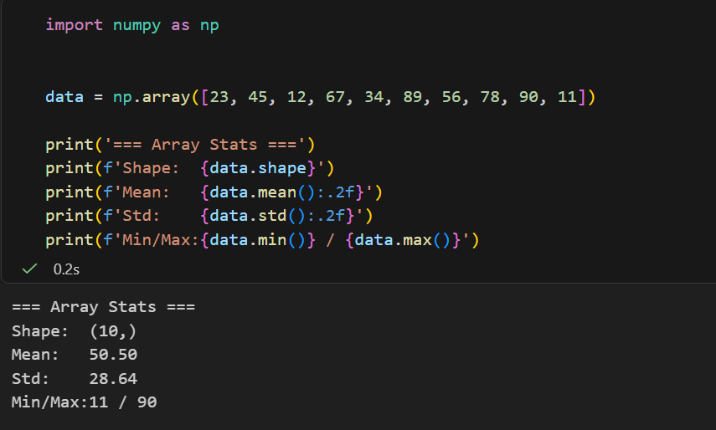

Exercise 2: Boolean Masking
Selected values greater than the array mean using Boolean masking.
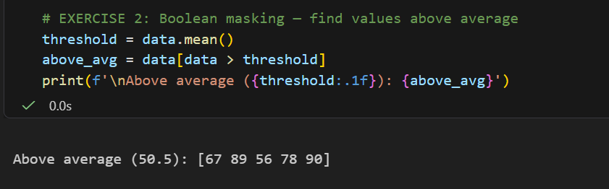

Exercise 3: Matrix Operations
Demonstrated matrix addition, matrix multiplication, and transpose.
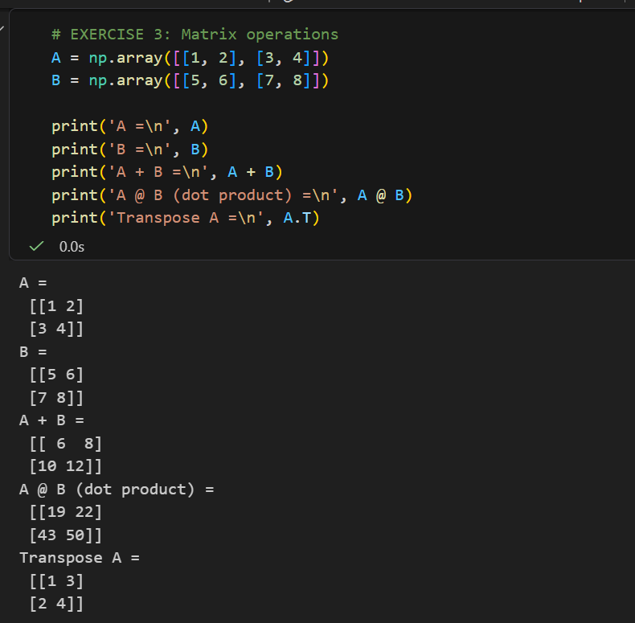

Exercise 4: Broadcasting and Z-score Normalisation
Normalised each column of a 5 × 3 array using its mean and standard deviation.
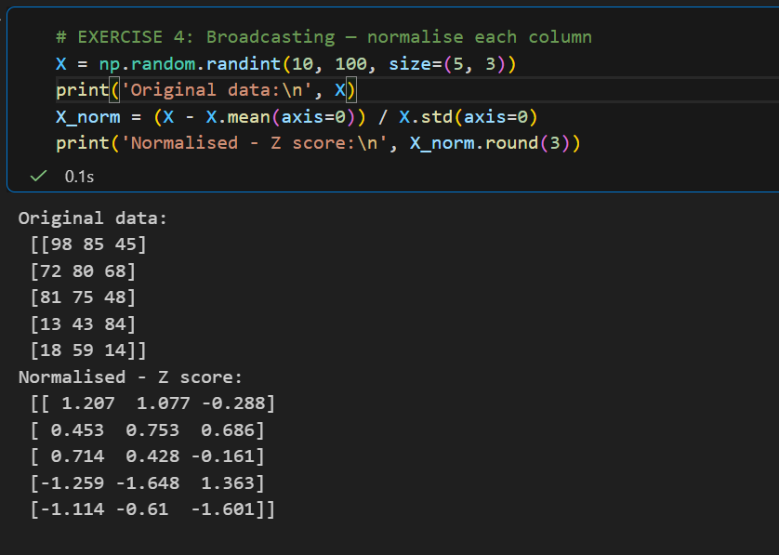

3. LangGraph Data Pipeline
The pipeline uses Pandas to load the rainfall CSV, inspect column types and missing values, remove rows with missing dates, convert the Date column to datetime, and save raw and cleaned outputs.

Pipeline Output: Loading and Inspection
Loaded the rainfall dataset and displayed its shape and data types.
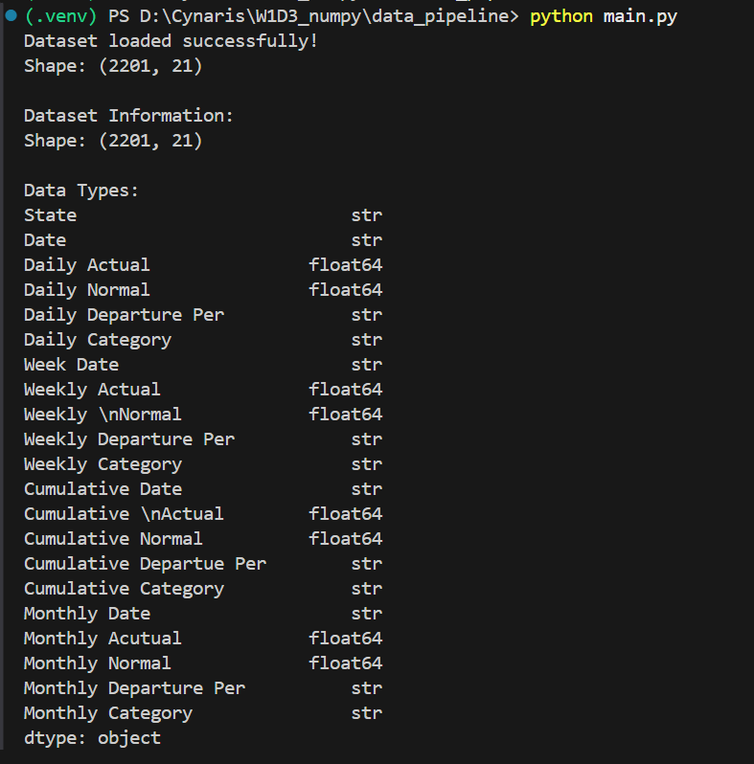

Pipeline Output: Missing-value Inspection
Displayed missing-value counts for the dataset columns.
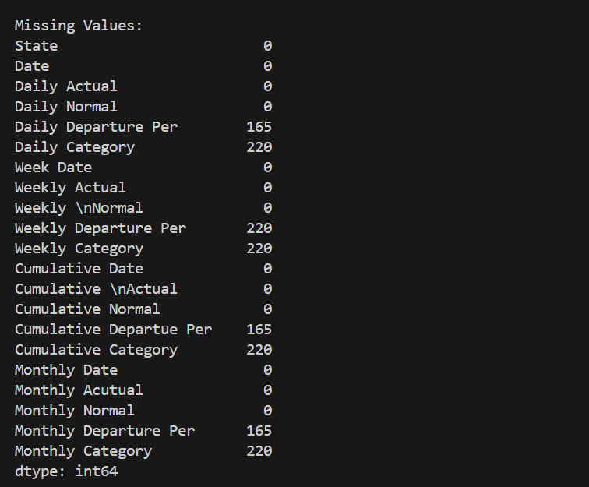

Pipeline Output: Cleaning and Artifact Logging
Completed the pipeline and reported raw and cleaned CSV artifact filenames.
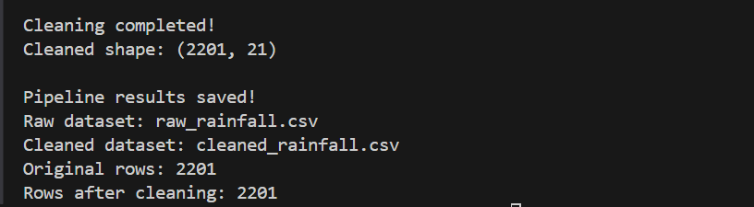

4. Observations
Dataset shape reported by the pipeline: 2,201 rows × 21 columns.
The Date column had zero missing values, so the current cleaning rule did not remove any rows. Other missing values were reported during inspection but were not removed or imputed by the current code.
The terminal output confirmed that the pipeline saved raw_rainfall.csv and cleaned_rainfall.csv. The screenshots document the successful execution shown during the run.

