CYNARIS SOLUTIONS PRIVATE LIMITED

Week 2 – Day 4 Report
Train/Test Split, Feature Scaling and Cross-Validation
AI/ML Internship | Execution Report with Terminal Evidence

1. Objective
The objective of W2D4 was to create a reproducible synthetic regression dataset, split it into training and testing subsets, compare StandardScaler, MinMaxScaler, and RobustScaler, and evaluate a regression pipeline using five-fold cross-validation.

2. Dataset Generation
The dataset-generation script created 100 records with four columns: age, income, score, and target. The income feature includes three deliberately extreme values: 500,000; 750,000; and 1,200,000. The target was synthetically generated from the input features with added random noise. The dataset was saved successfully as `W2D4_trainTestCV/data/synthetic_data.csv`.

3. Train/Test Split and Feature Scaling
The data was divided into 80 training rows and 20 testing rows. The script compared three scaling methods:
- StandardScaler: centres features around zero and scales them using their standard deviation.
- MinMaxScaler: scales training feature values to the 0–1 range.
- RobustScaler: uses the median and interquartile range and is less sensitive to extreme values.
Each scaler was fitted on the training data and then used to transform both the training and test data. This helps prevent data leakage from the test set into the scaling parameters. The displayed RobustScaler test output included an income value of 6.05, illustrating that transformed test values can lie outside a limited range when the test observation is far from the training distribution. MinMaxScaler does not guarantee that test values remain between 0 and 1.

4. Cross-Validation
A Linear Regression model was evaluated with five-fold cross-validation on the training subset. The scaler and model were combined in a Scikit-learn Pipeline so that scaling is fitted separately within each cross-validation training fold.
All three scalers produced the same displayed cross-validation R² scores: 0.998, 0.999, 0.981, 0.985, and 0.985. The reported average R² score was 0.99 for each method. Similar scores are plausible here because the target was generated from a linear combination of the features and linear regression is generally insensitive to simple rescaling of input features. The high score reflects this synthetic dataset and should not be taken as evidence of equivalent performance on real-world data.

5. Automated Testing
The command `python -m pytest tests/test_scalers.py -v` collected and passed four tests: StandardScaler behaviour, MinMaxScaler bounds on the scaled training data, RobustScaler median behaviour, and cross-validation output validity.
Test result: 4 passed in 1.50 seconds.

6. Terminal Evidence

Figure 1. Dataset generation output: first five records, dataset dimensions, outlier income values, and save confirmation.
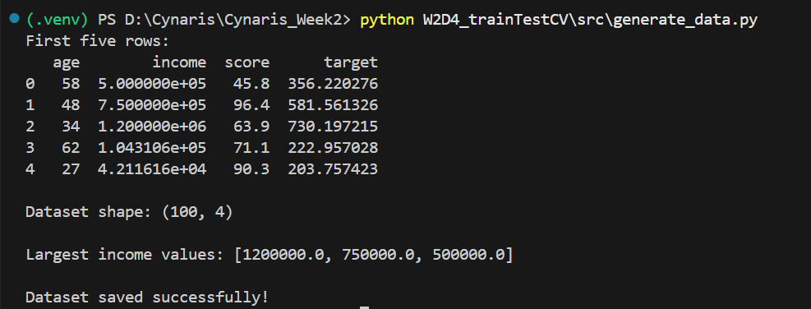

Figure 2. StandardScaler and MinMaxScaler results for training and testing samples.
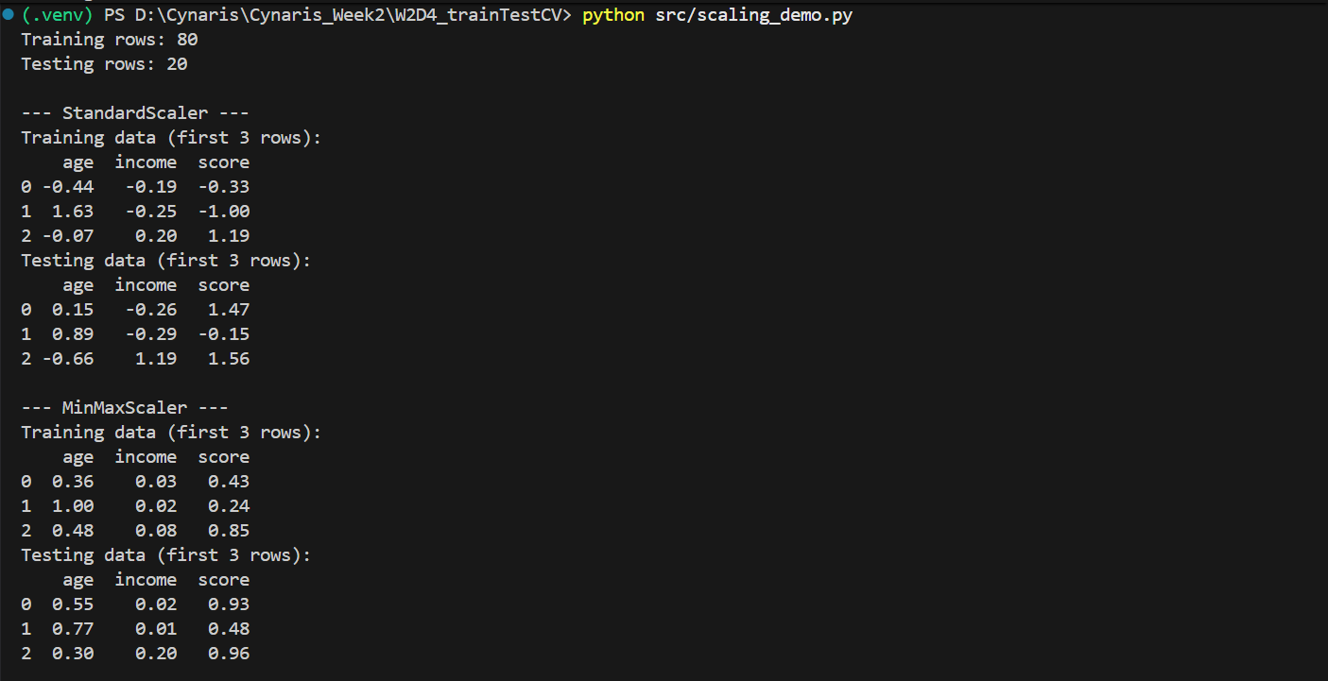

Figure 3. RobustScaler results, including the transformed test sample with a large income value.
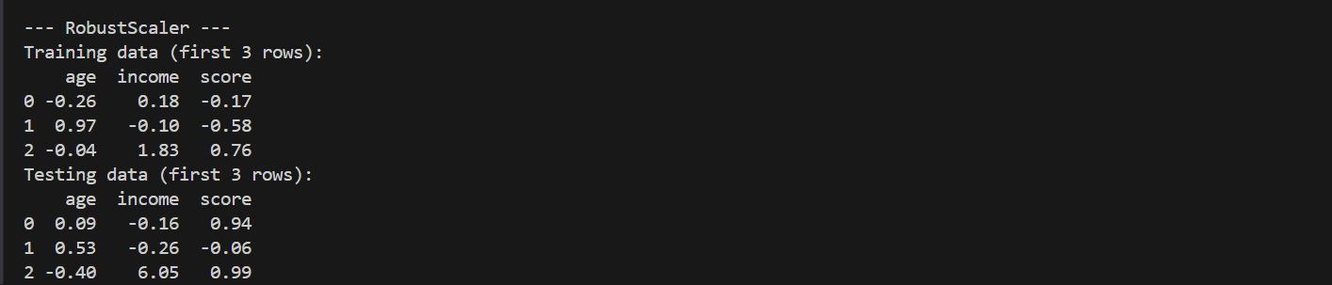

Figure 4. Five-fold cross-validation results for the three scaling methods.
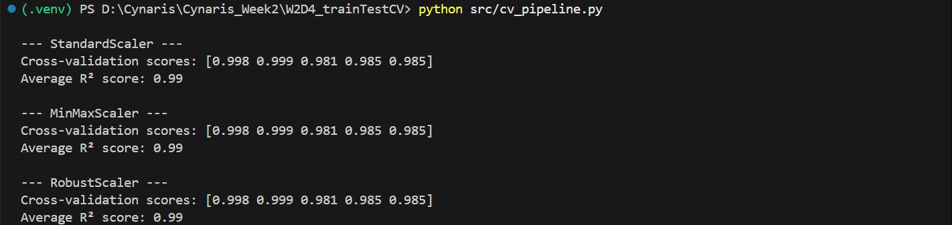

Figure 5. Pytest output showing that all four tests passed.
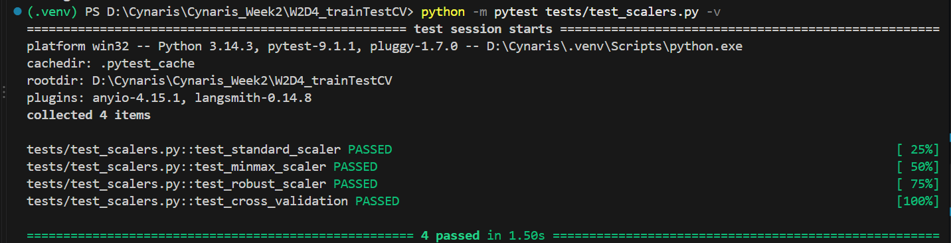

7. Conclusion
W2D4 successfully generated the dataset, split it into training and testing subsets, compared three scaling methods, evaluated a pipeline with five-fold cross-validation, and passed all four automated tests. The scripts fit scalers on training data rather than on the full dataset, and the cross-validation pipeline handles scaling separately within each fold.

8. Commands Executed
python W2D4_trainTestCV\src\generate_data.py
python src/scaling_demo.py
python src/cv_pipeline.py
python -m pytest tests/test_scalers.py -v

