CYNARIS SOLUTIONS
W2D5 – Titanic Preprocessing Pipeline
Implementation and Test Evidence

1. Objective
Build an end-to-end preprocessing pipeline using the Titanic dataset: inspect the data, handle missing values, encode categorical features, scale numerical features, split the data into training and testing sets, and export ML-ready CSV files.

2. Dataset Overview
The program loaded a dataset with 891 rows and 12 columns.
Original missing-value counts shown by the program:
Column | Missing values
Age | 177
Cabin | 687
Embarked | 2
Survival counts: 549 passengers labelled 0 (did not survive) and 342 labelled 1 (survived).

3. Preprocessing Results
Validation item | Observed result
Training feature rows | 712
Testing feature rows | 179
Processed feature columns | 12
Missing values in training features | 0
Missing values in testing features | 0
Exported files | X_train.csv, X_test.csv, y_train.csv, y_test.csv

4. Automated Test Results
The provided pytest terminal screenshot shows all four tests passing.
- test_all_output_files_exist — PASSED
- test_train_test_row_counts — PASSED
- test_processed_features_have_no_missing_values — PASSED
- test_train_and_test_have_same_features — PASSED

Screenshot 1: Automated tests
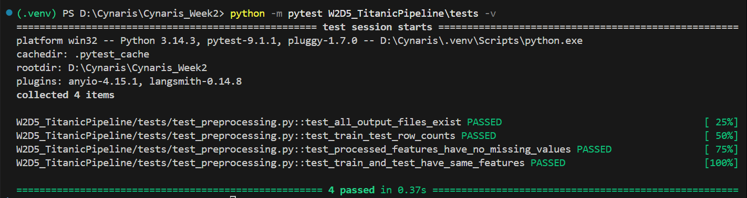

Screenshot 2: Dataset overview and original missing-value counts
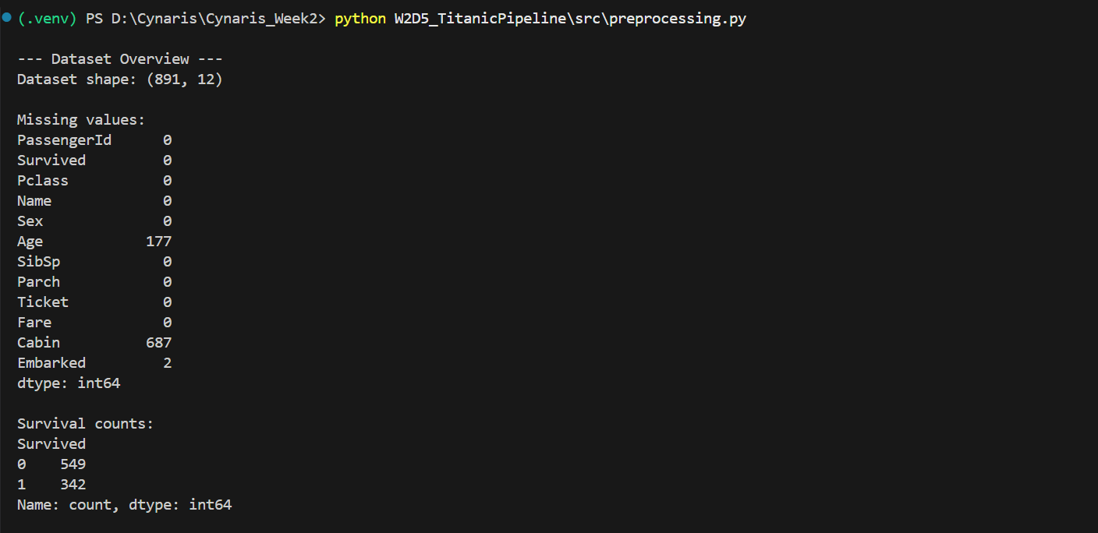

Screenshot 3: Final preprocessing summary and successful completion
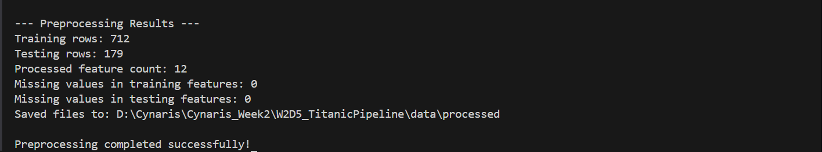

5. Scope
This deliverable covers data preprocessing and export only. It does not include training or evaluating a classification model. The evidence documents the execution and tests shown in the supplied terminal screenshots.

