CYNARIS SOLUTIONS PRIVATE LIMITED

W3D4 – Technical Work Report
Decision Tree and Random Forest Experiments | AI/ML Internship

1. Objective
The supplied W3D4 practical compares a single Decision Tree with a Random Forest, evaluates model performance, explores the number of trees and maximum depth, calculates the out-of-bag (OOB) score, and examines feature importance.

2. Lesson Scope Note
The lesson title is “SVM & KNN — When to Use What,” but the supplied playground code and resources focus on Decision Trees and Random Forests. This implementation follows the supplied practical material. SVM and KNN models were not implemented because the provided practical did not specify their implementation tasks.

3. Dataset and Setup
- Dataset: synthetic binary-classification data generated using scikit-learn make_classification.
- Samples: 1,000; features: 20; informative features: 10; redundant features: 5.
- Train/test split: 80% / 20%, random_state=42, with stratified sampling.
- Evaluation: training accuracy, test accuracy, and 5-fold cross-validation accuracy.
- Random Forest experiments use out-of-bag (OOB) scoring.

4. Implementation
- Decision Tree baseline: Trains a single DecisionTreeClassifier and records training, test, and cross-validation accuracy.
- Random Forest baseline: Trains a 100-estimator RandomForestClassifier and records accuracy and OOB score.
- 500-tree experiment: Trains a Random Forest with n_estimators=500.
- Depth-limited experiment: Trains a Random Forest with max_depth=5.
- Feature importance: Prints the top ten feature importances and saves a PNG chart.
- MLflow: Creates the Cynaris-W3D4-Tree-Ensemble experiment and logs parameters, metrics, and the feature-importance artifact.

5. Results
Experiment | Train accuracy | Test accuracy | 5-fold CV
Decision Tree baseline | 1.0000 (100%) | 0.8050 (80.5%) | 0.8260 (82.6%)
Random Forest baseline | 1.0000 (100%) | 0.9100 (91.0%) | 0.9330 (93.3%)
Random Forest — 500 trees | 1.0000 (100%) | 0.9050 (90.5%) | 0.9360 (93.6%)
Random Forest — max_depth=5 | 0.9575 (95.75%) | 0.8800 (88.0%) | 0.9120 (91.2%)

6. OOB Scores
Random Forest experiment | OOB score
Baseline (100 trees) | 0.9200 (92.00%)
500 trees | 0.9375 (93.75%)
max_depth=5 | 0.9087 (90.87%)

7. Feature Importance
The chart was saved at outputs/rf_feature_importance.png. Top features printed by the run:
- feature_14: 0.1313
- feature_11: 0.1139
- feature_17: 0.0906
- feature_15: 0.0778
- feature_7: 0.0646
- feature_2: 0.0572
- feature_16: 0.0531
- feature_18: 0.0530
- feature_3: 0.0450
- feature_1: 0.0446

8. Testing
The test file tests/test_w3d4.py was run using pytest. The captured terminal screenshot shows 1 test passed in 1.64 seconds. The test checks that Random Forest training succeeds, training/test accuracy values are between 0 and 1, and the OOB score is between 0 and 1.
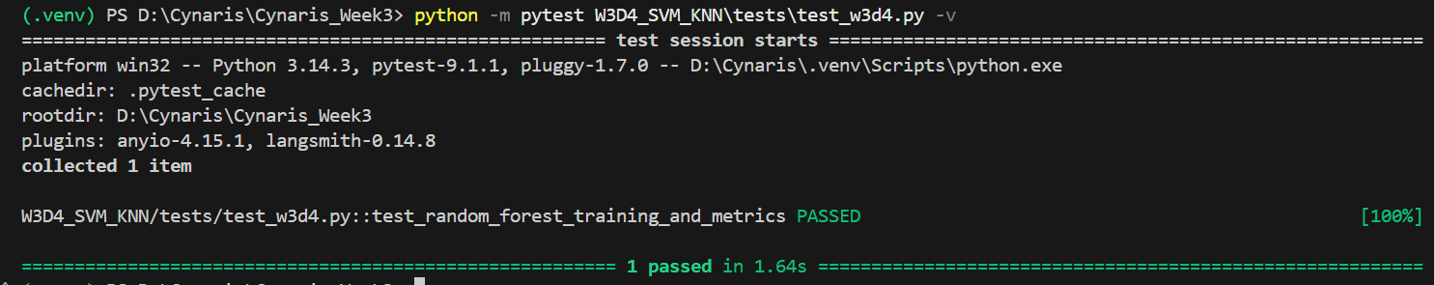
Figure 1. Pytest execution showing the automated test passed.

9. MLflow Tracking Evidence
The MLflow experiment is named Cynaris-W3D4-Tree-Ensemble. The captured baseline run shows a finished status and the following metrics: train_accuracy=1.0, test_accuracy=0.91, cv_accuracy=0.933, and oob_score=0.92.
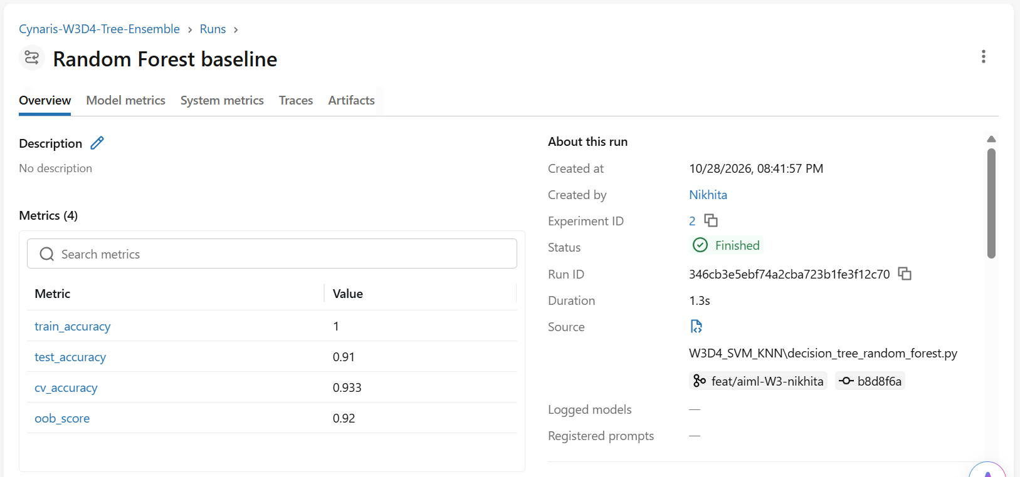
Figure 2. MLflow Random Forest baseline run with recorded metrics.

10. Project Files
- decision_tree_random_forest.py — training, experiments, evaluation, and MLflow tracking.
- tests/test_w3d4.py — automated Random Forest training and metric checks.
- outputs/rf_feature_importance.png — feature-importance visualization.
- README.md — experiment overview, results, and test instructions.

11. Git Workflow
Weekly branch: feat/aiml-W3-nikhita
Commit 1: feat(w3d4): implement tree ensemble experiments (e682838)
Commit 2: test(w3d4): add validation tests (7c3d128)
The two commits were created locally. The report does not mark the push or pull request as complete; confirm those actions after they succeed.

12. Conclusion
The baseline Random Forest outperformed the single Decision Tree on the test set (91.0% versus 80.5%). The 500-tree model achieved the highest 5-fold CV accuracy (93.6%) and OOB score (93.75%) among the evaluated Random Forest runs, although its test accuracy was slightly below the 100-tree baseline. Limiting depth to five reduced training accuracy and also reduced test and CV performance in this run. Results are specific to this generated dataset and split.

