W1D1 OUTPUT EVIDENCE
Python for ML — NumPy Fundamentals
Cynaris Solutions Internship
Evidence of successful execution for Tasks 1–6

Task 1 — 1D, 2D and 3D Arrays
Created one-dimensional, two-dimensional, and three-dimensional NumPy arrays and verified their shapes: (5,), (2, 3), and (2, 2, 2).
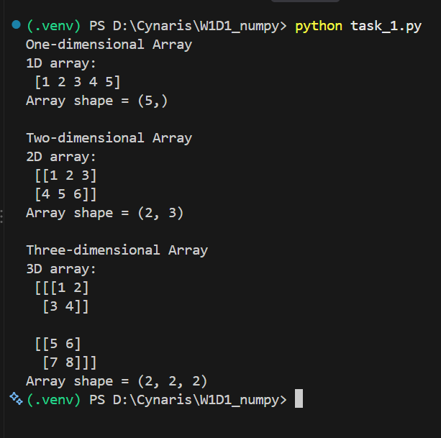

Task 2 — Broadcasting
Demonstrated scalar broadcasting and adding a one-dimensional array to each row of a two-dimensional matrix.
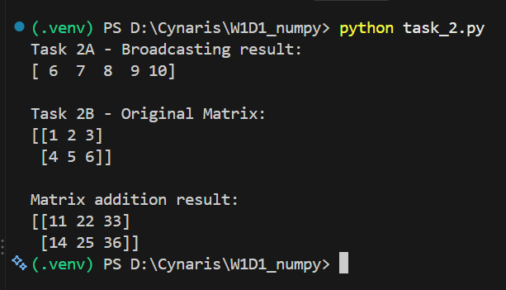

Task 3 — Vectorized Operations
Applied addition, multiplication, and squaring to an array without using Python loops.
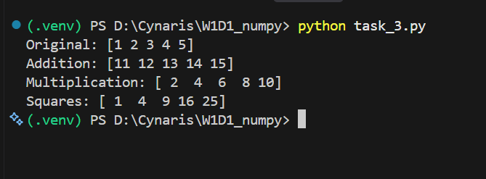

Task 4 — Matrix Multiplication
Multiplied two 2 × 2 matrices using NumPy; the displayed result is [[19, 22], [43, 50]].
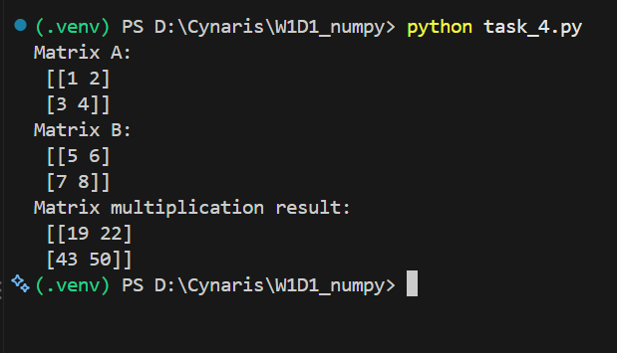

Task 5 — Student Scores Statistics
Loaded the student_scores.csv practice dataset and calculated the mean, sample standard deviation, and correlation matrix for study hours and exam scores.
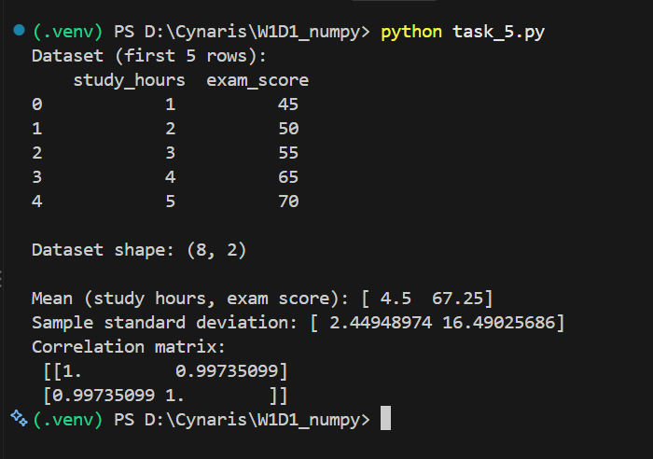

Task 6 — Iris Dataset Statistics
Loaded the Iris dataset (150 rows, 5 columns) and calculated mean, standard deviation, and the correlation matrix for its four numeric features.
