PRACTICAL REPORT

W4D3: Model Serialisation
Using Pickle and Joblib

Organisation | Cynaris Solutions Private Limited
Programme | AI/ML Internship
Week / Day | Week 4 – Day 3
Practical | Model Serialisation using Pickle and Joblib

Objective
Train a classification model, save the fitted model using Pickle and Joblib, reload both saved versions, and verify that their predictions match those of the original model.

1. Overview
Model serialisation is the process of converting a trained machine learning model into a representation that can be stored and later restored. It allows a model to be reused without training it from scratch every time.
In this practical, a Logistic Regression classifier was trained using the Breast Cancer Wisconsin dataset available in Scikit-learn. The same fitted model was saved in two formats—Pickle (.pkl) and Joblib (.joblib)—and both saved models were loaded back for prediction consistency verification.

2. Objectives
- Load and prepare a built-in Scikit-learn classification dataset.
- Split the data into training and testing sets.
- Train a Logistic Regression classification model.
- Save the fitted model using Pickle and Joblib.
- Load both serialized model files.
- Compare predictions from the original and reloaded models.
- Compare the generated model file sizes.
- Validate the implementation using automated Pytest tests.

3. Tools and Libraries Used
Tool / Library | Purpose
Python | Implementation language
Scikit-learn | Dataset loading, train-test split and Logistic Regression
Pickle | Serialising and deserialising the trained model
Joblib | Saving and loading the trained model
NumPy | Comparing prediction arrays
Pytest | Automated testing
pathlib | Constructing project-relative file paths

4. Project Structure
W4D3_Model_Serialisation/
├── scripts/
│ ├── __init__.py
│ └── model_serialisation.py
├── tests/
│ ├── __init__.py
│ └── test_model_serialisation.py
├── artifacts/
│ ├── model_pickle.pkl
│ └── model_joblib.joblib
└── README.md

5. Implementation and Methodology

5.1 Project paths
The pathlib.Path utility was used to derive the practical directory from the script location. The artifacts directory and the two model file paths were then defined relative to the project folder. This avoids relying on a hard-coded absolute computer path.

5.2 Dataset preparation
The load_breast_cancer() function from Scikit-learn was used to load the Breast Cancer Wisconsin dataset. The input measurements were assigned to X and the target labels to y. The train_test_split() function created training and testing subsets using test_size=0.2, random_state=42 and stratify=y.

5.3 Model training
A LogisticRegression classifier was created with max_iter=5000 and trained using model.fit(X_train, y_train). The fitted model was retained as the original model and used to generate baseline predictions on X_test.

5.4 Saving with Pickle and Joblib
The same fitted model was saved using pickle.dump() into model_pickle.pkl and joblib.dump() into model_joblib.joblib. Pickle used a file opened in binary write mode. Joblib accepted the target file path directly.

5.5 Loading the saved models
The Pickle model was restored using pickle.load() from a binary read-mode file. The Joblib model was restored using joblib.load(). The restored objects were then used to generate predictions on the same test data.

5.6 Prediction verification and file-size comparison
NumPy's array_equal() function compared the original predictions with the predictions from each restored model. The file sizes were read using Path.stat().st_size and displayed in bytes.

6. Execution Results
The implementation script executed successfully. The dataset split and prediction verification results are summarised below.
Execution detail | Observed result
Training samples | 455
Testing samples | 114
Original vs Pickle predictions | True
Original vs Joblib predictions | True
Pickle model file size | 907 bytes
Joblib model file size | 1,103 bytes
Execution status | Completed successfully
For this execution, the Pickle file was 907 bytes and the Joblib file was 1,103 bytes. These are measured results for this model and environment; they do not imply that either format is always smaller or faster.

7. Evidence 1 – Model Serialisation Execution
The following terminal evidence shows the dataset loading, model training, saving with both formats, successful loading, matching predictions, and measured file sizes.
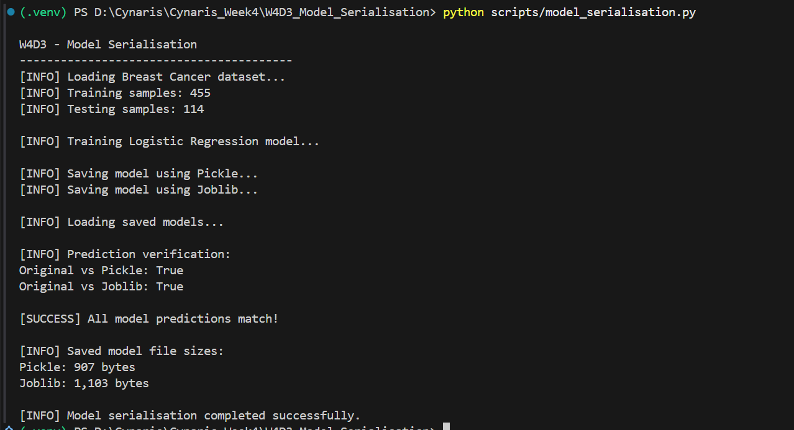
Figure 1. Successful execution of the model serialisation script.

8. Automated Testing
Automated tests were written using Pytest. The tests use a temporary directory (tmp_path) for generated test model files so that the test runs do not overwrite the practical's artifacts.
- test_pickle_file_exists – verifies Pickle file creation.
- test_joblib_file_exists – verifies Joblib file creation.
- test_pickle_load_success – verifies that the Pickle model can be loaded and exposes predict().
- test_joblib_load_success – verifies that the Joblib model can be loaded and exposes predict().
- test_prediction_consistency – verifies that predictions from both loaded models match the original model.
- test_file_sizes_nonzero – verifies that both generated model files are non-empty.
Final test result: 6 passed in 3.72 seconds.

9. Evidence 2 – Pytest Results
The following terminal evidence confirms that all six automated tests were collected and passed.
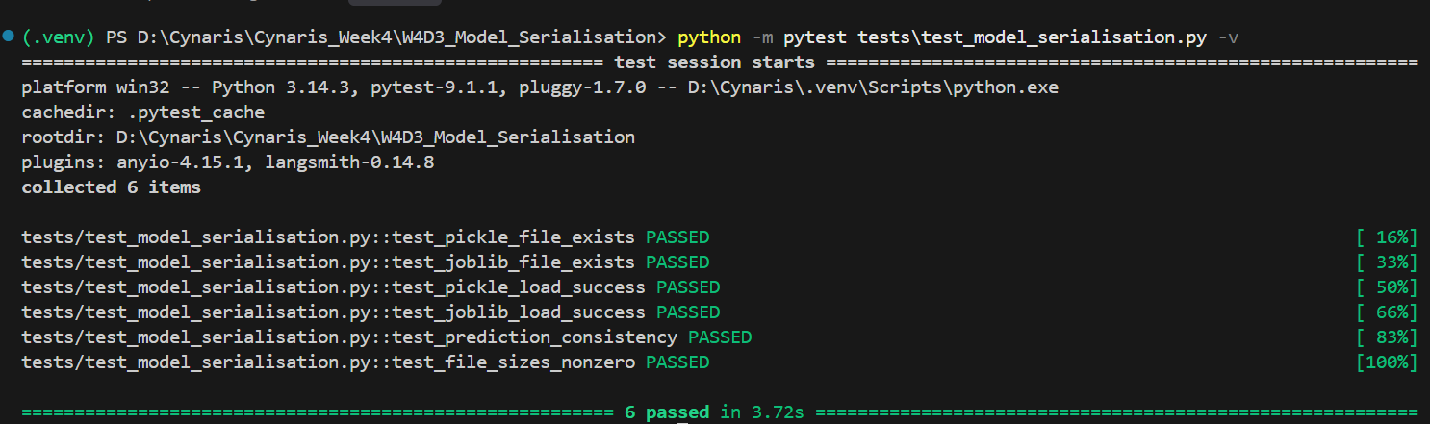
Figure 2. Pytest output showing all six tests passed.

10. Security Considerations
Pickle and Joblib model files must only be loaded from trusted sources. Deserialising an untrusted file can execute malicious code. Model artifacts should therefore be verified and obtained from trusted locations. Compatibility between the Scikit-learn and related library versions should also be considered when moving serialized models between environments.

11. Conclusion
The W4D3 practical successfully demonstrated model serialisation and deserialisation using Pickle and Joblib. A Logistic Regression model was trained on the Breast Cancer Wisconsin dataset, saved in both formats, and loaded back. Both restored models generated predictions identical to those of the original model on the test set. The implementation completed successfully, and all six automated tests passed.

