CYNARIS SOLUTIONS PRIVATE LIMITED
AI/ML Internship — Week 3, Day 1

Linear Regression — Scikit-Learn
Intern: Nikhita P. Shetty
Task: W3D1 | Date: 26 October 2026

1. Objective
The objective of this task was to build and evaluate regression models using Scikit-Learn. The implementation creates a synthetic housing dataset, trains Linear Regression, Ridge Regression, and Lasso Regression, evaluates their predictions using four metrics, and visualizes prediction quality and residual errors.

2. Dataset and Preparation
A reproducible synthetic dataset containing 200 house records was generated using NumPy. The input features are size_sqft, bedrooms, and age_years. The target variable is price. The dataset was split into training and testing sets using an 80/20 split with random_state=42.
- Total records: 200
- Input features: 3
- Training records: 160
- Testing records: 40

3. Implementation Summary
- Generated the synthetic housing data and inspected its first rows and dimensions.
- Separated the input features (X) from the target (y).
- Split the data into training and testing sets.
- Trained a LinearRegression model and printed its coefficients and intercept.
- Calculated MSE, RMSE, MAE, and R² on the test set.
- Trained Ridge and Lasso models using StandardScaler within Scikit-Learn pipelines.
- Generated predictions for all three models and compared their evaluation metrics in a table.
- Created an actual-versus-predicted scatter plot and a residuals plot for Linear Regression.

4. Linear Regression Coefficients
Feature / Parameter | Learned value
size_sqft coefficient | 151.6919
bedrooms coefficient | 19098.3023
age_years coefficient | -1041.4745
Intercept | 1409.5570
Interpretation: holding the other features constant, the model associates larger house size and more bedrooms with higher generated prices, while greater house age is associated with lower generated prices. These relationships come from the synthetic data-generation formula and are not real-world market findings.

5. Linear Regression Evaluation
Metric | Test-set result
MSE | 482,645,007.4603
RMSE | 21,969.1831
MAE | 17,755.6648
R² | 0.952253
The R² score of approximately 0.9523 indicates that the fitted model explains about 95.23% of the variation in prices in this test set. It does not mean that 95.23% of individual predictions are correct.

6. Comparison of Three Models
Model | MSE | RMSE | MAE | R²
Linear Regression | 4.826450e+08 | 21969.1831 | 17755.6648 | 0.9523
Ridge Regression | 4.786349e+08 | 21877.7255 | 17756.9694 | 0.9527
Lasso Regression | 4.826288e+08 | 21968.8133 | 17755.7150 | 0.9523
Ridge Regression had the lowest MSE and RMSE and the highest R² among these three runs. The differences were small. These results apply to this generated dataset and this train/test split.

7. Output Evidence
Figure 1. Linear Regression: Actual vs. Predicted Prices
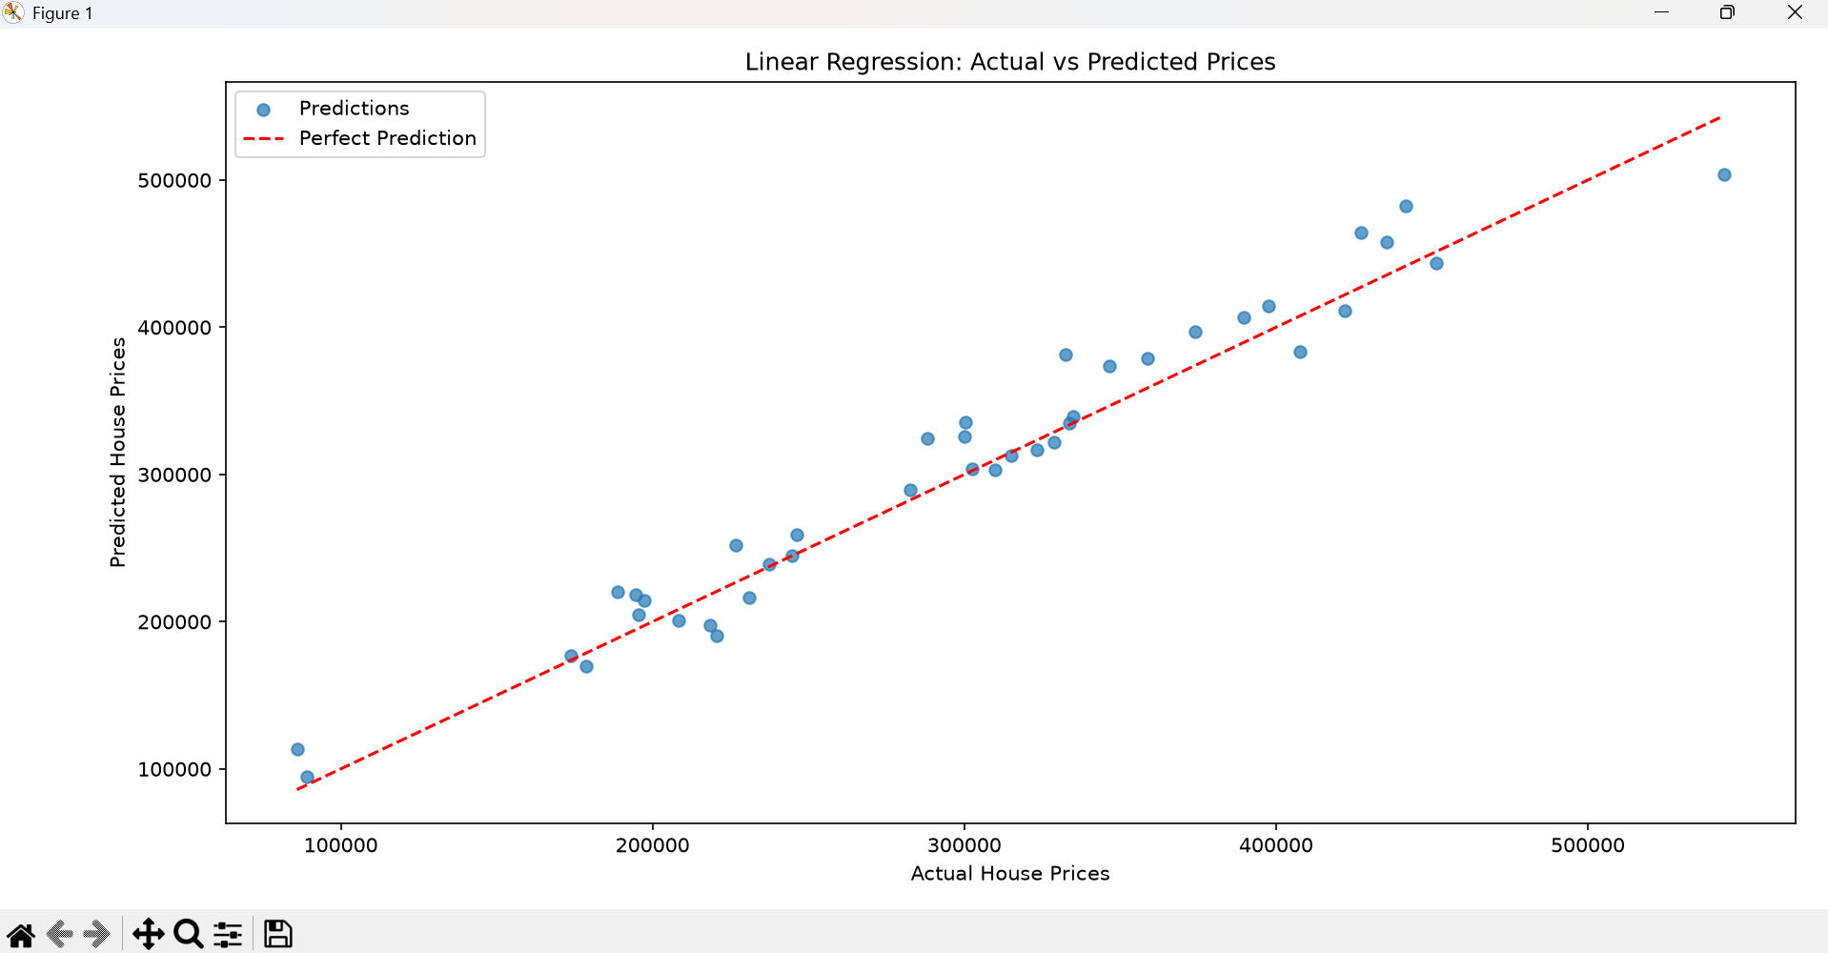
Figure 2. Linear Regression: Residuals Plot
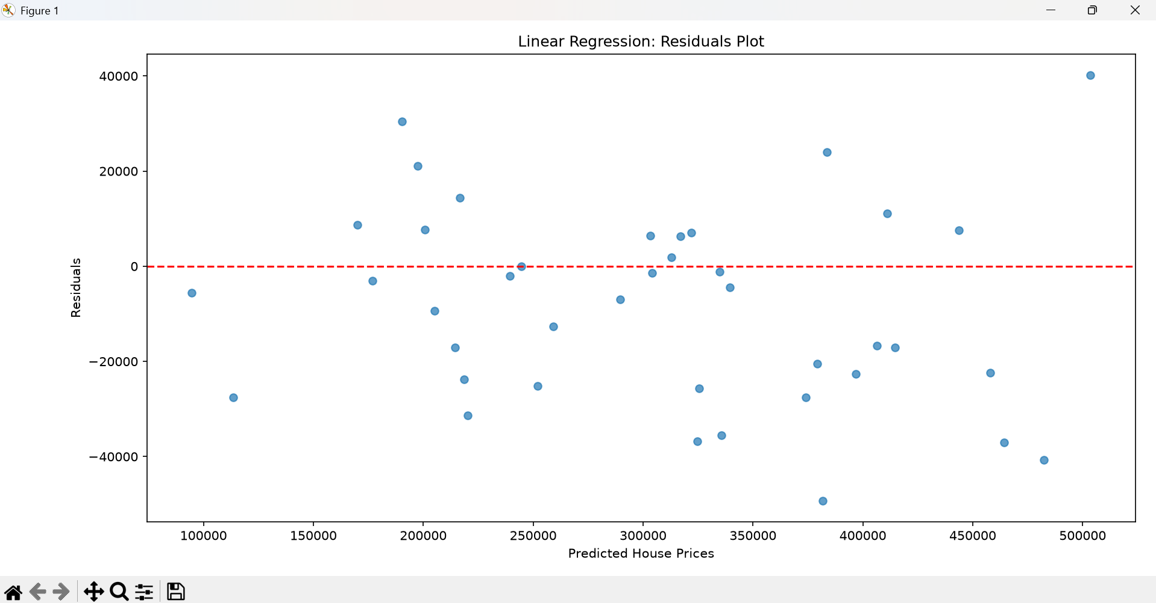
Figure 3. Terminal output showing model evaluation and comparison table
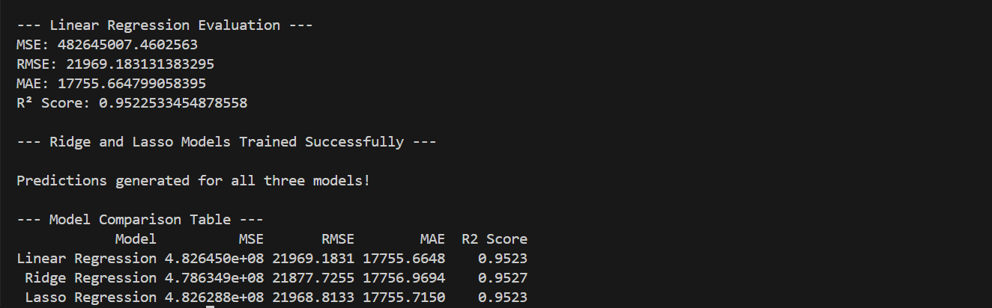
Figure 4. Terminal output showing dataset shapes, coefficients, and sample predictions
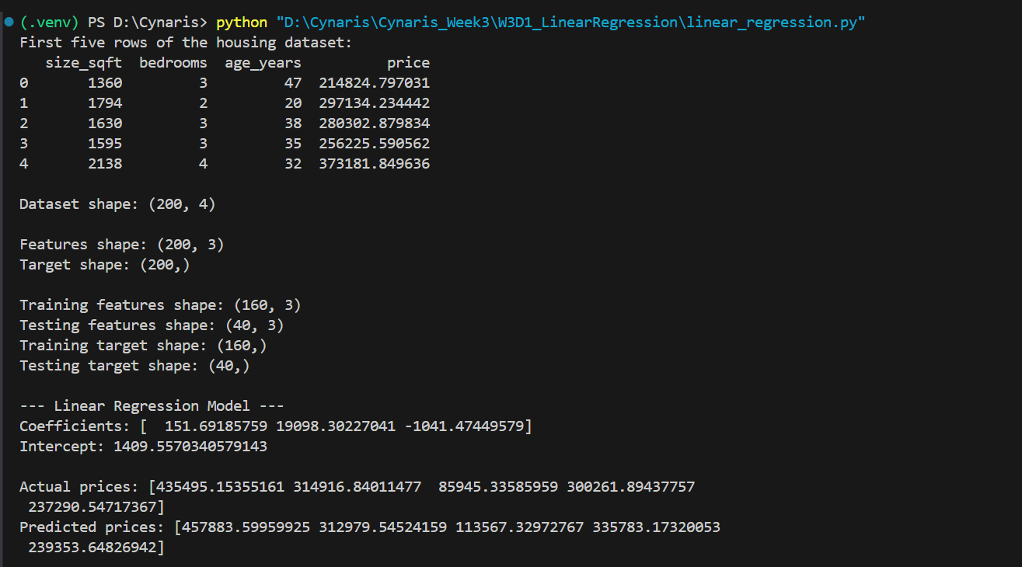

8. Conclusion
The W3D1 implementation successfully trained Linear Regression, Ridge Regression, and Lasso Regression models on a reproducible synthetic housing dataset. The script printed the learned Linear Regression coefficients, calculated MSE, RMSE, MAE, and R², compared the three models, and generated both required plots. Ridge Regression showed a slightly better test-set result in this run.

