CYNARIS SOLUTIONS PRIVATE LIMITED

W4D5 Practical Report
Binary Classification: Logistic Regression vs Random Forest

Report Detail | Information
Internship | AI/ML Internship
Week / Day | Week 4 – Day 5
Practical Title | 1M Capstone: Sentiment Classifier — Deploy & Document
Implementation Dataset | Breast Cancer Wisconsin dataset (Scikit-learn)
Models | Logistic Regression and Random Forest
Programming Language | Python

1. Objective
The objective of this practical was to implement a binary classification workflow, train and compare Logistic Regression and Random Forest classifiers, evaluate their performance using classification metrics, generate visual evaluation plots, save the trained models, and verify the saved model artifacts.

2. Dataset Description
The Breast Cancer Wisconsin dataset provided by Scikit-learn was used. It contains 569 samples and 30 numerical features. The target classes are malignant and benign. The dataset was divided into training and testing subsets using an 80:20 split with stratification to preserve the class distribution.
Dataset Detail | Value
Total samples | 569
Number of features | 30
Malignant samples (class 0) | 212
Benign samples (class 1) | 357
Training samples | 455
Testing samples | 114

3. Methodology
- Loaded the Breast Cancer Wisconsin dataset using Scikit-learn.
- Separated the input features (X) and target labels (y).
- Split the data into 80% training and 20% testing sets using stratify=y and random_state=42.
- Created a Logistic Regression pipeline with StandardScaler followed by LogisticRegression(max_iter=5000).
- Created a RandomForestClassifier with 100 trees and random_state=42.
- Trained both models using the same training data and evaluated them on the same test data.
- Generated classification reports, confusion matrices, ROC curves and ROC-AUC scores.
- Saved both trained models using Joblib and reloaded them to verify that their predictions matched the original models.

4. Evaluation Metrics
Metric | Meaning
Accuracy | Proportion of all predictions that were correct.
Precision | Proportion of predicted positive cases that were actually positive.
Recall | Proportion of actual positive cases correctly identified.
F1-score | Harmonic mean of precision and recall.
ROC-AUC | Measures how well the model separates the two classes across classification thresholds.

The classification_report output includes precision, recall, F1-score and support for each class, along with accuracy, macro average and weighted average.

5. Model Performance and Comparison
Metric | Logistic Regression | Random Forest
Accuracy | 98.25% | 95.61%
Precision (weighted) | 98.25% | 95.61%
Recall (weighted) | 98.25% | 95.61%
ROC-AUC | 0.9954 | 0.9937

On this particular train-test split, Logistic Regression achieved higher accuracy, weighted precision, weighted recall and ROC-AUC than Random Forest. Both models achieved high ROC-AUC scores. These results describe performance on this test split and should not be interpreted as a guarantee of performance on unseen real-world data.

6. Confusion Matrix Analysis

6.1 Logistic Regression
Actual / Predicted | Malignant | Benign
Malignant | 41 | 1
Benign | 1 | 71

The Logistic Regression confusion matrix shows 41 malignant and 71 benign samples correctly classified, with 2 incorrect predictions.

6.2 Random Forest
Actual / Predicted | Malignant | Benign
Malignant | 39 | 3
Benign | 2 | 70

The Random Forest confusion matrix shows 39 malignant and 70 benign samples correctly classified, with 5 incorrect predictions.

7. Visual Results
The following plots were generated and saved in the figures directory.

7.1 Logistic Regression — Confusion Matrix
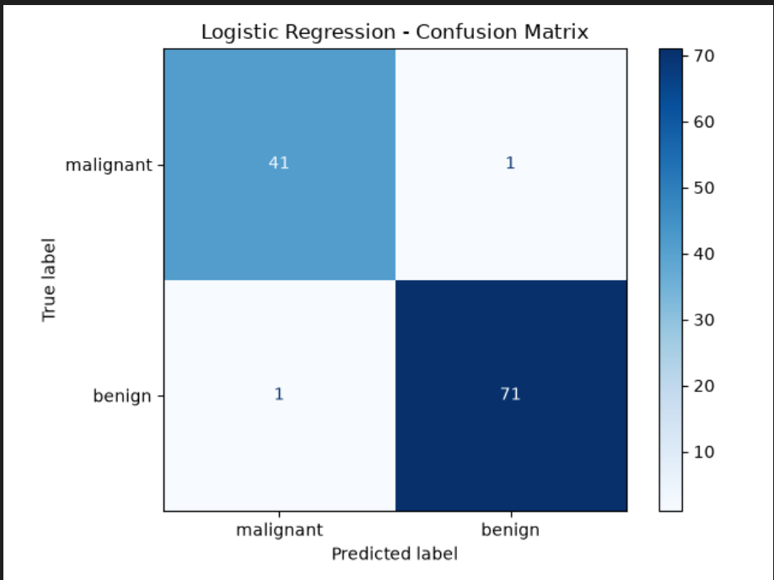
Figure 1. Logistic Regression confusion matrix.

7.2 Logistic Regression — ROC Curve
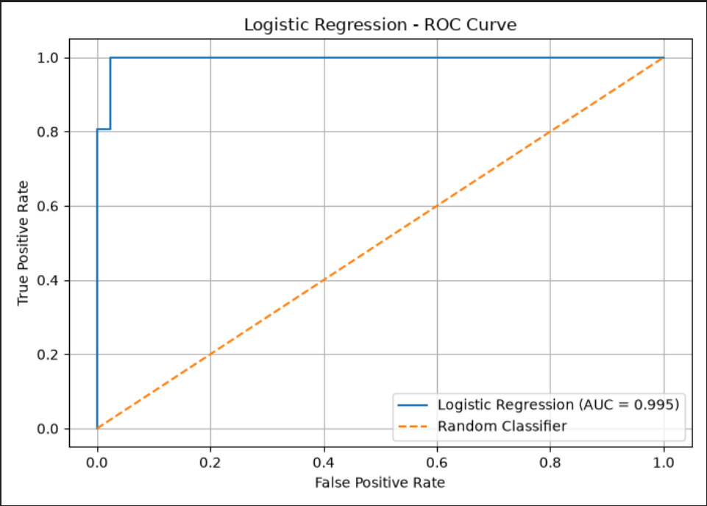
Figure 2. Logistic Regression ROC curve (AUC = 0.995).

7.3 Random Forest — Confusion Matrix
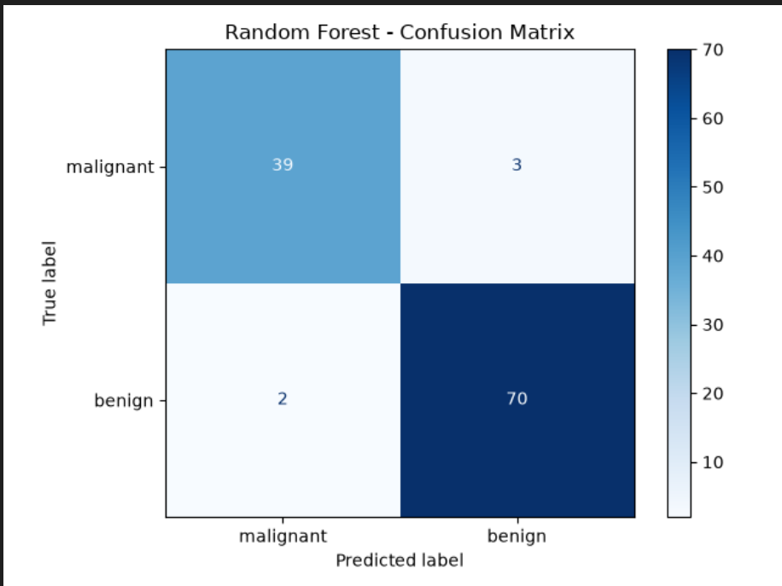
Figure 3. Random Forest confusion matrix.

7.4 Random Forest — ROC Curve
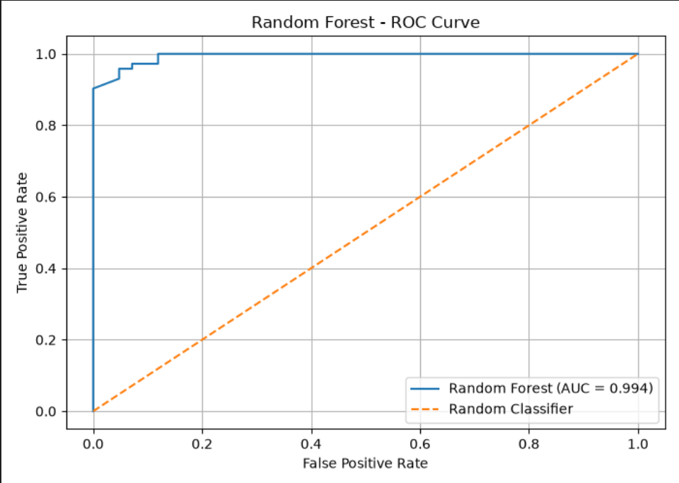
Figure 4. Random Forest ROC curve (AUC = 0.994).

8. Model Serialization and Verification
The trained models were saved using Joblib so that they can be loaded later without retraining. The Logistic Regression pipeline, including its scaler, was saved as one artifact.
Saved Artifact | Location
Logistic Regression | models/logistic_regression.joblib
Random Forest | models/random_forest.joblib

Both artifacts were successfully loaded again. Predictions from each reloaded model were compared with predictions from the corresponding trained model, and the checks passed.

9. Automated Testing
Three automated tests were executed using pytest. All tests passed.
Test | Purpose | Result
test_dataset_split | Checks the expected training and testing sample counts. | PASSED
test_models_can_train_and_predict | Checks that both models train and return valid binary predictions. | PASSED
test_saved_models_exist_and_load | Checks that both Joblib files exist and can be loaded. | PASSED

Test summary: 3 passed in 1.56 seconds
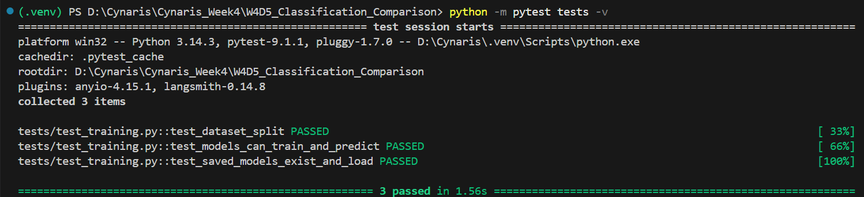
Figure 5. Pytest execution showing all three tests passed.

10. Project Structure
W4D5_Classification_Comparison/
├── models/
│ ├── logistic_regression.joblib
│ └── random_forest.joblib
├── figures/
│ ├── logistic_regression_confusion_matrix.png
│ ├── logistic_regression_roc_curve.png
│ ├── random_forest_confusion_matrix.png
│ └── random_forest_roc_curve.png
├── tests/
│ └── test_training.py
├── train.py
└── README.md

11. Challenges and Learning Outcomes
- Learned how to prepare a binary classification dataset using a stratified train-test split.
- Understood why feature scaling is used with Logistic Regression.
- Compared a linear classification algorithm with an ensemble tree-based algorithm.
- Interpreted classification reports and confusion matrices.
- Learned to generate ROC curves and compare ROC-AUC scores.
- Saved and reloaded trained models using Joblib.
- Used pytest to validate data splitting, model predictions and saved model artifacts.

12. Conclusion
The binary classification practical was completed successfully. Logistic Regression achieved 98.25% accuracy and a ROC-AUC of 0.9954, while Random Forest achieved 95.61% accuracy and a ROC-AUC of 0.9937 on the selected test split. Both models were saved and verified using Joblib. The four evaluation plots were generated, and all three automated tests passed. Based on the observed test results, Logistic Regression performed better in this experiment.

