CYNARIS SOLUTIONS PRIVATE LIMITED

Week 2 – Day 3 Report
Feature Engineering and SMOTE-Based Class Imbalance Handling
AI/ML Internship | Execution Report with Terminal Evidence

1. Objective
The objective of W2D3 was to generate a synthetic e-commerce dataset, create useful features, inspect return patterns, and run a modelling pipeline that addresses class imbalance using SMOTE. The workflow also evaluates the model and verifies key behaviour with automated tests.

2. Dataset and Feature Engineering
The feature-engineering script saved the dataset to `W2D3_SMOTE/data/synthetic_ecom.csv`. The displayed dataset shape was 200 rows and 6 columns. The `returned` target contained 176 class-0 records and 24 class-1 records.
The displayed engineered features included `age_group`, `high_value_order`, `is_weekend`, and `value_per_item`, alongside customer age, order value, and the return label. The script also summarized return rates by weekend status and age group.
The reported return rates were 0.132 for non-weekend orders and 0.083 for weekend orders. By age group, the rates were Young: 0.091, Prime: 0.143, Senior: 0.103, and Elder: 0.135. These describe this synthetic dataset and should not be interpreted as real-world customer behaviour.

3. SMOTE Pipeline and Model Evaluation
The pipeline output showed that splitting happened before balancing. The training set contained 141 class-0 records and 19 class-1 records. The test set remained unchanged, with 35 class-0 records and 5 class-1 records. SMOTE should be applied only to training data so that the held-out test data continues to provide a fair evaluation.
The displayed evaluation metrics were:
- Accuracy: 0.550
- Precision: 0.067
- Recall: 0.200
- F1-score: 0.100
The confusion matrix was [[21, 14], [4, 1]]. The classification report showed class 1 precision of 0.07, recall of 0.20, and F1-score of 0.10. The minority-class results are weak in this run. For an imbalanced dataset, accuracy alone is not enough; precision, recall, F1-score, and the confusion matrix are also important.

4. Automated Testing
The command `python -m pytest W2D3_SMOTE\tests -v` collected three tests. All passed: dataset generation, feature creation, and the test checking that SMOTE balances the training data.
Test result: 3 passed in 1.73 seconds.

5. Terminal Evidence

Figure 1. Feature engineering output: dataset generation, class counts, engineered features, and return-rate summaries.
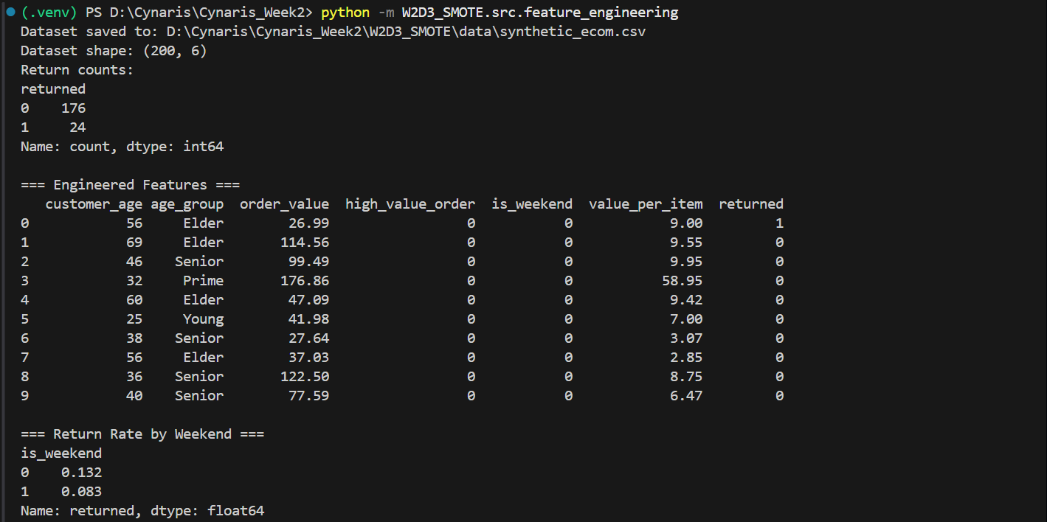

Figure 2. Return rates by age group.
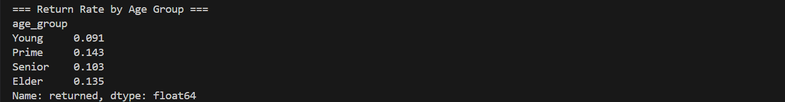

Figure 3. SMOTE pipeline: training and test distributions, evaluation metrics, and confusion matrix.
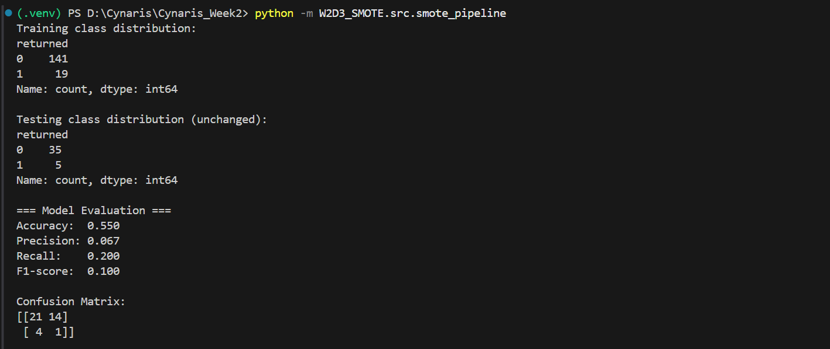

Figure 4. Classification report for both classes.
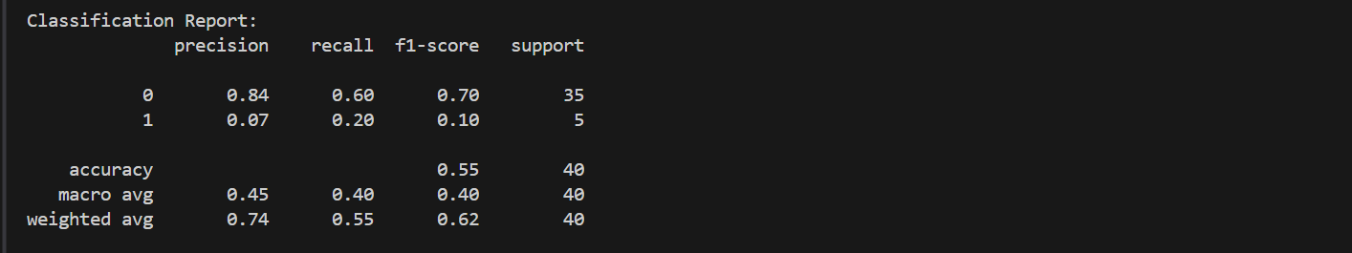

Figure 5. Pytest output confirming all three tests passed.
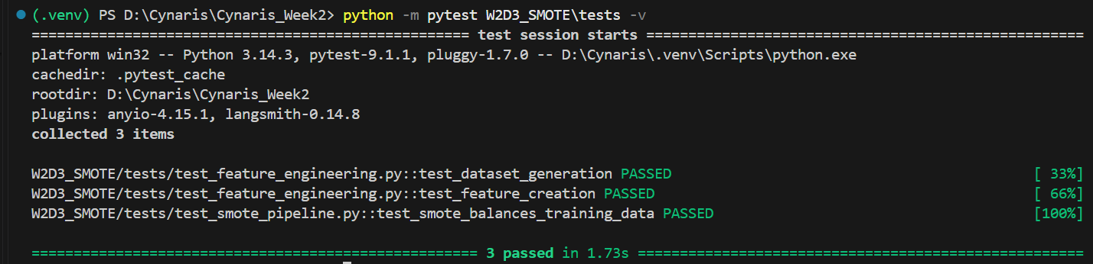

6. Conclusion
W2D3 generated the dataset, engineered features, produced descriptive return-rate summaries, ran the SMOTE-based modelling pipeline, and passed all three automated tests. The test set remained unchanged during balancing. Because the reported minority-class metrics are low, this model should be treated as a baseline rather than a strong predictor. Model tuning would be a separate follow-up task.

7. Commands Executed
python -m W2D3_SMOTE.src.feature_engineering
python -m W2D3_SMOTE.src.smote_pipeline
python -m pytest W2D3_SMOTE\tests -v

