Objectives
- Explain the characteristics of a Single Page Application (SPA)
  - Works inside a browser, no page reload, example multi page application (MPA) sites, example SPA sites, technologies to develop SPA (HTML, CSS, JavaScript, jQuery, ajax, AngularJS, Angular, ReactJS, Ember.js)

- Describe the Single Page Application Lifecycle
  - Traditional page life cycle in Servlet/ASP.NET, initial request, single time loading of HTML resources, AJAX, JSON
    - SPA Lifecyle Diagram: https://cdn.goconqr.com/uploads/media/image/20395412/desktop_6edf2ce8-99ea-4dc1-80b6-01a2b7b2f9ab.png

- Demonstrate usage of JavaScript objects
  - Objects, Property, Property Value
    - Ref - https://www.w3schools.com/js/js_objects.asp

- Demonstrate usage of JavaScript Object Notation (JSON)
  - Lightweight format for storing and transferring data, used when data is sent from a server to web page, self-describing, easy to understand, syntax, name value pair, separator is comma, curly braces hold objects, square brackets hold arrays, JSON value data types (string, number, object, array, boolean)
    - Intro - https://www.w3schools.com/js/js_json_intro.asp
    - Syntax - https://www.w3schools.com/js/js_json_syntax.asp
    - Data Types - https://www.w3schools.com/js/js_json_datatypes.asp
    - Parsing - https://www.w3schools.com/js/js_json_parse.asp

- Explain the need and benefits of Angular
  - Limitations of implementing SPA using JavaScript, Limitations of implementing SPA using jQuery, how to implement using angular, better performance since UI resources loads only once, gives better user experience, clear separation of view, action and web service call

- Describe the difference between AngularJS and Angular
  - Angular JS is version 1, called as Angular from version 2, how Angular JS works, key differences between Angular JS and Angular, Angular JS uses JavaScript, Angular uses TypeScript, Angular is command line based, Angular has a compilation step

SPA Characteristics - Difference between a Single Page Application and Multi Page Application Settings
Observe the difference between a Single Page Application and Multi Page Application
Multi Page Application
- Most of the new websites will be a multi-page application
- In browser go to https://www.thehindu.com/
- When a new article is clicked the page goes blank and the entire page is loaded
Single Page Application
- In browser go to https://translate.google.com/
- Provide a word in left hands side window
- The result of the translation is displayed in the right hand side without page reload.

JavaScript Object - Define JavaScript object for employee
Create a JavaScript object variable and display the content in console using console.log() method.
Include the JavaScript in a HTML file and execute it in browser.
Property | Value | Type
First Name | John | String
Last Name | Stoke | String
Salary | 5000 | Number
Permanent Staff | true | Boolean
Sample Output
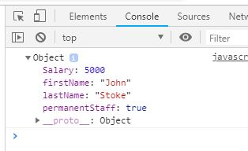

JSON - Define JSON for employee details and parse
Create JSON text based on the below given employee data and assign to a JavaScript string variable. Then convert it into a JavaScript object using parse() method and display the data by directly reading individual property values and printing using console.log() method. Write an html web page with JavaScript that will implement the above-mentioned features.
Property | Value | Type
First Name | John | String
Last Name | Stoke | String
Salary | 5000 | Number
Permanent Staff | true | Boolean
Sample Output
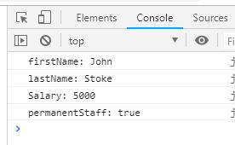

JSON - Add department details to employee
Modify the JSON in the previous program to include department details as per the requirement below. Read the specific property value from the JavaScript object and display the department details.
Property | Value | Type
Department | Object with id and department name  ID = 3  Name = “Payroll” | Object
Sample Output
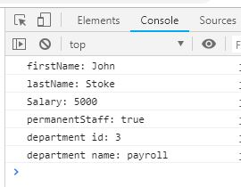

JSON - Add skill details to employee
Modify the JSON in the previous program to include skill details as per the requirement below. Get the skills property and iterate through the array to display the skill id and name.
Property | Value | Type
Skills | Array of skill with each skill having id and skill name.  Skill 1: id = 1; value = HTML  Skill 2: id = 2; value = CSS  Skill 3: id = 3; value = JavaScript | Object Array
Sample Output
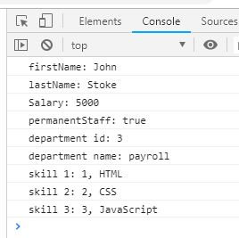

Angular Benefits - Implement SPA using JavaScript
Get partially implemented code from here and open it in browser.
Clicking on “Get Names” button actually retrieves user details as JSON from internet (https://reqres.in/api/users) and displays them. Refer screen shot below.
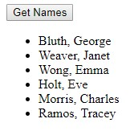
Try accessing https://reqres.in/api/users in a browser to get a feel about the JSON data returned.
SME to walk through the JavaScript code.
Implement changes in this code so that it displays more details about each user in the following layout:
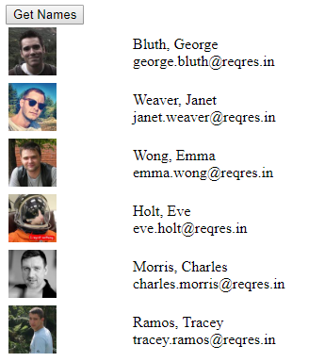

Angular Benefits - Implement SPA using jQuery
The jQuery implementation of the previous problem is available here.
SME to walkthrough and explain about the code in jquery.html file.
Modify the code to bring the same layout as done in the previous problem.

Angular Benefits - Implement SPA using Angular
The solution for the previous problem is implemented using angular and is available here.
Please go through the code in the following files:
- app.component.html
- app.component.ts
- user.service.ts
- user.ts

