Objectives
- List key features of ECMAScript6 (ES6)
  - European Computer Manufacturers Association (ECMA) standards organization, ECMAScript, scripting language specification, let, const, arrow functions, classes, TypeScript ES6 is related to TypeScript and Angular
    - Ref - https://www.w3schools.com/js/js_es6.asp

- Explain the need and benefits of TypeScript
  - static typing, superset of JavaScript, TypeScript code compiles to JavaScript, browser compatible, open source, primary language of angular
    - Ref - https://medium.com/swlh/the-major-benefits-of-using-typescript-aa8553f5e2ed

- Demonstrate compilation and execution of a TypeScript file
  - Install typescript npm package, write TypeScript program, compile and run
    - Ref - https://www.typescriptlang.org/docs/handbook/typescript-in-5-minutes.html

- Demonstrate defining objects using data types, interfaces and classes
  - Data Types (boolean, number, string, array, tuple, enum, any, void) interfaces, class
    - Data Types - https://www.typescriptlang.org/docs/handbook/basic-types.html
    - Interface - https://www.typescriptlang.org/docs/handbook/interfaces.html
    - Classes - https://www.typescriptlang.org/docs/handbook/classes.html
    - Modules - https://www.typescriptlang.org/docs/handbook/modules.html

- Interpret how to implement functions and for .. of in TypeScript
  - Defining functions with parameters' data type and return data type defined, using for .. of to iterate through arrays
    - Functions Ref - https://www.typescriptlang.org/docs/handbook/functions.html
    - for .. of Ref - https://www.typescriptlang.org/docs/handbook/iterators-and-generators.html

ES6 - Understanding ES6 features
The below link contains details and examples about the features of ES6.
SME to walkthrough the following topics in this link:
- let
- const
- Arrow Functions
- Classes
Use the “Try it Yourself” option to demonstrate how each feature works.
https://www.w3schools.com/js/js_es6.asp

TypeScript - Write, Compile and Execute a TypeScript program
Follow the steps below to understand how TypeScript works:
- Ensure Node JS is already installed in the PC
- Install TypeScript by executing the command ‘npm install -g typescript’ in command line
- Go to the link specified below. Copy the TypeScript code under 'Classes' heading.
- Paste the copied code into Visual Studio Code and save the file as hello.ts.
- Compile hello.ts using command ‘tsc hello.ts’ in command line which will generate hello.js.
- Open hello.js in Visual Studio Code and observe the difference in code between ts and js files.
- Execute hello.js by creating hello.html (refer greeter.html code from the link below)
Reference: https://www.typescriptlang.org/docs/handbook/typescript-in-5-minutes.html

TypeScript data types and interface – Define Employee interface and display
Define an interface for employee and display the details. Refer file wise specification below.
employee.ts
An interface with name Employee.
Properties - id, name, salary, permanent with data types number, string, number and boolean types respectively.
employee-test.ts
TypeScript file to test the usage of Employee interface. Implement steps specified below:
- Import Employee interface
- Defines values based on Employee interface and assign to a variable
- Display the employee details using console.log() method.
employee-test.js
Compile employee-test.ts to generate this file.
employee-test.html
Includes employee-test.js that displays the console output in browser.
Troubleshooting Tips
To avoid runtime error include the following line above the script definition tags in employee-test.html.
<script> var exports = {}; </script>
<script src="employee-test.js"></script>
Sample Output in Chrome Browser Console
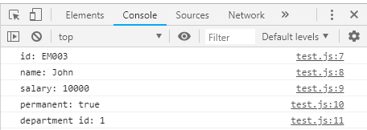

TypeScript data types and interface – Include Department details in Employee and display
Upgrade the previous problem to include department details in employee.
department.ts
An interface to represent Department.
Properties – id and name with data types number and string respectively
employee.ts
Import department and include it as attribute.
employee-test.ts
Include code to display department id and name using console.log.
Expected output in the chrome browser console
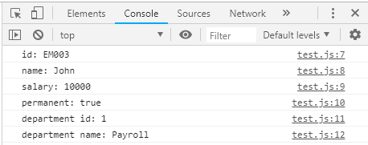

TypeScript data types and interface – Include Skill details in Employee and display
Make changes in the previous program to include skill details in employee.
skill.ts
An interface to represent Skill.
Properties – id and name with data types number and string respectively.
employee.ts
Import skill and include an array of skills as attribute.
employee-test.ts
Include code to display all skill id and skill name by iterating through the skills.
Expected output in the chrome browser console
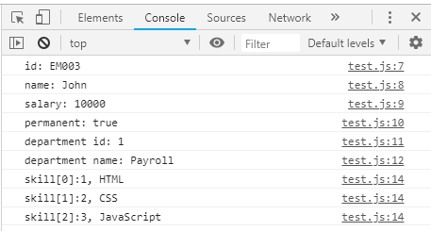

TypeScript data types and interface – Use class to display employee details
Display Employee details using a class following the steps below:
- Convert code in employee-test.ts to have a class with class name EmployeeTest.
- Include employee as property of EmployeeTest
- Initialize employee property in constructor and include the code that sets the values for properties of employee.
- Include display() method in EmployeeTest that will display employee details.
- Instantiate EmployeeTest class, set the employee and invoke the display() method.

TypeScript functions and for .. of
SME to provide a walkthrough of code as specified below.
Functions
https://www.typescriptlang.org/docs/handbook/functions.html
Explain the code under ‘Type the function’ section.
for .. of
https://www.typescriptlang.org/docs/handbook/iterators-and-generators.html
Explain the code under ‘for .. of statements’ section.

