Objectives
- Demonstrate creation of angular application
  - Create new angular application in command line (ng new), execute the application (ng serve), understanding app component and app component html, importance of app module
    - New Application - https://angular.io/cli/new
    - Start Server - https://angular.io/cli/serve App Component
    - File Structure - https://angular.io/guide/file-structure

- Demonstrate displaying data using interpolation, ngIf and ngFor
  - Property definition in component, using double curly brackets, ngIf directive, ngFor directive
    - Ref - https://angular.io/guide/displaying-data

- Demonstrate using pipes to format number and date
  - Data to view transformation, pipe character, built-in pipes (Date, UpperCase, LowerCase, Currency, Percent), parameterizing pipes, chained pipes
    - Ref - https://angular.io/guide/pipes

- Demonstrate karma test case creation with DOM reading
  - ng test, TestBed, fixture, component, debugElement, nativeElement, detectChanges(), it(), expect(), toEqual(), toBe()
    - Ref - https://angular.io/guide/testing

Angular Intro - Angular App Creation and Testing
Steps to create a new angular application and test it:
- Create a new application named “angular-learning” using ng new. [NOTE: Select routing support option during application creation]
- Run the application in browser using ng serve command
- Stop the service using Ctrl+C keyboard shortcut in command line
- Test the application using ng test command in the command line
- This will launch the test results in a browser window.
Steps to fail a test case:
- Open app.component.spec.ts
- Modify the title value in line 22 to fail the test case. Change angular-learning to angular-learn and save.
- The test results in browser will display failed error test case details.
- Revert the code back, so that all test cases succeed.
- SME to walkthrough the code in app.component.spec.ts.

Angular Intro – Hello World in angular
SME to provide explanation about the following files in the generated code:
- app.component.ts
- app.component.html
- app.module.ts
Modify app.component.html to display the message “Hello World” alone in the view.

Interpolation – Display favorite movie
Modify angular-learning application to display your favorite movie name.
Create a property named favoriteMovie in app.component.ts
Display the favorite movie in the below format:
Favorite Movie: Lord of the Rings
Karma Testing
- Include test case to validate if favorite movie property and HTML element value matches.
- Use 'expect' function of Karma to perform the validation. 'toEqual' of expect function can be used to do the data comparison.
- The sample snippet as shown below can be used to find the HTML element, h1.
  - const compiled = fixture.debugElement.nativeElement;
  - compiled.querySelector('h1').textContent

Interpolation – Display Employee details
Modify angular-learning application to display employee’s id, name and salary.
Use Employee, Department and Skill interfaces created earlier.
Sample screen layout
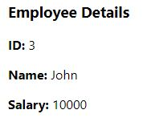

Interpolation – Display employee permanent details using ngIf
Include employee permanent details using ngIf directive.
Sample Layout
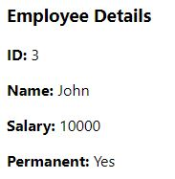

Interpolation – Display employee department details
Interpolation – Display employee department details
Sample Layout
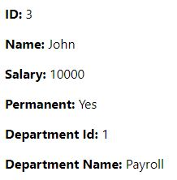

Interpolation – Display employee skill details using ngFor
Include employee skill details using ngFor directive.
Sample Layout
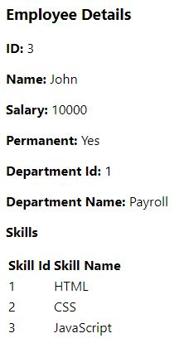

Interpolation - Display employee details with date of birth
Include dateOfBirth property of type Date in employee.ts.
Set dateOfBirth value in component.ts using new Date('12/31/2000') option.
Include Date of Birth details in html.
Sample Layout
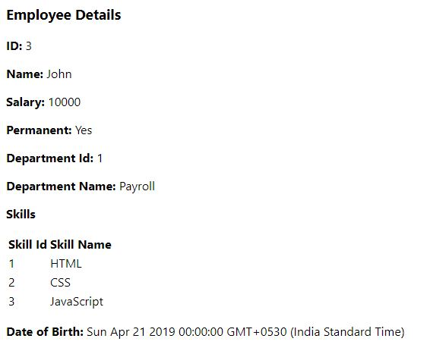

Karma Testing
- Include test case to check if the department name property and the value in HTML matches.
- Use the sample code snippet as shown below to find the HTML element & perform the comparison with model property
  - const compiled = fixture.debugElement.nativeElement;
  - compiled.querySelector('#departmentName').textContent
  - component.employee.department.name

Pipes – Display employee date of birth and salary in custom format
Display Salary in currency format with any currency symbol of your choice.
Display date of birth as per the layout defined below.
