SPACEX FALCON 9 FIRST STAGE LANDING PREDICTION
IBM DATA SCIENCE PROFESSIONAL CERTIFICATE
CAPSTONE PROJECT REPORT
Submitted By
Nikhil Agrawal
B.Tech – Computer Science and Engineering
Bharati Vidyapeeth College of Engineering, Pune
Project Title:
SpaceX Falcon 9 First Stage Landing Prediction
Project Domain:
Data Science and Machine Learning
Tools and Technologies Used:
- Python
- Jupyter Notebook
- Pandas and NumPy
- Matplotlib and Seaborn
- SQL
- Folium
- Plotly Dash
- Scikit-learn
Academic Year: 2026–2027

ABSTRACT
The SpaceX Falcon 9 First Stage Landing Prediction project focuses on analyzing historical rocket launch data and predicting whether the first-stage booster of a Falcon 9 rocket will land successfully.
SpaceX uses reusable rocket technology to reduce the cost of space transportation. Successful recovery and reuse of the first-stage booster are important for making space missions more economical.
In this project, historical SpaceX launch data containing 90 launch records and 19 features was analyzed using Python and various data science techniques. Data cleaning, exploratory data analysis (EDA), SQL queries, and data visualization were performed to identify patterns and understand the factors affecting landing success.
An interactive map was created using Folium to display launch sites, and a dashboard was developed using Plotly Dash to explore launch statistics. Machine learning algorithms, including Logistic Regression, Decision Tree, and Support Vector Machine (SVM), were implemented to predict landing outcomes.
Among the tested models, the Decision Tree classifier achieved the highest test accuracy of 94.44%. Its average accuracy using 5-fold cross-validation was 84.44%.
The project demonstrates how data science and machine learning can be used to analyze rocket launch data and predict first-stage landing outcomes.

1. INTRODUCTION
SpaceX (Space Exploration Technologies Corp.) is a private aerospace company that develops advanced rockets and spacecraft. One of its most important launch vehicles is the Falcon 9 rocket, which is designed to transport satellites, cargo, and astronauts into space.
A major innovation of SpaceX is the development of reusable rocket technology. Traditionally, the first stage of a rocket was discarded after launch. However, SpaceX developed a technology that allows the first-stage booster of the Falcon 9 rocket to return to Earth and land safely for future reuse.
Reusing rocket boosters helps reduce launch costs, save resources, and improve the efficiency of space missions. However, successful landing depends on several factors, such as payload mass, launch site, target orbit, booster configuration, and previous flight history.
This project, titled "SpaceX Falcon 9 First Stage Landing Prediction," uses data science and machine learning techniques to study historical Falcon 9 launches and predict whether the first-stage booster will land successfully.
The project involves data collection, data cleaning, exploratory data analysis, SQL operations, interactive mapping, dashboard development, and machine learning model building.
Python and its data science libraries are used to process and analyze the dataset. Different machine learning algorithms are trained and evaluated to identify the model that provides the best prediction performance.
The main purpose of this project is to demonstrate how data science can solve real-world problems by extracting useful insights from historical data and building predictive models.

2. PROJECT OVERVIEW
The SpaceX Falcon 9 First Stage Landing Prediction project is a data science and machine learning project that focuses on analyzing historical rocket launch data and predicting the landing success of the Falcon 9 first-stage booster.
The project uses a dataset containing 90 historical Falcon 9 launch records. Each record provides information about launch dates, payload mass, launch sites, target orbits, booster details, and landing outcomes.
The project follows a complete data science workflow, starting from understanding and preparing the dataset to developing and evaluating machine learning models.
2.1 Project Workflow
The major stages of this project are:
- Data Collection: Obtaining the SpaceX Falcon 9 dataset from IBM Skills Network.
- Data Preprocessing: Cleaning the dataset, handling missing values, and preparing features.
- Exploratory Data Analysis: Studying launch success patterns using graphs and statistical analysis.
- SQL Analysis: Using SQL queries to extract useful information from the dataset.
- Interactive Mapping: Displaying SpaceX launch locations using the Folium library.
- Dashboard Development: Creating an interactive dashboard using Plotly Dash.
- Machine Learning: Training Logistic Regression, Decision Tree, and Support Vector Machine models.
- Model Evaluation: Comparing model performance using accuracy, confusion matrices, and cross-validation.
2.2 Technologies Used
The following tools and technologies were used:
- Python: Main programming language for data analysis and machine learning.
- Pandas: Used for loading, cleaning, and manipulating data.
- NumPy: Used for numerical operations.
- Matplotlib and Seaborn: Used to create data visualizations.
- SQL: Used to perform database queries and analysis.
- Folium: Used to create an interactive geographical map.
- Plotly Dash: Used to develop an interactive dashboard.
- Scikit-learn: Used to train and evaluate machine learning models.
- Jupyter Notebook: Used to write and execute project code.
- Visual Studio Code: Used as the development environment.

3. PROBLEM STATEMENT AND OBJECTIVES
3.1 Problem Statement
SpaceX Falcon 9 rockets use reusable first-stage boosters to reduce the cost of space transportation. After launching a payload into space, the first-stage booster attempts to return to Earth and land safely so that it can be reused in future missions.
However, not every landing attempt is successful. The landing outcome depends on several factors, including payload mass, launch site, target orbit, booster flight history, and other technical characteristics.
The main problem addressed in this project is to analyze historical Falcon 9 launch data and develop a machine learning model that can predict whether the first-stage booster will land successfully.
3.2 Project Objectives
The major objectives of this project are:
- To understand the working and importance of SpaceX Falcon 9 reusable rocket technology.
- To collect and analyze historical Falcon 9 launch data.
- To clean and preprocess the dataset for further analysis.
- To identify patterns and relationships between launch features and landing outcomes.
- To perform exploratory data analysis using Python libraries.
- To analyze launch information using SQL queries.
- To visualize launch locations using an interactive Folium map.
- To develop an interactive dashboard using Plotly Dash.
- To build machine learning models for predicting landing success.
- To evaluate and compare different machine learning algorithms.
- To identify the best-performing model based on its prediction results.
3.3 Expected Outcome
The expected outcome of this project is to develop a machine learning model capable of predicting Falcon 9 first-stage landing success based on historical launch information.
The analysis also aims to identify important patterns in launch data and demonstrate how data science techniques can support decision-making in the aerospace industry.

4. DATASET DESCRIPTION
The dataset used in this project contains historical information about SpaceX Falcon 9 rocket launches. It provides details about launch dates, payload mass, launch locations, target orbits, booster information, and landing outcomes.
The dataset was obtained from the IBM Skills Network dataset provided for the IBM Data Science Capstone Project.
The dataset contains 90 launch records and 19 columns. Each row represents one Falcon 9 launch.
4.1 Dataset Features
The following are the important features available in the dataset:
Feature | Description
FlightNumber | Unique number assigned to each launch
Date | Date of the rocket launch
BoosterVersion | Version of the Falcon 9 booster
PayloadMass | Mass of the payload in kilograms
Orbit | Target orbit of the payload
LaunchSite | Location from which the rocket was launched
Outcome | Landing outcome of the booster
Flights | Number of flights completed by the booster
GridFins | Indicates whether grid fins were used
Reused | Indicates whether the booster was reused
Legs | Indicates whether landing legs were used
LandingPad | Landing platform used by the booster
Block | Version of the Falcon 9 booster block
ReusedCount | Number of times the booster was reused
Serial | Unique booster serial number
Longitude | Longitude of the launch site
Latitude | Latitude of the launch site
Class | Target variable representing landing success or failure
Year | Year of the launch
4.2 Dataset Summary
The basic details of the dataset are:
- Total launch records: 90
- Total columns: 19
- Successful landings: 60
- Unsuccessful landings: 30
- Overall landing success rate: 66.67%
4.3 Target Variable
The target variable used for machine learning is Class.
- Class = 1: Successful first-stage landing.
- Class = 0: Unsuccessful first-stage landing.
This variable is used to train machine learning models and predict future landing outcomes based on the available launch features.

5. DATA COLLECTION AND PREPROCESSING
Data collection and preprocessing are important stages of a data science project. In this project, historical SpaceX Falcon 9 launch data was obtained from the IBM Skills Network dataset provided for the capstone project.
The dataset was downloaded in CSV format and loaded into Python using the Pandas library.
5.1 Data Collection
The dataset was collected from the IBM Skills Network public dataset.
Dataset URL:
https://cf-courses-data.s3.us.cloud-object-storage.appdomain.cloud/IBM-DS0321EN-SkillsNetwork/datasets/dataset_part_2.csv
The downloaded dataset was stored in the project's data folder as a CSV file.
5.2 Loading the Dataset
The Pandas library was used to load the dataset into a DataFrame.
The following Python code was used:
import pandas as pd

df = pd.read_csv("../data/spacex_dataset.csv")

print(df.head())
print(df.shape)
The dataset was successfully loaded and contained 90 rows and 19 columns.
5.3 Data Cleaning
Data cleaning was performed to check the quality and completeness of the dataset.
The following operations were performed:
- Checked the dataset structure and column names.
- Identified missing values in each column.
- Checked for duplicate records.
- Converted the Date column into the datetime format.
- Extracted the year from the Date column for further analysis.
The following code was used:
df["Date"] = pd.to_datetime(df["Date"])

df["Year"] = df["Date"].dt.year

print(df.isnull().sum())
print("Duplicate records:", df.duplicated().sum())
5.4 Missing Value Analysis
During the missing value analysis, it was observed that the LandingPad column contained 26 missing values.
All other columns had zero missing values.
There were no duplicate records in the dataset.
The missing LandingPad values were retained during the initial dataset analysis. However, the LandingPad column was excluded from the machine learning dataset during model preparation.
5.5 Data Preprocessing for Machine Learning
Before training machine learning models, the dataset was prepared by removing columns that were not required as model input.
The following columns were removed:
- Date
- BoosterVersion
- Outcome
- LandingPad
- Serial
- Longitude
- Latitude
Categorical variables such as Orbit and LaunchSite were converted into numerical values using One-Hot Encoding.
The target variable was separated from the input features:
- Input features (X): Variables used to predict landing outcomes.
- Target variable (y): Class, representing successful or unsuccessful landing.
Finally, the dataset was divided into training and testing sets using an 80:20 ratio.
The training dataset contained 72 records, while the testing dataset contained 18 records.
This prepared dataset was used for training and evaluating the machine learning models.

6. EXPLORATORY DATA ANALYSIS (EDA)
Exploratory Data Analysis (EDA) is the process of examining and understanding a dataset using statistical methods and visualizations.
In this project, EDA was performed using Python libraries such as Pandas, Matplotlib, and Seaborn.
The main purpose was to identify patterns, relationships, and trends that could influence the landing success of the Falcon 9 first-stage booster.
6.1 Landing Success and Failure Analysis
The dataset contains 90 Falcon 9 launches.
Out of these:
- 60 launches resulted in successful landings.
- 30 launches resulted in unsuccessful landings.
- The overall landing success rate was 66.67%.
This analysis shows that successful landings occurred in approximately two-thirds of the recorded launches.
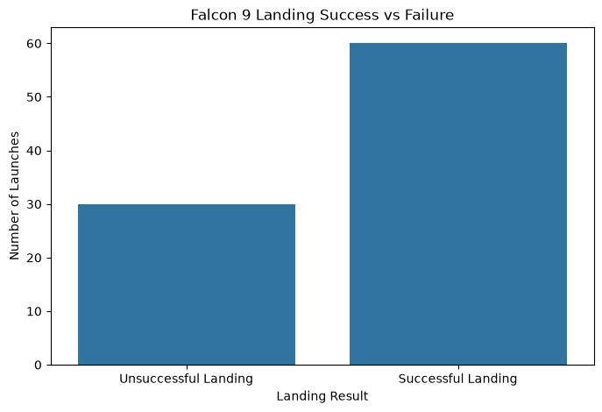
6.2 Success Rate by Year
The yearly analysis was performed to understand how Falcon 9 landing performance changed over time.
The results show that landing success improved significantly over the years. Early launches had lower success rates, while later launches generally achieved higher success rates.
The highest yearly success rate in the analyzed dataset was 90% in 2019.
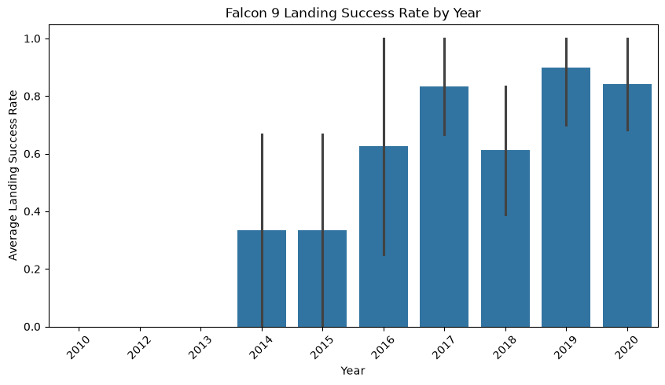6.3 Success Rate by Launch Site
The analysis compared landing performance across three launch sites:
- CCAFS SLC 40: 60% success rate.
- KSC LC 39A: 77.27% success rate.
- VAFB SLC 4E: 76.92% success rate.
KSC LC 39A had the highest success rate among the three launch sites in this dataset.
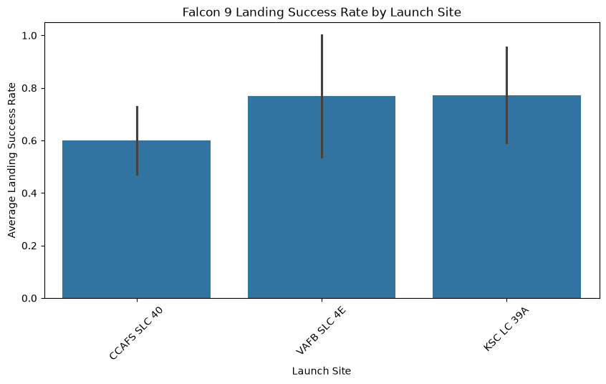6.4 Success Rate by Orbit
Different types of orbits were analyzed to understand their relationship with landing outcomes.
The analysis showed that success rates varied across different orbit categories. SSO, HEO, GEO, and ES-L1 recorded 100% success rates in this dataset, although some of these categories contained very few launches.
GTO recorded a success rate of approximately 51.85%.
This suggests that the target orbit may be an important factor to investigate when studying landing outcomes.
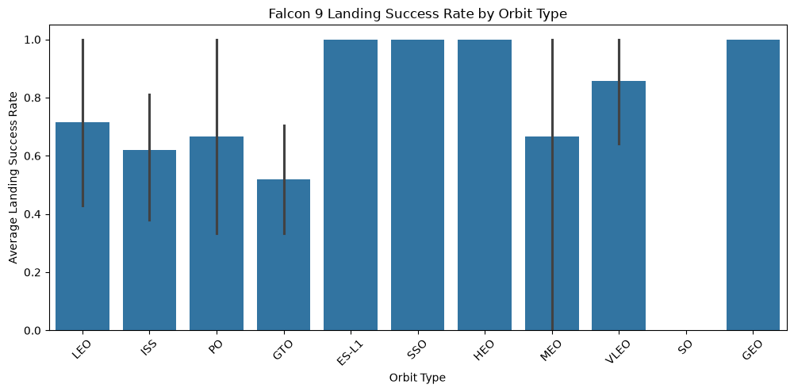6.5 Payload Mass Analysis
Payload mass was analyzed to understand its relationship with landing success.
The average payload mass for unsuccessful landings was approximately 4,784.56 kg, while the average payload mass for successful landings was approximately 6,765.16 kg.
This indicates that successful landings in the dataset were associated with a higher average payload mass. However, payload mass alone does not determine landing success.
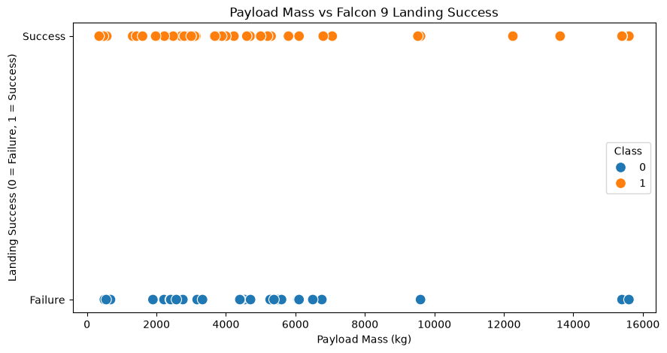6.6 Booster Flight History Analysis
The number of flights completed by a booster was analyzed to understand whether previous flight experience was associated with landing success.
The analysis compared landing success rates across different booster flight counts.
This helped identify patterns related to booster reuse and operational experience.
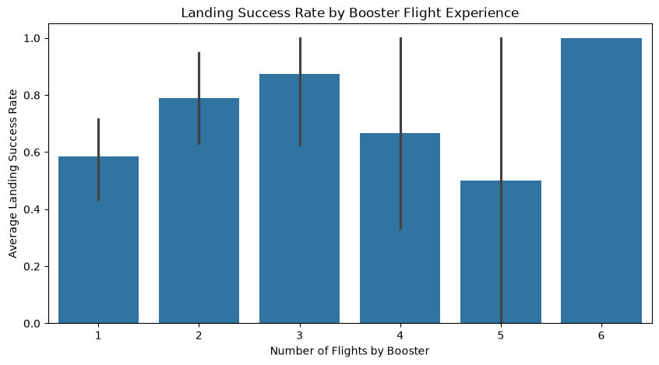6.7 Grid Fins Analysis
Grid fins help control the direction of a returning rocket booster during its descent.
The dataset showed the following results:
- Without grid fins: 2 successful landings out of 20 launches (10%).
- With grid fins: 58 successful landings out of 70 launches (82.86%).
This shows a strong association between the presence of grid fins and successful landing outcomes in the analyzed dataset.
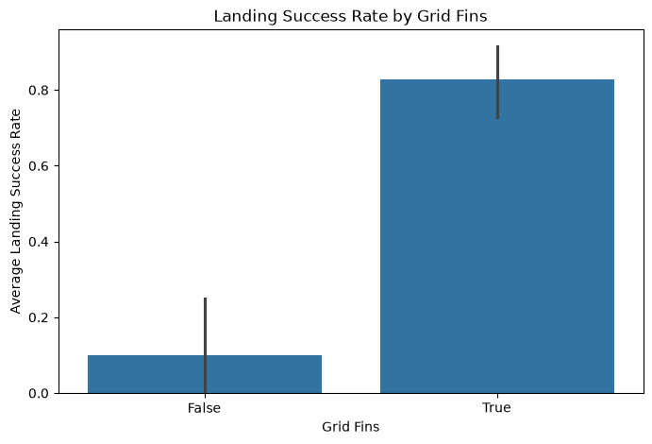6.8 Landing Legs Analysis
Landing legs are used by the Falcon 9 booster to support a controlled landing.
The dataset was analyzed to compare landing success rates for launches with and without landing legs.
This helped examine the relationship between landing equipment and successful booster recovery.
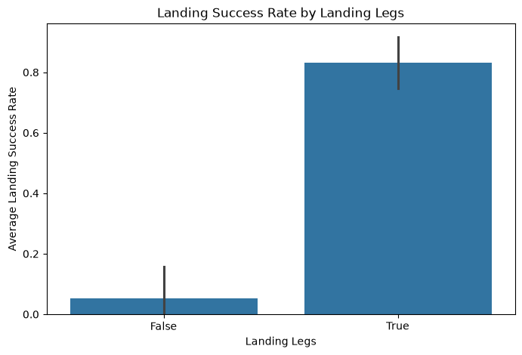6.9 Booster Reuse Analysis
The Reused feature was analyzed to understand the relationship between booster reuse and landing outcomes.
The comparison helped identify whether previously used boosters showed different landing success patterns compared with boosters that had not been reused.
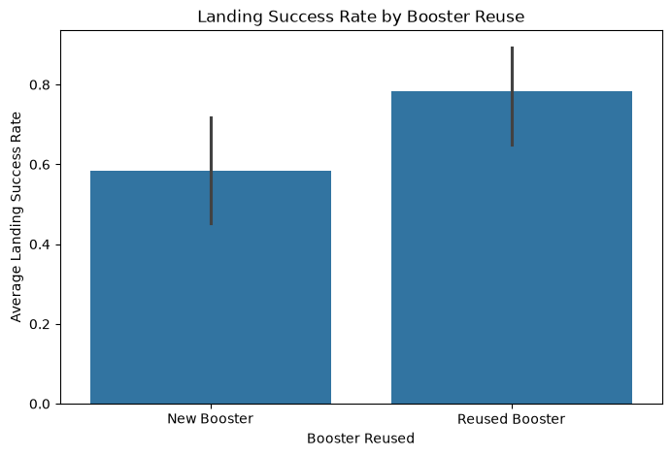6.10 Correlation Analysis
A correlation heatmap was created to examine relationships between numerical variables in the dataset.
The heatmap helped identify positive and negative relationships between different features.
This analysis provided additional information about the dataset and supported the selection of features for machine learning.
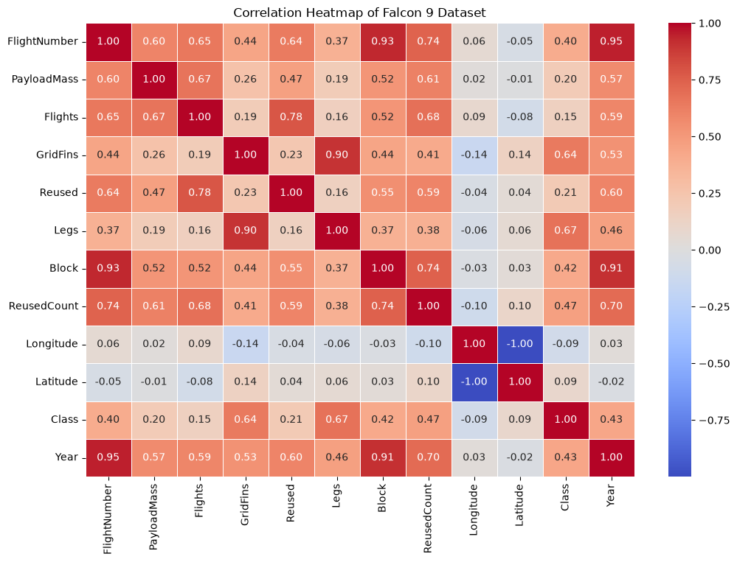6.11 EDA Summary
The exploratory data analysis revealed several important findings:
- The overall landing success rate was 66.67%.
- Landing success generally improved over the years.
- KSC LC 39A had the highest success rate among the three launch sites.
- Landing success varied across different target orbits.
- Successful landings had a higher average payload mass in this dataset.
- Launches with grid fins showed a higher success rate.
- Booster flight history and reuse were useful factors to investigate.
These findings provided a foundation for further SQL analysis and machine learning model development.

7. SQL ANALYSIS
SQL (Structured Query Language) was used to perform database operations and analyze the SpaceX Falcon 9 launch dataset.
The dataset was imported into an SQLite database, and SQL queries were executed to extract useful information about launch records, landing success rates, launch sites, and target orbits.
The main objective of SQL analysis was to understand the dataset through database queries and identify important patterns.
7.1 Database Creation
An SQLite database named spacex_database.db was created to store the SpaceX launch dataset.
The dataset was loaded into a database table named SPACEX.
7.2 Total Number of Launches
An SQL query was executed to calculate the total number of launches.
Query:
SELECT COUNT(*) AS Total_Launches
FROM SPACEX;
Result: 90 total launches.
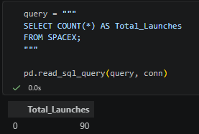
7.3 Launches by Launch Site
The following query was used to count launches from each launch site.
Query:
SELECT LaunchSite, COUNT(*) AS Total_Launches
FROM SPACEX
GROUP BY LaunchSite;
Results:
Launch Site | Total Launches
CCAFS SLC 40 | 55
KSC LC 39A | 22
VAFB SLC 4E | 13
CCAFS SLC 40 recorded the highest number of launches in the dataset.
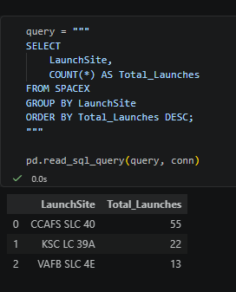
7.4 Landing Success Rate by Launch Site
The following query was used to calculate the landing success rate for each launch site.
Query:
SELECT LaunchSite,
COUNT(*) AS Total_Launches,
SUM(Class) AS Successful_Landings,
ROUND(AVG(Class) * 100, 2) AS Success_Rate
FROM SPACEX
GROUP BY LaunchSite;
Results:
Launch Site | Success Rate
CCAFS SLC 40 | 60.00%
KSC LC 39A | 77.27%
VAFB SLC 4E | 76.92%
KSC LC 39A recorded the highest landing success rate among the three launch sites.
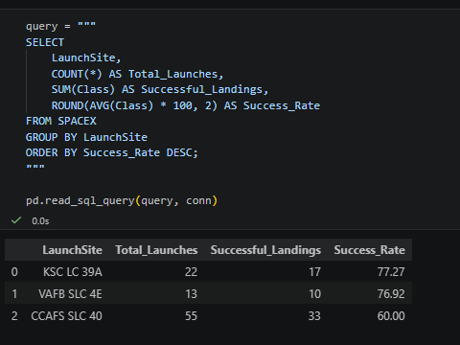
7.5 Landing Success Rate by Orbit
The following query was used to compare landing success rates across different target orbits.
Query:
SELECT Orbit,
COUNT(*) AS Total_Launches,
ROUND(AVG(Class) * 100, 2) AS Success_Rate
FROM SPACEX
GROUP BY Orbit
ORDER BY Success_Rate DESC;
The results showed that landing success rates varied across different orbit categories. Some orbits recorded 100% success rates, while GTO recorded approximately 51.85%.
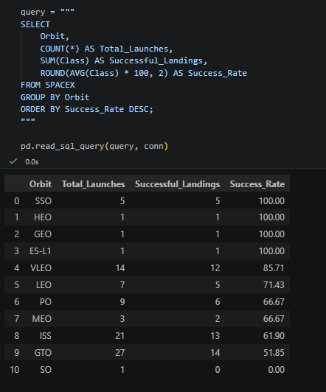
7.6 Yearly Landing Success Rate
The yearly success rate was calculated to understand changes in landing performance over time.
Query:
SELECT Year,
COUNT(*) AS Total_Launches,
ROUND(AVG(Class) * 100, 2) AS Success_Rate
FROM SPACEX
GROUP BY Year
ORDER BY Year;
The analysis showed that landing success generally improved over the years, reaching 90% in 2019.
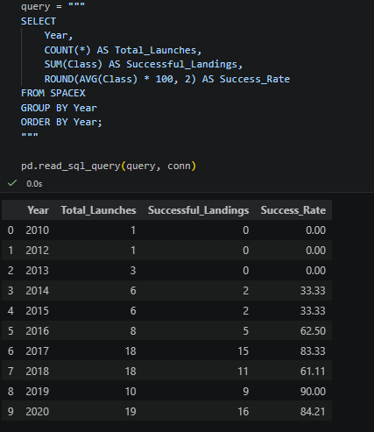
7.7 Average Payload Mass by Landing Outcome
The following query was used to compare the average payload mass for successful and unsuccessful landings.
Query:
SELECT Class,
ROUND(AVG(PayloadMass), 2) AS Average_Payload_Mass
FROM SPACEX
GROUP BY Class;
Results:
Landing Outcome (Class) | Average Payload Mass
Unsuccessful (0) | 4784.56 kg
Successful (1) | 6765.16 kg
The results showed that successful landings had a higher average payload mass in the analyzed dataset.
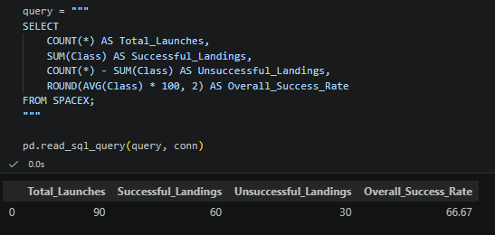
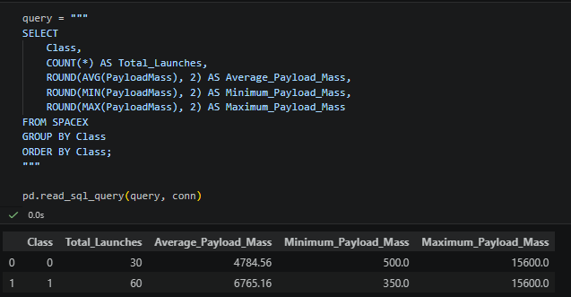
7.8 SQL Analysis Summary
SQL analysis helped extract important information from the SpaceX dataset.
The analysis identified the total number of launches, launch distribution by site, success rates by launch site and orbit, yearly performance, and average payload mass.
These results supported the findings from exploratory data analysis and helped develop a better understanding of Falcon 9 landing performance.

8. INTERACTIVE MAP USING FOLIUM
Folium is a Python library used to create interactive geographical maps. It combines the data processing capabilities of Python with the mapping features of Leaflet.js.
In this project, Folium was used to visualize the geographical locations of SpaceX Falcon 9 launch sites.
The interactive map helps users understand where SpaceX launches its rockets and compare the landing performance of different launch locations.
8.1 Objective
The main objectives of creating the interactive map were:
- To display the geographical locations of SpaceX launch sites.
- To visualize launch site information on an interactive map.
- To show the total number of launches at each location.
- To display successful landings and success rates for each launch site.
8.2 Launch Sites Used
Three SpaceX launch sites were displayed on the map:
- CCAFS SLC 40
- KSC LC 39A
- VAFB SLC 4E
Markers were added to the map to represent the geographical locations of these launch sites.
8.3 Interactive Map Features
The Folium map includes the following features:
- Interactive geographical map.
- Markers showing the locations of launch sites.
- Popup information for each launch site.
- Total number of launches.
- Number of successful landings.
- Landing success percentage.
The popup information allows users to explore launch statistics by selecting individual markers.
8.4 Results
The map displayed the following launch site statistics:
Launch Site | Total Launches | Successful Landings | Success Rate
CCAFS SLC 40 | 55 | 33 | 60.00%
KSC LC 39A | 22 | 17 | 77.27%
VAFB SLC 4E | 13 | 10 | 76.92%
The results show that KSC LC 39A had the highest landing success rate among the three launch sites.
Figure 8.1: Interactive Map of SpaceX Falcon 9 Launch Sites
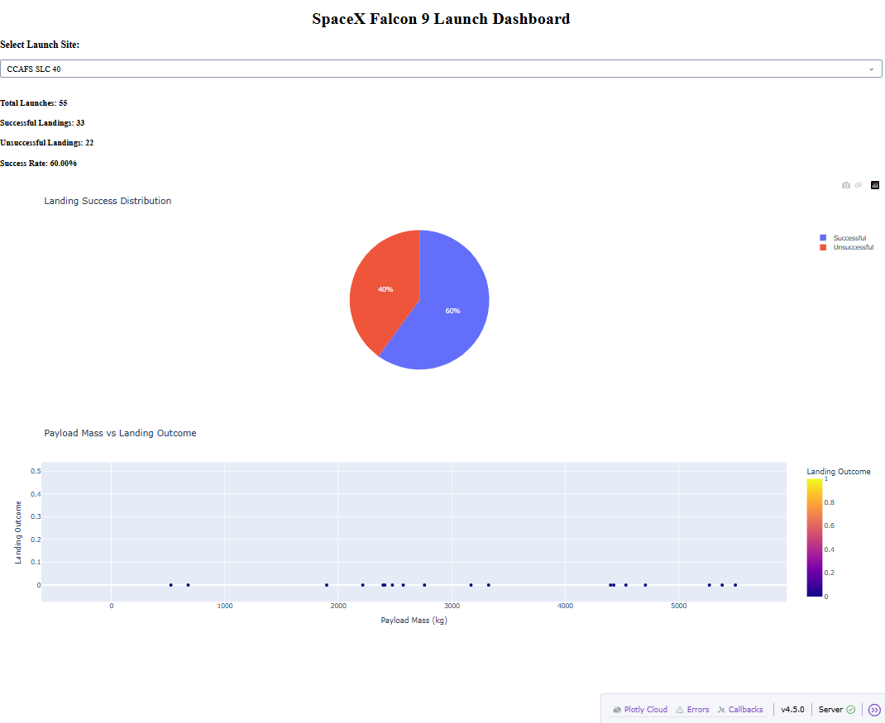
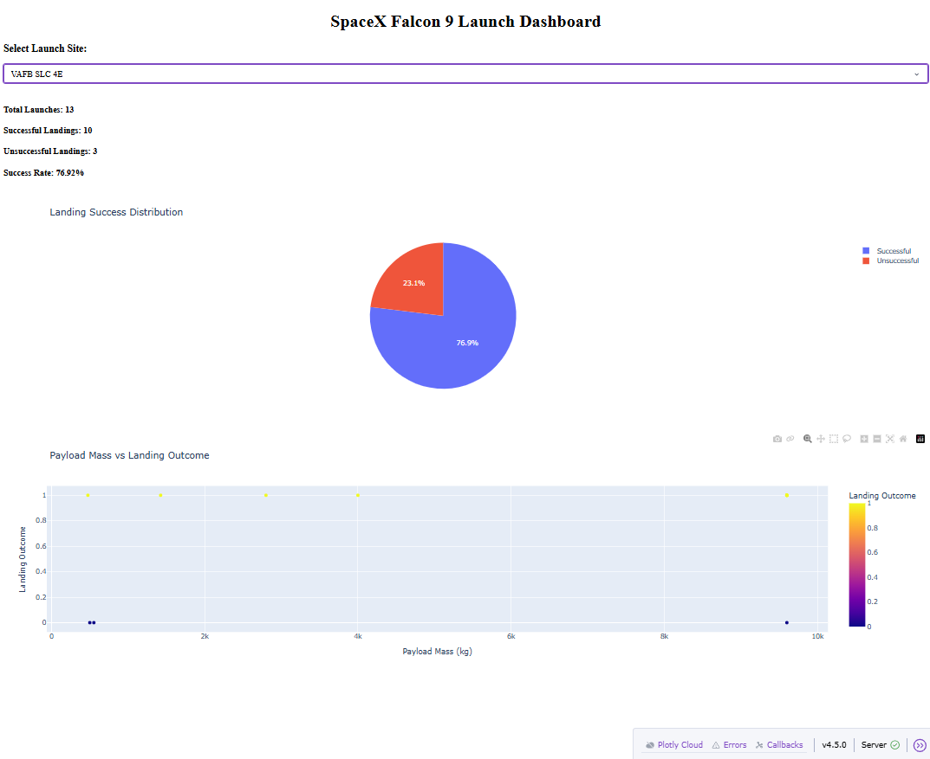
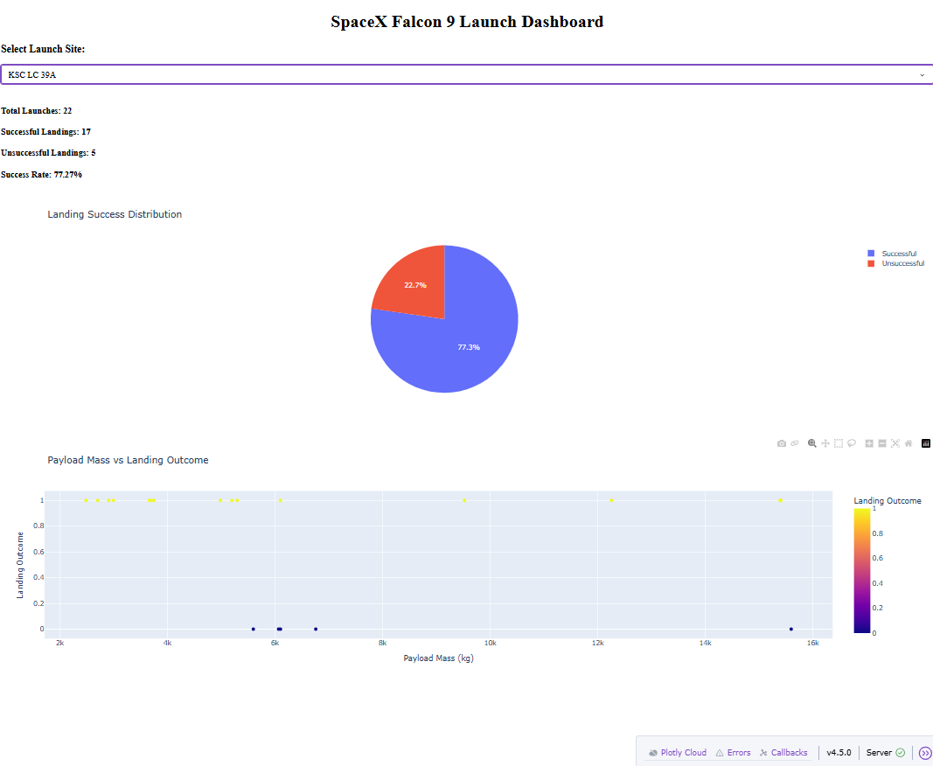
8.5 Conclusion
The Folium interactive map provides a geographical representation of SpaceX launch locations. It makes the launch site information easier to understand and helps users explore location-based launch statistics.

9. INTERACTIVE DASHBOARD USING PLOTLY DASH
Plotly Dash is a Python framework used to create interactive web-based dashboards for data visualization and analysis.
In this project, Plotly Dash was used to develop an interactive dashboard for exploring SpaceX Falcon 9 launch data.
The dashboard allows users to select different launch sites and view important launch statistics through interactive charts and summary metrics.
9.1 Objective
The main objectives of developing the dashboard were:
- To present SpaceX launch data in a user-friendly format.
- To display important launch statistics.
- To compare successful and unsuccessful landings.
- To provide an interactive launch-site selection feature.
- To make data analysis easier through graphical representations.
9.2 Dashboard Features
The developed dashboard includes the following features:
- Launch-site selection dropdown.
- Total launch count.
- Successful landing count.
- Unsuccessful landing count.
- Landing success percentage.
- Pie chart showing successful and unsuccessful landings.
- Scatter plot showing payload mass and landing outcomes.
9.3 Launch Site Analysis
The dashboard allows users to select individual launch sites and explore their launch statistics.
The following results were observed:
Launch Site | Total Launches | Successful | Unsuccessful | Success Rate
CCAFS SLC 40 | 55 | 33 | 22 | 60.00%
KSC LC 39A | 22 | 17 | 5 | 77.27%
VAFB SLC 4E | 13 | 10 | 3 | 76.92%
9.4 Dashboard Results
The dashboard successfully displayed launch statistics for all three launch sites.
Users could change the dropdown selection to explore different launch locations. The summary metrics and visualizations updated according to the selected launch site.
This interactive approach made it easier to compare launch performance and understand the distribution of landing outcomes.
Figure 9.1: SpaceX Dashboard – CCAFS SLC 40
Figure 9.2: SpaceX Dashboard – KSC LC 39A
Figure 9.3: SpaceX Dashboard – VAFB SLC

9.5 Conclusion
The Plotly Dash dashboard provides an interactive way to explore SpaceX Falcon 9 launch information.
It combines summary statistics and graphical visualizations in a single interface, making the analysis easier to understand and interpret.

10. MACHINE LEARNING MODEL DEVELOPMENT
Machine Learning is a branch of Artificial Intelligence that enables computers to learn patterns from data and make predictions.
In this project, machine learning algorithms were used to predict whether the first-stage booster of a SpaceX Falcon 9 rocket would land successfully.
The prepared dataset was used to train different classification algorithms. Their performance was evaluated to identify the most suitable model for landing prediction.
10.1 Objective
The main objective of machine learning was to develop a predictive model that could classify Falcon 9 landing outcomes into two categories:
- Class 1: Successful landing.
- Class 0: Unsuccessful landing.
10.2 Feature Selection
Before training the models, unnecessary columns were removed from the dataset.
The following columns were excluded:
- Date
- BoosterVersion
- Outcome
- LandingPad
- Serial
- Longitude
- Latitude
The remaining features were used as input variables for machine learning.
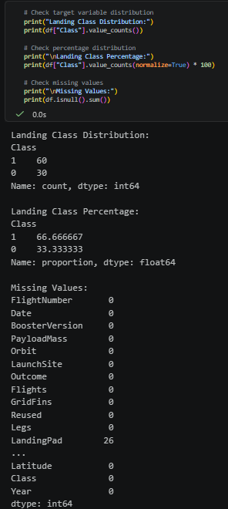
10.3 Data Encoding
Machine learning algorithms require numerical input.
The categorical features Orbit and LaunchSite were converted into numerical columns using One-Hot Encoding.
This process creates separate binary columns for different categories.
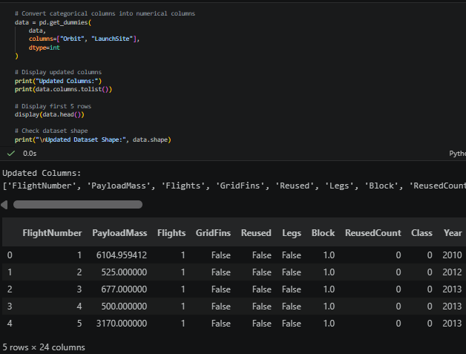
10.4 Training and Testing Data
The dataset was divided into training and testing sets using an 80:20 ratio.
- Training records: 72
- Testing records: 18
The training dataset was used to train the machine learning algorithms, while the testing dataset was used to evaluate their prediction performance.
Stratified sampling was applied to maintain the proportion of successful and unsuccessful landing records in both datasets.
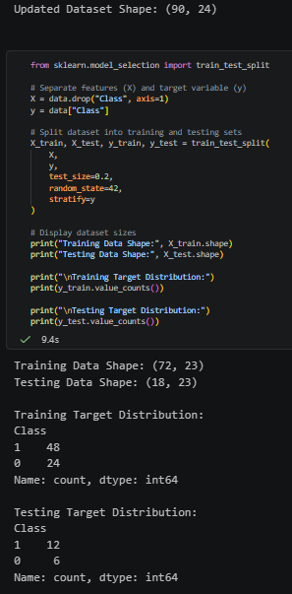
10.5 Machine Learning Algorithms
Three different machine learning algorithms were implemented.
A. Logistic Regression
Logistic Regression is a supervised classification algorithm used to predict the probability of an outcome.
In this project, Logistic Regression was used to classify Falcon 9 landing outcomes into successful and unsuccessful categories.
Feature scaling was applied using StandardScaler to improve model training.
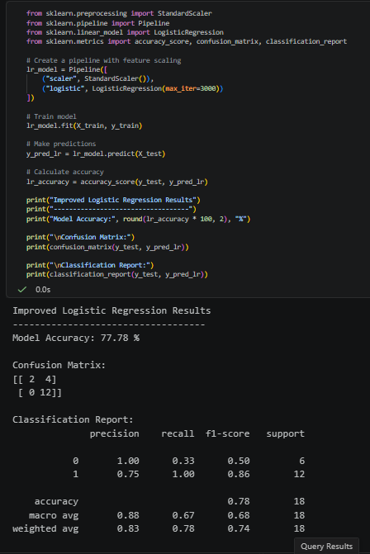
B. Decision Tree Classifier
A Decision Tree is a supervised machine learning algorithm that makes predictions using a tree-like structure of decision rules.
It divides the dataset into smaller groups based on feature values and predicts the final class.
In this project, a Decision Tree classifier with a maximum depth of 5 was implemented.
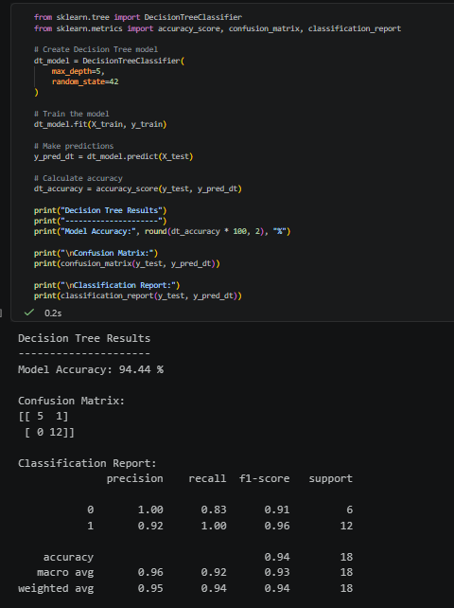
C. Support Vector Machine (SVM)
Support Vector Machine is a supervised learning algorithm used for classification.
It identifies a decision boundary that separates different classes in the dataset.
In this project, an SVM classifier with an RBF kernel was implemented. Feature scaling was also applied before training.
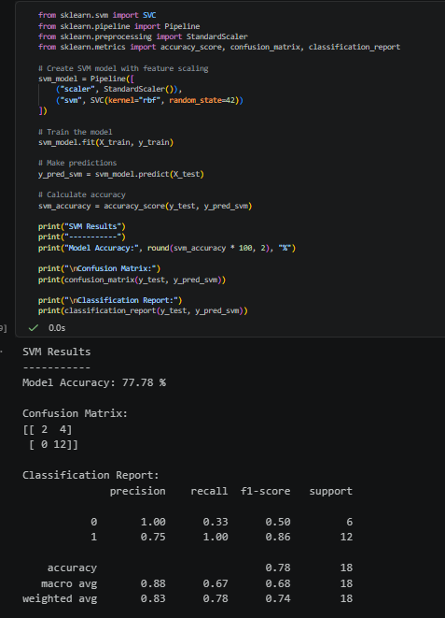
10.6 Model Training
All three machine learning algorithms were trained using the training dataset.
The models learned patterns from the input features and their corresponding landing outcomes.
After training, the models were used to predict landing outcomes for the testing dataset.
The prediction results were then compared to evaluate the performance of each algorithm.
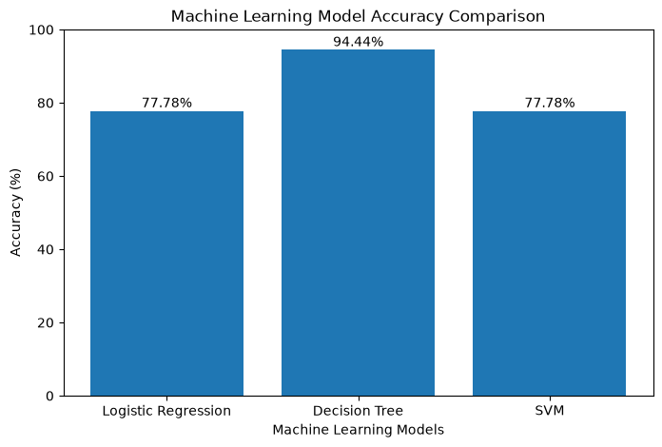

11. MODEL EVALUATION AND COMPARISON
Model evaluation is an important step in machine learning. It helps determine how accurately a trained model can predict outcomes using unseen data.
In this project, three classification algorithms were evaluated: Logistic Regression, Decision Tree, and Support Vector Machine (SVM).
The models were compared using test accuracy, confusion matrices, classification reports, and 5-fold cross-validation.
11.1 Model Accuracy
Accuracy measures the percentage of correct predictions made by a machine learning model.
The following results were obtained on the testing dataset:
Machine Learning Model | Test Accuracy
Logistic Regression | 77.78%
Decision Tree | 94.44%
Support Vector Machine (SVM) | 77.78%
The Decision Tree classifier achieved the highest test accuracy of 94.44%.
11.2 Confusion Matrix
A confusion matrix is used to evaluate the performance of a classification model by comparing actual and predicted outcomes.
The confusion matrix for the Decision Tree model was:
 | Predicted Failure (0) | Predicted Success (1)
Actual Failure (0) | 5 | 1
Actual Success (1) | 0 | 12
The model correctly predicted 17 out of 18 test records.
It correctly identified 5 unsuccessful landings and all 12 successful landings. It incorrectly classified one unsuccessful landing as successful.
11.3 Classification Report
The classification report provides precision, recall, and F1-score for each class.
The Decision Tree model produced the following results:
Class | Precision | Recall | F1-Score
0 – Unsuccessful | 1.00 | 0.83 | 0.91
1 – Successful | 0.92 | 1.00 | 0.96
The results indicate that the Decision Tree model performed well in identifying both successful and unsuccessful landing outcomes.
11.4 Cross-Validation
Five-fold cross-validation was performed to evaluate model performance across different training and validation splits.
The average cross-validation results were:
Model | Average Accuracy | Standard Deviation
Logistic Regression | 82.22% | 6.48%
Decision Tree | 84.44% | 6.48%
SVM | 81.11% | 6.67%
The Decision Tree classifier achieved the highest average cross-validation accuracy of 84.44%.
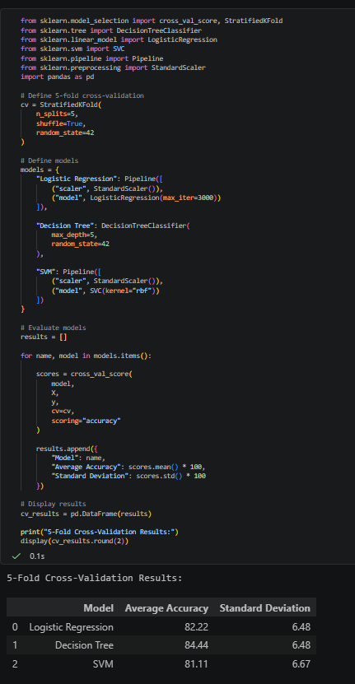
11.5 Final Model Selection
Based on the evaluation results, the Decision Tree classifier was selected as the best-performing model.
It achieved:
- Test accuracy: 94.44%.
- Cross-validation accuracy: 84.44%.
- Correct predictions: 17 out of 18 test records.
The Decision Tree model was saved as a reusable machine learning file for future predictions.
11.6 Conclusion
The evaluation results show that the Decision Tree classifier performed better than Logistic Regression and SVM on the testing dataset.
Although the Decision Tree achieved high test accuracy, its cross-validation accuracy was lower. Therefore, further testing with additional launch data would be useful to understand how well the model generalizes to new launches.

12. RESULTS AND DISCUSSION
The SpaceX Falcon 9 First Stage Landing Prediction project successfully demonstrated the use of data science, data visualization, SQL, and machine learning techniques to analyze historical rocket launch data.
The project analyzed 90 Falcon 9 launch records and identified several important patterns related to landing success.
12.1 Key Findings from Data Analysis
The exploratory data analysis and SQL operations produced the following findings:
- The dataset contained 90 launch records, with 60 successful and 30 unsuccessful landings.
- The overall landing success rate was 66.67%.
- KSC LC 39A recorded the highest landing success rate of 77.27%.
- Landing success rates varied across different target orbits.
- Successful landings had a higher average payload mass than unsuccessful landings.
- Launches using grid fins showed a higher landing success rate in the analyzed dataset.
- Landing success generally improved over the years.
12.2 Interactive Visualization Results
The Folium map successfully displayed the geographical locations of three SpaceX launch sites.
The Plotly Dash dashboard provided an interactive interface for exploring launch statistics. Users could select different launch sites and view the corresponding launch counts, landing outcomes, and visualizations.
These tools made the results easier to understand and interpret.
12.3 Machine Learning Results
Three machine learning algorithms were trained and evaluated.
The test accuracy results were:
- Logistic Regression: 77.78%
- Decision Tree: 94.44%
- Support Vector Machine: 77.78%
The Decision Tree classifier achieved the highest test accuracy of 94.44%.
It also achieved the highest average accuracy of 84.44% during 5-fold cross-validation.
12.4 Overall Discussion
The results demonstrate that historical launch information can be used to identify patterns associated with Falcon 9 first-stage landing outcomes.
The Decision Tree classifier performed best among the three tested models. However, its test accuracy was higher than its cross-validation accuracy, indicating that additional data would be useful for evaluating its generalization performance.
The project successfully combined data analysis, database operations, interactive visualization, and predictive modelling into a complete data science workflow.

13. CONCLUSION AND FUTURE SCOPE
13.1 Conclusion
The SpaceX Falcon 9 First Stage Landing Prediction project successfully demonstrated how data science and machine learning techniques can be applied to analyze historical rocket launch information and predict landing outcomes.
The project involved several stages, including data collection, data cleaning, exploratory data analysis, SQL analysis, interactive mapping, dashboard development, and machine learning.
Python libraries such as Pandas, NumPy, Matplotlib, Seaborn, and Scikit-learn were used to process and analyze the dataset. Folium was used to create an interactive map, while Plotly Dash was used to develop an interactive dashboard.
Three machine learning algorithms were implemented: Logistic Regression, Decision Tree, and Support Vector Machine.
Among these algorithms, the Decision Tree classifier achieved the highest test accuracy of 94.44% and an average 5-fold cross-validation accuracy of 84.44%.
The project helped identify important patterns related to launch sites, payload mass, target orbits, booster reuse, and landing outcomes.
Overall, this project provided practical experience in solving a real-world data science problem using data analysis, visualization, database operations, and machine learning.
13.2 Future Scope
The project can be improved and extended in several ways:
- Larger Dataset: Additional SpaceX launch records can be included to improve model training and evaluation.
- Advanced Algorithms: Algorithms such as Random Forest, Gradient Boosting, and XGBoost can be explored.
- Hyperparameter Tuning: Model parameters can be optimized to improve prediction performance.
- Real-Time Data: Live launch information can be integrated to provide updated predictions.
- Improved Dashboard: Additional interactive charts and filters can be included.
- Model Deployment: The trained machine learning model can be deployed as a web application for users.
- Better Evaluation: More testing data and additional evaluation techniques can be used to check model reliability.
13.3 Final Statement
This project demonstrates the importance of data science in understanding complex engineering problems. By combining historical data analysis with machine learning, it is possible to develop predictive systems that support research and decision-making in the aerospace industry.

14. REFERENCES
The following resources were used during the development of this project:
- IBM Skills Network – Data Science Capstone Project
IBM Data Science Professional Certificate.
https://cf-courses-data.s3.us.cloud-object-storage.appdomain.cloud/IBM-DS0321EN-SkillsNetwork/
- SpaceX Official Website
Information about Falcon 9 rockets and reusable launch technology.
https://www.spacex.com/
- Pandas Documentation
https://pandas.pydata.org/docs/
- NumPy Documentation
https://numpy.org/doc/
- Matplotlib Documentation
https://matplotlib.org/stable/
- Seaborn Documentation
https://seaborn.pydata.org/
- Scikit-learn Documentation
https://scikit-learn.org/stable/
- Folium Documentation
https://python-visualization.github.io/folium/
- Plotly Dash Documentation
https://dash.plotly.com/
- SQLite Documentation
https://www.sqlite.org/docs.html

