**NAME: NAYANA J**

**USN: 1BM19CS0795**

**BDA LAB 3**

Program 1. Perform the following DB operations using Cassandra.

1. Create a key space by name Employee



2. Create a column family by name Employee-Info with attributes Emp_Id Primary Key, Emp_Name, Designation, Date_of_Joining, Salary, Dept_Name

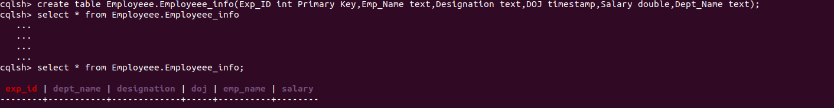

3. Insert the values into the table in batch

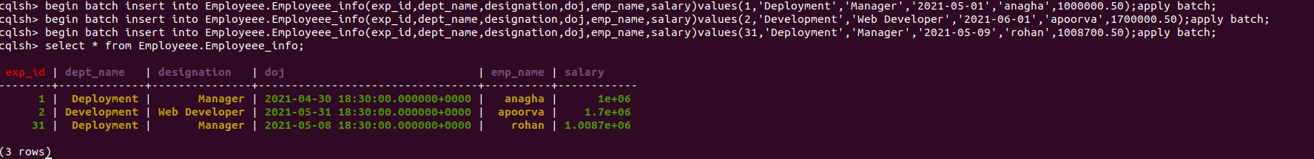

4. Update Employee name and Department of Emp-Id 121

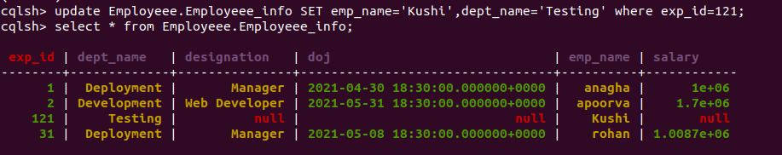

6.Alter the schema of the table Employee_Info to add a column Projects which stores a set of Projects done by the corresponding Employee.

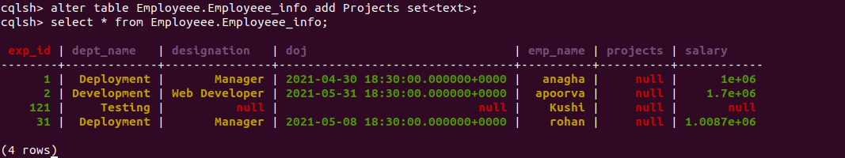

7. Update the altered table to add project names.

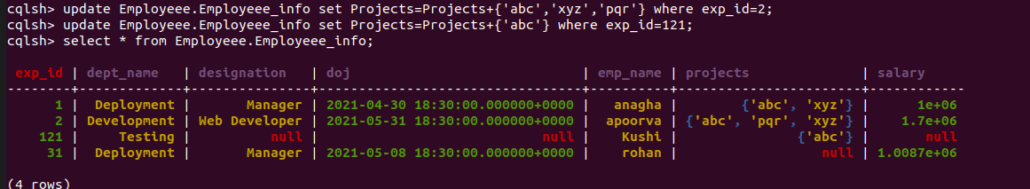

8 Create a TTL of 15 seconds to display the values of Employees.

