MONGO CRUD EXECUTIONS
NAME : NAYANA J
USN : 1BM19CS095

- CREATE DATABASE IN MONGODB.

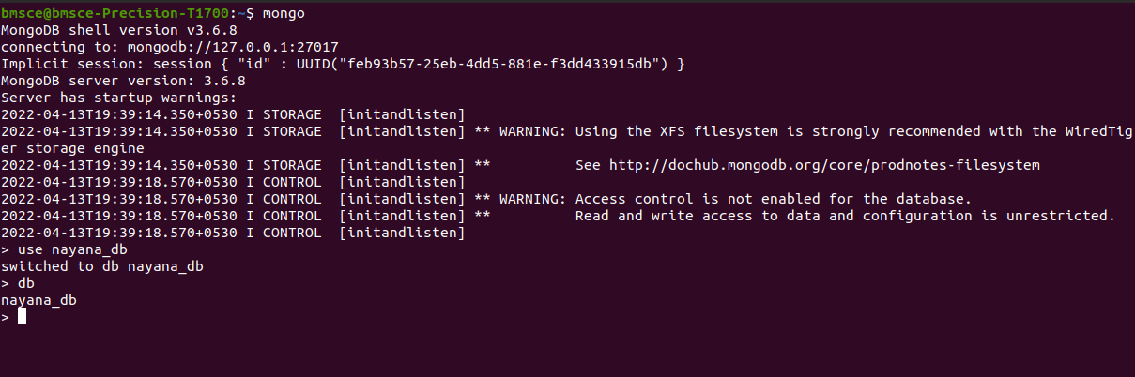

2. CRUD (CREATE, READ, UPDATE, DELETE) OPERATIONS
- To create a collection by the name “Student”. Let us take a look at the collection list prior to the creation of the new collection “Student”.

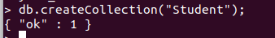

- Create a collection by the name “Students” and store the following data in it.

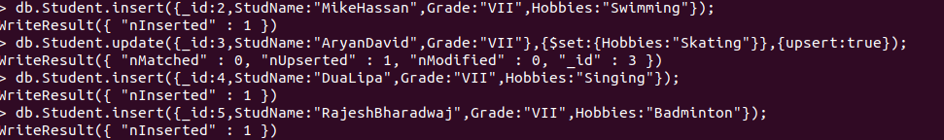

- FIND METHOD
A. To search for documents from the “Students” collection based on certain search criteria.
B. To display only the StudName and Grade from all the documents of the Students collection. The identifier_id should be suppressed and NOT displayed.

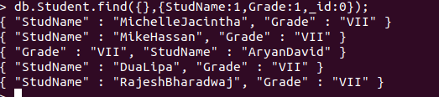
C. To find those documents where the Grade is set to ‘VII’

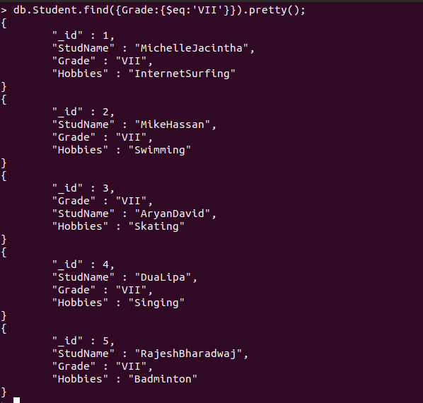
D. To find those documents from the Students collection where the Hobbies is set to either ‘singing’ or is set to ‘Skating’.

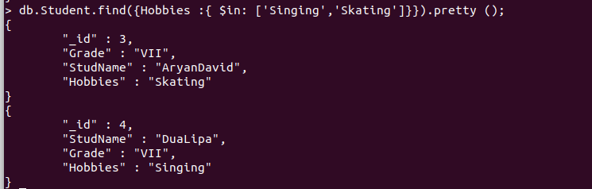
E. To find documents from the Students collection where the StudName begins with “R”.


F. To find documents from the Students collection where the StudNamehas an “a” in any position.

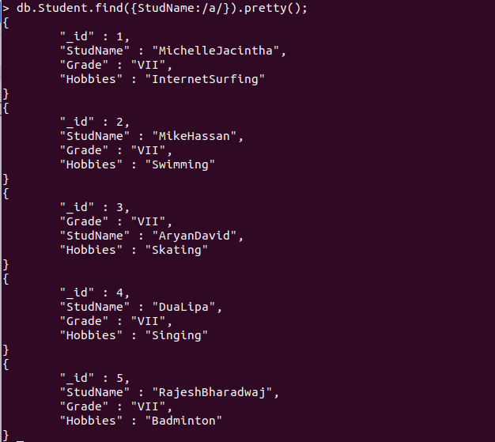

G. To find the number of documents in the Students collection.

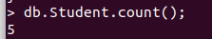
H. To sort the documents from the Students collection in the descending order of StudName.

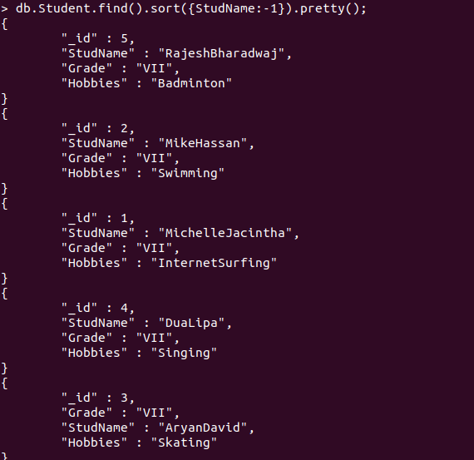
3.Save Method :
Save() method will insert a new document, if the document with the _id does not exist. If it exists it will replace the exisiting document.

Add a new field to existing Document:

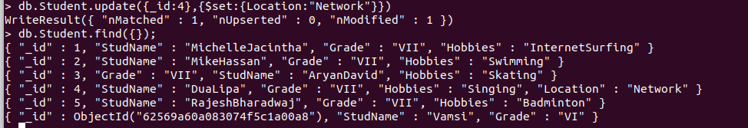
Remove the field in an existing Document

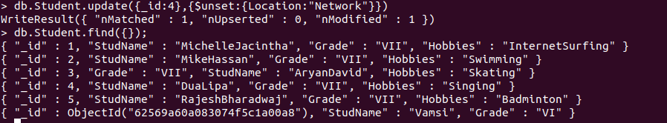
Finding Document based on search criteria suppressing few fields

To find those documents where the Grade is not set to ‘VII’

To find documents from the Students collection where the StudName ends with n.

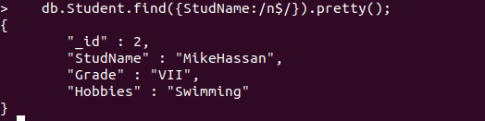
to set a particular field value to NULL

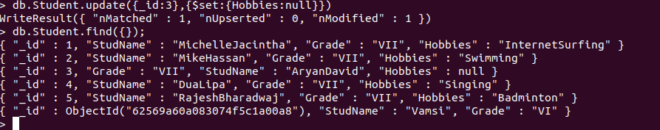

Count the number of documents in Student Collections

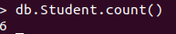
Count the number of documents in Student Collections with grade :VII



food database using mongodb

Create a collection by name “food” and add to each document add a “fruits” array

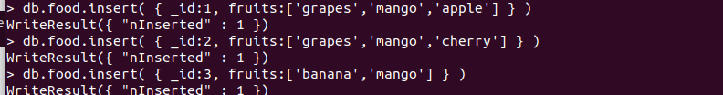

To find those documents from the “food” collection which has the “fruits array” constitute of “grapes”, “mango” and “apple”.

To find all the documets from the food collection which have elements mango and grapes in the array “fruits”

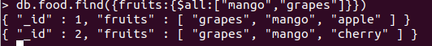
update on Array:
using particular id replace the element present in the 1st index position of the fruits array with apple

